Phospholipid Bilayer Inspired Sandwich Structural Nanofibrous Membrane for Selective Water Harvesting and Release
Zhihua Yuª, Shuhui Li^{bc}, Jichao Zhangª, Zhijuan Zhouª, Ziqi Qinª, Xiaojie Liuª, Yuekun Lai^{d}* and Shaohai Fuª*
- Jiangsu Engineering Research Center for Digital Textile Inkjet Printing, Key Laboratory of Eco-Textile, Jiangnan University, Ministry of Education, Wuxi, Jiangsu 214122, P.R. China
- Zhejiang Engineering Research Center for Tissue Repair Materials, Wenzhou Institute, University of Chinese Academy of Sciences, Wenzhou, Zhejiang 325000, P.R. China
- Department of Chemistry, University College London, London WC1H 0AJ, UK
- College of Chemical Engineering, Fuzhou University, Fuzhou 350116, P.R. China
* Corresponding authors.

Supplemental figure captions.
Figure S1. FTIR spectra curves of CB@PAN and CB-PDMS@PAN.
Figure S2. SEM and EDS spectra of CB-PDMS@PAN.
Figure S3. SEM images of CB-Ag@PAN.
Figure S4. Elements distribution of CB-Ag-LiCl@PAN.
Figure S5. EDS spectra of CB-Ag-LiCl@PAN.
Figure S6. XRD patterns of CB@PAN, CB-Ag@PAN, and CB-Ag-LiCl@PAN.
Figure S7. Photograph of the hydrostatic pressure test of CB-PDMS@PAN.
Figure S8. Antibacterial test of the CB-Ag-LiCl@PAN against E. coli.
Figure S9. Antibacterial rate and bacterial adhesion of CB-Ag-LiCl@PAN and CB-LiCl@PAN.
Figure S10. Force analysis of droplet in the hydrophobic pore.
Figure S11. A comparative chart of the water absorption capacity for some up-to-date reported water harvesting materials.
Figure S12. The ion concentration of the collected water.
Figure S13. Evaporation rate of ORI@San-PAN and CB@San-PAN.
Figure S14. Evaporation rate of CB-LiCl@San-PAN and CB-Ag-LiCl@San-PAN.

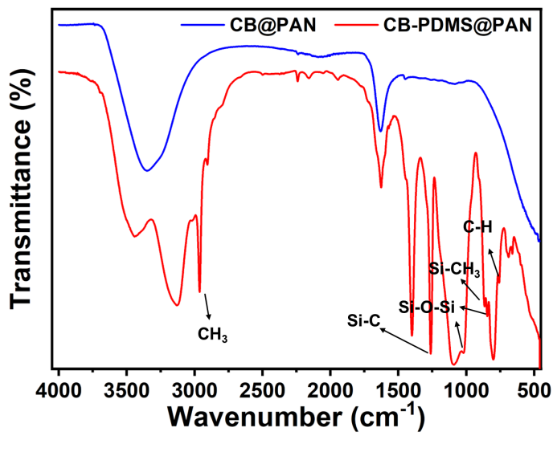
Figure S1. FTIR spectra curves of CB@PAN and CB-PDMS@PAN.

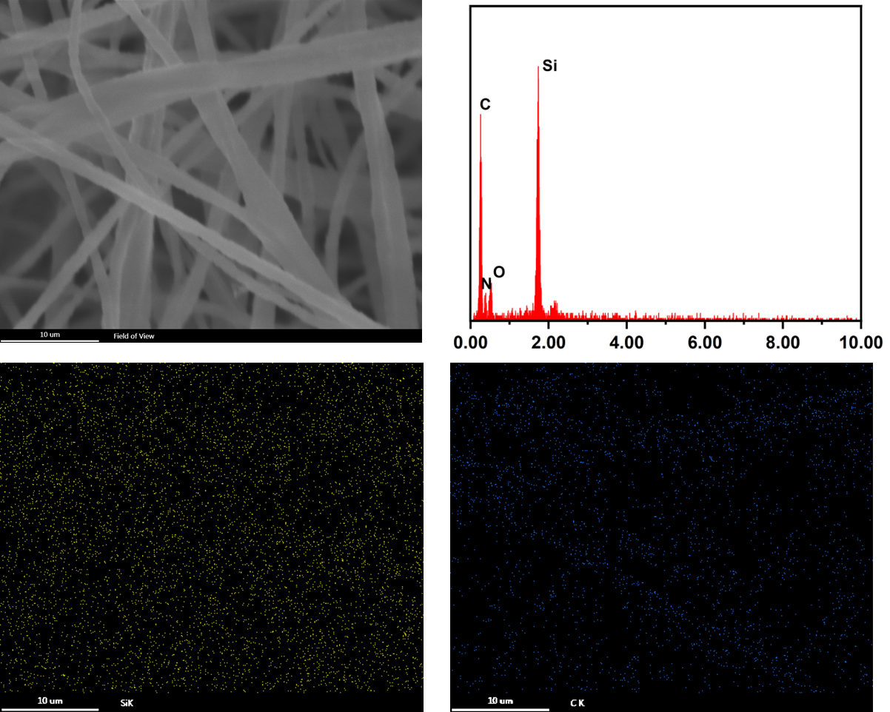
Figure S2. EDS spectra and elements distribution of CB-PDMS@PAN.

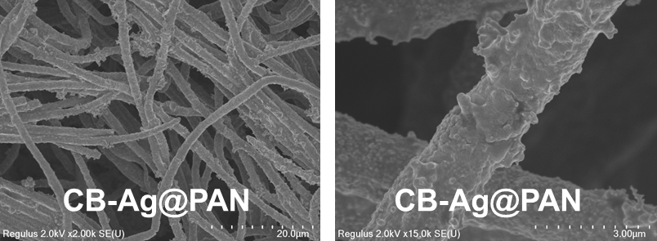
Figure S3. SEM images of CB-Ag@PAN.

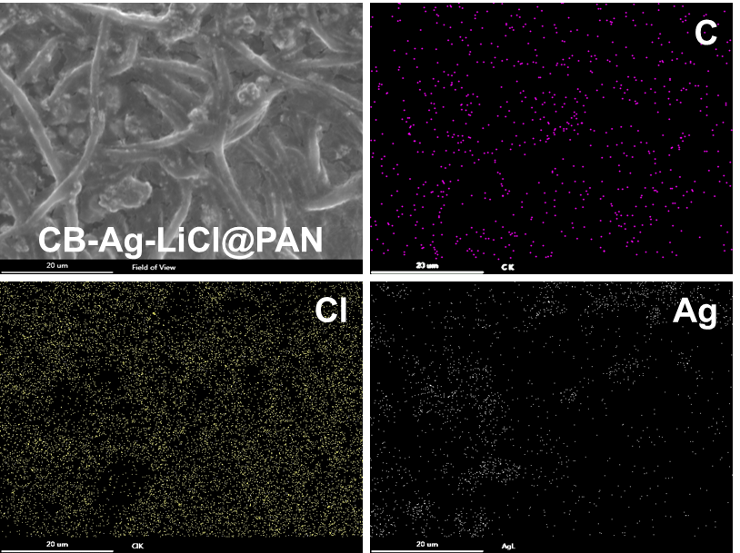
Figure S4. Elements distribution of CB-Ag-LiCl@PAN.

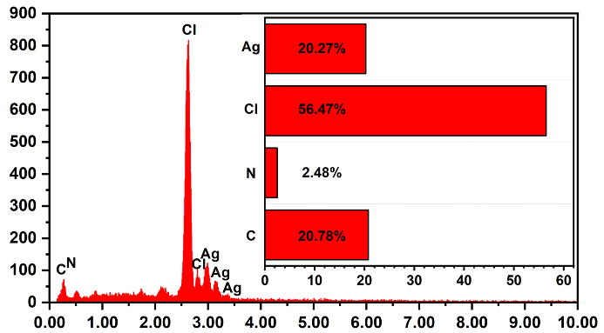
Figure S5. EDS spectra of CB-Ag-LiCl@PAN.

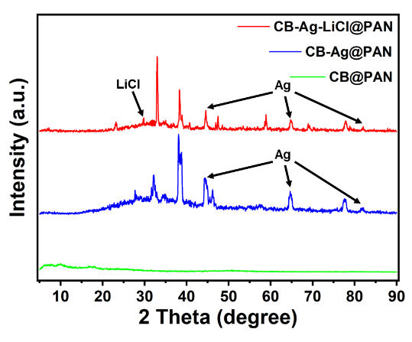
Figure S6. XRD patterns of CB@PAN, CB-Ag@PAN, and CB-Ag-LiCl@PAN.

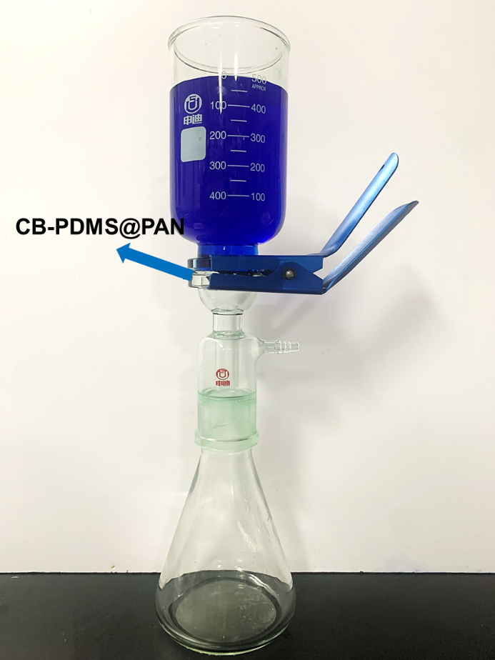
Figure S7. Photograph of the hydrostatic pressure test of CB-PDMS@PAN.

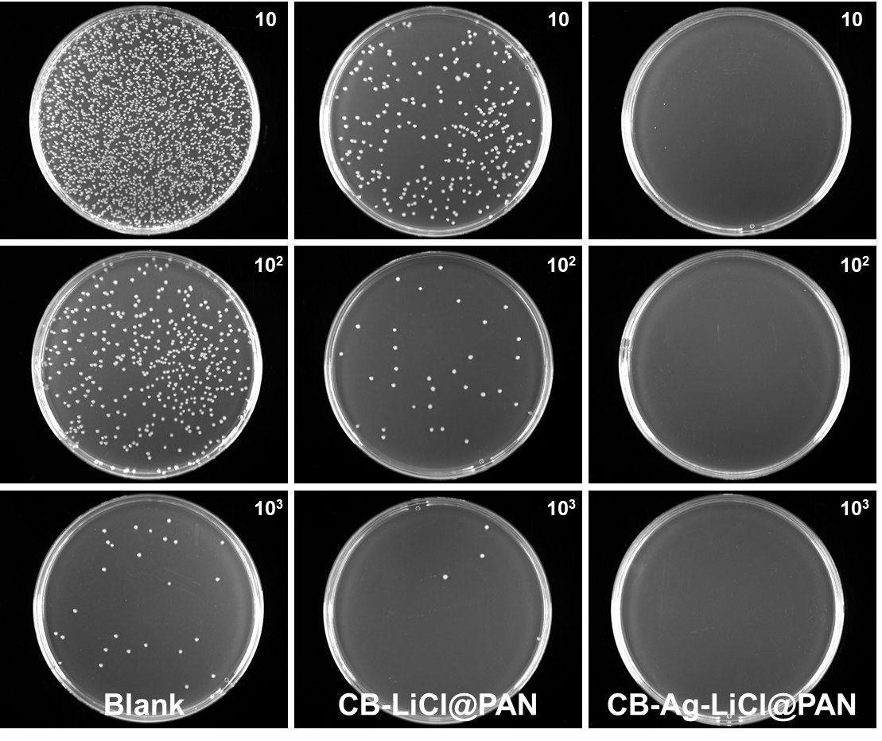
Figure S8. Antibacterial test of the CB-Ag-LiCl@PAN against E. coli.
Figure S9. Antibacterial rate and bacterial adhesion of CB-Ag-LiCl@PAN and CB-LiCl@PAN.

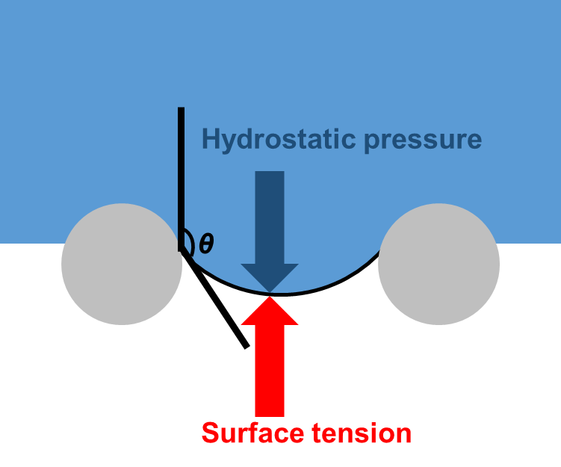
Figure S10. Force analysis of droplet in the hydrophobic pore.

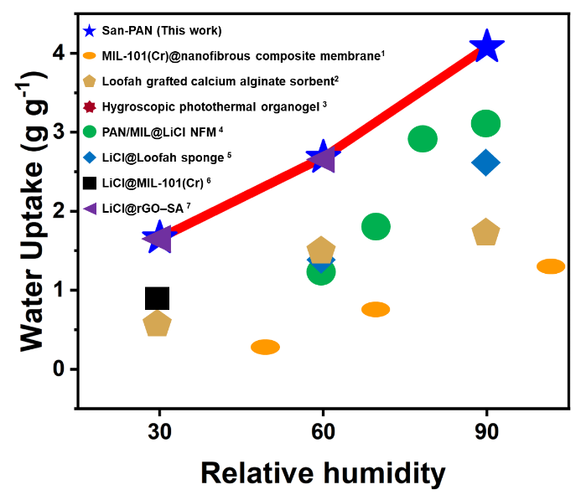
Figure S11. A comparative chart of the water absorption capacity for some up-to-date reported water harvesting materials.

References:
- Jianyong Yu, et al. Energy Environ. Mater. 2021, 5, 12254.
- Ruzhu Wang, et al. Nano Energy 2021, 90, 106642.
- Tao Chen, et al. Angew. Chem. Int. Ed. 2020, 59, 19237–19246.
- Bin Ding, et al. Nat. Commun. 2020, 11, 3302.
- Jianfeng Shen, et al. ACS Appl. Mater. Interfaces 2022, 14, 4680−4689.
- Ruzhu Wang, et al. Angew. Chem. Int. Ed. 2020, 59, 5202–5210.
- Ruzhu Wang, et al. Energy Environ. Sci. 2021, 14, 5979.

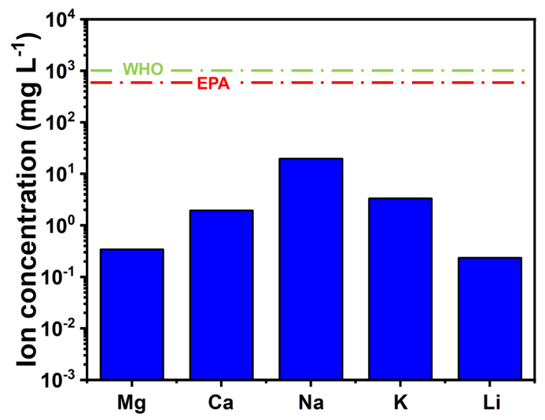
Figure S12. The ion concentration of the collected water.

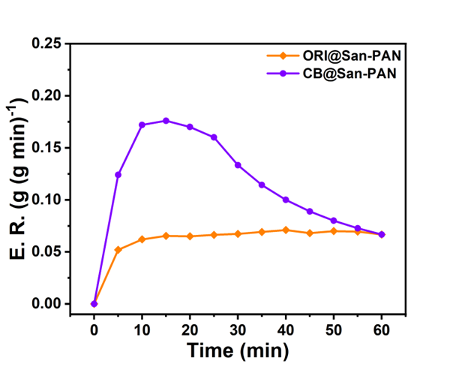
Figure S13. Evaporation rate of ORI@San-PAN and CB@San-PAN.

Figure S14. Evaporation rate of CB-LiCl@San-PAN and CB-Ag-LiCl@San-PAN.

