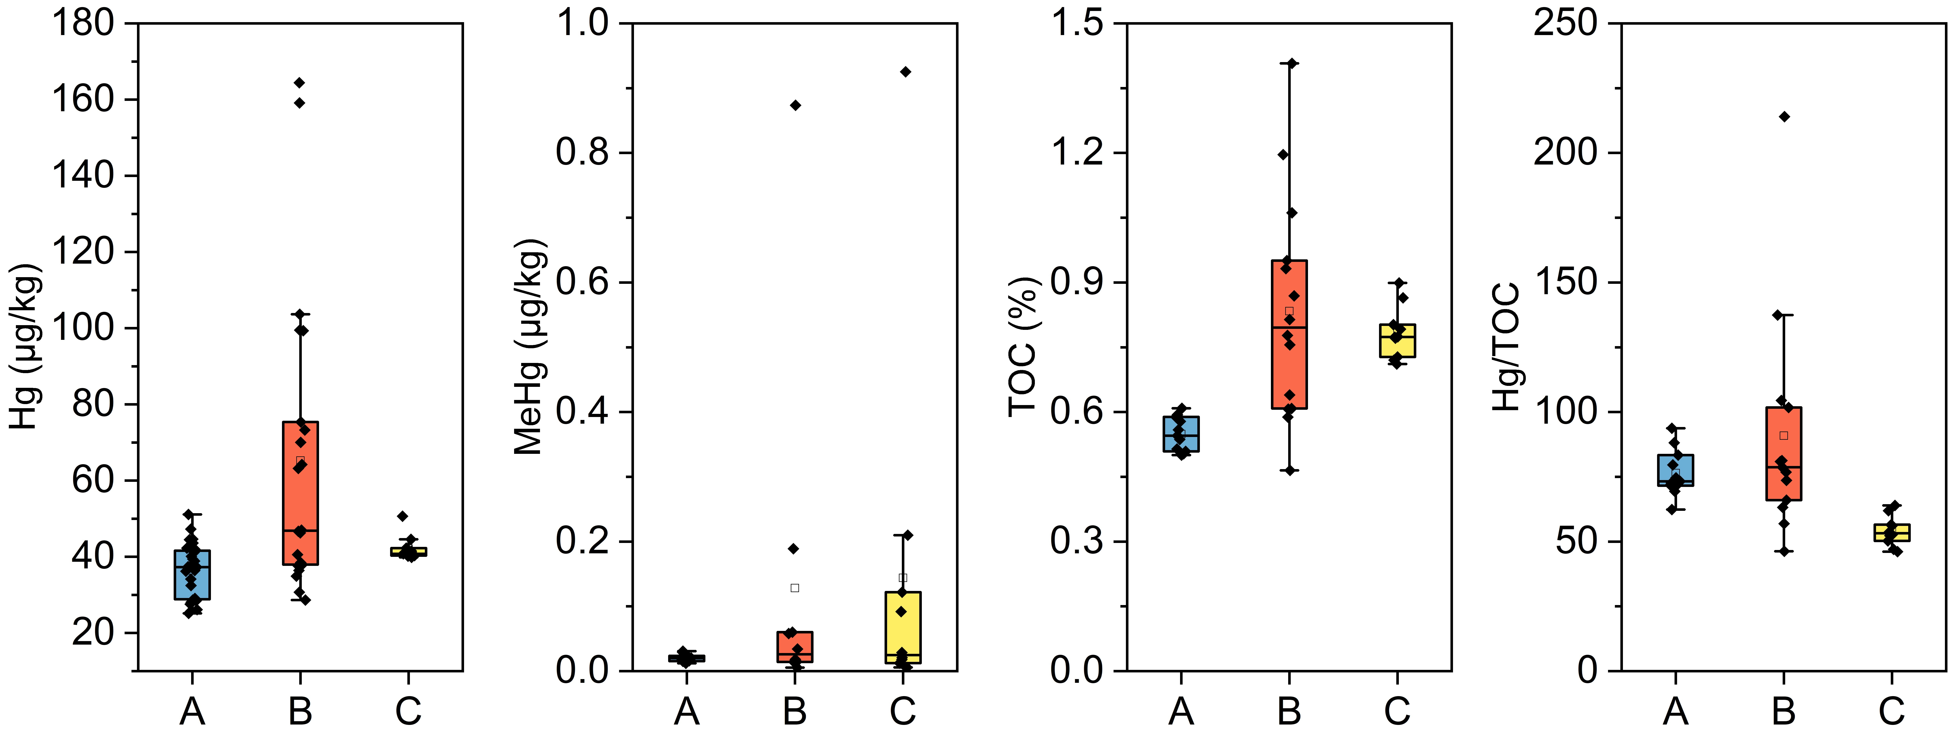
Supplementary Figure 1 Box-type diagram of TOC, total Hg, MeHg and Hg/TOC in the sediment cores of the Haima cold seep, South China Sea. Data were from core A1-A4 from the reference area, B1-B2 from the active area, and C1 from the in active area.
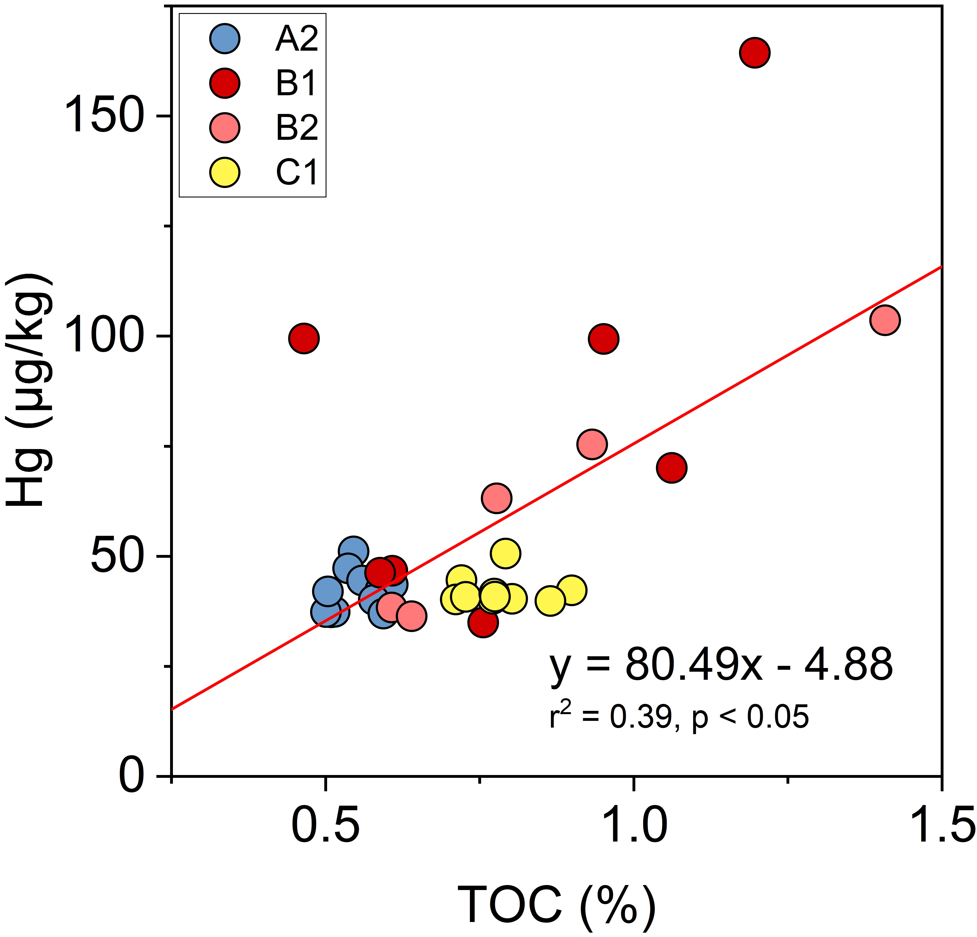

Supplementary Figure 2 Plots of TOC versus total-Hg in the “Haima” cold seep sediments, South China Sea. Data were from core A2 in the reference area, B1 and B2 in the active area, and C1 in the inactive area.
Supplementary Figure 3 The distribution pattern of Hg-methylating and demethylating MAGs, in these sediment metagenomes from the “Haima” cold seep sediments, South China Sea. Data were from core B1 and B2 in the active area, and C1 in the inactive area. Detail information of abundance can be found in Supplementary Table 4.

Supplementary Figure 4 the depth-related distribution pattern of δ²⁰²Hg, Δ¹⁹⁹Hg, Δ²⁰⁰Hg, Δ²⁰¹Hg, and Δ²⁰⁴Hg values in the sediment cores from the “Haima” cold seep, South China Sea. a. the reference area; b. the active area; c. the inactive area.

