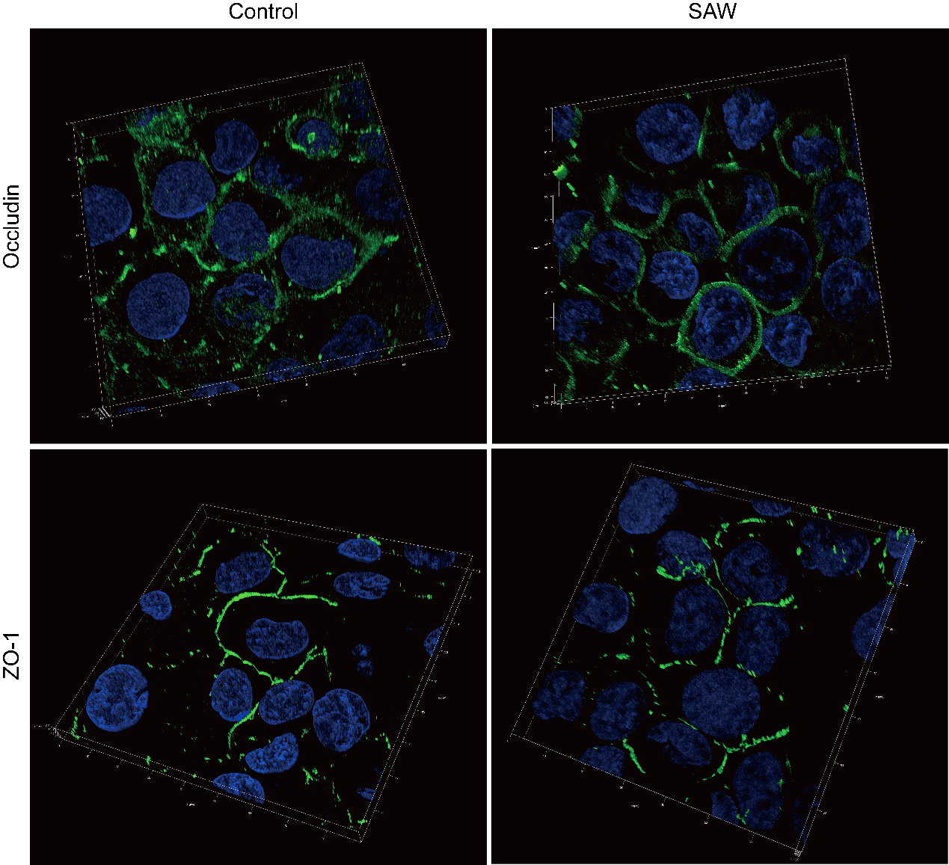
Supplementary Figure 1: Three-dimensional (3-D) image of tight junction proteins. hBMECs were seeded in round slides for 48 h when firm barrier formed, then the slides were exposed on a SAW (19.68 MHz, 37.8 dBm, 5 min), which was same with Figure 6. The z axis was selected for 10 μm, and 11 continuous pictures were acquired. The 3-D distribution of cell tight junction proteins was reconstituted and shown.

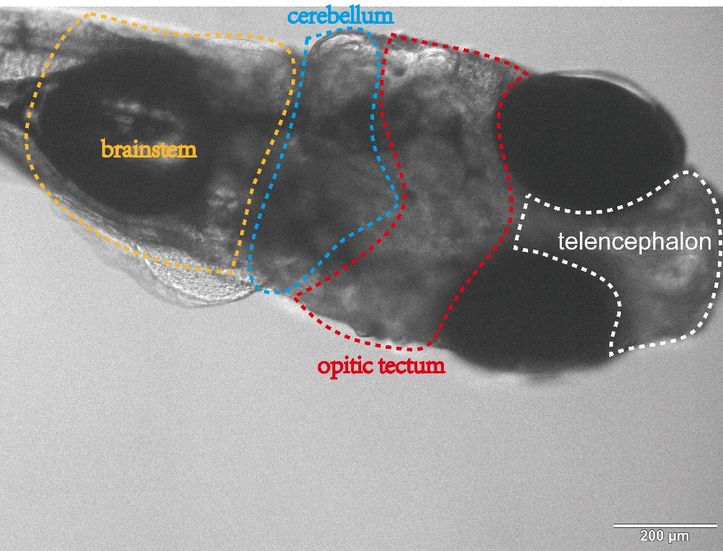
Supplementary Figure 2: A schematic diagram of brain region in 10-day-old zebrafish. The main brain regions include telencephalon, optic tectum, cerebellum and brainstem. The dotted lines only indicate the relative position of each brain region, and the area is not represented the full size of each region. Scale bar was 200 μm.

