Supporting information for “A pruned feed-forward neural network (pruned-FNN) approach to measure air pollution exposure”.

Table of Contents
Table S1. Performance comparison of the pruned-FNN with different combination of input variables
Fig. S1. Substructure representing the pollution exposure index (PEI) contributed by one emission source in the pruned-FNN model
Fig. S2. Cross validation of the pruned-FNN based on time periods of the data
Fig. S3. Sensitivity analysis of the pruned FNN with different quantity of training data
Fig. S4. Distributions of relative absolute errors (RAEs) in (a) 10-fold cross validations; (b) 100 random cross validations
Fig. S5. Predicted pollution exposure indexes (PEIs) and monitoring records in one cross validation of the pruned-FNN model
Table S1 Performance comparison of the pruned-FNN with different combination of input variables
Variables in the model | T, H, EM, D, ED, W (Original model) | T, H, D, ED, W | T, H, EM, ED, W | H, EM, D, ED, W | T, EM, D, ED, W | T, H, EM, D, W | T, H, EM, D, ED | EM, D
Mean* | 0.911 | 0.469 | 0.553 | 0.813 | 0.777 | 0.771 | 0.737 | 0.869
Median* | 0.915 | 0.473 | 0.422 | 0.825 | 0.785 | 0.734 | 0.765 | 0.852
Standard deviation* | 0.048 | 0.073 | 0.097 | 0.059 | 0.058 | 0.068 | 0.038 | 0.031
* All statistics are the Spearman rank correlation coefficients in the 10 times of the 10-fold cross validations.

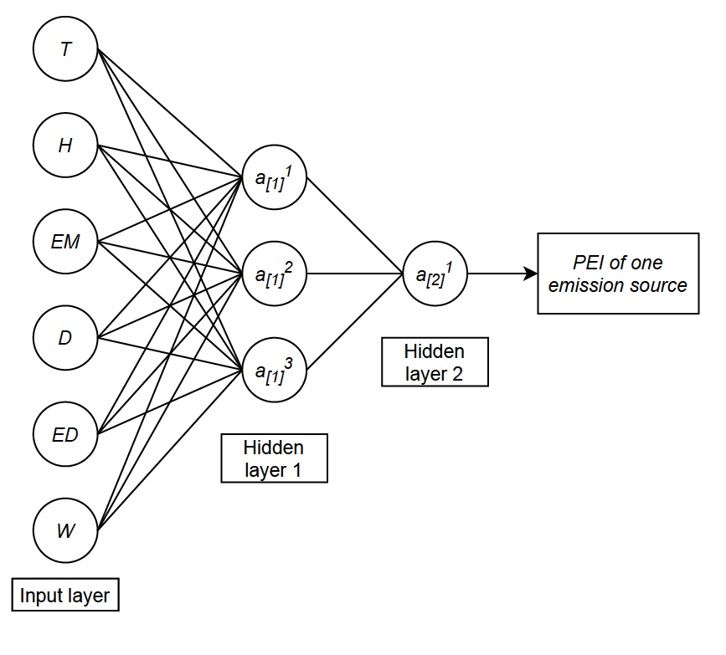
Fig. S1. Substructure representing the pollution exposure index (PEI) contributed by one emission source in the pruned-FNN model

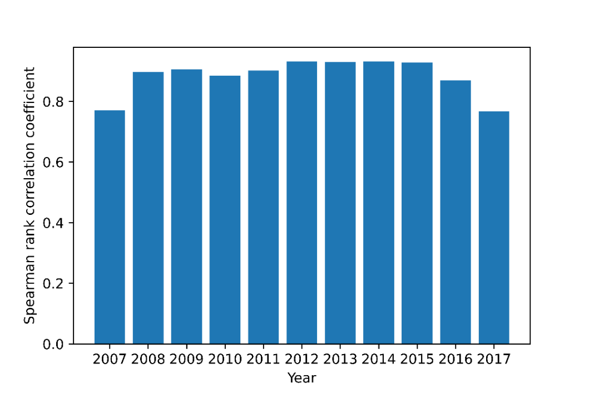
Fig. S2. Cross validation of the pruned-FNN based on time periods of the data
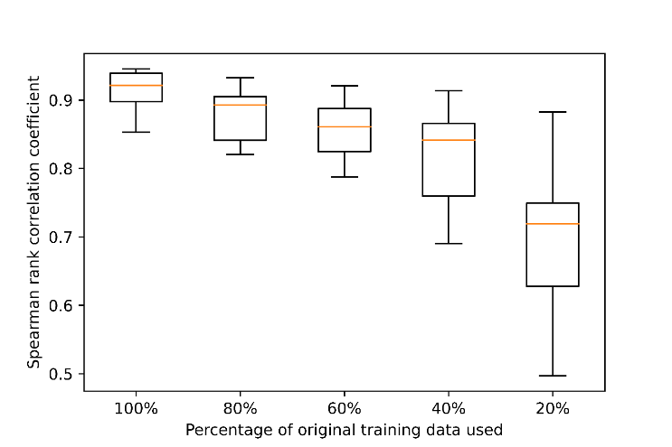
Fig. S3. Sensitivity analysis of the pruned FNN with different quantity of training data

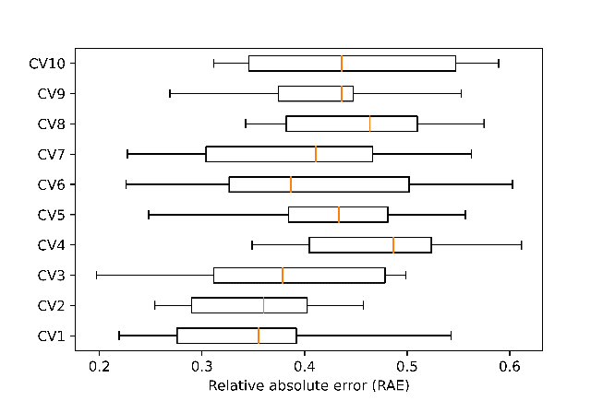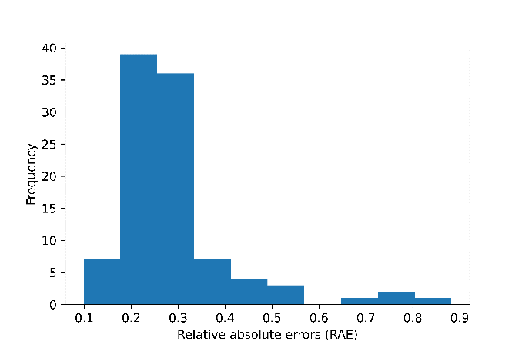
(a) (b)
Fig. S4. Distributions of relative absolute errors (RAEs) in (a) 10-fold cross validations; (b) 100 random cross validations
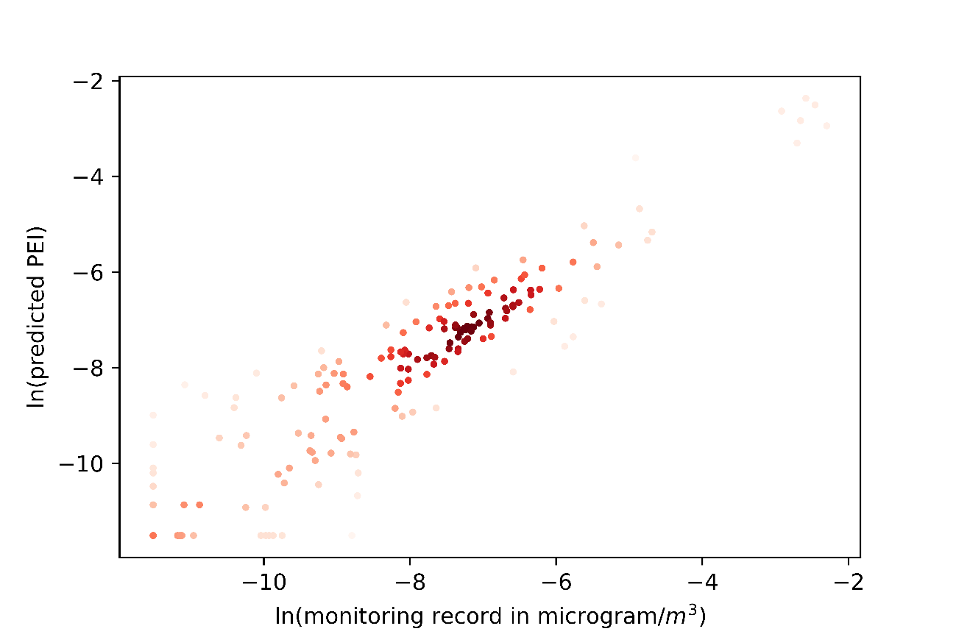
Fig. S5. Predicted pollution exposure indexes (PEIs) and monitoring records in one cross validation of the pruned-FNN model

