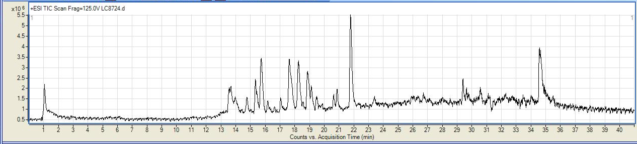
Figure S1: Total ion chromatogram (TIC) of C. diurnum extract.

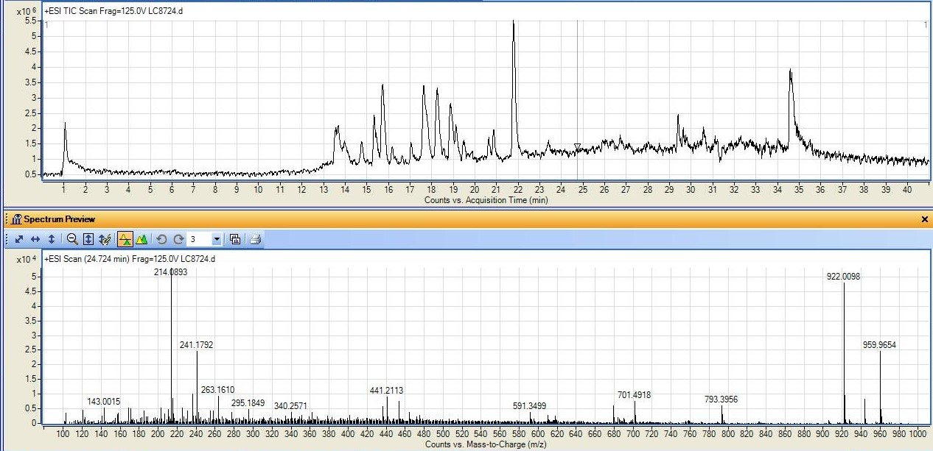
Figure S2: MS spectrum of C. diurnum extract at 24.72 min.

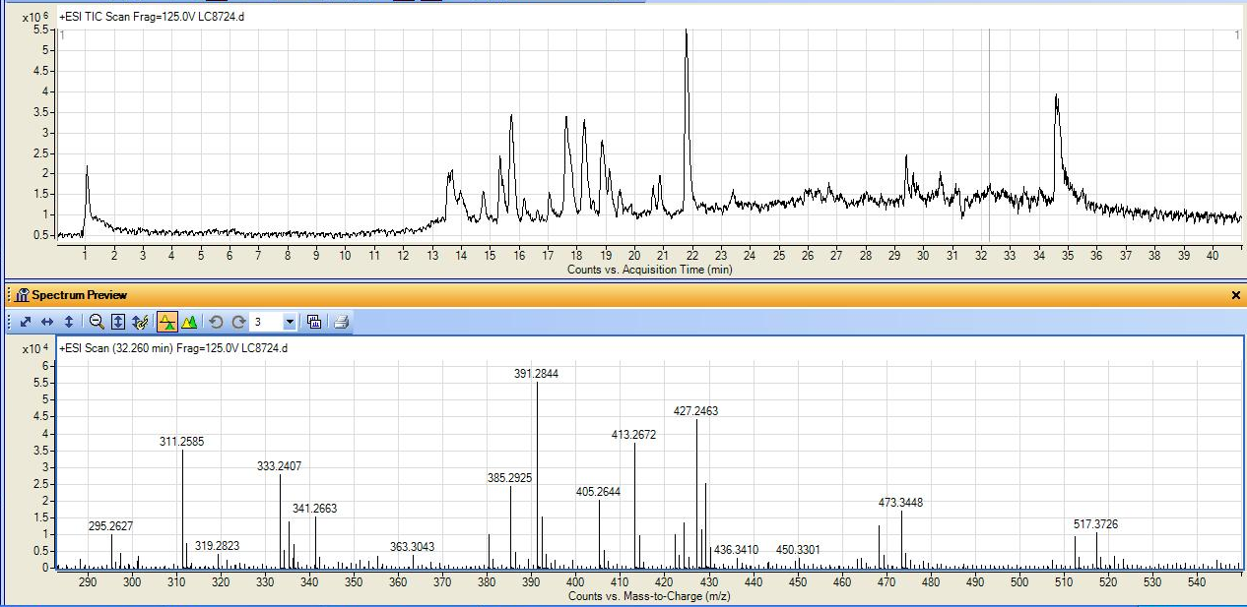
Figure S3: MS spectrum of C. diurnum extract at 32.26 min.

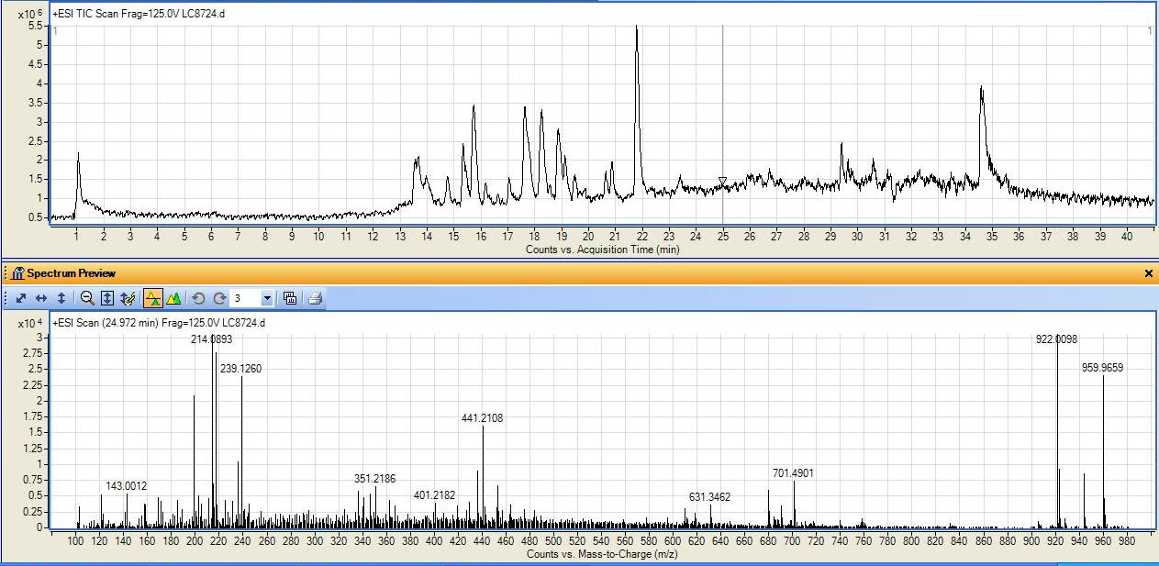
Figure S4: MS spectrum of C. diurnum extract at 24.97 min.

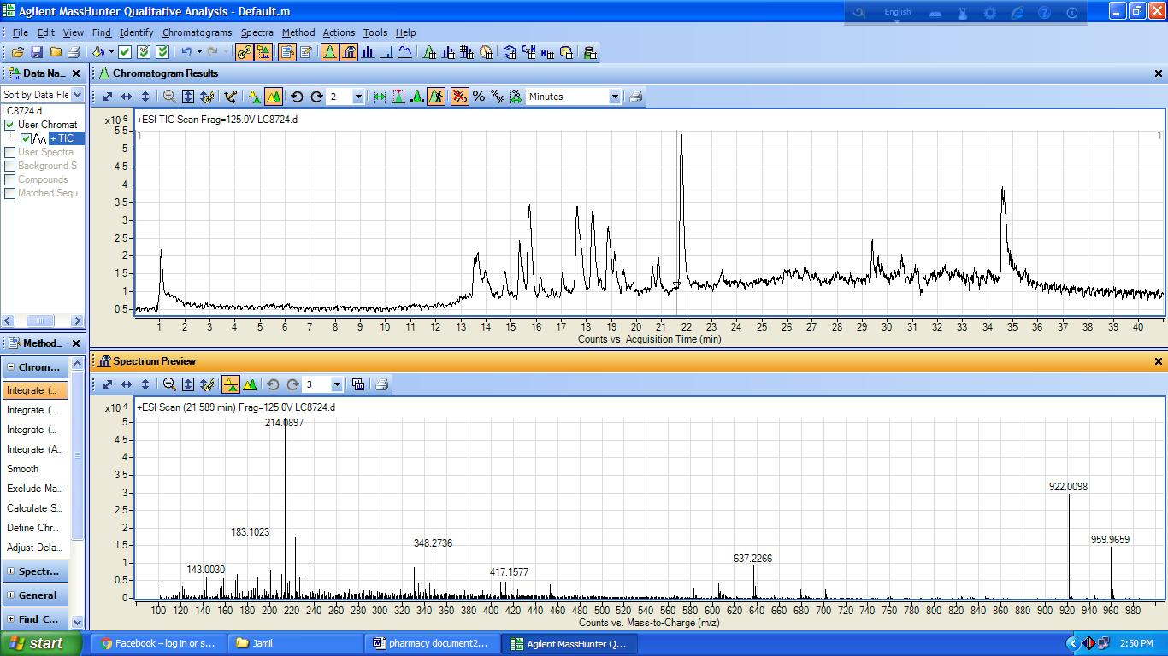
Figure S5: MS spectrum of C. diurnum extract at 21.58 min.

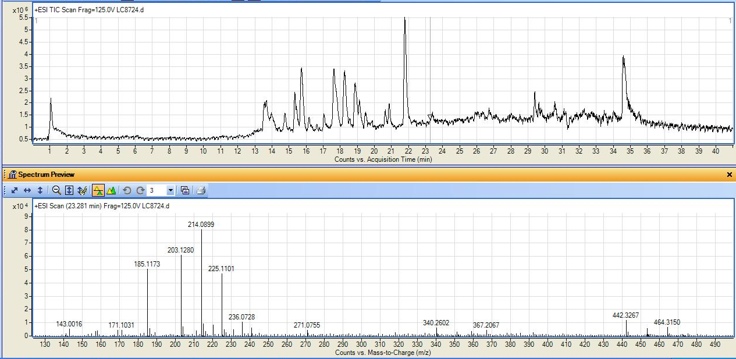
Figure S6: MS spectrum of C. diurnum extract at 23.28 min.

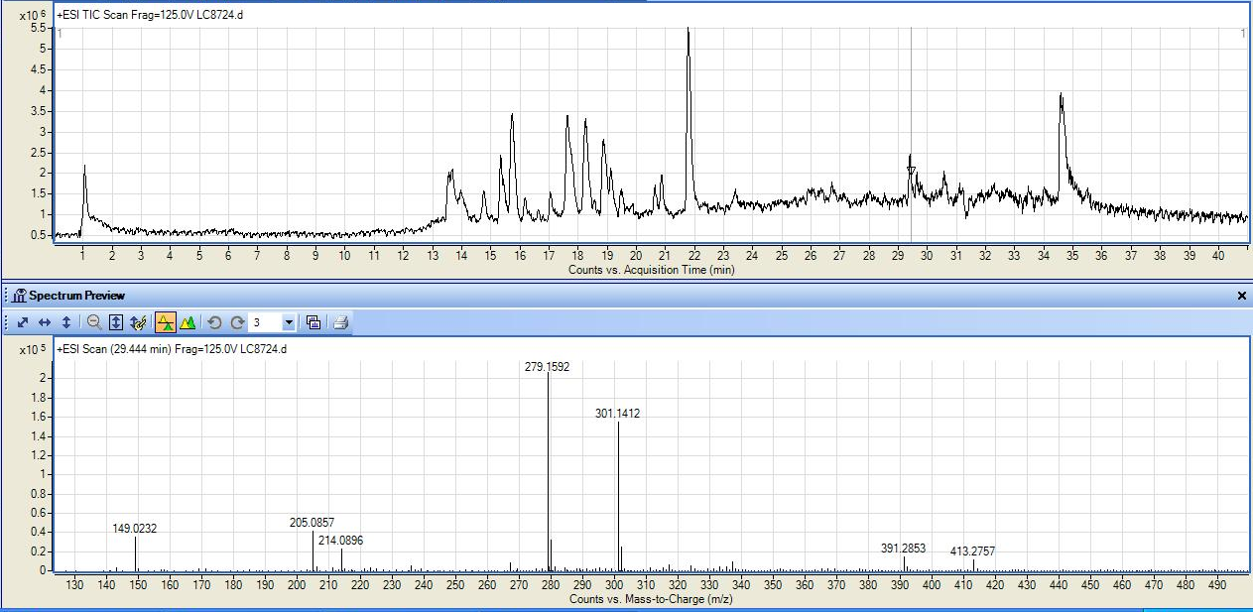
Figure S7: MS spectrum of C. diurnum extract at 29.44 min.

Figure S8: MS spectrum of C. diurnum extract at 21.58 min.

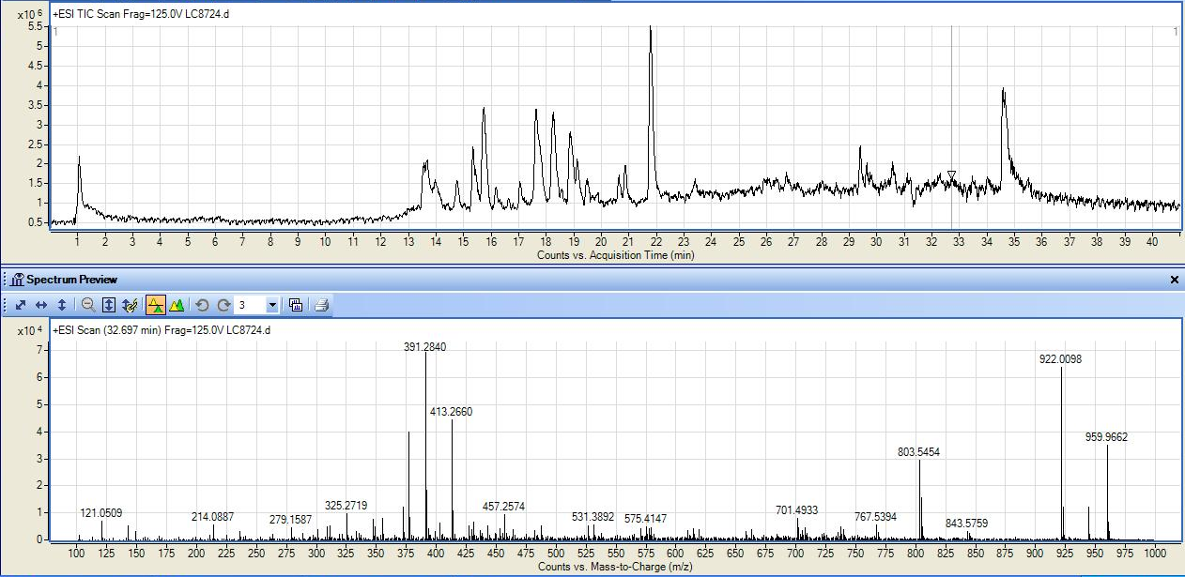
Figure S9: MS spectrum of C. diurnum extract at 32.69 min.

