Correlations between proteins at baseline | Correlations between proteins at 9th week | Correlations between proteins at 6-month
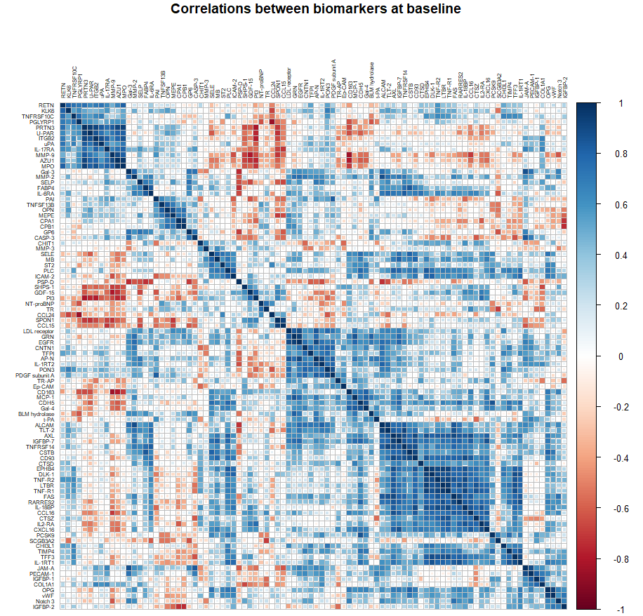 | 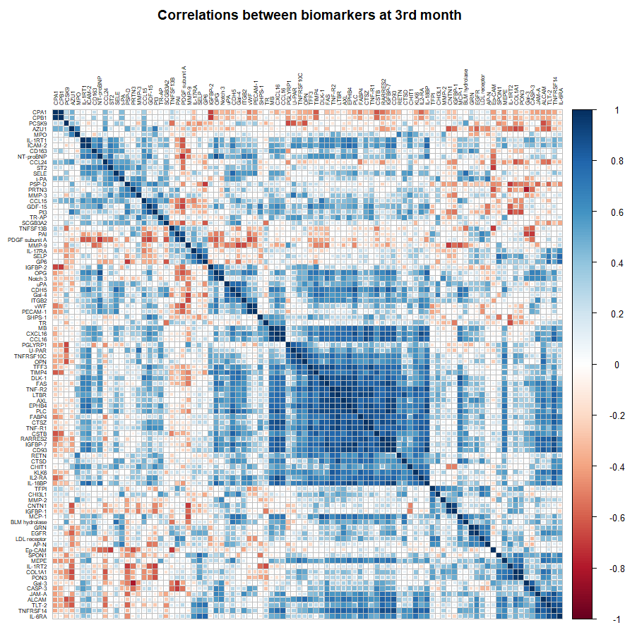 | 