Exploring anti-nonalcoholic fatty liver disease mechanism of Gardeniae Fructus by combining an animal model with network pharmacology and molecular docking
Lin Li^{1†}, Li-hua Lu ^{2 †}, Zhong-yan Tang ³ and Zheng-xiang Xia^{4,*}
*Correspondence: Zheng-xiang Xia, xzx5380537@163.com
†Lin Li and Li-hua Lu are the co-first authors.

Figure S1. Effects of GF on serum biochemical parameters in rats.
Figure S2. Effects of GF on serum glucose and insulin in rats.
Figure S3. Liver tissue sections stained with haematoxylin and eosin (H&E)
Figure S4. PPI Network of GF target protein treated on NAFLD.
Figure S5. Affinity between quercetin and PPARγ.

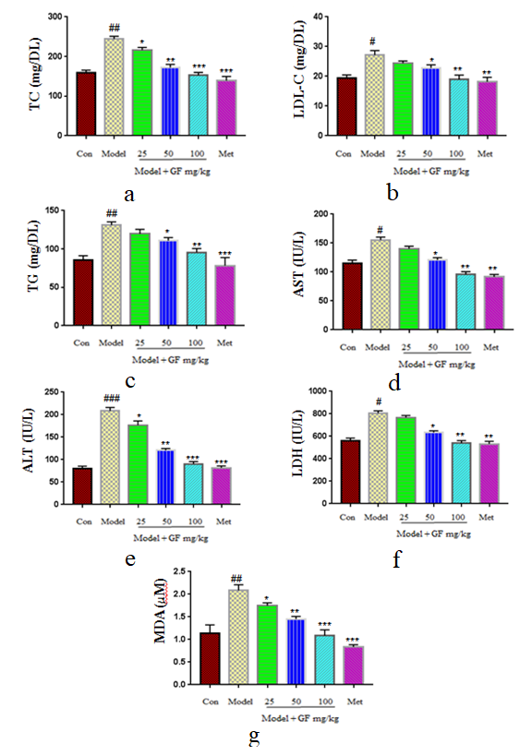
Figue S1. Effects of GF on serum biochemical parameters in rats. Data represent means ±SEM. #p < 0.05, ##p < 0.01, ###p < 0.001 vs. Con; * p < 0.05, ** p < 0.01, ***p < 0.001 vs. model.

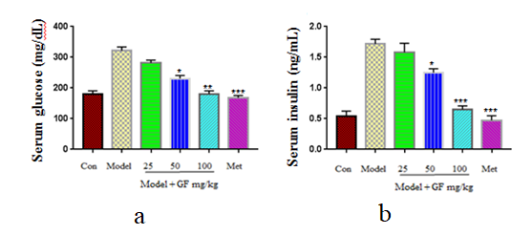
Figue S2. Effects of GF on serum glucose and insulin in rats. Data represent means ±SEM. #p < 0.05, ##p < 0.01, ###p < 0.001 vs. Con; * p < 0.05, ** p < 0.01, ***p < 0.001 vs. model.

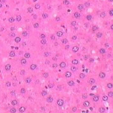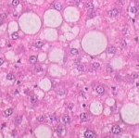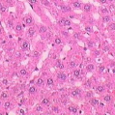
a b c
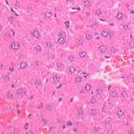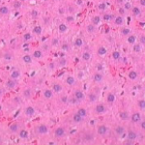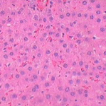
d e f
Figure S3. Liver tissue sections stained with haematoxylin and eosin (H&E). (a) Control group, showing normal tissue structure and architecture with no steatosis; (b) Model group showed multifocal mononuclear cell infiltration and hepatocyte ballooning; (c) Model + 25 mg/kg GF; (d) Model + 50 mg/kg GF; (e) Model + 100 mg/kg GF; (f) Model + Metformin.

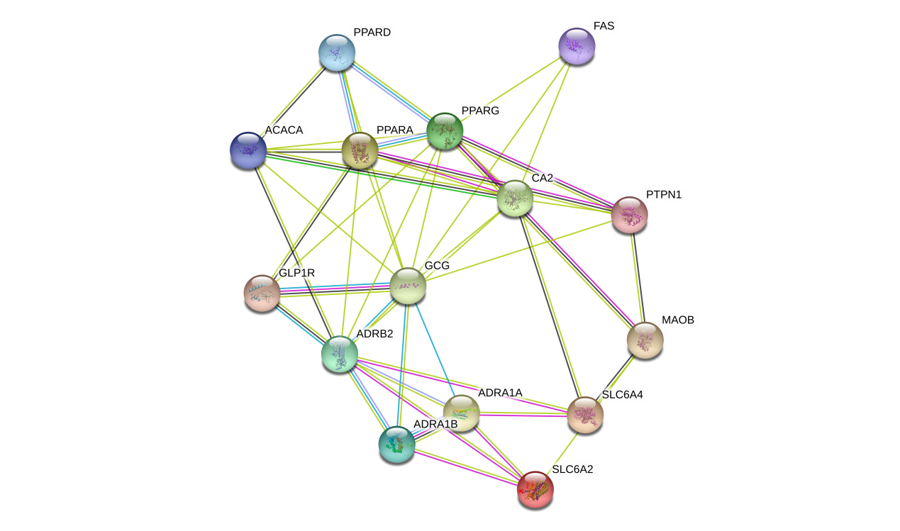
Figure S4. PPI Network of GF target protein treated on NAFLD.

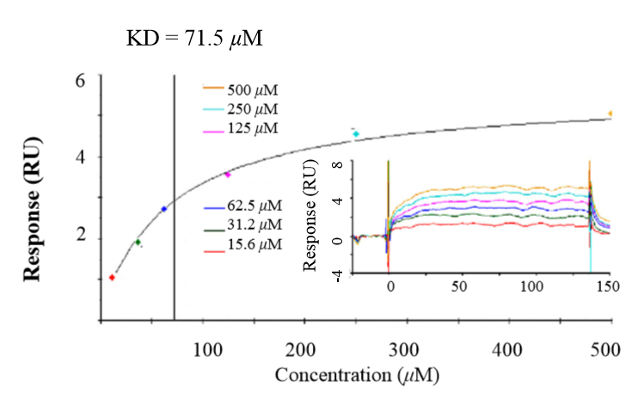
Figure S5. Affinity between quercetin and PPARγ.

