Supplemental Information

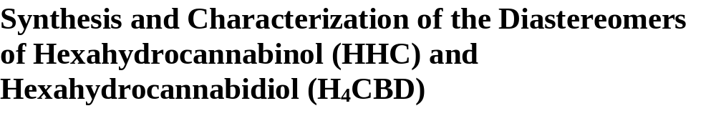Collins A¹, Ramirez G¹, Tesfatsion T¹, Ray K^{1,2}, Cruces W^{1,2}
¹Colorado Chromatography Labs, 10505 S Progress Way, Parker, CO, 80134
²Blackstone Therapeutics, 10505 S Progress Way, Parker, CO, 80134

Corresponding Author: Westley Cruces, Wes@coloradochromatography.com

Table of Contents:
- Abbreviations S2
- ¹H NMR, 2D NMR and ¹³C NMR of HHC diastereomers S3 - S15
- 1H NMR, 2D NMR and 13C NMR of H4CBD diastereomers S16 - S28
- LCMS and MS data of HHC and H4CBD diastereomers S29 - S31
- HPLC data of HHC and H4CBD diastereomers S32
- GC-MS data of HHC and H4CBD diastereomers S33

Abbreviations
HPLC: High performance liquid chromatography
NMR: Nuclear magnetic resonance
D3-MeCN:Deuterated Acetonitrile
GCMS: Gas Chromatography-Mass Spectrometry
HHC: Hexahydrocannabinol
H4CBD: Hydrogenated Cannabidiol
COSY: Correlated Spectroscopy
HSQC: Heteronuclear Single Quantum Coherence
HMBC: Heteronuclear Multiple Bond Correlation
NOESY: Nuclear Overhauser Effect Spectroscopy

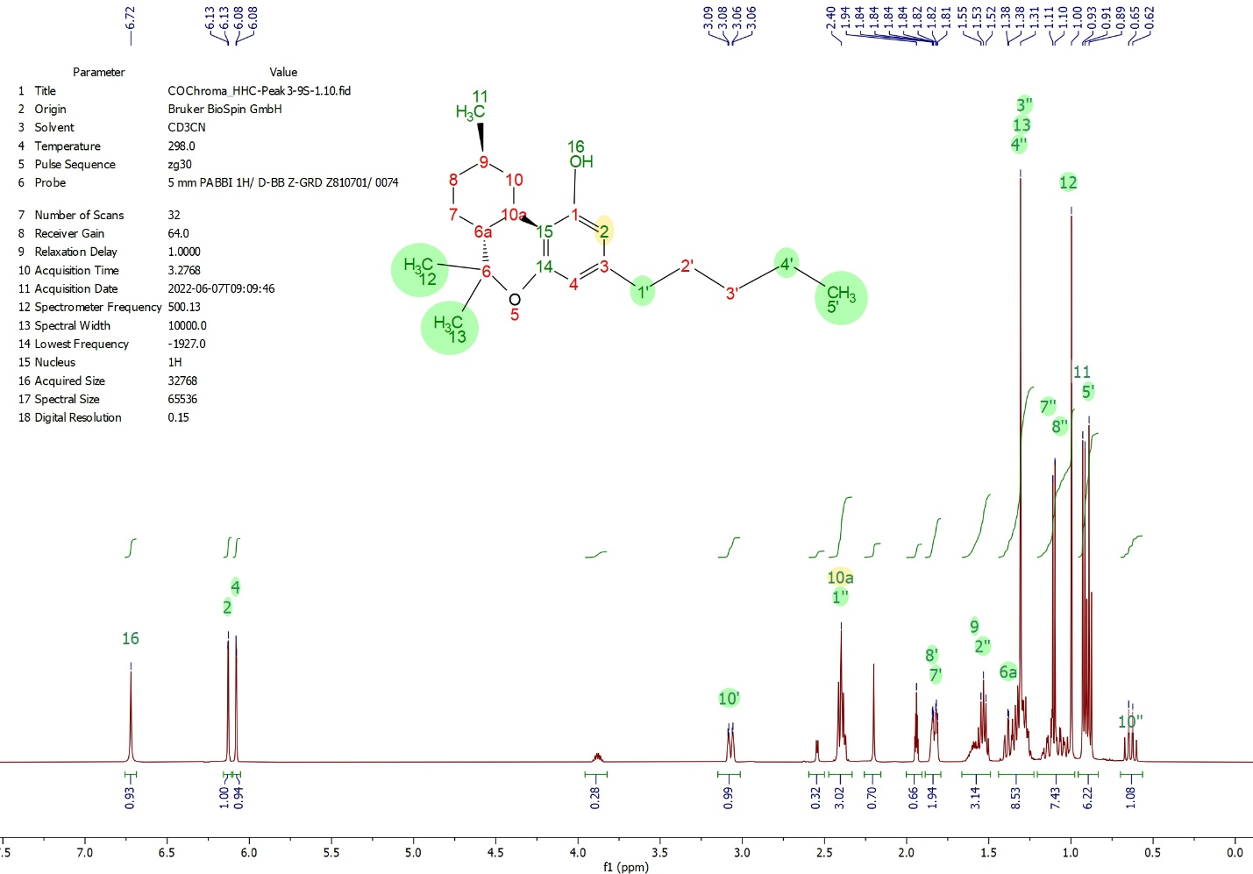
Figure 1: ¹H NMR spectrum of HHC-Peak3-9S-1 (Fraction 2) in CD3CN

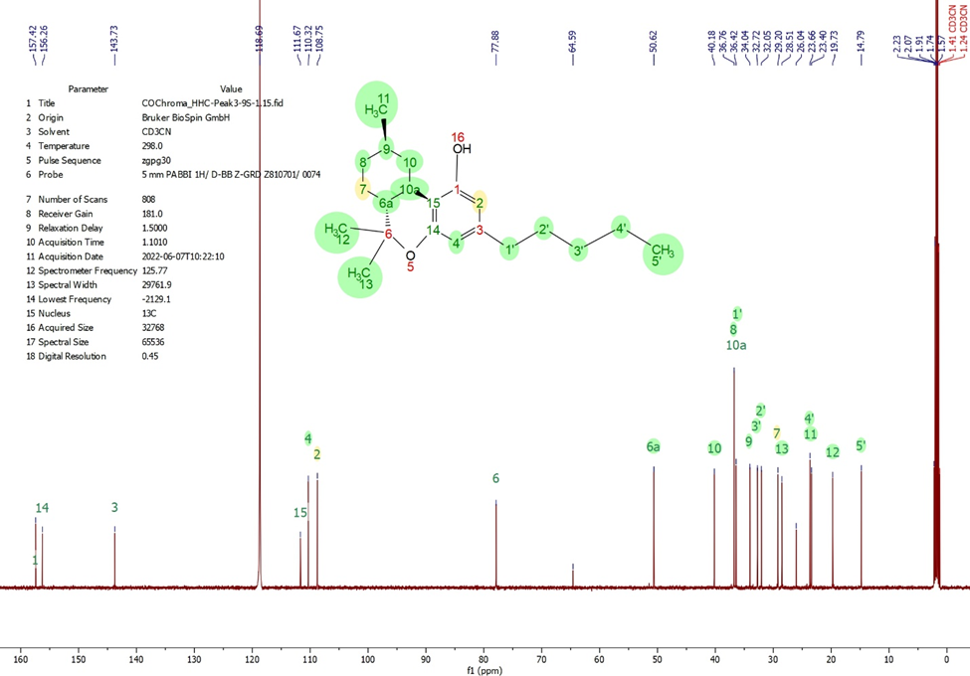
Figure 2: ¹³C NMR spectrum of HHC-Peak3-9S-1 (Fraction 2) in CD3CN

Atom number | Atom type | H chemical shift | C chemical shift
1 | C |  | 157.42
2 | CH | 6.13 | 108.75
3 | C |  | 143.73
4 | CH | 6.08 | 110.32
5 | O
6 | C |  | 77.88
6a | CH | 1.39 | 50.62
7 | CH2 | 1.14, 1.82 | 29.20
8 | CH2 | 1.06, 1.84 | 36.76
9 | CH | 1.59 | 34.04
10 | CH2 | 0.64, 3.07 | 40.18
10a | CH | 2.40 | 36.76
11 | CH3 | 0.92 | 23.40
12 | CH3 | 1.00 | 19.73
13 | CH3 | 1.31 | 28.51
14 | C |  | 156.26
15 | C |  | 111.67
16 | OH | 6.72
1’ | CH2 | 2.40 | 36.42
2’ | CH2 | 1.54 | 32.05
3’ | CH2 | 1.29 | 32.72
4’ | CH2 | 1.33 | 23.66
5’ | CH3 | 0.89 | 14.79
Table 1: HHC-Peak3-9S (Fraction 2) ¹H and ¹³C Assignment

Atom number | Atom type | H chemical shift | C chemical shift
1 | C |  | 157.35
2 | CH | 6.13 | 108.75
3 | C |  | 143.60
4 | CH | 6.08 | 110.34
5 | O
6 | C |  | 77.78
6a | CH | 1.39 | 51.49
7 | CH2 | 1.14, 1.82 | 24.24
8 | CH2 | 1.06, 1.84 | 33.51
9 | CH | 1.59 | 29.34
10 | CH2 | 0.64, 3.07 | 37.26
10a | CH | 2.40 | 30.70
11 | CH3 | 0.92 | 19.56
12 | CH3 | 1.00 | 19.83
13 | CH3 | 1.31 | 28.40
14 | C |  | 156.53
15 | C |  | 111.93
16 | OH | 6.73
1’ | CH2 | 2.40 | 36.47
2’ | CH2 | 1.54 | 32.09
3’ | CH2 | 1.29 | 32.77
4’ | CH2 | 1.33 | 23.70
5’ | CH3 | 0.89 | 14.83
Table 2: HHC-Peak2-9R (Fraction 1) ¹H and ¹³C Assignment
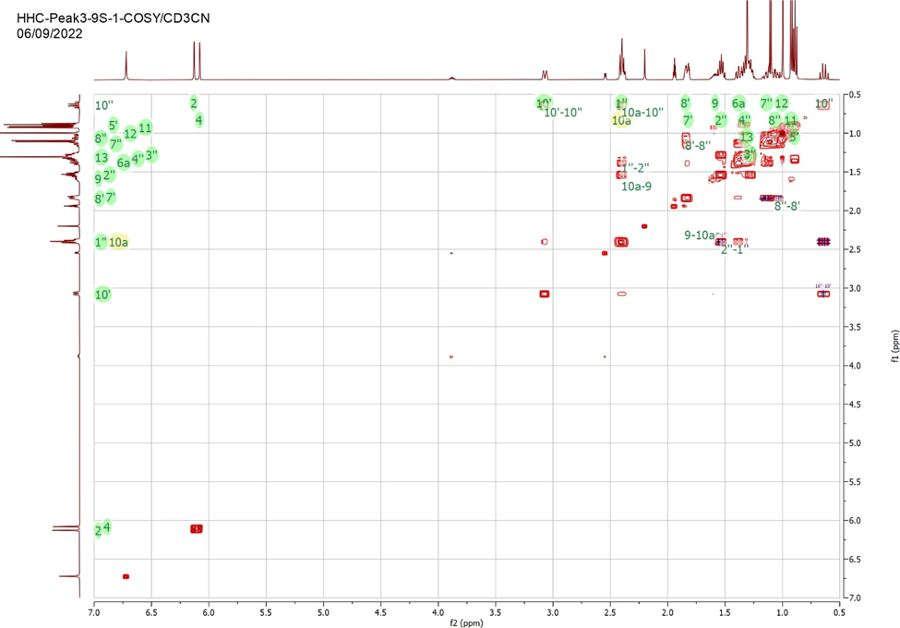

Figure 3: 1H-1H COSY NMR data of HHC-Peak3-9S-1 in acetonitrile-d3 at 25C.

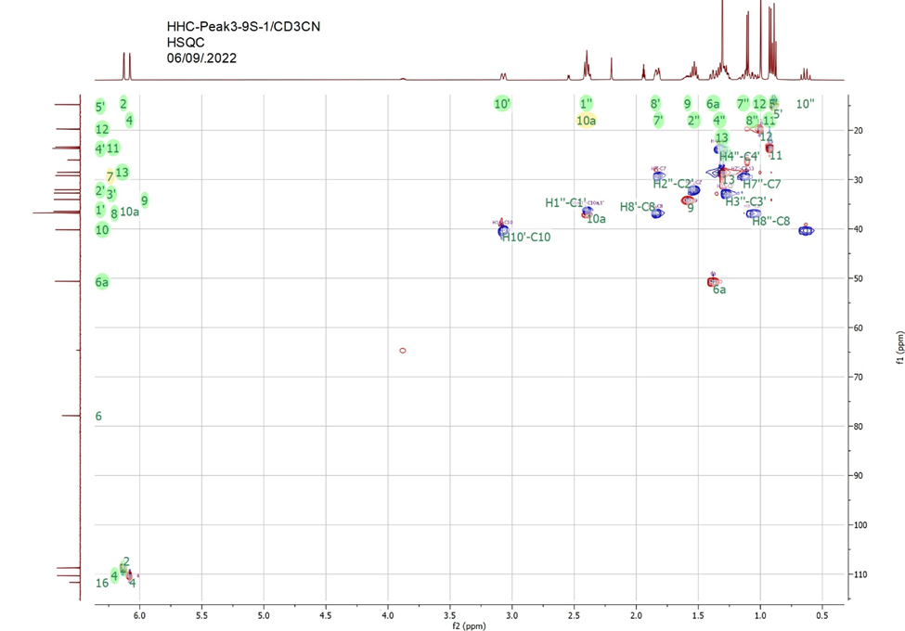
Figure 4: ¹H-13C HSQC data of HHC-Peak3-9S-1(Fraction 2).
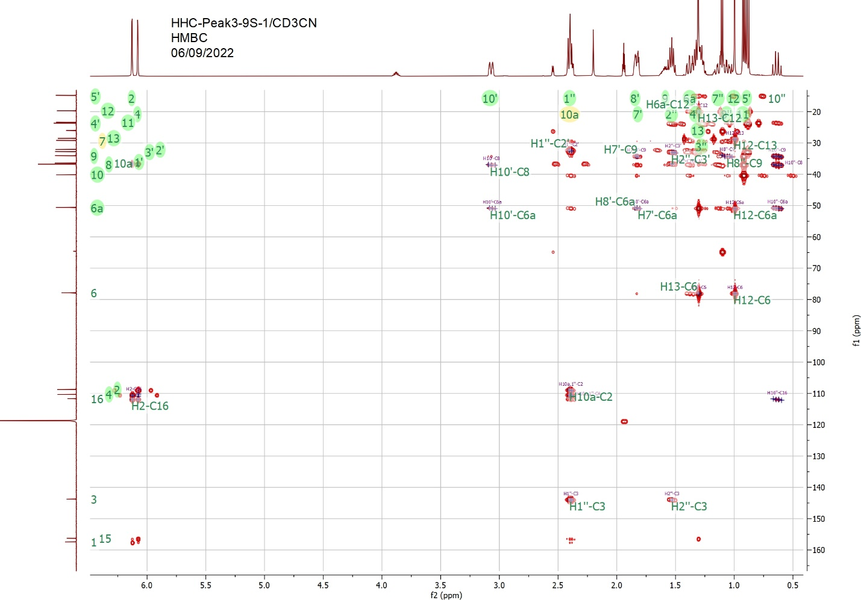
Figure 5:1H-13C HMBC data of HHC-Peak3-9S-1 (Fraction 2)
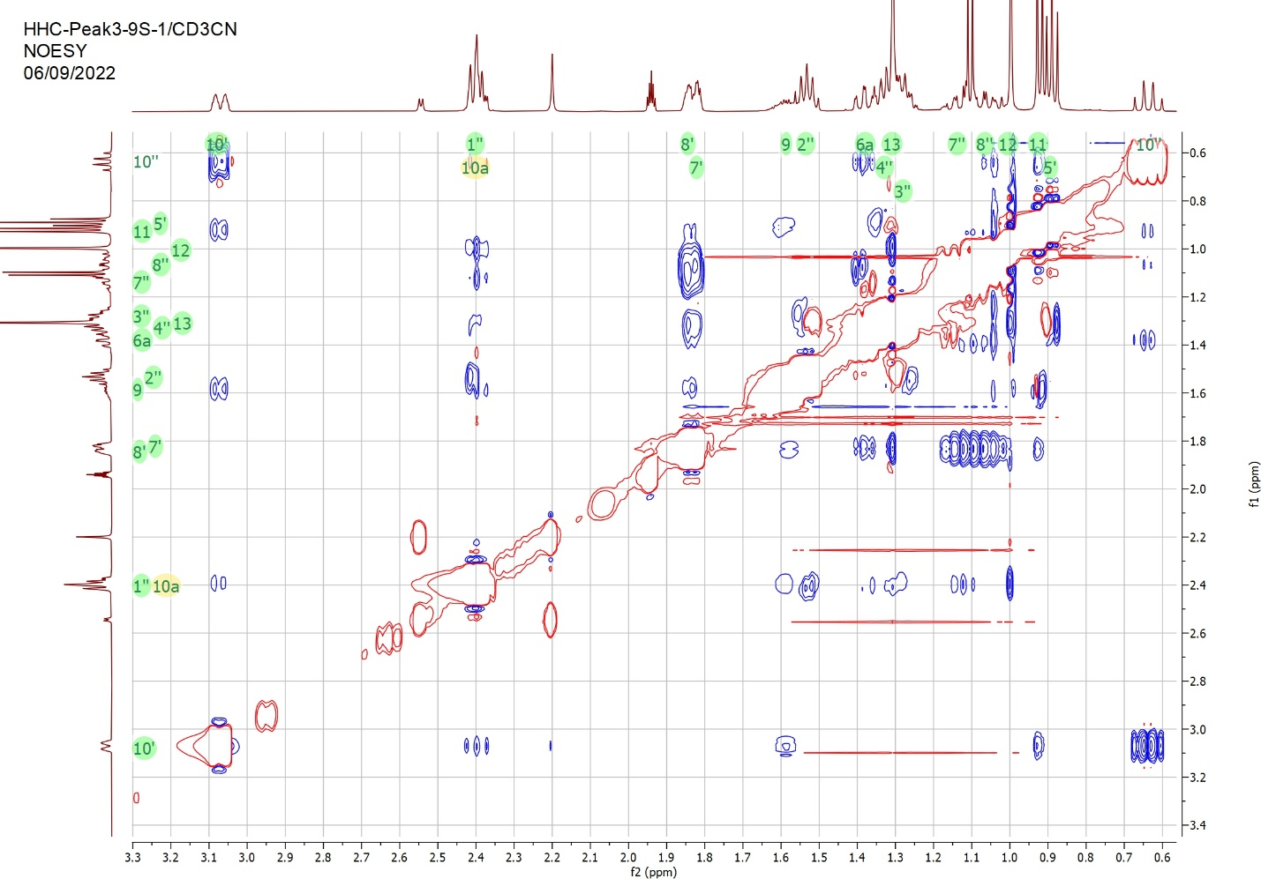
Figure 8: 1H-1H NOESY NMR data of HHC-Peak3-9S-1 (Fraction 2).

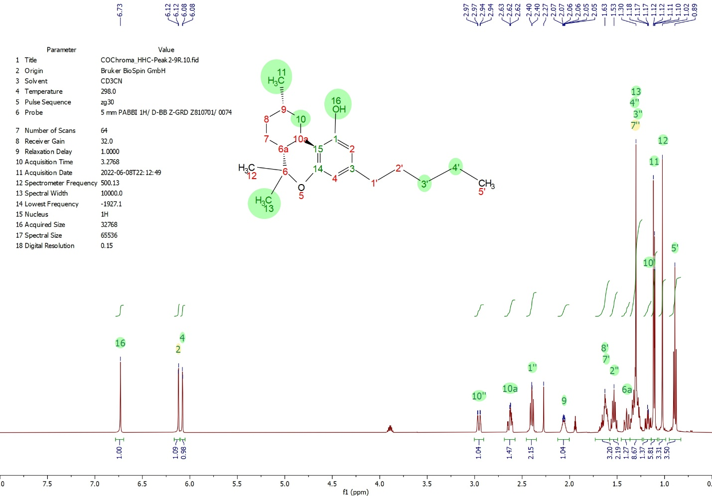Figure 9: 1H NMR spectrum of HHC-Peak2-9R (Fraction 1)
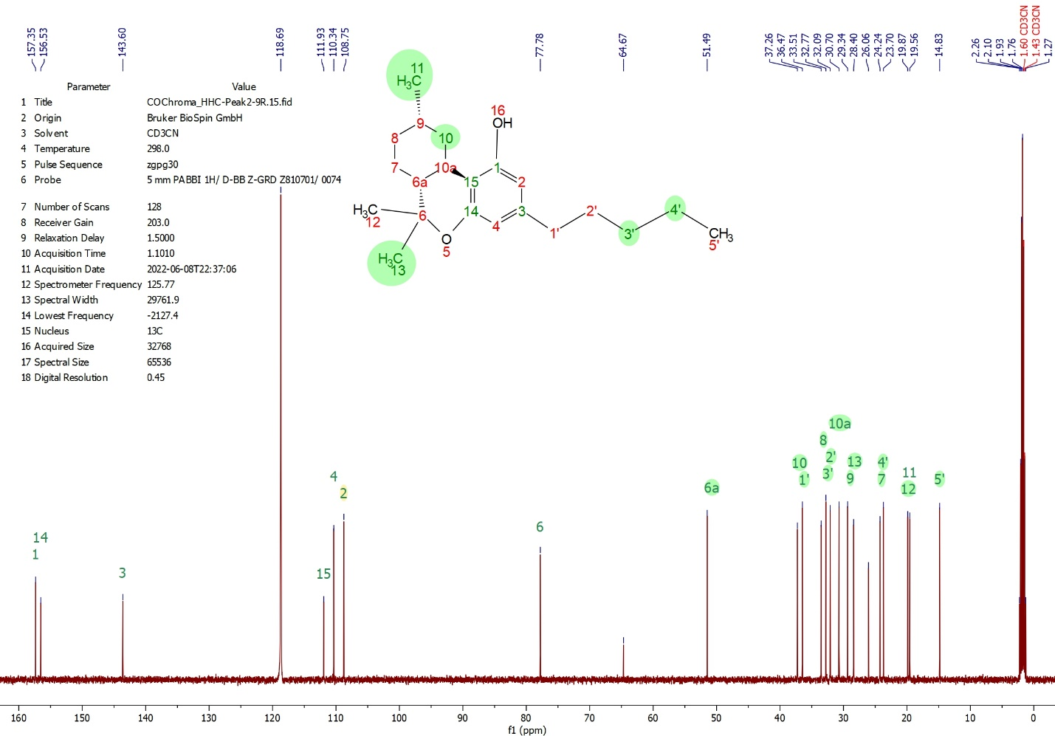
Figure 10: 13C NMR spectrum of HHC-Peak2-9R (Fraction 1)
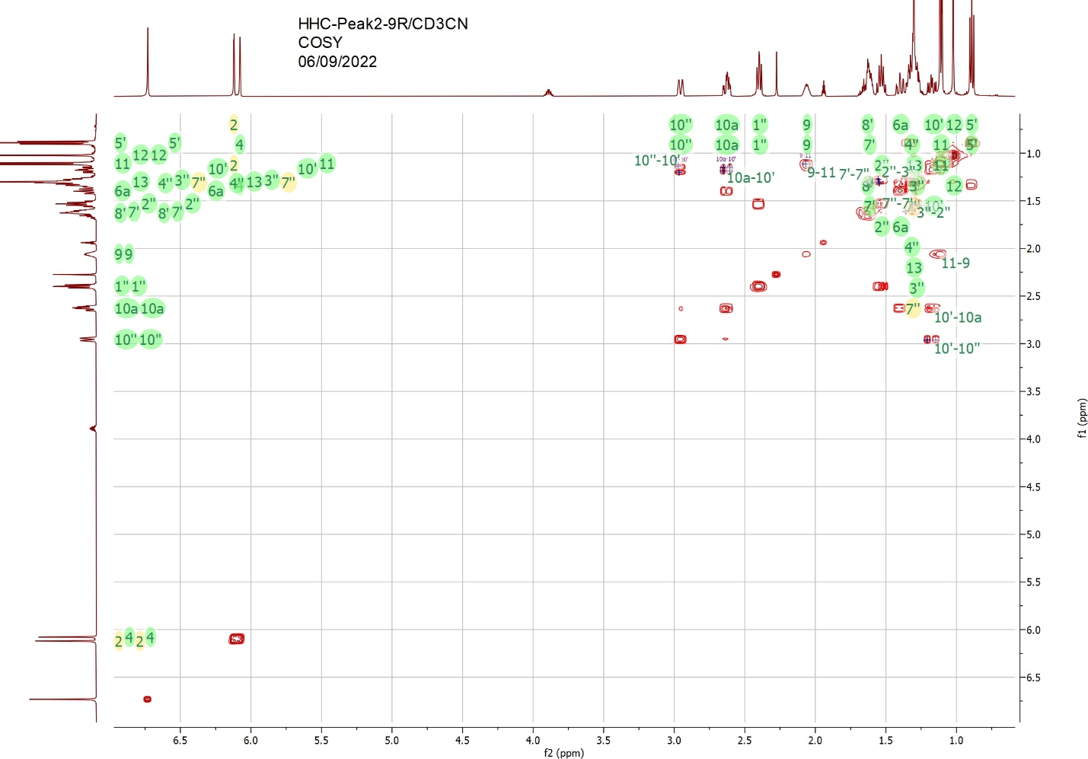
Figure 11: 2D 1H-1H COSY NMR data of HHC-Peak2-9R (Fraction 1)
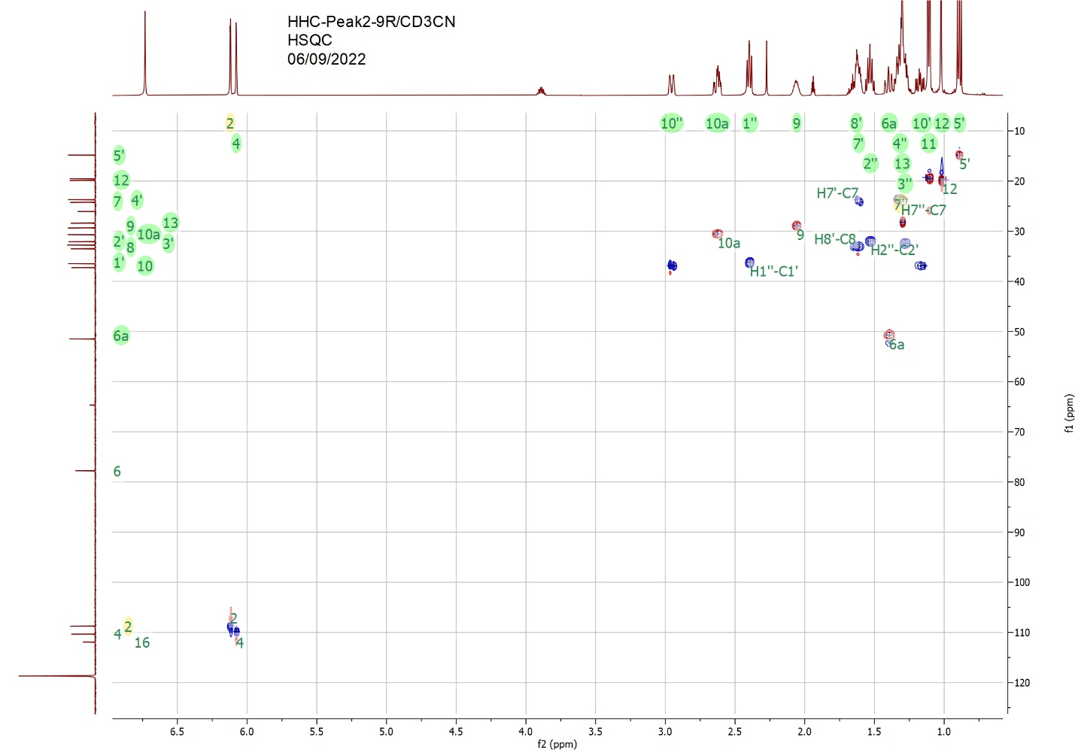
Figure 12: 2D 1H-13C HSQC NMR data of HHC-Peak2-9R (Fraction 1)
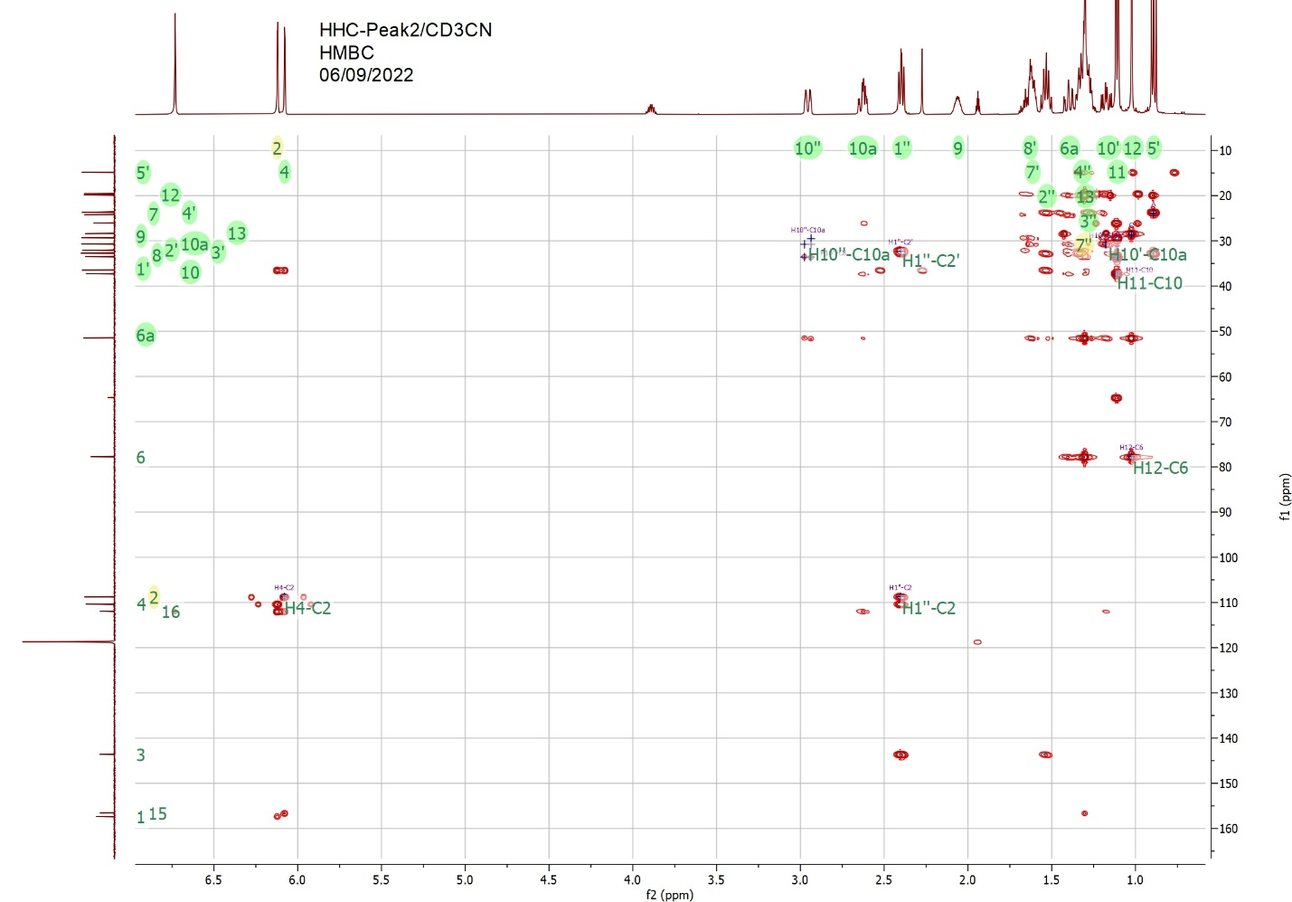
Figure 13: 2D 1H-13C HMBC NMR data of HHC-Peak2-9R (Fraction 1)
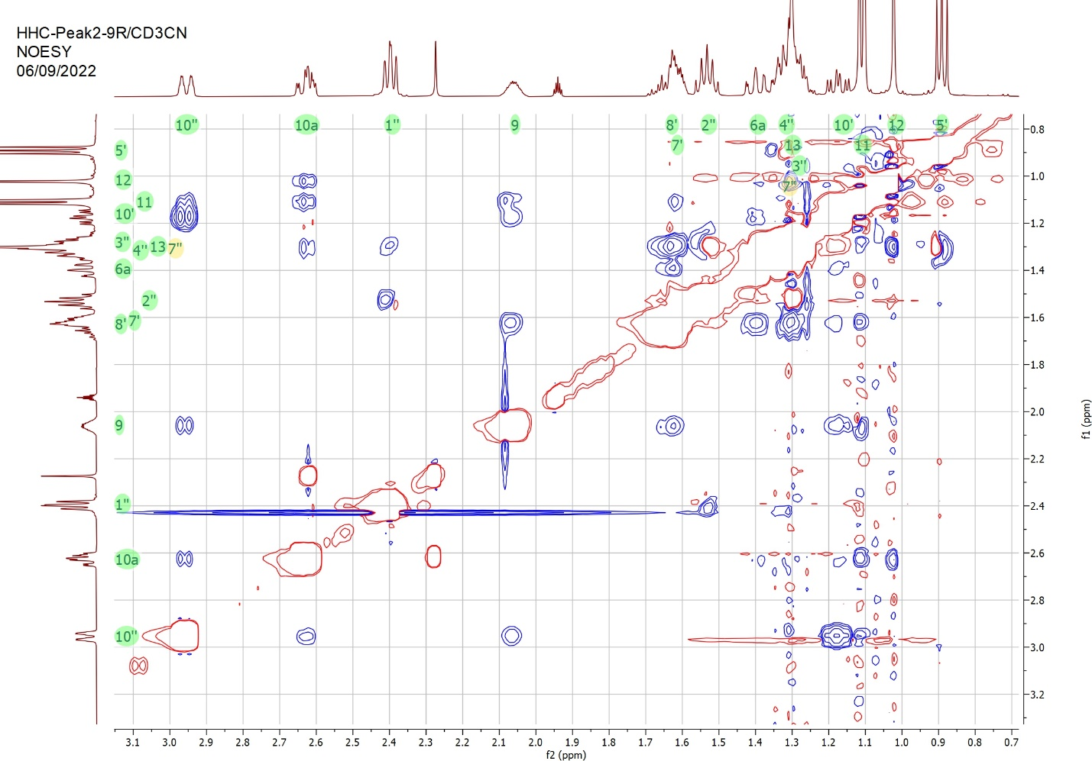
Figure 14: 2D 1H-1H NOESY NMR data of HHC-Peak2-9R (Fraction 1)

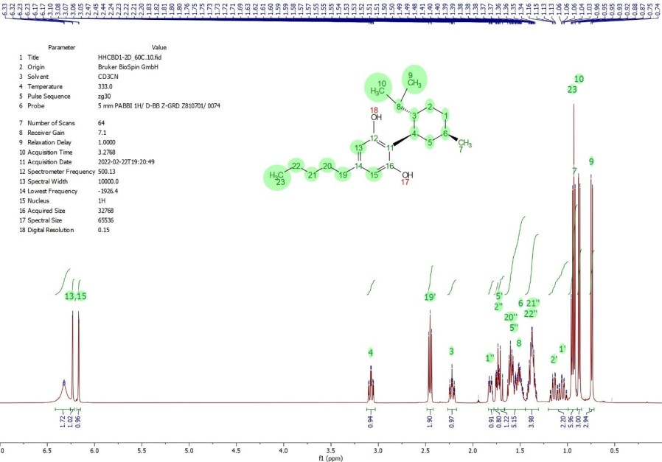
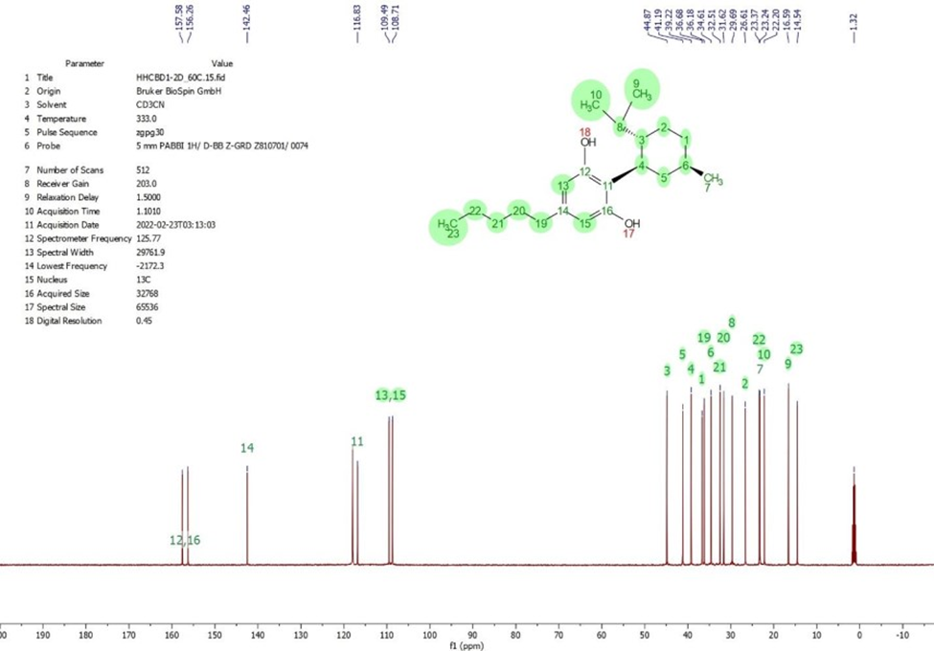
Figure 15: 13C NMR spectrum of HHCBD1 in acetonitrile-d3 at 60ºC

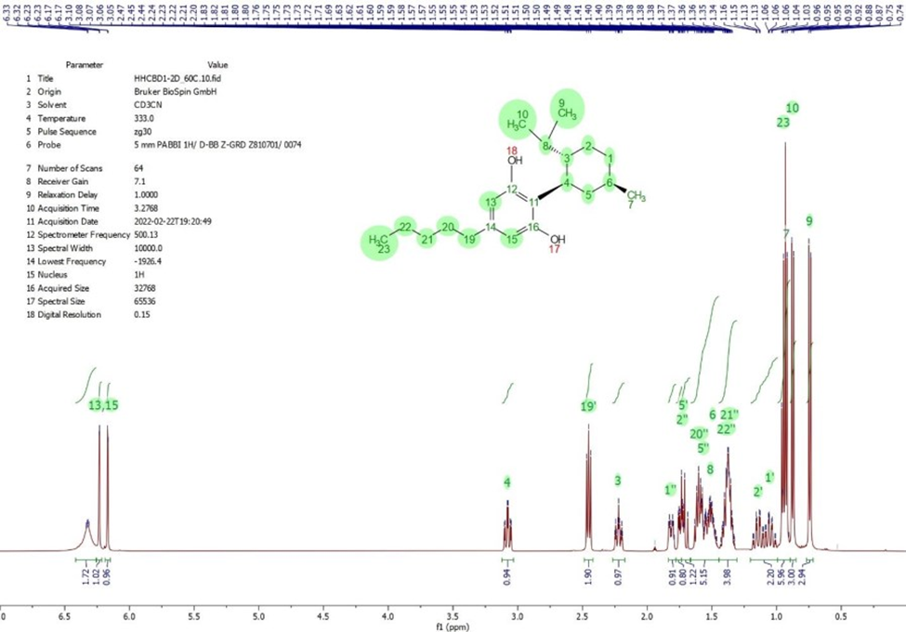
Figure 16: 1H NMR spectrum of HHCBD1 in acetonitrile-d3 at 60ºC

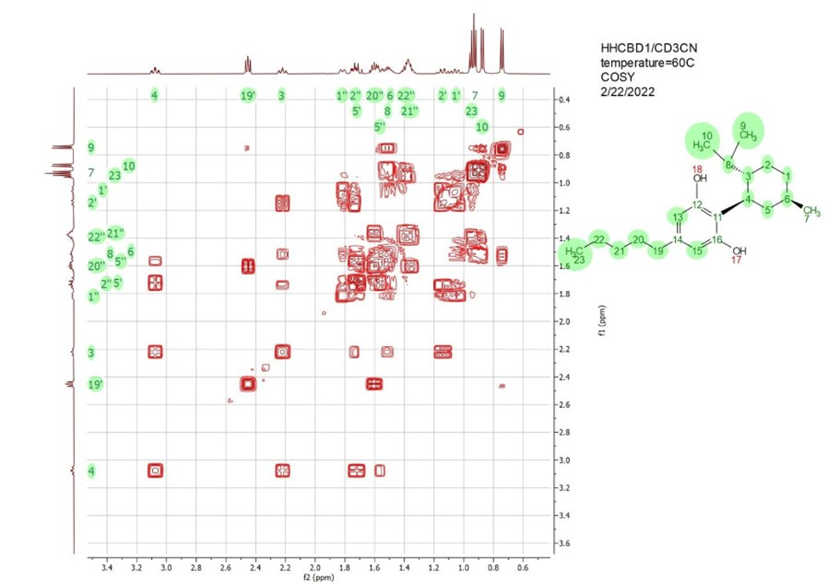
Figure 17: 1H-1H COSY NMR data of HHCBD1 in acetonitrile-d3 at 60ºC

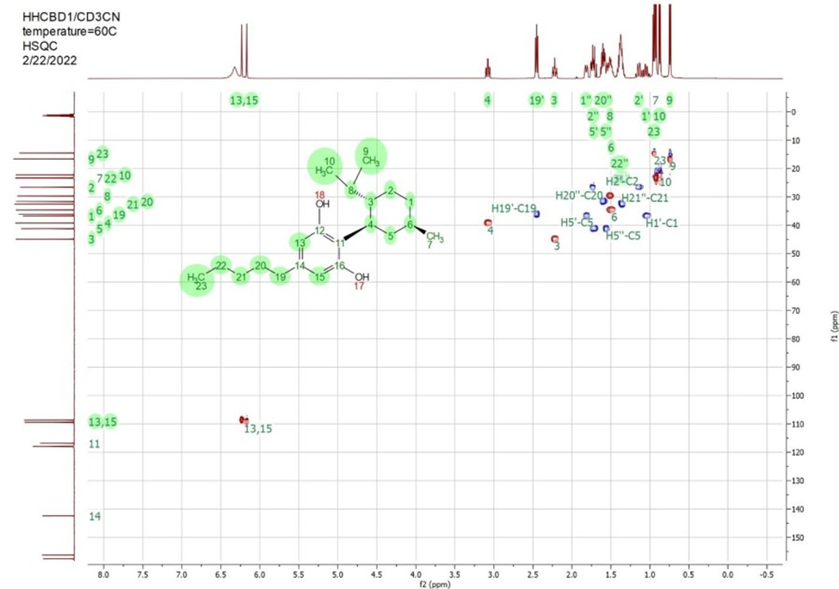

Figure 18: 1H-13C HSQC data of HHCBD1 in acetonitrile-d3 at 60C

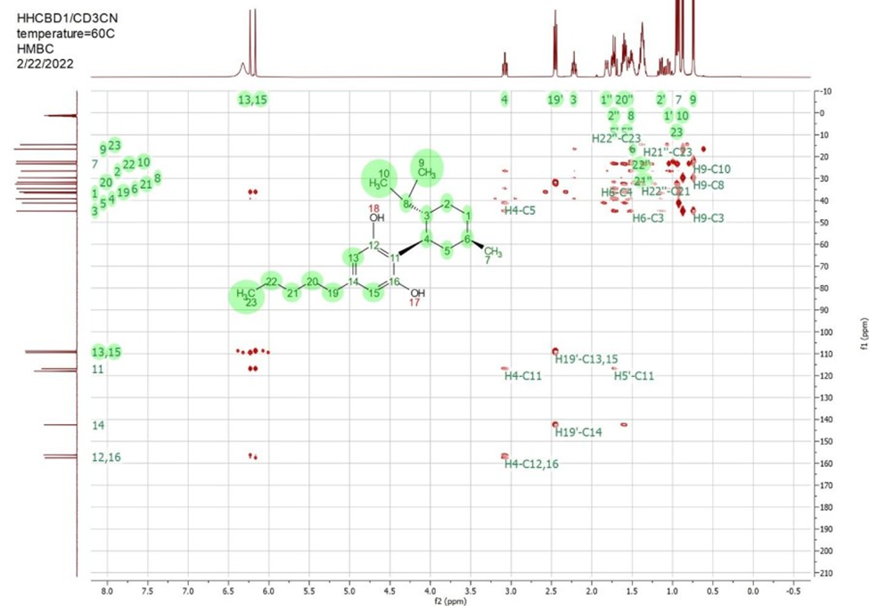
Figure 19: 1H-13C HMBC data of HHCBD1 in acetonitrile-d3 at 60ºC

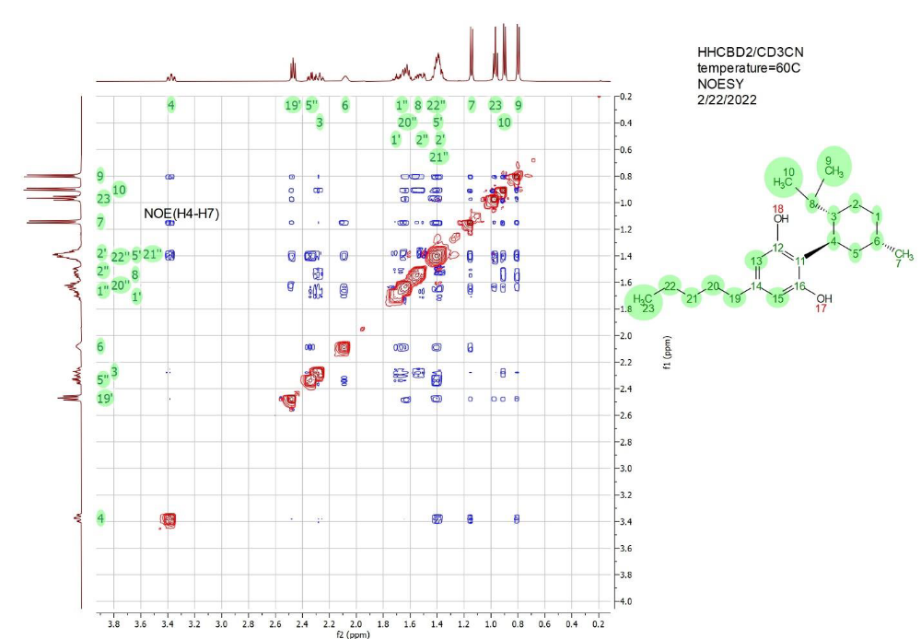
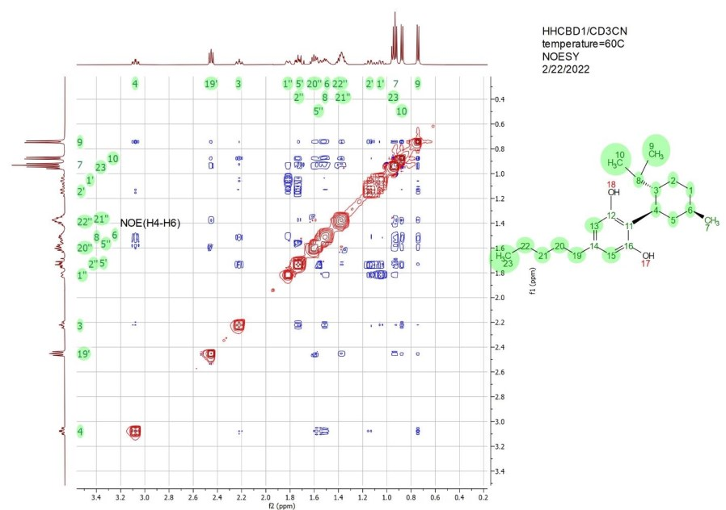
Figure 20: 1H-1H NOESY NMR data of HHCBD1 in acetonitrile-d3 at 60C.
The green numbers on the top and left of the plot notate peaks assigned to the corresponding protons in the structure on the right. The blue cross peaks represent NOE peaks between pairs of protons on the top and left. The NOE peak between protons H4 and H6 are marked with a black label.

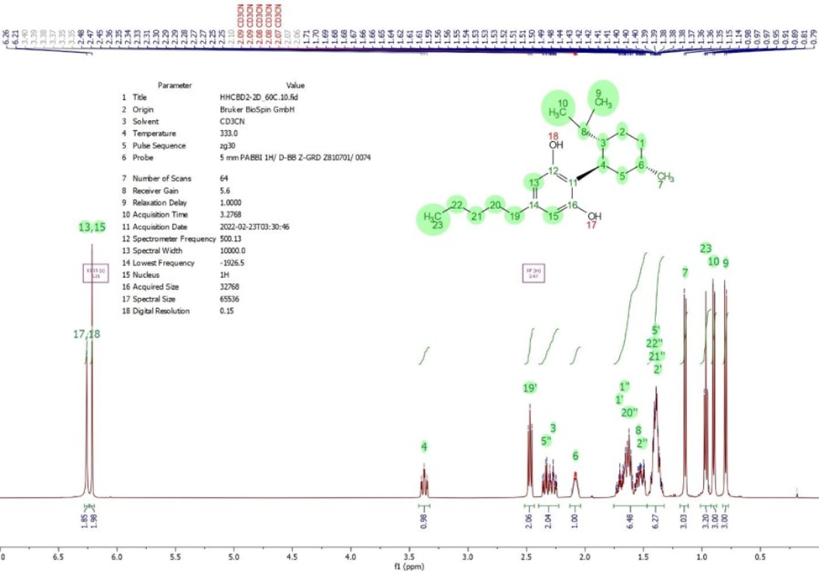
Figure 21: 1H NMR spectrum of HHCBD2 in acetonitrile-d3 at 60ºC

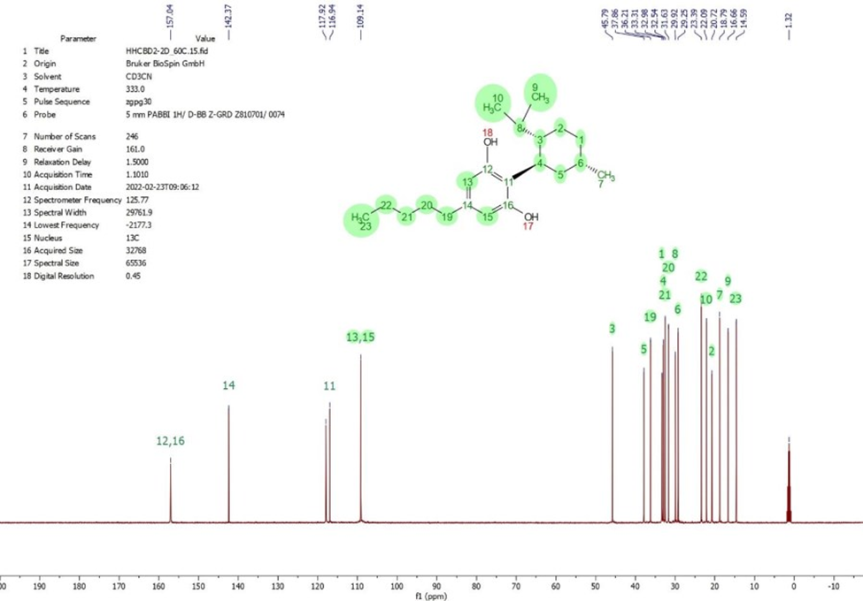
Figure 22: 13C NMR spectrum of HHCBD2 in acetonitrile-d3 at 60ºC

Atom number | Atom type | 1H chemical shift | 13C chemical shift | Comment
1 | CH2 | 1.05, 1.82 | 36.68
2 | CH2 | 1.14, 1.74 | 26.61
3 | CH | 2.22 | 44.87
4 | CH | 3.08 | 39.22
5 | CH2 | 1.56, 1.72 | 41.19
6 | CH | 1.50 | 34.61
7 | CH3 | 0.93 | 23.24
8 | CH | 1.52 | 29.69
9 | CH3 | 0.74 | 16.59 | 9 and 10 results can  be interchanged
10 | CH3 | 0.87 | 22.20
11 | C |  | 116.83
12 | C |  | 157.58 | 12 and 16 results can  be interchanged
13 | CH | 6.17 | 109.49 | 13 and 15 results can  be interchanged
14 | C |  | 142.46
15 | CH | 6.23 | 108.71
16 | C |  | 156.26
17 | OH | 6.33
18 | OH | 6.33
19 | CH2 | 2.45 | 36.18
20 | CH2 | 1.60 | 31.62
21 | CH2 | 1.36 | 32.51
22 | CH2 | 1.39 | 23.37
23 | CH3 | 0.95 | 14.54

Table 3: HHCBD1 (Fraction 1) in acetonitrile-d3 at 60C 1H and 13C Assignment

Atom number | Atom type | 1H chemical shift | 13C chemical shift | Comment
1 | CH2 | 1.66, 1.69 | 33.31
2 | CH2 | 1.38, 1.51 | 20.72
3 | CH | 2.27 | 45.79
4 | CH | 3.38 | 32.98
5 | CH2 | 1.40, 2.33 | 37.86
6 | CH | 2.08 | 29.25
7 | CH3 | 1.14 | 19.79
8 | CH | 1.55 | 29.92
9 | CH3 | 0.80 | 16.66 | 9 and 10 results can  be interchanged
10 | CH3 | 0.90 | 22.09
11 | C |  | 116.94
12 | C |  | 157.04 | 12 and 16 results can  be interchanged
13 | CH | 6.21 | 109.14 | 13 and 15 results can  be interchanged
14 | C |  | 142.37
15 | CH | 6.21 | 109.14
16 | C |  | 157.04
17 | OH | 6.26
18 | OH | 6.26
19 | CH2 | 2.47 | 36.21
20 | CH2 | 1.63 | 31.63
21 | CH2 | 1.39 | 32.54
22 | CH2 | 1.41 | 23.39
23 | CH3 | 0.97 | 14.59

Table 4: HHCBD2 (Fraction 2) in acetonitrile-d3 at 60C 1H and 13C Assignment

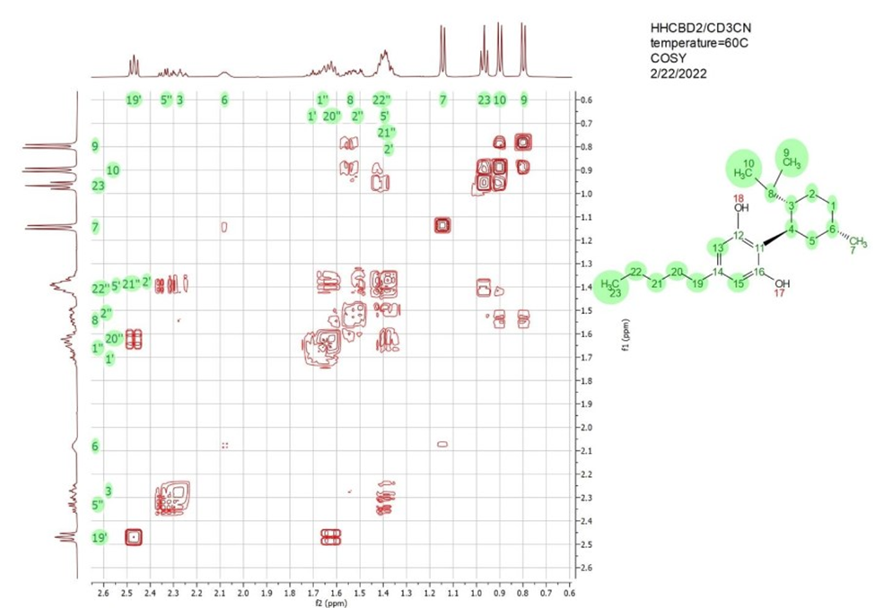
Figure 23: 2D 1H-1H COSY NMR data of HHCBD2 in acetonitrile-d3 at 60ºC

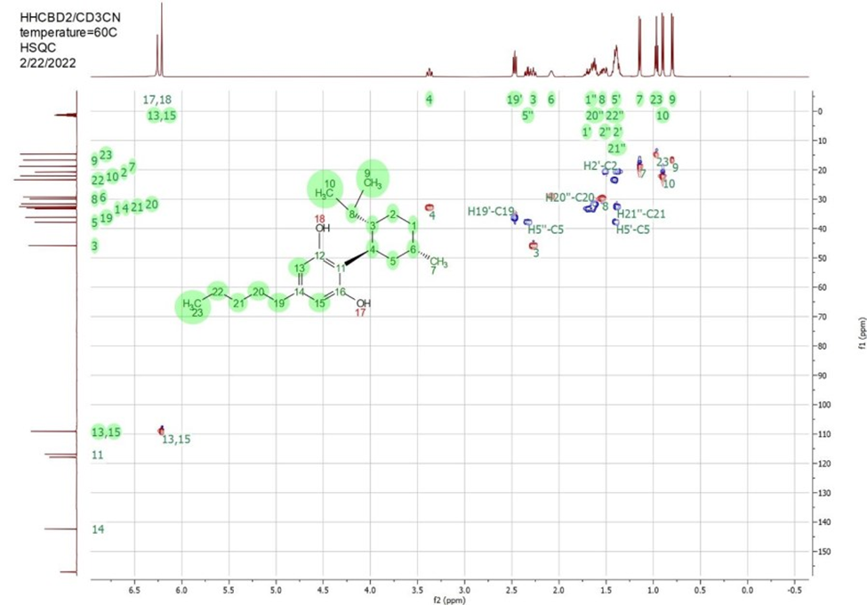
Figure 24: 2D 1H-13C HSQC NMR data of HHCBD2 in acetonitrile-d3 at 60ºC

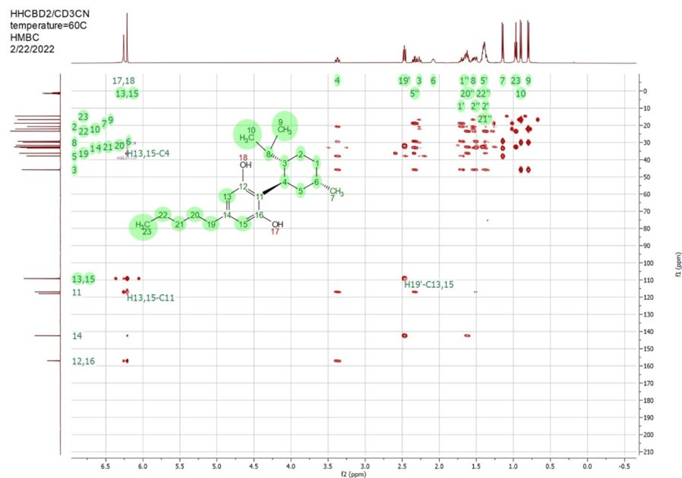
Figure 25: 2D 1H-13C HMBC NMR data of HHCBD2 in acetonitrile-d3 at 60ºC.

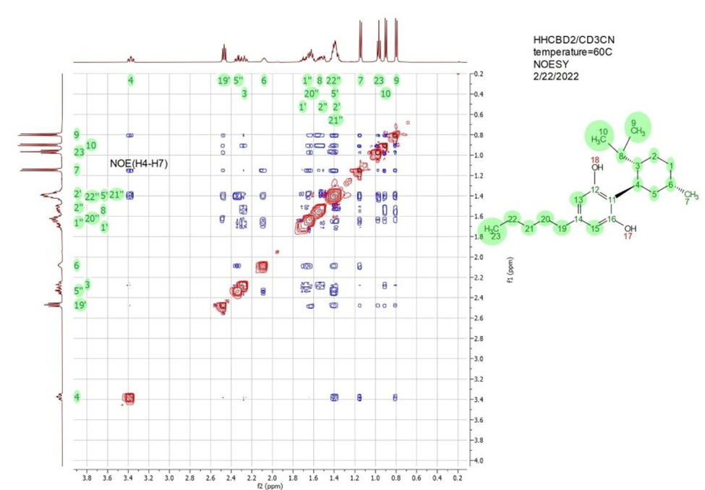
Figure 26: 2D 1H-1H NOESY NMR data of HHCBD2 in acetonitrile-d3 at 60C.
The green numbers on the top and left of the plot notate peaks assigned to the corresponding protons in the structure on the right. The blue cross peaks represent NOE peaks between pairs of protons on the top and left. The NOE peak between protons H4 and H7 are marked with a black label.

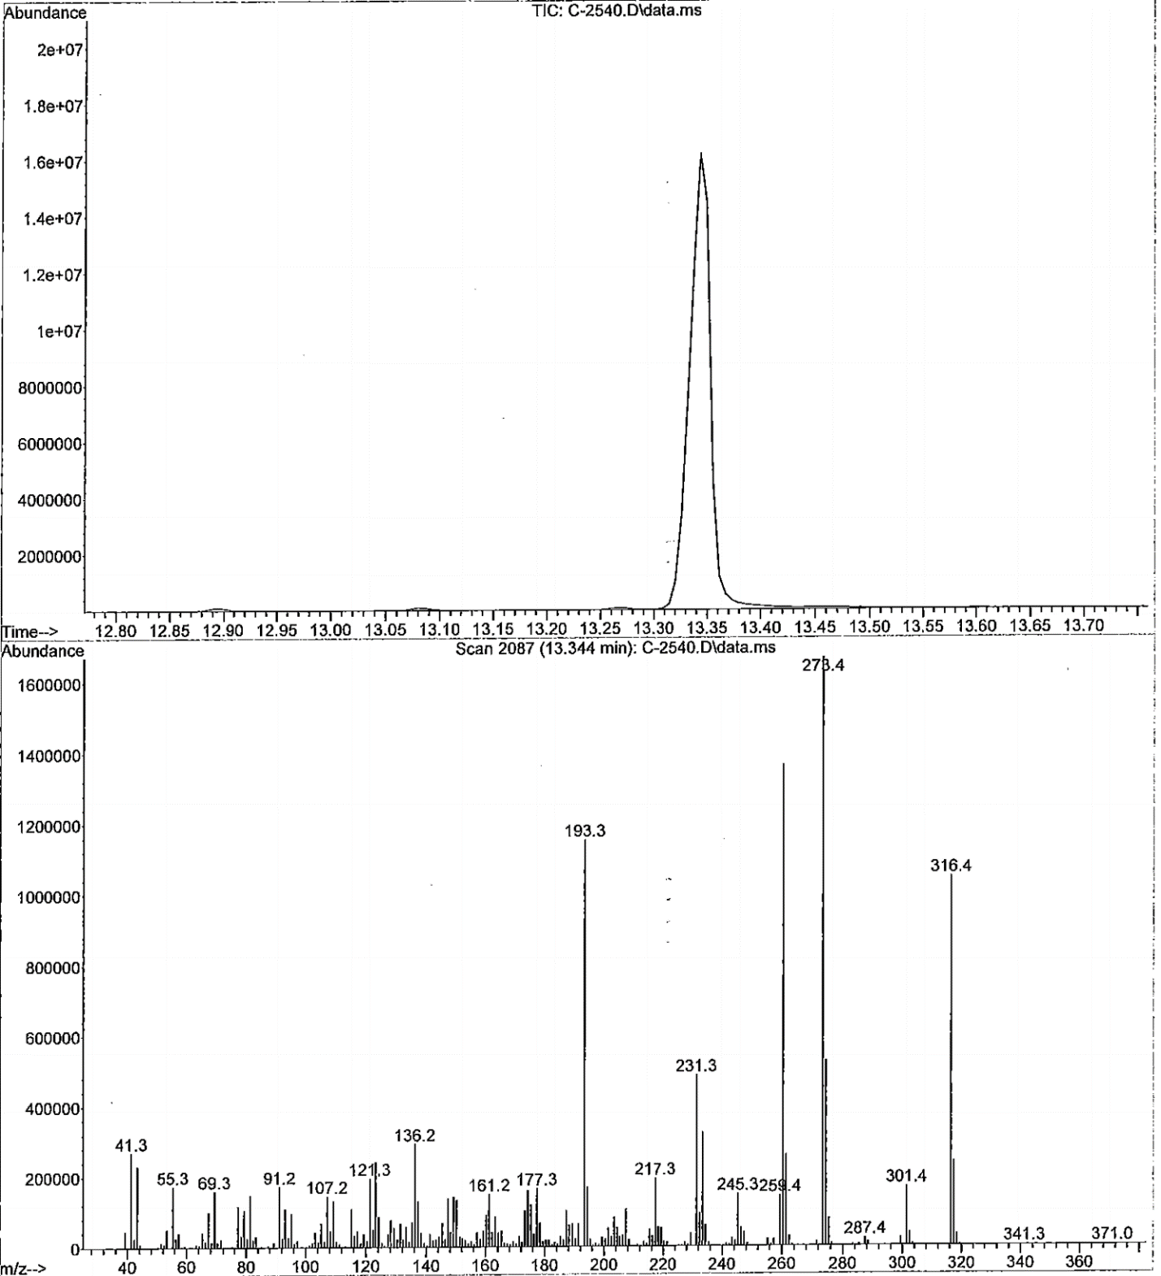

Figure 27: LCMS of 9R-HHC

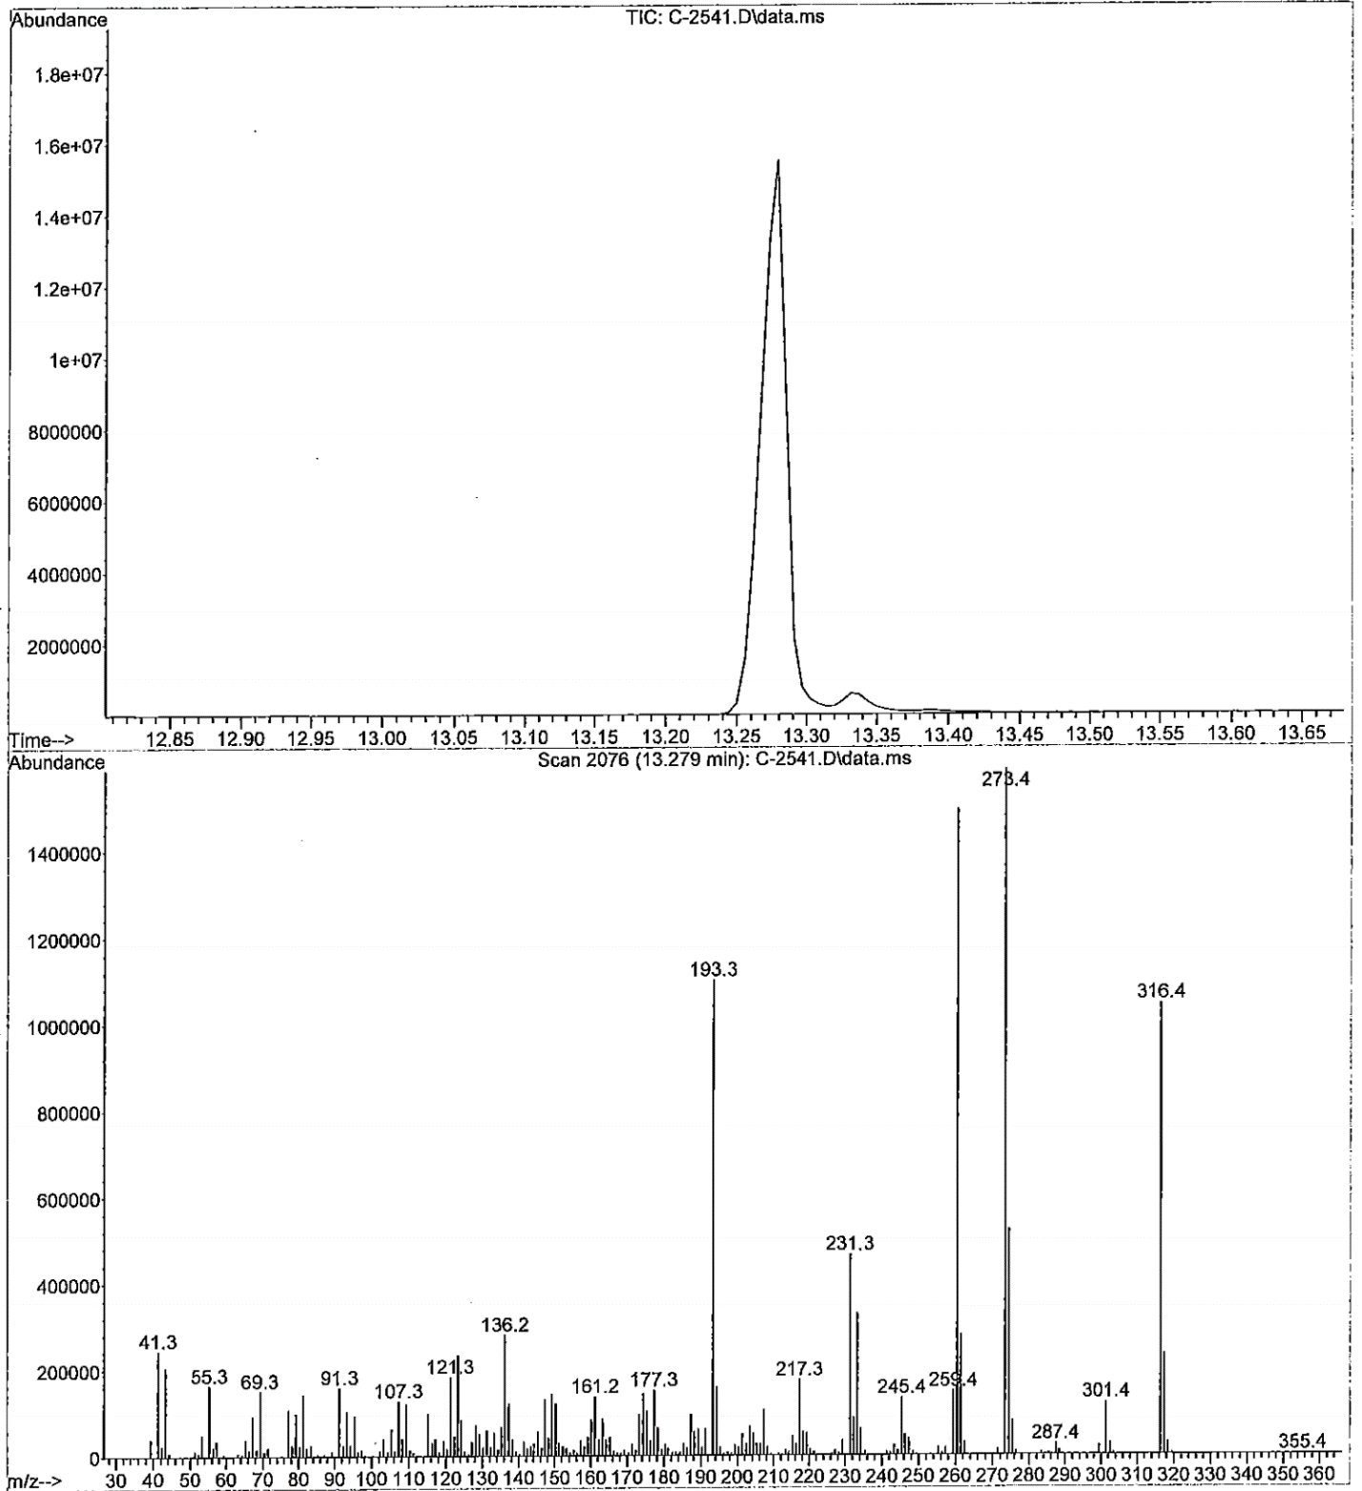

Figure 28. LCMS of 9S-HHC
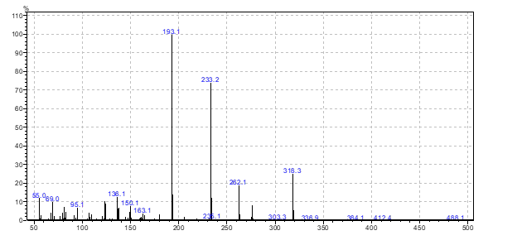
Figure 29: The mass spectra of (R)-H4CBD isomer

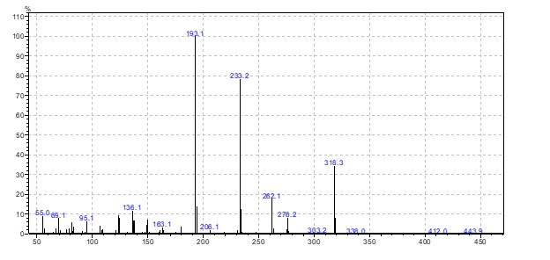
Figure 30: The mass spectra of (S)-H4CBD

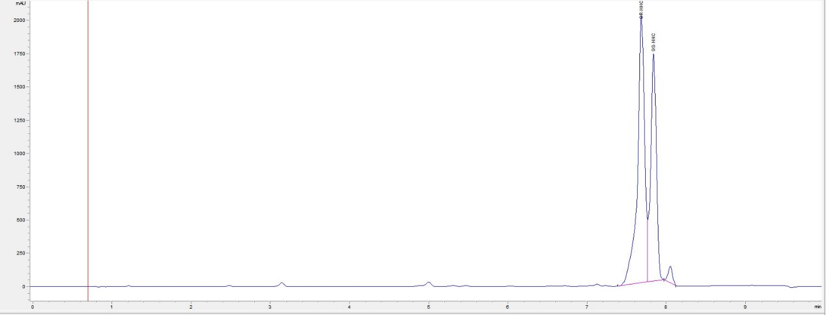
Figure 31: HPLC of crude R/S-isomer of HHC

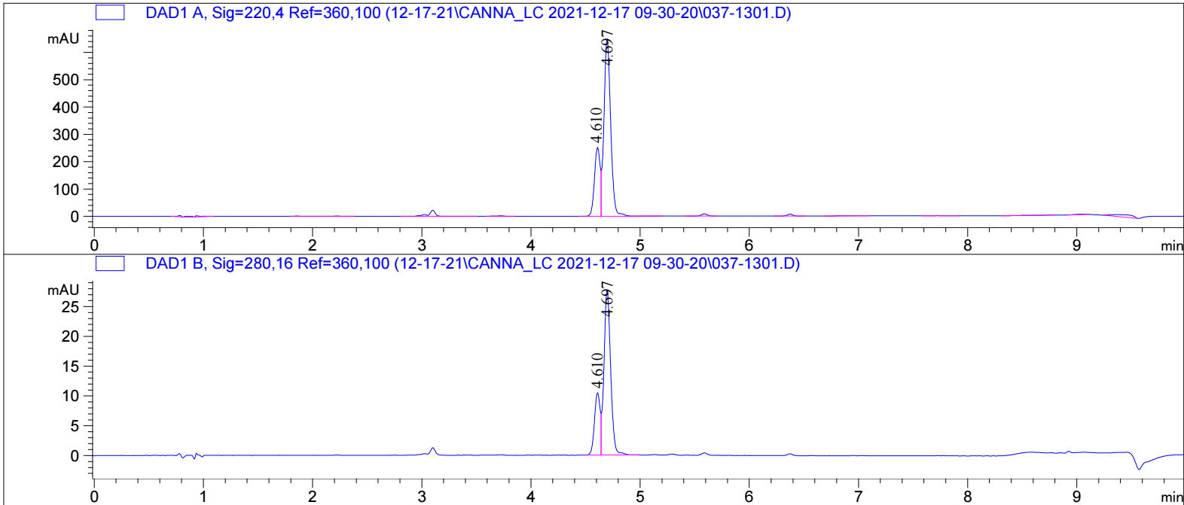
Figure 32: HPLC of R/S-isomer of H4CBD
The R-isomer on the left peak and S-isomer on the right peak of H4CBD

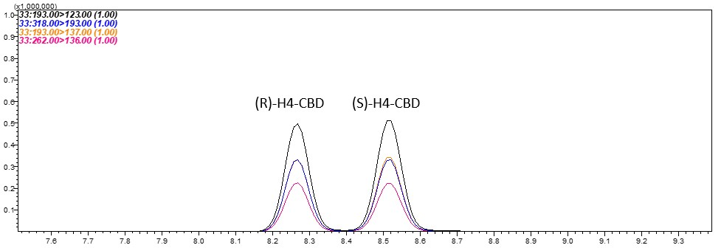
Figure 33: GC-MS of R/S isomer of H4CBD (m/z 318, 262 and 193)

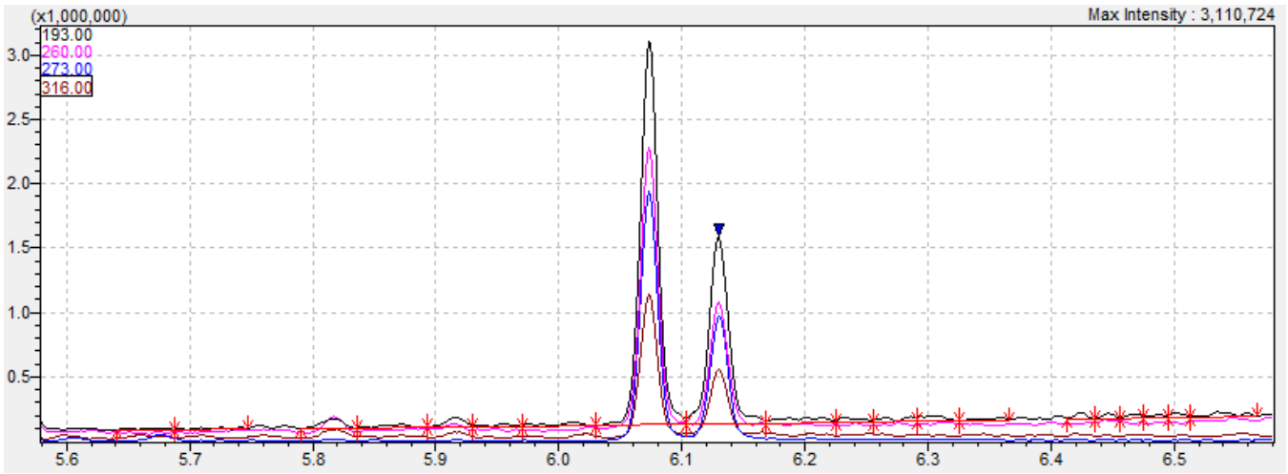
Figure 34: GC-MS of R/S isomer of HHC (m/z 316, 273, 260 and 193)
Event # | Compound Name | Start Time (min) | End Time (min) | Acq. Mode | Ch1 m/z | Ch1 CE | Ch2 m/z | Ch2 CE | Ch3 m/z | Ch3 CE | Ch4 m/z | Ch4 CE | Q1 Resolution | Q3 Resolution
26 | 9S- and 9R-HHC | 3 | 17.25 | MRM | 260.00>136.00 | 15 | 273.00>177.00 | 15 | 316.00>273.00 | 10 | 316.00>260.00 | 10 | Low | Low
33 | H4-CBD | 3 | 17.25 | MRM | 193.00>123.00 | 15 | 318.00>193.00 | 20 | 193.00>137.00 | 15 | 262.00>136.00 | 15 | Low | Low
Figure 35: MS acquisition data table

