Supplemental Information
Characterization of (HHC) Hexahydrocannabinol Diastereomers, and H₄CBD Diastereomers Using NMR, HPLC, and GC-MS
Collins A¹, Ramirez G¹, Tesfatsion T¹, Ray K^{1,2}, Cruces W^{1,2}
¹Colorado Chromatography Labs, 10505 S Progress Way, Parker, CO, 80134
²Blackstone Therapeutics, 10505 S Progress Way, Parker, CO, 80134

Corresponding Author: Westley Cruces, Wes@coloradochromatography.com
Table of Contents:
- Abbreviations……………………………………………………………………………………………………………………………S2
- 1H NMR, 2D NMR and 13C NMR of HHC.………………………………………………………………………………….S3
- 1H NMR, 2D NMR and 13C NMR of H4CBD……………….………………………………………………………..…..S15
- HPLC of H4CBD and HHC………………………………………………………………………………………………………...S29
- GC-MS of H4CBD and HHC……………………..…………………………………………………………………….…………S30

Abbreviations
HPLC: High performance liquid chromatography
NMR: Nuclear magnetic resonance
D3-MeCN:Deuterated Acetonitrile
GCMS: Gas Chromatography-Mass Spectrometry
HHC: Hexahydrocannabinol
H4CBD: Hydrogenated Cannabidiol
COSY: Correlated Spectroscopy
HSQC: Heteronuclear Single Quantum Coherence
HMBC: Heteronuclear Multiple Bond Correlation
NOESY: Nuclear Overhauser Effect Spectroscopy

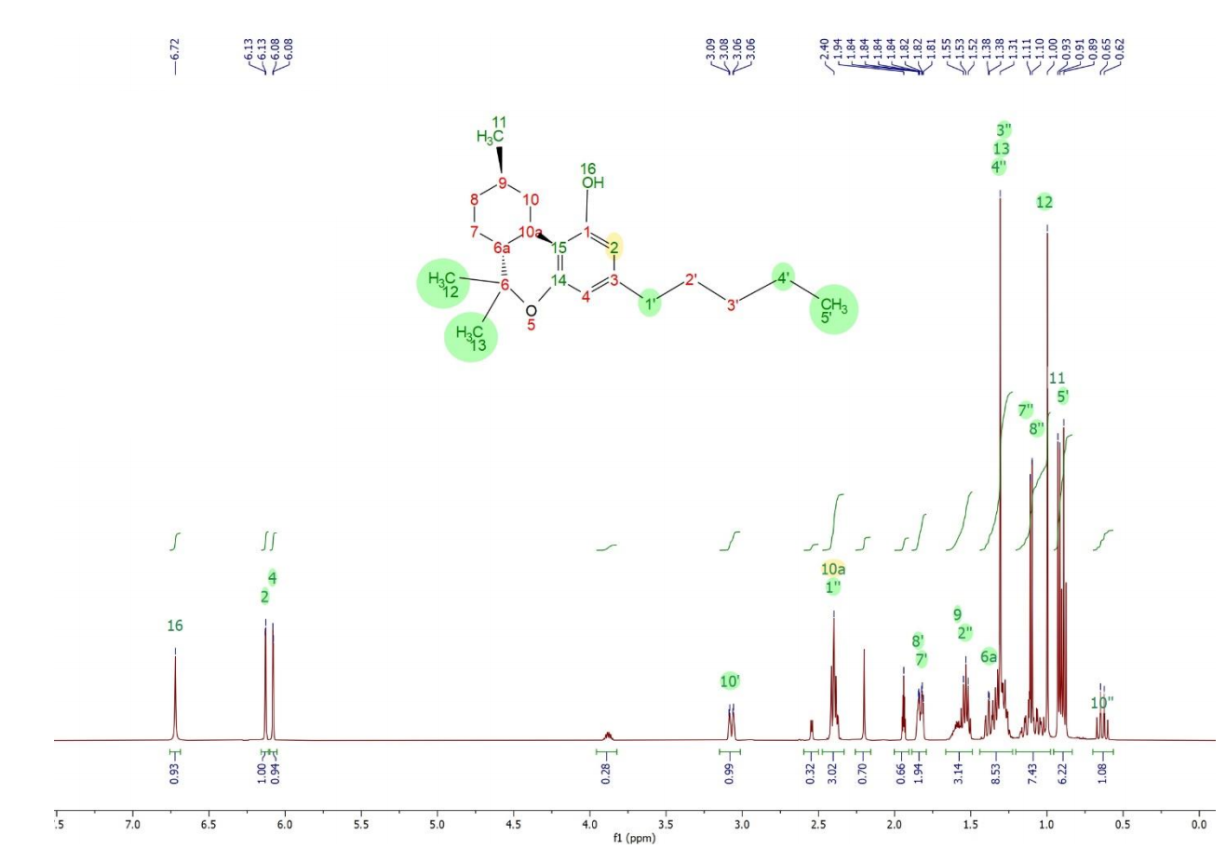
¹H NMR spectrum of HHC-Peak3-9R-1 in acetonitrile-d3 at 25C.

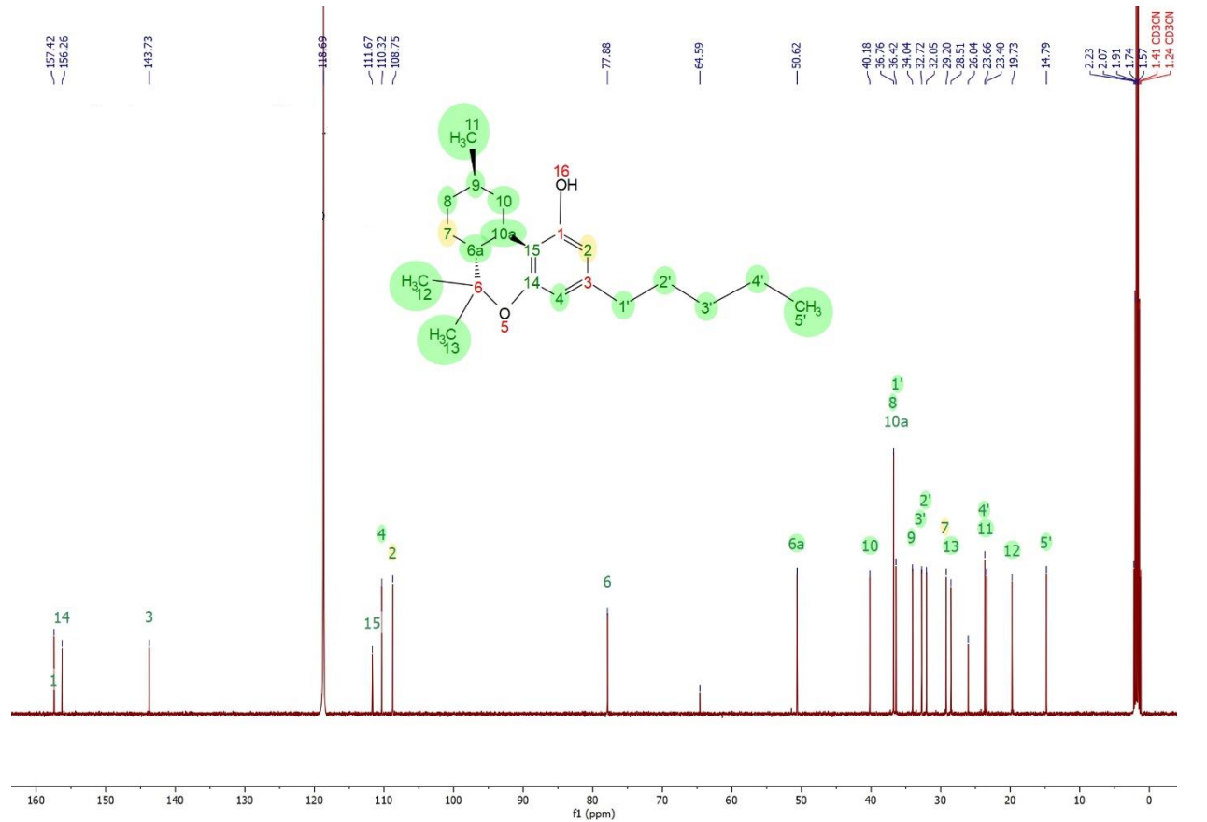
Figure 4, 13C NMR spectrum of HHC-Peak3-9R-1 in acetonitrile-d3 at 25C.

Atom number | Atom type | H chemical shift | C chemical shift
1 | C |  | 157.4
2 | CH | 6.13 | 108.8
3 | C |  | 143.7
4 | CH | 6.08 | 110.3
5 | O
6 | C |  | 77.9
6a | CH | 1.39 | 50.6
7 | CH2 | 1.14, 1.82 | 29.2
8 | CH2 | 1.06, 1.84 | 36.8
9 | CH | 1.59 | 34.0
10 | CH2 | 0.64, 3.07 | 40.2
10a | CH | 2.40 | 36.8
11 | CH3 | 0.92 | 23.4
12 | CH3 | 1.00 | 19.7
13 | CH3 | 1.31 | 28.5
14 | C |  | 156.3
15 | C |  | 111.7
16 | OH | 6.72
1’ | CH2 | 2.40 | 36.4
2’ | CH2 | 1.54 | 32.0
3’ | CH2 | 1.29 | 32.7
4’ | CH2 | 1.33 | 23.7
5’ | CH3 | 0.89 | 14.8

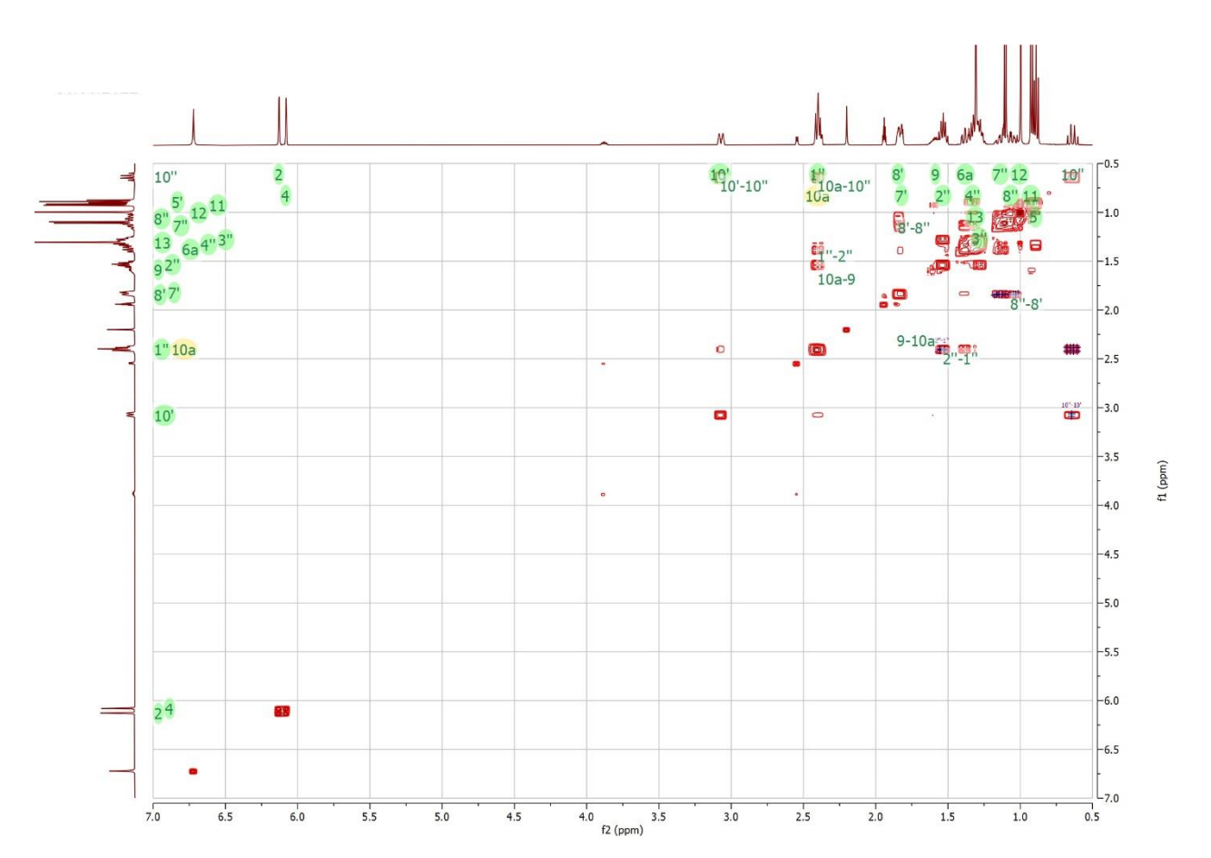

1H-1H COSY NMR data of HHC-Peak3-9R-1 in acetonitrile-d3 at 25C.

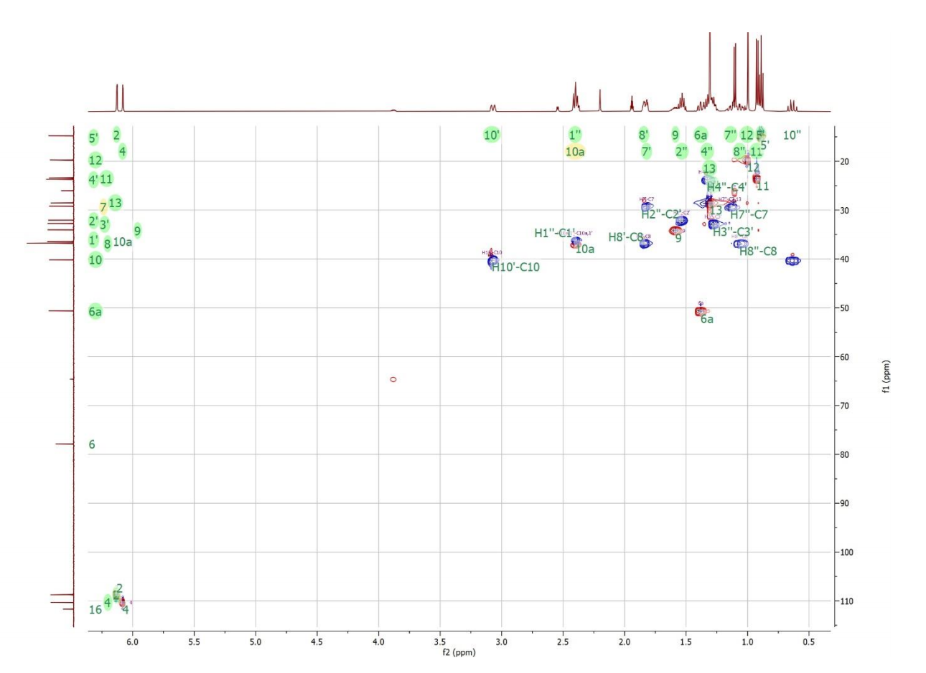
1H-13C HSQC data of HHC-Peak3-9R-1 in acetonitrile-d3 at 25C.
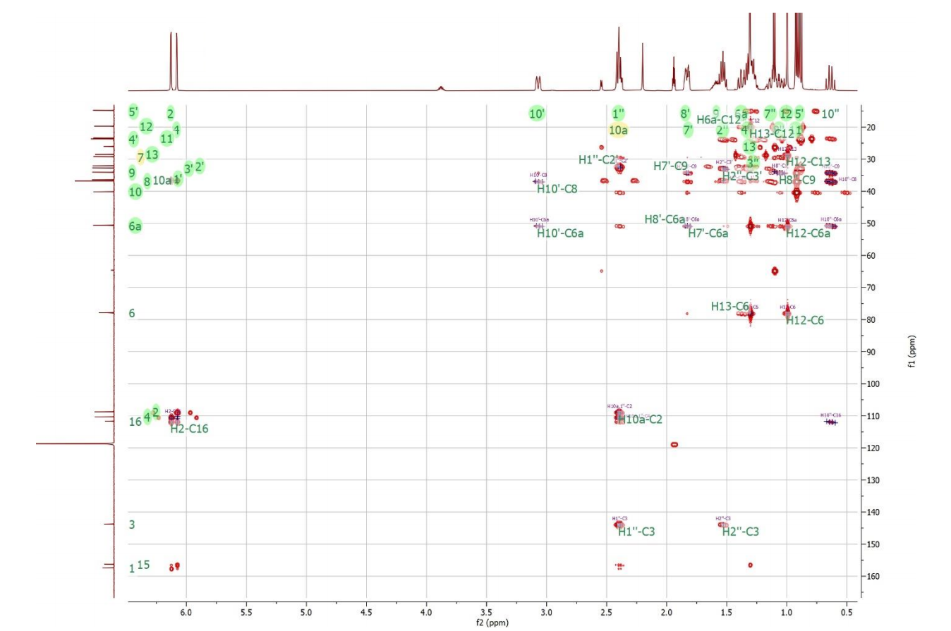
Figure 7, 1H-13C HMBC data of HHC-Peak3-9R-1 in acetonitrile-d3 at 25C.
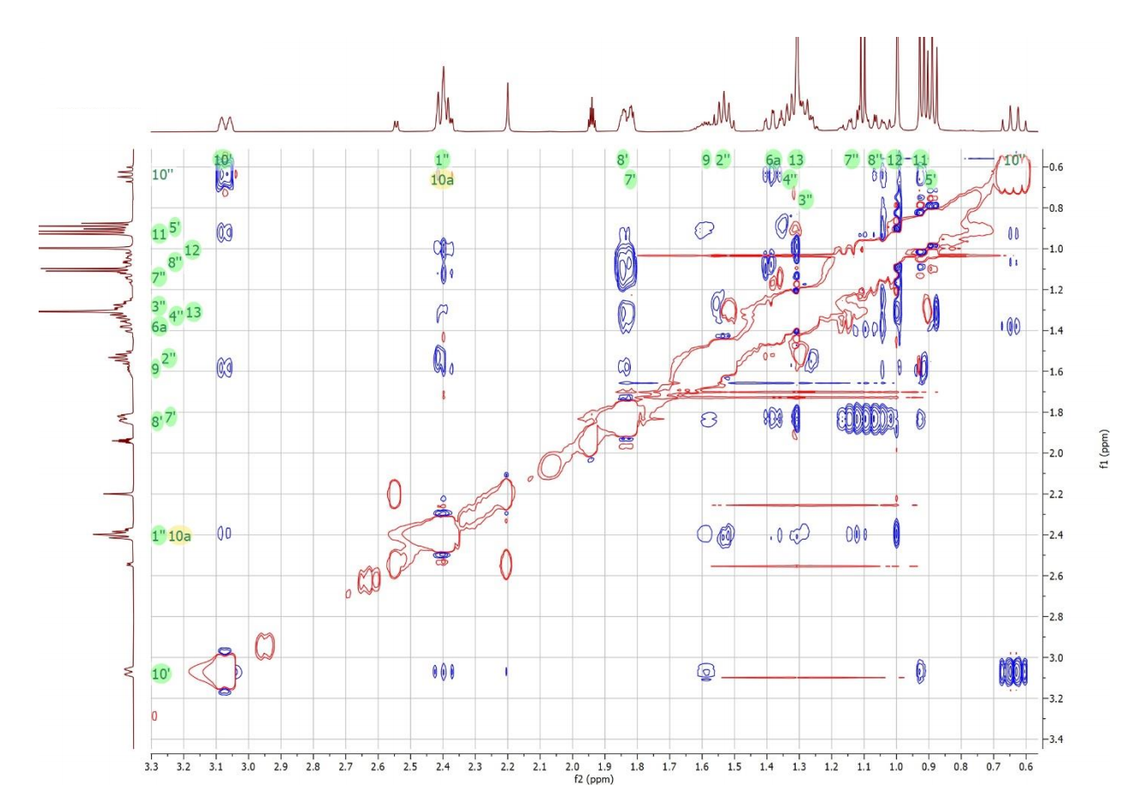
Figure 8, 1H-1H NOESY NMR data of HHC-Peak3-9R-1 in acetonitrile-d3 at 25C.

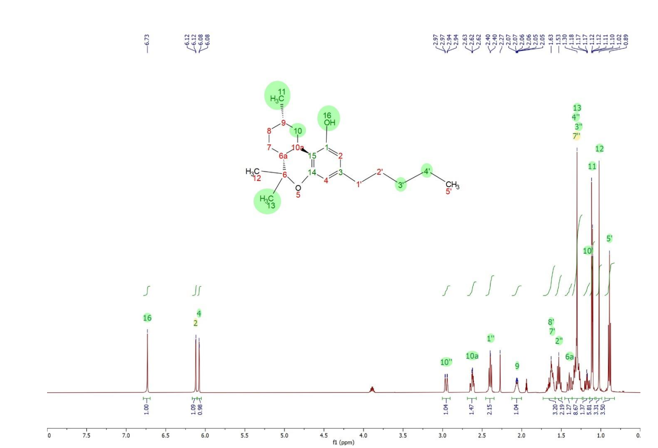Figure 9, 1H NMR spectrum of HHC-Peak2-9S in acetonitrile-d3 at 25C.
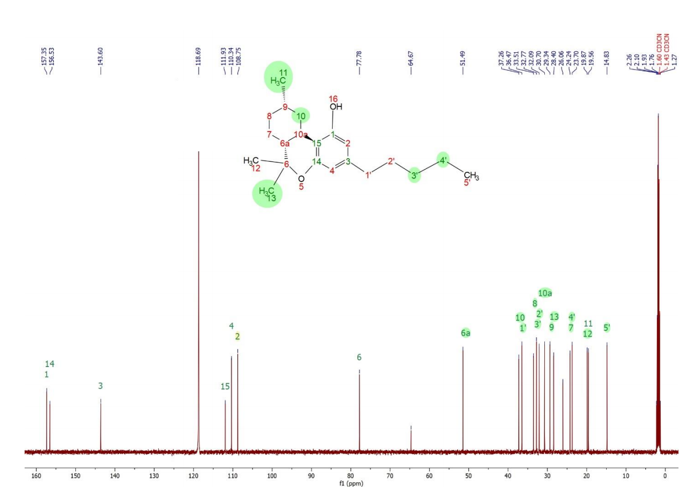
Figure 10, 13C NMR spectrum of HHC-Peak2-9S in acetonitrile-d3 at 2
Atom number | Atom type | H chemical shift | C chemical shift
1 | C |  | 157.4
2 | CH | 6.13 | 108.8
3 | C |  | 143.6
4 | CH | 6.08 | 110.3
5 | O
6 | C |  | 77.8
6a | CH | 1.39 | 51.5
7 | CH2 | 1.14, 1.82 | 24.2
8 | CH2 | 1.06, 1.84 | 33.5
9 | CH | 1.59 | 29.3
10 | CH2 | 0.64, 3.07 | 37.3
10a | CH | 2.40 | 30.7
11 | CH3 | 0.92 | 19.6
12 | CH3 | 1.00 | 19.8
13 | CH3 | 1.31 | 28.4
14 | C |  | 156.5
15 | C |  | 111.9
16 | OH | 6.73
1’ | CH2 | 2.40 | 36.5
2’ | CH2 | 1.54 | 32.1
3’ | CH2 | 1.29 | 32.8
4’ | CH2 | 1.33 | 23.7
5’ | CH3 | 0.89 | 14.8

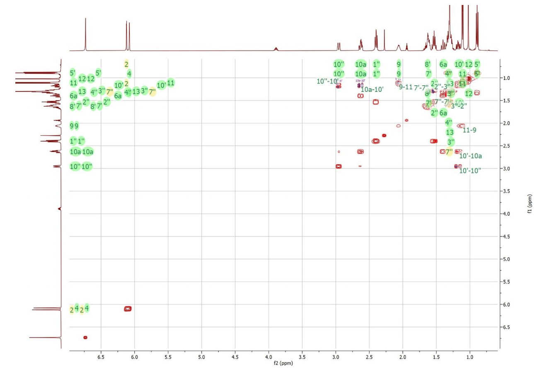
Figure 11, 2D 1H-1H COSY NMR data of HHC-Peak2-9S in acetonitrile-d3 at 25C.
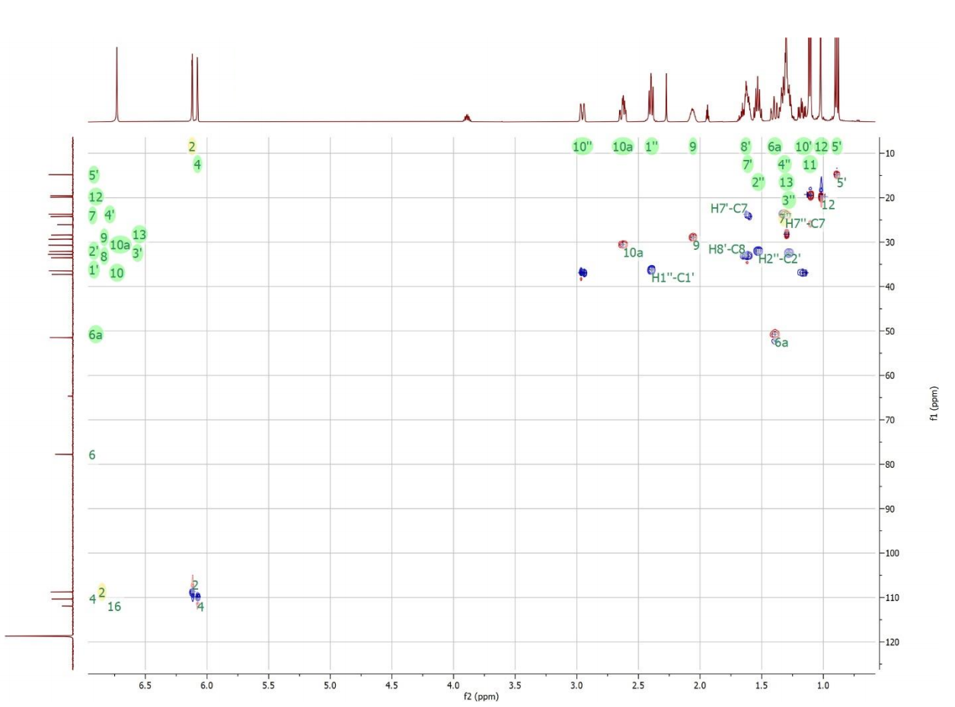
Figure 12, 2D 1H-13C HSQC NMR data of HHC-Peak2-9S in acetonitrile-d3 at 25C.
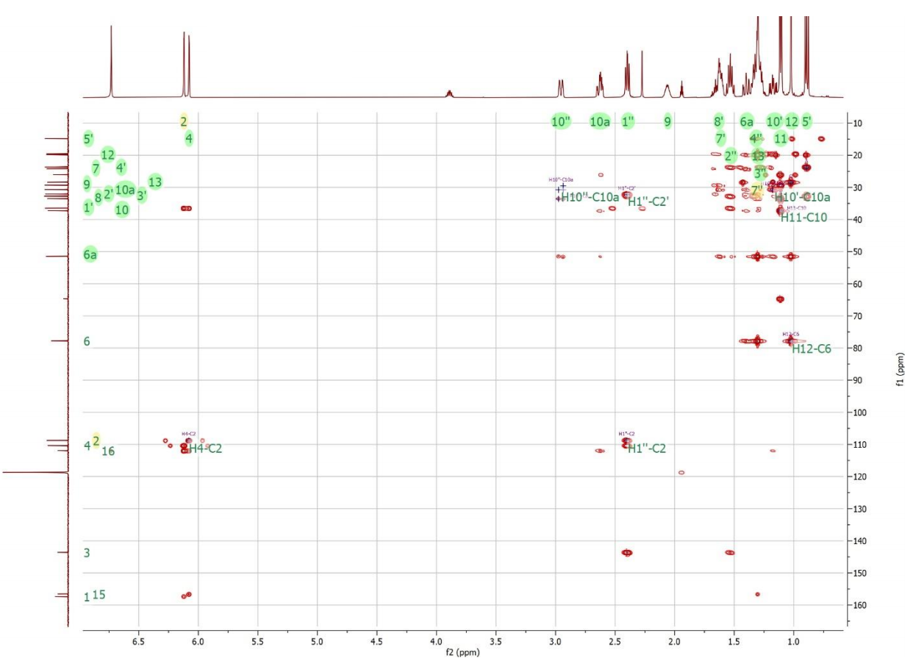
Figure 13, 2D 1H-13C HMBC NMR data of HHC-Peak2-9S in acetonitrile-d3 at 25C.
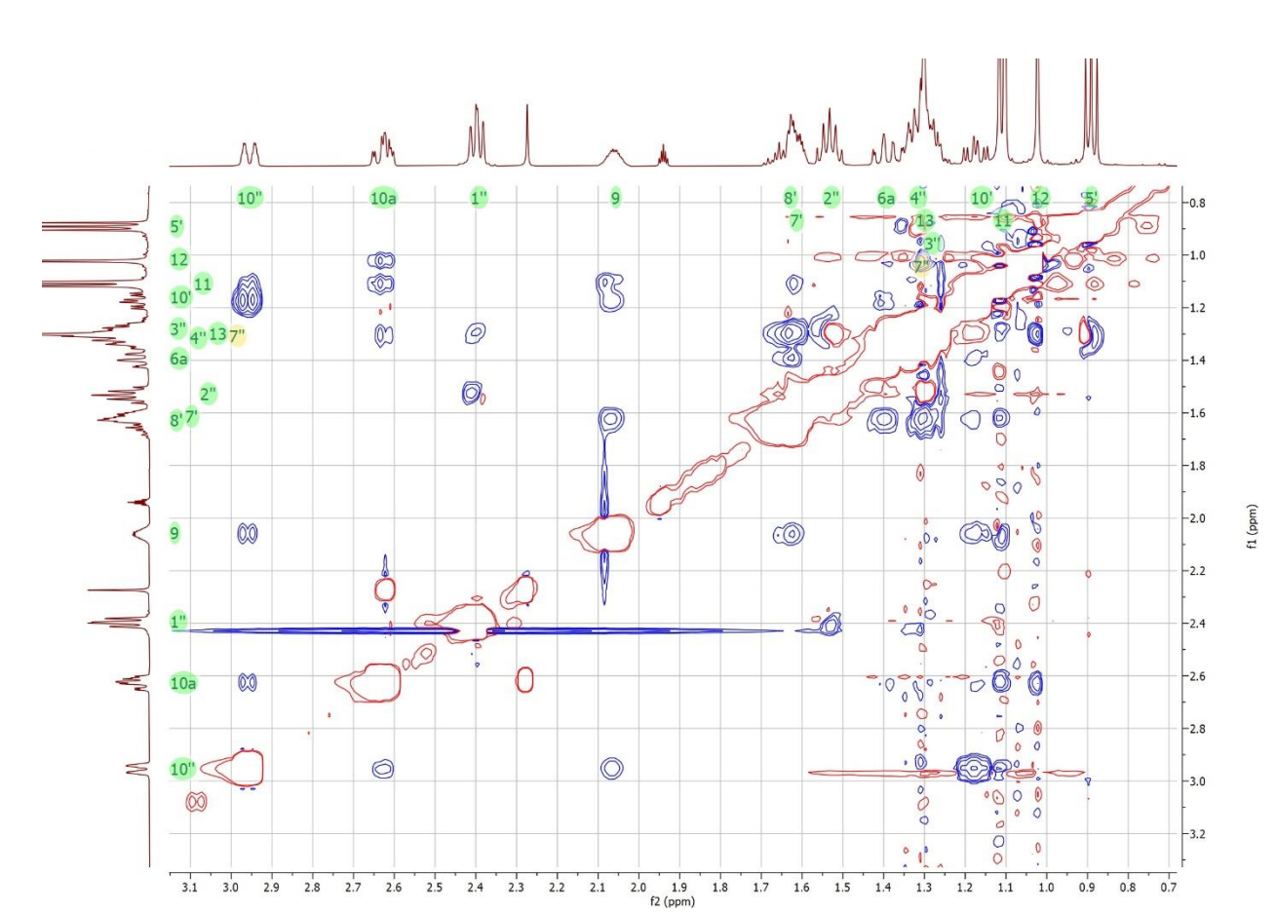
Figure 14, 2D 1H-1H NOESY NMR data of HHC-Peak2-9S in acetonitrile-d3 at 25C.

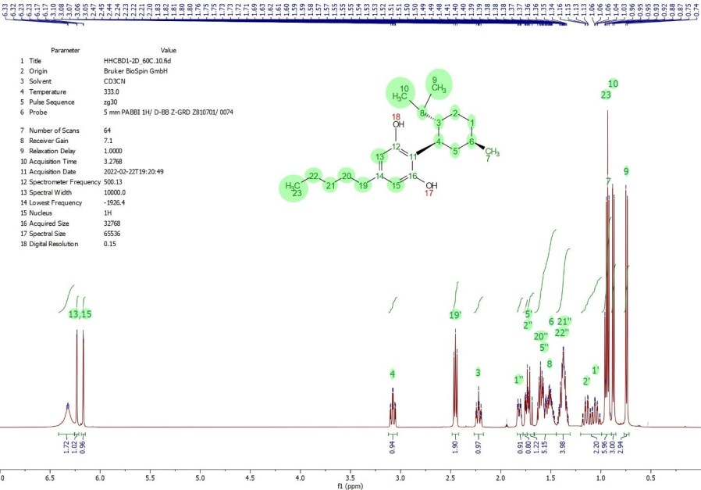

1H NMR spectrum of HHCBD1 in acetonitrile-d3 at 60C.

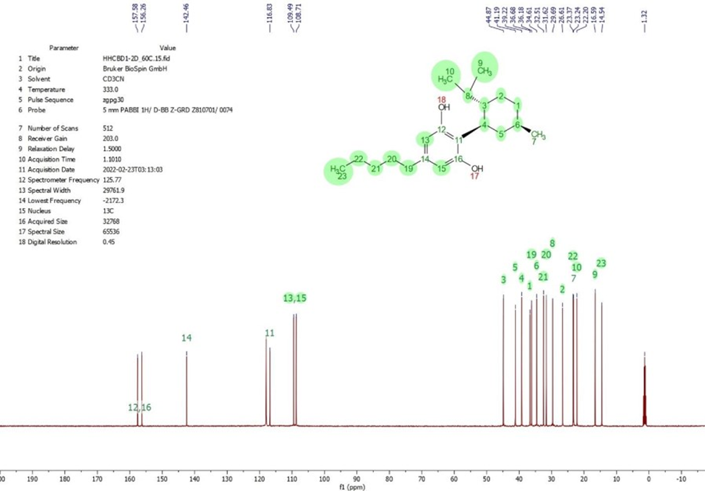
13C NMR spectrum of HHCBD1 in acetonitrile-d3 at 60C.
Atom number | Atom type | H chemical shift | C chemical shift | Comment
1 | CH2 | 1.05, 1.82 | 36.7
2 | CH2 | 1.14, 1.74 | 26.6
3 | CH | 2.22 | 44.9
4 | CH | 3.08 | 39.2
5 | CH2 | 1.56, 1.72 | 41.2
6 | CH | 1.50 | 34.6
7 | CH3 | 0.93 | 23.2
8 | CH | 1.52 | 29.7
9 | CH3 | 0.74 | 16.6 | 9 and 10 results can  be interchanged
10 | CH3 | 0.87 | 22.2
11 | C |  | 116.8
12 | C |  | 157.6 | 12 and 16 results can  be interchanged
13 | CH | 6.17 | 109.5 | 13 and 15 results can  be interchanged
14 | C |  | 142.5
15 | CH | 6.23 | 108.7
16 | C |  | 156.3
17 | OH | 6.33
18 | OH | 6.33
19 | CH2 | 2.45 | 36.2
20 | CH2 | 1.60 | 31.6
21 | CH2 | 1.36 | 32.5
22 | CH2 | 1.39 | 23.4
23 | CH3 | 0.95 | 14.5

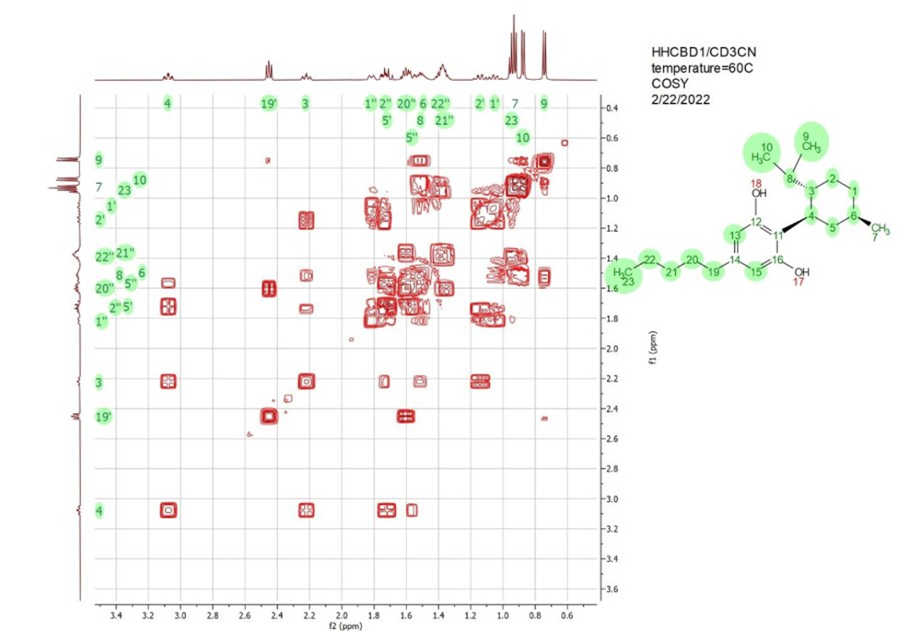
1H-1H COSY NMR data of HHCBD1 in acetonitrile-d3 at 60C.

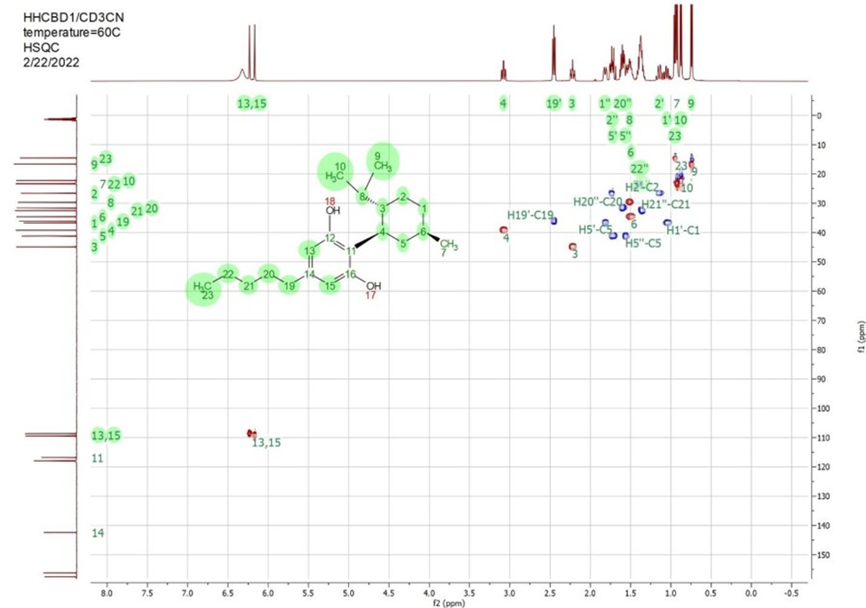

1H-13C HSQC data of HHCBD1 in acetonitrile-d3 at 60C.

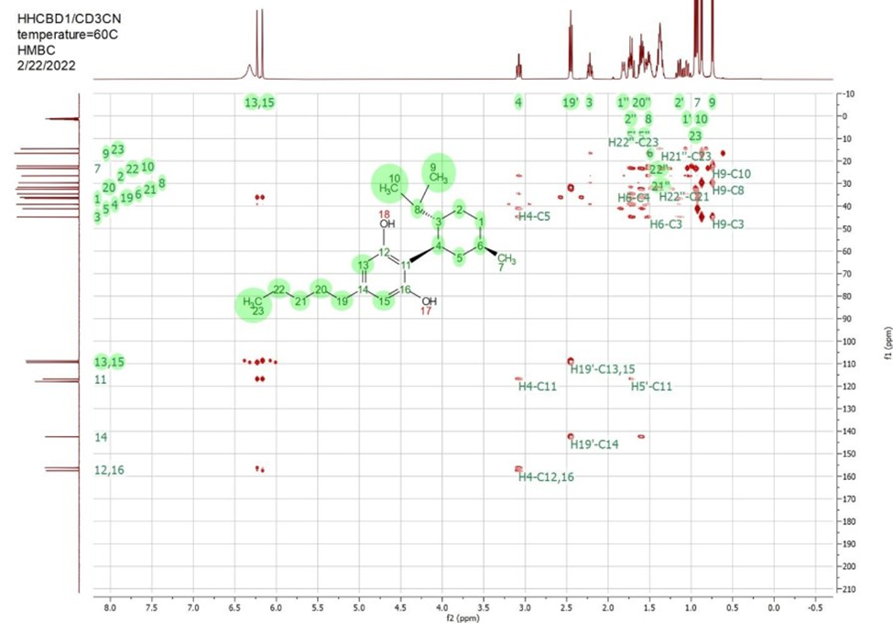
1H-13C HMBC data of HHCBD1 in acetonitrile-d3 at 60C.

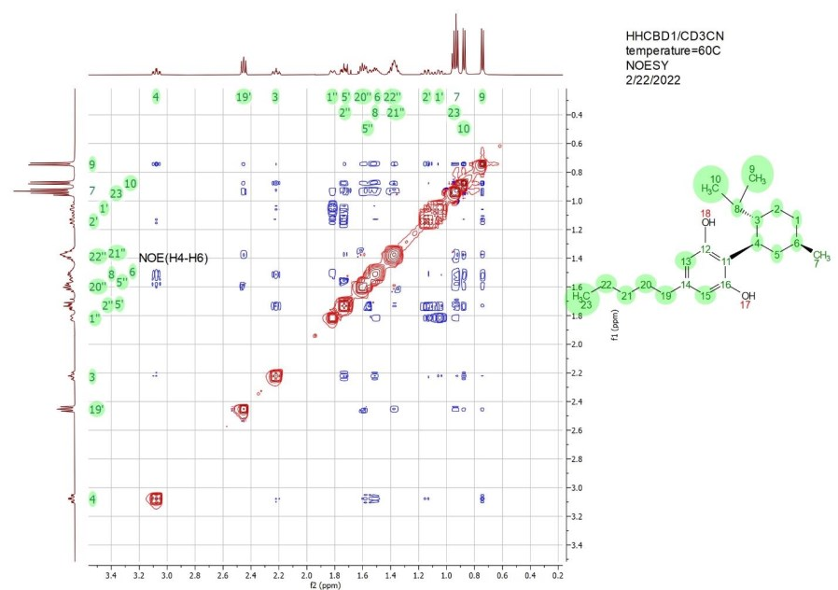

1H-1H NOESY NMR data of HHCBD1 in acetonitrile-d3 at 60C. The green numbers on the top and left of the plot notate peaks assigned to the corresponding protons in the structure on the right. The blue cross peaks represent NOE peaks between pairs of protons on the top and left. The NOE peak between protons H4 and H6 are marked with a black label.

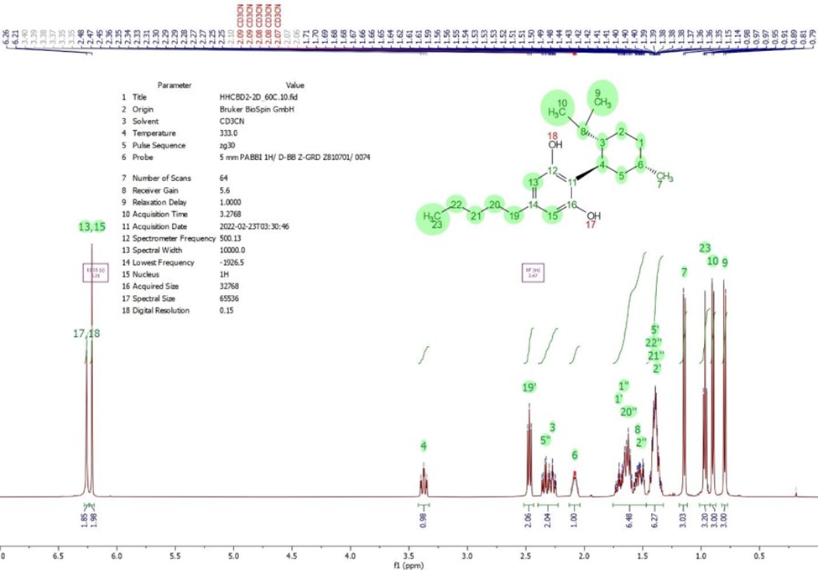
1H NMR spectrum of HHCBD2 in acetonitrile-d3 at 60C.

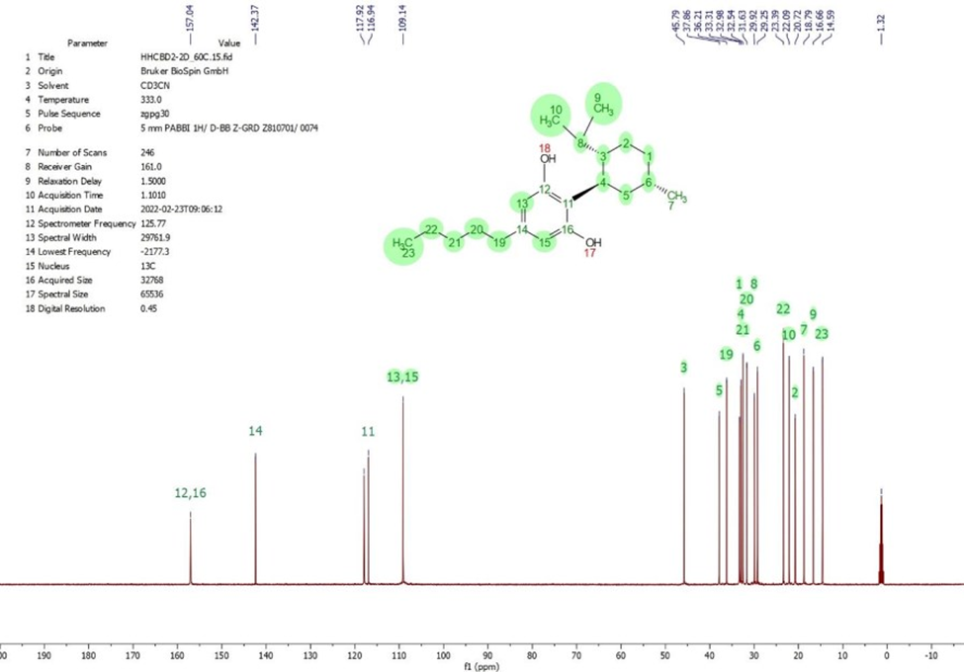
13C NMR spectrum of HHCBD2 in acetonitrile-d3 at 60C.
Atom number | Atom type | H chemical shift | C chemical shift | Comment
1 | CH2 | 1.66, 1.69 | 33.3
2 | CH2 | 1.38, 1.51 | 20.7
3 | CH | 2.27 | 45.8
4 | CH | 3.38 | 33.0
5 | CH2 | 1.40, 2.33 | 37.9
6 | CH | 2.08 | 29.3
7 | CH3 | 1.14 | 19.8
8 | CH | 1.55 | 29.9
9 | CH3 | 0.80 | 16.7 | 9 and 10 results can  be interchanged
10 | CH3 | 0.90 | 22.10
11 | C |  | 116.9
12 | C |  | 157.0 | 12 and 16 results can  be interchanged
13 | CH | 6.21 | 109.1 | 13 and 15 results can  be interchanged
14 | C |  | 142.4
15 | CH | 6.21 | 109.1
16 | C |  | 157.0
17 | OH | 6.26
18 | OH | 6.26
19 | CH2 | 2.47 | 36.2
20 | CH2 | 1.63 | 31.6
21 | CH2 | 1.39 | 32.5
22 | CH2 | 1.41 | 23.4
23 | CH3 | 0.97 | 14.4

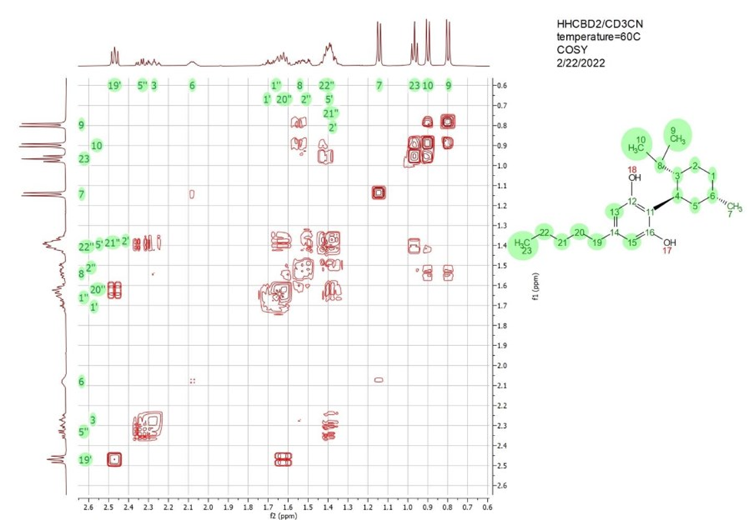
2D 1H-1H COSY NMR data of HHCBD2 in acetonitrile-d3 at 60C.

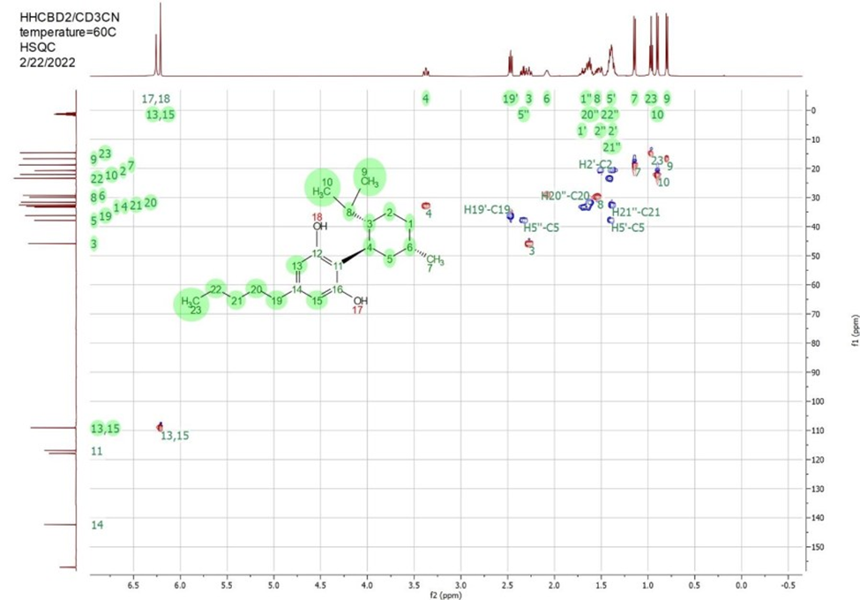
2D 1H-13C HSQC NMR data of HHCBD2 in acetonitrile-d3 at 60C.

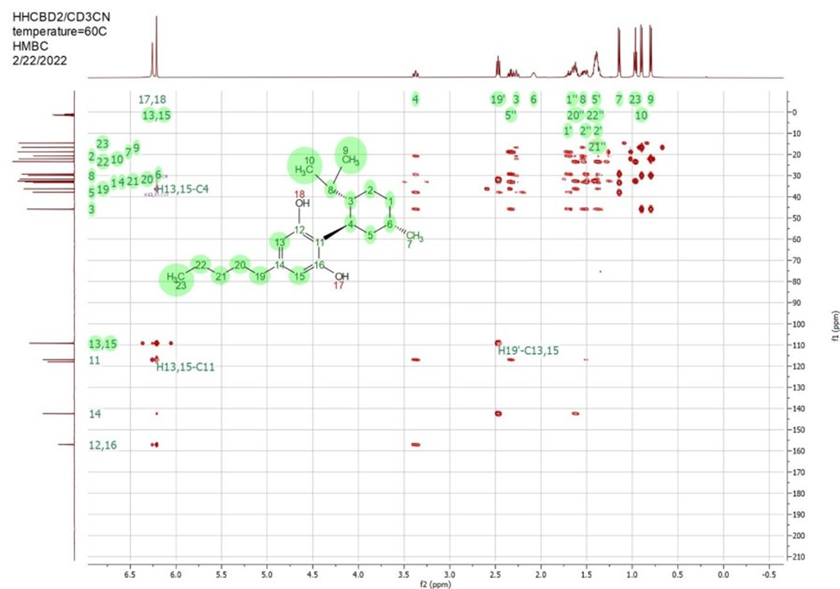
2D 1H-13C HMBC NMR data of HHCBD2 in acetonitrile-d3 at 60C.

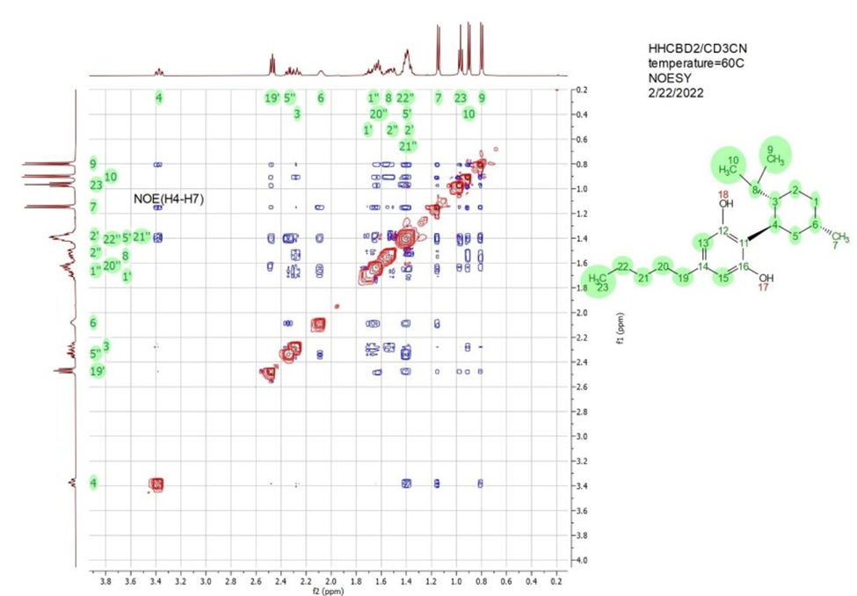
2D 1H-1H NOESY NMR data of HHCBD2 in acetonitrile-d3 at 60C. The green numbers on the top and left of the plot notate peaks assigned to the corresponding protons in the structure on the right. The blue cross peaks represent NOE peaks between pairs of protons on the top and left. The NOE peak between protons H4 and H7 are marked with a black label.

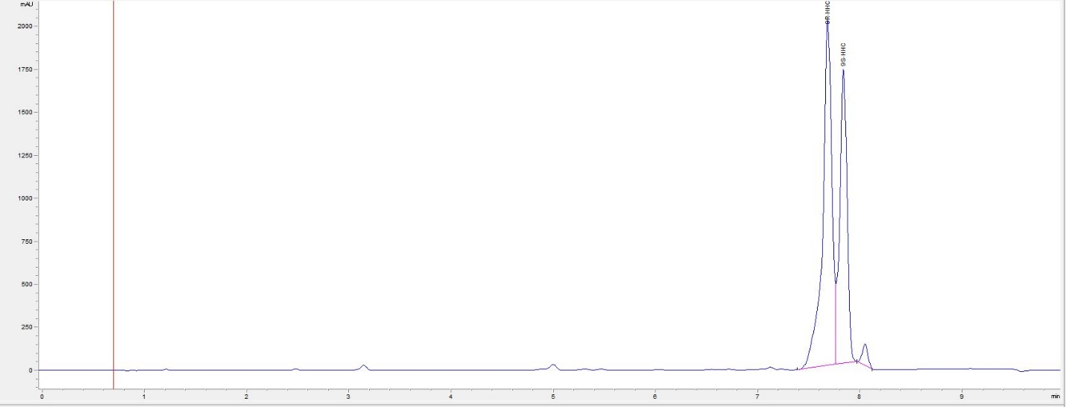
HPLC of R/S-isomer of HHC

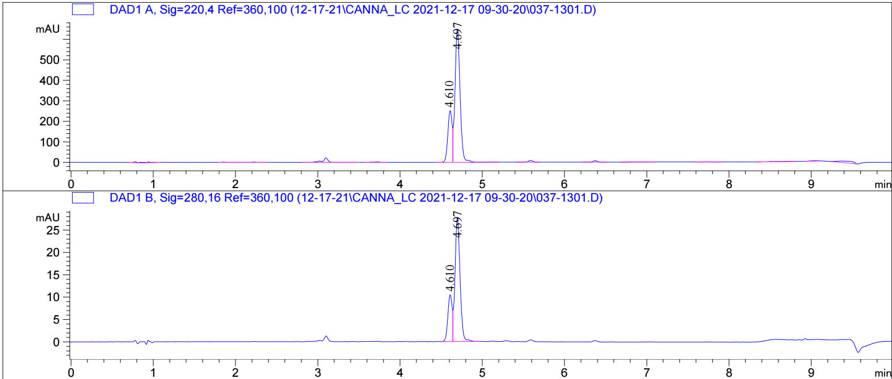
HPLC of R/S-isomer of H4CBD

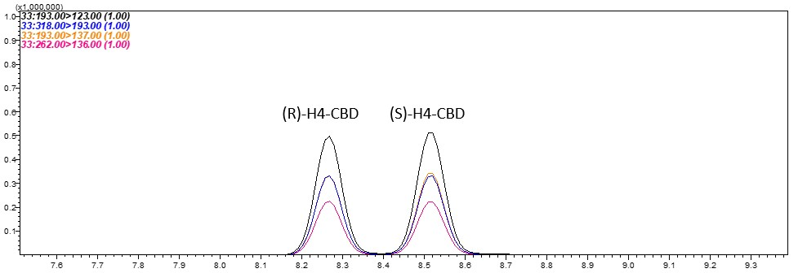
GC-MS of R/S isomer of H4CBD

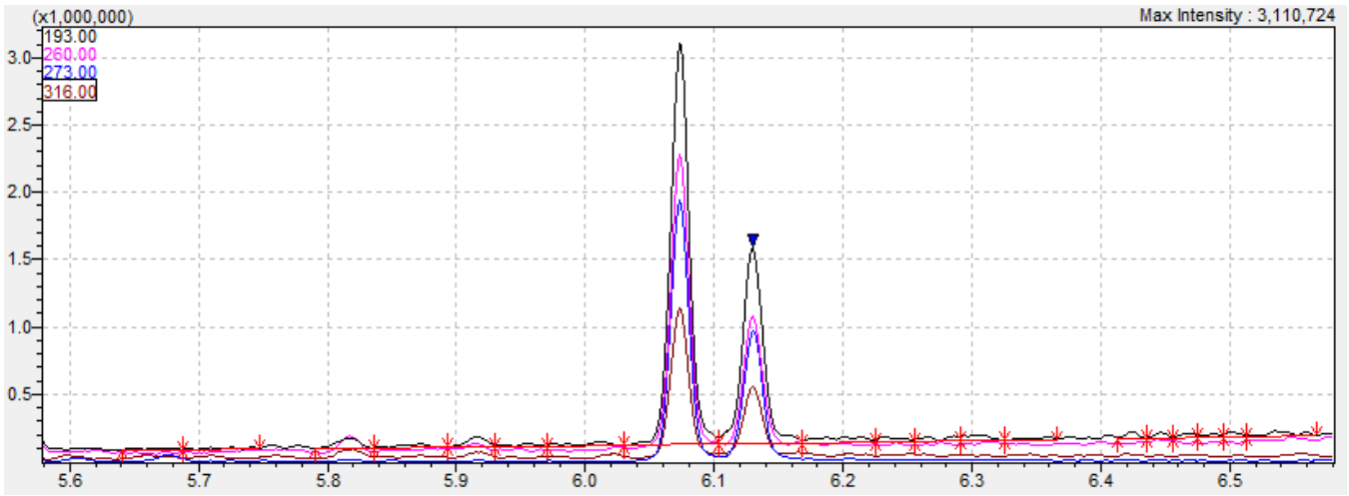
GC-MS of R/S isomer of HHC

