Supporting Information

Overcoming Small-Bandgap Charge Recombination in Visible and NIR-Light-Driven Hydrogen Evolution by Engineering the Polymer Photocatalyst Structure

Mohamed Hammad Elsayed^{1,2,3,4} Mohamed Abdellah^{5,6}, Islam M. A. Mekhemer¹, Ahmed Esmail A. Aboubakr ^{7, 8, 9}, Mohamed Gamal Mohamed¹⁰, Shiao-Wei Kuo¹⁰, Chen-Hsiung Hung⁹, Li-Chyong Chen^{3, 11, 12}, Kuei-Hsien Chen^{2, 3}, Ho-Hsiu Chou*^{,1}

¹Department of Chemical Engineering, National Tsing Hua University, Hsinchu 30013, Taiwan
²Institute of Atomic and Molecular Sciences, Academia Sinica, Taipei, 10617, Taiwan.
³Center for Condensed Matter Sciences, National Taiwan University, Taipei, 10617, Taiwan
⁴Department of Chemistry, Faculty of Science, Al-Azhar University, Nasr City 11884, Cairo, Egypt.
⁵Chemical Physics and NanoLund, Lund University, 22100 Lund, Sweden
⁶Department of Chemistry, Qena Faculty of Science, South Valley University, 83523 Qena, Egypt.
⁷Sustainable Chemical Science and Technology, Taiwan International Graduate Program, Taiwan
⁸Department of Applied Chemistry, National Yang Ming Chiao Tung University, Hsinchu 30010, Taiwan
⁹Institute of Chemistry, Academia Sinica, 128 Sec 2 Academia Rd., Nankang, Taipei, 11529, Taiwan.
¹⁰Department of Materials and Optoelectronic Science, Center of Crystal Research, National Sun Yat-Sen University, Kaohsiung 804, Taiwan.
¹¹Center of Atomic Initiative for New Materials, National Taiwan University, Taipei 10617, Taiwan.
¹²Department of Physics, National Taiwan University, Taipei 10617, Taiwan.
*Corresponding Author E-mail: hhchou@mx.nthu.edu.tw

Keywords: 𝜋-linker effect; near-infrared photocatalyst; polymer dots photocatalysts, visible-light; hydrogen evolution; ITIC-polymers

Synthesis procedures of polymers
All reagents were obtained from commercial suppliers and used without further purification. 4-Bromophthalic Anhydride (compound 1), Ethyl acetoacetate (compound 2), malononitrile (compound 4), and the other chemicals and solvents were purchased from Matrix and Alfa Aesar. Compound 6 (IDTT-CHO) (Dithieno[2,3-d:2,3-d]-s-indaceno[1,2-b:5,6-b]dithiophene-2,8-dicarboxaldehyde, 6,6,12,12-tetrakis(4-hexylphenyl)-6,12-dihydro), compound B-Ph-B (1,4-bis(4,4,5,5-tetramethyl-1,3,2-dioxaborolan-2-yl)benzene), compound Sn-Th-Sn (2,5-Bis(trimethylstannyl)thiophene), and compound Sn-ThF-Sn (3,4-difluoro-2,5-bis-trimethylstannanylthiophene) were purchased from Derthon Optoelectronic Materials Science Technology Co Ltd. The compound IC-Br, the monomer Br-ITIC-Br, and the PITIC-Ph, PITIC-Th, PITIC-ThF polymers were synthesized according to Scheme 1 and 2.
Synthesis of compound 3 (5-bromo-1H-indene-1,3(2H)-dione). Compound 1 (4-bromophthalic anhydride) ((5 g, 22 mmol), acetic anhydride (12 mL) and triethylamine (6.5 mL) was added to a two-necked round bottom flask under a nitrogen atmosphere, then the compound 2 (ethyl acetoacetate) (3.15 mL) was added quickly under argon. The solution color will be changed from orange to red after the addition of compound 2. The mixture was stirred at room temperature for 22 h, then ice-water (8.5 g) and concentrated HCl (8 mL) were added to the mixture followed by the addition of 5M HCl (35 mL). After that, the mixture was stirred at 80 °C for 15 min. Then, the crude product was cooled to room temperature, water was added, and the mixture was extracted with dichloromethane (DCM). The organic phase was taken, and the solvent evaporated under reduced pressure. The dried solid was dissolved in a minimum volume of acetone and cooled to –20 °C. The product was collected by filtration and then dried under high vacuum to give a material which was obtained as a brown solid. ¹H-NMR (500 MHz, CD₂Cl₂): δ 8.1(s, 1H), 7.94 (d, 1H), 7.83 (d, 1H), 3.23(s, 2H).
Synthesis of compound 5 (IC-Br) (2-(5(6)-bromo-3-oxo-2,3-dihydro-1H-inden-1-ylidene) malononitrile). Compound 3 (2.33 g, 10.35 mmol) and malononitrile (1.37 g, 20.7 mmol) were mixed in 40 mL ethanol in a 250 mL single neck round bottom flask and stirred for 30 min at room temperature. Then, anhydrous sodium acetate (1.28 g, 15.52 mmol) was added to the reaction, and the mixture was stirred at room temperature for 2 h. After the reaction 40 mL water was added, and the mixture was stirred at room temperature for half an hour. Then, concentrated HCl was dropped into the mixture to acidify the mixture with pH = 2. The precipitate was filtered and washed with water many times. The crude product was further purified by flash column chromatography to afford title compound 3 as yellow solid (0.38 g, yield: 29.4%). ¹H NMR (500 MHz, CDCl3) δ 8.75 (s, 1H), 8.49 (d, 1H), 8.1 (s, 1H), 7.97 (m, 1H), 7.82 (d, 1H), 3.72 (d, 2H).
Synthesis of compound 7 (Br-ITIC-Br). Compound 5 (558 mg, 2.04 mmol) and Compound 6 (400 mg, 0.38 mmol) were added to a 250 ml two-necked round bottom flask, after being rinsed with a mild stream of nitrogen for ten minutes, then anhydrous chloroform (100 mL) was added to the flask. Finally, pyridine (2 mL) was added to the reaction, the mixture turned green gradually. Then, the reaction was placed in an oil bath at 65 ºC stirred and refluxed for 12 hours. After the reaction was completed, it was cooled to room temperature. The crude product was poured into methanol (400 mL), then the precipitate was filtered and purified by flash column (DCM/Hexane (1:1)). ¹H NMR (500 MHz, CDCl3) δ 8.85 (d, 1H), 8.79 (dd, 0.5H), 8.52 (dd, 0.5H), 8.21 (d, 1H), 7.99 (dd, 0.5H), 7.85-7.82 (m, 1H), 7.74 (dd, 0.5H), 7.62 (m, 1H), 7.19-7.10 (dd, 8H), 2.56-2.53 (m, 4H), 1.60-1.52 (m, 4H), 1.32 (dq, 12H), 0.84 (t, 6H).
Synthesis of compound 10 (Br-BTIC-Br). Compound 5 (558 mg, 2.04 mmol) and Compound 9 (400 mg, 0.38 mmol) were added to a 250 ml two-necked round bottom flask, after being rinsed with a mild stream of nitrogen for ten minutes, then anhydrous chloroform (100 mL) was added to the flask. Finally, pyridine (2 mL) was added to the reaction, the mixture turned green gradually. Then, the reaction was placed in an oil bath at 65 ºC stirred and refluxed for 12 hours. After the reaction was completed, it was cooled to room temperature. The crude product was poured into methanol (400 mL), then the precipitate was filtered and purified by flash column (DCM/Hexane (1:1)). ¹H NMR (500 MHz, CDCl3) δ δ 9.14 (s, 1H), 8.68 (d, J = 5.7 Hz, 0.5H), 7.96 (s, 0.5H), 7.83 – 7.65 (m, 2H), 4.90 – 4.67 (m, 4H), 3.22 (t, J = 7.6 Hz, 4H), 2.10 – 2.00 (m, 2H), 1.90-1.80 (m, 2H), 1.41 – 0.92 (m, 52H), 0.81-0.60 (m, 20H), 0.68 (m, 6H).
Synthesis of PITIC-Ph and PBTIC-Ph polymers: PITIC-Ph and PBTIC-Ph were prepared by Suzuki–Miyaura coupling polymerization. Monomer Br-ITIC-Br or Br-BTIC-Br (152 mg 0.1 mmol), respectively, monomer B-Ph-B (33 mg, 0.1 mmol), Na₂CO₃ (79 mg, 0.75 mmol), tetra-n-butylammonium bromide (1.6 mg, 0.005 mmol), and Pd(PPh₃)₄ (9.0 mg, 0.008 mmol), toluene (10 mL), and water (2.5 mL) were injected into a sealed tube. The mixture was degassed by bubbling with N₂ for 30 min and then heated at 120 °C for 72 h. After cooling to room temperature, bromobenzene was added and then the sealed tube was heated at 120 °C for 6 h, followed by the addition of phenylboronic acid and heating at 120 °C for another 6 h. The mixture was cooled to room temperature and poured into MeOH. The precipitate was collected through membrane filtration. Purification of the polymer was performed through Soxhlet extraction with MeOH and hexane. Finally, the polymer was dissolved in hot CHCl₃, concentrated, and then precipitated in MeOH. The polymer was collected and dried under vacuum.
Synthesis of PITIC-Th and PBTIC-Th polymers: PITIC-Th and PBTIC-Th were prepared by Stille coupling polymerization. Monomer Br-ITIC-Br or Br-BTIC-Br (152 mg 0.1 mmol), respectively, monomer Sn-Th-Sn (41 mg, 0.1 mmol), Pd(PPh₃)₄ (9.0 mg, 0.008 mmol), and anhydrous toluene (10 mL) were added to a sealed tube. The mixture was degassed by bubbling with N₂ for 30 min and then stirred at 100 °C for 24 h. After cooling to room temperature, the mixture was poured into MeOH. The precipitate was collected through membrane filtration. Purification of the polymer was performed through Soxhlet extraction with MeOH and hexane. Finally, the polymer was dissolved in hot CHCl₃, concentrated, and then precipitated in MeOH. The polymer was collected and dried under vacuum.
Synthesis of PITIC-ThF and PBTIC-ThF polymer: PITIC-Th and PBTIC-ThF were prepared by the same synthetic method of PITIC-Th mentioned above. Monomer Br-ITIC-Br or Br-PBTIC-Br (152 mg 0.1 mmol), respectively, monomer Sn-ThF-Sn (44.6 mg, 0.1 mmol), Pd(PPh₃)₄ (9.0 mg, 0.008 mmol), and anhydrous toluene (10 mL) were added to a sealed tube. Then follow the same procedure above.

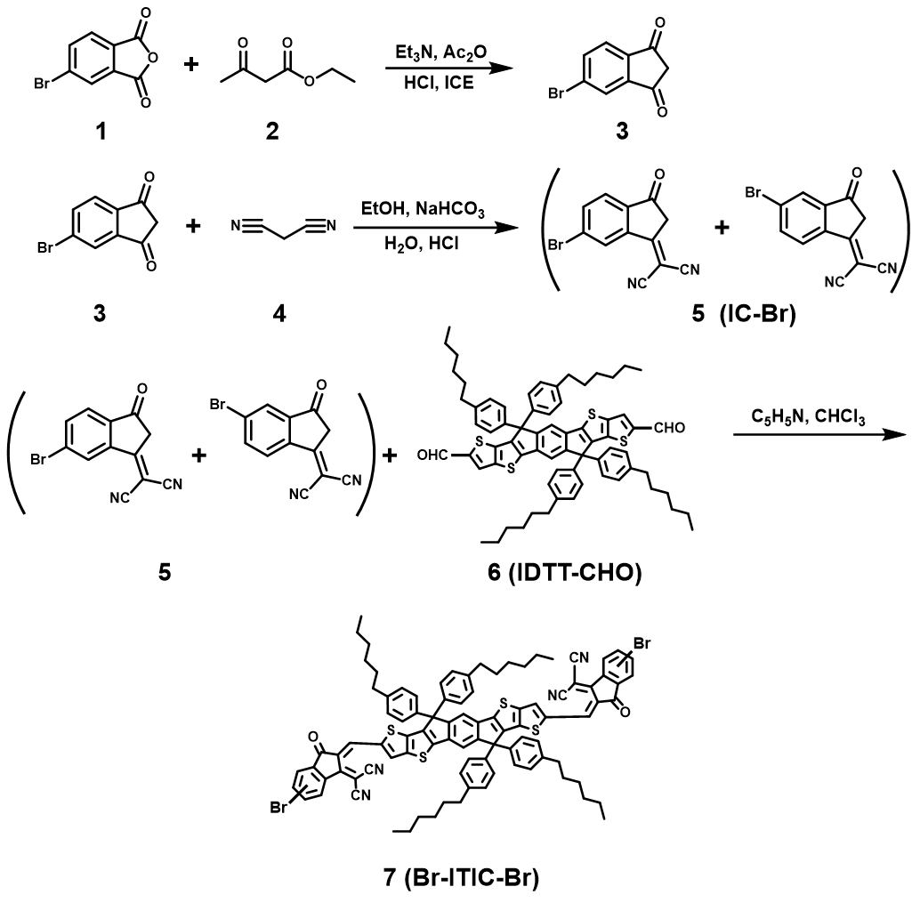
Scheme S1. Synthetic procedures for the IC-Br (isomers containing Br atom at either 5 or 6 positions) and the monomers of Br-ITIC-Br (isomers containing Br atom at either 5 or 6 positions).

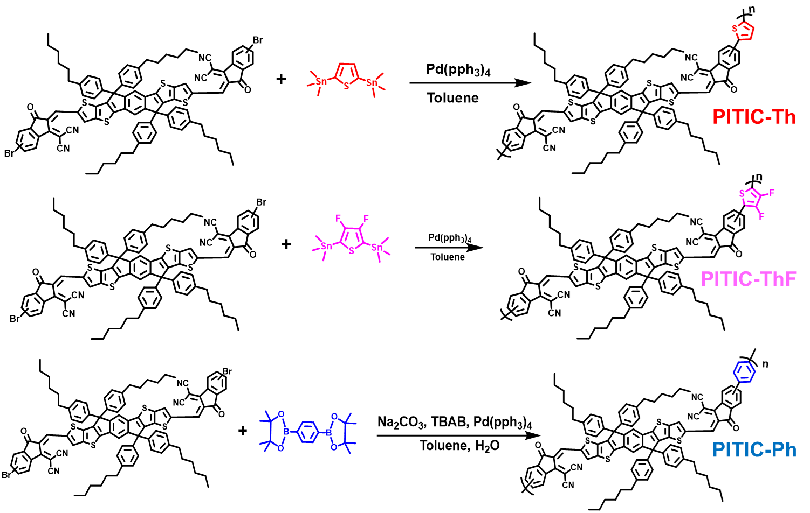
Scheme S2. Synthetic procedures for PITIC-Ph, PITIC-Th, and PITIC-ThF polymers.

Scheme S3. Synthetic procedures for the IC-Br (isomers containing Br atom at either 5 or 6 positions) and the monomers of Br-BTIC-Br (isomers containing Br atom at either 5 or 6 positions).

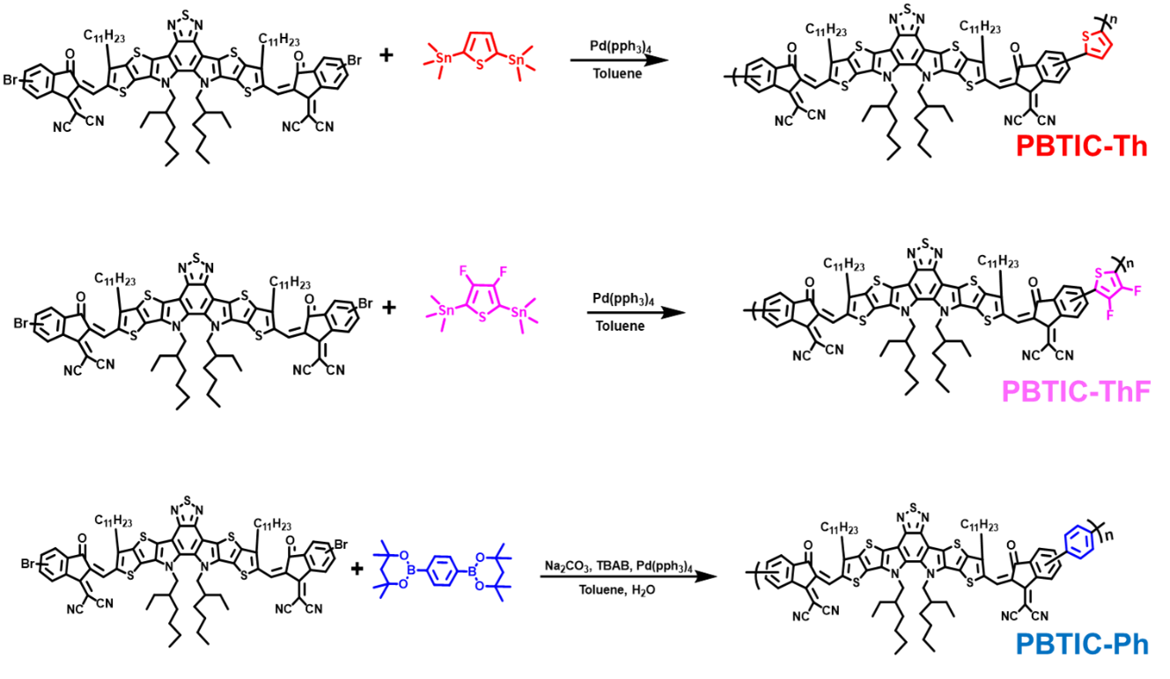
Scheme S4. Synthetic procedures for PBTIC-Ph, PBTIC-Th, and PBTIC-ThF polymers.

Figure S1. ¹H NMR spectrum for 5-bromo-1H-indene-1,3(2H)-dione measured in CDCl₃.

Figure S2. ¹H NMR spectrum for 2-(5(6)-bromo-3-oxo-2,3-dihydro-1H-inden-1-ylidene) malononitrile measured in CDCl₃.

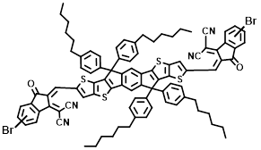
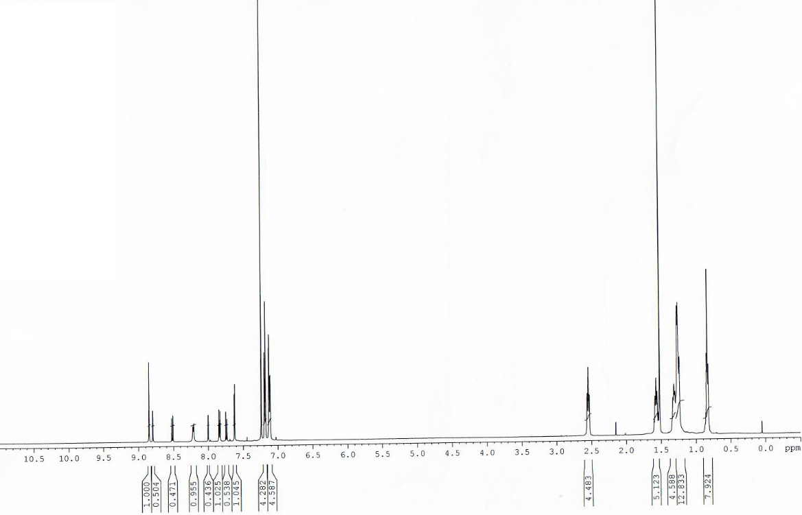
Figure S3. ¹H NMR spectrum for Br-ITIC-Br measured in CDCl₃.

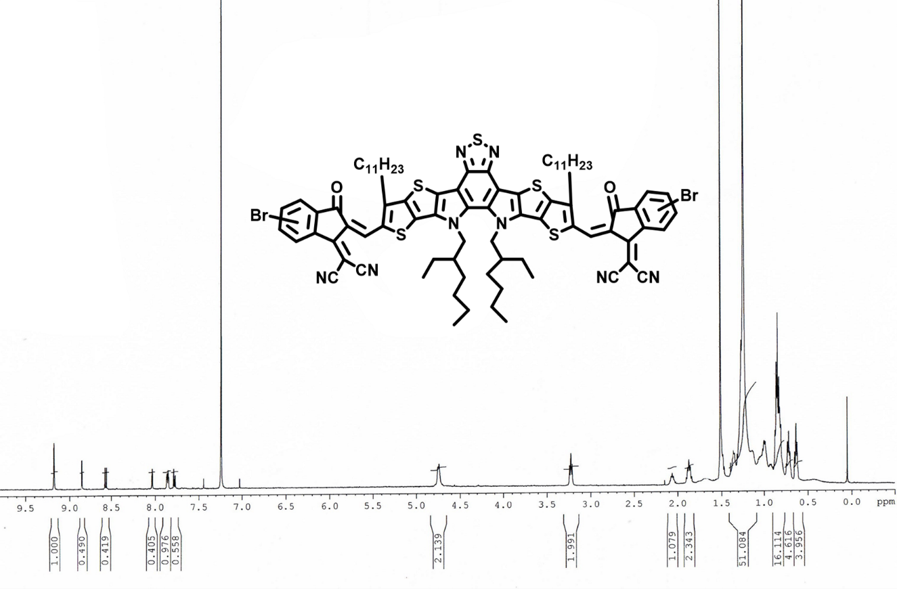
Figure S4. ¹H NMR spectrum for Br-BTIC-Br measured in CDCl₃.

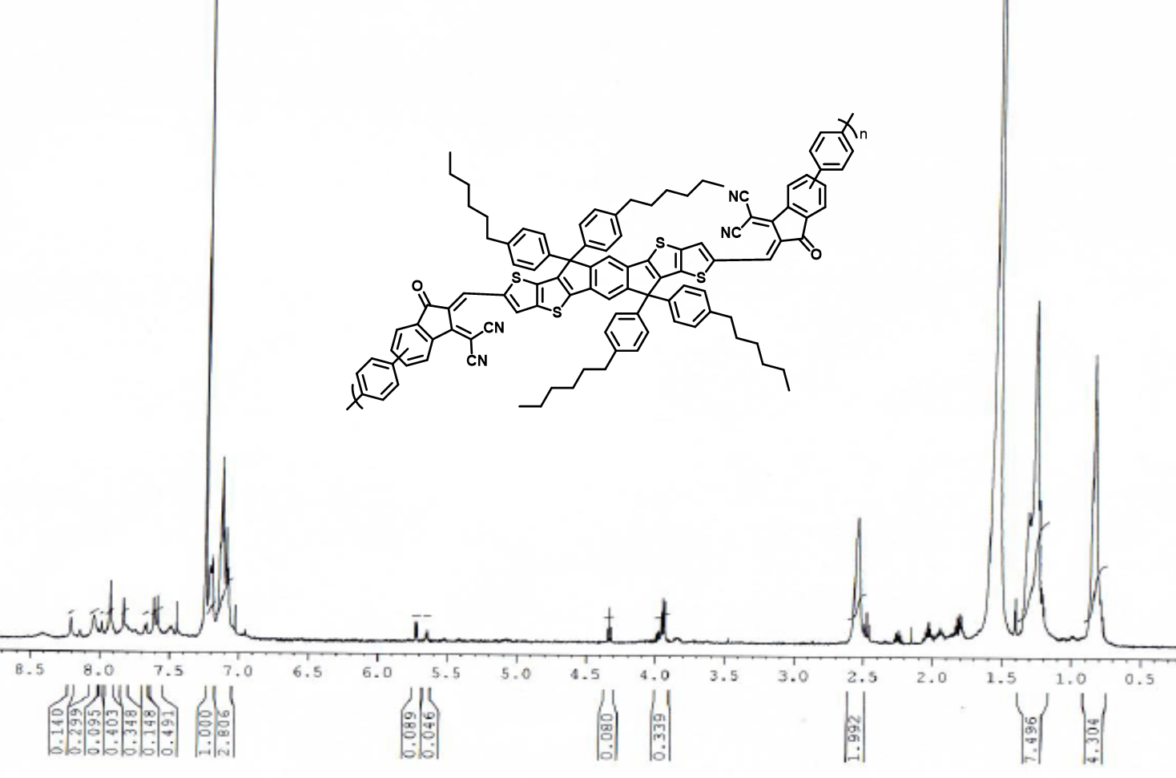
Figure S5. ¹H NMR spectrum of PITIC-Ph in CDCl₃.

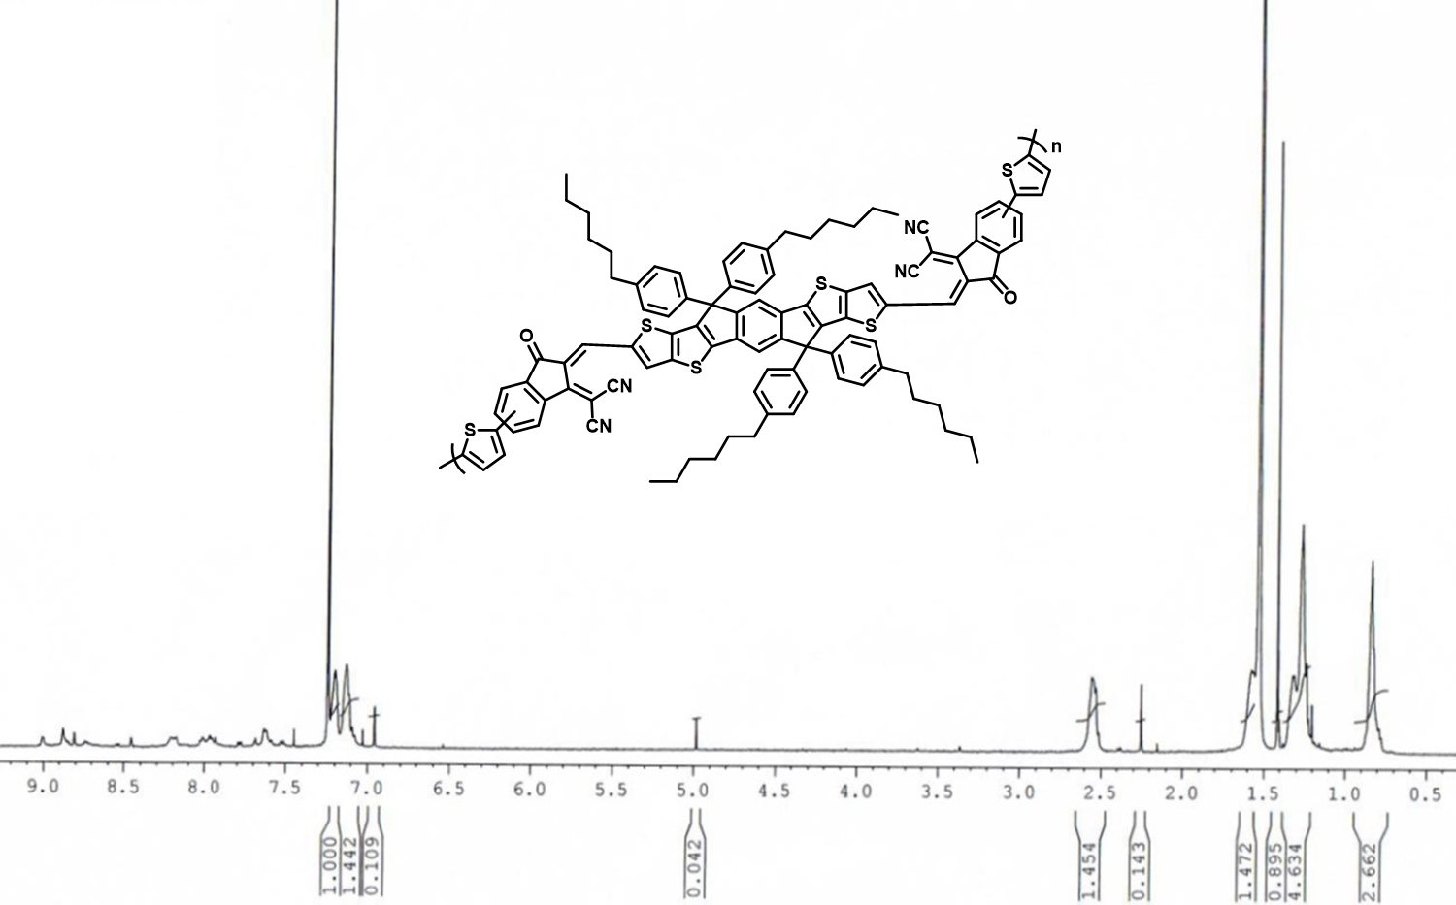
Figure S6. ¹H NMR spectrum of PITIC-Th in CDCl₃.

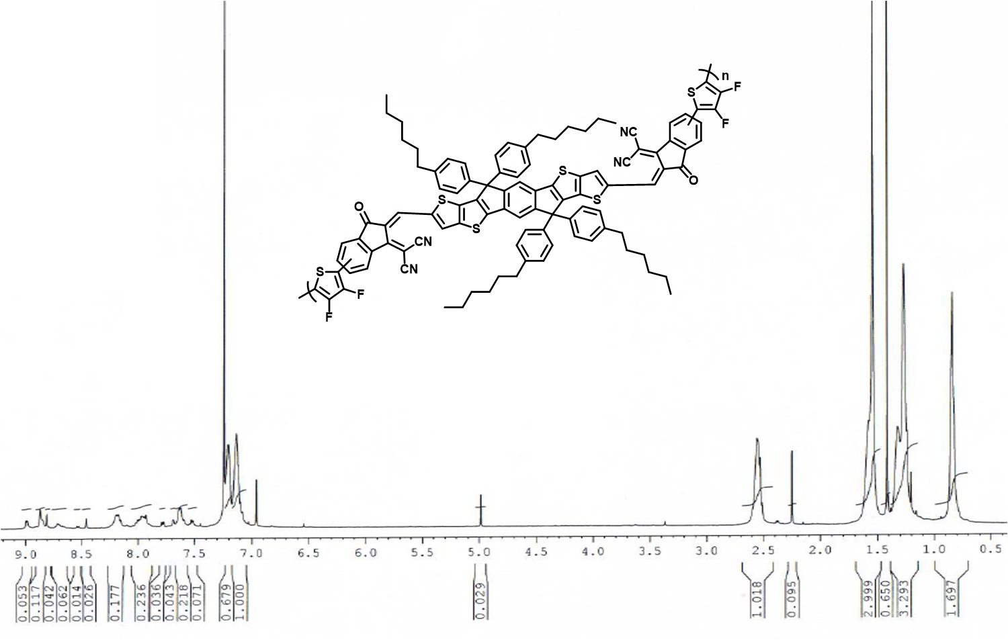
Figure S7. ¹H NMR spectrum of PITIC-ThF in CDCl₃.

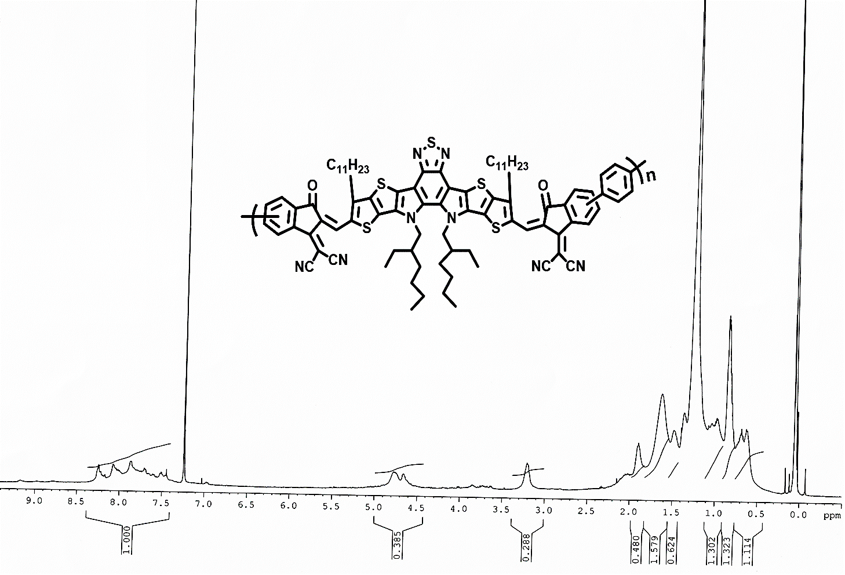
Figure S8. ¹H NMR spectrum of PBTIC-Ph in CDCl₃.

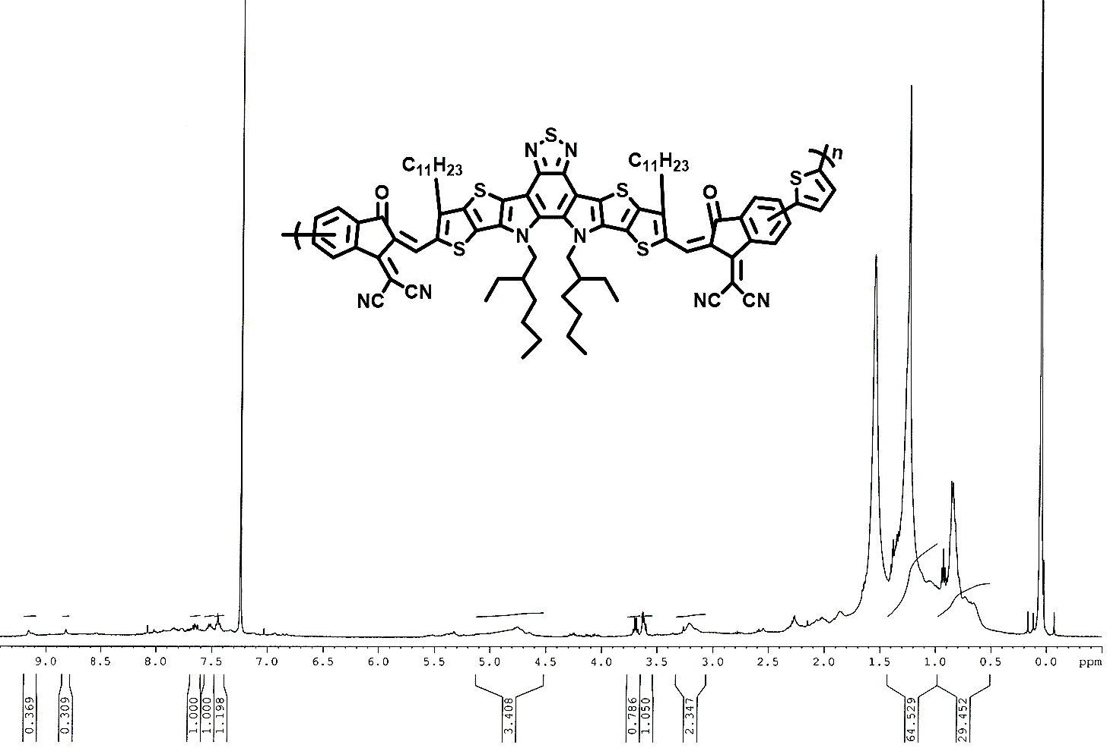
Figure S9. ¹H NMR spectrum of PBTIC-Th in CDCl₃.

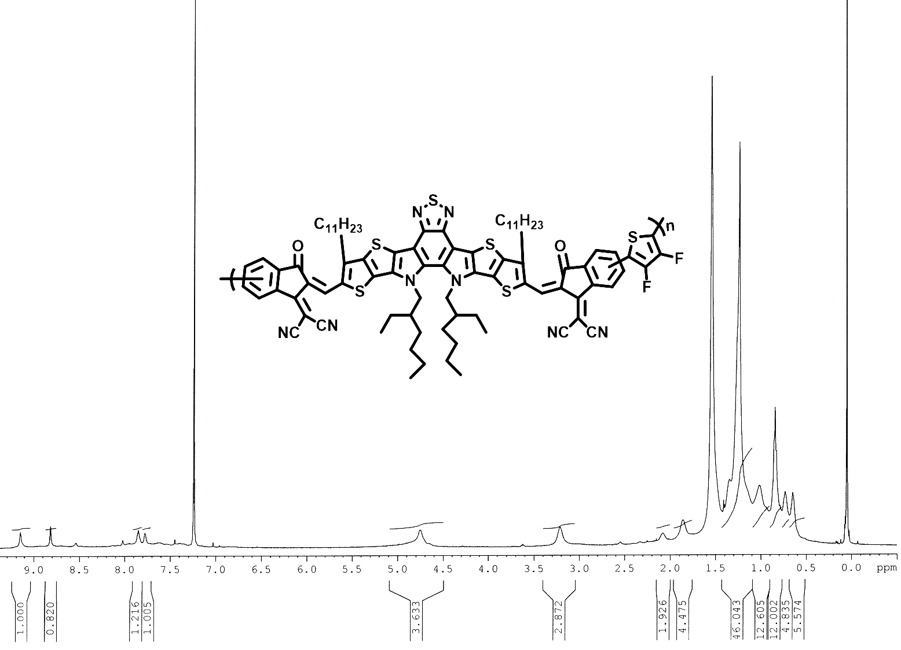
Figure S10. ¹H NMR spectrum of PBTIC-ThF in CDCl₃.

Table S1. Physical properties of polymer dots.
Polymer blends | Absorptivity [L.g⁻¹.cm⁻¹] | Particle sizeª [nm] | T_{d}  (°C)^{b} | Contact angle [°]^{c}
PITIC-Ph | 16.1 | 14.9 | 293.1 | 97.5
PITIC-Th | 4.8 | 12.4 | 297.2 | 95.4
PITIC-ThF | 11.5 | 15.7 | 332.1 | 98.6
PBTP-Ph | 7.5 | 13.7 | 413.3 | 124.7
PBTP-Th | 1.8 | 15.7 | 305.8 | 122.3
PBTP-ThF | 3.1 | 17.9 | 274.5 | 116.5
^{a)} Particle sizes of polymers were determined by DLS methods. ^{b)} The decomposition temperature was determined by Thermogravimetric analysis. ^{c)} Measured contact angles of polymer films with water at RT.

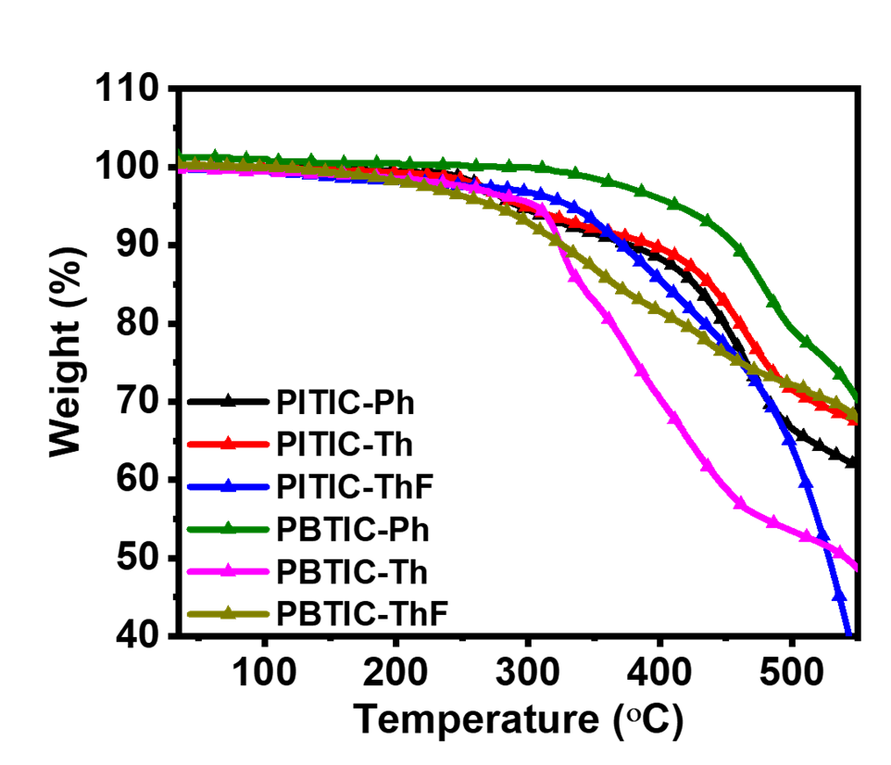
Figure S11. Thermogravimetric analysis for all polymers. The TGA curves show that both PITIC-X- and PBTIC-X-based polymers have good thermal stability, with high decomposition temperatures ranging from 290−413 °C.

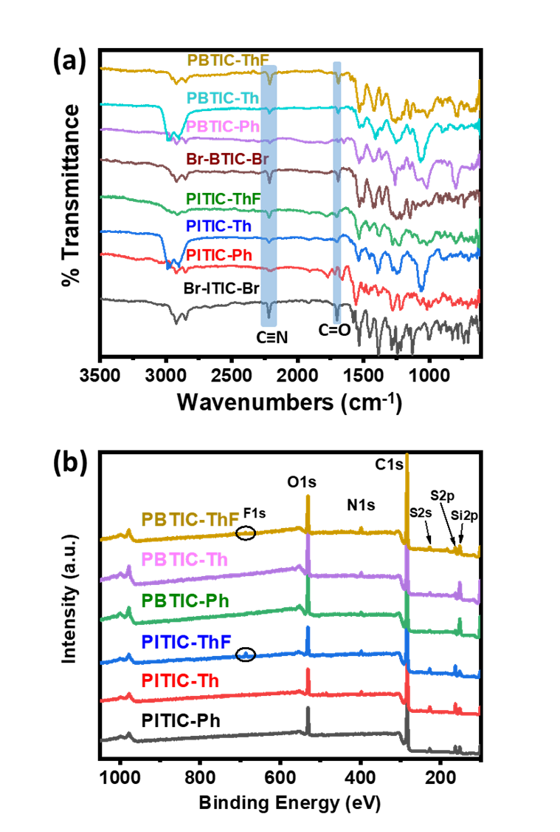
Figure S12: (a) FTIR and (b) XPS data of PITIC-X, and PBTIC-X based polymers and their starting materials. The FTIR results have characteristic absorption peaks at 2,200 cm−1 and 1,700 cm−1, which correspond to the appearance of C≡N and C=O groups, respectively; these are present in all polymers.
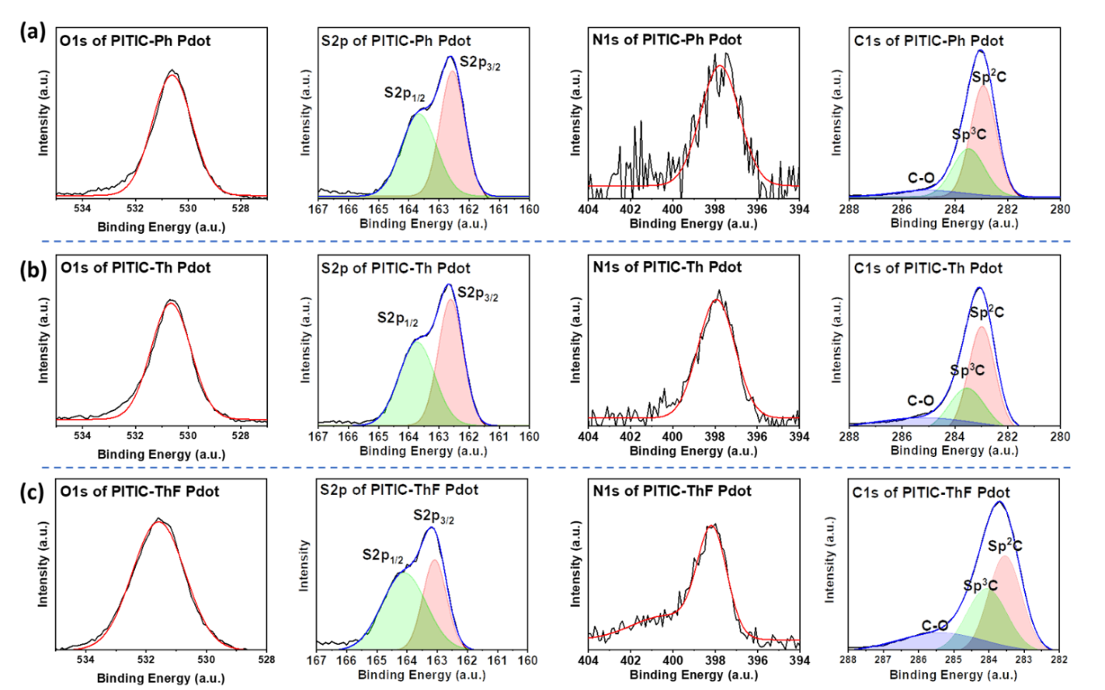

Figure S13: The high-resolution XPS of C1s, O1s, S2p and N1s peaks for (a) PITIC-Ph, (b) PITIC-Th, (c) PITIC-ThF. The surface chemical composition of the polymers was analyzed by XPS methods to investigate the surface electronic structure and bonding configuration.

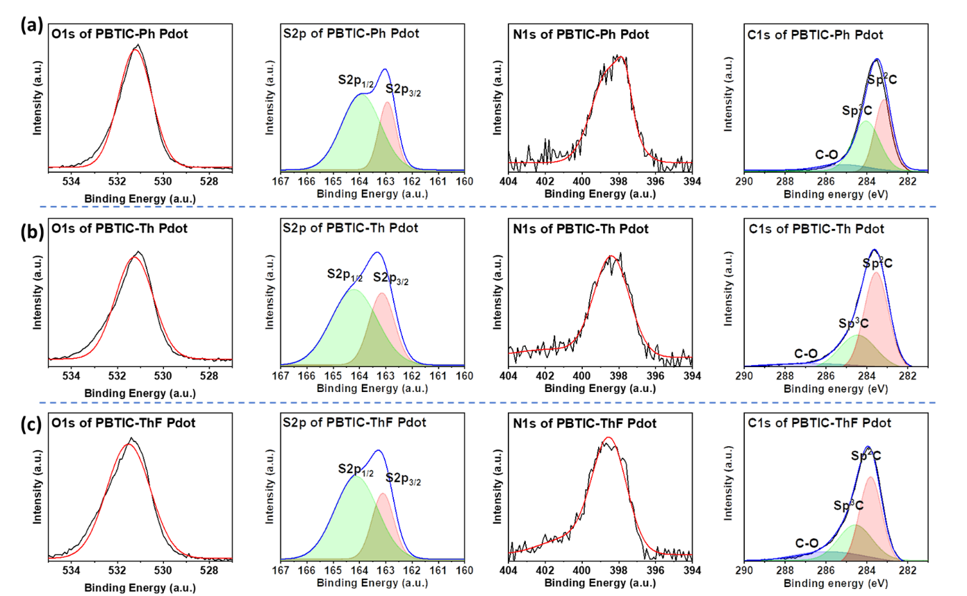

Figure S14: The high-resolution XPS of C1s, O1s, S2p and N1s peaks for (a) PBTIC-Ph, (b) PBTIC-Th, (c) PBTIC-ThF.

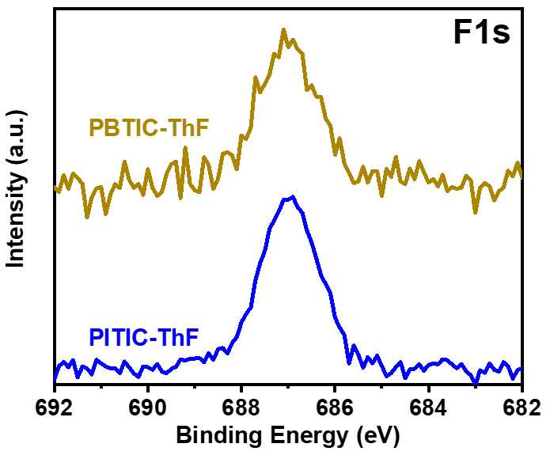
Figure S15: The high-resolution XPS of F1s peak for PBTIC-ThF and PITIC-ThF. The XPS spectra reveal that the major constituent elements in the six polymers are C, N, O, and S, while F is detected only in the PITIC-ThF and PBTIC-ThF polymers. These results indicate the purity of the prepared polymers from any other elements that may originate during the preparation process. Figures S13, S14, and S15 show the high-resolution C 1s, S 2p, N 1s, and O 1s XPS peaks of all six polymers, and Figure S15 shows the high-resolution F 1s XPS peaks for PBTIC-ThF and PITIC-ThF. The C 1s spectra can be deconvoluted into three peaks corresponding to sp² carbon bonding (sp² C), sp³ carbon bonding (sp³ C), and the carbon in C=O bonding. Furthermore, the S 2p spectra of the PITIC-Th(ThF) and PBTIC-Th (ThF) polymers can be deconvoluted into two peaks corresponding to S 2p_{3/2} and S 2p_{1/2}.
Figure S16. Synthesis of Pdot structure.

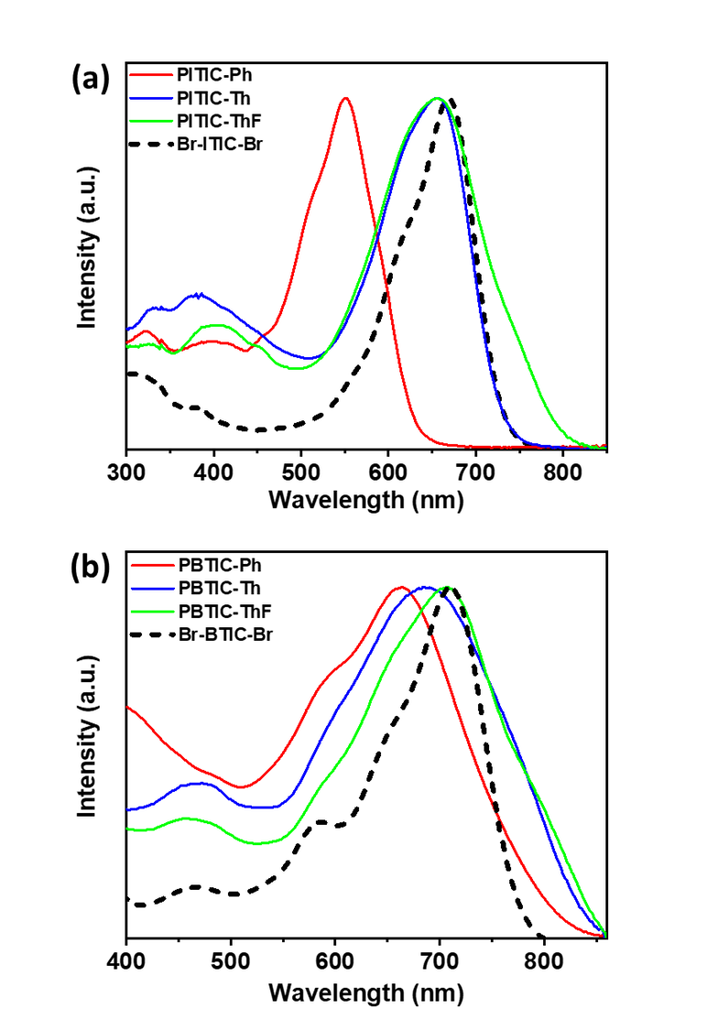
Figure S17: Comparison between the UV-vis absorption of (a) Br-ITIC-Br and (b) Br-BTIC-Br monomers and their polymers with different linkers.
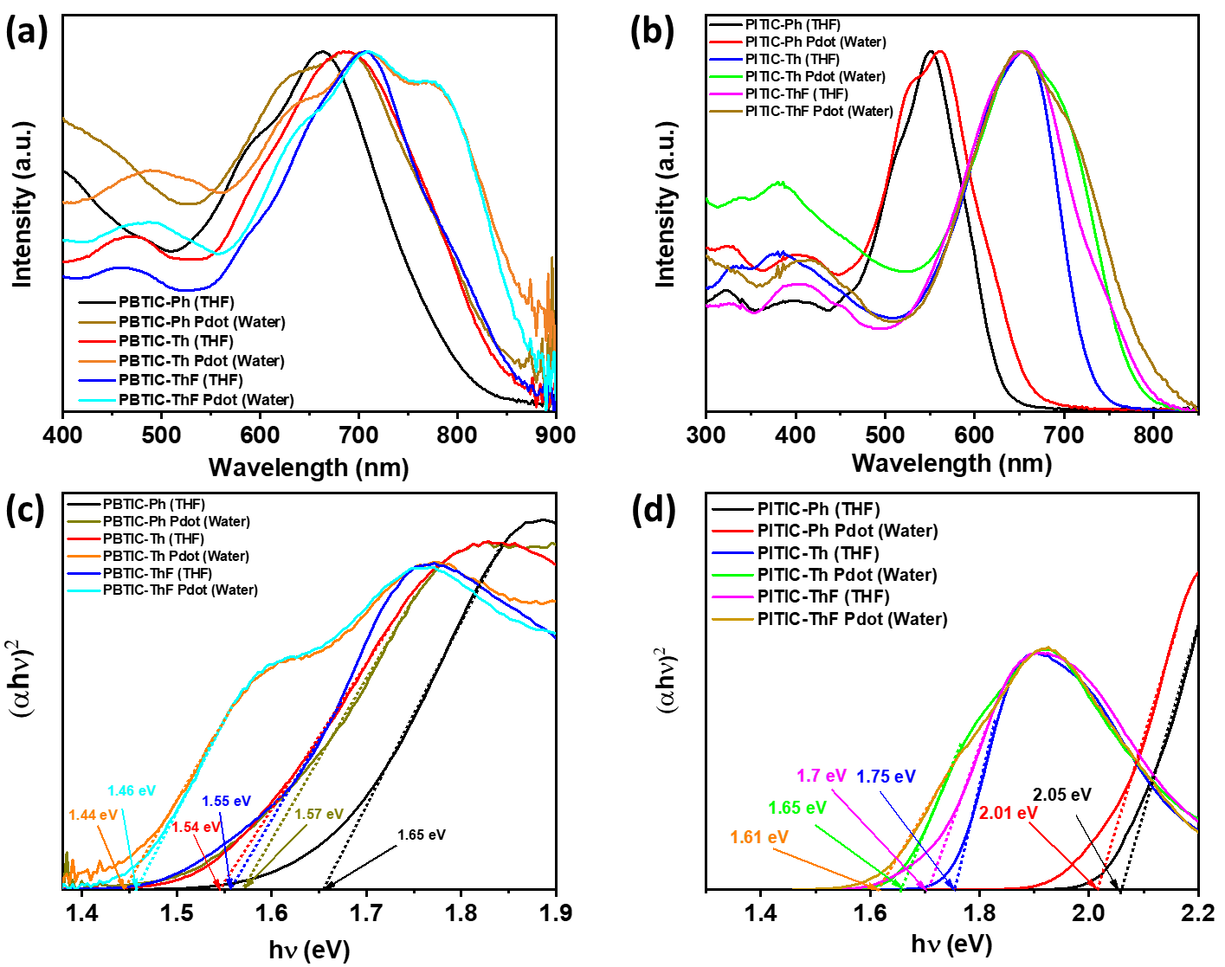
Figure S18: UV-vis absorption spectra of polymers in THF (solid lines) and as Pdot in water solution (dotted lines) for (a) PBTIC-X series and (b) PITIC-X series. The Tauc plot of (αhν)² versus (hν) from the UV-Vis spectra for calculating the bandgap of (c) PBTIC-X series and (d) PITIC-X series. The optical bandgap (E_{g}) of the polymers in THF and Pdots in water are extracted from Tauc plots ((αhν)² versus (hν)) and αhν = A(hν − E_{g})^{1/2} by extrapolation of the linear part of the curve to the energy axis to obtain the optical bandgap.

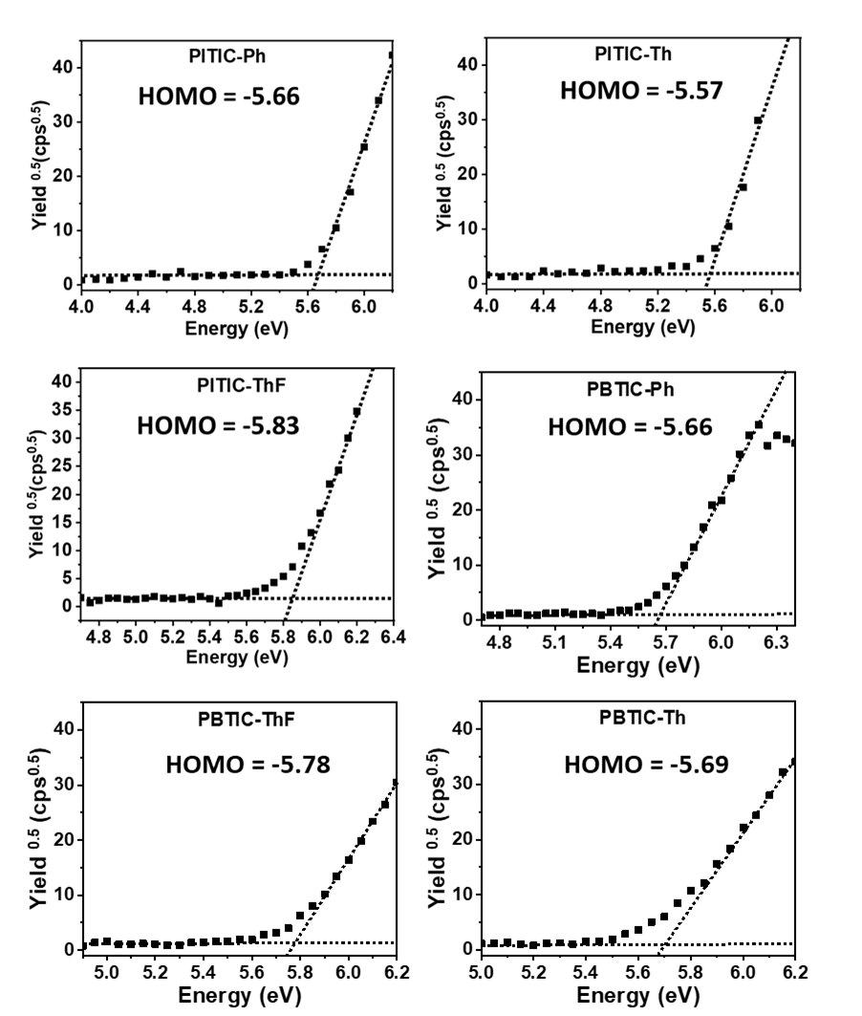
Figure S19: The HOMO levels of six conjugated polymers were determined by a photoelectron spectrometer. The highest occupied molecular orbital (HOMO) energy level of all polymers was determined by photoelectron spectrometry (Figure S19). The energy of the HOMO is subtracted from Eg to obtain the value of the lowest unoccupied molecular orbital (LUMO), and the data are summarized in Table 1.
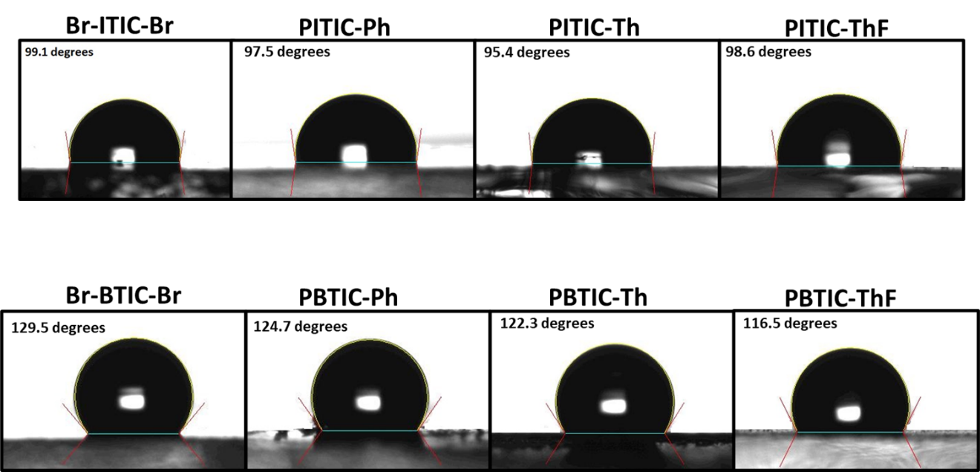

Figure S20. Water contact angles for all polymer materials.

Figure S21. Emission spectra of the light source used in the hydrogen evolution reaction experiment (PAR30 LED lamp, λ > 420 nm, 20 W, 6500 K).

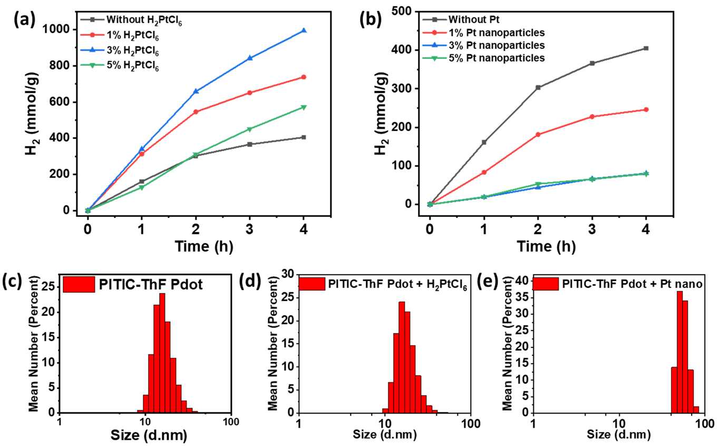
Figure S22. (a) Optimizing the concentration of H₂PtCl₆ during the photocatalytic hydrogen production using PITIC-ThF Pdot. (b) effect of different concentrations of Pt nanoparticles on the HER of PITIC-ThF Pdot. (c), (d), and (e) hydrodynamic diameter spectra of PITIC-ThF Pdot without Pt, in the presence of H₂PtCl₆, and in the presence of Pt nanoparticles, respectively. Two different types of Pt were tested with the PITIC-ThF Pdots: chloroplatinic acid solution (H₂PtCl₆ in water) and platinum nanoparticles (particle size of 3 nm) dispersed in an aqueous solution. H₂PtCl₆ enhances the HER of the PITIC-ThF Pdots, and the optimized amount of H₂PtCl₆ is 3%, as shown in Figure S22a. The Pt nanoparticles decrease the HER of the PITIC-ThF Pdots owing to aggregation (Figure S22b); notably, the particle size of the PITIC-ThF Pdots with the Pt nanoparticles is larger than that with H₂PtCl₆ (Figures S22c, S22d, and S22e).

Table S2: Physical and optical properties of the PITIC-X- and PBTIC-X-based polymers
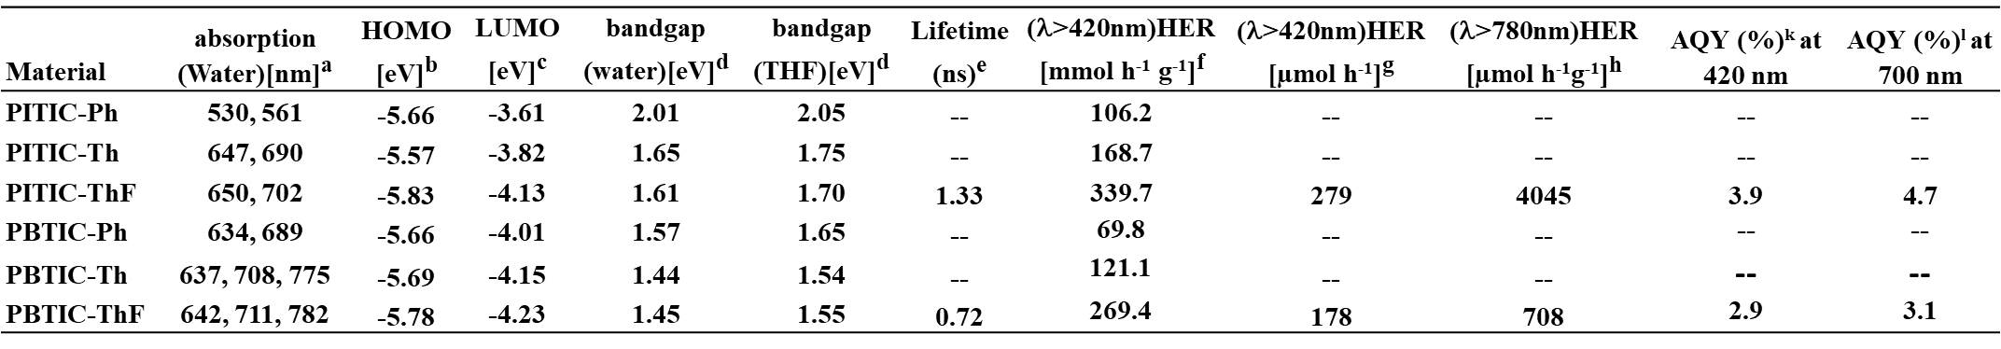
^{a)} Absorption spectra were measured in water solution. ^{b)} Determined by photoelectron spectrometer. ^{c)} Derived by extracting the HOMO level from the optical bandgap. ^{d)} Derived from the Tauc plots. ^{e)} Fluorescence lifetime. ^{f)} Conditions: 10 mL of Pdot solution (containing 0.1 mg of the polymer, 0.1 M AA, and 3% H₂PtCl₆), white LED light (λ >420 nm, 20 W, and 6500 K). ^{g)} Conditions: 50 mL of Pdot solution (containing 5 mg of the polymer, 0.1 M AA, and 3% H₂PtCl₆), white LED light (λ >420 nm, 20 W, and 6500 K). ^{h)} Conditions: 10 mL of Pdot solution (containing 5 mg of the polymer, 0.1 M AA, and 3% H₂PtCl₆), xenon lamp (AM1.5, λ >780 nm, and 3000 W m⁻²). ^{k)} Apparent quantum yield at 420 nm. ^{l)} Apparent quantum yield at 700 nm.

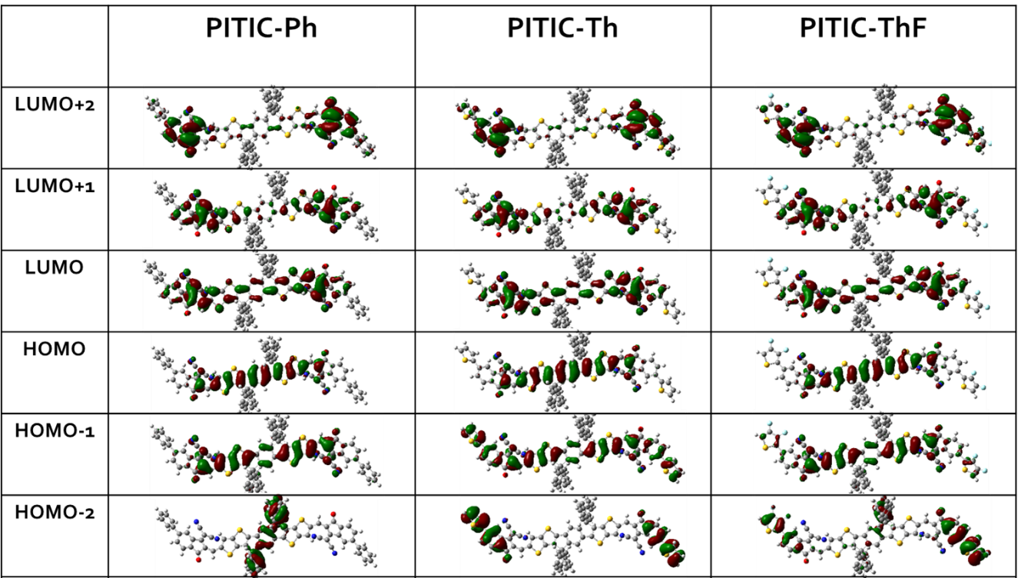

Figure S23. Electron orbital distributions of the molecular orbitals of the PITIC-X based polymers.

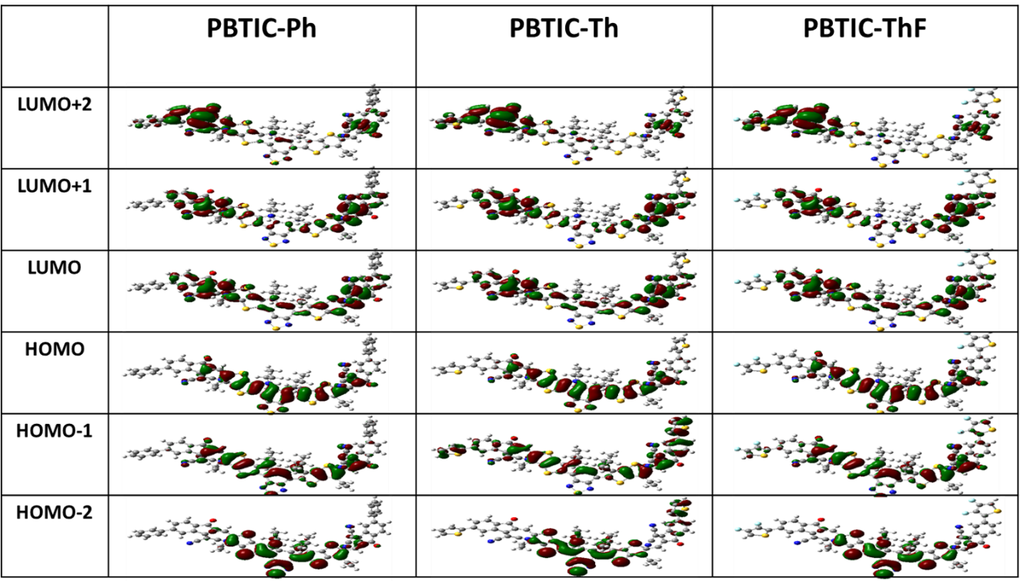

Figure S24. Electron orbital distributions of the molecular orbitals of the PBTIC-X based polymers.

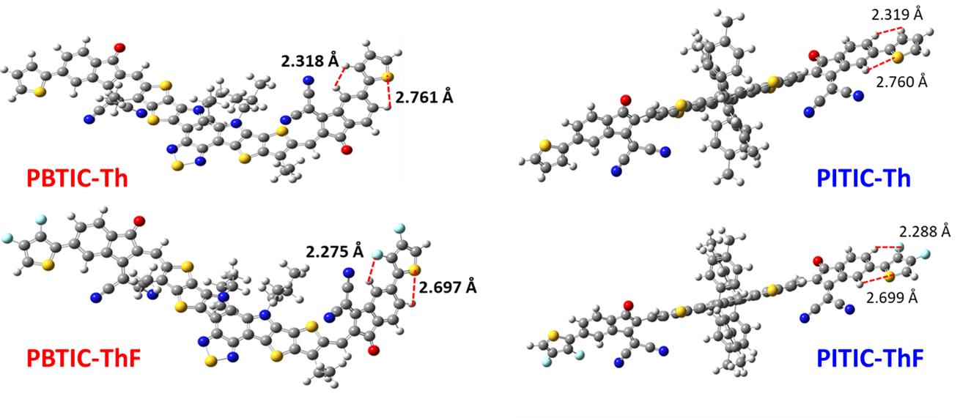

Figure S25. Molecular models of PBTIC-Th, PBTIC-ThF, PITIC-Th, and PITIC-ThF with F−H and S−H bonding distance.

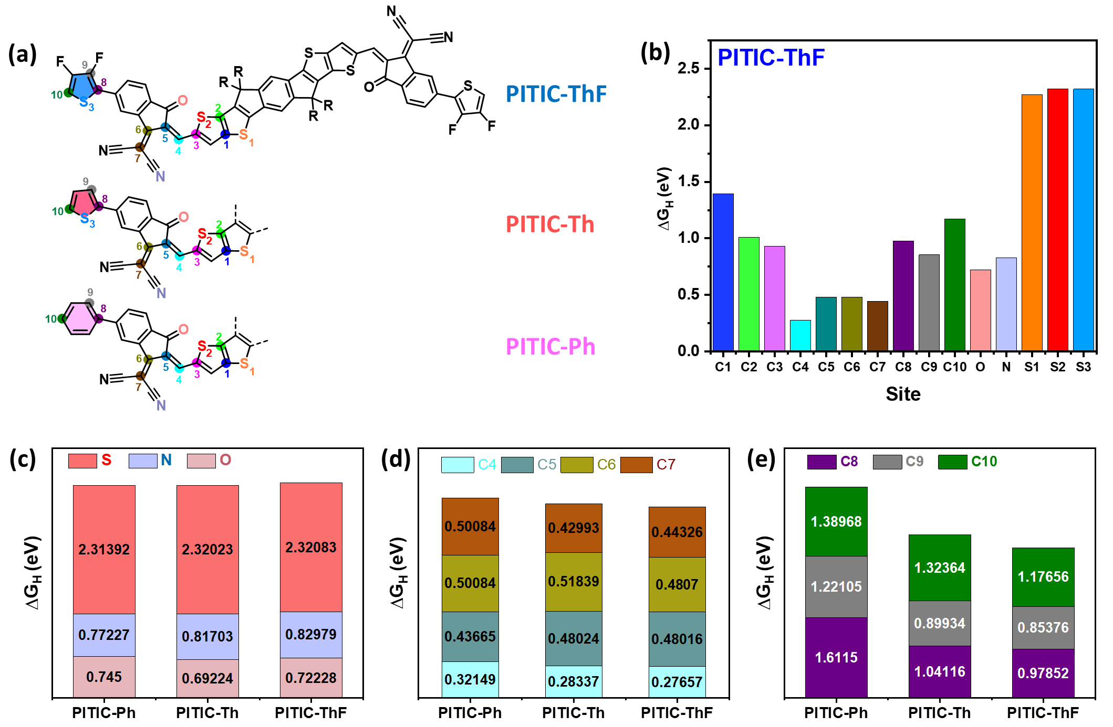
Figure S26. Hydrogen binding free energy (ΔG_{H}) at the different sites of PITIC-X (Ph, Th, and ThF).
Furthermore, the determination of possible active sites for H₂ production could be indication for location of the acceptor and donor parts. We investigated the expected active sites of our designated structure by employing DFT calculations to evaluate the hydrogen binding free energy (ΔG_{H}), which has been recognized as a good descriptor for such cases.¹ To ease the protonation process without high barriers for H₂ formation and release, hydrogen adsorption should be moderate (neither too weak nor too strong) with an optimal value of ΔG_{H} = 0 eV.² The ΔG_{H} of hydrogen adsorption at different C, S, and N sites of the ITIC repeated unit (as a model of the polymers) was computed (Figure S26a). As shown in Figure S26b, the C4-7, O, and N sites of the IC moiety of PITIC-ThF have lower ΔG_{H} values, which indicates the effective role of the IC acceptor part. Most sites in the donor group (C1-3, S1, and S2) show high binding energy compared to the sites of the IC acceptor moiety, indicating that hydrogen has more affinity to adsorb and that the photocatalytic reaction occurs on the IC acceptor moiety. Furthermore, altering the π-linkers between the repeated ITIC moieties (Ph, Th, and ThF) results in nearly the same value of ΔG_{H} at the heteroatom sites (Figure S26c) and C4-7 sites (Figure S26d), while a notable variation in ΔG_{H} is noted at the C8-10 sites of the various π-linker moieties (Figure S26e). Notably, the ΔG_{H} of C8-10 sites is arranged as ITIC-Ph > ITIC-Th > ITIC-ThF. This indicates that the presence of a ThF π-linker in the polymeric structure leads to stronger hydrogen adsorption, which in turn results in more favourable H₂ formation energetics.

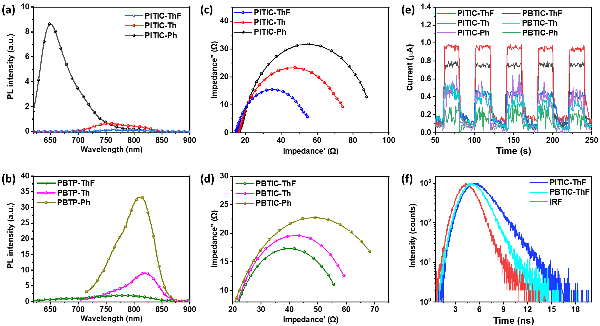
Figure S27: (a) and (b) Photoluminescence emission spectra of PITIC-X and PBTIC-X based Pdots, respectively. (c) and (d) The electrochemical impedance spectroscopy (EIS) of PITIC-X and PBTIC-X based Pdots, respectively. (e) Photocurrent response of presented polymers. The steady-state photoluminescence spectra measurements can explain the charge recombination of the photocatalyst, which strongly affects its photocatalytic activity. Figures S27a and b present the photoluminescence (PL) emission of the polymers, and the results exhibit the strongly quenched PL emission of the ThF- and Th-based polymers compared to the Ph-based polymers, revealing lower charge recombination during the photocatalytic reaction. Figures S27c and d show the electrochemical impedance spectroscopy (EIS) Nyquist plots representing the negative imaginary vs. real parts of the polymer dot impedance of individual electrochemical cells or electrodes. The arc radii of the PITIC-ThF and PBTP-ThF Pdots are smaller than those of the corresponding phenyl- and thiophene-containing comonomers, suggesting a smaller charge resistance in the photocatalytic Pdots. In addition, Figure S27e shows the photoresponse ability of the corresponding samples using the transient photocurrent response, which was collected under visible light irradiation at 1.1 V (vs. Ag/AgCl). The photocurrent-time (I-t) curves for samples were assumed by adopting the switch on-off illumination method. The results show that the PITIC-ThF and PBTIC-ThF Pdots present strong photocurrent responses compared to other Pdots. This is clear evidence that both the PITIC-ThF and PITIC-Th Pdots have the highest photocurrent density, suggesting that they also have the highest charge separation efficiency, which leads to their high photocatalytic performance. Moreover, the time-resolved fluorescence decay spectra of the PITIC-X-based polymers present a longer excited state fluorescent lifetime than that of the PBTIC-X-based polymers (Figure S27f and Table S2). As a result, the recombination rate of the photogenerated electron-hole pairs with PITIC-X polymers will be slower than that of the PBTIC-X-based polymers, which is favorable for more electron transfer to the cocatalyst for the proceeding reduction reaction.

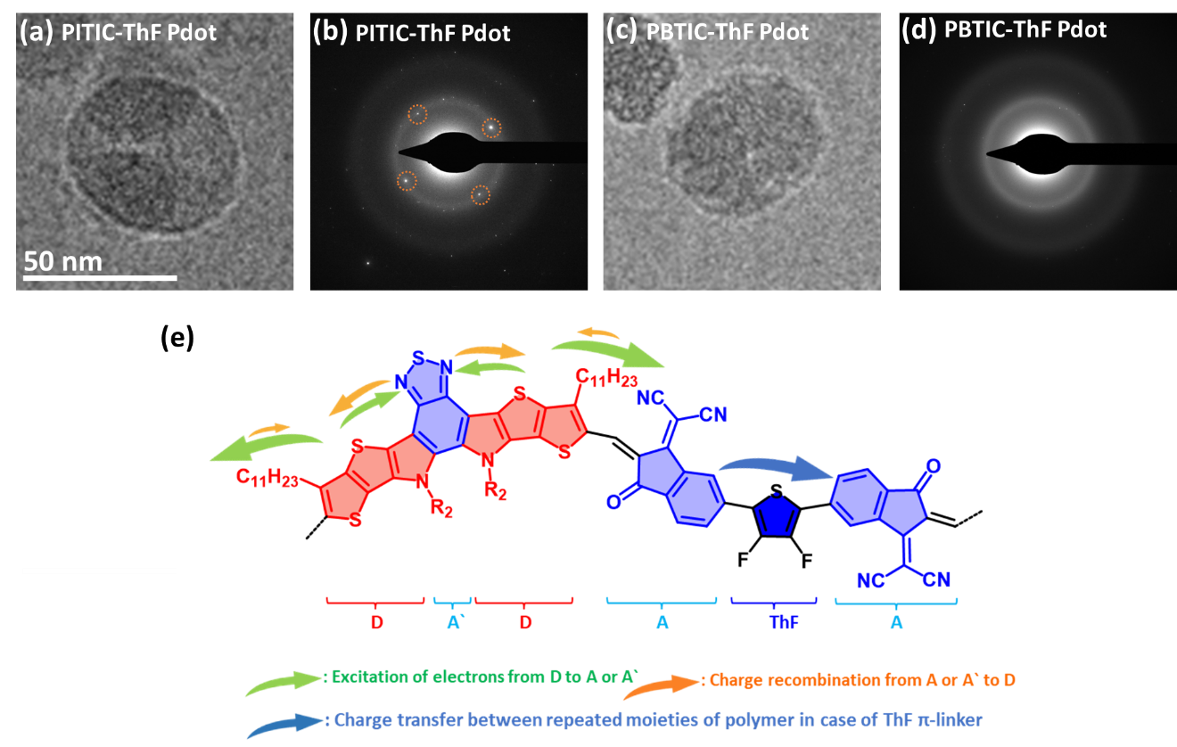
Figure S28: (a) Cryo-TEM micrograph, and (b) cryo-electron diffraction of the PITIC-ThF Pdots. (c) Cryo-TEM micrograph, and (d) cryo-electron diffraction of the PBTIC-ThF Pdots. (e) Schematic diagram showing the charge transfer through the PBTIC-ThF polymer chain during the photocatalytic reaction. The high-magnification cryo-TEM images clearly show spherical particles with lattice fringes in the PITIC-ThF Pdot image (Figure S28a), which distinguishes the PITIC-ThF Pdots from the PBTIC-ThF Pdots (Figure S28c) in terms of crystallinity. The cryo-electron diffraction (Cryo-ED) of the PITIC-ThF Pdots (Figure S28b) displays clear bright spots compared to the PBTIC-ThF Pdots (Figure S28d), denoting that the PITIC-ThF Pdots have better natural crystallinity than the PBTIC-ThF Pdots, which facilitates charge transfer between the PITIC-ThF Pdots and Pt cocatalyst and increases the final yield of the photocatalytic reaction.³ Furthermore, the structure design of BTIC moiety (A-DA`D-A) contains A` between the two D, which enables the photo-excited electrons to distribute between the A and A` then the charge recombination occurs easily from the A` to D (Figure S28e). Consequently, all ITIC-based polymers outperform the BTIC-based polymers in terms of their photocatalytic efficiency for H₂ evolution.

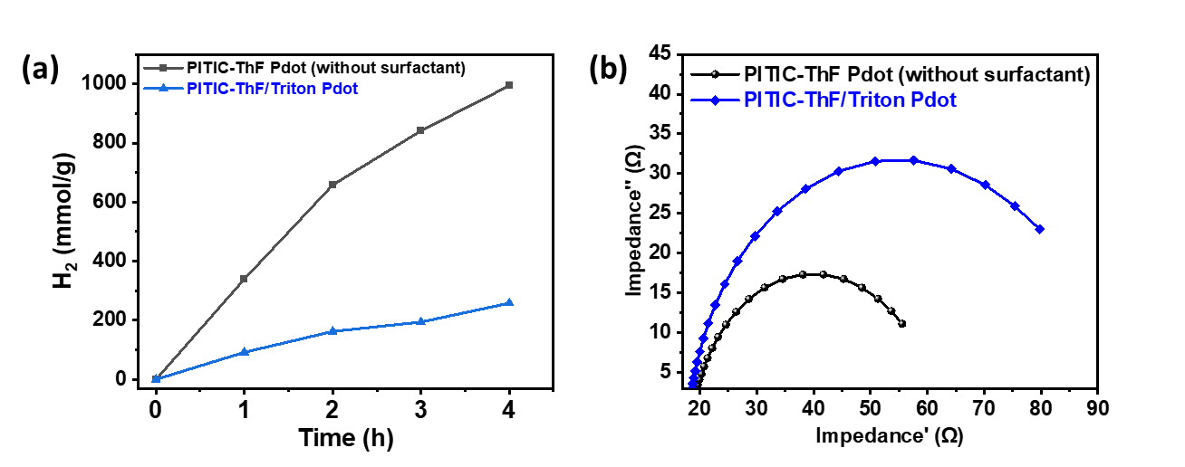
Figure S29. (a) Effect of Triton surfactant on the photocatalytic hydrogen production activity of the PITIC-ThF Pdots. (b) Electrochemical impedance spectroscopy (EIS) of the PITIC-ThF Pdots (with and without Triton surfactant).

Table S3. H₂ generation activities of some known organic conjugated polymers- and Pdots-based photocatalysts.
Polymerª | Conditions | HER λ >420 nm  (mmol h⁻¹ g⁻¹) | AQY %  (λ = 420, 500, 550, 600, 700 nm) | References
PFBT-Pdots | 0.2M AA solution | 8.3 | 0.5, -, -, -,- | ⁴
PFODTBT Pdot | 0.2M AA solution | 50.0 | 0.9, 0.3, 0.6, 0.3, - | ⁵
PFTFQ-PtPy15 | Water/ 20 vol% TEA | 12.7 | 0.0, 0.4, 0.0, 0.0, - | ⁶
F8T2 Pdots/g-C3N4 | Water/10 vol% TEOA | 0.93 | 5.7, 2.8, 0.8, 0.0, - | ⁷
HE-CP10-Dots | 0.18 M AA solution | 0.84 | 0.0, 0.9, 0.0, 0.0, - | ⁸
F8DTBT Pdots/CNNS | Water/ 10 vol% TEOA | 0.181 | 3.4, 0.4, 0.2, 0.5, - | ⁹
PFN-Br | Water/ TEOA | 0.68 | none | ¹⁰
PBDTBT-7EO (3.0 wt% Pt) | 0.2M AA solution | -- | 0.13, 0.14, 0.25, 0.30, - | ¹¹
PFTBTA-PtPy | Water/ 20 vol% TEA | 7.34 | 0.5, 0.0,  0.0, 0.0, - | ¹²
PFNBTBr Pdots/CNNS | Water/ TEOA (10%) | 1.2 | 7.71, 2.5,  2.0, 0.0, - | ¹³
PTB7-Th/EH-IDTBR Pdot | 0.2M AA solution | 28.13 | 2.0, 2.3, 4.3 (620 nm), 5.6 (660 nm), 6.2 | ¹⁴
PyDTDO-3 (w/o Pt) | 1.0 M AA solution / 10 vol% DMF | 16.32 | 3.70, 3.68, 3.93, 2.30, - | ¹⁵
PS-PEG5-FNP | 0.2M AA solution | 37.2 | 2.5, 0.0, 0.0, 0.0, - | ¹⁶
PyBS-3 | 0.2M AA solution | 100.1 | 29.3, -, -, -,- | ¹⁷
PBDTTS-1SO | 0.1M AA solution | 97.12 | 13.5, 16.7, 18.5, 9.8, - | ¹⁸
PITIC-ThF Pdot  PBTIC-ThF Pdot | 0.1M AA solution | 339.7  269.4 | (3.9, 3.2, 3.1, 3.9, 4.7)  (2.9, 2.7, 2.5, 2.8, 3.1) | This work  This work

References
1. Pati PB, et al. An experimental and theoretical study of an efficient polymer nano-photocatalyst for hydrogen evolution. Energy Environ. Sci. 10, 1372-1376 (2017).

2. Li H, et al. Activating and optimizing MoS₂ basal planes for hydrogen evolution through the formation of strained sulphur vacancies. Nat. Mater. 15, 48-53 (2016).

3. Liu A, et al. Panchromatic Ternary Polymer Dots Involving Sub-Picosecond Energy and Charge Transfer for Efficient and Stable Photocatalytic Hydrogen Evolution. J. Am. Chem. Soc. 143, 2875-2885 (2021).

4. Wang L, et al. Organic Polymer Dots as Photocatalysts for Visible Light-Driven Hydrogen Generation. Angew. Chem.-Int. Edit. 55, 12306-12310 (2016).

5. Pati PB, et al. An experimental and theoretical study of an efficient polymer nano-photocatalyst for hydrogen evolution. Energy Environ. Sci. 10, 1372-1376 (2017).

6. Tseng P-J, et al. Design and Synthesis of Cycloplatinated Polymer Dots as Photocatalysts for Visible-Light-Driven Hydrogen Evolution. ACS Catal. 8, 7766-7772 (2018).

7. Zhou W, Jia T, Shi H, Yu D, Hong W, Chen X. Conjugated polymer dots/graphitic carbon nitride nanosheet heterojunctions for metal-free hydrogen evolution photocatalysis. J. Mater. Chem. A 7, 303-311 (2019).

8. Zhao P, et al. Hyperbranched Conjugated Polymer Dots: The Enhanced Photocatalytic Activity for Visible Light-Driven Hydrogen Production. Macromolecules 52, 4376-4384 (2019).

9. Zhou W, Jia T, Zhang D, Zheng Z, Hong W, Chen X. The enhanced co-catalyst free photocatalytic hydrogen evolution and stability based on indenofluorene-containing donor-acceptor conjugated polymer dots/g-C3N4 nanosheets heterojunction. Appl. Catal. B-Environ. 259, 118067 (2019).

10. Hu Z, et al. Highly efficient photocatalytic hydrogen evolution from water-soluble conjugated polyelectrolytes. Nano Energy 60, 775-783 (2019).

11. Hu Z, et al. Conjugated Polymers with Oligoethylene Glycol Side Chains for Improved Photocatalytic Hydrogen Evolution. iScience 13, 33-42 (2019).

12. Chang C-L, et al. Low-toxic cycloplatinated polymer dots with rational design of acceptor co-monomers for enhanced photocatalytic efficiency and stability. Appl. Catal. B-Environ. 268, 118436 (2020).

13. Zhou W, Hu ZC, Huang F, Hong W, Chen XD. Metal-free hydrophilic D-A conjugated polyelectrolyte dots/g-C3N4 nanosheets heterojunction for efficient and irradiation-stable water-splitting photocatalysis. Appl. Catal. B-Environ. 270, 118852 (2020).

14. Kosco J, et al. Enhanced photocatalytic hydrogen evolution from organic semiconductor heterojunction nanoparticles. Nat. Mater. 19, 559-565 (2020).

15. Han C, et al. Realizing high hydrogen evolution activity under visible light using narrow band gap organic photocatalysts. Chem. Sci. 12, 1796-1802 (2021).

16. Yu M, Zhang W, Guo Z, Wu Y, Zhu W. Engineering Nanoparticulate Organic Photocatalysts via a Scalable Flash Nanoprecipitation Process for Efficient Hydrogen Production. Angew. Chem.-Int. Edit. 60, 15590-15597 (2021).

17. Shu C, et al. Boosting the Photocatalytic Hydrogen Evolution Activity for D-pi-A Conjugated Microporous Polymers by Statistical Copolymerization. Adv. Mater. 33, e2008498 (2021).

18. Lin W-C, et al. Sulfide oxidation tuning in 4,8-bis(5-(2-ethylhexyl)thiophen-2-yl)benzo[1,2-b:4,5-b′]dithiophene based dual acceptor copolymers for highly efficient photocatalytic hydrogen evolution. J. Mater. Chem. A 10, 6641-6648 (2022).

