Table 1: Clinical features in children in derivation cohort
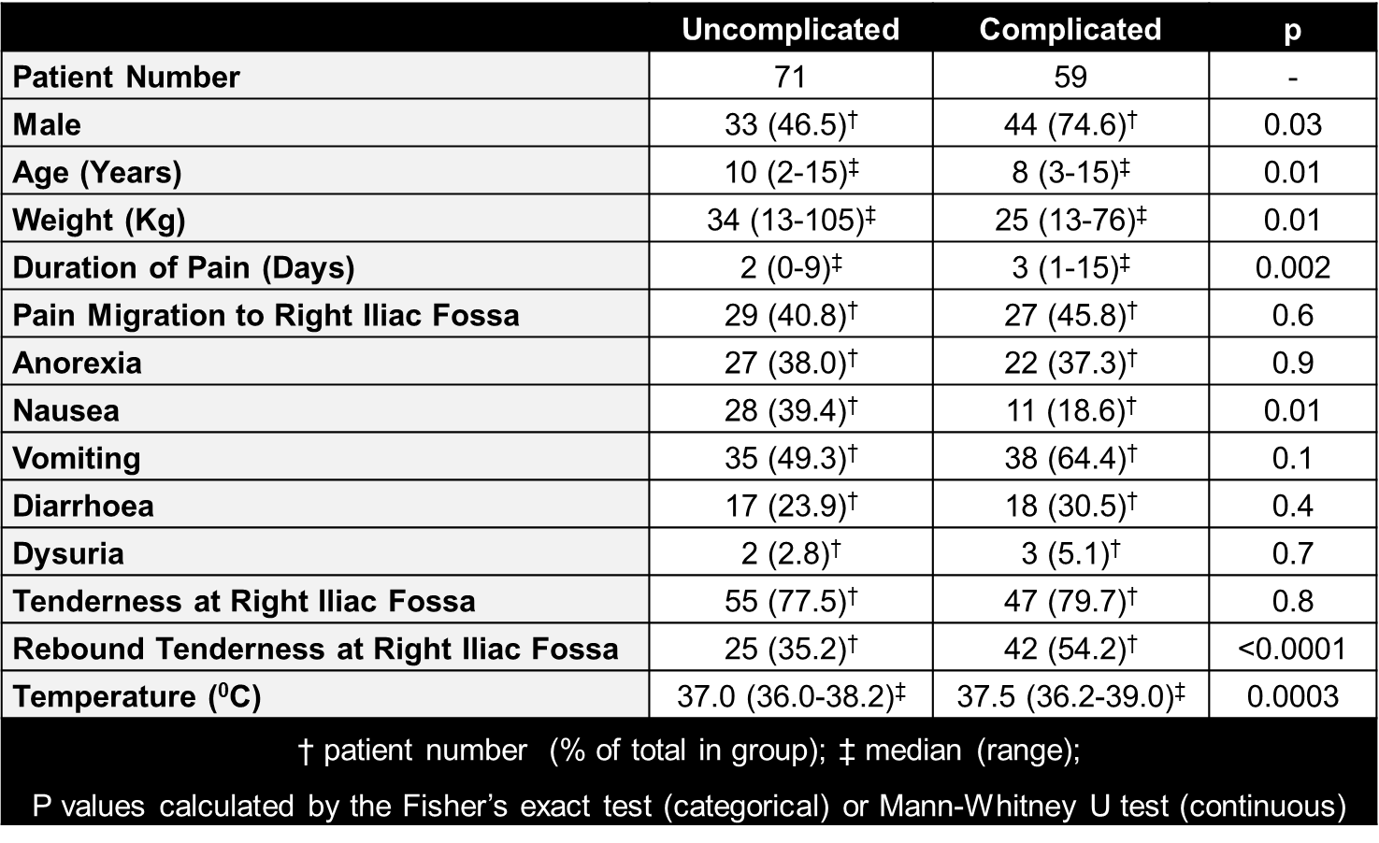

Table 2: Laboratory parameters in children in derivation cohort

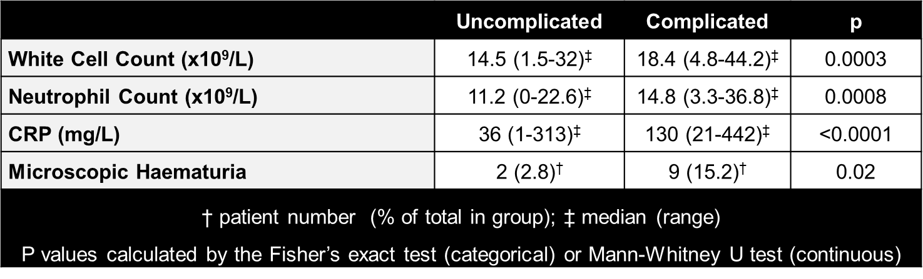

Table 3: Logistic regression analysis to derive score
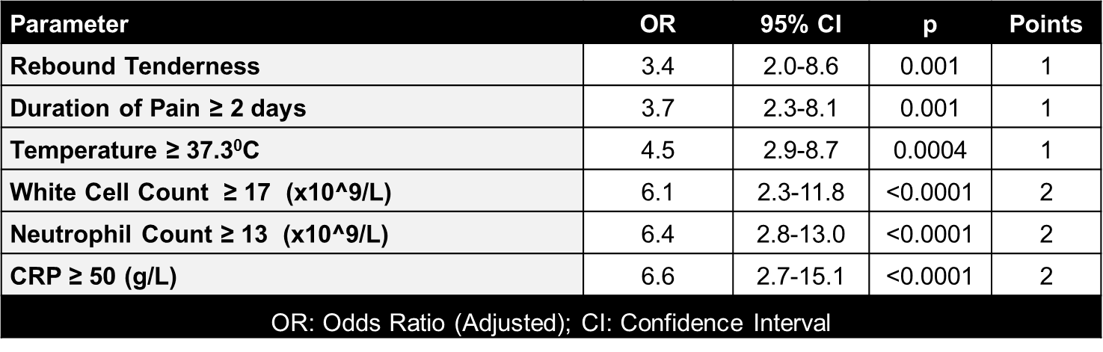

Table 5 Internal validation in derivation cohort prior to optimisation
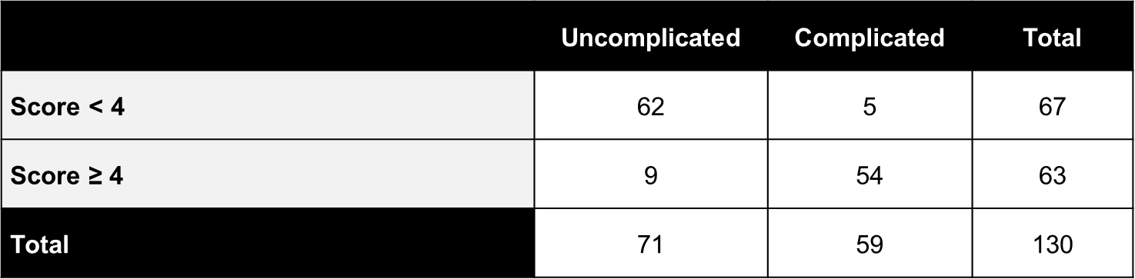

Table 6 – Revised score after optimisation
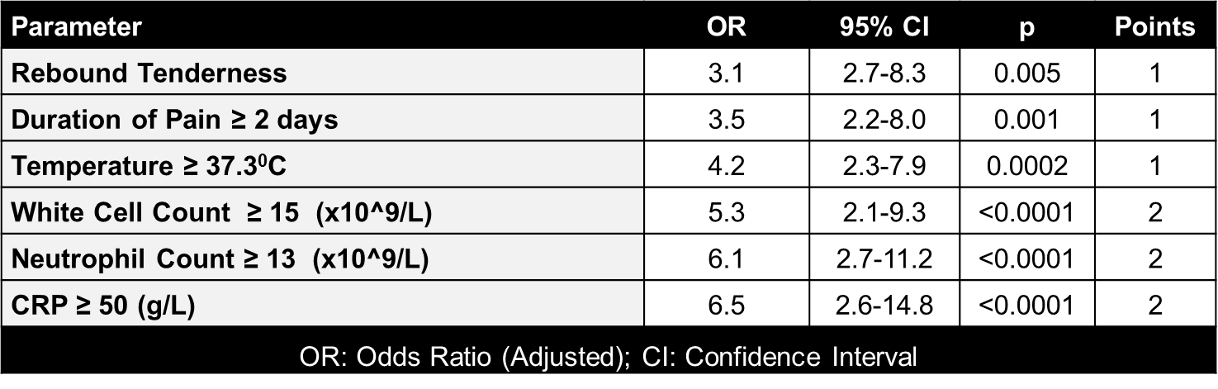

Table 7 – Internal validation in derivation cohort after score optimisation
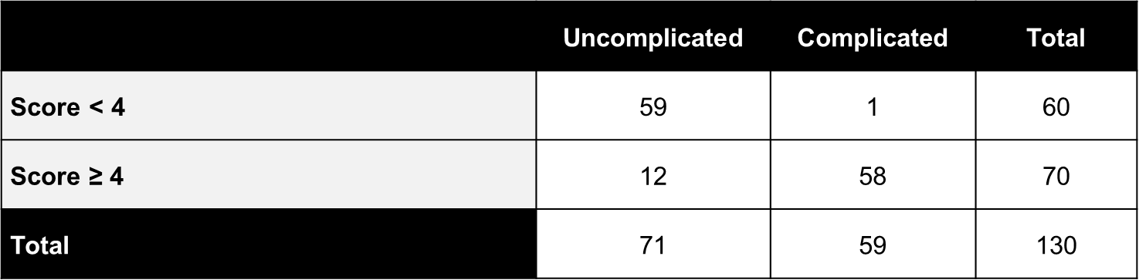

Table 8 – Score performance in validation cohort
