Additional File 1

Table S1. Vector-competent ticks for the four tick-borne pathogens covered in the ecological analysis.
 | Anaplasma marginale | Ehrlichia ruminantium | Babesia bigemina | Babesia  bovis
Tick species
Amblyomma gemma |  | X
Amblyomma variegatum |  | X
Hyalomma rufipes | X
Rhipicephalus decoloratus | X |  | X
Rhipicephalus pulchellus | X
Rhipicephalus microplus | X |  | X | X
Rhipicephalus evertsi evertsi | X
Rhipicephalus annulatus | X |  | X | X
Rhipicephalus geigyi
Rhipicephalus appendiculatus
Hyalomma truncatum
Rhipicephalus lunulatus
Rhipicephalus praetextatus
Note:
X: considered to be vector-competent.
‘’: other tick species frequently collected, and tested for potential associations with pathogen prevalence (see ‘Statistical Analysis’)

Table S2. Distribution of (co-)infections in cattle individuals.
Co-infection | Overall | Burkina Faso | Benin | Ethiopia | Ghana | Nigeria | Tanzania | Uganda
A. marginale | 60.77 | 86.45 | 46.76 | 59.60 | 62.93 | 52.05 | 56.39 | 74.80
A. marginale x B. bigemina | 11.19 | 1.08 | 16.41 | 6.78 | 17.41 | 9.36 | 14.81 | 2.56
B. bigemina | 8.46 | 0.86 | 7.70 | 14.55 | 0.53 | 23.59 | 9.51 | 6.10
A. marginale x E. ruminantium | 4.98 | 2.37 | 8.71 | 6.36 | 7.37 | 2.34 | 2.45 | 0.79
A. marginale x B. bovis | 2.98 | 1.29 | 2.57 | 0.00 | 7.05 | 0.78 | 5.03 | 1.18
A. marginale x A. centrale | 2.27 | 0.65 | 2.01 | 3.67 | 0.11 | 5.46 | 3.80 | 0.79
A. marginale x B. bigemina x E. ruminantium | 1.74 | 0.00 | 4.24 | 0.85 | 2.24 | 0.78 | 1.77 | 0.20
E. ruminantium | 1.68 | 4.09 | 1.56 | 3.11 | 0.11 | 2.14 | 0.14 | 2.36
B. bigemina x E. ruminantium | 1.28 | 0.00 | 2.68 | 3.11 | 0.00 | 1.95 | 0.54 | 0.20
B. bovis | 1.11 | 2.37 | 1.23 | 0.00 | 0.32 | 0.00 | 0.68 | 4.53
A. marginale x B. bigemina x B. bovis | 0.78 | 0.00 | 1.56 | 0.00 | 0.85 | 0.00 | 2.04 | 0.00
A. marginale x B. bovis x E. ruminantium | 0.50 | 0.22 | 1.23 | 0.00 | 0.85 | 0.00 | 0.41 | 0.20
A. marginale x A. centrale x B. bigemina | 0.48 | 0.00 | 1.23 | 0.71 | 0.00 | 0.78 | 0.41 | 0.00
T. parva | 0.46 | 0.00 | 0.00 | 0.00 | 0.00 | 0.00 | 0.00 | 4.33
B. bigemina x B. bovis | 0.27 | 0.00 | 0.22 | 0.00 | 0.11 | 0.19 | 1.09 | 0.20
A. marginale x A. centrale x E. ruminantium | 0.23 | 0.00 | 0.11 | 0.99 | 0.00 | 0.39 | 0.00 | 0.20
A. centrale | 0.21 | 0.43 | 0.11 | 0.28 | 0.00 | 0.19 | 0.27 | 0.39
A. marginale x B. bigemina x B. bovis x E. ruminantium | 0.21 | 0.00 | 0.56 | 0.00 | 0.11 | 0.00 | 0.54 | 0.00
A. marginale x A. centrale x B. bigemina x E. ruminantium | 0.08 | 0.00 | 0.45 | 0.00 | 0.00 | 0.00 | 0.00 | 0.00
B. bigemina x B. bovis x E. ruminantium | 0.06 | 0.00 | 0.22 | 0.00 | 0.00 | 0.00 | 0.14 | 0.00
B. bovis x E. ruminantium | 0.04 | 0.22 | 0.11 | 0.00 | 0.00 | 0.00 | 0.00 | 0.00
B. bigemina x T. parva | 0.04 | 0.00 | 0.00 | 0.00 | 0.00 | 0.00 | 0.00 | 0.39
A. marginale x T. parva | 0.04 | 0.00 | 0.00 | 0.00 | 0.00 | 0.00 | 0.00 | 0.39
A. marginale x A. centrale x B. bovis | 0.04 | 0.00 | 0.22 | 0.00 | 0.00 | 0.00 | 0.00 | 0.00
E. ruminantium x T. parva | 0.02 | 0.00 | 0.00 | 0.00 | 0.00 | 0.00 | 0.00 | 0.20
A. marginale x B. bovis x T. parva | 0.02 | 0.00 | 0.00 | 0.00 | 0.00 | 0.00 | 0.00 | 0.20
A. marginale x A. centrale x B. bigemina x B. bovis | 0.02 | 0.00 | 0.11 | 0.00 | 0.00 | 0.00 | 0.00 | 0.00
Co-infected cows (%) | 27.27 | 5.83 | 42.64 | 22.47 | 36.1 | 22.03 | 33.03 | 7.5
Infected individuals | 4762 | 465 | 896 | 708 | 936 | 513 | 736 | 508
Note: Prevalences refer to the number of host individuals with one or more tick-borne pathogens. From top to bottom: most to least frequently observed (combinations of) infections. (Percentages sum to 100% for each).

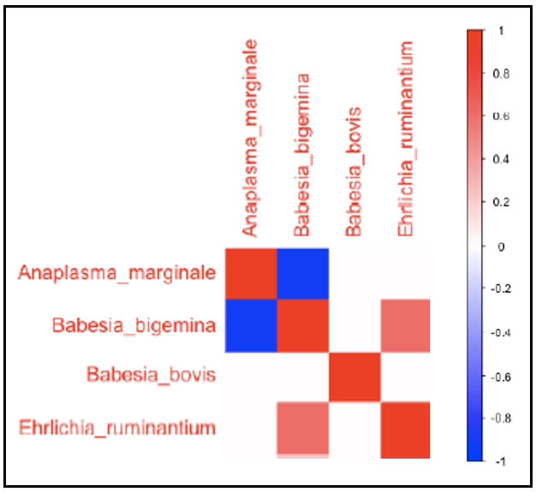
Fig. S1. Heatmap of TBHPs species-to-species associations (co-infections) based on the HMSC model with the cattle individual’s identity as a sampling unit, after controlling for covariates (including locations where the blood sample was taken). Blue and red colours show parameters that are estimated to be positive and negative, respectively, with at least 0.95 posterior probability.

