Table 6. Molecular Docking of selected phytoligands and standard chemotherapeutic agent with SARS-CoV-2 viral virulence factors.

Ligand / Standard | Chemical structure† | E Value (Kcal/mol)§
Ligand / Standard | Chemical structure† | Main Protease 3CLpro | Spike glycoprotein | NSP15 endoribonuclease
Allicin | 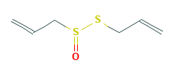 | -121.34 | -108.38 | -157.34
Berberine | 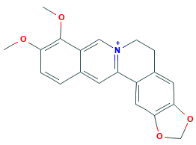 | -211.64 | -179.51 | -240.83
Beta-caryophyllene | 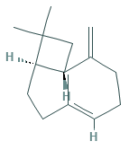 | -129.23 | -132.62 | -176.22
11-keto-beta-boswellic acid | 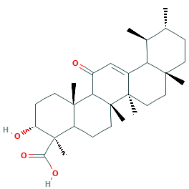 | -253.66 | -199.35 | -269.92
Citronellal | 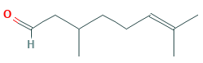 | -139.41 | -134.74 | -160.92
Curcumin | 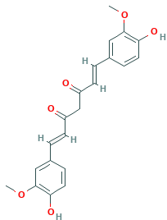 | -213.59 | -197.87 | -247.25
Gamma-Glutamyl-S-allylcysteine | 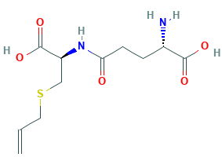 | -493.53 | -578.57 | -825.00
6-Gingerol | 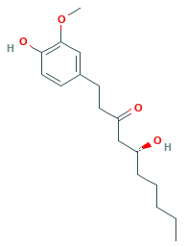 | -199.85 | -178.86 | -221.35
Quercetin | 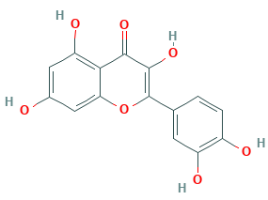 | -189.57 | -158.27 | -204.25
Salvianolic acid | 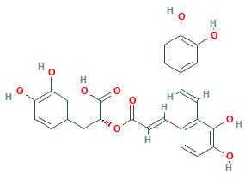 | -261.56 | -223.97 | -275.44
Tinosporaside | 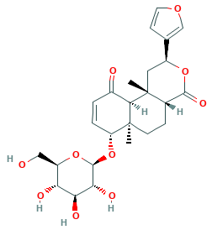 | -233.14 | -223.92 | -268.79
Withanolide | 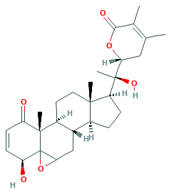 | -207.18 | -214.98 | -253.37
Hydroxy-chloroquine | 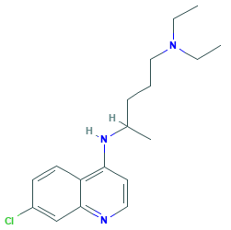 | -235.48 | -207.47 | -213.54
†Chemical structures have been derived from PubChem (https://pubchem.ncbi.nlm.nih.gov/); §ΔG_{binding} = ΔG_{complex} – (ΔG_{receptor} + ΔG_{ligand}); Grey shaded cells indicate highly significant E value of docking as compared to the standard chemotherapeutic agent; Green shaded cells indicate holistic phytoligands exhibiting optimum E value for all the three selected viral virulence factors (These phytoligands have been further analysed for salt-bridge analysis and electrostatic interactions).

