Table 2. Active pockets and corresponding pocket area, volume, enclosure and druggability indices for SARS-CoV-2 virulence factors.

Viral Virulence Factor (PDB ID) | Total Pockets | Active pockets† | Area (Å²) | Volume (Å³) | Enclosure (Å) | Hydrophobicity (Kcal/ Å²) | Drug Score | Representation
Spike glycoprotein (6VSB) | 106 | P_11 | 807.13 | 662.19 | 0.06 | 0.27 | 0.84 | 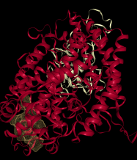
Spike glycoprotein (6VSB) | 106 | P_7 | 1027.4 | 885.73 | 0.16 | 0.31 | 0.83
Spike glycoprotein (6VSB) | 106 | P_9 | 792.72 | 781.17 | 0.08 | 0.24 | 0.82
Spike glycoprotein (6VSB) | 106 | P_10 | 987.15 | 728.29 | 0.08 | 0.44 | 0.82
Spike glycoprotein (6VSB) | 106 | P_6 | 1194.9 | 1024.5 | 0.17 | 0.42 | 0.81
NSP15 endoribonuclease (6VWW) | 31 | P_1 | 787.38 | 683.48 | 0.06 | 0.24 | 0.86 | 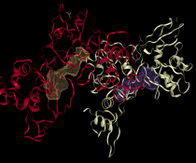
NSP15 endoribonuclease (6VWW) | 31 | P_0 | 712.51 | 685.95 | 0.08 | 0.25 | 0.85
NSP15 endoribonuclease (6VWW) | 31 | P_3 | 561.74 | 467.99 | 0.23 | 0.46 | 0.78
NSP15 endoribonuclease (6VWW) | 31 | P_2 | 832.74 | 507.64 | 0.14 | 0.54 | 0.76
NSP15 endoribonuclease (6VWW) | 31 | P_5 | 621.35 | 344.13 | 0.07 | 0.45 | 0.70
Main Protease 3CLpro (1Q2W) | 11 | P_0 | 2867.9 | 2443.7 | 0.12 | 0.33 | 0.80 | 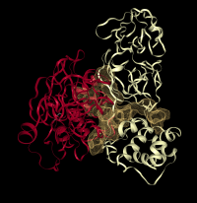
Main Protease 3CLpro (1Q2W) | 11 | P_1 | 589.09 | 364.2 | 0.2 | 0.59 | 0.75
Main Protease 3CLpro (1Q2W) | 11 | P_2 | 341.62 | 297.14 | 0.25 | 0.48 | 0.47
Main Protease 3CLpro (1Q2W) | 11 | P_4 | 430.51 | 222.15 | 0.25 | 0.44 | 0.47
Main Protease 3CLpro (1Q2W) | 11 | P_3 | 373.5 | 237.35 | 0.25 | 0.25 | 0.46
†Only the most active pockets have been presented with a high druggability score; Shaded rows indicate the most druggable pockets which will be further employed for docking studies.

