PVT1 Inhibition Stimulates Anti-tumor Immunity, Prevents Metastasis, and Depletes Cancer Stem Cells in Squamous Cell Carcinoma

Zhen Qin^{a, b#}, Wenbo Zhang^{a#}, Shuo Liuª, Yujia Wang^{a, b}, Xin Pengª*, Lingfei Jia^{a, b, c}*
Affiliation:
ªDepartment of Oral and Maxillofacial Surgery, Peking University School and Hospital of Stomatology, Beijing 100081, China.
^{b}Department of Central Laboratory, Peking University School and Hospital of Stomatology, Beijing 100081, China.
^{c}National Center of Stomatology & National Clinical Research Center for Oral Diseases & National Engineering Laboratory for Digital and Material Technology of Stomatology, Beijing 100081, China.
#These authors contributed equally to this work
*Corresponding author:
Lingfei Jia, PhD
22 Zhongguancun South Avenue, Beijing 100081, China.
E-mail: jialingfei1984@sina.com
Tel: (8610) 82195109
Fax: (8610) 82193402
Xin Peng, MD, DDS.
22 Zhongguancun South Avenue, Beijing 100081, China.
Tel: (8610) 82195210
Fax: (8610) 62173402
E-mail: pxpengxin@263.net
Supplemental Figures

Supplemental Table

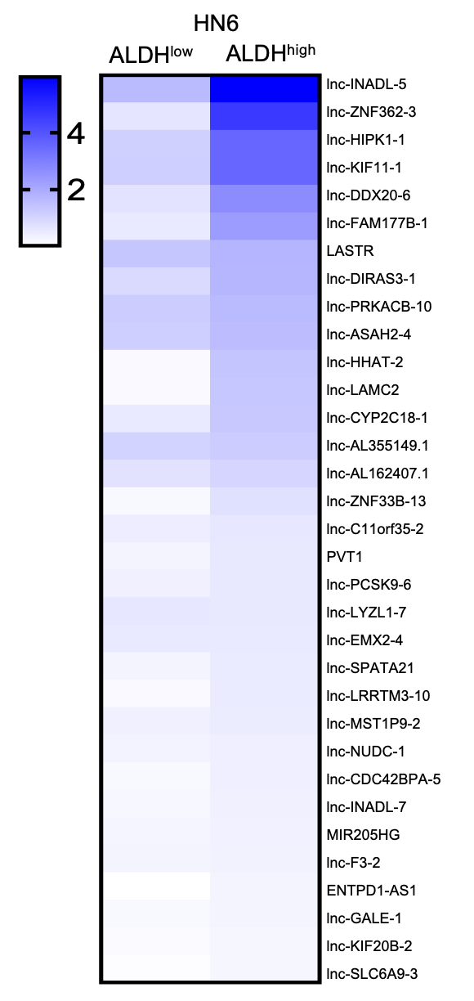
Supplemental Fig. S1 A cluster heatmap (fold change > 3.0, p < 0.01) showing the 33 most upregulated lncRNAs in ALDH^{high} CSCs compared with ALDH^{low} non-CSCs.
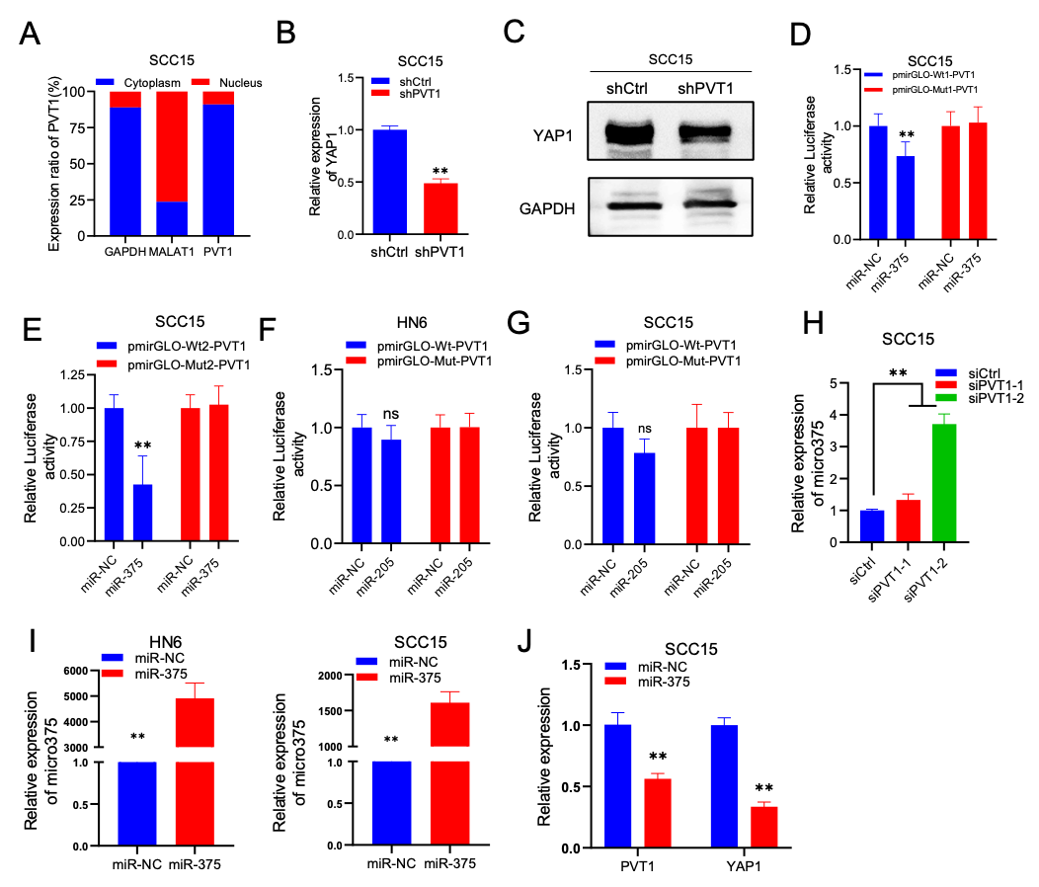

Supplemental Fig. S2 MiR-375 combined with PVT1 and YAP1.
A The subcellular localization of PVT1 by qRT-PCR analysis in SCC15 cells. MALAT1 and GAPDH RNA were used as controls for the nuclear and cytoplasmic fractions, respectively. B qRT-PCR analysis of YAP1 expression in SCC15 cells with PVT1 KD. Data are shown as the mean ± SD. **p < 0.01 using an unpaired Student’s t-test. C Western blot of YAP1 in SCC15 cells with PVT1 KD. D-E The relative luciferase activity in SCC15 cells transfected with pmirGLO-Wt1/Mut1-PVT1, pmirGLO-Wt2/Mut2-PVT1, and miR-375. Data are shown as the mean ± SD. **p < 0.01 using an unpaired Student’s t-test. F-G The relative luciferase activities of HN6 and SCC15 cells transfected with pmirGLO-Wt/Mut-PVT1 and miR-205 mimics (miR-205). Data are shown as the mean ± SD. ns, p > 0.05 using an unpaired Student’s t-test. H qRT-PCR assessment of miR-375 expression in SCC15 cells transfected with siPVT1-1/2. Data are shown as the mean ± SD. **p < 0.01 using an unpaired Student’s t-test. I qRT-PCR assessment of miR-375 expression in HN6 and SCC15 cells transfected with miR-375. Data are shown as the mean ± SD. **p < 0.01 using an unpaired Student’s t-test. J qRT-PCR assessment of PVT1 and YAP1 expression in SCC15 cells transfected with miR-375. Data are shown as the mean ± SD. **p < 0.01 using an unpaired Student’s t-test.

Supplemental Table S1. Sequences of qRT-PCR primers, other primers, and siRNAs used in the present study

Target gene | Forward primer (5′-3′) | Reverse primer (3′-5′)
GAPDH | AACGGGAAGCTTGTCATCAA | TGGACTCCACGACGTACTCA
CD24 | TGAAGAACATGTGAGAGGTTTGAC | GAAAACTGAATCTCCATTCCACAA
BMI1 | TGCTTTGGTCGAACTTGGTG | TTTGCAGACTGGGGACAATG
SOX2 | GCCGAGTGGAAACTTTTGTCG | GGCAGCGTGTACTTATCCTTCT
ALDH1 | ACTTACCTGTCCTACTCA | CTTATCTCCTTCTTCTACCT
OCT4 | TCCCATGCATTCAAACTGAGG | CCTTTGTGTTCCCAATTCCTTCC
LASTR | GTGGGTGAAGTCCTGGTT | GGCTGAAGGGTTTAGATG
lnc-LAMC2 | CACGAACTTGTGGTTACTTGCTCAC | ATCCAAACCAACATCCACCCC
lnc-ZNF33B | CCTCAGTTTGGGAATTCAGTG | AAGCAAGCAGGCGAAGAA
PVT1 | TTCAGCACTCTGGACGGACTT | TATGGCATGGGCAGGGTAG
MIR205HG | GACCGTTGTTAGCACGCCTT | CACGTATCGGTCCGTGTTGG
ENTPD1-AS1 | GCAGGTTTACTCCACATACTGTGTT | ACCACAAGTTTTAGAGGTTTAAGCC
IFNB | GCCATCAGTCACTTAAACAGC | GAAACTGAAGATCTCCTAGCCT
CXCL9 | GTGGTGTTCTTTTCCTCTTGGG | ACAGCGACCCTTTCTCACTAC
CXCL10 | GCAAGCCAATTTTGTCCACG | ACATTTCCTTGCTAACTGCTTTCAG
CXCL11 | CAGAATTCCACTGCCCAAAGG | GTAAACTCCGATGGTAACCAGCC
MALAT1 | GTTCTGATCCCGCTGCTATT | TCCTCAACACTCAGCCTTTATC
YAP1 | TAGCCCTGCGTAGCCAGTTA | TCATGCTTAGTCCACTGTCTGT
miR-375-RT | GTCGTATCCAGTGCAGGGTCCGAGGTATTCGCACTGGATACGACTCACGC
miR-375-qPCR | GTG CAG GGT CCG AGGT | AGC CGT TTG TTC GTT CGG CT
Target gene | siRNA sequence (5′-3′)
siPVT1-1 | CAGCTTCAACCCATTACGATT
siPVT1-2 | GCCATCATGATGGTACTTTAA
shPVT1 | CCUGAUGGAUUUACAGUGATT

