Full and uncropped western blot for Figure 3E
HN6 BMI1, HN6 GAPDH, SCC15 BMI1, SCC15 GAPDH are on the figure
HN6 GAPDH
HN6 BMI1

SCC15 GAPDH
SCC15 BMI1

Full and uncropped western blot for Figure 7B
HN6 pH2A.X, HN6 GAPDH, SCC15 pH2A.X, SCC15 GAPDH are on the figure
HN6 GAPDH
HN6 pH2A.X

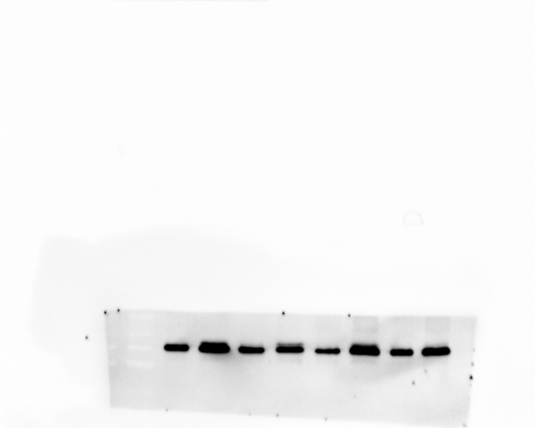
SCC15 pH2A.X
SCC15 GAPDH

Full and uncropped western blot for Figure 8C
HN6 YAP1, HN6 GAPDH are on the figure
HN6 GAPDH
HN6 YAP1

Full and uncropped western blot for Supplemental Figure S2C
SCC15 YAP1, SCC15 GAPDH are on the figure
SCC15 YAP1

SCC15 GAPDH

Full and uncropped western blot for Figure 8L
HN6 YAP1, HN6 GAPDH, SCC15 YAP1, SCC15 GAPDH are on the figure
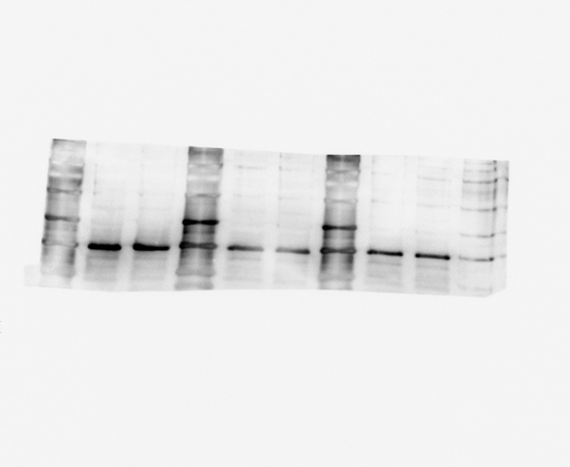
HN6 GAPDH
HN6 YAP1

SCC15 GAPDH

SCC15 YAP1

