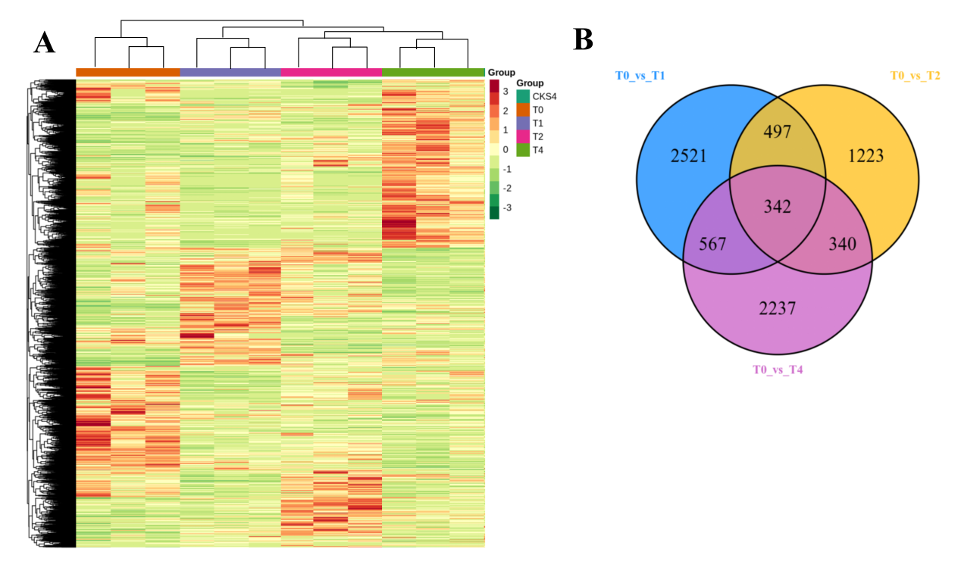Fig. S1 Differentially expressed gene statistics. (A) Heat map of clustering of all differential genes. Horizontal coordinates indicated sample names and hierarchical clustering results, vertical coordinates indicated differential genes and hierarchical clustering results. Red indicated high expression, green indicated low expression. (B) Venn diagrams for DEGs in T0 vs T1, T0 vs T2 and T0 vs T4.

