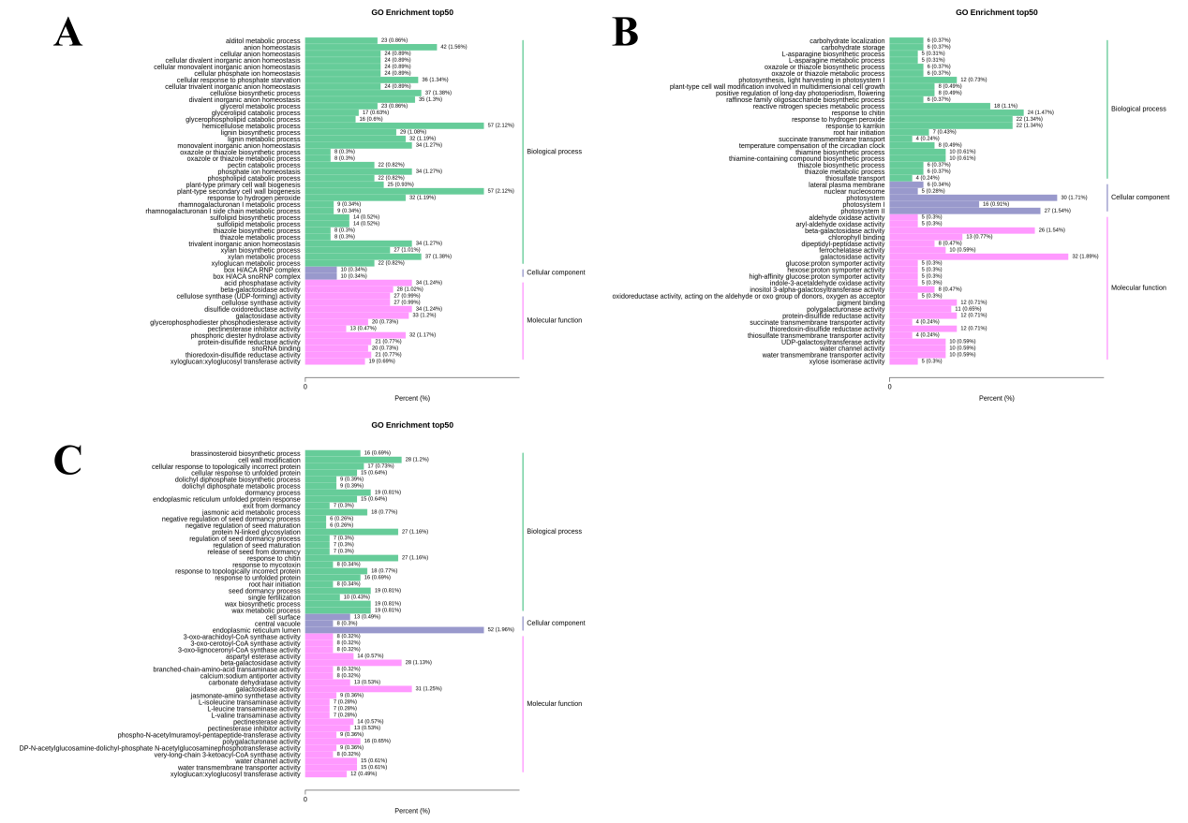
Fig. S2 GO enrichment analysis. (A) T0 vs T1. (B) T0 vs T2. (C) T0 vs T4.

