Electronic Supporting Information

Pyrene functionalized luminescent phenylalanine for selective detection of copper (II) ions in aqueous media

Arpna Tamrakar, Kamlesh Kumar Nigam, Tarkeshwar Maddeshiya, Mrituanjay D. Pandey*
Department of Chemistry, Institute of Science, Banaras Hindu University Varanasi–221005, India. E-mail: mdpandey.chem@bhu.ac.in

Contents:

Figure S1&S2: - ¹H & ¹³C NMR spectra of 1…………………………….……...……S2
Figure S3: - HRMS (ESI-TOF) spectra of 1.............................................…....................S3
Figure S4: - UV-Visible data of 1 …………………………………………....………...S3
Figure S5: - UV-Visible titration of 1 with Cu²⁺ ion …………………………………. S4
Figure S6: - Fluorescence spectra of 1.…………………………………..….………… S4
Figure S7: - Fluorescence titration of 1 with Cu²⁺ ion ………………………..……… S5
Figure S8: - Stern-Volmer plot of 1……………………………………………………. S5
Figure S9: - Benise-Hildebrand plot for determination of binding constant of 1….…. S6
Figure S10: - Fluorescence sensitivity of 1 in the presence of a different concentration of Cu²⁺ (10⁻¹¹ to 10⁻³ M) ions…………………………………………………………. S6
Figure S11: - Fluorescence sensitivity of 1 in the presence of a different concentration of Cu²⁺ (1 x 10⁻⁸ to 9 x 10⁻⁸ M) ions……………………………………………………S7
Figure S12: - Reversibility of 1-Cu²⁺ with EDTA solution through fluorescence in (Water: DMSO 9:1, v/v)……………………..…………………………………………..S7
Figure S13: - Proposed binding mechanism of 1 with Cu²⁺ ion……………………S8

¹H NMR Spectra of 1
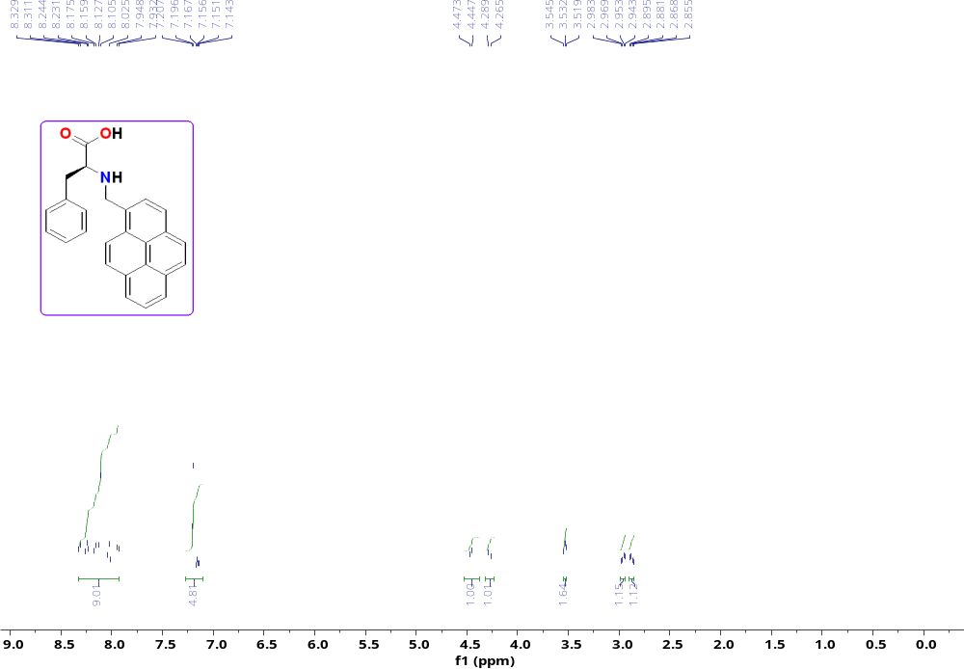
Figure S1:- ¹HNMR spectra of chemosensor 1 in CDCl_{3.}
¹³C NMR Spectra of 1
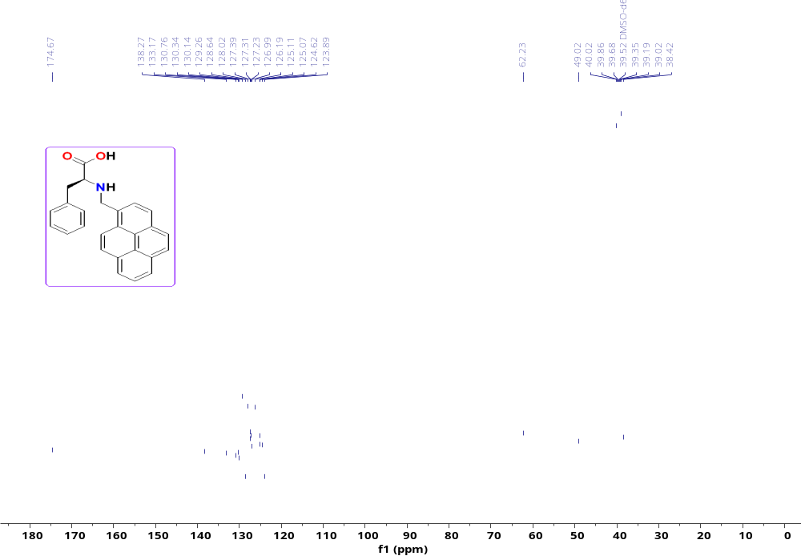
Figure S2:- ¹³CNMR spectra of chemosensor 1 in CDCl₃.

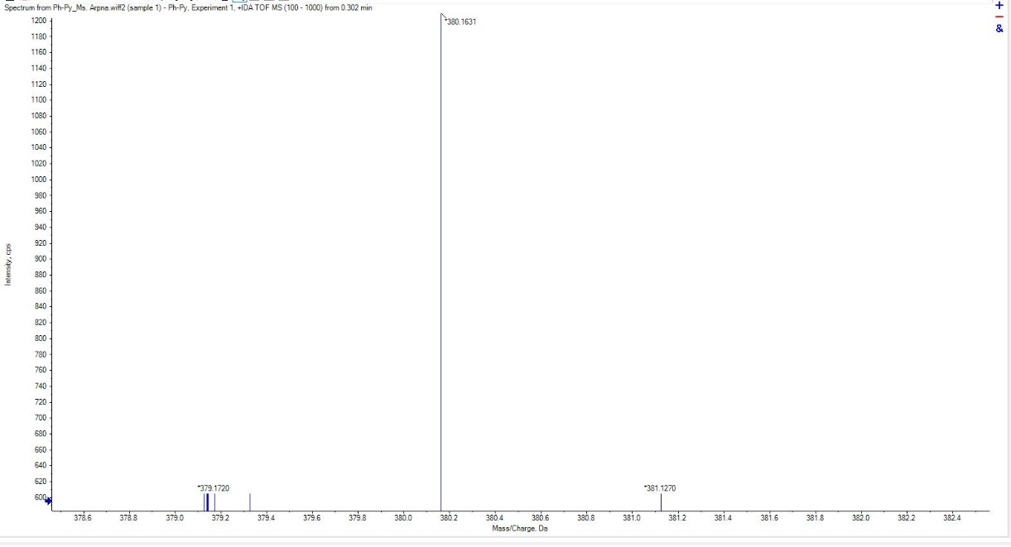
Figure S3: - HRMS (ESI-TOF)⁺ spectra of chemosensor 1.
Figure S4: - UV-Visible spectra of 1.
Figure S5: - UV-Visible titration spectra of 1 on the addition of increasing concentration of Cu²⁺ ion.

Figure S6: - Fluorescence spectra of 1.
Figure S7: - Fluorescence titration of chemosensor 1 with Cu²⁺ (0 eq. to 10eq) in DMSO: water (1:9, v/v at room temperature).
Figure S8: - Stern-Volmer plot of 1.

Figure S9: - Benise-Hildebrand plot for determination of binding constant of 1.

Figure S10: - Fluorescence sensitivity of 1 in the presence of a different concentration of Cu²⁺ (10⁻¹¹ to 10⁻³ M) ions.

Figure S11: - Fluorescence sensitivity of 1 in the presence of a different concentration of Cu²⁺ (1 x 10⁻⁸ to 9 x 10⁻⁸ M) ions.
Figure S12: - Reversibility of 1-Cu²⁺ with EDTA solution through fluorescence in (Water: DMSO 9:1, v/v )
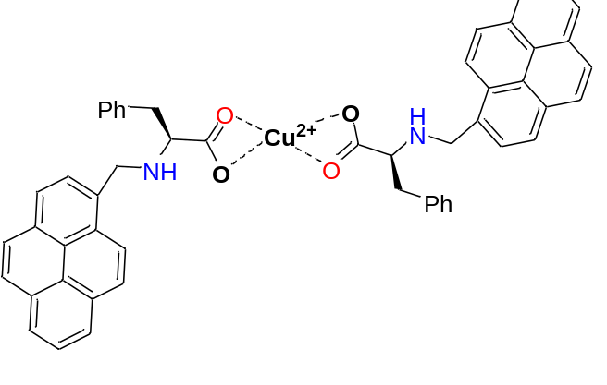
Figure S13: - Proposed binding mechanism of 1 with Cu²⁺ ion.
Determination of the quantum yield.
Standard used: Quinine sulfate salt (QS); QS in 0.5M sulfuric acid has ϕ_{f} = 0.546 (at 25˚C)
A 1×10⁻⁵ M solution of Quinine sulfate is prepared in 0.5M H₂SO_{4,} the absorbance maximum of the solution at 345nm, Abs = 0.305. The emission spectrum is also recorded with λ_{exc.}= 345nm, fluorescence emission is integrated into the range 365-627nm range:6.14×10⁷ a.u.
A 1×10⁻⁵M solution of 1 and 1+Cu²⁺ is prepared in DMSO: Water (9:1, v/v), and the absorbance maximum of the solution at 342 shows Abs.= 0.35 for 1 and Abs.= 0.28 for 1+Cu²⁺. The emission spectrum is also recorded with λ_{exc.}= 342nm for 1 and 1+Cu²⁺. Fluorescence emission of 1 was integrated in the range 360-460nm range: 3.609×10⁷ a.u. and Fluorescence emission of 1 on the addition of Cu²⁺ was integrated in the range 360-470nm range: 7.48×10⁶ a.u.
Formula used for calculating quantum yield
Φ_{s} = ϕ_{rf}. I_{s}/I_{rf}. A_{rf}/A_{s}
Where Φ_{s} is the fluorescence quantum yield of the sample, ϕ_{rf} is the fluorescence quantum yield of the standard reference, I_{s} and I_{rf} are the integrated emission intensities of the sample and the standard reference respectively, A_{rf} and A_{s} are the absorbance of the standard reference and the sample at the excitation wavelength, respectively, and n_{s} and n_{rf} are the refractive indexes of the corresponding solution of sample and reference.
The refractive index of the solvent η_{s}/η_{rf} were considered one.
So,
Quantum yield of neat 1 (ϕ) = 0.23
Quantum yield of 1+Cu²⁺ (ϕ) = 0.06

