Extended figures and tables for: A multi-model analysis of post-Glasgow climate action and feasibility gap

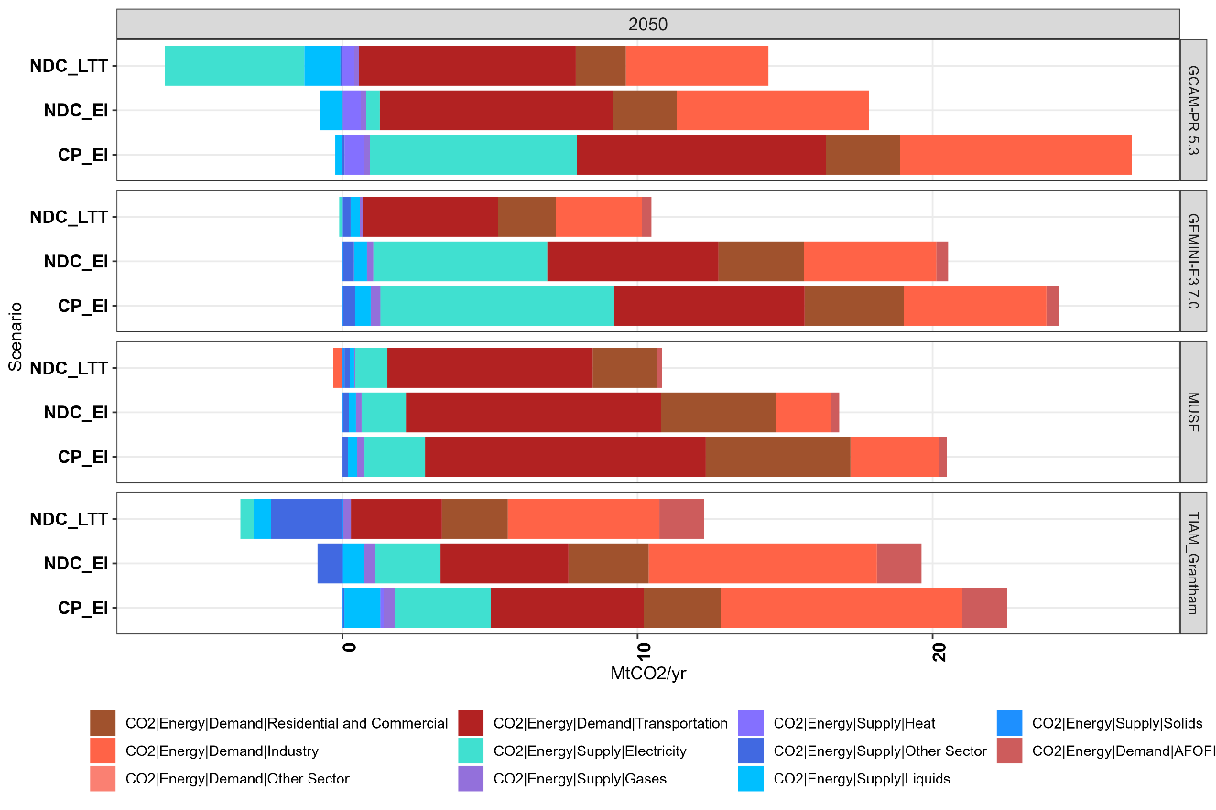
Extended Figure 1: Remaining global CO2 emissions from different sectors for each model, in 2050

Extended figure 2: Comparison of pre- and post-Glasgow current policy and NDC 2030 global emissions. Pre-Glasgow emissions are taken from Sognnaes et al (2021) referring to CP_Intensity and NDC_Intensity scenarios¹⁸.

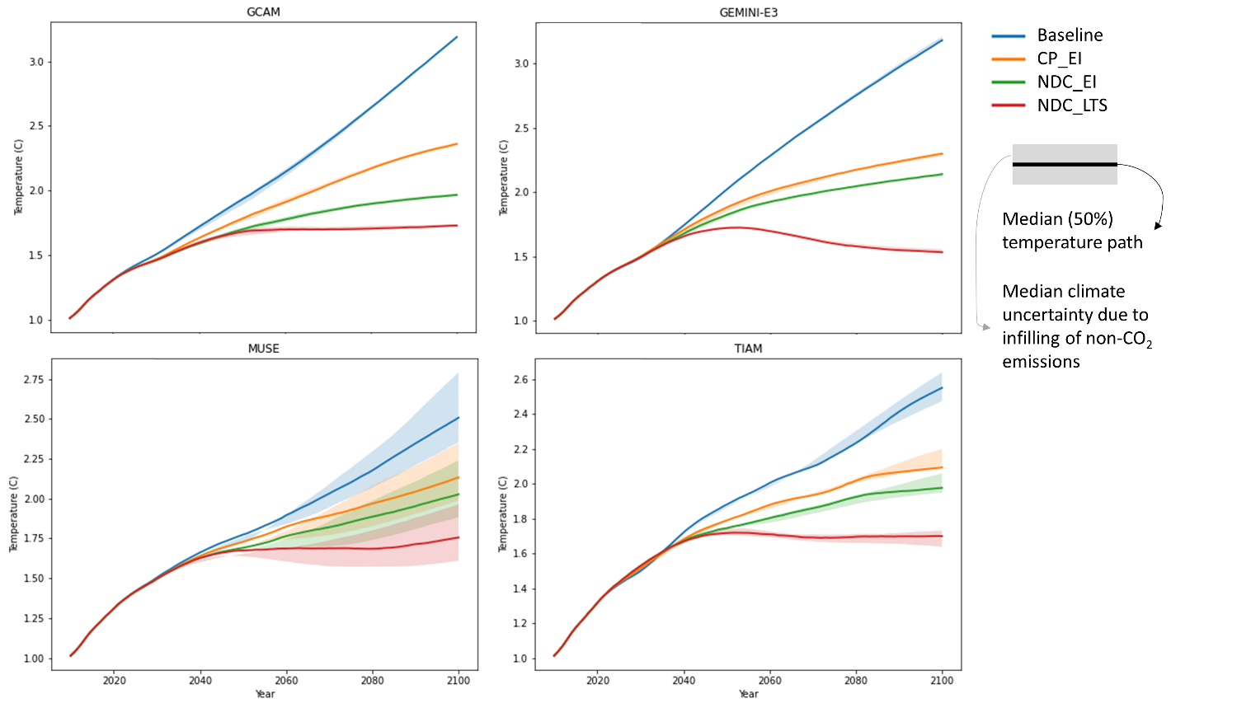
Extended figure 3: Median temperature pathways until 2100 for all models and scenarios in this study, and a no-policy baseline scenario for comparison. The shaded ranges reflect the uncertainty related with infilling the emission databases with unreported gases. See Methods section for more details.

Extended table 1: Post-Glasgow updated NDC pledges to be applied in the second global modelling iteration.
Country | Target type* | New target value (lower value applied) | Base year | Target year | Relative to previous target
China | GDP Intensity | over 65% reduction | 2005 | 2030 | Improved target
India | GDP Intensity | 40-45% reduction | 2005 | 2030 | Improved target
USA | Base year | 50-52% reduction | 2005 | 2030 | Improved target
EU | Base year | 55% reduction | 1990 | 2030 | Improved target
UK | Base year | 68% reduction | 1990 | 2030 | Improved target
Norway | Base year | 50-55% reduction | 1990 | 2030 | Improved target
Japan | Base year | 46% reduction | 2013 | 2030 | Improved target
South Korea | Base year | 40% reduction | 2018 | 2030 | Improved target
Canada | Base year | 40-45% reduction | 2005 | 2030 | Improved target
Australia | Base year | 43% reduction | 2005 | 2030 | Improved target
Argentina | BAU | 39% reduction | 2030 | 2030 | Improved target
Chile | Cap | 95 Mt CO₂eq |  | 2030 | Improved target (change from BAU to cap)
Colombia | BAU | 51% reduction | 2030 | 2030 | Improved target
Equador | BAU | 9-20.9% reduction | 2025 | 2025 | no target last iteration
Peru | BAU | 30-40% reduction | 2030 | 2030 | Improved target
Indonesia | BAU | 29.1-41.3% reduction | 2030 | 2030 | adapted (higher) BAU
Malaysia | GDP Intensity | 45% reduction | 2005 | 2030 | Improved target
Singapore | Cap | 65 Mt CO₂eq |  | 2030 | Improved target
Belarus | Base year | 35% reduction | 1990 | 2030 | Improved target
Ukraine | Base year | 65% reduction | 1990 | 2030 | Improved target
Viet Nam | BAU | 9-27% reduction | 2030 | 2030 | adapted (higher) BAU

Extended table 2: Long-term emissions targets to be applied in the second global modelling iteration.
Country | Year | Target type | Target status | All GHG | Comment
USA | 2050 | Net-zero | In policy document | yes
UK | 2050 | Net-zero | in law | yes
Sweden | 2045 | Net-zero | in law | yes
European union | 2050 | Net-zero | in law | yes
Germany | 2045 | Net-zero | in law | yes
India | 2070 | Net-zero | Gov. announcement
China | 2060 | Net-zero | In policy document
Canada | 2050 | Net-zero | in law | yes
Australia | 2050 | Net-zero | in policy document | yes
New Zealand | 2050 | Net-zero | in law | yes | biogenic methane is excluded
Nigeria | 2060 | Net-zero | in law
Saudi Arabia | 2060 | Net-zero | Gov. announcement
Russian Federation | 2060 | Net-zero | Gov. announcement
South-Korea | 2050 | Net-zero | in law | yes
Japan | 2050 | Net-zero | in law | yes
Brazil | 2050 | Net-zero | In policy document
South Africa | 2050 | Net-zero | In policy document
Malawi | 2050 | Net-zero | In policy document
Argentina | 2050 | Net-zero | Gov. announcement
Chile | 2050 | Net-zero | In policy document | yes | Plans to reach net zero through domestic actions
Vietnam | 2050 | Net-zero | Gov. announcement
Thailand | 2065 | Net-zero | Gov. announcement |  | carbon neutrality by 2050 and net zero emissions by 2065
Colombia | 2050 | Net-zero | Gov. announcement
Kazakhstan | 2060 | Carbon neutrality |  |  | carbon neutrality
Turkey | 2053 | Net-zero | Gov. announcement
Italy | 2050 | Net-zero | Gov. announcement
UAE | 2050 | Net-zero | Gov. announcement | no | only co2 is covered
Switzerland | 2050 | Net-zero | In policy document
Denmark | 2050 | Net-zero | in law | yes
Peru | 2050 | Net-zero | Gov. announcement
France | 2050 | Net-zero | in law | yes
Norway | 2050 | 90-95% reduction
Mexico | 2050 | 50% below 2000 emissions

