Virulence and population diversity of wheat leaf blotch (Zymoseptoria tritici) isolates in Oromia, Ethiopia
Girma Ababa*¹, Girma Adugna², Bekele Hundie³ and Tilahun Mekonnen⁴

1 Ethiopian Institute of Agricultural Research, Holetta Agricultural Research Center, Holetta, Ethiopia. Email:girmaabebe65@gmail.com
2 Jimma University, Department ofHorticulture and Plant Sciences, College of Agriculture and Veterinary Medicine, Jimma, Ethiopia. Email: girma.adugna@yahoo.com.
3 Ethiopian Institute of Agricultural Research, Kulumsa Agricultural Research Center, Assela, Ethiopia. Email:bekelehundie@yahoo.com
4 Addis Ababa University, Institute of Biotechnology,Addis Ababa, Ethiopia. Email:mekonnentilahun27@yahoo.com

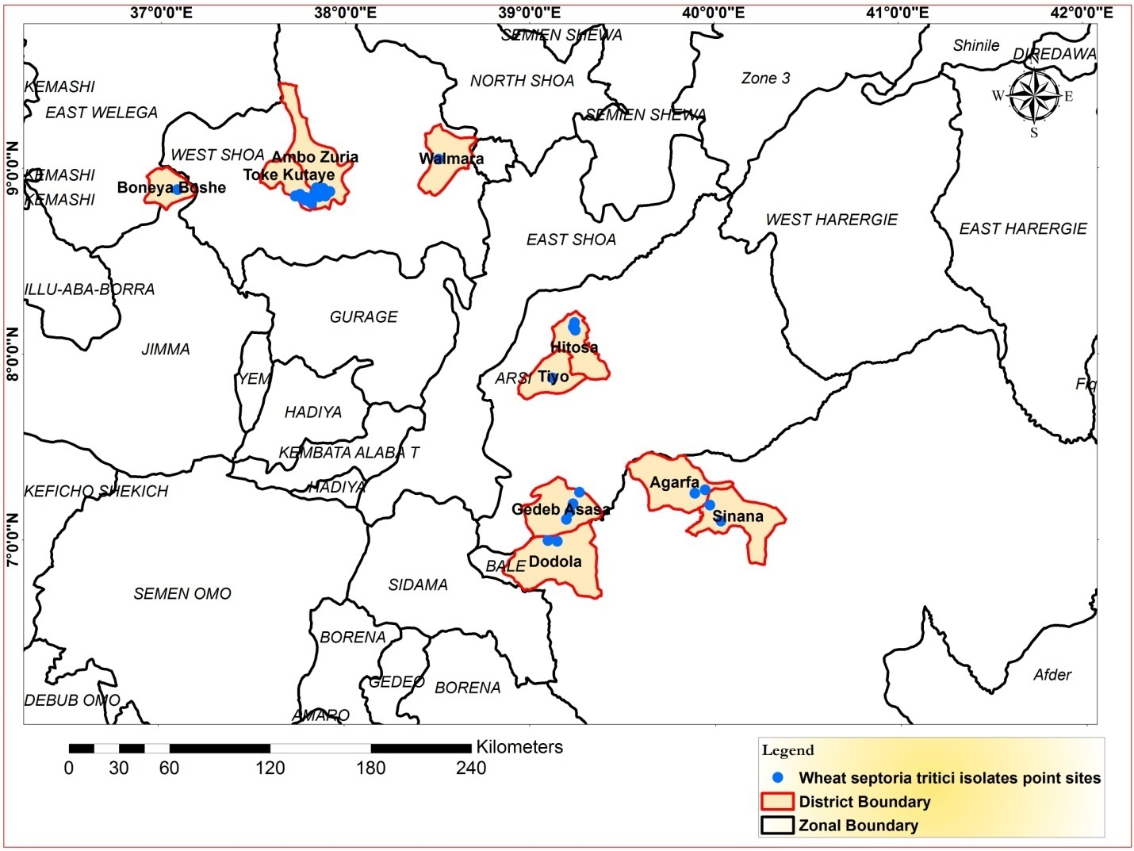

Figure 1 : Map showing the geographic locations of the Zymoseptoria tritici isolates in 2019 in Oromia Ethiopia

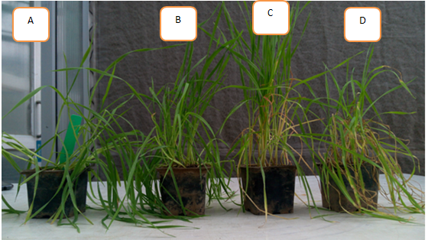
Figure 2: Reaction of differential lines to Ethiopian Zymoseptoria tritici isolates: A. VERANOPOLIS to EtB-2; B. Kavkaz-K4500 to EtA-7; C. TADINIA to EtAm-10; D. ESTANZUELA FEDERAL to EtAm-19.

