Support Information
Buried-in Interface with Two-terminal Functional Groups for Perovskite-based Photovoltaic Solar Cells
Zhenhua Xu^{1,2}, Xinming Zhou², Xiaohui Li¹, Handong Li,³ Hassan Algadi,^{4,5} Putao Zhang¹*
¹Key Laboratory of Photovoltaic Materials, Henan University, Kaifeng, Henan, 475004, China
²Institute of New Energy Technology, College of Information Science and Technology, Jinan University, Guangzhou, 510632, China
³ School of Engineering, Newcastle University, Newcastle upon Tyne, UK
⁴ Department of Electrical Engineering, Faculty of Engineering, Najran University, Najran, 11001, Saudi Arabia
⁵ College of Materials Science and Engineering, Taiyuan University of Science and Technology, Taiyuan, 030024, China
Experimental Section
Materials
Chlorobenzene (CB), 4-tert-butylpyridine (t-BP), and lithium bis (trifluoromethylsulfonyl) imide salt (Li-TFSI) were purchased from Sigma Aldrich. Lead (II) iodide (PbI₂, 99.98%), lead bromide (PbBr₂, 99.5%), SnO2 colloid precursor (15 wt% in water) and isonicotinic acid hydrazide (INHA, 99.5%) were purchased from Alfa Aesar. PEAI, Formamidinium iodide (FAI), methylammonium bromide (MABr), and cesium iodide (CsI, 99.9%), N, N-dimethylformamide (DMF, 99.8%), dimethyl sulfoxide (DMSO, 99.9%) and ITO glass were obtained from Liaoning Youxuan New Energy Technology Co., Ltd. 2,2′,7,7′-tetrakis(N, N-dipmethoxyphenylamine)-9,9′-spirobifluorene (Spiro-OMeTAD) was purchased from Xi’an Polymer Light Technology Corp. All chemicals were used without any further purification process.
Device Fabrication
The ITO glass was cleaned by ultra-sonication in detergent, deionized water, acetone, and isopropyl alcohol, sequentially, for 15 min each. After dried by air blowing, the cleaned ITO substrates were treated with plasma for 15 min to remove organic residues. Then the prepared SnO2 precursor (diluted by water with SnO2/H2O=1/2, v/v) was spin-coated onto the ITO substrate at 5000 rpm for 30 s, followed by thermal annealing at 150 °C for 30 min in ambient air. The cooled ITO/SnO₂ films were soaked into 0.1 M INHA aqueous solution for 10 minutes followed by washing with deionized water and blow-drying. The film was heated for 30 min on a 100 °C hot plate. The SnO₂ and SnO₂/INHA films were treated with plasma for 15 min before deposition of perovskite film. 70 μL of mix-cation perovskite precursor with 1.12 mol of PbI₂, 0.2 mol of PbBr₂, 0.2 mol of MABr, 0.05 M CsI, and 1.1 mol of FAI were dissolved in 1 mL mixed solvent of DMF and DMSO (DMF/DMSO=4/1, v/v) solvent was then spin-coated onto ITO/SnO₂ by two consecutive spin-coating steps (1000 rpm 5 s and 5000 rpm 20 s). During the spin-coating process, 120 μL of CB was poured onto the perovskite film at 15 s. Then the perovskite film was annealed at 60 ℃ for 10 min and 100 ℃ for 40 min. PEAI/IPA solution (5 mg mL⁻¹) was spin-coated at 4000 rpm for 20 s on perovskite films and dried on a hot plate at 100 ºC for 10 min. The hole transporting layer (HTL) was deposited onto the top of the perovskite film by 4000 rpm for 30 s with the composition of 72.3 mg Spiro-OMeTAD, 28.8 µL 4-tertbutylpyridine, 17.5 µL bis(trifluoromethane) sulfonimide lithium salt (Li-TFSI) stock solution (520 mg Li-TFSI in 1 mL acetonitrile) and 1 mL CB. Finally, 100 nm of Ag was thermally evaporated as a counter electrode.
Characterizations and measurements
The crystallization of prepared films was obtained with X-ray diffraction (Bruker D8 Advance) (Cu Kα radiation (λ=1.5418 Å), 45 kV and 200 mA). X-ray photoelectron spectroscopy (XPS) measurement was carried out by Axix Ultra spectrometer (Kratox) with 12 kV aluminum Ka X-ray. Fourier transform infrared (FTIR) spectroscopy was conducted in the infrared spectrometer (Vertex 70) and the film samples were baked under infrared lamp before testing. The morphology, grain size of perovskite films and device cross section were obtained with a field emission scanning electron microscope (FE-SEM, JSM-7001F). The roughness of the samples was measured by AFM. The steady-state PL and time-resolved PL (TRPL) decay were measured by an integrated confocal microscopy system (Tau-3-P) with a laser excitation source. The current-voltage (J-V) curves were measured with a solar simulator (94043A-S) and a Keithley 2400 source meter. The intensity of light irradiation was calibrated with a standard Si photodetector, and adjusted to 1 sun light intensity (100 mW·cm⁻² AM1.5G). The electrochemical impedance spectrum (EIS) analysis was performed using an electrochemical measurement system (IM6 Zahner) in the dark conditions at an applied bias of 0.6 V (10⁵~10⁻¹ Hz).
DFT calculation: All density functional theory calculations are conducted using the Vienna Ab-initio Simulation Package (VASP) within the framework of the generalized gradient approximation (GGA) with the Perdew-Burke Ernzerhof (PBE) functional.^{[1-2]} In order to simplify the calculation, atomic ratio (FA/MA and I/Br) in perovskite crystals have been treated approximately. Considering the small content of Cs, Cs atoms are not included in the model.
Additional data and results.
Figure S1. FTIR spectra of INHA molecular.

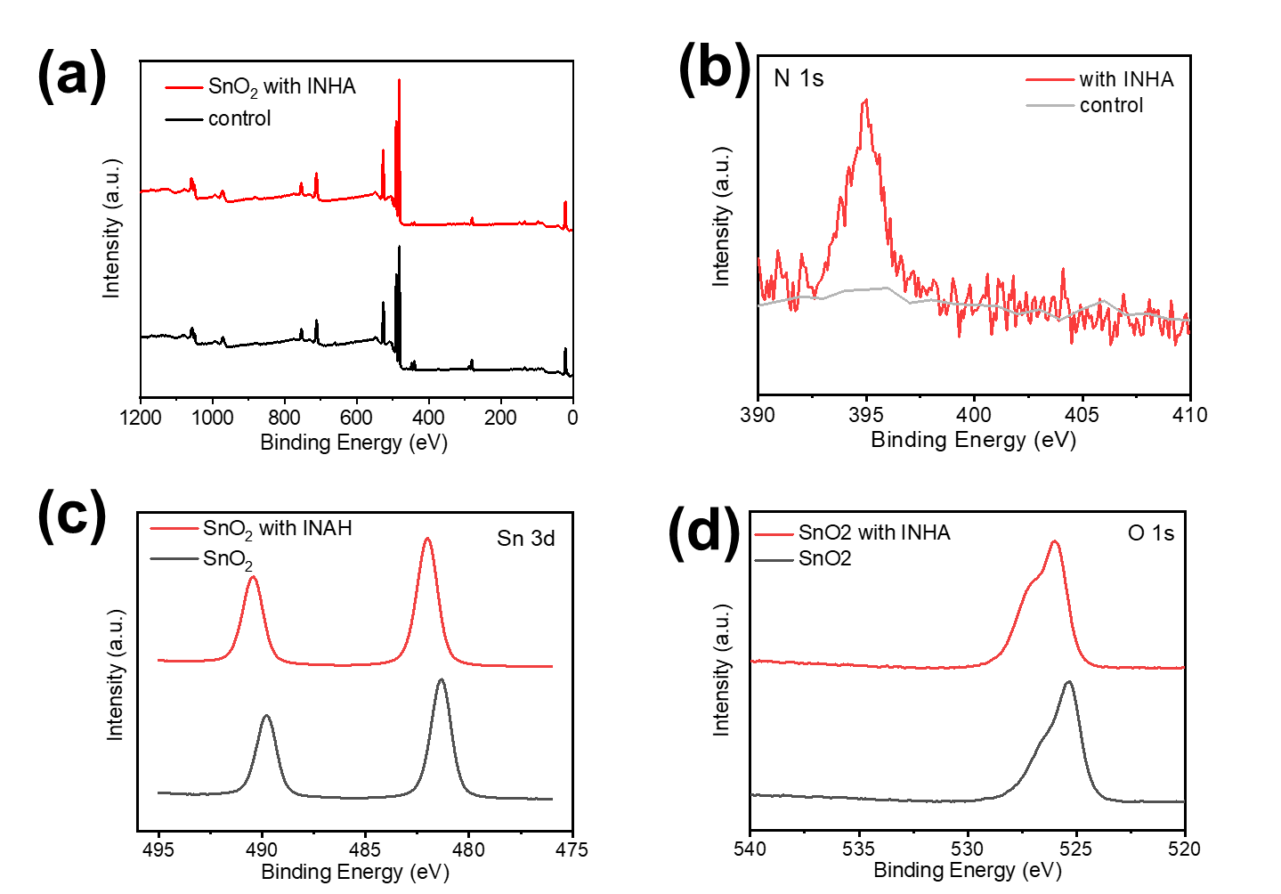
Figure S2. (a) XPS spectra of control SnO₂ electron transport layer and INHA-modified layer (b), (c), and (d) The N 1s, Sn 3d, and O1s perovskite of variant layers. There was N peaks in INHA-modified SnO₂ layer, which indicated INHA located on SnO₂ substrate.

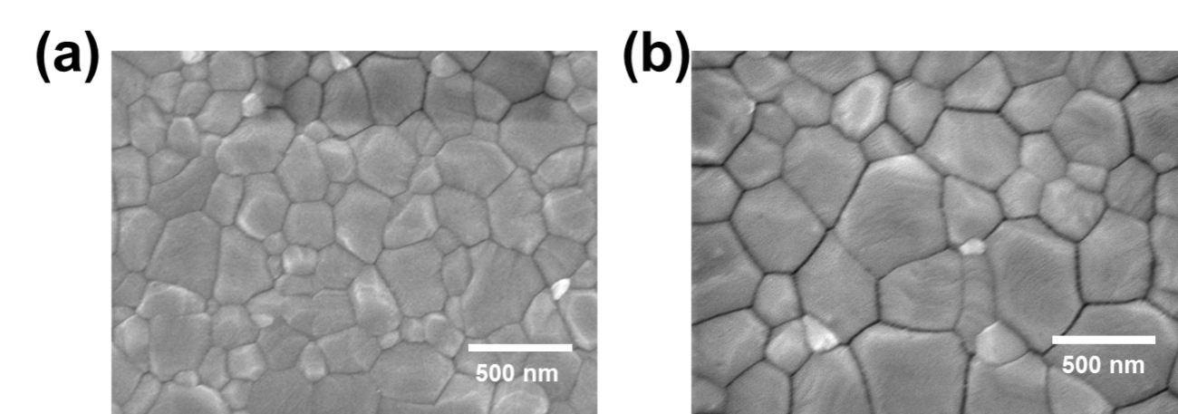

Figure S3. (a) and (b) The control perovskite film and INHA-modified film in SEM images, where the grainsize become larger with the increased functional group
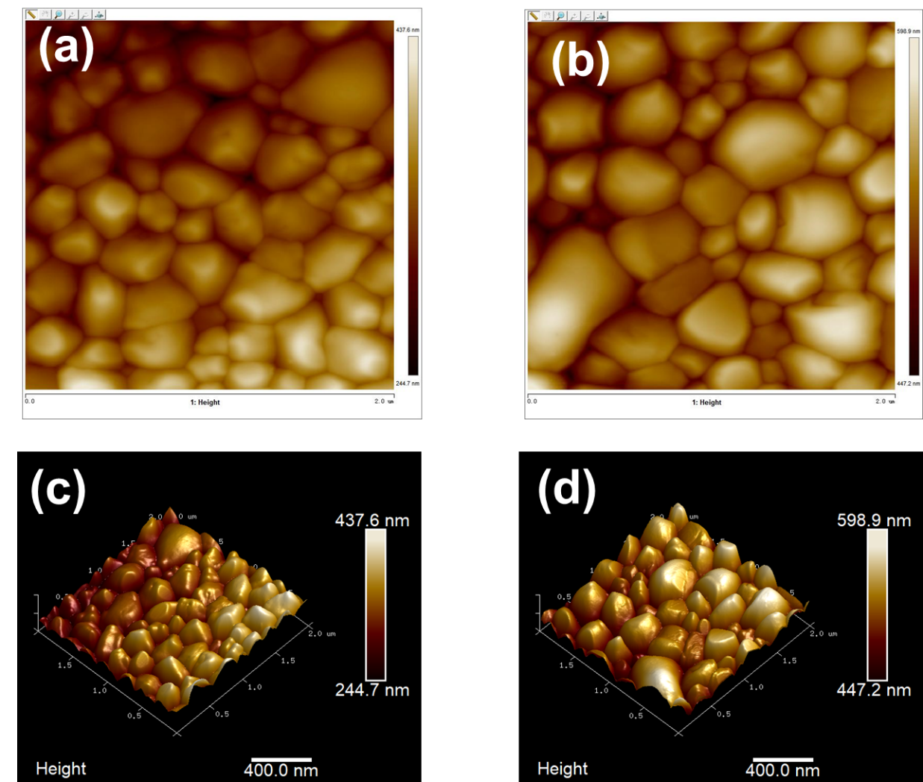
Figure S4. (a), (b) AFM images of the control and the optimal INHA-modified films. (c) and (d) The AFM contour of the corresponding layers.

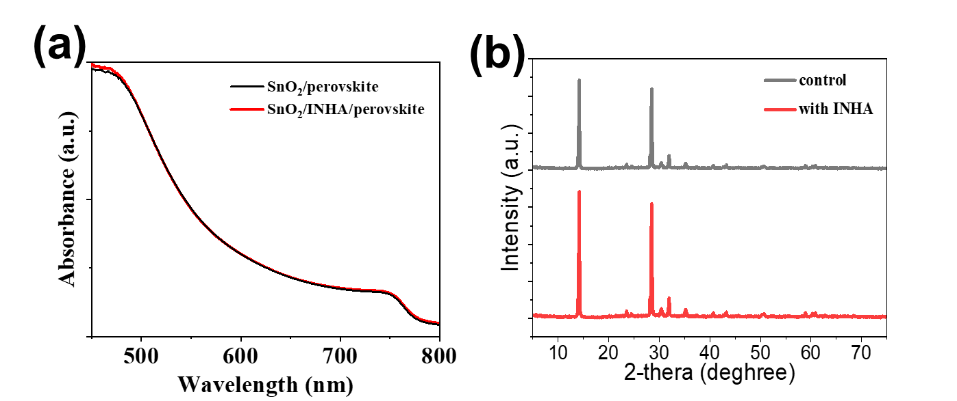
Figure S5. UV-vis absorption and (b) XRD patterns of the control perovskite film and optimal INHA-SAM modified film.

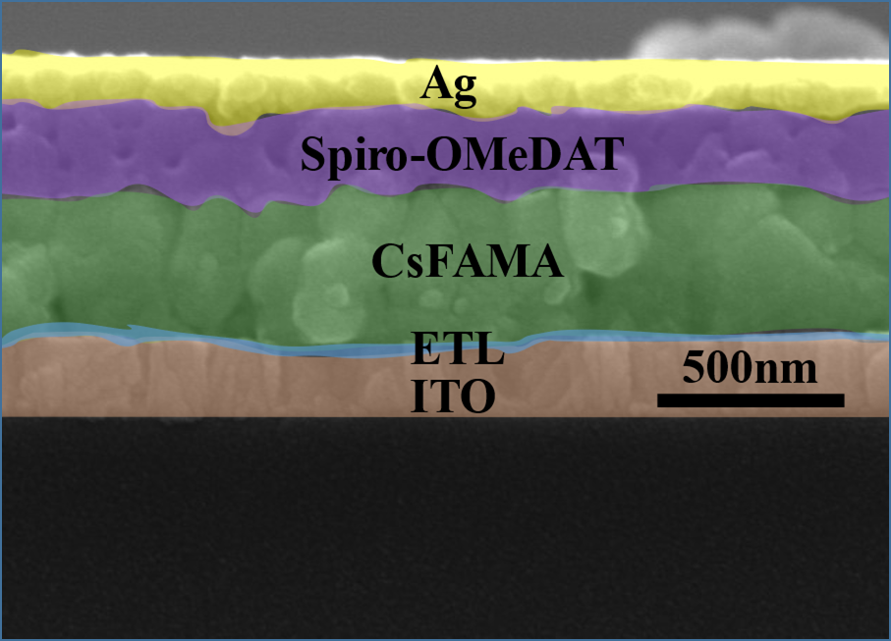
Figure S6. The cross-view of a completed perovskite solar devices.

Figure S7. The distribution of PCEs for 30 independent devices based on control and INHA-modified ETL.

Table S1. Detailed performance parameters of devices based on control and INHA-modified ETL.
Type | V_{OC}(V) | J_{SC}(mA/cm²) | FF | PCE(%)
control (RS) | 1.12 | 21.92 | 0.74 | 18.17
control (FS) | 1.09 | 21.79 | 0.72 | 17.10
with INAH (RS) | 1.17 | 23.15 | 0.78 | 21.12
with INAH (FS) | 1.14 | 23.06 | 0.75 | 19.71

Equation 1. The dependence of V_{OC} on the light intensity:
V_{OC} = nkT ln(I)/e + constant
Where k is the Boltzmann constant, T is the absolute temperature, e is the elementary charge, I is the light intensity normalized to 1 sun, and ideality factor n can be measured by different intensities.

Equation 2. Simulation the TPV by Origin (Origin 8.5 vision) simulation equation ExpDecay 2.
f (t) = Ai∑ exp (-t/τ_{i}) +K
where Ai is the decay amplitude, τ_{i} is the decay time, and K is a constant for the baseline offset.

[1] G. Kresse, J. Hafner. Phys. Rev. B. 1993, 47, 558-561.
[2] J. P. Perdew, K.Burke, Ernzerhof, M. Phys. Rev. Lett. 1996, 77, 3865-3868.

