EXTENDED DATA FIGURES
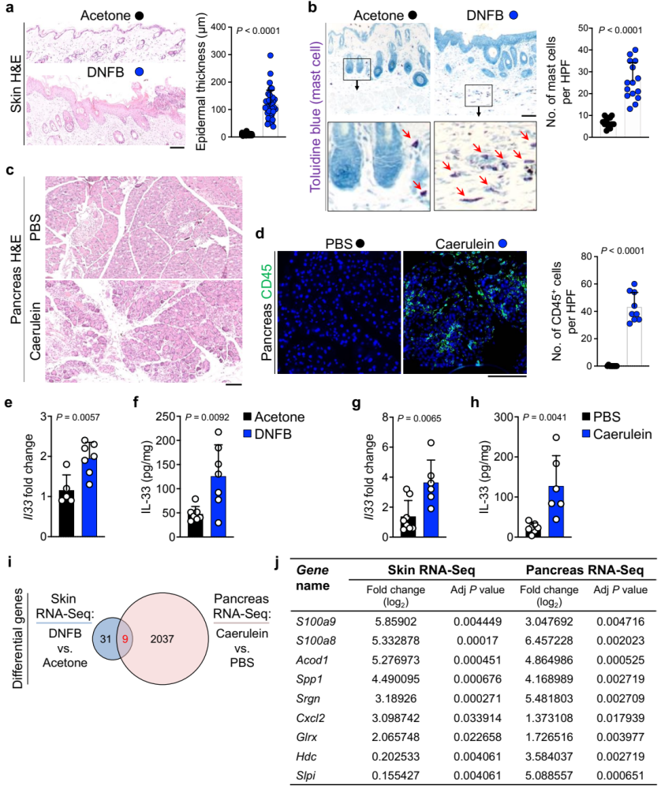

Extended Data Fig. 1. IL-33 induction is associated with DAMPs upregulation in chronic inflammation.

a, (Left) Representative images of H&E-stained skin of DNFB- and acetone-treated WT mice. (Right) The epidermal thickness of DNFB- and acetone-treated WT skin. Each dot represents the average of three measurements in an HPF image. Ten random HPF images per skin sample are included (n=4 in each group).

b, (Left) Representative images of toluidine blue-stained skin of DNFB- and acetone-treated WT mice. Insets and red arrows highlight mast cells in purple. (Right) Quantification of mast cells in DNFB- and acetone-treated WT skin. Each dot represents cell counts from an HPF image. Five randomly selected HPF images are included per sample (n=3 in each group).

c, Representative images of H&E-stained pancreas of caerulein- and PBS-treated WT mice.

d, (Left) Representative images of CD45-stained pancreas of caerulein- and PBS-treated WT mice. (Right) CD45⁺ immune cell counts in caerulein- and PBS-treated WT pancreas. Each dot represents cell counts from an HPF image. Three randomly selected HPF images are included per sample (n=3 in each group).

e, Il33 expression in DNFB- versus acetone-treated WT skin (n=7 in DNFB and n=5 in acetone group).

f, IL-33 protein levels in DNFB- versus acetone-treated WT skin (n=7 in each group).

g, Il33 expression in caerulein- versus PBS-treated WT pancreas (n=6 in caerulein and n=8 in PBS group).

h, IL-33 protein levels in caerulein- versus PBS-treated WT pancreas (n=6 in caerulein and n=7 in PBS group).

i, Venn diagram of shared differentially expressed genes from RNA sequencing (RNA-Seq) of the DNFB-treated skin and caerulein-treated pancreas compared with acetone- and PBS-treated controls, respectively.

j, The list of nine differentially expressed genes shared between chronically inflamed skin and pancreas. Graphs show mean + SD, unpaired t test, scale bar: 100 μm.
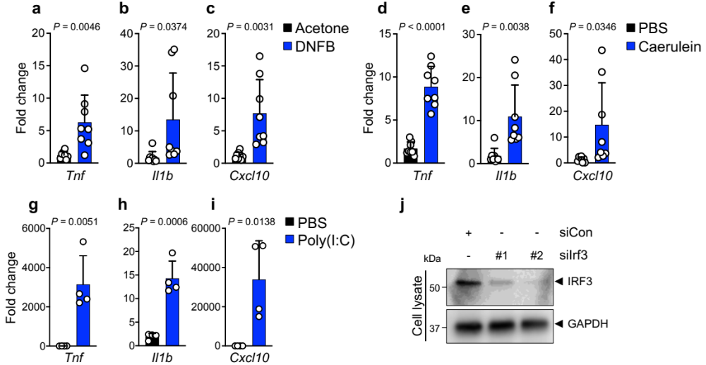

Extended Data Fig. 2. IRF3 target genes are increased in chronic inflammation.
a-c, Tnf (a), Il1b (b), and Cxcl10 (c) expression in DNFB- versus acetone-treated WT skin (n=8 in each group).
d-f, Tnf (d), Il1b (e), and Cxcl10 (f) expression in caerulein- versus PBS-treated WT pancreas (n=8 in each group).

g-i, Tnf (g), Il1b (h), and Cxcl10 (i) expression in poly(I:C) versus PBS-treated Pam212 cells (n=4 in each group).

j, Immunoblot of IRF3 and GAPDH proteins in siIrf3- versus siCon-treated Pam212 cells.

Graphs show mean + SD, unpaired t test.
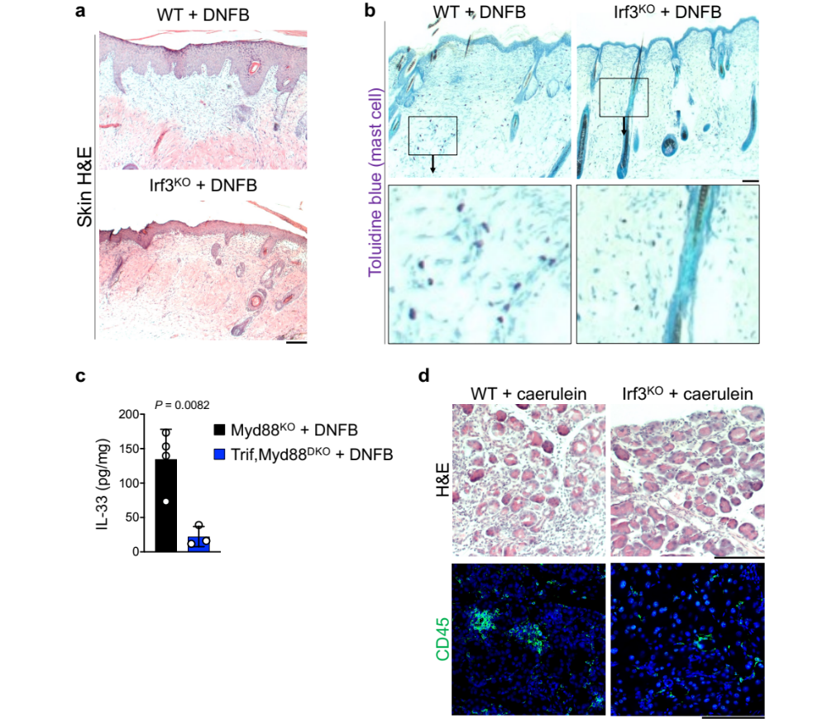

Extended Data Fig. 3. IRF3 is required for the development of chronic inflammation.

a, Representative images of H&E-stained skin of DNFB-treated WT or Irf3^{KO} mice.

b, Representative images of toluidine blue-stained skin of DNFB-treated WT or Irf3^{KO} mice. Insets highlight the dense collection of mast cells (purple) in WT skin compared with infrequent mast cells in Irf3^{KO} skin.

c, IL-33 protein levels in DNFB-treated Myd88^{KO} and Trif,Myd88^{DKO} skin (n=4 in Myd88^{KO} and n=3 in Trif,Myd88^{DKO} group).

d, Representative images of H&E- and CD45-stained pancreas of caerulein-treated WT and Irf3^{KO} mice.

Graphs show mean + SD, unpaired t test, scale bar: 100 μm.
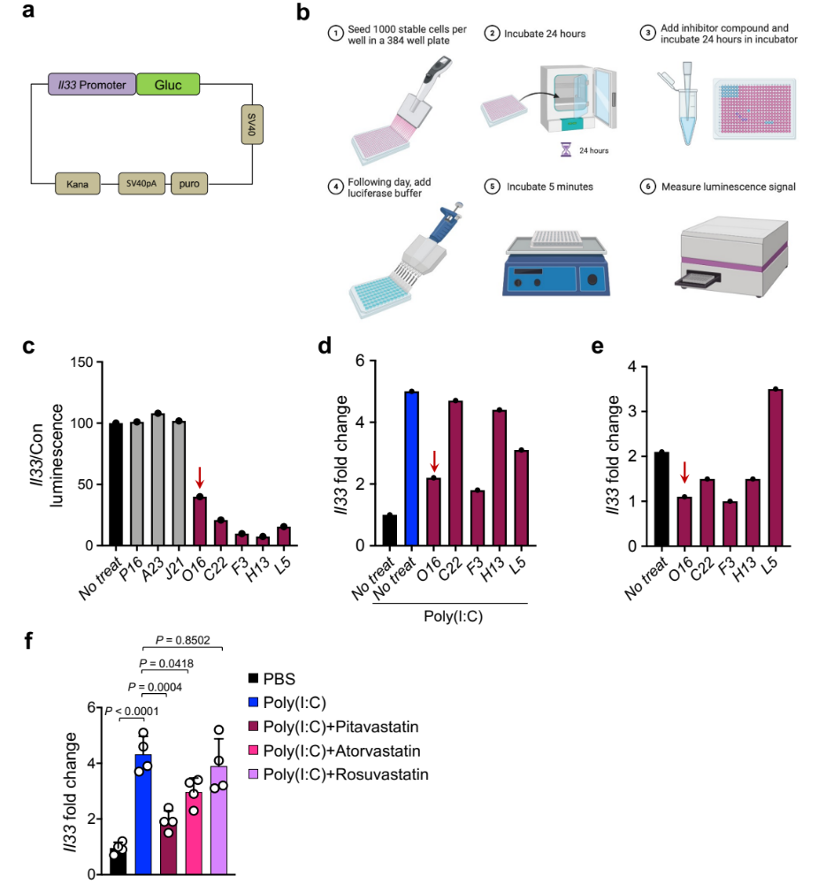

Extended Data Fig. 4. Small molecule IL-33 inhibitor discovery platform.

a, Schematic of Il33 gene promoter vector construct for FDA-approved drug library screening.

b, Schematic method of luciferase screening assay.

c, Candidate compounds with inhibitory effect on Il33 reporter.

d, Candidate inhibitory compounds’ effect on Il33 expression induced by poly(I:C) in Pam212 cells. The red arrow points to pitavastatin calcium (labeled as O16 in the screening process).

e, Inhibitory effect of 5 candidate drugs on endogenous Il33 expression in PyMt^{tg} breast cancer cell line.

f, Il33 expression in poly(I:C)-treated Pam 212 cells that received pitavastatin, atorvastatin versus rosuvastatin (n=4 in each group).

Graphs show mean + SD, one-way ANOVA.
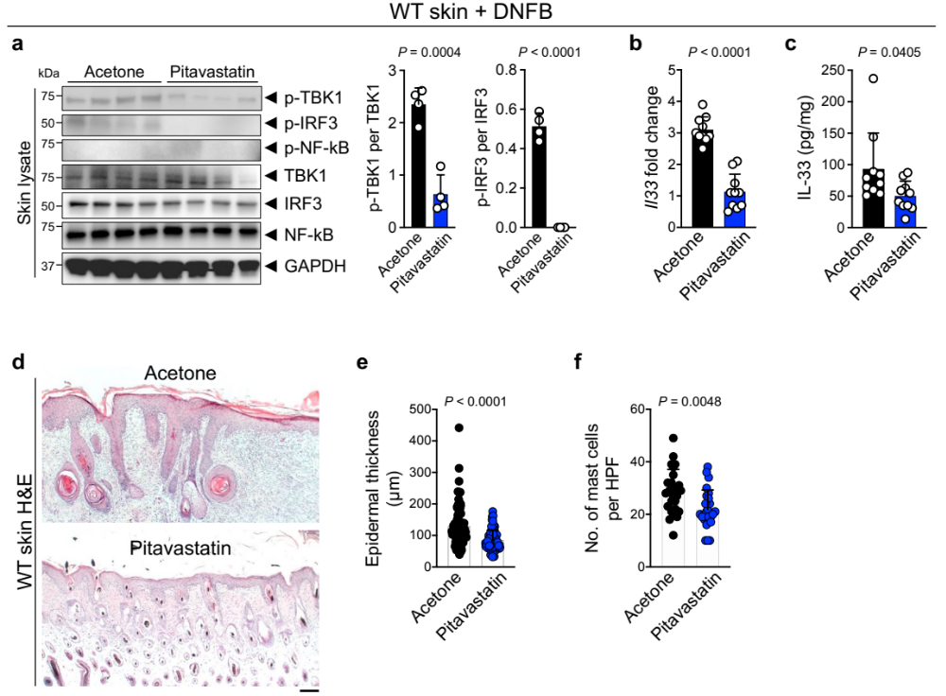

Extended Data Fig. 5. Pitavastatin blocks chronic inflammation in the skin.

a, (Left) Immunoblot of p-TBK1, p-IRF3, p-NF-kB, TBK1, IRF3, NF-kB, and GAPDH proteins in topical pitavastatin- versus acetone-treated WT skin at the completion of DNFB treatment protocol (n=4 in each group). (Right) The ratio of p-TBK1/TBK1 and p-IRF3/IRF3 protein band intensity quantified from the immunoblot shown on the left.

b, Il33 expression in pitavastatin- versus acetone-treated WT skin at the completion of DNFB treatment protocol (n=10 in each group).

c, IL-33 protein levels in pitavastatin- versus acetone-treated WT skin at the completion of DNFB treatment protocol (n=10 in each group).

d, Representative images of H&E-stained skin from pitavastatin- and acetone-treated WT mice at the completion of DNFB treatment protocol.

e, Epidermal thickness of pitavastatin- versus acetone-treated WT skin at the completion of DNFB treatment protocol. Each dot represents the average of three measurements in an HPF image. Ten random HPF images per skin sample are included (n=8 in each group).

f, Mast cell counts in pitavastatin- versus acetone-treated WT skin at the completion of DNFB treatment protocol. Each dot represents cell counts from an HPF image. Five randomly selected HPF images are included per sample (n=5 in each group).

Graphs show mean + SD, unpaired t test, scale bar: 100 μm.
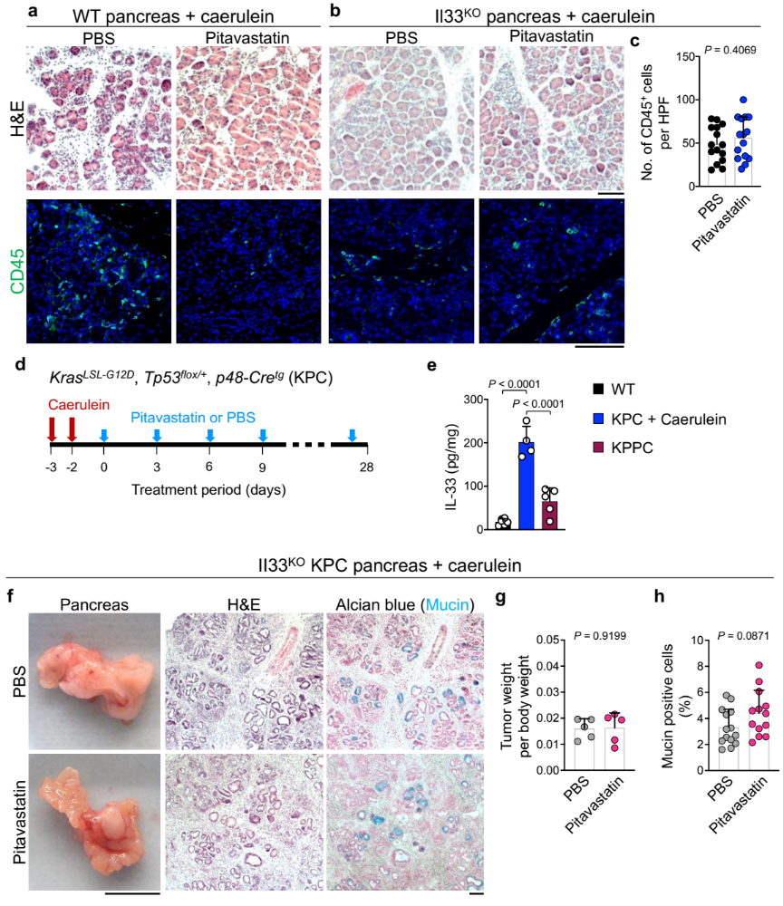

Extended Data Fig. 6. Pitavastatin blocks chronic pancreatitis and its cancer sequela in an IL-33-dependent manner.

a, Representative images of H&E- and CD45-stained pancreas from pitavastatin- and PBS-treated WT mice at the completion of the caerulein treatment protocol.

b, Representative images of H&E- and CD45-stained pancreas from pitavastatin- and PBS-treated Il33^{KO} mice at the completion of the caerulein treatment protocol.

c, CD45⁺ immune cell counts in pitavastatin- and PBS-treated Il33^{KO} pancreas at the completion of the caerulein treatment protocol. Each dot represents cell counts from an HPF image. Three randomly selected HPF images are included per sample (n=5 in each group).

d, Schematic diagram of the experimental design for the induction of chronic inflammation-associated pancreas cancer in mice. KPC mice received seven hourly intraperitoneal caerulein injections over two days, followed by intraperitoneal pitavastatin versus PBS injections once every three days over four weeks.

e, IL-33 protein levels in WT, caerulein-treated KPC, and KPPC (Tp53 homogenous floxed mouse) (n=6 in WT, n=4 in caerulein-treated KPC, and n=5 in KPPC group).

f, Representative images of macroscopic, H&E, and Alcian blue-stained pancreatic tumors from pitavastatin- versus PBS-treated Il33^{KO} KPC mice that underwent caerulein-induced pancreatic cancer protocol.

g, Ratio of pancreatic tumor per body weight in pitavastatin- versus PBS-treated Il33^{KO} KPC mice at the completion of caerulein-induced pancreatic cancer protocol (n=5 in each group).

h, Percent mucin-positive cells in pitavastatin- versus PBS-treated Il33^{KO} KPC tumors at the completion of caerulein-induced pancreatic cancer protocol. Each dot represents % mucin-positive cells in an HPF image. Two to three randomly selected HPF images are included per sample (n=5 in each group).

Graphs show mean + SD, unpaired t test, one-way ANOVA for Extended Fig 6e, scale bars: 1cm (macroscopic images), 100 μm (microscopic images).
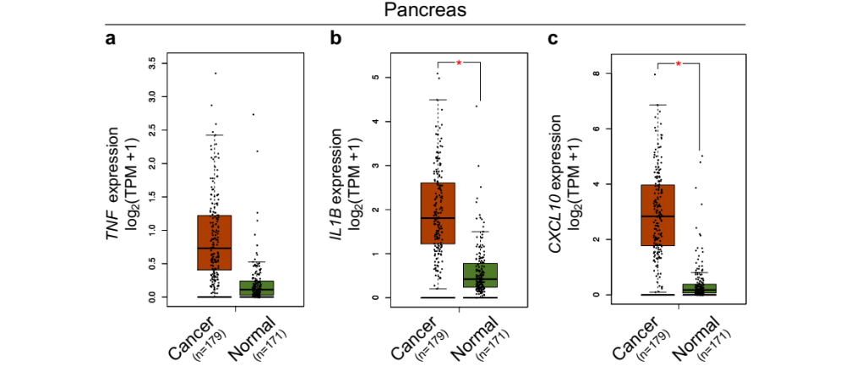

Extended Data Fig. 7. IRF3 target genes are upregulated in human pancreatic cancer.

a-c, Box plot of TNF (a), IL1B (b), and CXCL10 (c) expression in pancreatic cancer versus normal pancreas across TCGA/GTEx datasets (* P < 0.01, one-way ANOVA, Gene Expression Profiling Interactive Analysis database).

SUPPLEMENTARY TABLES

Supplementary Table S1.
Baseline Characteristics: Matched Cohorts
 |  | Pitavastatin |  | Ezetimibe
Number of patients |  | 242,645 |  | 242,645
Age at index (years) |  | Mean | SD | Mean | SD
 |  | 63.8 | 10.9 | 63.4 | 11.7
Gender |  | N | % | N | %
 | Male | 102,968 | 42.436 | 101,989 | 42.032
 | Female | 139,588 | 57.528 | 140,591 | 57.941
 | Unknown | 89 | 0.037 | 65 | 0.027
Race |  | Mean | % | Mean | %
 | White | 79,571 | 32.793 | 76,501 | 31.528
 | Black | 6,103 | 2.515 | 5,829 | 2.402
 | Asian | 1,624 | 0.669 | 876 | 0.361
 | American Indian or  Alaska Native | 0 | 0 | 0 | 0
 | Native Hawaiian and  Other Pacific Islander | 0 | 0 | 0 | 0
 | Unknown | 155,347 | 64.022 | 159,439 | 65.709
Ethnicity |  | Mean | % | Mean | %
 | Hispanic or Latino | 4,433 | 1.827 | 4,500 | 1.855
 | Not Hispanic or Latino | 84,913 | 34.995 | 80,960 | 33.366
 | Unknown | 153,299 | 63.178 | 157,185 | 64.78

Supplementary Table S2. Antibodies, staining kits, and primers information.
Western blotting Antibodies | Clone | Company

Primary antibodies
p-TBK1 | D52C2 | Cell Signaling Technology, Danvers, MA
p-IRF3 | D601M | Cell Signaling Technology
p-NF-κB | 93H1 | Cell Signaling Technology
TBK1 | D1B4 | Cell Signaling Technology
IRF3 | D83B9 | Cell Signaling Technology
GAPDH | D16H11 | Cell Signaling Technology
Anti-mouse IL-33 | Polyclonal | R&D Systems, Minneapolis, MN
NF-κB | D14E12 | Cell Signaling Technology
Na,K-ATPase | Polyclonal | Cell Signaling Technology

Secondary antibodies | Cat # | Company
Peroxidase Goat Anti-Mouse IgG | 115-035-003 | Jackson ImmunoResearch, West Grove, PA
Peroxidase Goat Anti-Rabbit IgG | 111-035-003 | Jackson ImmunoResearch

siRNA | Cat # | Company
siTrif (siTicam1) | 4390771 | Thermo Fisher Scientific, Waltham, MA
siIrf3 | SI00210770 | QIAGEN, Hilden, Germany
siCon | 1022076 | QIAGEN

Immunostaining antibodies | Clone | Company
IL-33 (mouse) | Nessy-1 | ENZO, Farmingdale, NY
IL-33 (human) | Polyclonal | Sigma, St. Louis, MO
IRF3 (human) | SL-12 | Santa Cruz Biotechnology, Dallas, TX

Staining kits | Cat # | Company
Antigen unmasking solution | H3300 | Vector Laboratories, Burlingame, CA
VECTASTAIN Elite ABC universal Kit | PK6200 | Vector Laboratories
ImmPACT DAB chromogen staining kit | SK-4105 | Vector Laboratories

Immunofluorescence staining Antibodies | Clone | Company
CD45 | Polyclonal | Abcam, Waltham, MA

Secondary antibodies | Cat # | Company
Goat anti-Rabbit IgG, Alexa Fluor 488 conjugate | A11034 | Thermo Fisher Scientific, Waltham, MA

qPCR primers | Cat # | Company

Taqman
Il33 | Mm.PT.58.  12022572 | Integrated DNA Technologies, Coralville, Iowa
Gapdh | Mm.PT.39a.1 | Integrated DNA Technologies

SYBR green
Tnf | forward: CCCTCACACTCAGATCATCTTCT  reverse: GCTACGACGTGGGCTACAG
Il1b | forward: TGACGGACCCCAAAAGATGA  reverse: TGCTGCTGCGAGATTTGAAG
Cxcl10 | forward: GTGTTGAGATCATTGCCACGA  reverse: GCGTGGCTTCACTCCAGTTAA
Gapdh | forward: AATGTGTCCGTCGTGGATCTGA  reverse: GATGCCTGCTTCACCACCTTCT
Il33 promoter | forward: GAAACTCATGCAGACTGTTGACCAA  reverse: GTGCACGATTCTTAGAAAATGTT

PCR primers for mouse genotyping
Gene name
IL-33 | forward: GAGAGATCAAATGAGGCC
 | forward mutant: GGTCGCTACCATTACCAG
 | reverse: GCTGGAGACCAGACTTGT
Kras- LSL-G12D | forward wild-type: GTCGACAAGCTCATGCGGG
 | forward mutant: CCATGGCTTGAGTAAGTCTGC
 | reverse: CGCAGACTGTAGAGCAGCG
Cre | forward: GCATTACCGGTCGATGCAACGAGTGATGAG
 | reverse: GAGTGAACGAACCTGGTCGAAATCAGTGCG
P53 flox | forward: GGTTAAACCCAGCTTGACCA
 | reverse: GGAGGCAGAGACAGTTGGAG
Trif | forward: AGATGGTTCAGCTGGGTGTC
 | reverse wild-type: GGTTCTCCGAACACTCAGTC
 | reverse mutant: GGTTCTCCGAACACTCAGTT
MyD88 | forward wild-type: GTTGTGTGTGTCCGACCGT
 | forward mutant: CCACCCTTGATGACCCCCTA
 | reverse: GTCAGAAACAACCACCACCATGC
IRF3 | common: GAACCTCGGAGTTATCCCGAAGG
 | wt: GTTTGAGTTATCCCTGCACTTGGG
 | mut: TCGTGCTTTACGCTATCGCCGCTCCCGATT

