Food profiling using innovative voltammetric metallic-glassy carbon electrodes evaluated by clustering metrics

Szymon WÓJCIK ª, Valentin MIRCESKI ^{b,c,d}, Bogusław BAŚ ª, Małgorzata JAKUBOWSKA ª*

ª AGH University of Science and Technology, Faculty of Materials Science and Ceramics,
30-059 Kraków, al. Mickiewicza 30, Poland
^{b} Department of Inorganic and Analytical Chemistry, University of Lodz, Tamka 12, 91-403 Lodz, Poland
^{c} Institute of Chemistry, Faculty of Natural Sciences and Mathematics, “Ss Cyril and Methodius” University, P.O. Box 162, Skopje, North Macedonia
^{d} Research Center for Environment and Materials, Macedonian Academy of Sciences and Arts, Bul. Krste Misirkov 2, Skopje, North Macedonia

Fig. S1. Comparison of the signals recorded in the overall SW cathodic potential direction sampled with the current sampling frequency of 1 kHz, directly measured current samples: a) compilation for three different electrodes for the yellow isotonic drink, b) enlarged fragment of a), c) compilation for the tested isotonic drinks obtained on the qDIrPt electrode, d) enlarged fragment of c). Potential window: -1000 to 1000 mV.

Fig. S2. Net-voltammograms recorded in cathodic potential direction on the qDPtGCE for three dyes dissolved in a white isotonic drink: a) interpretation using the SWV technique, b) interpretation using the DSSWV technique. The concentration of each dye is: 0.01 gL⁻¹.

Fig. S3. Net-SWV signals recorded in cathodic potential direction for individual isotonic drinks (data for profiling), recorded on the electrodes: a) qDPtGC, b) qDIrGC, c) qDIrPt.

Fig. S4. Net-DSSWV signals recorded in cathodic potential direction for individual isotonic drinks (data for profiling), recorded on the electrodes: a) qDPtGC, b) qDIrGC, c) qDIrPt.

Fig. S5. Silhouette indices for all 12 datasets considered, assuming k = 5. The arrows indicate those datasets for which each of the coefficients indicated that the optimal value of k for k-means is 5 (A - anodic scan, C - cathodic scan).

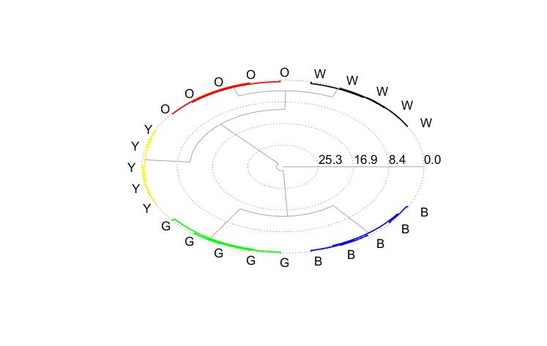
Fig. S6. Polar dendrogram for the best experimental variant, i.e. for cathodic waveforms recorded with qDIrPtE, using the DSSWV technique.

*Corresponding autor

