Comparative ecotoxicity of graphene, functionalized multiwalled CNT and their mixture in freshwater microalgae, Scenedesmus obliquus: Analysing the role of oxidative stress

Soupam Dasª, Sayani Giriª, Gaurav Wadhwaª, Mrudula Pulimiª, Shalini Anand^{b}, Natarajan Chandrasekaranª, Seyed ali Johari^{c}, Pramod Kumar Rai^{b}, Amitava Mukherjee*

ª Centre for Nanobiotechnology, Vellore Institute of Technology, Vellore, Tamil Nadu, India
^{b} Centre for Fire, Explosives and Environment Safety, Timarpur, Delhi 110054, India

^{c} Aquaculture Department, Faculty of Natural Resources, University of Kurdistan, Kurdistan, Iran.

*Corresponding author
Dr. Amitava Mukherjee
Senior Professor & Director
Centre for Nanobiotechnology
Vellore Institute of Technology, Vellore – 632014, India.
Email: amit.mookerjea@gmail.com, amitav@vit.ac.in
Phone: 91 416 2202620
Fax: 91-416-224309

Supplementary information
Tables:
Table S1: EC₁₀, EC₅₀, and EC₉₀ values of f-MWCNT and Graphene nanoparticles

Nanoparticles | EC₁₀ | EC₅₀ | EC₉₀
f-MWCNT | 2.34 | 29.27 | 365.82
Graphene | 1.02 | 17.48 | 297.86

Figures:
Fig S1: (A) XRD plot of f-MWCNT nanoparticles (B) and the corresponding FTIR spectra
Fig S2: (A) XRD plot of Graphene nanoparticles (B) and the corresponding FTIR spectra
Fig S3: FE-SEM image of f-MWCNT and Graphene dispersed in Milli-Q

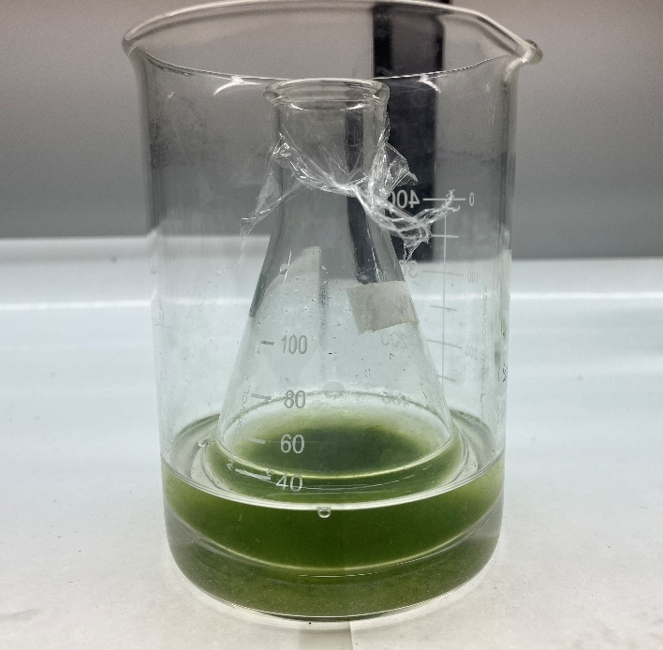
Fig. S4. Experimental setup for the examination of shading effect. As shown in the photo, the 100-mL conical flasks pre-incubated with exponentially growing algal cells were placed into 500 mL beakers which already contained NPs suspensions (1 mg/L) prepared in the algal medium. The level of NPs suspension in the beaker was kept at the same height with that of algal suspension in the conical flask. The algal cell numbers in the conical flasks were counted after shading with NPs suspension for 72 h. The contribution (%) of shading effect on algal growth inhibition was then calculated.

Fig. S5: Contribution of shading effect to the total toxicity of the nanoparticles

