Suplementary Information

A universal karyotypic system for hexaploid and diploid Avena species brings oat cytogenetics into the genomics era

Wenxi Jiang¹, Chengzhi Jiang¹, Weiguang Yuan¹, Meijun Zhang², Zijie Fang¹, Yang Li¹, Guangrong Li¹, Juqing Jia^{2,}* and Zujun Yang ^{1,}*
¹Center for Informational Biology, School of Life Science and Technology, University of Electronic and Technology of China, Chengdu 611731, China
²College of Agronomy, Shanxi Agricultural University, Taigu 030801, China
*Corresponding authors:
Juqing Jia, E-mail: jiajuqing@126.com
Zujun Yang, E-mail: yangzujun@uestc.edu.cn

Additional files
Table S1. The predicted total TRs in oat chromosomes by TRF.
chromosome | TR total length (bp) | Chromosome Length (bp) | TR content (%)
1A | 13716046 | 542795238 | 2.53
2A | 12331120 | 454026946 | 2.72
3A | 15077311 | 426317889 | 3.54
4A | 17454436 | 462057589 | 3.78
5A | 12271647 | 485535456 | 2.53
6A | 6297372 | 431567647 | 1.46
7A | 8190218 | 493489733 | 1.66
1C | 24229298 | 463431985 | 5.23
2C | 40130565 | 585391692 | 6.86
3C | 45492946 | 636099650 | 7.15
4C | 38144143 | 552251759 | 6.91
5C | 39100967 | 612252875 | 6.39
6C | 54168228 | 624915216 | 8.67
7C | 49889994 | 731989224 | 6.82
1D | 11055156 | 485732902 | 2.28
2D | 13662316 | 532459853 | 2.57
3D | 6727829 | 467934025 | 1.44
4D | 13884029 | 424978419 | 3.27
5D | 12012596 | 502323219 | 2.39
6D | 3349097 | 301592285 | 1.11
7D | 10026839 | 529301501 | 1.89

Table S2. Distribution and copy number prediction of Centromeric repeats Oligo-CCS1
Chromosome | Position (Mb) | Copy number
1A | 150-160 | 522
2A | 149-162 | 620
3A | 183-193 | 497
4A | 113-128 | 692
5A | 211-226 | 894
6A | 130-144 | 686
7A | 161-174 | 743
1D | 142-152 | 558
2D | 154-169 | 647
3D | 181-196 | 573
4D | 111-132 | 619
5D | 176-196 | 625
6D | 95-106 | 555
7D | 214-233 | 747

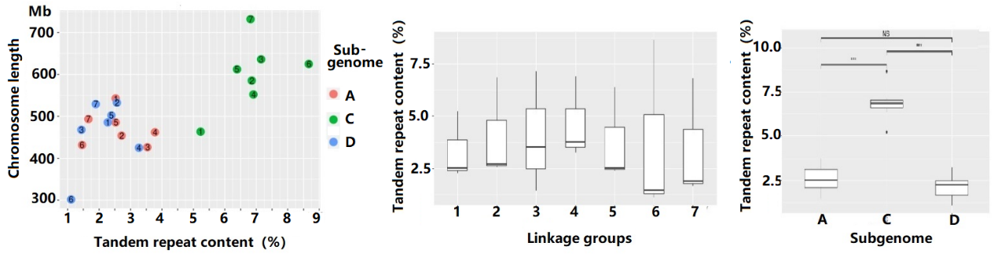
Fig. S1. The genomic distribution of TRs in assembled oat genome revealed by each chromosome (a), linkage group (b) and sub-genomes (c).

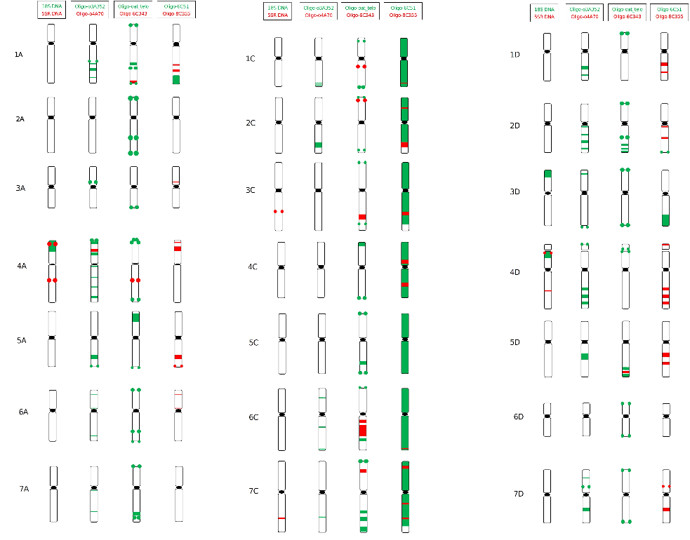
Fig. S2. ND-FISH karyotype of A. sativa revealed by multiple oligo probes of tandem repeats

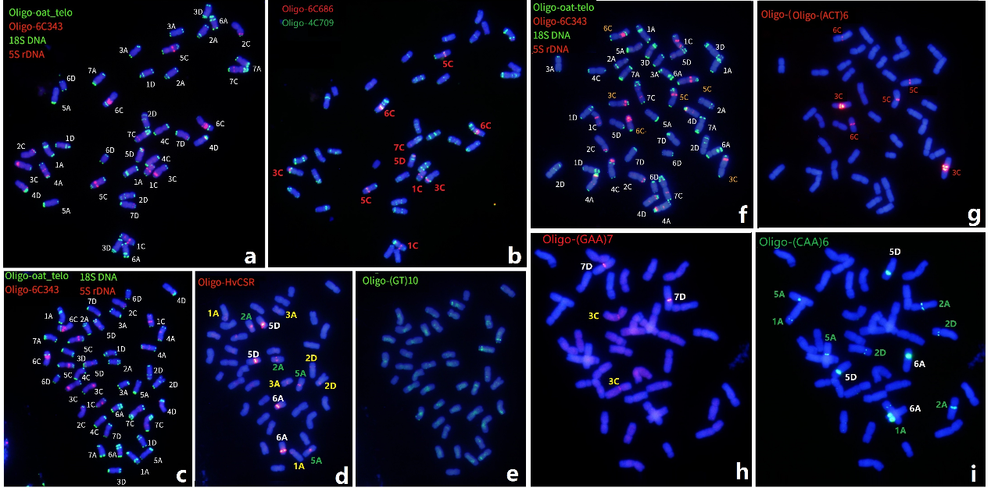
Fig. S3. Sequential ND-FISH based on hybridizing tandem repeat (TR) Oligo-probes onto metaphase chromosomes of oat cv. BaiyanII.
The probes used are: Oligo-oat-Telo + Oligo-6c343 + Oligo-18SrDNA + Oligo-5SrDNA (a, c, f), Oligo-6C686 + Oligo-4C70 (b), Oligo-HvCSR (d), SSR motifs of Oligo-(GTT)10 (e), Oligo-(ACT)6 (g), Oligo-(GAA)7 (h), and Oligo-(CAA)6 (i). The chromosomal locations of the hybridized probes are marked on each figure.

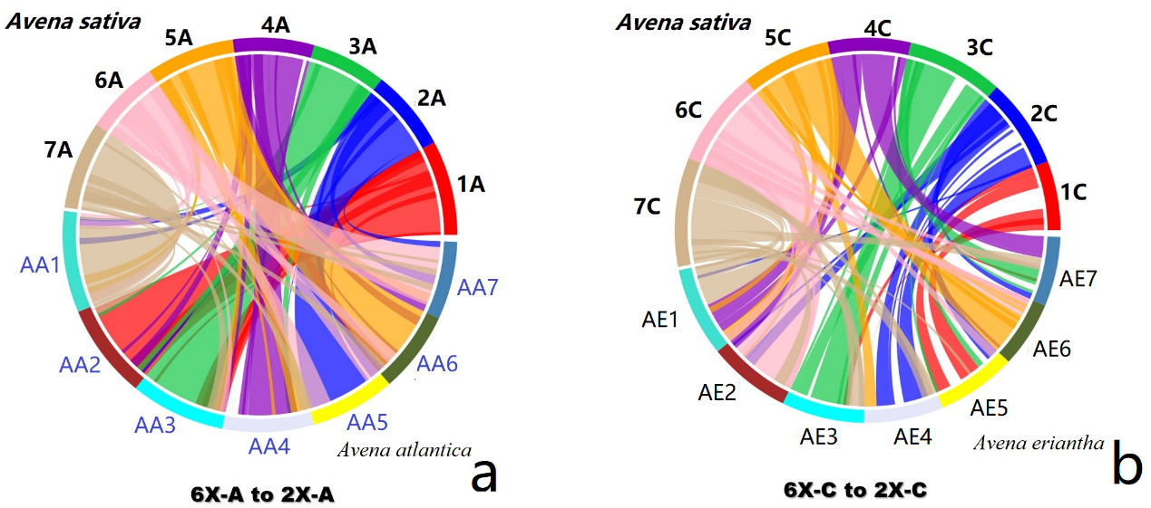
Fig. S4. The comparison between the A. sativa A-genome to A. atlantica AA-genome (a), and the A. eriantha AE genome (b), by Circos software with the annotated genes.

