Intra-dialytic Blood Pressure Variability Is a Greater Predictor of Cardiovascular Events in Hemodialysis Patients
Qixing Liu¹, Wei Wang², Xianglan Wu², Jiaxuan Lv², Shiming Cai², Yuehong Li².

Corresponding author: Yuehong Li, Email: lyha01051@btch.edu.cn.
Affiliation:
1 School of Medicine, Tsinghua University, Beijing, China.
2 Department of Nephrology, Beijing Tsinghua Changgung Hospital, Tsinghua University, Beijing, China.

Supplementary Material

Calculation of BPV metrics
Intra-dialytic SD is calculated as follows, where SBP represents peri-dialytic SBP among the 3 months exposure period, n represents the number of peri-dialytic SBP readings. The schematic plot is shown in Supplementary Fig. 1a.
$$SD= \frac{\sum_{i=1}^{n}{{({SBP}_{i}-\overline{SBP})}^{2}}}{n-1}$$
Intra-dialytic CV is calculated by intra-dialytic SD divided by the mean peri-dialytic SBP.
Intra-dialytic VIM is calculated by the equation shown below. m is a constant acquired by fitting a power model as follows. k is also a constant calculated from m. SD represents intra-dialytic SD, $\overline{SBP}$ represents the mean peri-dialytic SBP for each patient, and $\overset{̿}{SBP}$ is the mean peri-dialytic SBP of all patients. As for intra-dialytic VIM in this study, k=61.04278, m=0.8337003.
$$VIM=k×{SD}/{{\overline{SBP}}^{m}}$$
$$SD=constant×{\overline{SBP}}^{m}$$
$$k={\overset{̿}{SBP}}^{m}$$
Intra-dialytic ARV is the average ARV of all dialysis sessions during the exposure period. The calculation of ARV is shown as follows. SBP_{k} means the k^{th} reading of SBP, and n means the number of readings for each session. The schematic plot is shown in Supplementary Fig. 1b.
$$ARV= \frac{\sum_{k=1}^{n-1}{|{SBP}_{k+1}-{SBP}_{k}|}}{n-1}$$
Intra-dialytic residual is the average residual of peri-dialytic SBP readings from the predicted values estimated by fitting a 2-slope mixed-effects linear model with main effect terms for the time during a dialysis session. A typical dialysis session lasts for 4h. Hence, we decided to set the knot at 1h (at 0.25 proportion of HD elapsed). The schematic plot is shown in Supplementary Fig. 1c.
Visit-to-visit SD is calculated using pre-dialytic SBP among the 3 months exposure period. The calculation is the same as intra-dialytic SD. The schematic plot is shown in Supplementary Fig. 1d.
Visit-to-visit CV is calculated by visit-to-visit SD divided by the mean pre-dialytic SBP.
Visit-to-visit VIM is calculated using the same equation and model as intra-dialytic VIM. SD represents visit-to-visit SD, $\overline{SBP}$ represents the mean pre-dialytic SBP for each patient, and $\overset{̿}{SBP}$ is the mean pre-dialytic SBP of all patients. As for visit-to-visit VIM in this study, k=56.61194, m=0.8138768.
Visit-to-visit ARV is the ARV of pre-dialytic SBP during the exposure period. The equation is the same as that for intra-dialytic ARV. SBP_{k} means the pre-dialytic SBP of k^{th} dialysis session, and n means the number of dialysis sessions. The schematic plot is shown in Supplementary Fig. 1e.
Visit-to-visit residual is the average residual of pre-dialytic SBP readings from the predicted values estimated by a mixed-effects linear model over time. The schematic plot is shown in Supplementary Fig. 1f.
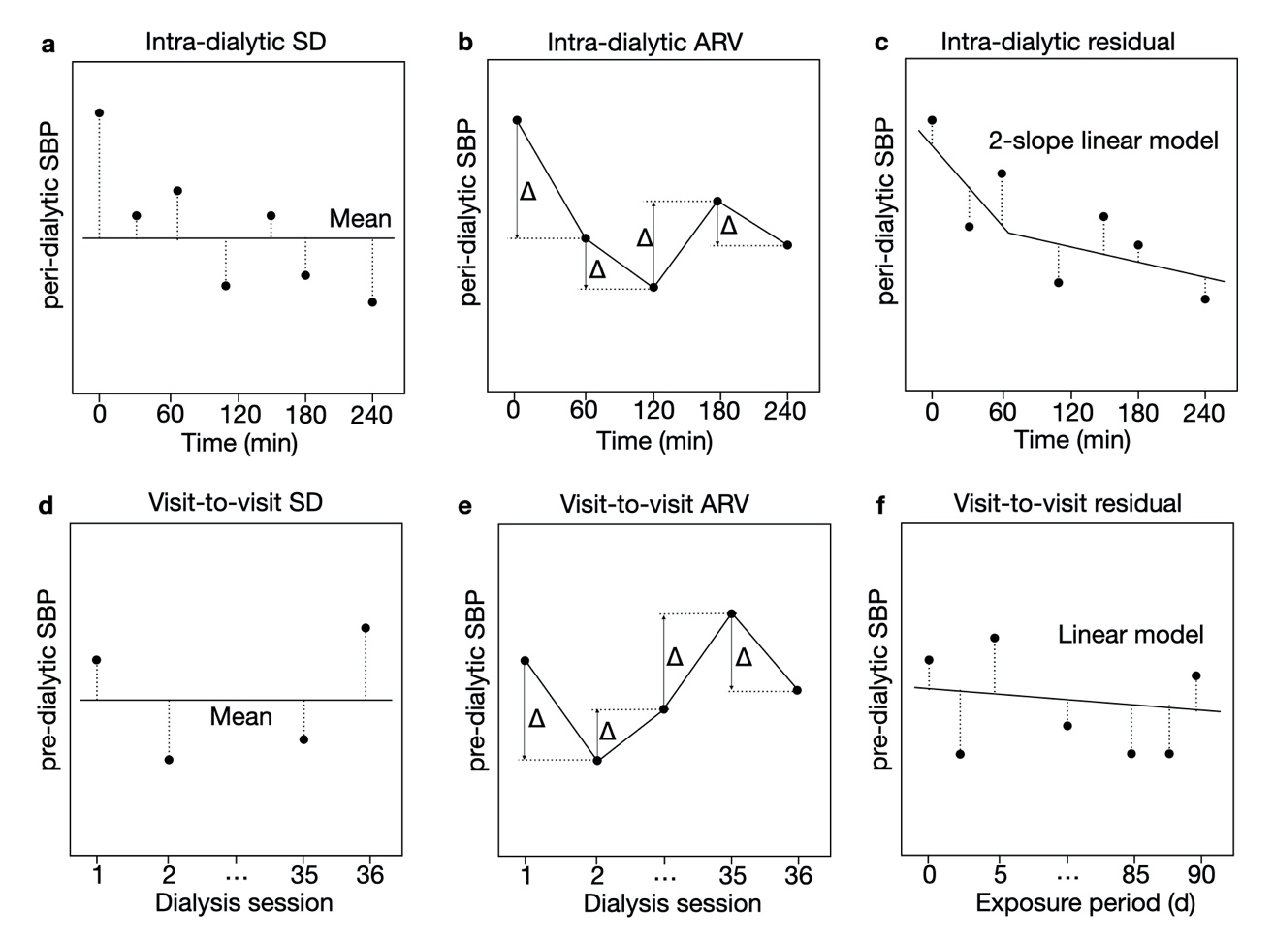
Supplementary Fig. 1 Schematic diagram of BPV metrics
(a) intra-dialytic SD, the dashed line represents the deviation of each reading from the mean peri-dialytic SBP. (b) intra-dialytic ARV, Δ represents the deviation between consecutive peri-dialytic SBP readings. (c) intra-dialytic residual, the solid line represents a 2-slope mixed-effects linear model with a knot at 60min. The dashed line demonstrates the residual of peri-dialytic SBP readings from the predicted values using a 2-slope. (d) visit-to-visit SD, the dashed line represents the deviation of pre-dialytic SBP from the mean pre-dialytic SBP. (e) visit-to-visit ARV, Δ represents the deviation between consecutive pre-dialytic SBP readings. (f) visit-to-visit residual, the solid line represents a mixed-effects linear model over time. The dashed line demonstrates the residual of pre-dialytic SBP readings.
Table 1 Correlation coefficient between intra-dialytic/visit-to-visit BPV and covariates.
 | Intra-dialytic BPV |  |  |  |  |  | Visit-to-visit BPV
Coefficient | SD | CV | VIM | ARV | Residual |  | SD | CV | VIM | ARV | Residual
SD | 1.00 | 0.88 | 0.92 | 0.59 | 0.96 |  | 1.00 | 0.90 | 0.93 | 0.84 | 0.95
CV | 0.88 | 1.00 | 0.99 | 0.46 | 0.85 |  | 0.90 | 1.00 | 0.99 | 0.74 | 0.85
VIM | 0.92 | 0.99 | 1.00 | 0.50 | 0.89 |  | 0.93 | 0.99 | 1.00 | 0.77 | 0.88
ARV | 0.59 | 0.46 | 0.50 | 1.00 | 0.48 |  | 0.84 | 0.74 | 0.77 | 1.00 | 0.87
Residual | 0.96 | 0.85 | 0.89 | 0.48 | 1.00 |  | 0.95 | 0.85 | 0.88 | 0.87 | 1.00
SBP | 0.41 | -0.03 | 0.07 | 0.40 | 0.40 |  | 0.28 | -0.12 | -0.04 | 0.26 | 0.28
Age | 0.15 | 0.21 | 0.20 | 0.13 | 0.14 |  | 0.11 | 0.15 | 0.14 | 0.16 | 0.13
Gender | 0.02 | -0.05 | -0.03 | 0.08 | -0.01 |  | -0.03 | -0.09 | -0.07 | -0.09 | -0.04
Smoking | 0.04 | 0.02 | 0.03 | 0.10 | 0.02 |  | 0.04 | 0.02 | 0.03 | 0.02 | 0.03
Drinking | -0.05 | -0.05 | -0.05 | -0.07 | -0.08 |  | -0.07 | -0.07 | -0.07 | -0.10 | -0.09
DM | 0.27 | 0.18 | 0.20 | 0.20 | 0.24 |  | 0.26 | 0.13 | 0.16 | 0.17 | 0.22
Hyperlipidemia | 0.20 | 0.12 | 0.14 | 0.11 | 0.19 |  | 0.20 | 0.14 | 0.15 | 0.12 | 0.18
CVD history | 0.32 | 0.32 | 0.33 | 0.26 | 0.24 |  | 0.25 | 0.21 | 0.22 | 0.22 | 0.25
Tumor | 0.03 | 0.03 | 0.03 | -0.05 | 0.06 |  | -0.00 | 0.03 | 0.02 | -0.01 | 0.03
Kt/V | -0.12 | -0.05 | -0.07 | -0.02 | -0.10 |  | -0.07 | -0.00 | -0.02 | 0.01 | -0.06
IDWG | 0.08 | 0.05 | 0.06 | 0.26 | 0.06 |  | 0.06 | -0.03 | -0.01 | 0.03 | 0.00
UF | 0.08 | 0.09 | 0.10 | 0.20 | 0.07 |  | 0.08 | 0.01 | 0.02 | 0.05 | 0.04
Dry weight | 0.06 | -0.00 | 0.01 | 0.14 | 0.04 |  | 0.07 | -0.01 | 0.01 | -0.01 | 0.02
Alb | -0.23 | -0.27 | -0.26 | 0.02 | -0.18 |  | -0.11 | -0.16 | -0.15 | -0.16 | -0.15
Hb | -0.21 | -0.21 | -0.21 | 0.07 | -0.23 |  | -0.19 | -0.23 | -0.22 | -0.11 | -0.17
Cr | -0.03 | -0.05 | -0.05 | 0.17 | -0.03 |  | -0.03 | -0.08 | -0.07 | 0.04 | 0.01
K | 0.10 | 0.13 | 0.13 | 0.06 | 0.11 |  | 0.06 | 0.06 | 0.05 | 0.09 | 0.04
Ca | -0.12 | -0.11 | -0.12 | -0.01 | -0.12 |  | -0.02 | -0.02 | -0.03 | 0.05 | 0.02
P | -0.03 | 0.05 | 0.04 | -0.02 | -0.02 |  | -0.07 | -0.02 | -0.03 | -0.05 | -0.04
PTH | -0.01 | -0.02 | -0.01 | 0.15 | -0.01 |  | -0.08 | -0.12 | -0.12 | 0.01 | -0.07
Table 2 Characteristics of high and low CV groups
 | Intra-dialytic BPV |  |  | Visit-to-visit BPV
Parameter | Low CV | High CV | P value | Low CV | High CV | P value
Sample size | 70 | 50 |  | 65 | 55
Male, n (%) | 44 (62.9) | 30 (60.0) | 0.75 | 43 (66.2) | 31 (56.4) | 0.28
Age (years) | 59.59±15.18 | 64.02±12.57 | 0.16 | 59.02±15.31 | 64.29±12.46 | 0.09
SBP (mmHg) | 139.71±16.79 | 138.66±16.55 | 0.88 | 144.28±18.70 | 141.57±14.57 | 0.51
Smoking habit, n (%) | 20 (28.6) | 12 (24.0) | 0.58 | 16 (24.6) | 16 (29.1) | 0.58
Drinking habit, n (%) | 6 (8.6) | 3 (6.0) | 0.60 | 6 (9.2) | 3 (5.5) | 0.44
Comorbidities, n (%)  Diabetes mellitus | 32 (45.7) | 29 (58.0) | 0.19 | 29 (44.6) | 32 (58.2) | 0.14
Hyperlipidemia | 34 (48.6) | 27 (54.0) | 0.56 | 29 (44.6) | 32 (58.2) | 0.14
Hypertension | 57 (81.4) | 46 (92.0) | 0.10 | 52 (80.0) | 51 (92.7) | 0.05
Cardiovascular disease | 30 (42.9) | 29 (58.0) | 0.10 | 27 (41.5) | 32 (58.2) | 0.07
Malignant tumor | 10 (14.3) | 9 (18.0) | 0.59 | 9 (13.8) | 10 (18.2) | 0.52
Dialysis parameters
IDWG (kg) | 2.91±1.17 | 2.91±1.57 | 0.95 | 2.80±1.30 | 3.04±1.40 | 0.53
UF (L) | 1.96± 0.65 | 2.17±0.71 | 0.14 | 2.08±0.71 | 2.02±0.65 | 0.53
Dry weight (kg) | 64.39± 10.68 | 65.68±12.61 | 0.44 | 65.30±11.26 | 64.48±11.84 | 0.92
Kt/V | 1.42± 0.26 | 1.39±0.27 | 0.43 | 1.41±0.25 | 1.41±0.28 | 0.89
Laboratory parameters
Alb (g/L) | 40.14±2.67 | 38.67±3.45 | 0.02 | 39.79±3.33 | 39.22±2.78 | 0.15
Hb (g/L) | 115.76±11.84 | 109.44±15.41 | 0.02 | 114.96±12.44 | 110.95±14.97 | 0.09
Cr (umol/L) | 858.74± 243.40 | 856.61±278.74 | 0.87 | 884.63±243.76 | 826.20±271.84 | 0.17
BUN (mmol/L) | 26.19±4.94 | 25.80±5.96 | 0.87 | 26.97±4.28 | 24.93±6.28 | 0.06
K (mmol/L) | 4.97±0.65 | 5.23±0.80 | 0.12 | 5.08±0.70 | 5.07±0.76 | 0.96
Ca (mmol/L) | 2.18±0.15 | 2.17±0.18 | 0.84 | 2.17±0.15 | 2.18±0.18 | 0.95
P (mmol/L) | 1.80±0.41 | 1.83±0.51 | 0.29 | 1.84±0.42 | 1.78±0.50 | 0.77
PTH (pg/mL) | 235.03±157.99 | 216.70±145.91 | 0.53 | 239.34±167.36 | 213.28±133.50 | 0.45
TC (mmol/L) | 3.75±0.79 | 4.07±1.01 | 0.11 | 3.79±0.89 | 3.99±0.90 | 0.18
LDL (mmol/L) | 1.85±0.63 | 2.09±0.78 | 0.08 | 1.91±0.70 | 2.00±0.71 | 0.28
BPV metric
SD | 13.02±2.42 | 18.78±3.50 | <0.01 | 11.62±2.24 | 17.84±3.88 | <0.01
CV | 0.09±0.01 | 0.14±0.02 | <0.01 | 0.08±0.01 | 0.13±0.02 | <0.01
VIM | 0.05±0.01 | 0.08±0.01 | <0.01 | 0.05±0.01 | 0.08±0.01 | <0.01
ARV | 9.83±2.51 | 11.82±3.18 | <0.01 | 11.94±2.97 | 17.52±4.54 | <0.01
Residual | 9.49±1.79 | 13.80±2.73 | <0.01 | 8.67±1.78 | 13.32±3.27 | <0.01
Outcome
CVD event | 16 (0.23) | 26 (0.52) | <0.01 | 22 (0.34) | 20 (0.36) | 0.78
All-cause death | 14 (0.20) | 21 (0.42) | <0.01 | 17 (0.26) | 18 (0.33) | 0.43
Table 3 Univariate Cox regression analysis for confounders
 | CVD event |  | All-cause mortality
Variable | HR (95% CI) | p-value | HR (95% CI) | p-value
SBP | 1.006 (0.988-1.025) | 0.504 | 1.006 (0.985-1.028) | 0.587
Male | 1.815 (0.928-3.550) | 0.081 . | 2.850 (1.240-6.550) | 0.014 *
Age | 1.034 (1.008-1.061) | 0.010 ** | 1.042 (1.011-1.074) | 0.008 **
Smoking history | 2.497 (1.334-4.674) | 0.004 ** | 2.014 (1.007-4.026) | 0.048 *
Drinking history | 3.247 (1.138-9.264) | 0.028 * | 4.895 (1.851-12.940) | 0.001 **
Diabetes mellitus | 3.348 (1.645-6.815) | 0.001 ** | 1.315 (0.664-2.605) | 0.432
Hyperlipidemia | 2.219 (1.168-4.218) | 0.015 * | 1.269 (0.645-2.498) | 0.490
CVD history | 3.117 (1.618-6.006) | 0.001 ** | 1.971 (0.987-3.940) | 0.055 .
Malignant tumor | 1.247 (0.553-2.812) | 0.595 | 2.391 (1.113-5.138) | 0.026 *
IDWG | 1.031 (0.812-1.308) | 0.803 | 1.074 (0.839-1.374) | 0.572
Ultrafiltration volume | 0.879 (0.573-1.350) | 0.556 | 0.801 (0.493-1.302) | 0.371
Dry weight | 0.998 (0.972-1.024) | 0.862 | 0.996 (0.968-1.025) | 0.801
Kt/V | 0.352 (0.100-1.233) | 0.102 | 0.139 (0.030-0.649) | 0.012 *
Alb | 0.961 (0.868-1.065) | 0.446 | 0.904 (0.815-1.003) | 0.057 .
Hb | 0.976 (0.955-0.999) | 0.036 * | 0.972 (0.950-0.995) | 0.018 *
Cr | 0.998 (0.997-0.999) | 0.002 ** | 0.998 (0.997-0.999) | 0.004 **
K | 1.007 (0.665-1.524) | 0.975 | 0.869 (0.543-1.392) | 0.560
Ca | 0.380 (0.050-2.865) | 0.348 | 0.367 (0.038-3.582) | 0.389
P | 1.026 (0.517-2.038) | 0.941 | 0.780 (0.365-1.666) | 0.521
PTH | 1.000 (0.998-1.002) | 0.840 | 0.998 (0.996-1.001) | 0.194
TC | 1.049 (0.761-1.446) | 0.771 | 0.962 (0.653-1.417) | 0.845
LDL | 1.250 (0.853-1.832) | 0.253 | 1.002 (0.612-1.640) | 0.994
Confounders with p-value<0.1 are selected for adjustment. Although ultrafiltration volume and P doesn’t reach significance in the univariate Cox regression analysis, we still consider to include them as representative confounders due to the fact that mineral disorders and regular volume removal are two typical features of dialysis patients. The following confounders are adjusted in Cox proportional hazards model for CVD events: gender, age, smoking history, drinking history, DM, hyperlipidemia, CVD history, Hb, Cr, ultrafiltration volume and P. As for all-cause mortality, gender, age, smoking history, drinking history, tumor, Kt/V, Alb, Hb, Cr, ultrafiltration volume and P are adjusted. ‘.’ indicates p<0.1, ‘*’ indicates p<0.05, ‘**’ indicates p<0.01.
Table 4 Adjusted Cox regression model for intra-dialytic and visit-to-visit CV
 | CVD event |  | All-cause mortality
Variable | HR (95% CI) | p-value | HR (95% CI) | p-value
Intra-dialytic CV | 1.801 (1.224-2.649) | 0.003 ** | 1.282 (0.844-1.950) | 0.244
Male | 3.603 (1.459-8.897) | 0.005 ** | 7.340 (1.902-28.323) | 0.004 **
Age | 1.022 (0.988-1.057) | 0.202 | 1.041 (1.002-1.081) | 0.040 *
Smoking history | 2.121 (1.033-4.357) | 0.041 * | 0.762 (0.320-1.816) | 0.539
Drinking history | 2.939 (0.884-9.766) | 0.079 . | 7.771 (2.131-28.337) | 0.002 **
Diabetes mellitus | 1.362 (0.551-3.370) | 0.504
Hyperlipidemia | 1.137 (0.527-2.454) | 0.743
CVD history | 1.458 (0.650-3.272) | 0.361 | 1.039 (0.418-2.584) | 0.935
Malignant tumor |  |  | 2.352 (0.936-5.911) | 0.069 .
Ultrafiltration volume | 0.492 (0.285-0.850) | 0.011 * | 0.468 (0.240-0.912) | 0.026 *
Kt/V |  |  | 0.480 (0.051-4.559) | 0.523
Alb |  |  | 0.949 (0.820-1.010) | 0.488
Hb | 0.978 (0.955-1.002) | 0.076 . | 0.969 (0.945-0.994) | 0.016 *
Cr | 0.998 (0.996-1.000) | 0.030 * | 0.998 (0.996-1.000) | 0.052 .
P | 2.185 (1.008-4.736) | 0.048 * | 1.240 (0.498-3.090) | 0.644
Visit-to-visit CV | 1.476 (0.990-2.200) | 0.056 · | 1.134 (0.750-1.716) | 0.551
Male | 3.149 (1.305-7.600) | 0.011 * | 6.565 (1.799-23.959) | 0.004 **
Age | 1.030 (0.998-1.063) | 0.065 . | 1.043 (1.005-1.082) | 0.025 *
Smoking history | 1.923 (0.935-3.955) | 0.076 . | 0.804 (0.343-1.884) | 0.616
Drinking history | 2.392 (0.744-7.691) | 0.143 | 7.232 (2.045-25.574) | 0.002 **
Diabetes mellitus | 1.623 (0.675-3.902) | 0.279
Hyperlipidemia | 0.982 (0.460-2.100) | 0.963
CVD history | 1.612 (0.734-3.542) | 0.235 | 1.085 (0.441-2.666) | 0.859
Malignant tumor |  |  | 2.488 (1.010-6.134) | 0.048 *
Ultrafiltration volume | 0.535 (0.307-0.932) | 0.027 * | 0.486 (0.250-0.942) | 0.033 *
Kt/V |  |  | 0.458 (0.048-4.366) | 0.500
Alb |  |  | 0.949 (0.820-1.097) | 0.478
Hb | 0.979 (0.956-1.003) | 0.085 . | 0.969 (0.944-0.995) | 0.017 *
Cr | 0.998 (0.996-1.000) | 0.043 * | 0.998 (0.996-1.000) | 0.062 .
P | 2.592 (1.160-5.792) | 0.020 * | 1.402 (0.559-3.520) | 0.472
‘.’ indicates p<0.1, ‘*’ indicates p<0.05, ‘**’ indicates p<0.01.

