Legends
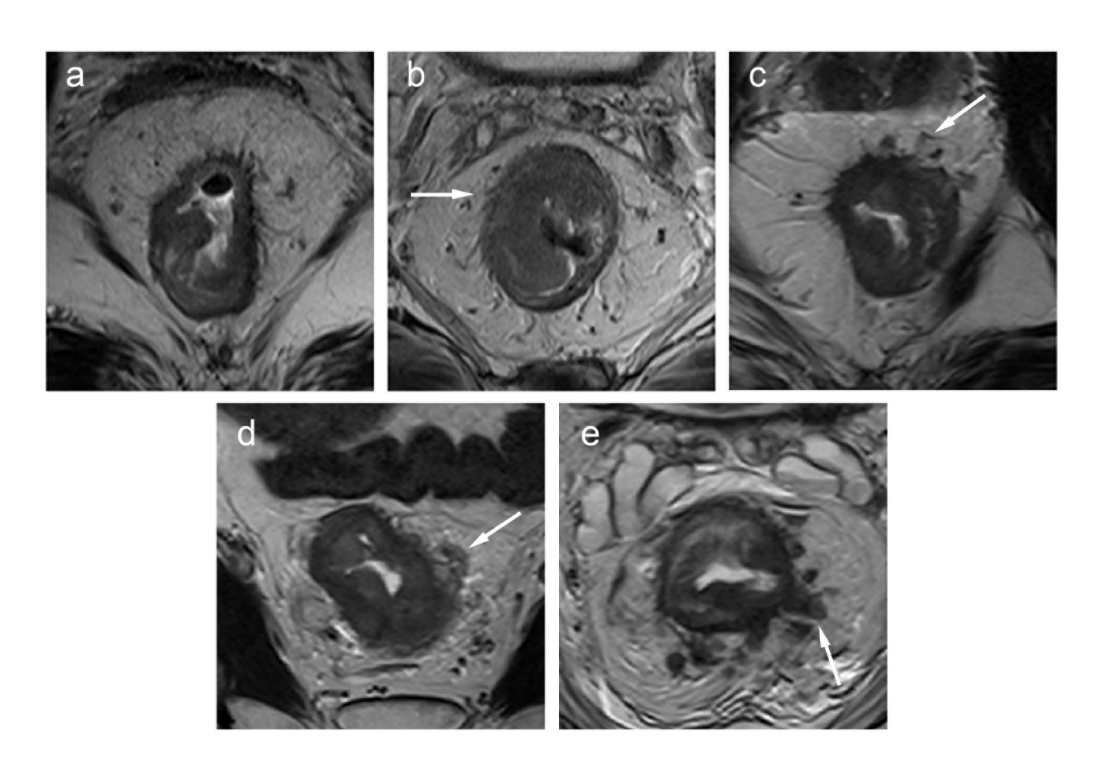
Supplementary Figure S1. Magnetic resonance imaging-defined EMVI (mrEMVI) scoring system (scores of 0,1 and 2 represent negative findings of EMVI and scores of 3 and 4 indicate positive findings of EMVI). (a) mrEMVI score 0: no vessels adjacent to areas of tumor penetration. (b) mrEMVI score 1: minimal extramural stranding or nodular extension, but not in the vicinity of extramural vessels. (c) mrEMVI score 2: stranding demonstrated in the vicinity of extramural vessels, but the vicinity of extramural vessels with normal caliber and no definite tumor signal within the vessel. (d) mrEMVI score 3: intermediate tumor signal intensity apparent within vessels with contour and caliber slightly expanded. (e) mrEMVI score 4: obvious irregular vessel contour or nodular expansion of vessel by definite tumor signal.

