Identifying areas of high drought risk in southwest Western Australia
Submitted to: Natural Hazards
Supplementary Materials
In this document, we present:
- Detailed metadata descriptions, data processing notes and rationale for applied weighting for each data layer (Supplementary Table 1)
- Larger versions of all component maps and component workflows (Supplementary Figure 1-50)

Table S1: detailed information about each layer of data included in the multi-criteria spatial analysis, including metadata description, data source and processing. All data sets were prepared so that output maps presented on the same spatial scale, a 1km grid.
Criteria Layer | Data Name | Description  (Metadata  Statement) | Source | Weighing | Data  Type | Restrictions | Accuracy/Intended Use | Metadata Link | Processing Notes
Change in growing season rainfall (Apr – Oct) - Historical | Average rainfall (mm), April to October, 1961 to 1990; Average rainfall (mm), April to October, 1991 to 2020 | Average rainfall (mm) interpolated from DPIRD’s network of automatic weather stations and radars throughout the state. | Climate Services for Agriculture, Department of Agriculture Water and Environment (DAWE) | 1 | Raster | Open/Public | N/A | https://climateservicesforag.indraweb.io/ | Created by calculating the percentage difference of average rainfall (mm) between 1961 to 1990 and 1991 to 2020 during April to October.  Class 1: 0-1.5  Class 2: 1.6-4.73  Class 3: 4.74-7.94  Class 4: 7.95-11.15  Class 5: 11.16-14.35  Min: 1.5  Max: 17.5  Unit: % decrease
Change in growing season rainfall (Apr – Oct) - Projected | Projected Average rainfall (mm), April to October, 2030; Average rainfall (mm), April to October, 2050 | The Statistical Seasonal Forecast (SSF) system uses historical relationships between global sea surface temperature and sea level pressure with rainfall in south-west Australia to produce forecasts of rainfall for future months. | Climate Services for Agriculture, DAWE | 1 | Raster | Open/Public | Statistical forecasts are not for exact amounts. They take the form of probability distributions that may represent a shift from historical rainfall probabilities. | https://climateservicesforag.indraweb.io/ | Created by calculating the percentage difference of projected average rainfall (mm) between 2030 and 2050 during April to October.  Class 1: 0-4.99  Class 2: 5-9.99  Class 3: 10-14.99  Class 4: 15-19.99  Class 5: ≥20  Min: 3.7  Max: 32.4  Unit: % decrease
Change in maturing season temperature (Aug to Nov) - Historical | Number of days above 34 degrees (Aug to Nov), 1961 to 1990; Number of days above 34 degrees (Aug to Nov) 1991 to 2020 | Data shows number of days above 34 degrees, interpolated using DPIRD and BOM automatic weather stations. | Climate Services for Agriculture, DAWE | 1 | Raster | Open/Public | Data produced using patched point and DPIRD station data | https://climateservicesforag.indraweb.io/ | Created by calculating the difference of the number of days above 34 degrees between 1961 to 1990 and 1991 to 2020 during August to November.  Class 1: -1 to -0.23  Class 2: -0.22 to -0.59  Class 3: 0.6-1.41  Class 4: 1.42-2.23  Class 5: ≥ 2.24  Min: -1  Max: 3.07  Unit: days
Change in maturing season temperature (Aug to Nov) - Projected | Future number of days above 34 degrees (Aug to Nov), 2030; Future number of days above 34 degrees (Aug to Nov) 2050 | Data shows projected number of days above 34 degrees, interpolated using DPIRD and BOM automatic weather stations. | Climate Services for Agriculture, DAWE | 1 | Raster | Open/Public | N/A | https://climateservicesforag.indraweb.io/ | Created by calculating the difference of the number of days above 34 degrees between 2030 and 2050 during August to November  Class 1: -0.14 to 0.69  Class 2: 0.7-1.54  Class 3: 1.54-2.39  Class 4: 2.4-3.24  Class 5: ≥ 3.25  Min: -0.14  Max: 4.12  Unit: days
Rainfall intensity (number of rainfall events >10mm) - Historical | Average number of days per annum with rainfall greater than 10mm (1990-2020) | The days of rain map series shows the average number of days when rainfall exceeds the total specified annually.  The Patched Point Dataset (PPD) combines observations and interpolations to provide daily data for a selected set of stations (locations). | Silo Patched Point Data, Queensland Department of Environment and Science | 1 | Point | Open/Public | The observational (station) data on which the analyses were based have  an associated accuracy of the order of 0.01 degrees (approximately  1km) or better. | http://qldspatial.information.qld.gov.au/catalogueadmin/catalog/search/resource/details.page?uuid=%7B0D1DF4A9-1D43-45E1-AC31-5A03BD93A406%7D | Point data interpolated to 1km grid  Class 1: ≥ 32  Class 2: 24-31  Class 3: 16-23  Class 4: 8-15  Class 5: ≤ 7  Min: 2  Max: 42  Unit: days
Rainfall intensity (number of rainfall events >25mm) - Historical | Average number of days annum with rainfall greater than 25mm (1990-2020) | The days of rain map series shows the average number of days when rainfall exceeds the total specified annually.  The Patched Point Dataset (PPD) combines observations and interpolations to provide daily data for a selected set of stations (locations). | Silo Patched Point Data, Queensland Department of Environment and Science | 1 | point | Open/Public | The observational (station) data on which the analyses were based have  an associated accuracy of the order of 0.01 degrees (approximately  1km) or better. | http://qldspatial.information.qld.gov.au/catalogueadmin/catalog/search/resource/details.page?uuid=%7B0D1DF4A9-1D43-45E1-AC31-5A03BD93A406%7D | Point data interpolated to 1km grid  Class 1: ≥ 9  Class 2: 7-8  Class 3: 5-6  Class 4: 3-4  Class 5: ≤ 2  Min: 1  Max: 16  Unit: days
Change in root zone soil moisture (%), 2000 to 2021 | Root zone soil moisture | Root Zone Soil Moisture is the sum of water in the Australian Water Resources Assessment Landscape model (AWRA-L) Upper and Lower soil layers and represents the percentage of available water content in the top 1 m of the soil profile. The maximum storage within the soil layer is calculated from the depth of the soil and the relative soil water storage capacity. | Australian Landscape Water Balance, Bureau of Meteorology (BOM) | 1 | Raster | Open/Public | Each of the models have differing strengths and weaknesses. Overall, given  runoff/streamflow is the dominant hydrological variable used in surface water resource  assessment, and that AWRA-L simultaneously performs well for root zone soil moisture  (a key agricultural variable), AWRA-L is considered the most fit-for-purpose national  hydrological model estimator for water resource and agricultural applications. Overall, the spatial plots and the time-series give confidence in the use of AWRA-L for water resources assessment; as they broadly follow the expected catchment responses and spatial and temporal trends expected across Australia. | http://www.bom.gov.au/water/landscape/assets/static/publications/AWRALv6_Model_Description_Report.pdf | Created by calculating the percentage difference between the actual values of the root zone soil moisture from 2000 and the actual values of the root zone soil moisture from 2020.  Class 1: -5,500 to -101  Class 2: -100 to -24  Class 3: -25 to -1  Class 4: 0-24  Class 5: ≥ 25  Min: -5,500  Max: 100  Unit: % change
Change in timing of the autumn break (%), 1975-1999 to 2000-2020 | Change in autumn break 1975 to 1999; Change in autumn break 2000 to 2020 | Data shows median break of season for the period of 1975-1999 and 2000-2020, interpolated using DPIRD and BOM automatic weather stations. | Department of Primary Industries and Regional Development (DPIRD) | 1 | Raster | Closed/  Restricted | N/A | N/A | Created by calculating the percentage difference of values in autumn break between 1975 to 1999 and 2000 to 2020.  Class 1: -6 to -1  Class 2: 0-2  Class 3: 3-5  Class 4: 6-8  Class 5: ≥ 9  Min: -5.8  Max: 15.54  Unit: % change
Change in drought frequency | Drought frequency 1980-1999. Drought frequency 2000-2020 | Data shows number of droughts that occurred during each time period. Drought is defined as rainfall during the growing season in the 10th percentile. It is calculated for each year against the average rainfall over the preceding 40 years. | Curtin University using SILO Longpaddock data | 1 | Raster | Closed/Restricted | See full report by Stan Mastrantonis, available on request | See full report by Stan Mastrantonis, available on request | Created by calculating the percentage difference of drought frequency values between 1980 to 1999 and 2000 to 2020.  Class 1: 3 or 4 fewer droughts  Class 2: 1 or 2 fewer droughts  Class 3: Equal number  Class 4: 1 or 2 more droughts  Class 5: 3 or 4 more droughts  Min: -4  Max: +4  Unit: count
Decline in average yield potential (1975-1999 to 2000-2020) | Average potential yield difference | Potential yield is the maximum yield possible given rainfall in the absence of any other constraints. Estimates of potential wheat yield are obtained using the French & Schultz potential yield model. | DPIRD | 1 | Raster | Closed/  Restricted | The potential yield model assumes crop emergence in April or May,  timing of rainfall during the season does not negatively affect crop growth (there is no drying off), and no soil constraints that hinder root growth. For later sowing and emergence (for example in June) use evaporation rate of 90 instead of 110 mm. If any assumptions are not met, then potential yield could be considerably lower than shown in the maps. | https://www.agric.wa.gov.au/dry-seasons-and-drought/seasonal-climate-information | Created by calculating the percentage difference of average potential yield (t/ha) between 1975 to 1999 and 2000 to 2020.  Class 1: -10 to -0.1  Class 2: 0-9.99  Class 3: 10-19.99  Class 4: 20-29.99  Class 5: ≥ 30  Min: -6.48  Max: 51.19  Unit: % change
Distance from the coast | Coastline | The line of contact between the ocean/sea and the land as best interpreted from ortho-imagery. This is a polygonised version of the Framework Line (LGATE-121) dataset more suited to mapping purposes. | Data WA, Landgate | 1 | Polygon | Closed/  Restricted | N/A | https://catalogue.data.wa.gov.au/dataset/medium-scale-topo-framework-polygon-coastline-lgate-120 | Created using buffers of 20km increments  .  Class 1: 0-19.99  Class 2: 20-39.99  Class 3: 40-59.99  Class 4: 60-79.99  Class 5: ≥ 80  Min: 0  Max: 200  Unit: km
Criteria Layer | Data Name | Description  (Metadata  Statement) | Source | Weighing | Data  Type | Restrictions | Accuracy/Intended Use | Metadata Link | Processing Notes
Average yield potential (t/ha) (2000-2020) | Average potential yield | Potential yield is the maximum yield possible given rainfall in the absence of any other constraints. Estimates of potential wheat yield are obtained using the French & Schultz potential yield model. | DPIRD | 1.5  Notes: higher relative weighting because of the primary economic importance of wheat production in the agriculture sector in the focus regions | Raster | Closed/  Restricted | The potential yield model assumes that crop emergence occurs in April or May,  the timing of rainfall during the season does not negatively affect crop growth (there is no drying off), and  there are no soil constraints that hinder root growth. For later sowing and emergence (for example in June) use evaporation rate of 90 instead of 110 mm. If any of these assumptions are not met, then potential yield could be considerably lower than shown in the maps. | https://www.agric.wa.gov.au/dry-seasons-and-drought/seasonal-climate-information | N/A  Class 1: 0-1.4  Class 2: 1.5-1.9  Class 3: 2-2.4  Class 4: 2.5-2.9  Class 5: ≥ 3  Min: 0.8  Max: 11.8  Unit: t/ha
Wheat yield (t/h) | Agricultural commodities, Australia and state/territory and LGA regions - 2015-16 | This publication contains final estimates for data items collected in the 2015-16 Agricultural Census. Included are statistics on land use, crop and horticultural area and production, livestock numbers, farm management and demographic information. | Australian Bureau of Statistics (ABS) | 1 | Table | Open/Public | The estimates in this publication are based on information obtained from agricultural businesses that responded to the 2015-16 Agricultural Census. However, since not all of the businesses that were selected provided data, the estimates are subject to sampling variability; that is, they may differ from the figures that would have been produced if information had been collected from all businesses. | https://www.abs.gov.au/AUSSTATS/abs@.nsf/Lookup/7121.0Explanatory%20Notes12015-16?OpenDocument | Table joined to LGA polygons. Clipped to Wheatbelt of WA (DPIRD-24) polygon. https://catalogue.data.wa.gov.au/dataset/wheatbelt-of-wa-dpird-028  Class 1: 0-1.3  Class 2: 1.4-1.7  Class 3: 1.8-2.1  Class 4: 2.2-2.5  Class 5: ≥ 2.6  Min: 0  Max: 3.14  Unit: t/ha
Canola yield (t/h) | Agricultural commodities, Australia and state/territory and LGA regions - 2015-16 | This publication contains final estimates for data items collected in the 2015-16 Agricultural Census. Included are statistics on land use, crop and horticultural area and production, livestock numbers, farm management and demographic information. | ABS | 1 | Table | Open/Public | The estimates in this publication are based on information obtained from agricultural businesses that responded to the 2015-16 Agricultural Census. However, since not all of the businesses that were selected provided data, the estimates are subject to sampling variability; that is, they may differ from the figures that would have been produced if information had been collected from all businesses. | https://www.abs.gov.au/AUSSTATS/abs@.nsf/Lookup/7121.0Explanatory%20Notes12015-16?OpenDocument | Table joined to LGA polygons. Clipped to Wheatbelt of WA (DPIRD-24) polygon. https://catalogue.data.wa.gov.au/dataset/wheatbelt-of-wa-dpird-028  Class 1: 0-0.8  Class 2: 0.9-1  Class 3: 1.1-1.2  Class 4: 1.3-1.4  Class 5: ≥ 1.5  Min: 0.72  Max: 1.81  Unit: t/ha
Barley yield (t/ha) | Agricultural commodities, Australia and state/territory and LGA regions - 2015-16 | This publication contains final estimates for data items collected in the 2015-16 Agricultural Census. Included are statistics on land use, crop and horticultural area and production, livestock numbers, farm management and demographic information. | ABS | 1 | Table | Open/Public | The estimates in this publication are based on information obtained from agricultural businesses that responded to the 2015-16 Agricultural Census. However, since not all of the businesses that were selected provided data, the estimates are subject to sampling variability; that is, they may differ from the figures that would have been produced if information had been collected from all businesses. | https://www.abs.gov.au/AUSSTATS/abs@.nsf/Lookup/7121.0Explanatory%20Notes12015-16?OpenDocument | Table joined to LGA polygons.  Clipped to Wheatbelt of WA (DPIRD-24) polygon. https://catalogue.data.wa.gov.au/dataset/wheatbelt-of-wa-dpird-028  Class 1: 0-1.3  Class 2: 1.4-1.7  Class 3: 1.8-2.1  Class 4: 2.2-2.5  Class 5: ≥ 2.6  Min: 0  Max: 3.33  Unit: t/ha
Sheep numbers per LGA | Agricultural commodities, Australia and state/territory and LGA regions - 2015-16 | This publication contains final estimates for data items collected in the 2015-16 Agricultural Census. Included are statistics on land use, crop and horticultural area and production, livestock numbers, farm management and demographic information. | ABS | 1 | Table | Open/Public | The estimates in this publication are based on information obtained from agricultural businesses that responded to the 2015-16 Agricultural Census. However, since not all of the businesses that were selected provided data, the estimates are subject to sampling variability; that is, they may differ from the figures that would have been produced if information had been collected from all businesses. | https://www.abs.gov.au/AUSSTATS/abs@.nsf/Lookup/7121.0Explanatory%20Notes12015-16?OpenDocument | Table joined to LGA polygons  Class 1: 0-29,999  Class 2: 30,000-59.999  Class 3: 60,000-119,999  Class 4: 120,000-239,999  Class 5: ≥ 240,000  Min: 0  Max: 632,526  Unit: head
Cattle numbers per LGA | Agricultural commodities, Australia and state/territory and LGA regions - 2015-16 | This publication contains final estimates for data items collected in the 2015-16 Agricultural Census. Included are statistics on land use, crop and horticultural area and production, livestock numbers, farm management and demographic information. | ABS | 1 | Table | Open/Public | The estimates in this publication are based on information obtained from agricultural businesses that responded to the 2015-16 Agricultural Census. However, since not all of the businesses that were selected provided data, the estimates are subject to sampling variability; that is, they may differ from the figures that would have been produced if information had been collected from all businesses. | https://www.abs.gov.au/AUSSTATS/abs@.nsf/Lookup/7121.0Explanatory%20Notes12015-16?OpenDocument | Table joined to LGA polygons  Class 1: 0-999  Class 2: 1,000-4.999  Class 3: 5,000-9,999  Class 4: 10,000-24,999  Class 5: ≥ 25,000  Min: 0  Max: 223,534  Unit: head
High quality agriculture land (HQAL) wheat yield potential (t/ha) | High quality agriculture land (HQAL)  Stages 1-3 | DAWE has worked closely with state and local planners and agricultural practitioners over the last four years to develop a new way to identify high quality agricultural land (HQAL). This methodology combines land capability for horticulture and dry land cropping and grazing with irrigation supplies, rainfall and yield information. It then ranks large tracts of “similar” land according to its versatility for a range of agricultural land uses. | DPIRD | 1 | Raster | Restricted | Batavia Coast and North Midlands Midwest planning regions. Central coast Wheatbelt planning region. | https://www.agric.wa.gov.au/sites/gateway/files/RMTR%20386%20HQAL%20Geraldton%202nd%20edition.pdf | Detailed Broadacre map unit wheat yield (t/ha)  Class 1: 0-1.3  Class 2: 1.4-1.7  Class 3: 1.8-2.1  Class 4: 2.2-2.5  Class 5: ≥ 2.6  Min: 0  Max: 3.4  Unit: t/ha
NDVI 20 year average | MODIS Vegetation Index Products (NDVI and EVI) | MODIS vegetation indices, produced on 16-day intervals and at multiple spatial resolutions, provide consistent spatial and temporal comparisons of vegetation canopy greenness, a composite property of leaf area, chlorophyll and canopy structure. | Landgate: https://www0.landgate.wa.gov.au/business-and-government/product-onsellers/value-added-resellers/property-products/ndvi-satellite-imagery | 1.5  Notes: higher relative weighting because of the detectability of drought impacts in NDVI data and the importance of vegetation cover for mitigating impacts of drought such as soil erosion. | Raster | Open/Public | The quality of the MOD13Q1/A1 product is assessed through the quality assessment (QA) metadata objects and per-pixel QA science data sets (SDS’s). The QA metadata objects summarize tile-level (granule) quality with several single words and numeric numbers, and thus are useful during data searching/ordering and screening processes. The QA SDS’s, on the other hand, document product quality on a pixel-by-pixel basis and thus are useful for data analyses, filtering, and application. | https://vip.arizona.edu/documents/MODIS/MODIS_VI_UsersGuide_June_2015_C6.pdf | NDVI average 2002-2021  Class 1: 100-119  Class 2: 20-139  Class 3: 140-159  Class 4: 160-179  Class 5: ≥ 180  Min: 100  Max: 200  Unit: NDVI
Trend in water quality – hydrozone risk | Salinity risk 2007-2012 | The Department of Agriculture and Food, Western Australia analysed groundwater trends for 1500 surveillance bores to assess salinity risk across the SW region, 2007–2012. | DPIRD | 1 | Polygon | Restricted | Hydrozones are defined to coincide with soil-landscape zones, except where hydrogeological boundaries dictate that several soil-landscape zones belong to a contiguous hydrogeological unit. | https://www.agric.wa.gov.au/report-card-conditions-and-trends/groundwater-trends-agricultural-areas-western-australia | Class 1: Very low  Class 2: Low  Class 3: Moderate  Class 4: High  Class 5: N/A  Min: 1  Max: 4  Unit: category
NDVI 20 year 20yr lowest 10% | MODIS Vegetation Index Products (NDVI and EVI) | MODIS vegetation indices, produced on 16-day intervals and at multiple spatial resolutions, provide consistent spatial and temporal comparisons of vegetation canopy greenness, a composite property of leaf area, chlorophyll and canopy structure. | Landgate: https://www0.landgate.wa.gov.au/business-and-government/product-onsellers/value-added-resellers/property-products/ndvi-satellite-imagery | 1.5  Notes: higher relative weighting because of the detectability of drought impacts in NDVI data and the importance of vegetation cover for mitigating impacts of drought such as soil erosion. | Raster | Open/Public | The quality of the MOD13Q1/A1 product is assessed through the quality assessment (QA) metadata objects and per-pixel QA science data sets (SDS’s). The QA metadata objects summarize tile-level (granule) quality with several single words and numeric numbers, and thus are useful during data searching/ordering and screening processes. The QA SDS’s, on the other hand, document product quality on a pixel-by-pixel basis and thus are useful for data analyses, filtering, and application. | https://vip.arizona.edu/documents/MODIS/MODIS_VI_UsersGuide_June_2015_C6.pdf | NDVI average 2002-2021  Class 1: 100-119  Class 2: 20-139  Class 3: 140-159  Class 4: 160-179  Class 5: ≥ 180  Min: 100  Max: 200  Unit: NDVI
Average household income ($/week) | Australian 2016 census of population and housing | Dataset outlines the nature and content of Australia's Census on Tuesday 9 August 2016. | ABS geopackage  https://datapacks.censusdata.abs.gov.au/geopackages/ | 1 | SA1 Polygon | Open/Public | The estimates are based on a sample of possible observations and are subject to sampling variability. The estimates may therefore differ from the figures that would have been produced if information had been collected for all households. A measure of the sampling error for a given estimate is provided by the standard error, which may be expressed as a percentage of the estimate (relative standard error). | https://www.abs.gov.au/ausstats/abs@.nsf/mf/2008.0 | Used table Median_tot_hhd_inc_weekly  Table joined to SA1 polygons  Class 1: 0-749  Class 2: 750-1,249  Class 3: 1,250-1,749  Class 4: 1,750-2,249  Class 5: ≥ 2,250  Min: 0  Max: 4,299  Unit: $ per week
Farm profit vulnerability | Drought Risk by farm profit 2021 | This layer displays the percentage of drought risk by Farm Profit by ABARES AAGIS (Australian Agricultural and Grazing Industry Survey) regions as determined by Australian Bureau of Agricultural and Resource Economics and Science (ABARES). Drought risk is defined as the percentage change in farm profit between normal and drought years. | Australian Bureau of Agricultural and Resource Economics and Sciences (ABARES) | 1 | AAGIS Polygon | Open/Public | ABARES AAGIS (Australian Agricultural and Grazing Industry Survey) regions. | https://data.gov.au/data/dataset/abares-drought-risk-by-farm-profit | Class 1: 0-24  Class 2: 25-34  Class 3: 35-44  Class 4: 45-54  Class 5: ≥ 55  Min: 14  Max: 77,67  Unit: % change
Employment in agriculture (% of population) | Australian 2016 census working population profile table | This dataset outlines the nature and content of Australia's Census on Tuesday 9 August 2016.  The Working Population Profile (WPP) DataPack provides information on key Census characteristics of employed persons. | ABS data package  https://datapacks.censusdata.abs.gov.au/datapacks/ | 1 | Table | Open/Public | The estimates are based on a sample of possible observations and are subject to sampling variability. The estimates may therefore differ from the figures that would have been produced if information had been collected for all households. A measure of the sampling error for a given estimate is provided by the standard error, which may be expressed as a percentage of the estimate (relative standard error). | https://datapacks.censusdata.abs.gov.au/datapacks/ | Table joined to SA2 polygons.  Used table Industry of Employment by Occupation (W12a)  Table joined to SA2 polygons  Class 1: 0-9.99  Class 2: 10-19.99  Class 3: 20-29.99  Class 4: 30-39.99  Class 5: ≥ 40  Min: 0  Max: 52  Unit: %
Average farm size (hectare) | Client Property Event System - Properties (DPIRD-018) | The Property boundaries dataset is a publically available subset of the information held in DPIRD’s Client Property Event (CPE) database. CPE is a spatially  linked database of agricultural and other properties in Western Australia. | Data WA, DPIRD | 1 | Polygon | Open/Public | Properties consist of one or more contiguous cadastral parcels – aggregated on land  management (this does not necessarily correspond with land management). The purpose of the database is to support the biosecurity and regulatory operations of DPIRD. Property information is collected through direct contact with landholders through mail-outs and attendance at field days. Properties may also contain information auto-generated from Landgate parcel data records. The underlying parcel data is updated twice a year using Cadastral boundaries supplied by Landgate. Property boundary and ownership information are updated on a daily basis. Landgate parcel data records. Accuracy of information is variable depending upon the degree of contact with landholders. | https://catalogue.data.wa.gov.au/dataset/client-property-event-system-properties/resource/e0ad6de0-b425-4103-ada7-12c1087f06c6 | Definition Query:  Property type = Agricultural  Determined average Agricultural property size (>2ha) by locality.  Class 1: 0-999  Class 2: 1,000-2,999  Class 3: 3,000-5,999  Class 4: 6,000-8,999  Class 5: ≥ 9,000  Min: 1  Max: 411,758  Unit: ha
Count of water assets (bores and dams) | Water Bore (WCORP-073) | Water Corporation access point for subsurface water delivery | Data WA, Water Corporation | 1 | Point | Open/Public | N/A | N/A | Count per 1km grid  Class 1: 0  Class 2: 1-3  Class 3: 4-6  Class 4: 7-9  Class 5: ≥ 10  Min: 0  Max: 42  Unit: count
Count of water assets (bores and dams) | Water Dam (WCORP-075) | Water Corporation water storage facility | Data WA, Water Corporation | 1 | Polygon | Open/Public | N/A | N/A
Count of water assets (bores and dams) | Farm dams of Western Australia (DPIRD-083) | Spatial boundaries of over 175,000 agricultural dams in Western Australia. | Data WA, DPIRD | 1 | Polygon | Open/Public | It has been calculated that with the South West agricultural region of WA this product excludes about 24,000 farm dams and that 1,800 features labelled as farm dams are in fact not farm dams. This is a result of the automated capture method. | https://catalogue.data.wa.gov.au/dataset/farm-dams-of-the-south-west-agricultural-region-of-wa/resource/bfb59742-8d3e-4a5c-8721-c0de17b84a65
Diversity of farm activities | Multiple data sources -Client Property Event (CPE) System – Property Activity.  Stock Brands and PIC register - stock numbers.  Catchment Scale Landuse Mapping (ALUM V7) | Catchment scale Landuse - This vector dataset is a compilation of land use data for Western Australia, as at August 2018. It has been derived from various vector datasets with attribution relevant to land use in Western Australia. The date of mapping (2008 to 2018) and scale of mapping (1:5 000 to 1:250 000) vary, reflecting the source data, capture date and scale. | DPIRD | 1 | Polygon | Restricted |  | https://data.gov.au/dataset/ds-dga-d897e165-46a3-4f3b-a2f2-b348ac06ddfe/details  https://www.agric.wa.gov.au/livestock-biosecurity/stock-brand-and-pic-register-search-guide  https://catalogue.data.wa.gov.au/dataset/client-property-event-system-properties/resource/e0ad6de0-b425-4103-ada7-12c1087f06c6 | Count of agricultural activity types per agricultural property. Activities included Sheep, Cattle, Pigs, Feedlot, Horticulture, Dairy, Plantations, Pivot Irrigation and Broadacre Cropping.  Total count of Agricultural activities and properties with broadacre cropping only were used to created composite product.  Class 1: ≥ 4  Class 2: 2-3  Class 3: 1 other than cropping  Class 4: Cropping only  Class 5: N/A  Min: 1  Max: 4  Unit: category
Accessibility and remoteness index of Australia | Remoteness Area (RA) ASGS Ed 2016 | The Australian Statistical Geography Standard (ASGS) defines Remoteness Areas into 5 classes of relative remoteness across Australia. These 5 classes of remoteness are:  Major Cities of Australia, Inner Regional Australia,  Outer Regional Australia,  Remote Australia and Very Remote Australia | ABS Data Cube | 1 | Polygon | Open/Public | The five classes of remoteness are determined using a process that provides a consistent definition across Australia and over time. This allows statistical data to be classified in a consistent way that allows users to analyse changes in data for different remoteness categories over time. Relative remoteness is measured in an objective way using the Accessibility and Remoteness Index of Australia (ARIA+), which is developed by the Hugo Centre for Migration and Population Research at the University of Adelaide. | https://www.abs.gov.au/ausstats/abs@.nsf/Latestproducts/1270.0.55.005Main%20Features1July%202016?opendocument&tabname=Summary&prodno=1270.0.55.005&issue=July%202016&num=&view= | N/A  Class 1: Major cities  Class 2: Inner Regional  Class 3: Outer Regional  Class 4: Remote  Class 5: Very Remote  Min: 1  Max: 5  Unit: category
Population % change from 2011 to 2020 | Australian Population Grid 2011 and Australian Population Grid 2020 | Estimated resident population (ERP) is the official estimate of the Australian population, which links people to a place of usual residence within Australia. Usual residence is the address at which a person considers themselves to currently live. ERP includes all people who usually live in Australia (regardless of nationality, citizenship or visa status), with the exception of people present for foreign military, consular or diplomatic reasons. | ABS population grids  2011: https://www.abs.gov.au/ausstats/abs@.nsf/mf/1270.0.55.007  2020: https://www.abs.gov.au/statistics/people/population/regional-population/2019-20#data-downloads-population-grid-files | 1 | Grid | Open/Public | The sub-state estimates in this product are subject to some error. Some caution should be exercised when using the estimates, especially for areas with very small populations. An indication of the accuracy of ERP can be gauged by assessing the size and direction of intercensal differences. | https://www.abs.gov.au/methodologies/regional-population-methodology/2019-20 | % change in grid population from 2011 to 2020  Class 1: -100 to -26  Class 2: -25 to 24  Class 3: 25-100  Class 4: 100-199  Class 5: ≥ 200  Min:-100  Max: 171,000  Unit: % change
Count of LGAs declared water deficient | Water Deficiency Declarations DWER | A 'water deficiency declaration' is a government response to safeguard the commercial interests of farmers during very dry periods. A declaration occurs when a group of five or more farmers, within a 20-kilometre radius, require water from an off-farm source and have to travel greater than a 40-kilometre radius from their farm to get this. In extreme circumstances, water may be provided for individual famers. | Department of Water and Environmental Regulation (DWER) Rural water ruralwater@dwer.wa.gov.au. | 1.25  Notes: higher relative weighting importance of water for mitigating impacts of drought on livestock and on farming communities; also water scarcity was identified as a high priority for regional stakeholders, particularly in the Great Southern and Wheatbelt sub-regions | Table | Restricted |  | https://www.water.wa.gov.au/planning-for-the-future/rural-water-support/emergency-farmland-water-response-planning-and-water-deficiency-arrangements | Count of LGA or locality from1994-2021  Class 1: 0  Class 2: 1  Class 3: 2  Class 4: 3  Class 5: ≥ 4  Min: 0  Max: 6  Unit: count
Criteria Layer | Data Name | Description  (Metadata  Statement) | Source | Weighing | Data  Type | Restrictions | Accuracy/Intended Use | Metadata Link | Processing Notes
Population >65 years | Population estimates by age and sex, by SA2, 2020 | This product contains preliminary estimates of the resident population by age and sex as at 30 June 2020. Data are provided for Statistical Areas Level 2 (SA2s) and states and territories of Australia, according to the 2016 edition of the Australian Statistical Geography Standard (ASGS). | ABS Data Cube | 1 | Table | Open/Public | Component data (births, deaths and overseas and internal migration) are confidential and constrained to add to the relevant state component estimates by age and sex. The resultant estimated resident populations are subsequently constrained to state population estimates by age and sex. As a result of confidentiality and forced additivity, estimates of under three people should be regarded as synthetic and only exist to ensure additivity to higher levels. While output is presented by five-year age group, all calculations are made at single year of age level. | https://www.abs.gov.au/methodologies/ regional-population-age-and-sex-methodology/2020 | Table joined to SA2 polygons  .  Class 1: 0-9.99  Class 2: 10-14.99  Class 3: 15-19.99  Class 4: 20-24.99  Class 5: ≥ 25  Min: 0  Max: 66.7  Unit: %
Unemployment | Census 2016, G43 Labour force status by age by sex (LGA) | Census 2016 Australia/State/GCCSA/SA4/SA3/SA2 based data for Total Labour force status by sex of parents by age of dependent children for families, for the 2016 Census of Population and Housing. Unit of measure: Count of all persons on Census night, based on place of usual residence. Excludes Overseas Visitors. Geographic coverage: LGA2016 | ABS Data Explorer | 1 | Table | Open/Public |  | https://www.abs.gov.au/methodologies/data-region-methodology/2015-20#data-download | Table joined to LGA polygons  Class 1: 0-1.99  Class 2: 2-2.99  Class 3: 3-3.99  Class 4: 4-4.99  Class 5: ≥ 5  Min: 0  Max: 8.9  Unit: %
Important water resources | DBCA - Legislated Lands and Waters (DBCA-011) | The DBCA Legislated Lands and Waters data set shows all lands and waters defined under acts which are applicable to DBCA. | Data WA, Department of Biodiversity, Conservation and Attractions (DBCA) | 0.5  Notes: lower relative weighting due to the nature of natural surface water resources in the region, particularly in the focus sub-region. Natural water resources are typically ephemeral, frequently saline and unlikely to contribute much to drought resilience as a result. | Polygon | Open/Public | N/A | https://catalogue.data.wa.gov.au/dataset/dbca-legislated-lands-and-waters | Definition Query:  Reserve Name LIKE '%Wetlands%  Class 1: Yes  Class 2: N/A  Class 3: N/A  Class 4: N/A  Class 5: No  Min: N/A  Max: N/A  Unit: category  '
Important water resources | South Coast Significant Wetlands (DBCA-018) | The former WRC SC region have developed a spreadsheet which aims to document the South Coast natural assets which come under the WRC jurisdiction. | Data WA, DBCA | 0.5  Notes: lower relative weighting because natural water resources in the region are typically ephemeral, frequently saline and unlikely to contribute much to drought resilience as a result. | Polygon | Open/Public | N/A | https://catalogue.data.wa.gov.au/dataset/south-coast-significant-wetlands | N/A  Class 1: Yes  Class 2: N/A  Class 3: N/A  Class 4: N/A  Class 5: No  Min: N/A  Max: N/A  Unit: category
Important water resources | Directory of Important Wetlands in Australia - Western Australia (DBCA-045) | This is a polygon coverage representing the Western Australian wetlands cited in the "A Directory of Important Wetlands in Australia" Third Edition (EA, 2001), plus various additions for wetlands listed after 2001. | Data WA, DBCA | 0.5  Notes: lower relative weighting because natural water resources in the region are typically ephemeral, frequently saline and unlikely to contribute much to drought resilience as a result. | Polygon | Open/Public | N/A | https://catalogue.data.wa.gov.au/dataset/directory-of-important-wetlands-in-western-australia | N/A  Class 1: Yes  Class 2: N/A  Class 3: N/A  Class 4: N/A  Class 5: No  Min: N/A  Max: N/A  Unit: category
Important water resources | Ramsar Sites (DBCA-010) | This data set describes the official boundaries of the nine wetland areas proposed in February 1990 by the Government of Western Australia for listing as Wetlands of International Importance under the Convention on Wetlands of Importance especially as Waterfowl Habitat, otherwise known as the Ramsar Convention. | Data WA, DBCA | 0.5  Notes: lower relative weighting because natural water resources in the region are typically ephemeral, frequently saline and unlikely to contribute much to drought resilience as a result. | Polygon | Open/Public | N/A | https://catalogue.data.wa.gov.au/dataset/ramsar-sites | N/A  Class 1: Yes  Class 2: N/A  Class 3: N/A  Class 4: N/A  Class 5: No  Min: N/A  Max: N/A  Unit: category
Important water resources | Hydrography, Linear (Hierarchy) (DWER-031) | Major streamlines of WA, coded with a hierarchy and are named. The dataset includes many streams in addition to the detailed Hydrography in areas where its data is limited (e.g. Eastern Wheatbelt and Western Plateau). | Data WA, DWER | 0.5  Notes: lower relative weighting because natural water resources in the region are typically ephemeral, frequently saline and unlikely to contribute much to drought resilience as a result. | Polyline | Open/Public | The Hydrography, Linear (Hierarchy) dataset is used by DWER for broad scale streamline presentation. It also provides definition of streamlines in ancient drainage landscapes, when other datasets do not have line work. | https://catalogue.data.wa.gov.au/dataset/hydrography-linear-hierarchy/resource/9908c7d1-7160-4cfa-884d-c5f631185859 | Definition Query:  level_name = 'Mainstream', or 'Major River'  To convert polyline dataset to polygon, a 20m buffer was applied.  Class 1: Yes  Class 2: N/A  Class 3: N/A  Class 4: N/A  Class 5: No  Min: N/A  Max: N/A  Unit: category
Important water resources | Medium Scale Topo Water (Polygon) (LGATE-016) | Water features that relate to the interior of the country. Multiple points that describe the feature’s perimeter. | Data WA, Landgate | 0.5  Notes: lower relative weighting because natural water resources in the region are typically ephemeral, frequently saline and unlikely to contribute much to drought resilience as a result. | Polygon | Closed/  Restricted | Based on DEM data. The accuracy of the contours derived from the DEM will be influenced by a number of factors. | https://catalogue.data.wa.gov.au/dataset/medium-scale-topo-water-polygon-lgate-016/resource/562b221a-ddb3-4e49-ae40-25a366f84a80 | Only used features that intersected with buffered 20m Hydrography, Linear (Hierarchy) dataset to assist in the conversion of polyline to polygon.  Class 1: Yes  Class 2: N/A  Class 3: N/A  Class 4: N/A  Class 5: No  Min: N/A  Max: N/A  Unit: category
Availability of groundwater resources | Bores | The current dataset is an extract of the National Groundwater Information System (NGIS), water levels, salinity measurements and hydro-chemistry data for a particular state, which has been processed for download from the Australian Groundwater Explorer. | Australian Groundwater Explorer, BOM | 1 | Point | Open/Public | The Bureau of  Meteorology maintains the NGIS data model that standardises and spatially enables the groundwater data. The Bureau then undertakes Quality Assurance/Quality Control (QA/QC) of the  State/Territory geodatabases and integrates them into the national geodatabase. | http://www.bom.gov.au/water/groundwater/ngis/documentation.shtml | N/A  Class 1: Yes  Class 2:N/A  Class 3: Limited  Class 4: N/A  Class 5: No  Min: N/A  Max: N/A  Unit: category
Quality of groundwater resources (salinity) | Groundwater Salinity State wide (DWER-026) | Interpretive and indicative Groundwater salinity mapping state wide. | Date WA, DWER | 1 | Polygon | Open/Public | The dataset is highly interpretive, and only broadly  indicative of the likely groundwater salinity, bearing  in mind the generalisations needed at such a small  scale. | https://catalogue.data.wa.gov.au/dataset/groundwater-salinity-statewide/resource/1882325f-f639-46fb-ba0a-d78889ac8b4b | N/A  Class 1: < 500  Class 2: 500-999  Class 3: 1,000-2,999  Class 4: 3,000-6,999  Class 5: ≥ 7,000  Min: 0  Max: 35,000  Unit: mg/L Total Dissolved Solids
Water protection area | Public Drinking Water Source Areas (DWER-033) | Public drinking water source areas (PDWSAs) are surface water catchments and groundwater areas that provide drinking water to cities, towns and communities throughout the state. | Data WA, DWER | 1 | Polygon | Open/Public | Good but variable as the accuracy is based on different means, scales and  methods of capture and definition. Where possible the original mapping and/or legal description was used for definition. | https://catalogue.data.wa.gov.au/dataset/public-drinking-water-source-areas/resource/33352803-7348-48d0-842f-de31b2f23c0c | N/A  Class 1: Yes  Class 2:N/A  Class 3: N/A  Class 4: N/A  Class 5: No  Min: N/A  Max: N/A  Unit: category
Land capability for dryland cropping | Land Capability - Dryland Cropping (DPIRD-031) | Land capability for cropping in the south west of Western Australia based on analysis and interpretation of the best available soil-landscape mapping dataset (DPIRD-027).  This assessment covers the production of rain-fed (non-irrigated) field crops under a cropping system that incorporates minimal tillage practices and stubble retention. | Data WA, DPIRD | 1.5  Notes: higher relative weighting because of the importance of soil capability for predicting agricultural production potential; an important part of resilience for agricultural communities | Polygon | Open/Public | Capability ratings do not take into account factors such as the availability and quality of water supplies for irrigation or climatic risks such as frost or heat stress. Such factors need to be considered as a separate layer of information.  Accuracy of attribution is variable depending upon scale of survey and the hierarchy level of the mapping. | https://catalogue.data.wa.gov.au/dataset/land-capability-dryland-cropping/resource/f392dd06-00c0-4ff4-8c06-71c2d198dbf0 | N/A  Class 1: A2  Class 2: B1  Class 3: B2  Class 4: C1  Class 5: C2  Min: A1  Max: C2  Unit: category
Plant available water capacity of the soil | Soil and Landscape Grid National Soil Attribute Maps - Available Water Capacity (3" resolution) - Release 1. Version v5. | This is Version 1 of the Australian Soil Available Water Capacity product of the Soil and Landscape Grid of Australia. The Soil and Landscape Grid of Australia has produced a range of digital soil attribute products. Each product contains six digital soil attribute maps, and their upper and lower confidence limits, representing the soil attribute at six depths: 0-5cm, 5-15cm, 15-30cm, 30-60cm, 60-100cm and 100-200cm. | TERN Data Discovery Portal, Commonwealth Scientific and Industrial Research Organisation (CSIRO) | 1 | Raster | Open/Public | National Soil Attribute Maps are generated by combining best available digital soil maps to calculate a variance weighted mean for each pixel. For this soil attribute the Australia-wide three-dimensional Digital Soil Property Maps are the only maps available. Thus the modelling for this soil attribute only used decision trees with piecewise linear models with kriging of residuals developed from soil site data across Australia. | https://portal.tern.org.au/soil-landscape-grid-release-1/23082 | TERN soil water availability depth: 15-30cm  Class 1: ≥ 16.32  Class 2: 13.91-16.31  Class 3: 11.5-13.9  Class 4: 9.09-11.4  Class 5: 6.68-9.08  Min: 6.68  Max: 18.7  Unit: %
Native vegetation extent | Native Vegetation Extent (DPIRD-005) | A data set containing vegetation extent polygons from the mapping of remnant vegetation in Western Australia. | Data WA, DPIRD | 1 | Polygon | Open/Public | Vegetation type is not attributed to this dataset. Attribution is  limited to information relating to the capture of the dataset, see Data Dictionary for a list  of attributes. | https://catalogue.data.wa.gov.au/dataset/native-vegetation-extent/resource/a7a4b590-604c-4ebb-806a-0eb0451c1a27 | Native vegetation percent calculated per 1km area of grid cell  Class 1: ≥ 85  Class 2: 60-79.99  Class 3: 35-59.99  Class 4: 10-34.99  Class 5: 0-9.99  Min: 0  Max: 100  Unit: %
NDVI trend | MODIS Vegetation Index Products (NDVI and EVI) | MODIS vegetation indices, produced on 16-day intervals and at multiple spatial resolutions, provide consistent spatial and temporal comparisons of vegetation canopy greenness, a composite property of leaf area, chlorophyll and canopy structure. | Landgate, https://www0.landgate.wa.gov.au/business-and-government/product-onsellers/value-added-resellers/property-products/ndvi-satellite-imagery | 1 | Raster | Open/Public | The quality of the MOD13Q1/A1 product is assessed through the quality assessment (QA) metadata objects and per-pixel QA science data sets (SDS’s). The QA metadata objects summarize tile-level (granule) quality with several single words and numeric numbers, and thus are useful during data searching/ordering and screening processes. The QA SDS’s, on the other hand, document product quality on a pixel-by-pixel basis and thus are useful for data analyses, filtering, and application. | https://vip.arizona.edu/documents/MODIS/MODIS_VI_UsersGuide_June_2015_C6.pdf | NDVI trend (4yr ave 2002 to 2005 compared to 4yr ave 2018 to 2021)  Class 1: < -5  Class 2: -5-0  Class 3: 0-4.99  Class 4: 5-14.99  Class 5: ≥ 15  Min: -45  Max: 72  Unit: % change
Surface salinity | Soil landscape land quality - Surface Salinity (current) (DPIRD-039) | Soil surface salinity is a land quality which may impact upon a variety of agricultural land uses and is based on analysis and interpretation of the best available soil-landscape mapping dataset (DPIRD-027). | Data WA, DPIRD | 1 | Polygon | Open/Public | Accuracy of attribution is variable depending upon scale of survey and the hierarchy level of the mapping. | https://catalogue.data.wa.gov.au/dataset/soil-landscape-surface-salinity-current/resource/5a424acc-0d79-4b19-8690-3772163ab9ae | N/A  Class 1: No  Class 2:N/A  Class 3: N/A  Class 4: N/A  Class 5: Yes  Min: 0 (no)  Max: 1 (yes)  Unit: category
Proximity to main road infrastructure | Medium Scale Topo General Transport (Line) (LGATE-117) | Topographic features whose primary characteristics are of a general transport nature. | Data WA, Landgate | 1 | Polyline | Closed/  Restricted | N/A | https://catalogue.data.wa.gov.au/dataset/medium-scale-topo-general-transport-line-lgate-117 | Created using multi ring buffers showing distance to Main roads.  Class 1: 0-9.99  Class 2: 10-24.99  Class 3: 25-49.99  Class 4: 50-99.99  Class 5: ≥ 100  Min: 0  Max: 200  Unit: km
Proximity to strategic community water supplies | Strategic Community Water supplies | A network of strategic community water supplies has been developed across Western Australia's dryland agricultural areas to provide an important source of emergency stock water during dry seasons.  These water supplies are for emergency use at times when low rainfall causes on-farm supplies to fail and forces farmers to travel outside their farm gate to collect water for livestock and other essential farming purposes.  The Department of Water and Environmental Regulation keeps in regular contact with rural communities to monitor the condition of strategic community water supplies and identify and address any maintenance issues. | DWER Rural water ruralwater@dwer.wa.gov.au. | 1 | Point | Closed/  Restricted | N/A | https://www.water.wa.gov.au/planning-for-the-future/rural-water-support/management-of-strategic-community-water-supplies | Created using multi ring buffers showing distance to water supply points.  Class 1: 0-9.99  Class 2: 10-19.99  Class 3: 20-39.99  Class 4: 40-69.99  Class 5: ≥ 70  Min: 0  Max: 200  Unit: km
Proximity to scheme water coverage | Water pipe (WCORP-002) | This dataset contains Centrelines only for all the Trunk, Distribution & Reticulation Water Mains in all the locations where the Water Corporation is licensed to provide Potable Water. It does not include Bore mains, Wastewater Reuse or Saline Mains. Bunbury & Busselton are excluded as the Water Service is supplied by those particular Local Councils. | Data WA, Water Corporation | 1 | Polyline | Open/Public | N/A | https://catalogue.data.wa.gov.au/dataset/water-pipe-wcorp-002 | Created using multi ring buffers showing distance to water pipe lines: 0-10,10-20,20-40, 40-70, >70km  Class 1: 0-9.99  Class 2: 10-19.99  Class 3: 20-39.99  Class 4: ≥ 40  Class 5: N/A  Min: 0  Max: 1,000  Unit: km

Table 2: Organisation and weighting of each composite map in the analysis. Weights provided describe the relative weighting applied to the data set during analysis and are relative to the other datasets within the same tier. Tier describes the level of analysis; primary = all individual component datasets and first-level composite maps, secondary = second-level composite maps made up of primary datasets and first-level composite maps, tertiary = composite maps made up of second-level composite maps, final = the final analysis drought vulnerability priority areas map made up of the tertiary maps.
Data set | Tier | Weight | Rationale
Vulnerability | Final | NA
Exposure | Secondary | 1.25 | Higher relative weighting because of the importance of climate factors in predicting the likelihood and severity of drought
Sensitivity | Secondary | 1
Production | Primary | 1.25 | Higher relative weighting because of the importance of agriculture for the economies of the focus regions and because the agriculture sector is likely to be hit hardest by drought
Impact | Tertiary | 2 | Higher relative weighting because of higher confidence in the biophysical and agricultural production data, and their link to drought risk, than the adaptive capacity data
Adaptive Capacity | Tertiary | 1
Human Capital | Secondary | 1
Natural Capital | Secondary | 1.5 | Higher relative weighting because of the importance of soil capability for predicting agricultural production potential, an important part of resilience for agricultural communities
Natural Capital (Other) | Primary | 1
Natural Capital (Water) | Primary | 1
Physical Capital | Secondary | 1.5 | Higher relative weighting because of the higher relative importance and higher level of confidence in the physical capital data compared to the human capital data

Figure 1: Change in growing season rainfall (historical)
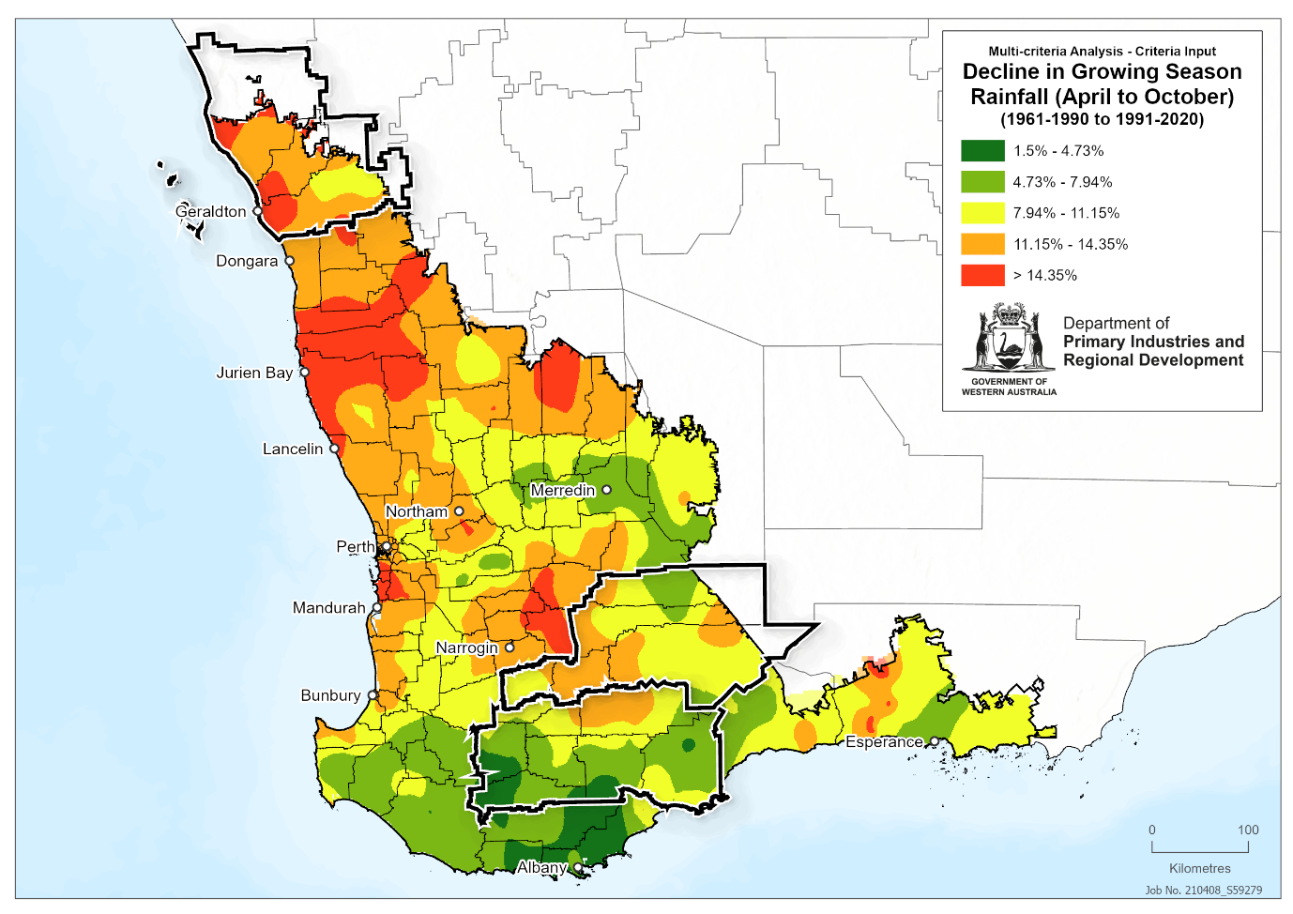
Figure 2: Change in growing season rainfall (projected)
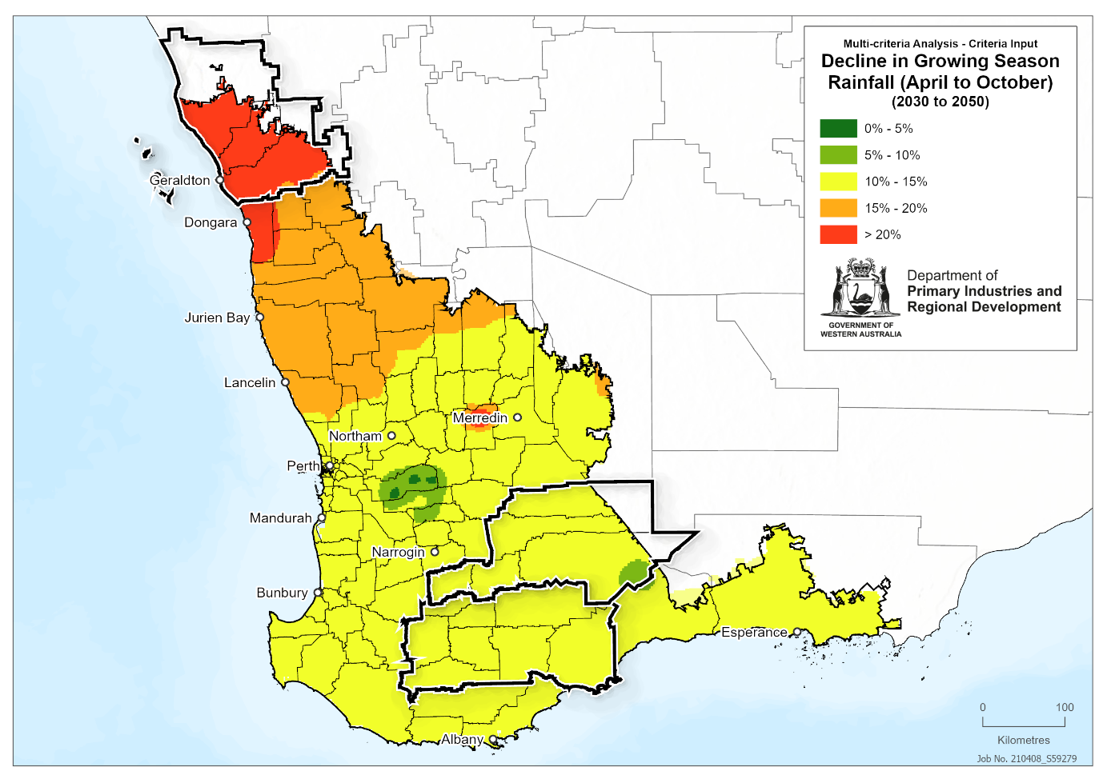
Figure 3: Change in maturing season temperature (historical)
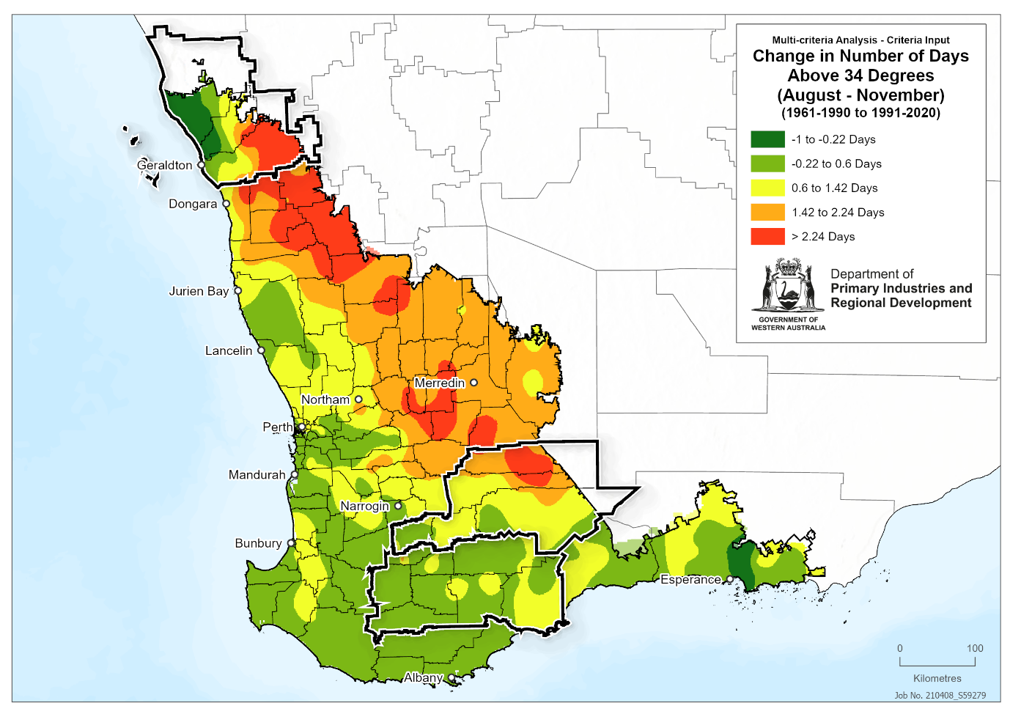
Figure 4: Change in maturing season temperature (projected)
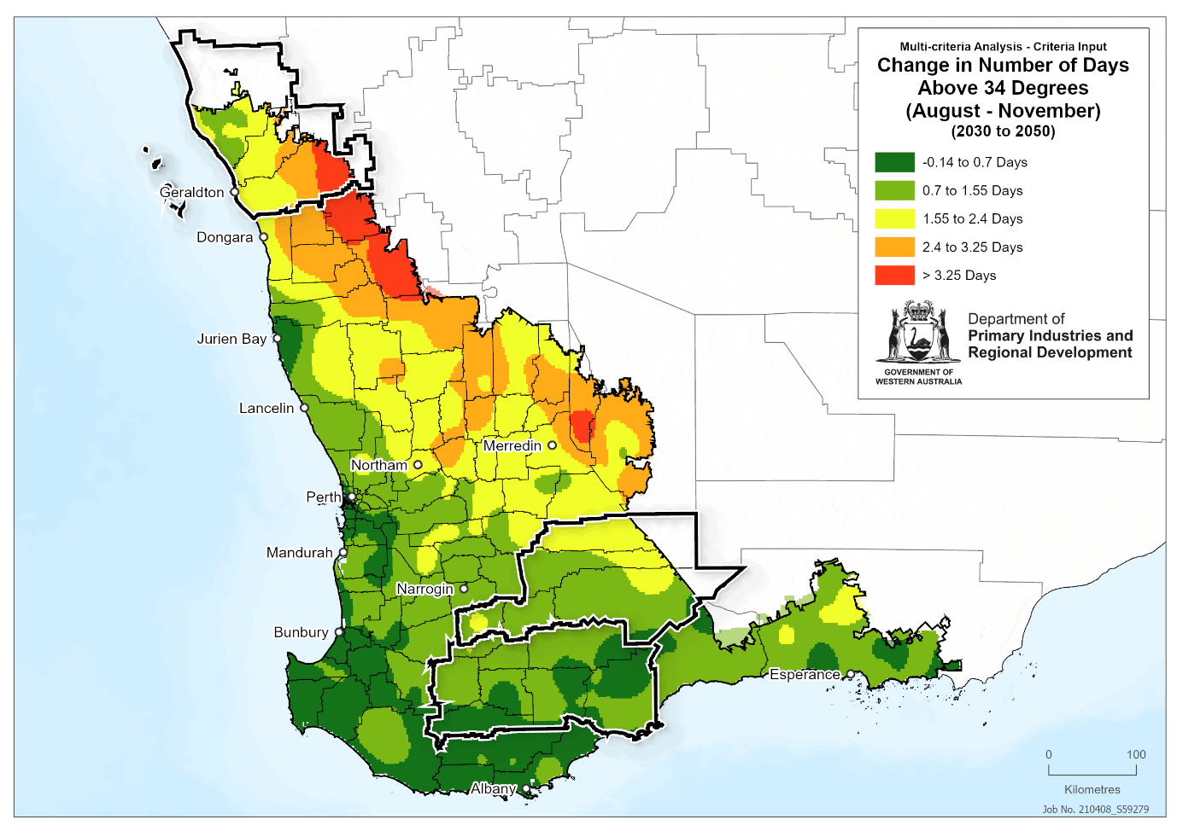
Figure 5: Rainfall intensity (events > 10mm)
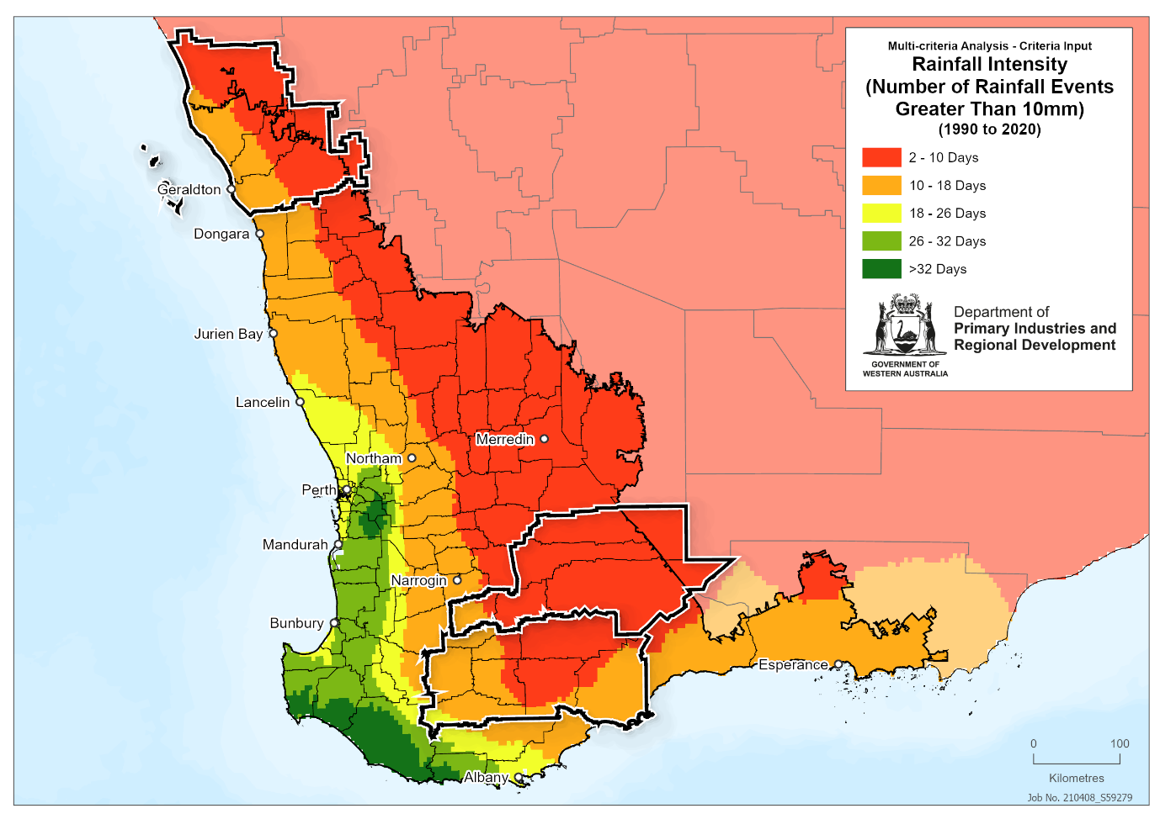
Figure 6: Rainfall intensity (events > 25 mm)
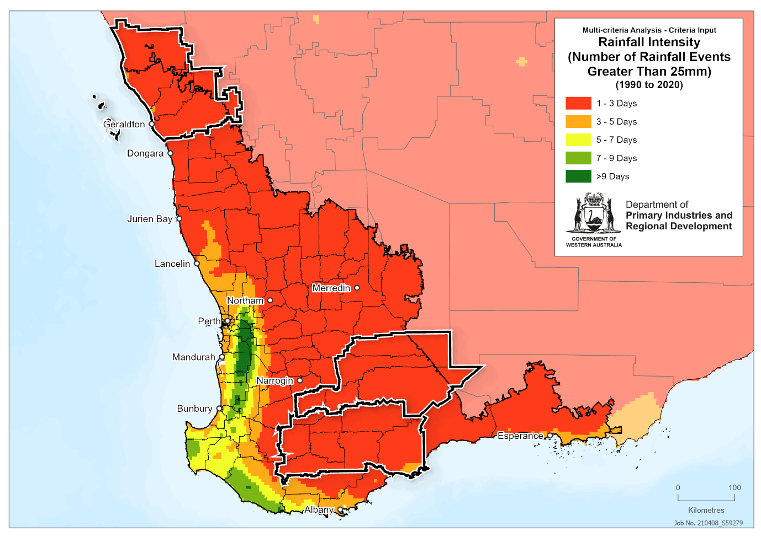
Figure 7: Change in root zone soil moisture
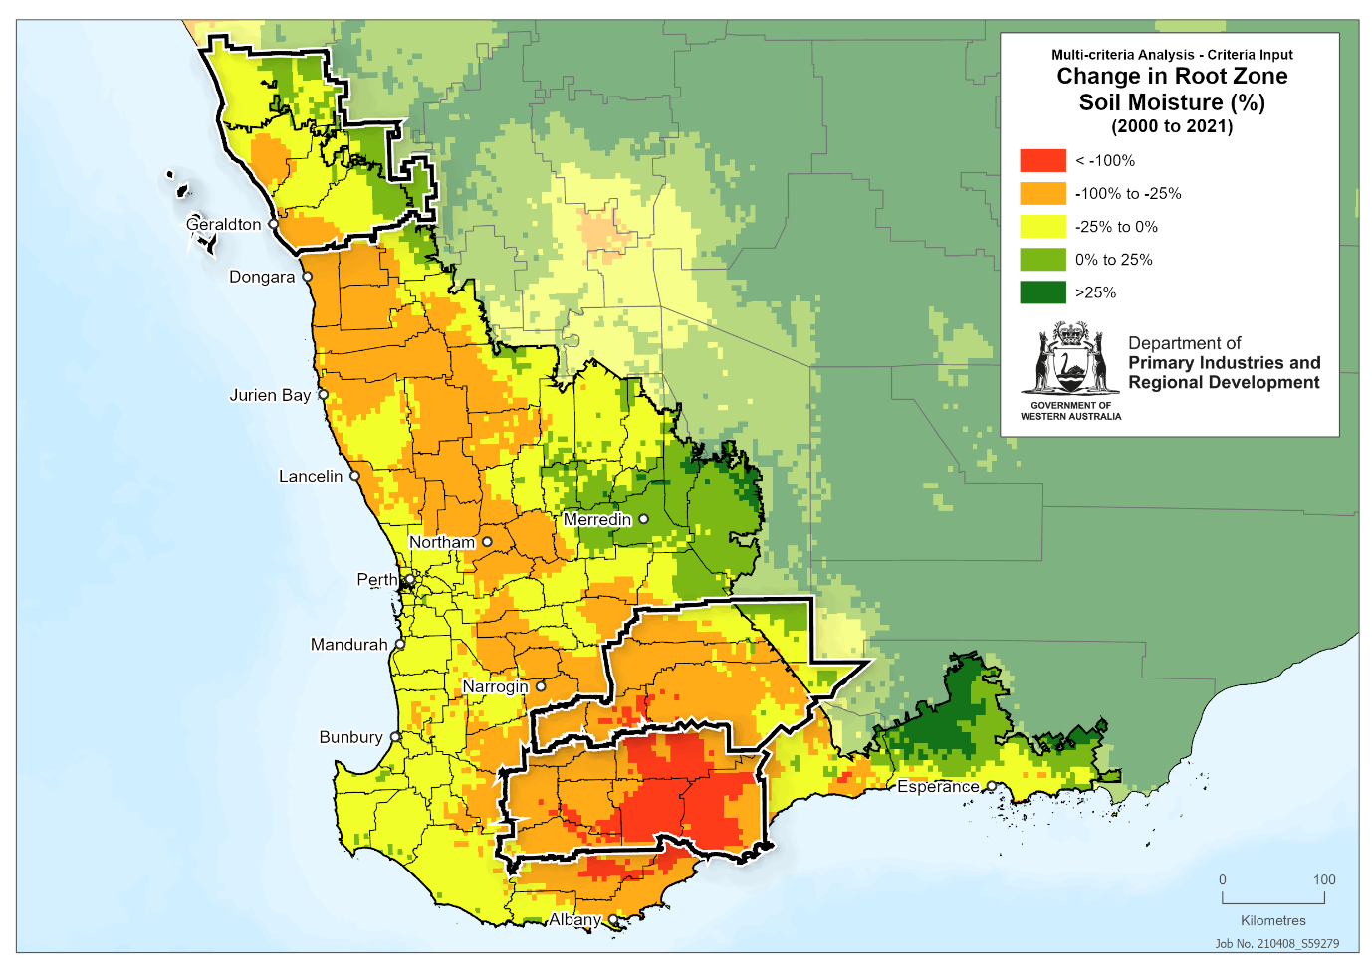
Figure 8: Change in timing of the autumn break
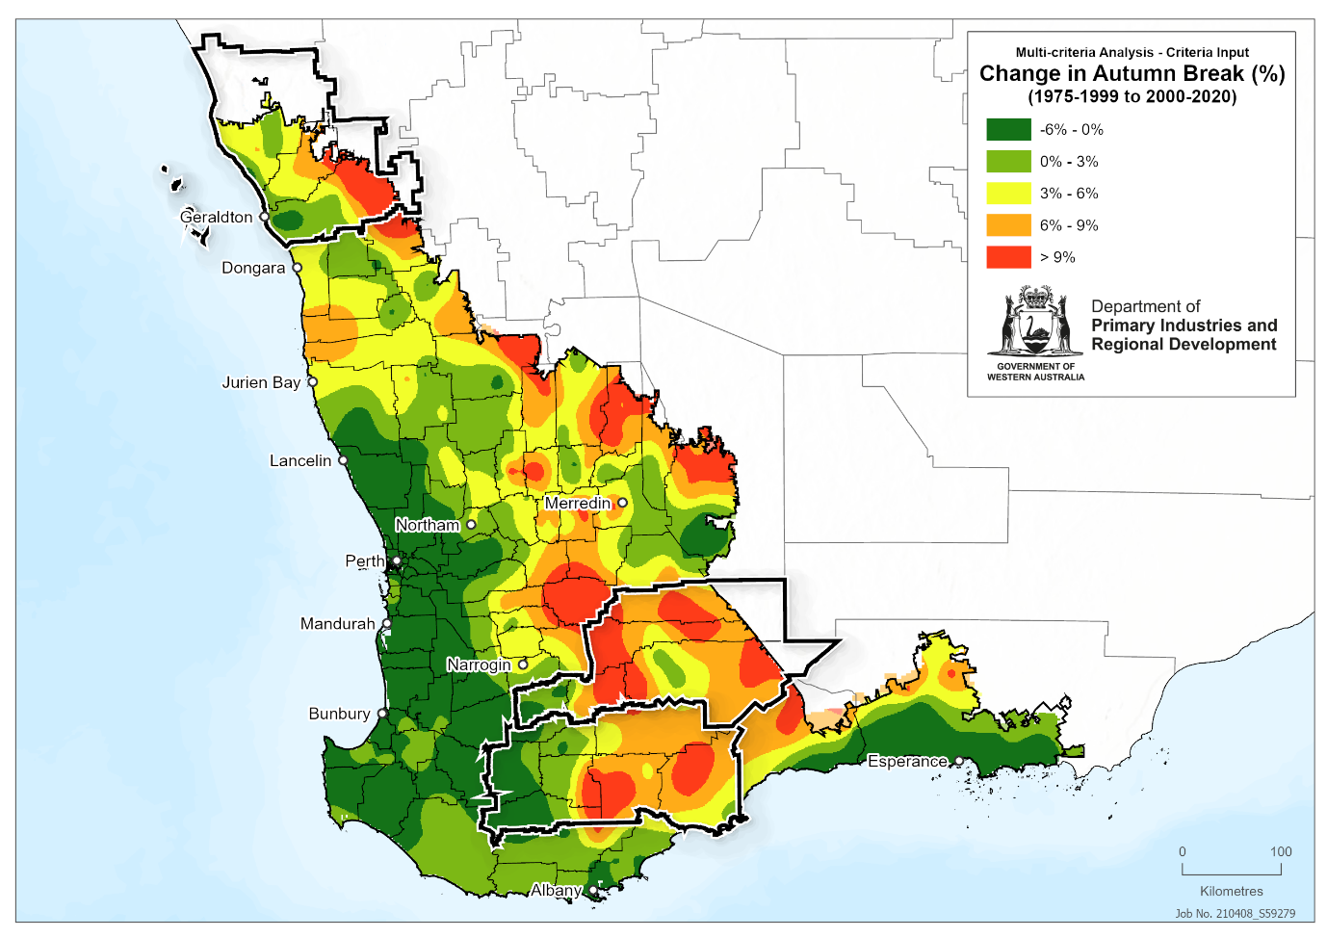
Figure 9: Change in drought frequency
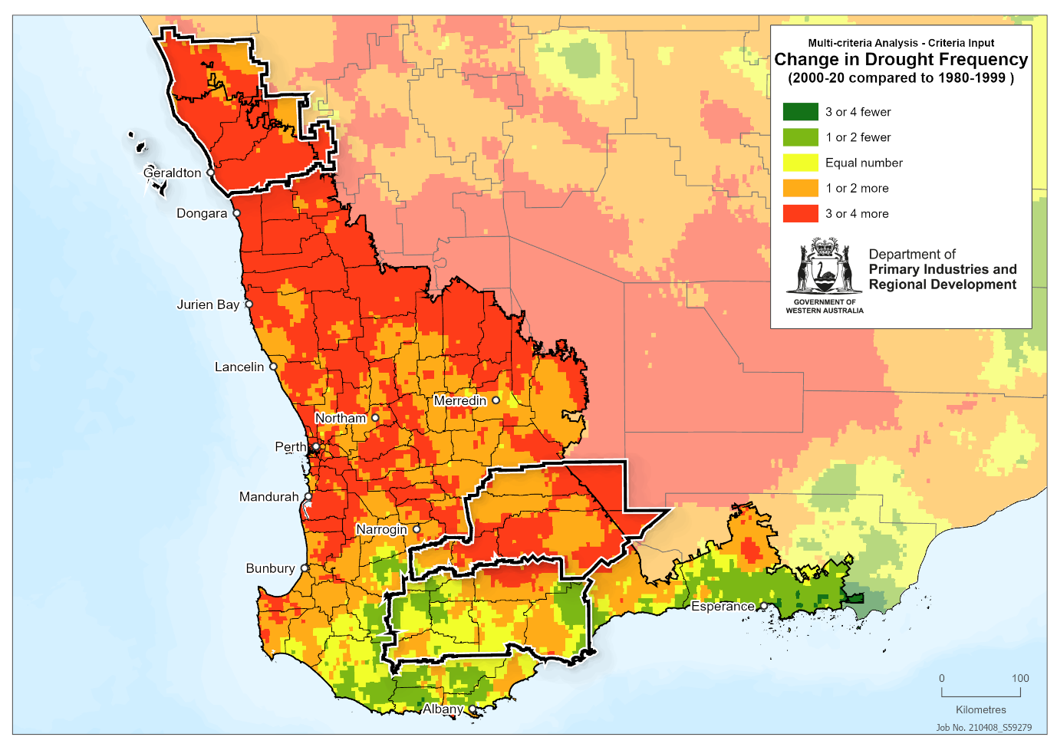
Figure 10: Change in potential wheat yield
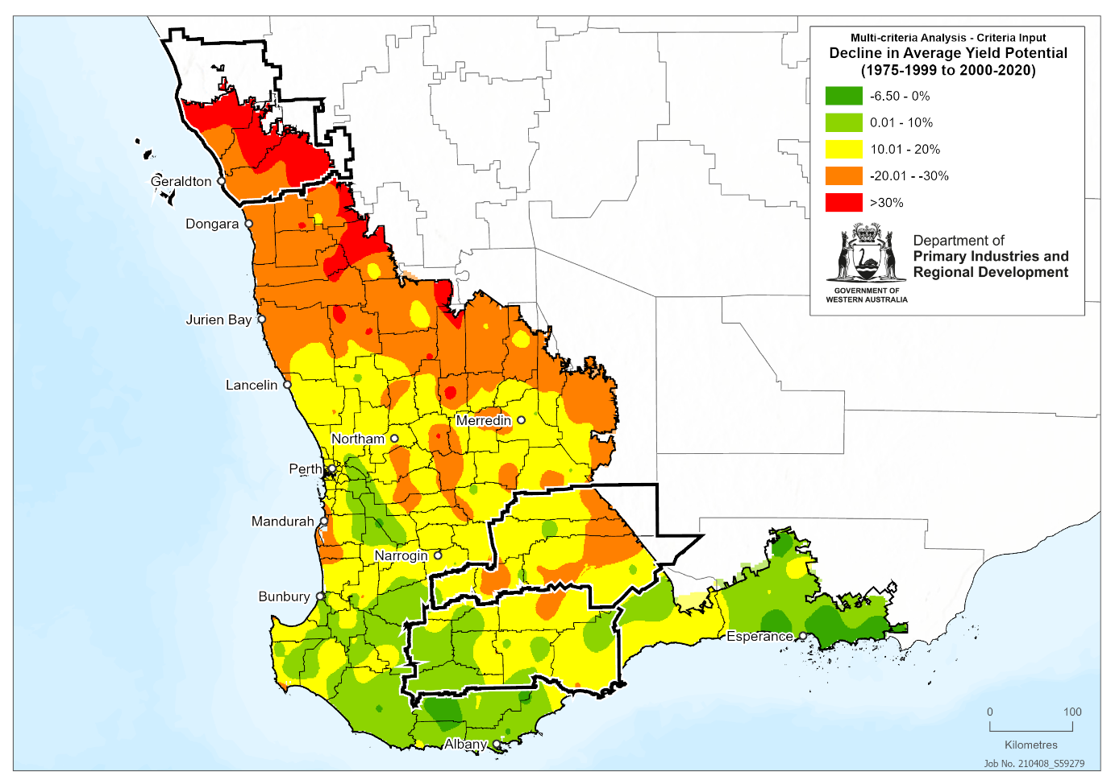
Figure 11: Distance from the coast
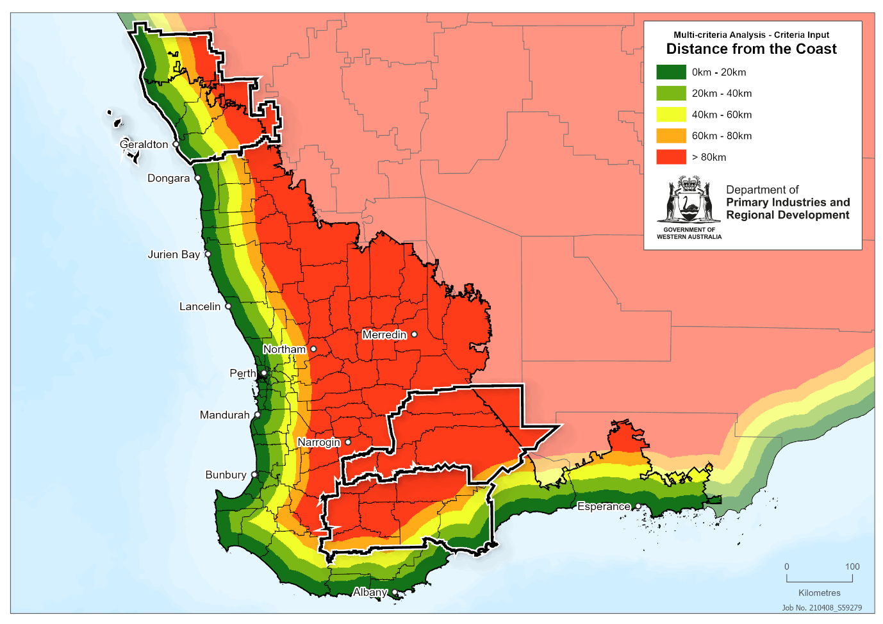
Figure 12: Composite exposure map.
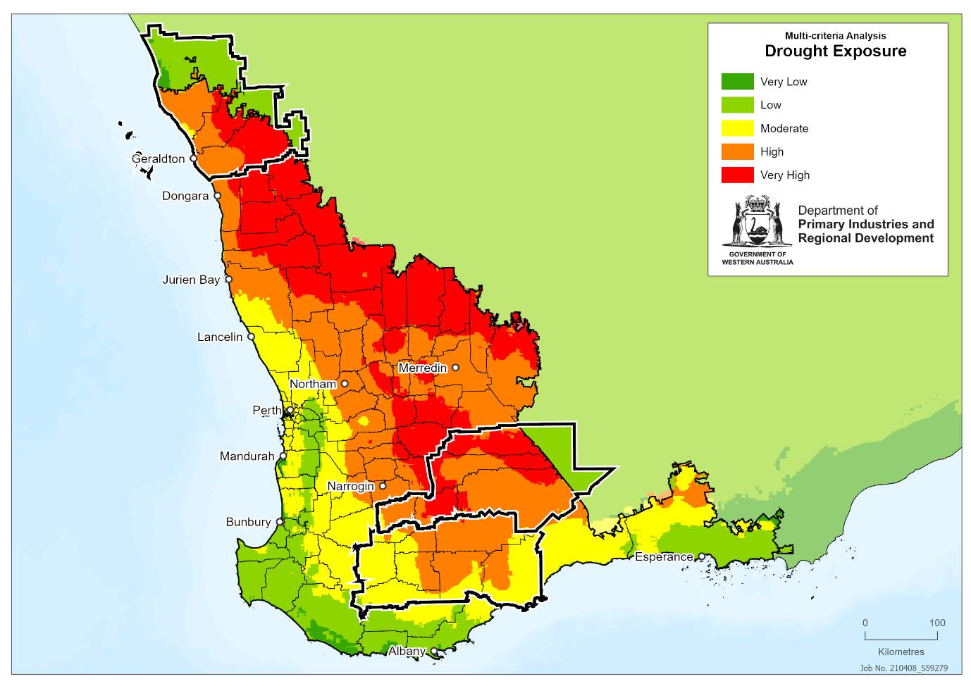
Figure 13: Exposure component work flow. Individual component maps are sized according to their weighting within each tier of analysis; primary = all individual component datasets and first-level composite maps, secondary = second-level composite maps made up of primary datasets and first-level composite maps.
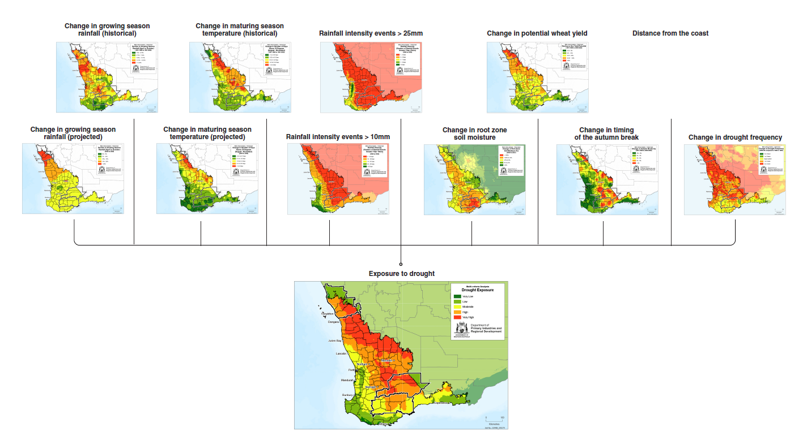
Figure 14: Wheat production t/ha
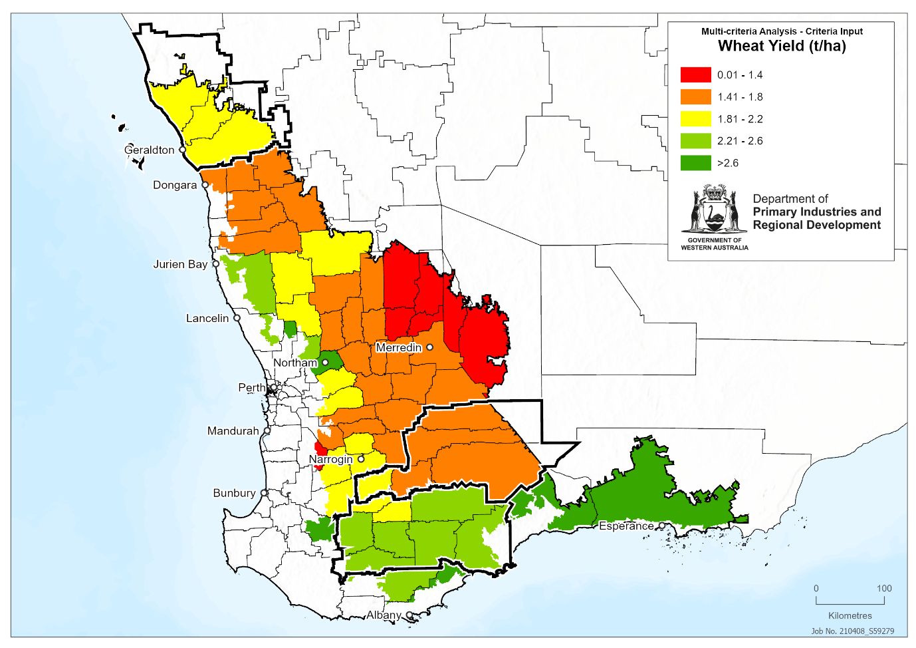

Figure 15: Canola production t/ha
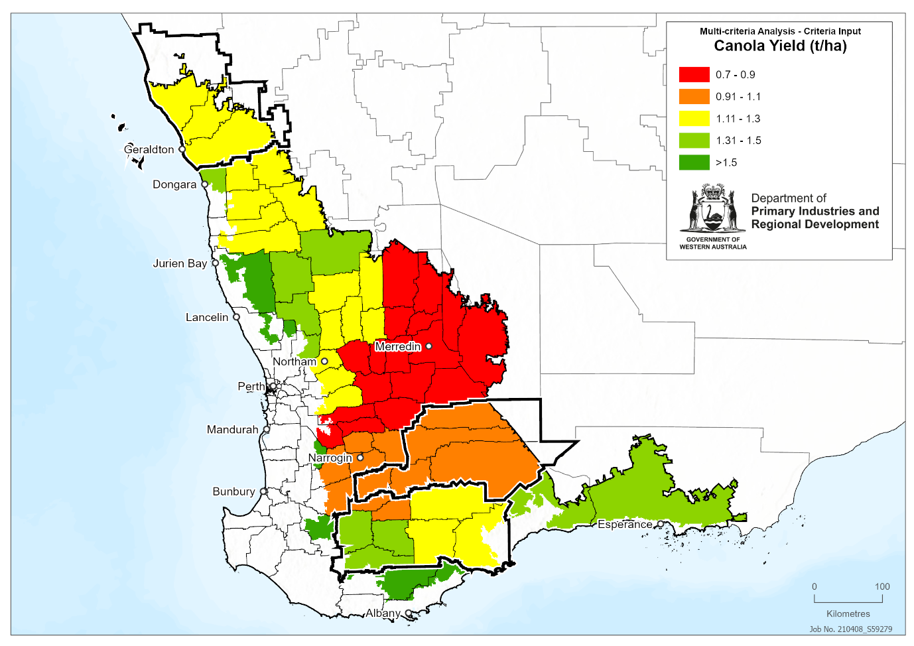
Figure 16: Barley production t/ha
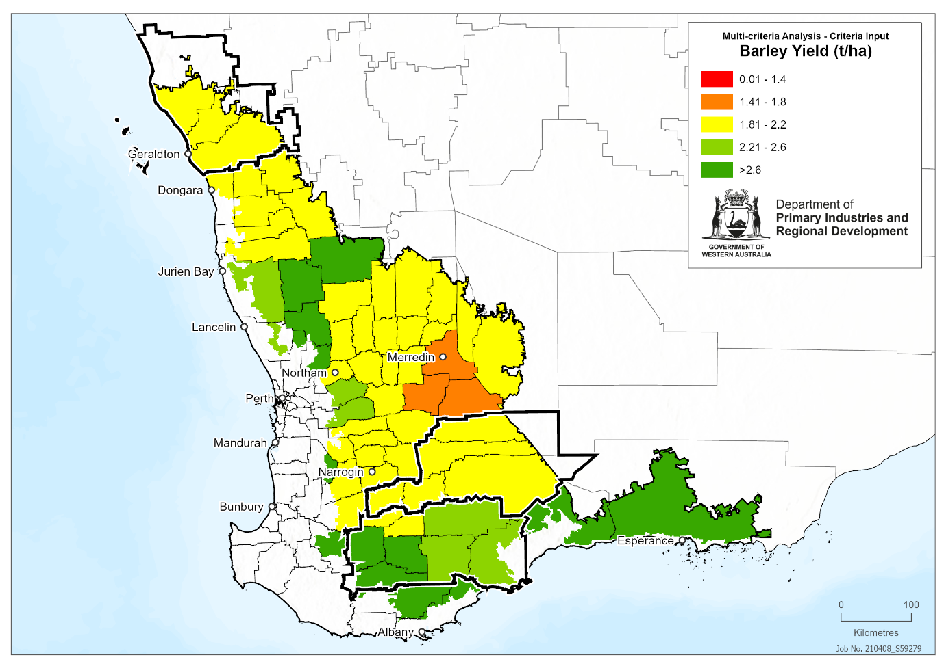
Figure 17: Cattle production (numbers)
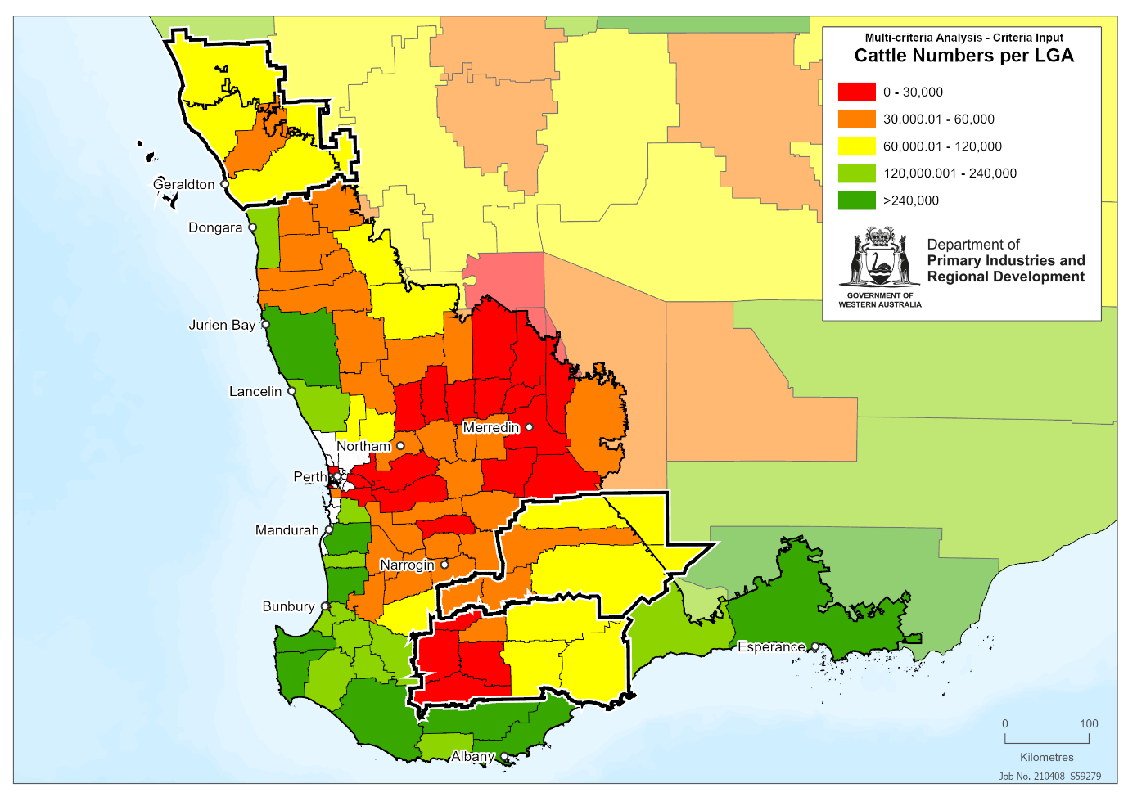
Figure 18: Sheep production (numbers)
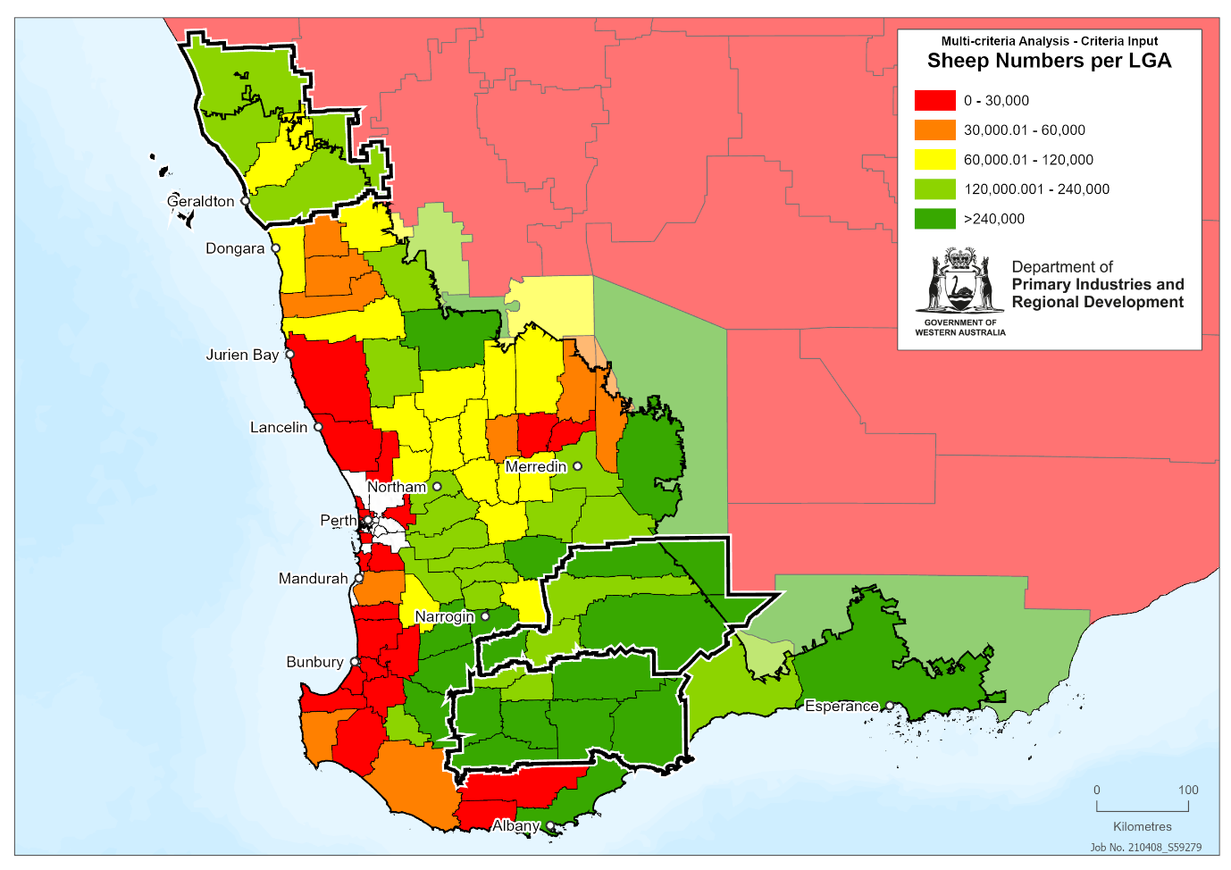
Figure 19: High quality agricultural land
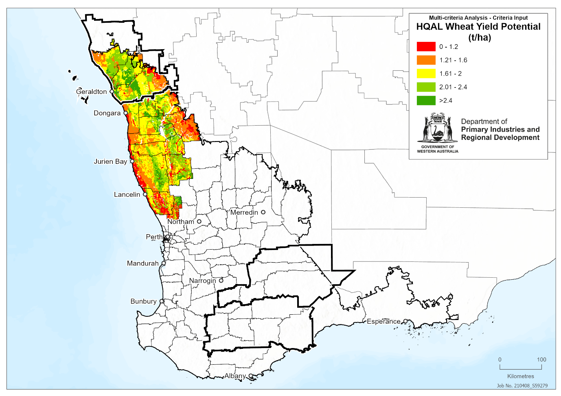
Figure 20: NDVI at the end of the growing season (20yr average)
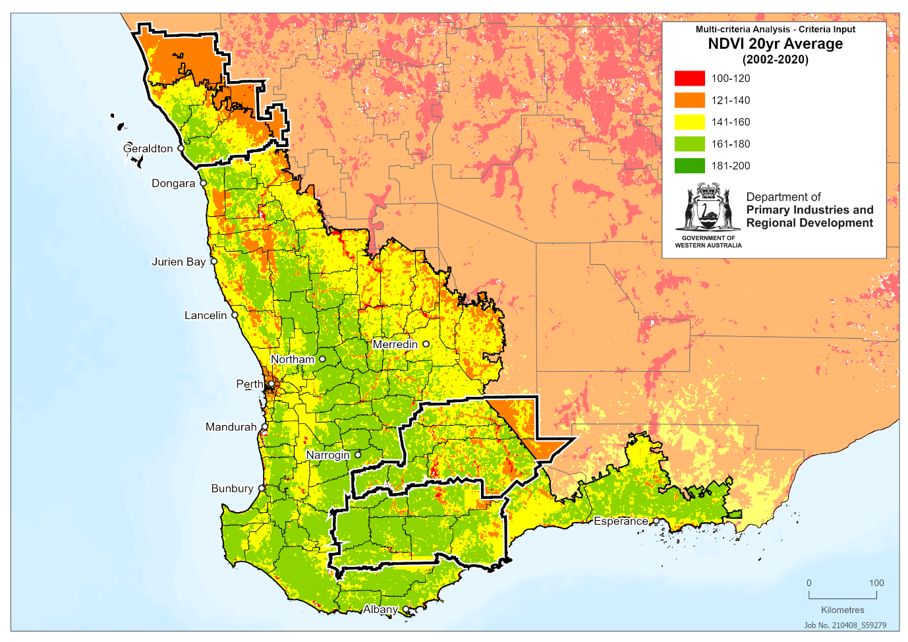
Figure 21: Water quality
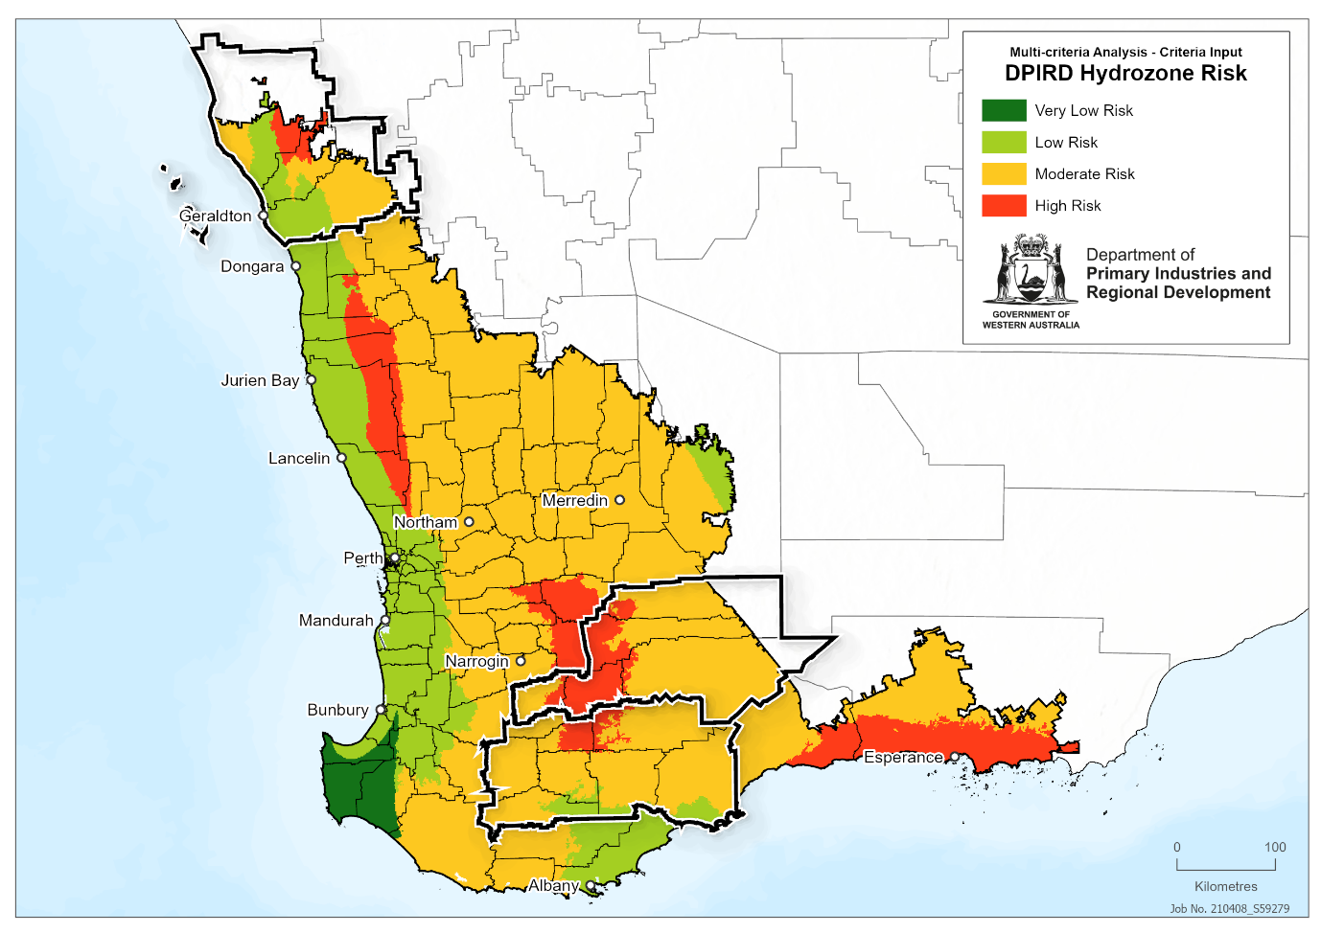
Figure 22: NDVI at the end of the growing season (lowest 10%)
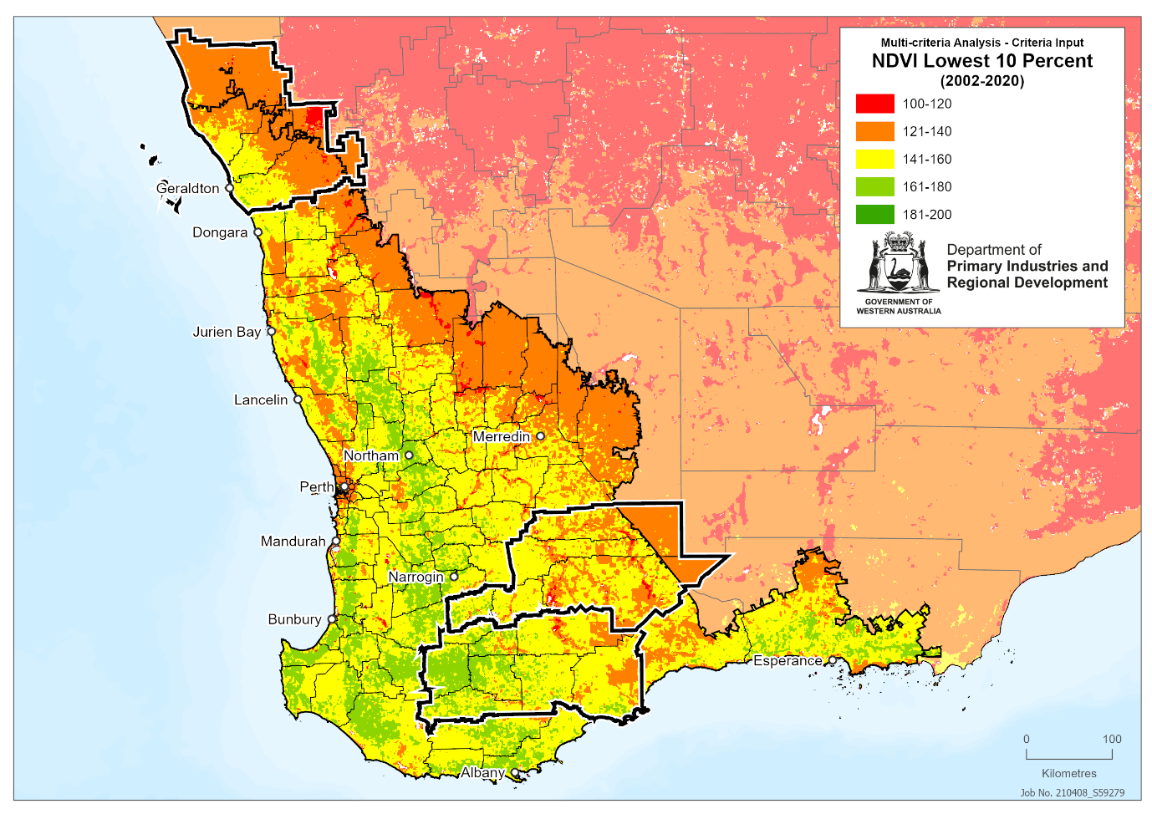
Figure 23: Average household income
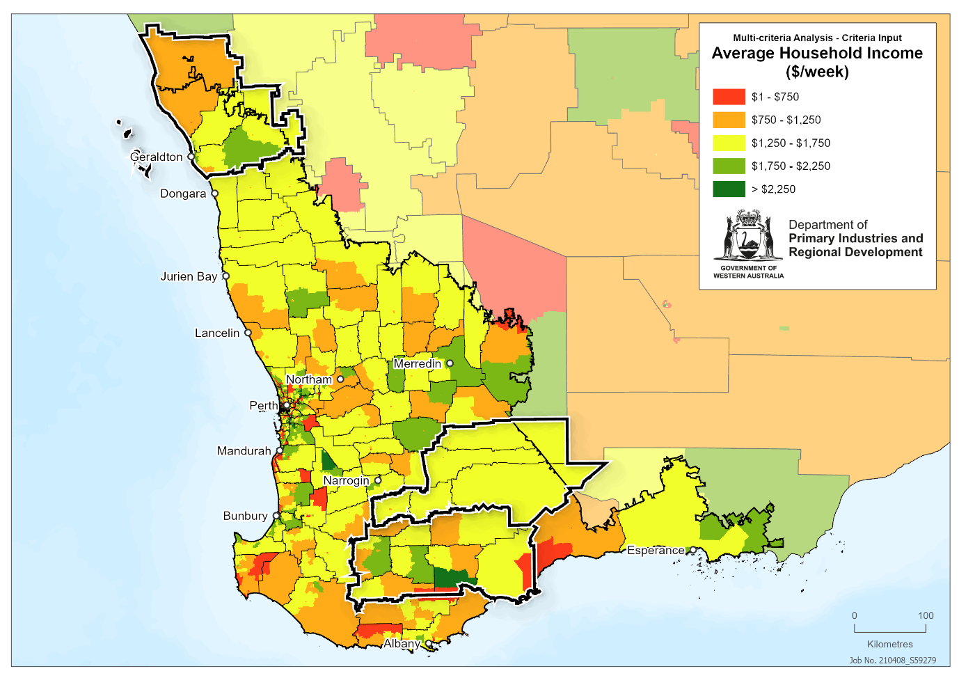
Figure 24: Farm profit vulnerability
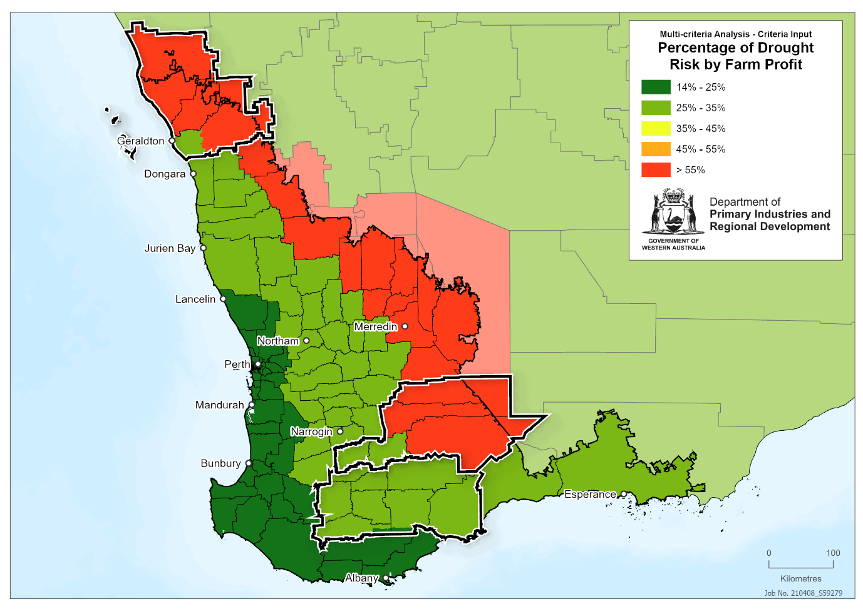
Figure 25: Percentage of the population employed in agriculture
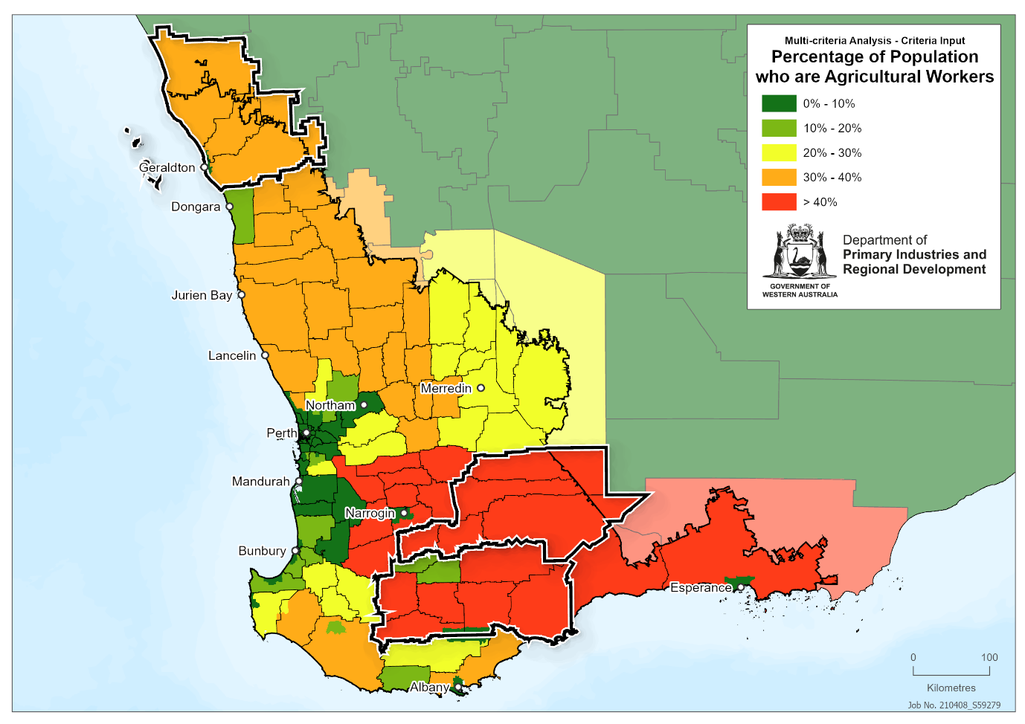
Figure 26: Average farm size
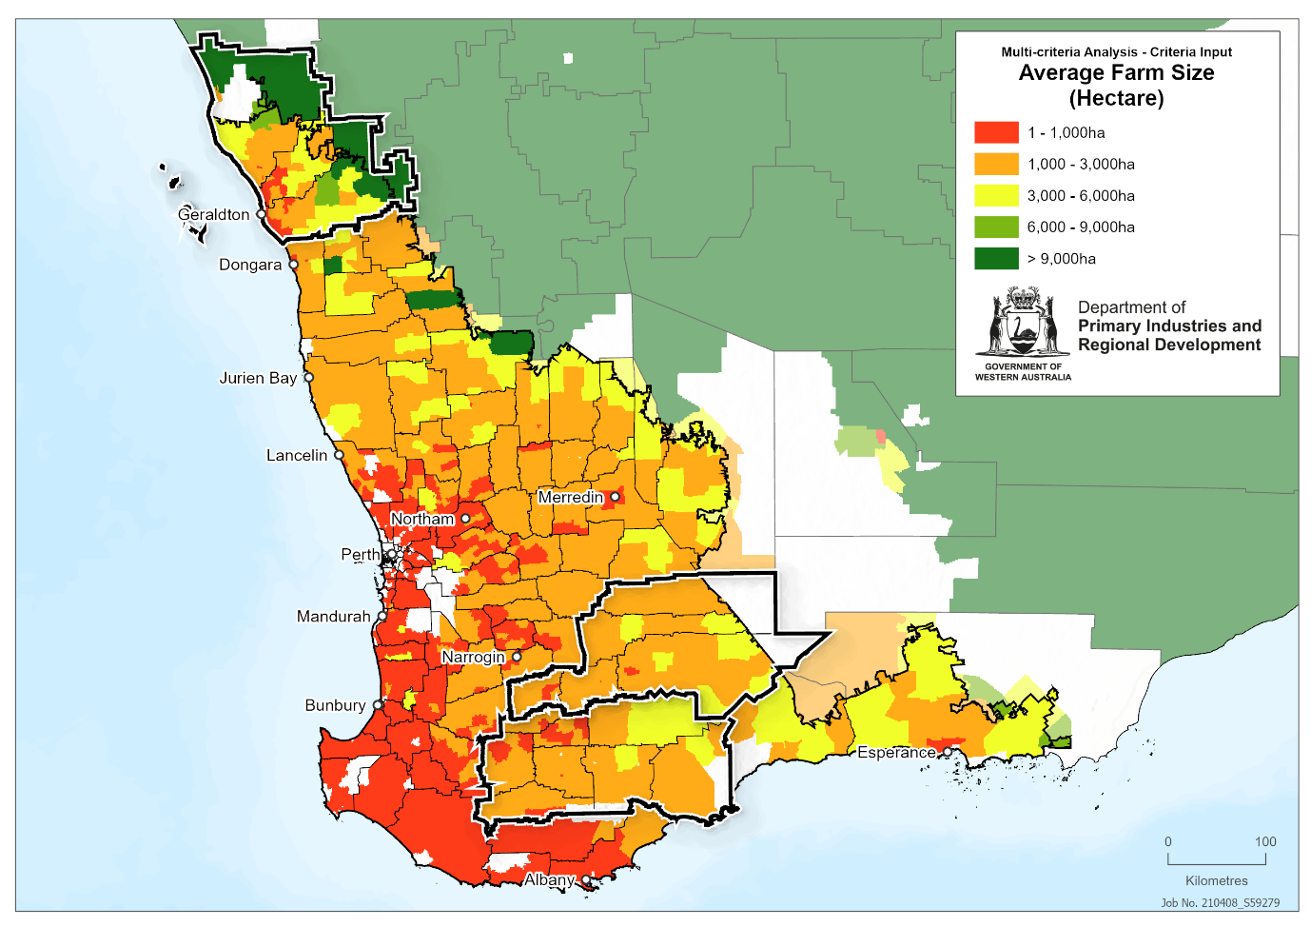
Figure 27: Presence of bores and dams
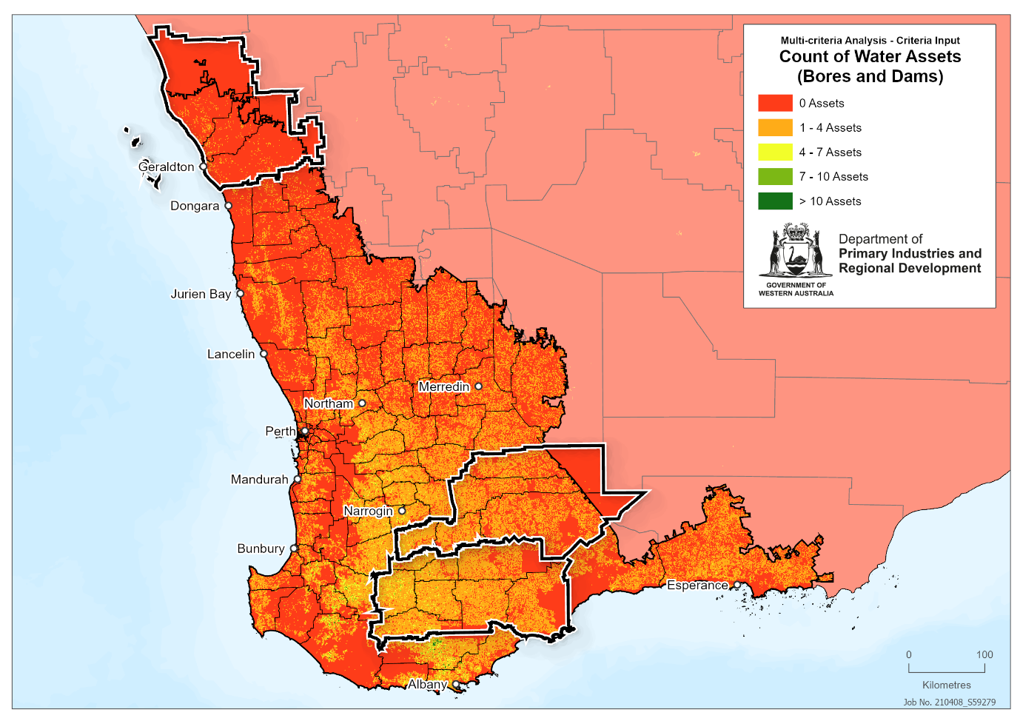
Figure 28: Farm diversity
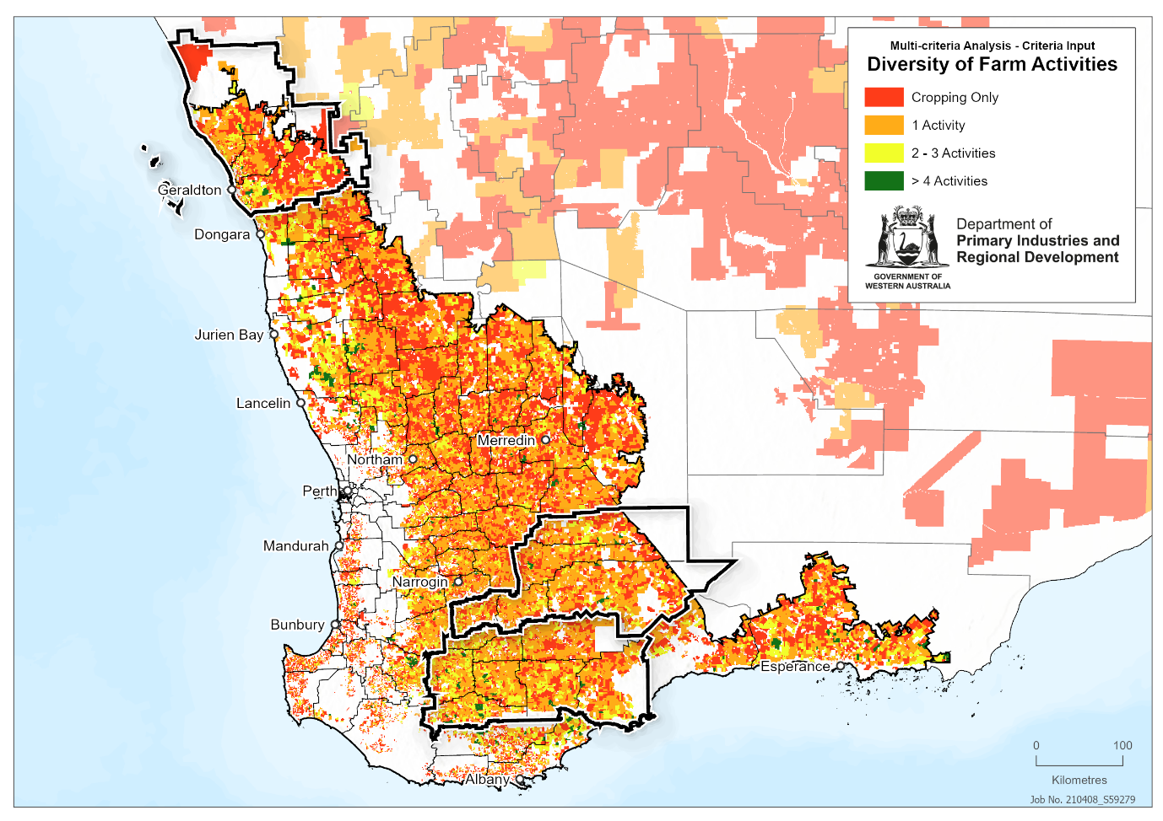
Figure 29: Accessibility and remoteness index
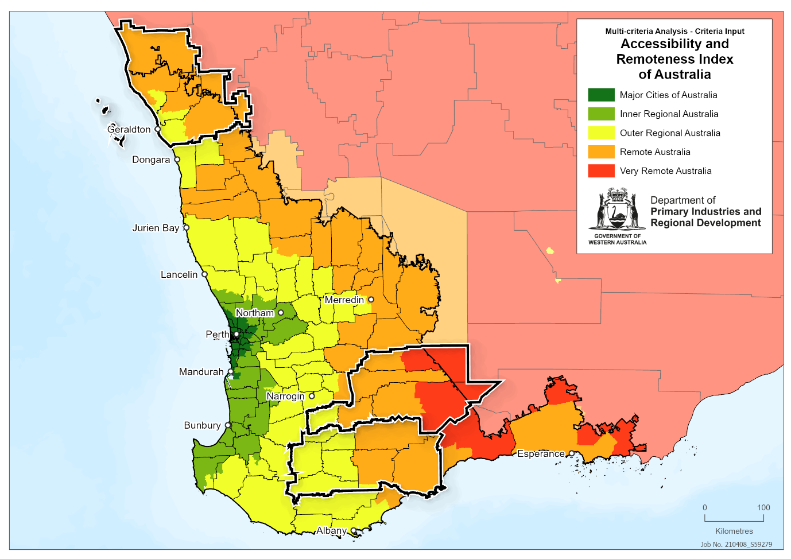
Figure 30: Population trends
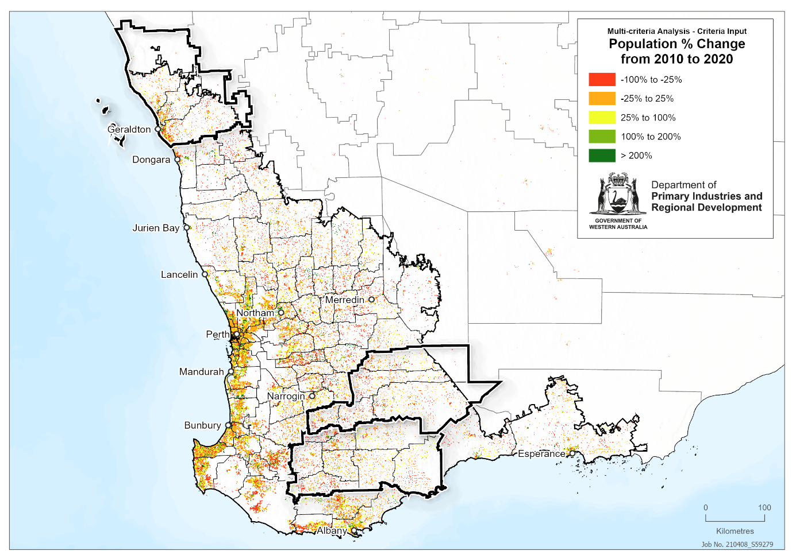
Figure 31: Areas declared water deficient
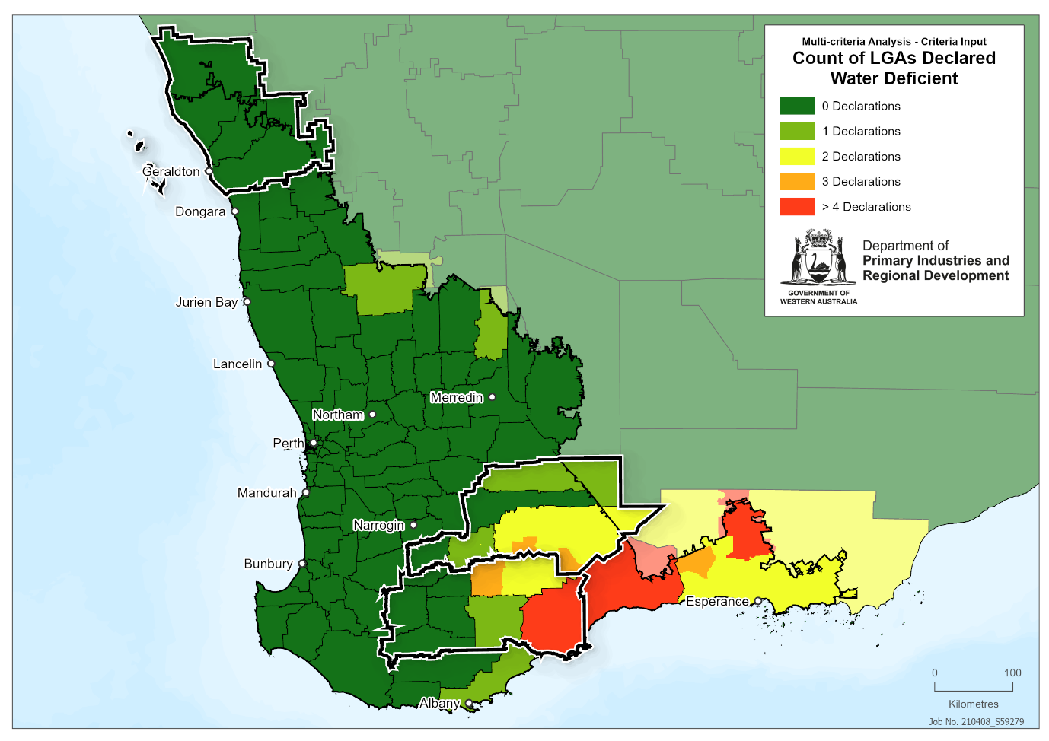
Figure 32: Composite map of production risk
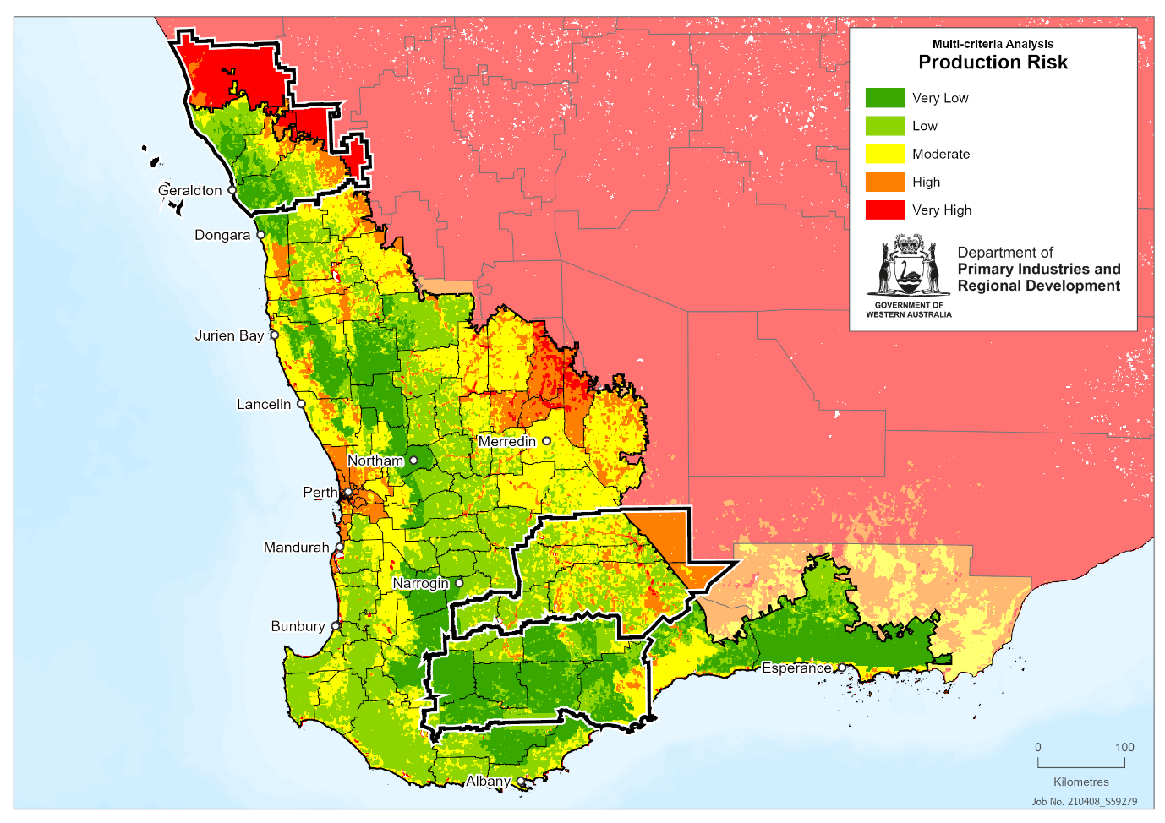
Figure 33: Composite sensitivity map
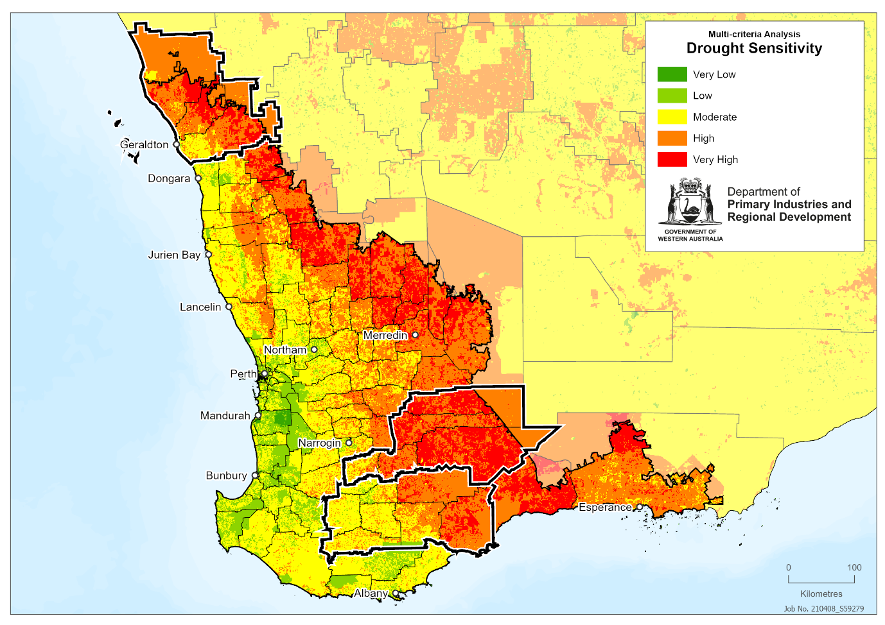
Figure 34: Sensitivity component work flow. Individual component maps are sized according to their weighting within each tier of analysis; primary = all individual component datasets and first-level composite maps, secondary = second-level composite maps made up of primary datasets and first-level composite maps.

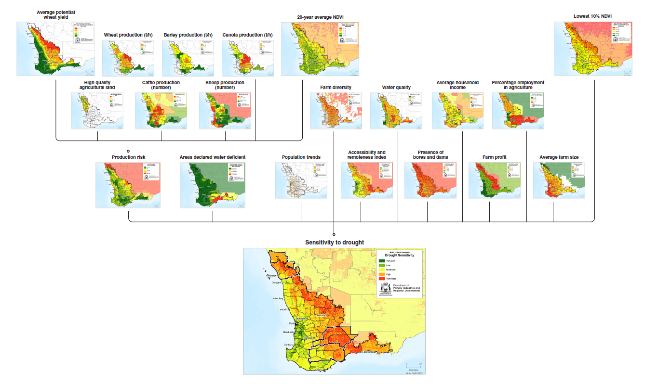
Figure 35: Population older than 65 years
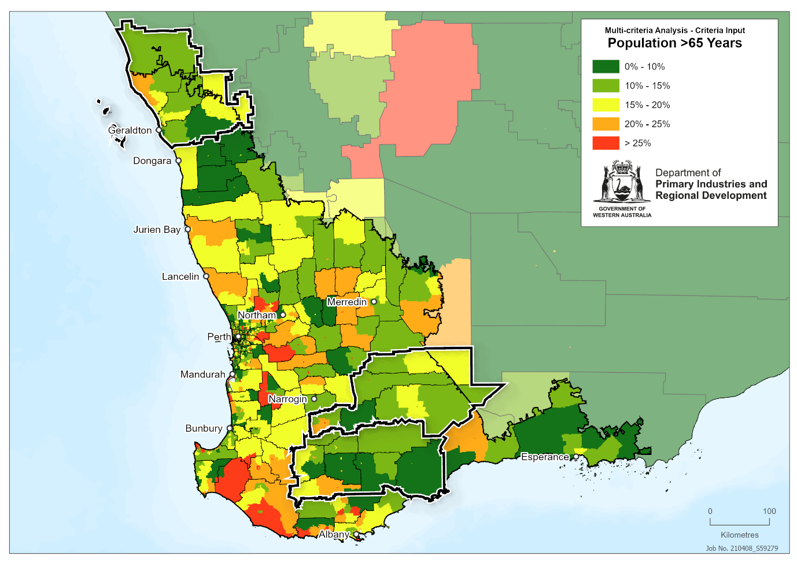
Figure 36: Percentage unemployment
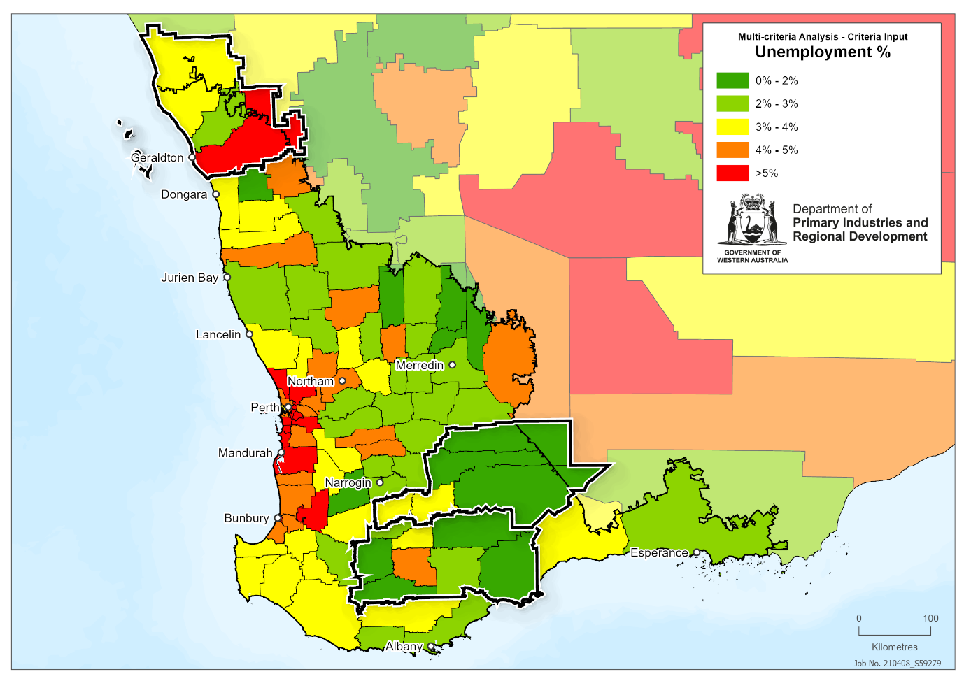
Figure 37: Important surface water resources
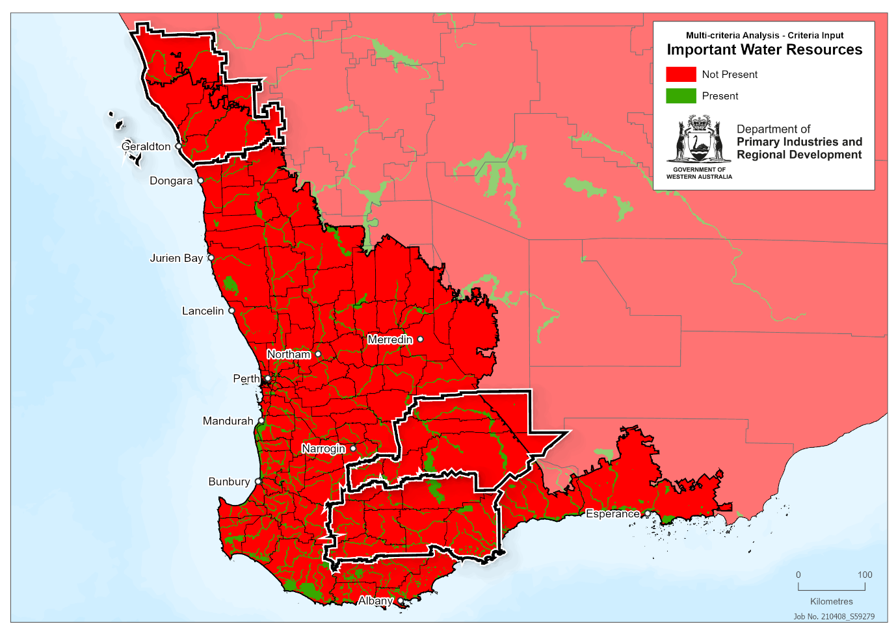
Figure 38: Groundwater resources
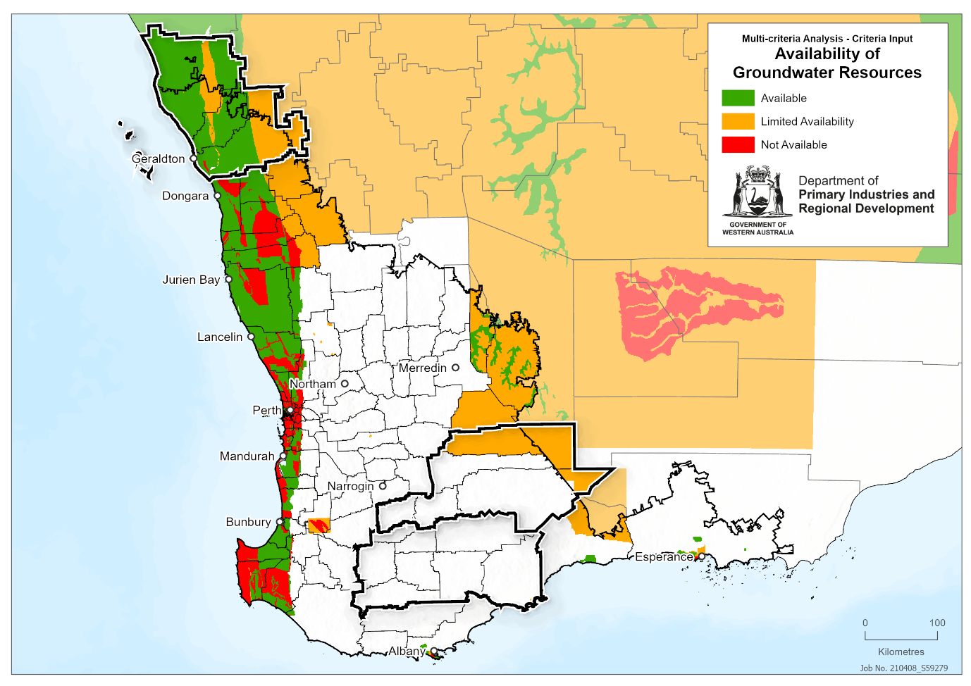
Figure 39: Groundwater quality
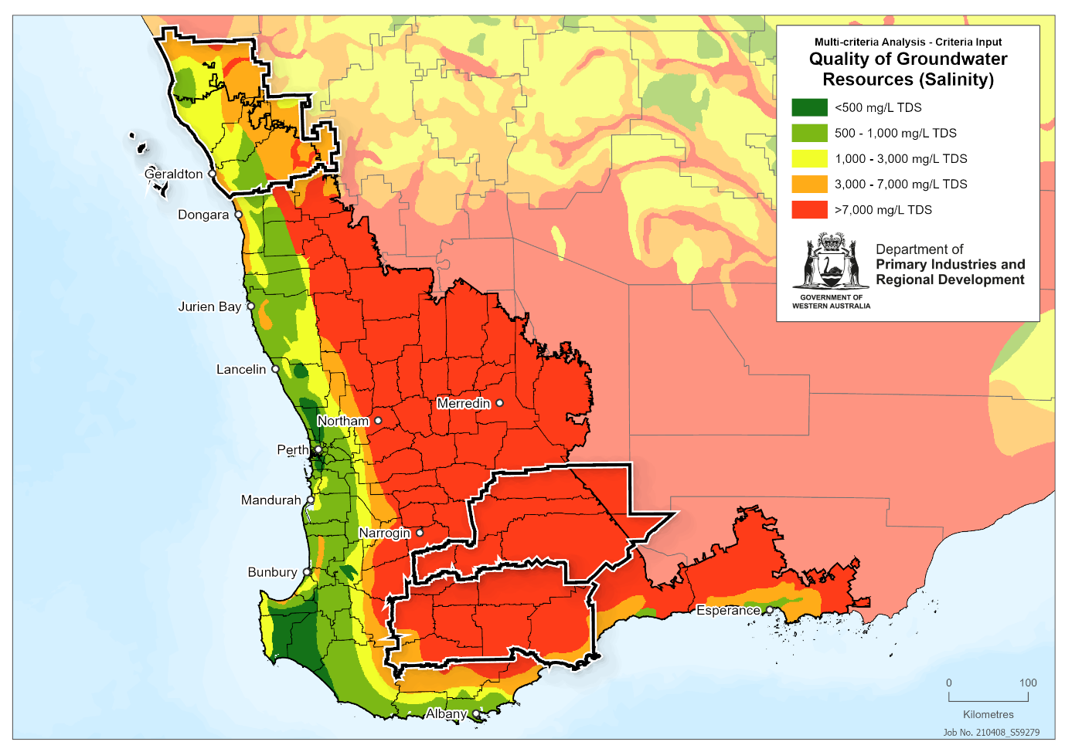Figure 40: Proclaimed water protection areas
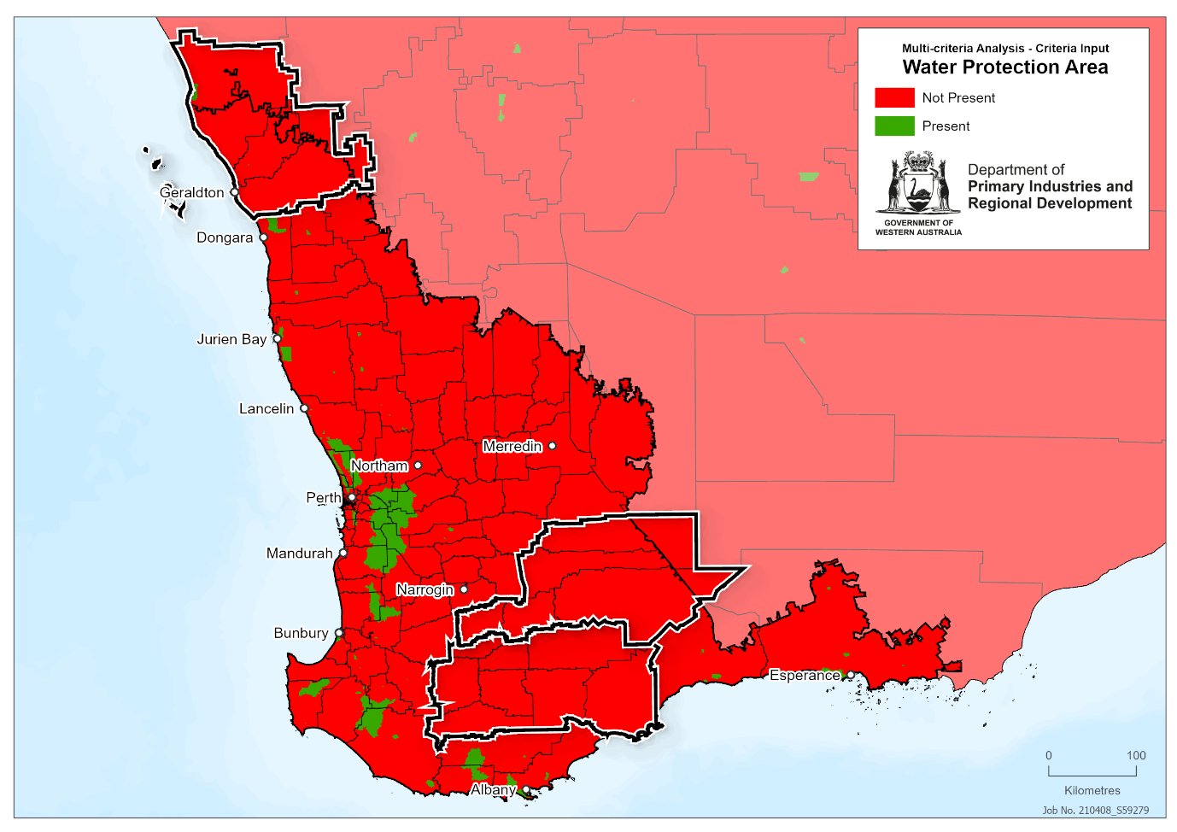
Figure 41: Soil capability
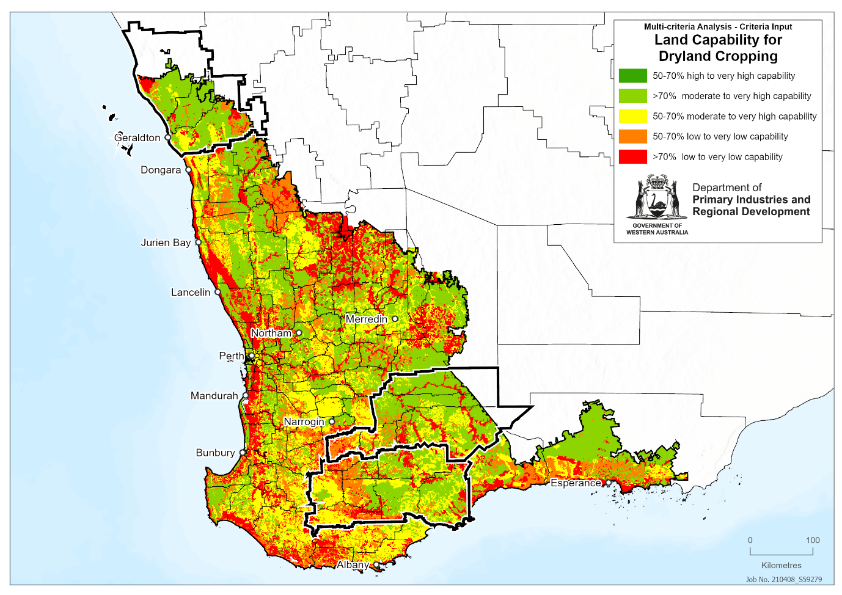
Figure 42: Plant available soil moisture 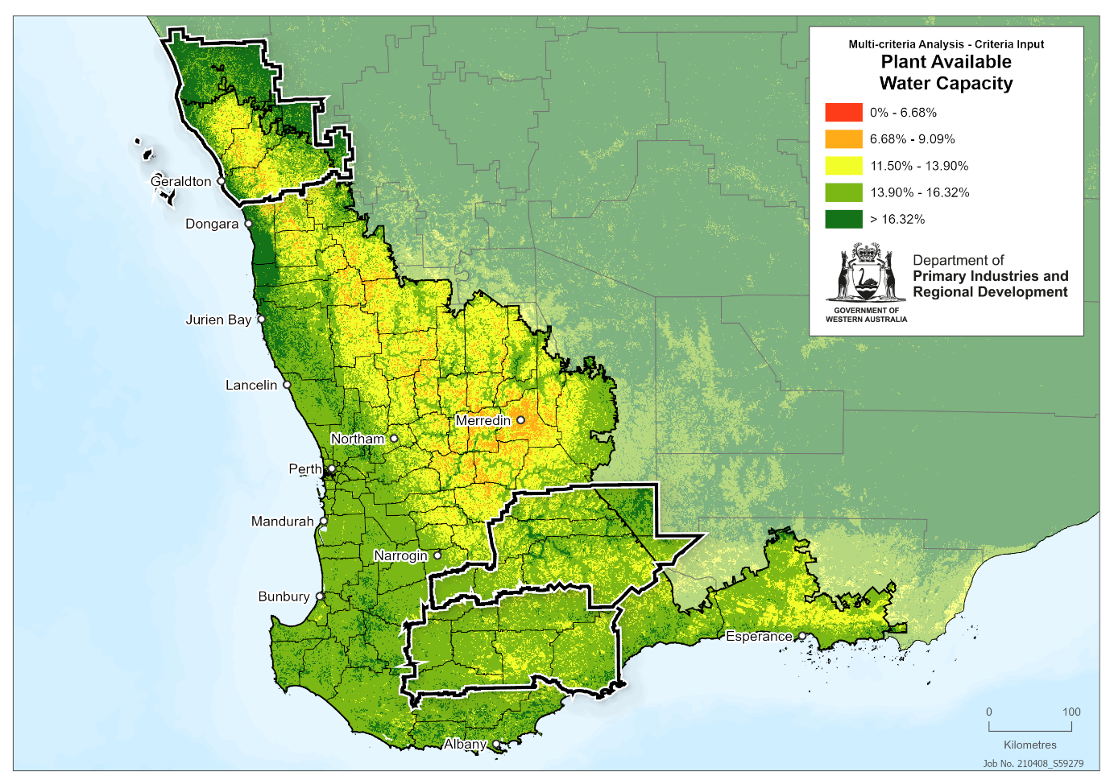
Figure 43: Native vegetation extent
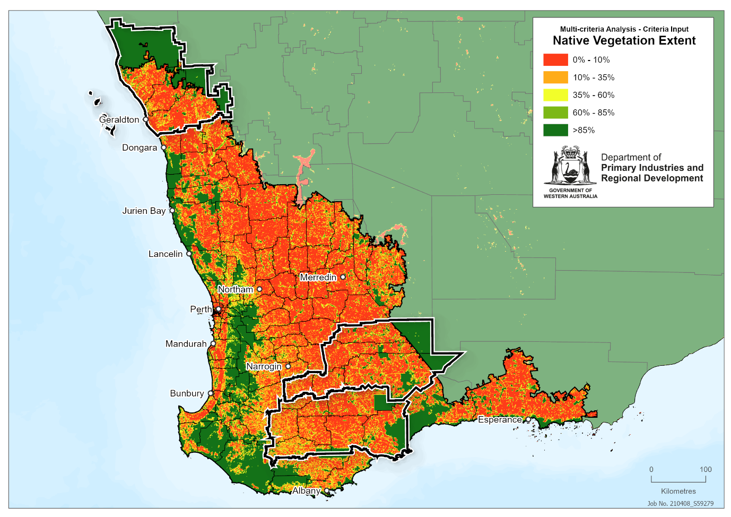
Figure 44: Trends in NDVI
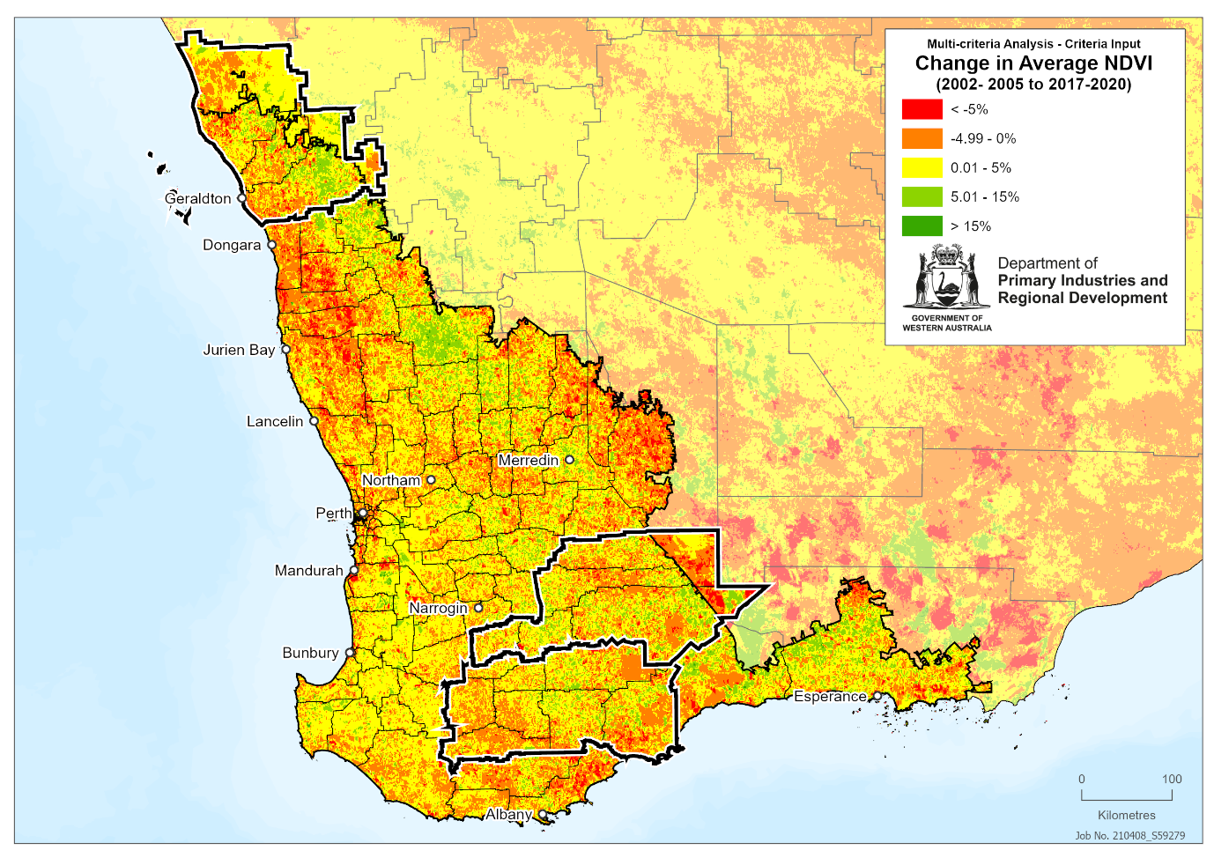
Figure 45: Proximity to road infrastructure
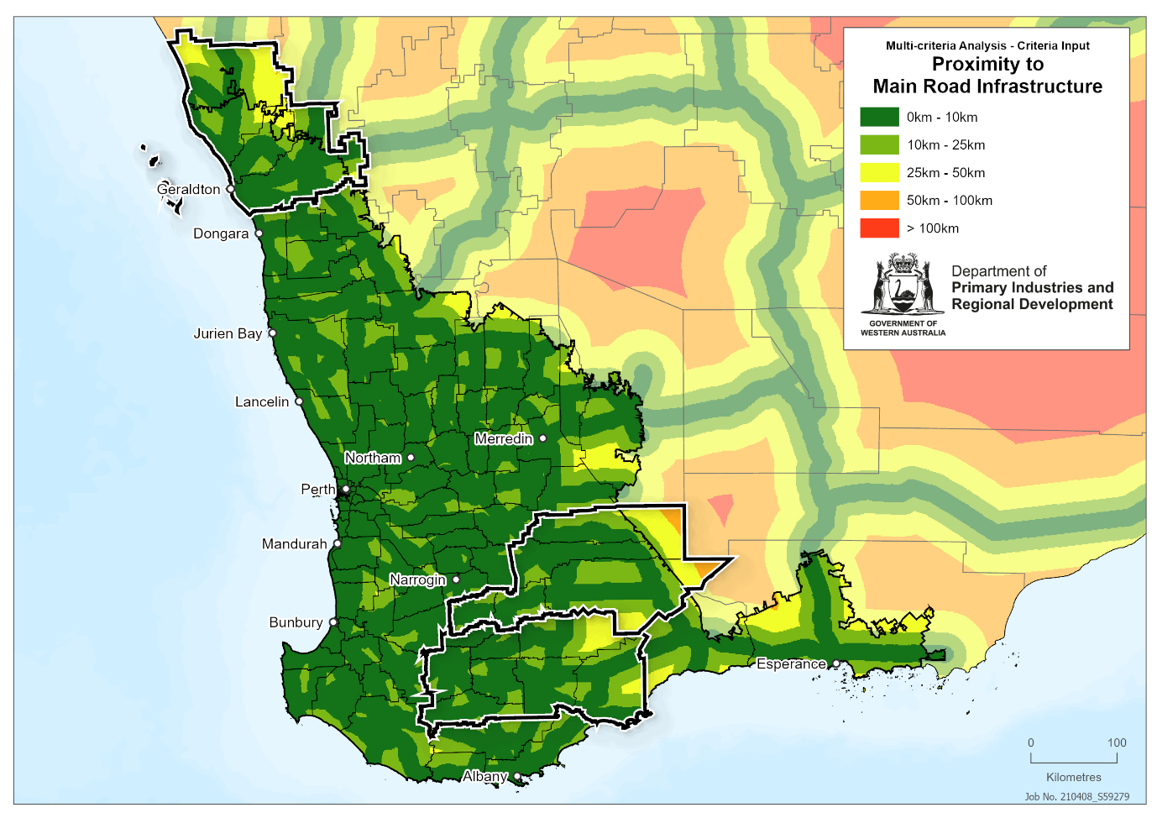
Figure 46: Proximity to strategic community water supplies
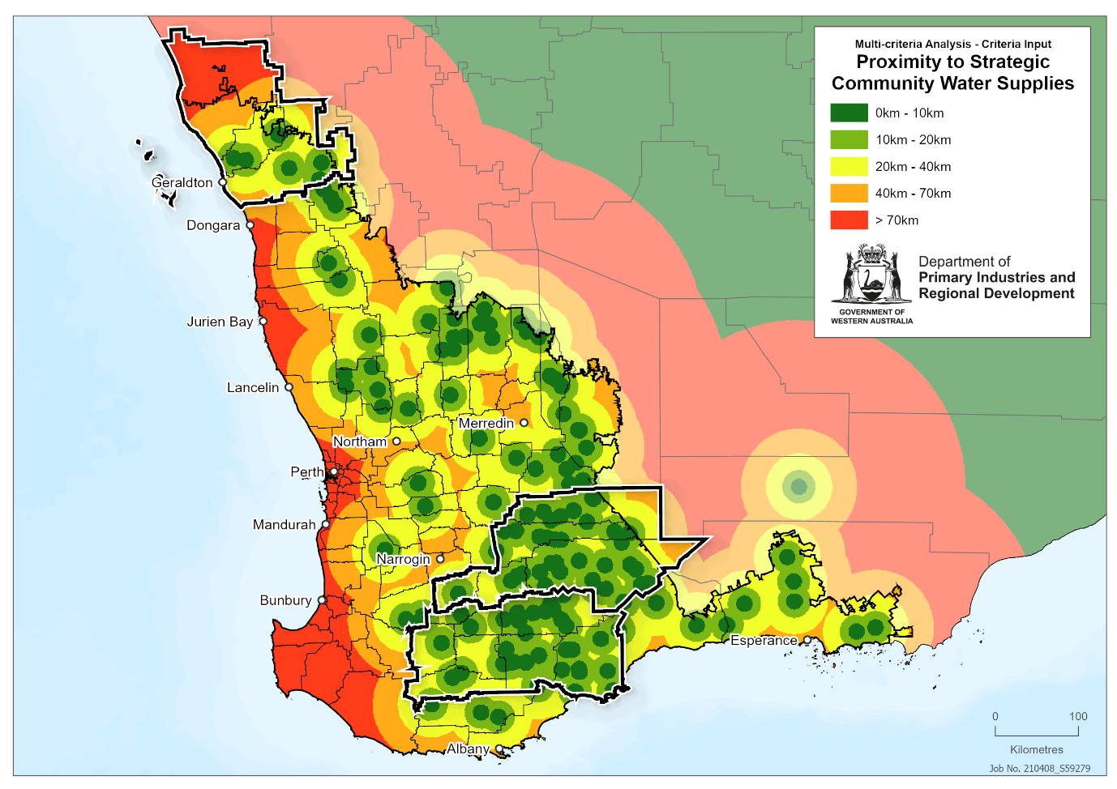
Figure 47: Proximity to scheme water coverage
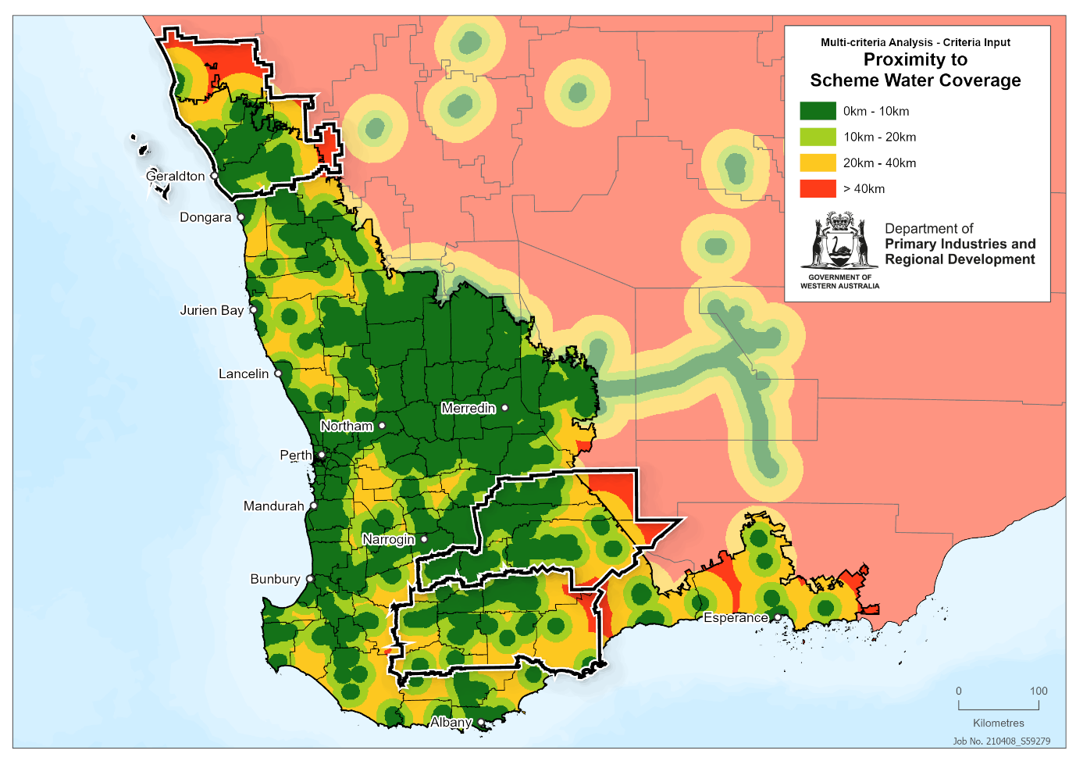
Figure 48: Composite human capital map
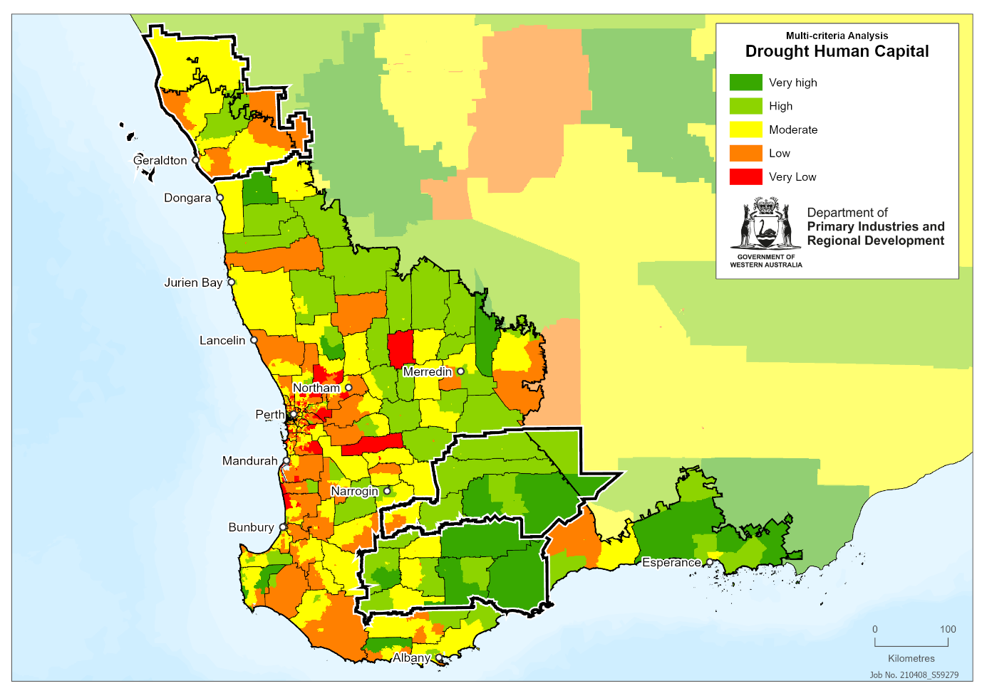
Figure 49: Composite natural capital map – water
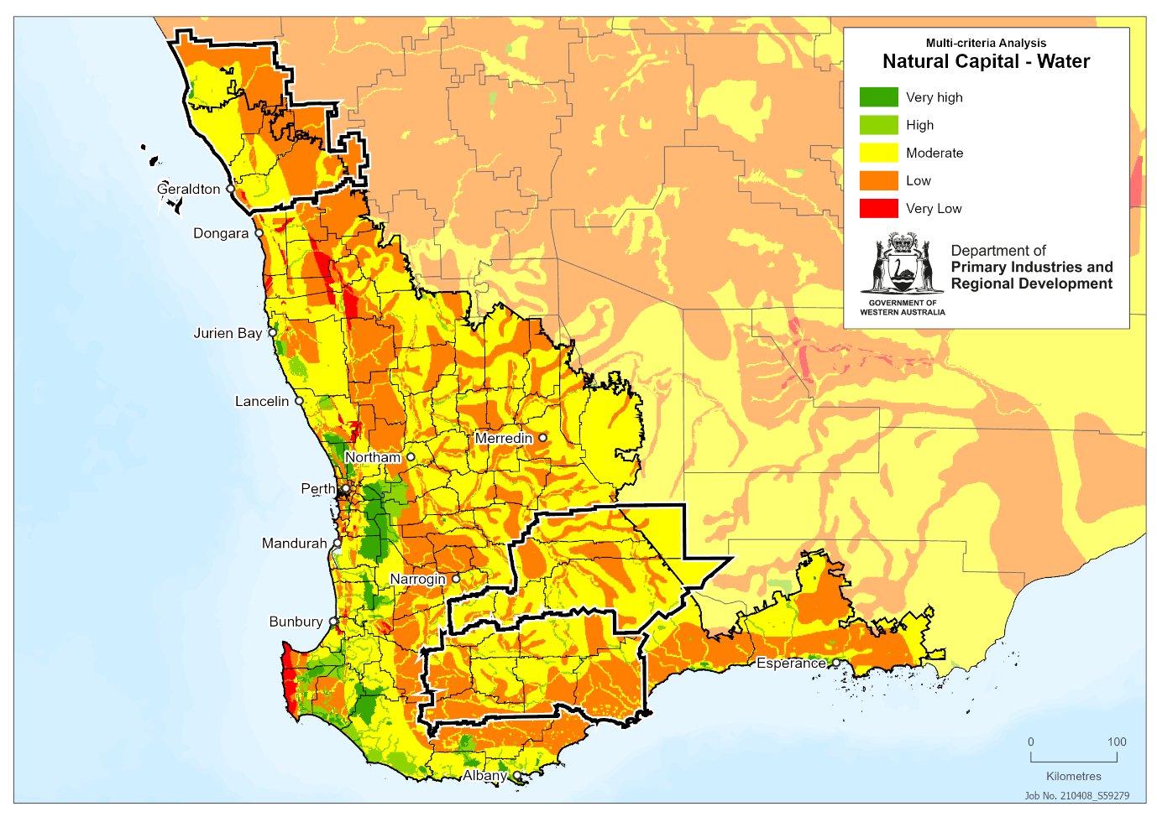
Figure 50: Composite natural capital map – other
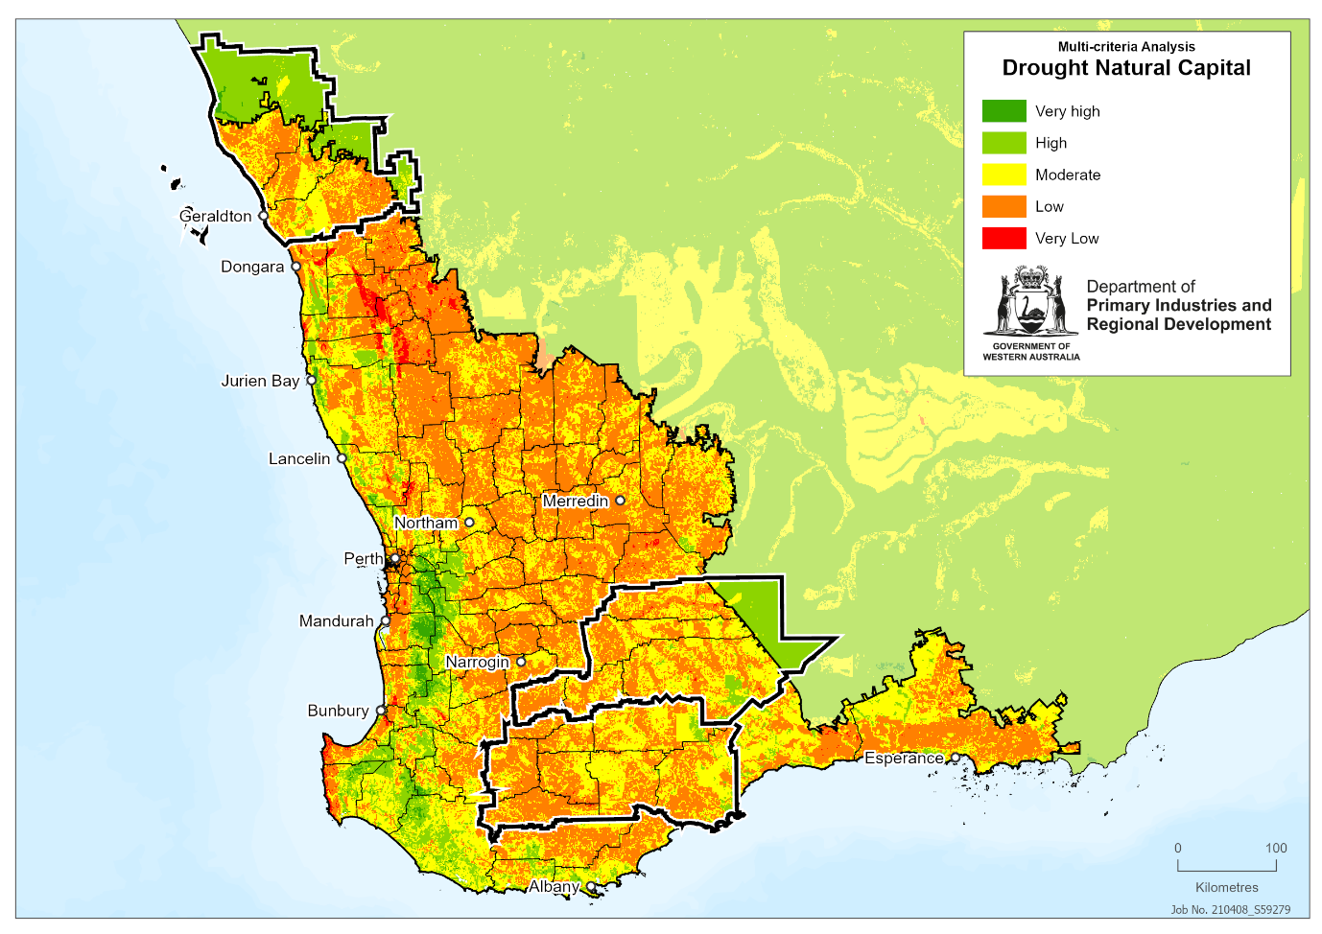
Figure 51: Composite physical capital map
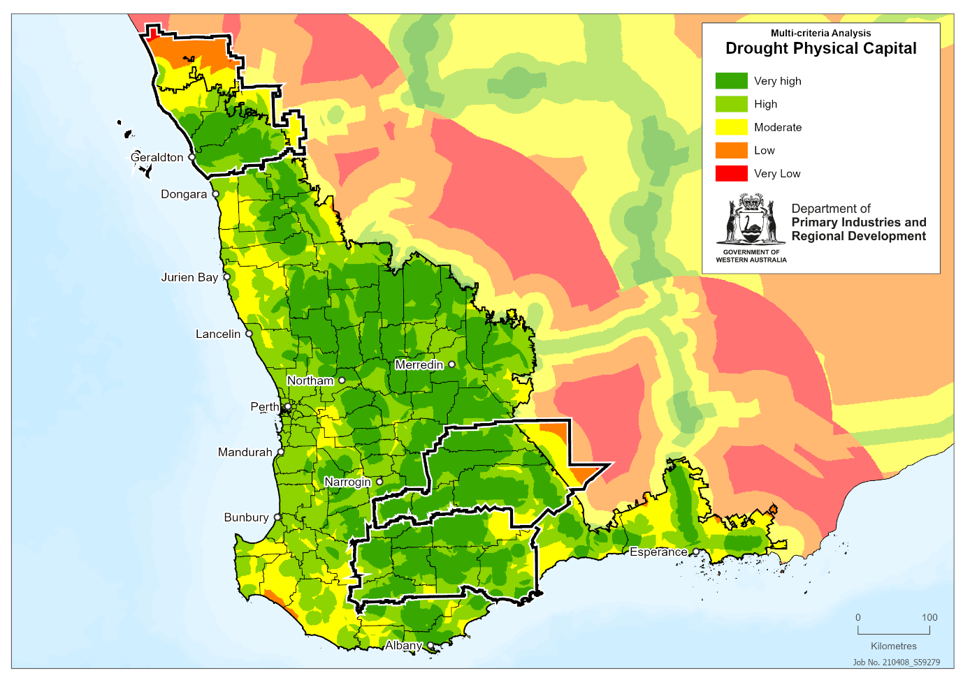
Figure 52: Composite adaptive capacity map
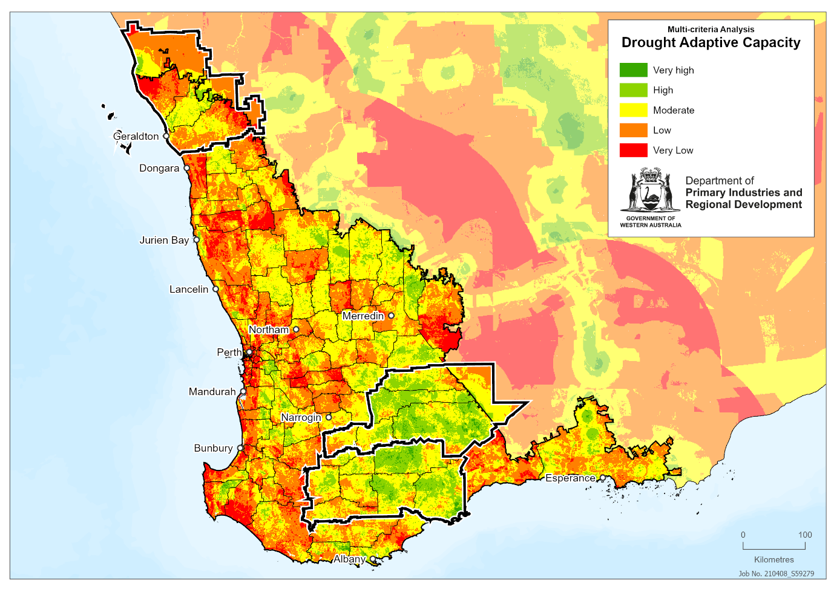
Figure 53: Adaptive capacity component work flow. Component maps are sized according to their weighting within each tier of analysis; primary = all individual component datasets and first-level composite maps, secondary = second-level composite maps made up of primary datasets and first-level composite maps, tertiary = composite maps made up of second-level composite maps. 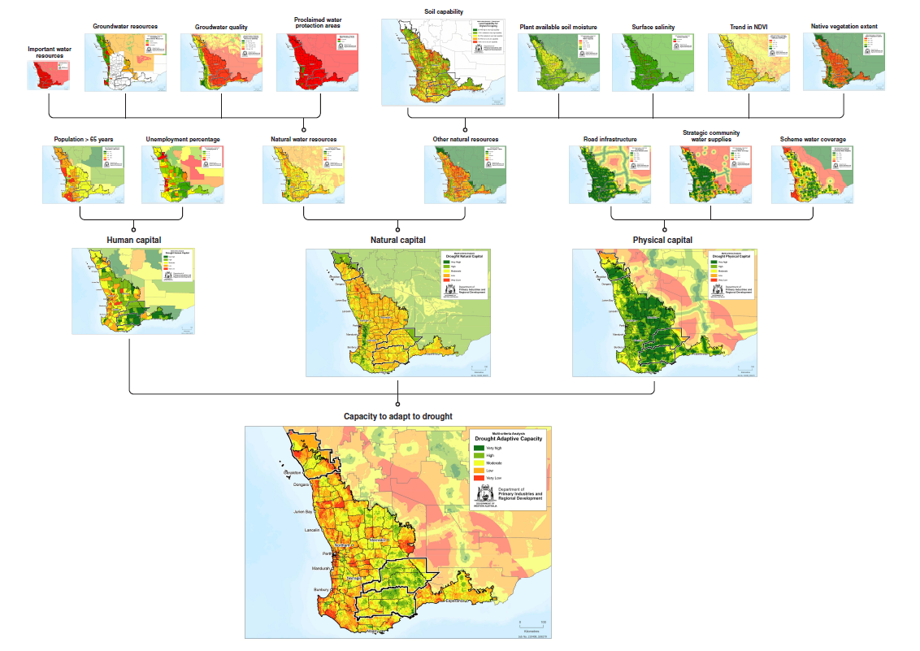
Figure 54: Simple work flow. Maps are sized according to their weighting within each tier of analysis; secondary = second-level composite maps made up of primary datasets and first-level composite maps (exposure, sensitivity), tertiary = composite maps made up of second-level composite maps (impact, adaptive capacity); final = the final analysis drought vulnerability priority areas map made up of the tertiary maps.
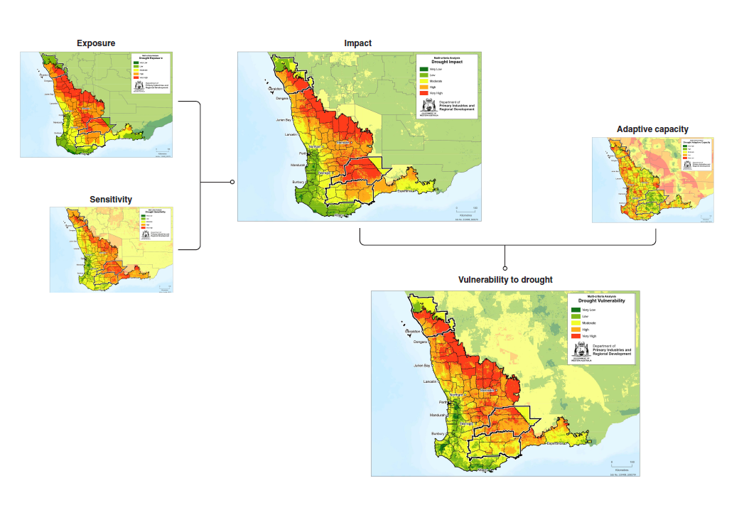

Figure 55: More detailed work flow. Maps are sized according to their weighting within each tier of analysis; primary = all individual component datasets and first-level composite maps (natural resources – water, natural resources – other); secondary = second-level composite maps made up of primary datasets and first-level composite maps (exposure, sensitivity, natural capital, physical capital, human capital), tertiary = composite maps made up of second-level composite maps (impact, adaptive capacity); final = the final analysis drought vulnerability priority areas map made up of the tertiary maps.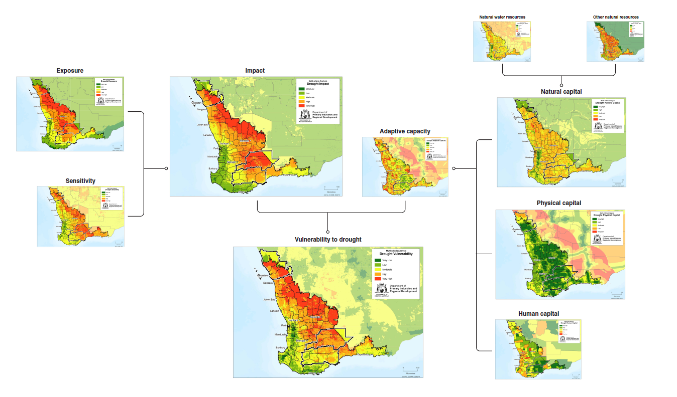
Figure 56: Full, detailed work flow including all component data sets and all composite maps. Maps are sized according to their weighting within each tier of analysis; primary = all individual component datasets and first-level composite maps (natural resources – water, natural resources – other); secondary = second-level composite maps made up of primary datasets and first-level composite maps (exposure, sensitivity, natural capital, physical capital, human capital), tertiary = composite maps made up of second-level composite maps (impact, adaptive capacity); final = the final analysis drought vulnerability priority areas map made up of the tertiary maps.
