Supplemental data:
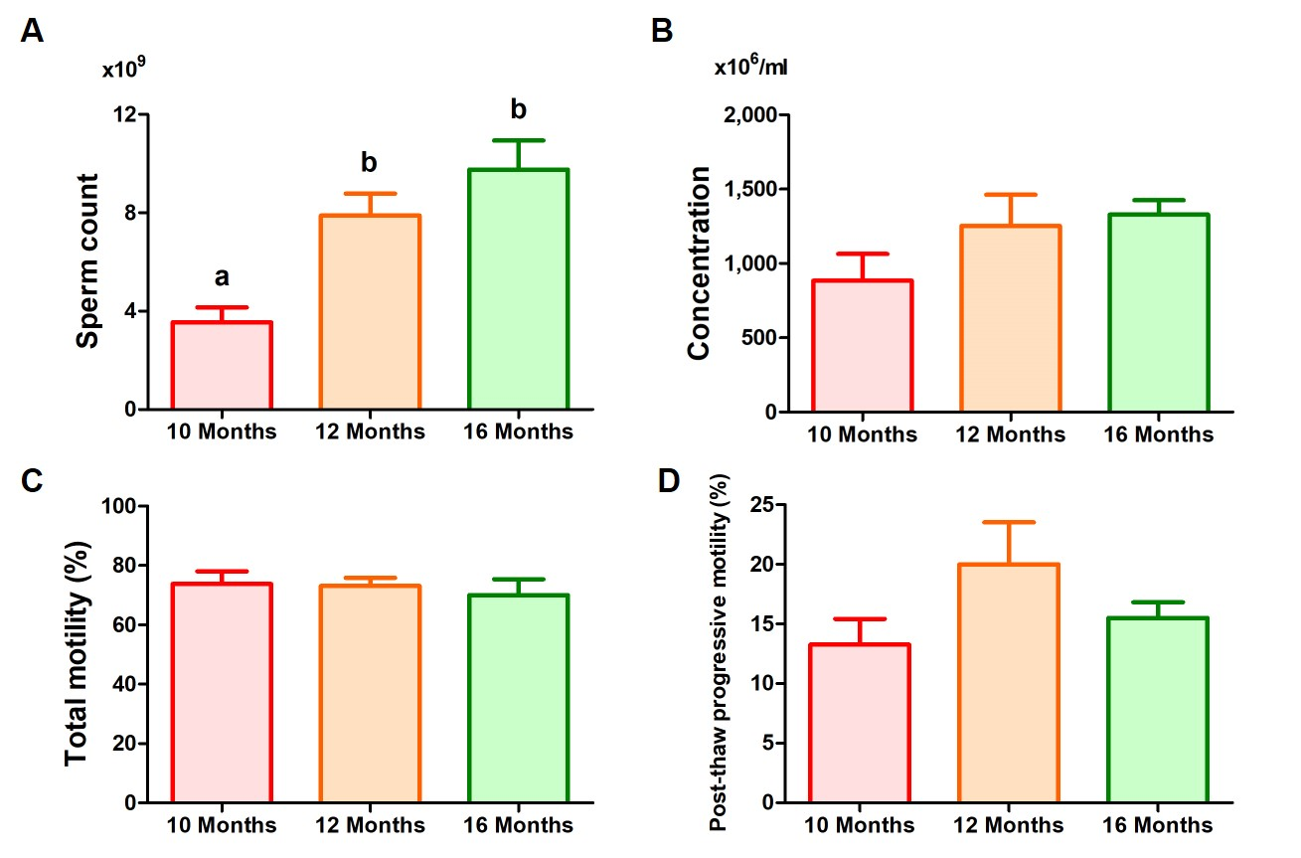
Fig. S1. Semen quality of bulls at 10, 12 and 16 months old. A: Sperm count; B: Sperm concentration; C: Total motility; D: Post-thaw progressive motility. Bars show the mean ± standard error; different letters represent p-value < 0.05.

