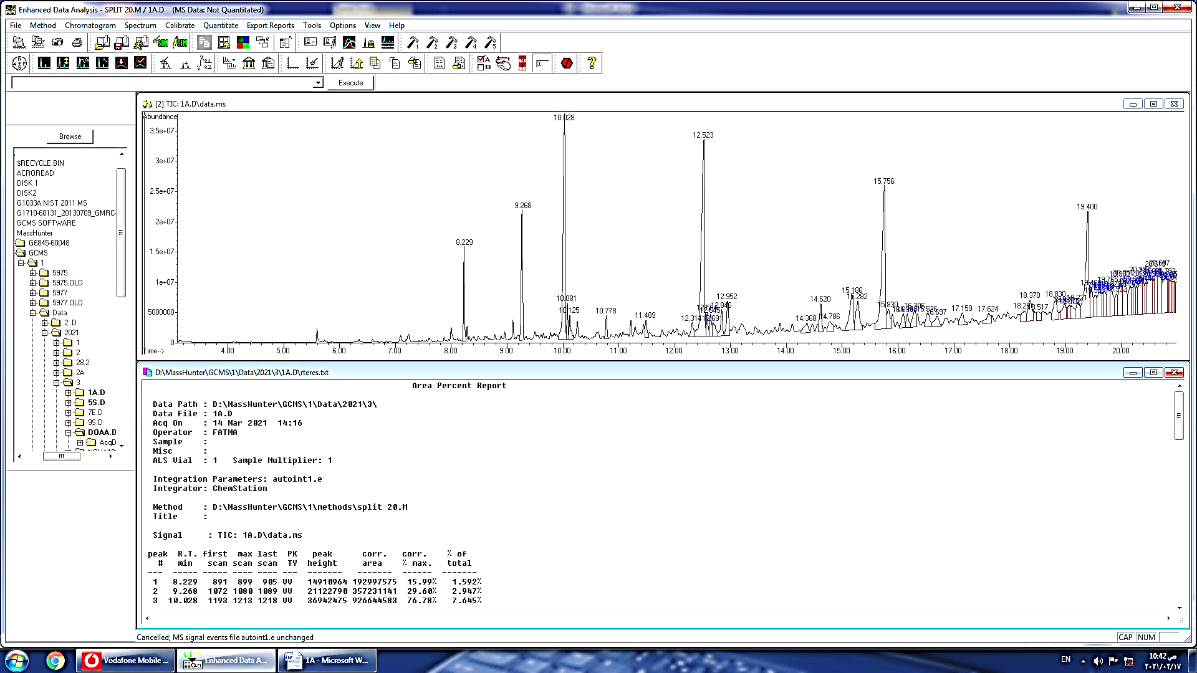

Figure 1: GCMS chromatogram of the Thermomyces lanuginosus

Area % | RT | Molecular  Weight | Formula | chemical compounds | no
1.592 | 8.229 | 196 | C14H28 | 2-Tetradecene, (E) | 1
2.947 | 9.268 | 206 | C14H22O | Phenol, 3,5-bis (1,1-dimethylethyl | 2
7.645 | 10.028 | 224 | C16H32 | 7-Hexadecene, (Z) | 3
0.675 | 10.081 | 226 | C16H34 | Hexadecane | 4
0.595 | 10.778 | 226 | C13H22O3 | Cyclopentaneacetic acid, 3-oxo-2-pentyl-, methyl ester | 6
0.605 | 11.489 | 226 | C13H22O3 | Benzoic acid, 2-ethylhexyl ester | 6
0.621 | 12.314 | 212 | C14H12O2 | Benzyl Benzoate | 7
9.957 | 12.523 | 252 | C18H36 | 1-Octadecene | 8
0.640 | 12.584 | 254 | C18H38 | Octadecane | 9
0.708 | 12.645 | 252 | C18H36 | -Octadecene, (E)5 | 10
0.777 | 12.691 | 224 | C16H32 | Cyclopropane, 1-methyl-1-(1-methylethyl)-2-nonyl | 11
1.182 | 12.952 | 270 | C17H34O2 | Isopropyl myristate | 12
0.707 | 14.368 | 490 | C35H70 | 17-Pentatriacontene | 13
1.157 | 14.620 | 276 | C17H24O3 | 7,9-Di-tert-butyl-1-oxaspiro (4,5)deca-6,9-diene-2,8-dione | 14
0.730 | 14.786 | 233 | C9H16BrNO | 2-Piperidinone, N-[4-bromo-n-butyl]- | 15
2.260 | 15.186 | 256 | C16H32O2 | n-Hexadecanoic acid | 16
1.803 | 15.282 | 278 | C16H22O4 | Dibutyl phthalate | 17
8.204 | 15.756 | 280 | C20H40 | Cycloeicosane | 18
0.947 | 15.830 | 282 | C20H42 | Eicosane | 19
0.726 | 16.099 | 280 | C19H36O | Cyclopropaneoctanal, 2-octyl- | 20
0.579 | 16.168 | 322 | C23H46 | 9-Tricosene, (Z)- | 21
1.078 | 16.306 | 220 | C16H12O | Ethanone, 1-(9-anthracenyl)- | 22
0.920 | 16.536 | 914 | C54H108Br2 | Tetrapentacontane, 1,54-dibromo- | 23
0.811 | 16.697 | 294 | C21H42 | 10-Heneicosene (c,t) | 24
0.831 | 17.159 | 280 | C20H40 | 5-Eicosene, (E)- | 25
0.756 | 17.624 | 296 | C21H44 | Heneicosane | 26
0.769 | 18.261 | 282 | C18H34O2 | 11,13-Dimethyl-12-tetradecen-1-ol acetate | 27
1.384 | 18.370 | 324 | C17H31F3O2 | Trifluoroacetic acid, pentadecyl ester | 28
0.588 | 18.517 | 284 | C18H36O2 | Octadecanoic acid | 29
0.622 | 19.075 | 258 | C16H34S | tert-Hexadecanethiol | 30
0.704 | 19.102 | 266 | C19H38 | 1-Nonadecene | 31
1.009 | 19.221 | 998 | C69H138O2 | Nonahexacontanoic acid | 32
1.396 | 19.468 | 314 | C20H42O2 | Ethanol, 2-(octadecyloxy) | 33
0.940 | 19.536 | 282 | C18H34O2 | 11,13-Dimethyl-12-tetradecen-1-ol acetate | 34
0.915 | 19.699 | 282 | C19H38O | Disparlure | 35
1.318 | 19.765 | 208 | C15H28 | 7-Pentadecyne | 36
1.521 | 19.820 | 998 | C69H138O2 | Nonahexacontanoic acid | 37
0.950 | 19.922 | 280 | C20H40 | Cyclotetradecane, 1,7,11-trimethyl-4-(1-methylethyl | 38
2.355 | 20.051 | 606 | C32H57F7O2 | Octacosyl heptafluorobutyrate | 39
0.764 | 20.192 | 208 | C15H28 | 7-Pentadecyne | 40
0.951 | 20.232 | 334 | C20H30O4 | 1,2-Benzenedicarboxylic acid, bis(4-methylpentyl) ester | 41
2.125 | 20.336 | 302 | C16H31Br | Pentadec-7-ene, 7-bromomethyl- | 42
0.896 | 20.440 | 282 | C18H34O2 | 11,13-Dimethyl-12-tetradecen-1-ol acetate | 43
2.808 | 20.500 | 338 | C24H50 | Tetracosane | 44
0.976 | 20.581 | 914 | C54H108Br2 | Tetrapentacontane, 1,54-dibromo | 45
1.888 | 20.619 | 268 | C19H40 | Nonadecane | 46

 | Spectrum of the compound | structure of the compound | no
 | 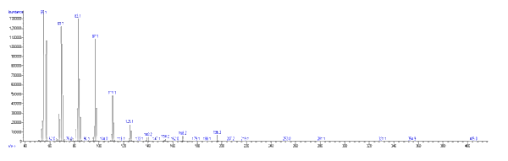 | 2-Tetradecene, (E)-  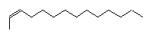 | 1
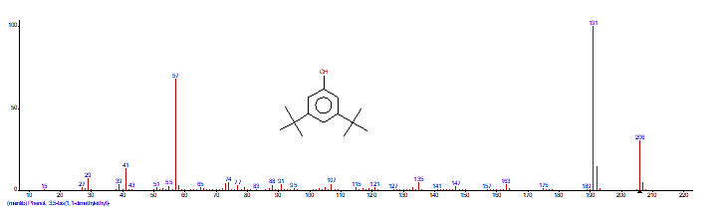 | 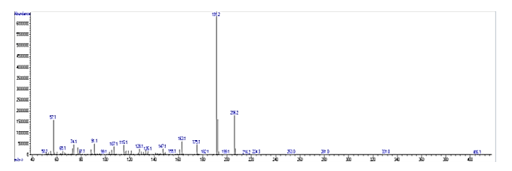 | 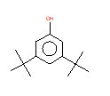  Phenol, 3,5-bis(1,1-dimethylethyl | 2
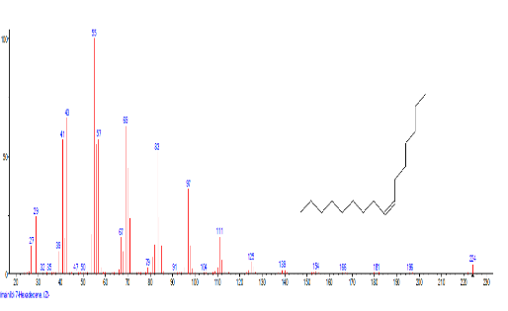 | 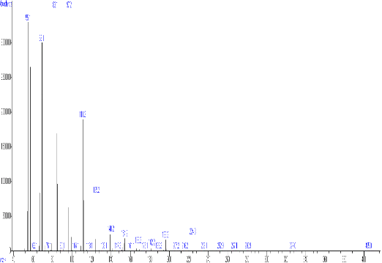 | 7-Hexadecene, (Z)-  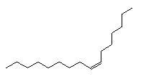 | 3
 | 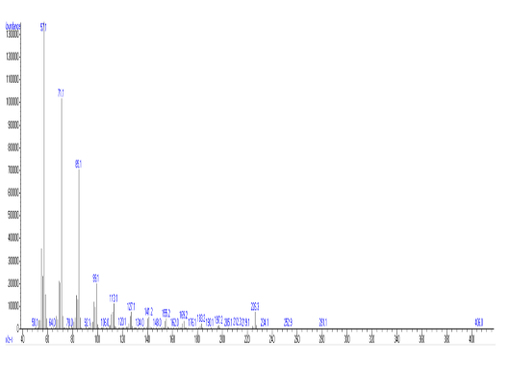 | Hexadecane  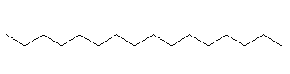 | 4
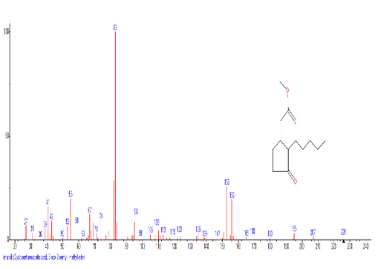 | 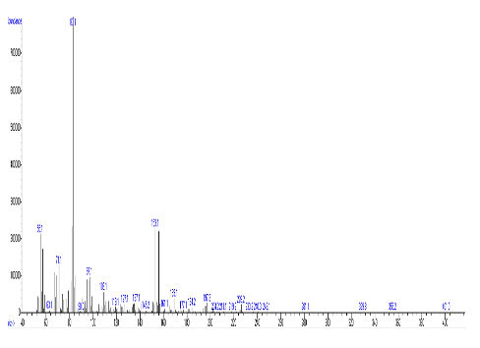 | Cyclopentaneacetic acid, 3-oxo-2-pentyl-, methyl ester  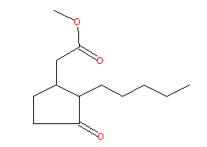 | 5
 | 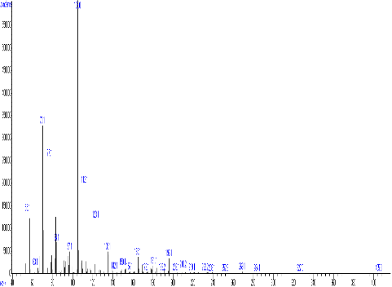 | Benzoic acid, 2-ethylhexyl ester  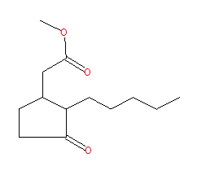 | 6
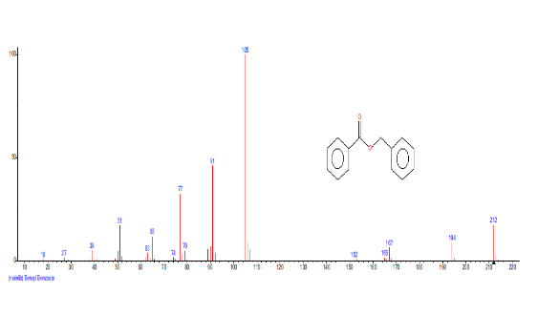 | 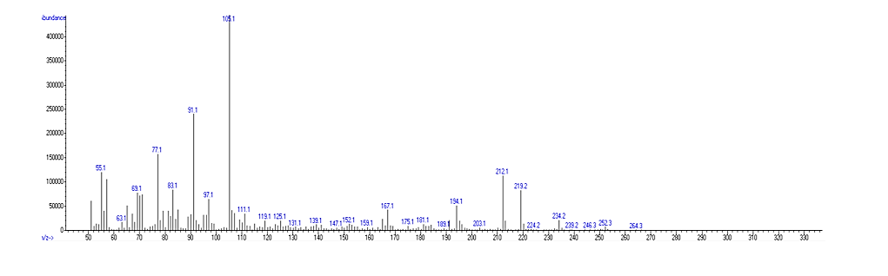 | Benzyl Benzoate  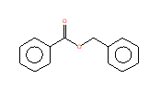 | 7
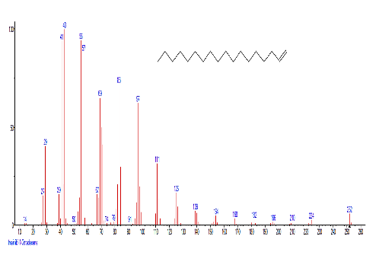 | 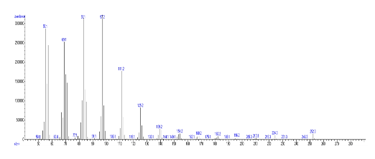 | 1-Octadecene  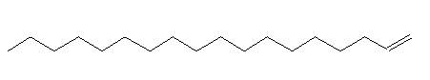 | 8
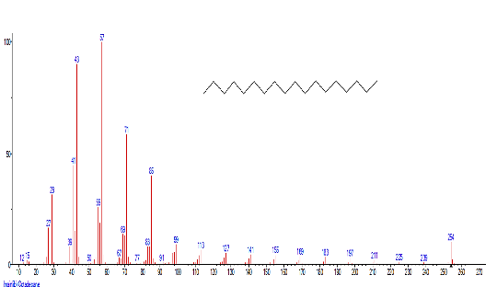 | 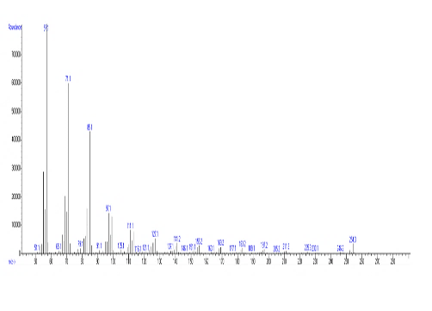 | Octadecane  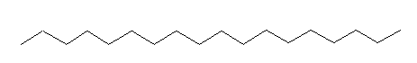 | 9
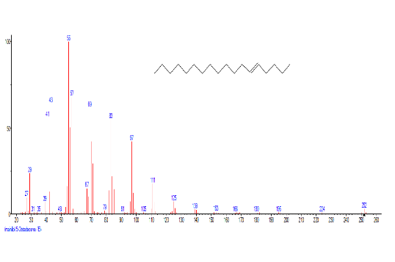 | 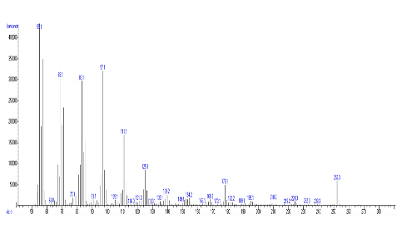 | 5-Octadecene, (E)-  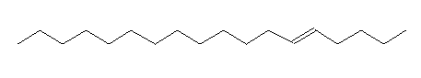 | 10
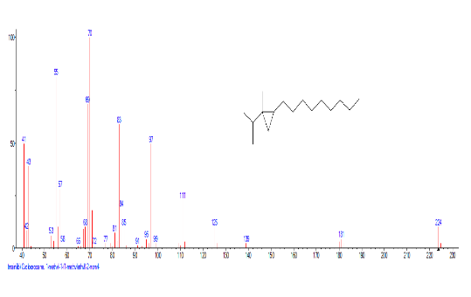 | 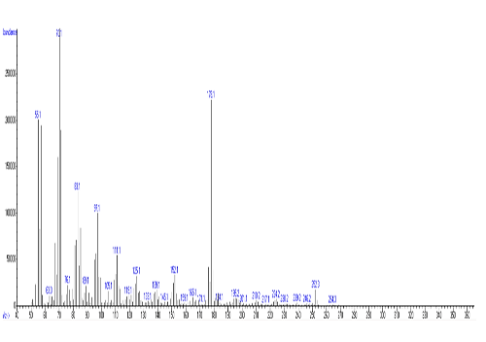 | Cyclopropane, 1-methyl-1-(1-methylethyl)-2-nonyl  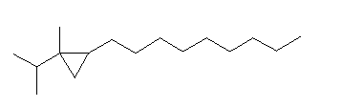 | 11
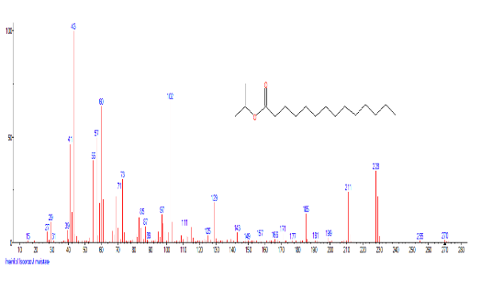 | 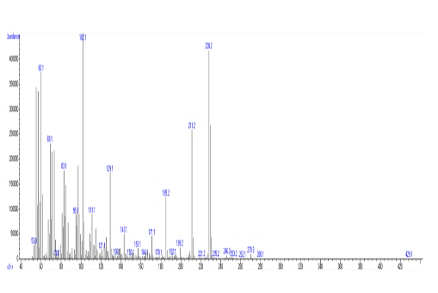 | Isopropyl myristate  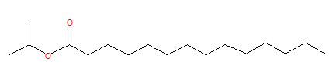 | 12
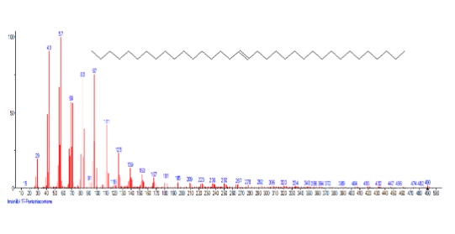   | 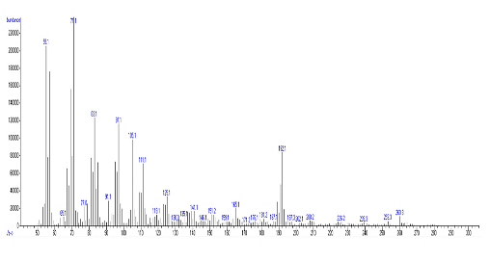 | 17-Pentatriacontene | 13
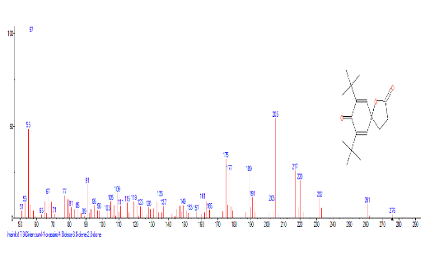 | 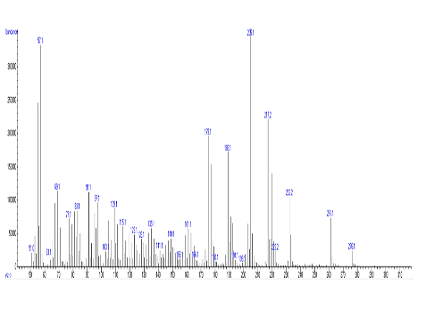 | 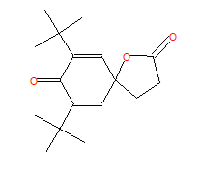  7,9-Di-tert-butyl-1-oxaspiro(4,5)deca-6,9-diene-2,8-dione | 14
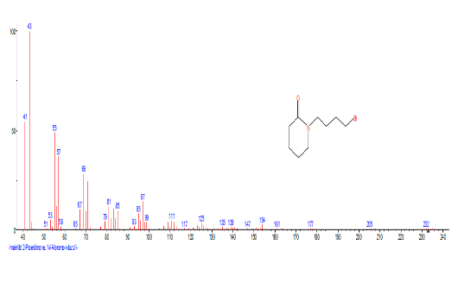 | 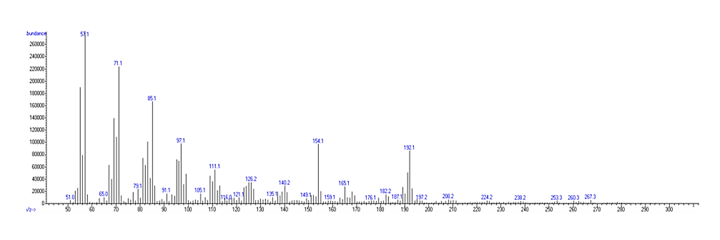 | 2-Piperidinone, N-[4-bromo-n-butyl]-  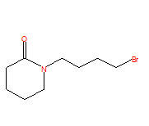 | 15
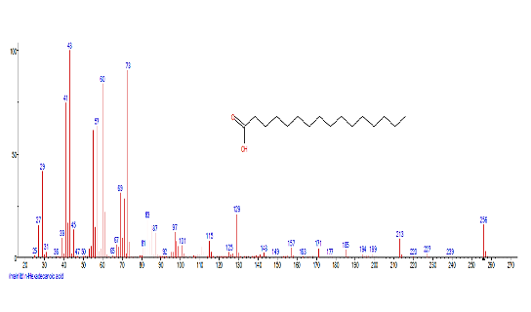 | 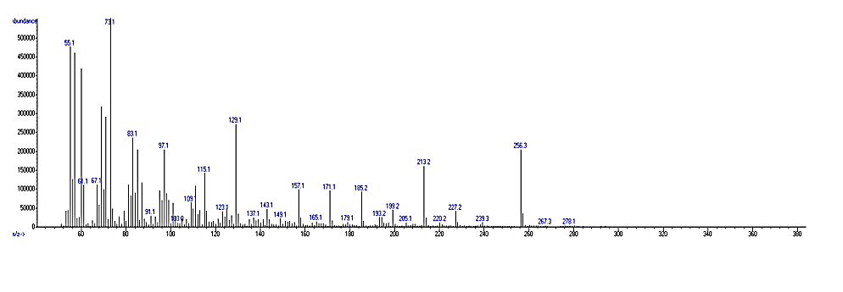 | n-Hexadecanoic acid  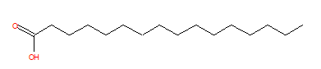 | 16
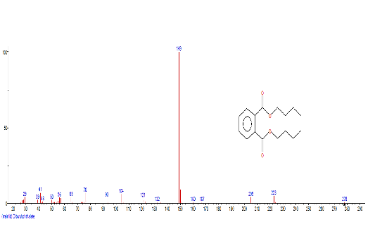 | 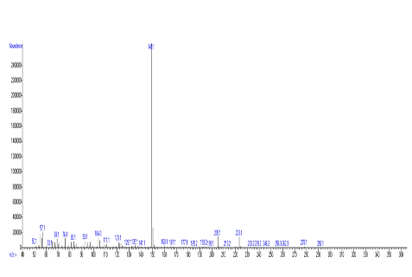 | Dibutyl phthalate  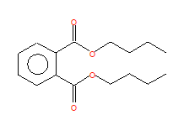 | 17
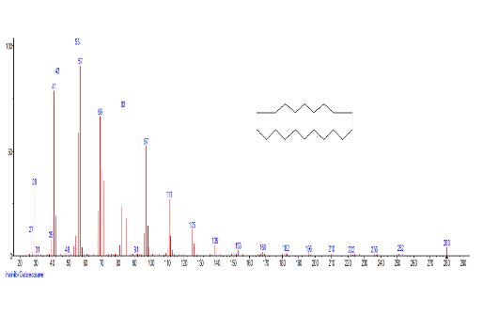 | 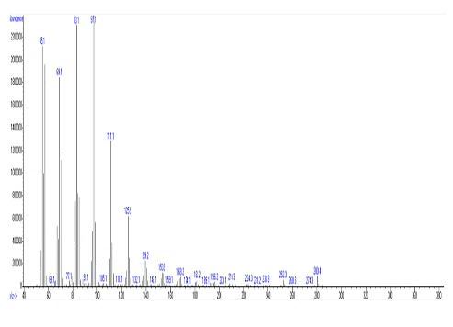 | Cycloeicosane  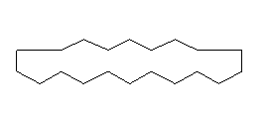 | 18
 | 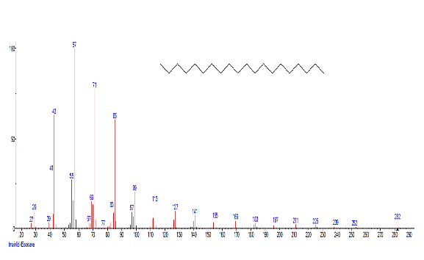  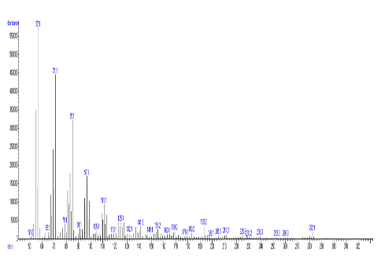 | Eicosane  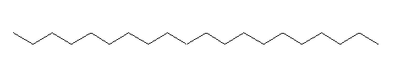 | 19
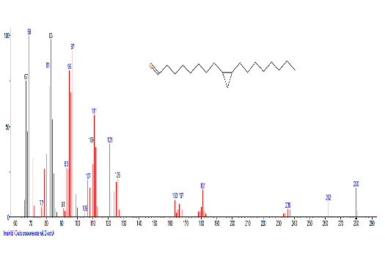 | 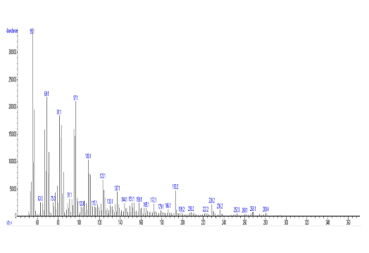 | Cyclopropaneoctanal, 2-octyl-  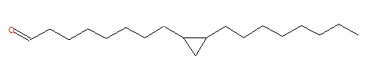 | 20
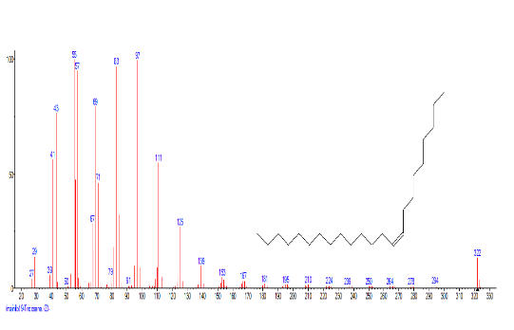 | 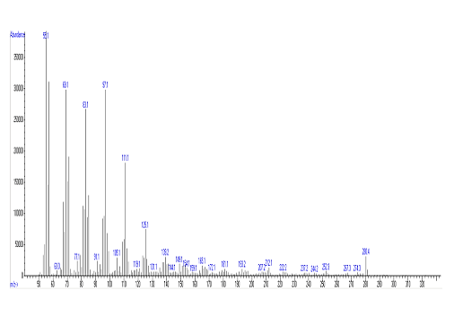 | 9-Tricosene, (Z)-  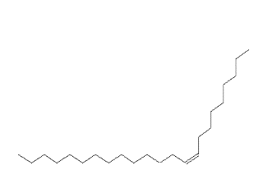 | 21
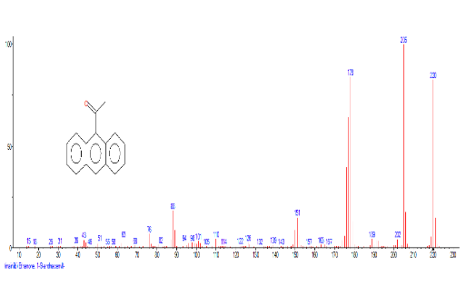 | 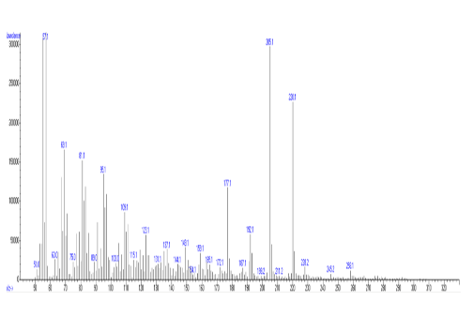 | Ethanone, 1-(9-anthracenyl)-  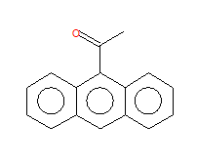 | 22
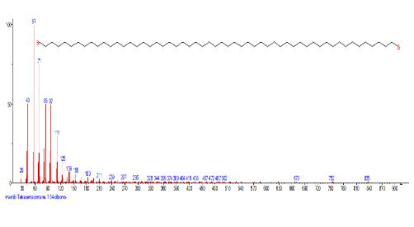 | 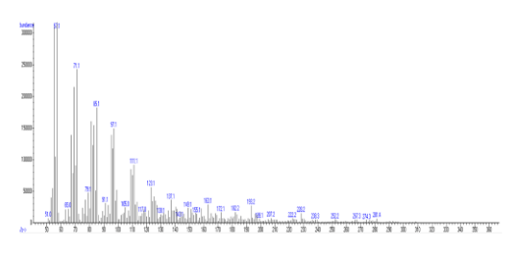 | 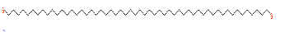  Tetrapentacontane, 1,54-dibromo- | 23
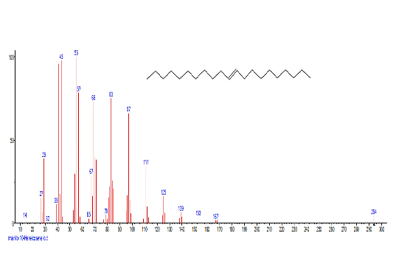 | 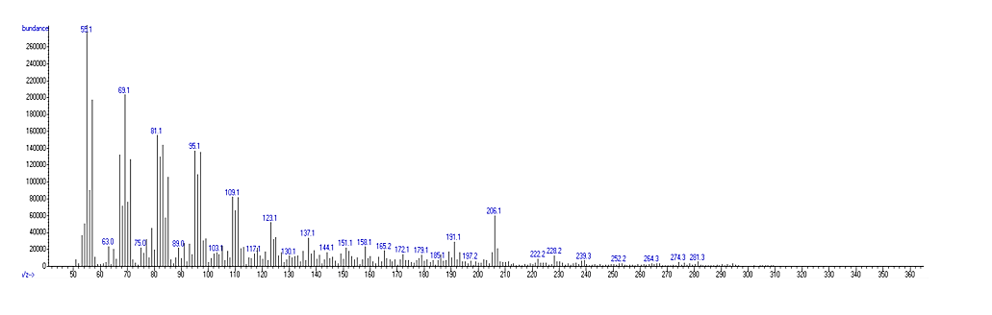 | 10-Heneicosene (c,t)  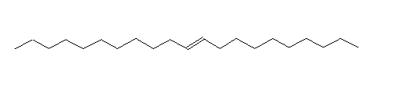 | 24
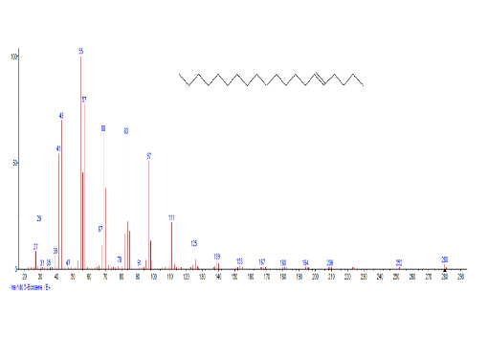 | 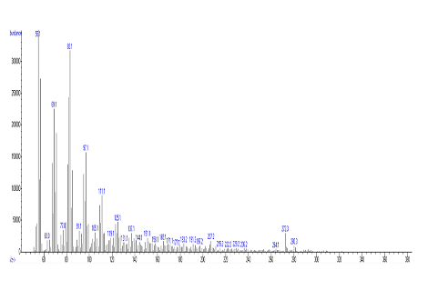 | 5-Eicosene, (E)-  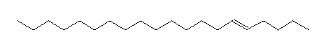 | 25
 | 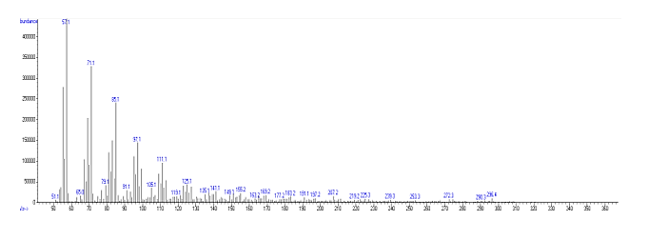 | Heneicosane  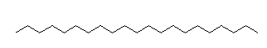 | 26
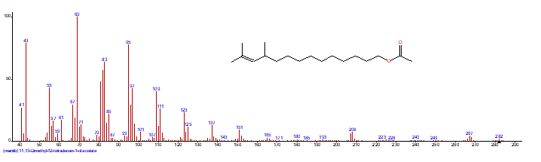  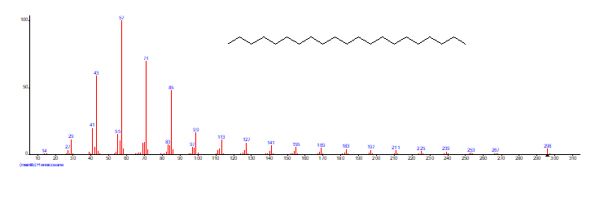 | 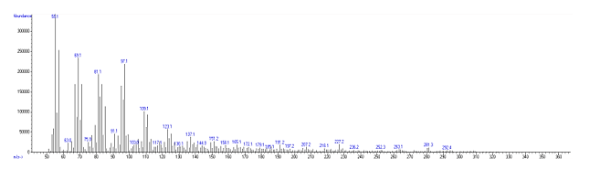 | 11,13-Dimethyl-12-tetradecen-1-ol acetate  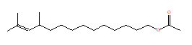 | 27
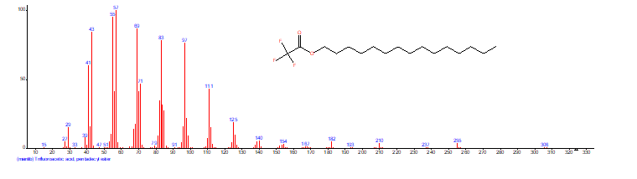 | 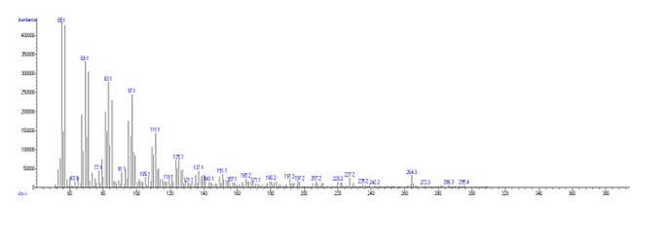 | Trifluoroacetic acid, pentadecyl ester  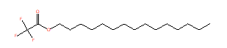 | 28
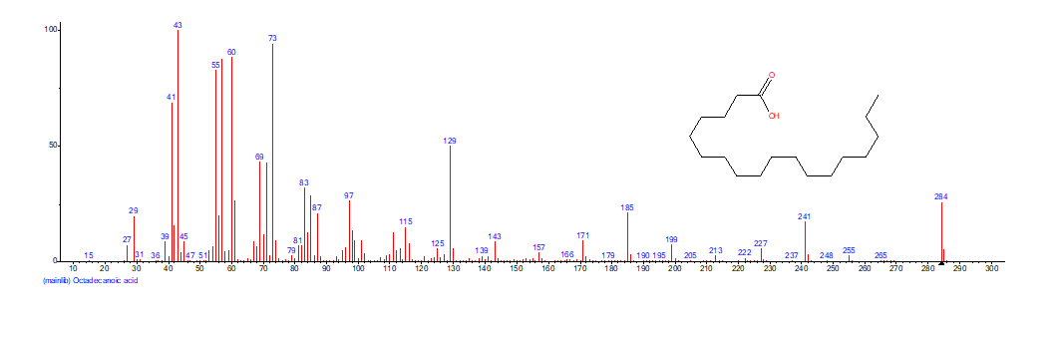 | 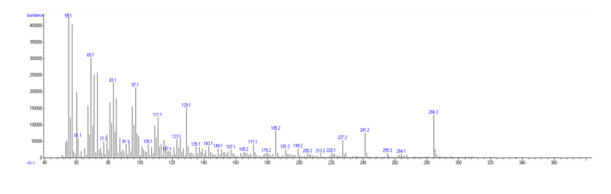 | 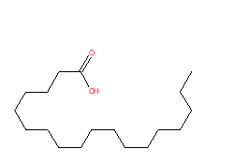  Octadecanoic acid | 29
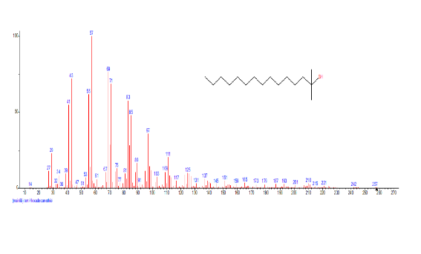 | 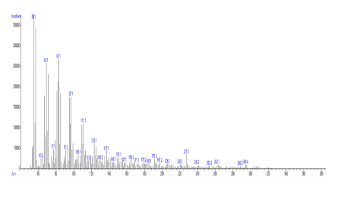 | tert-Hexadecanethiol  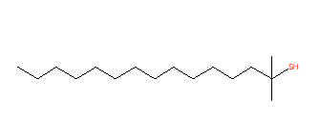 | 30
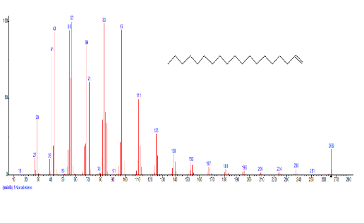 | 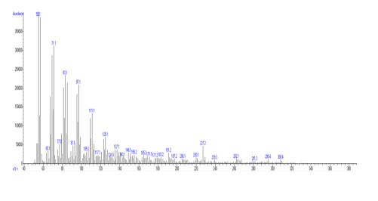 | 1-Nonadecene  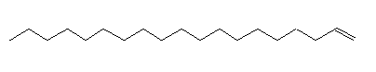 | 31
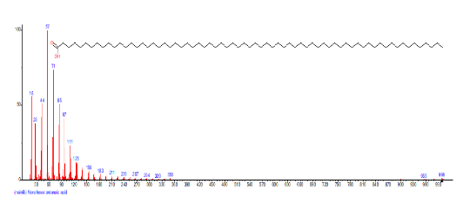 | 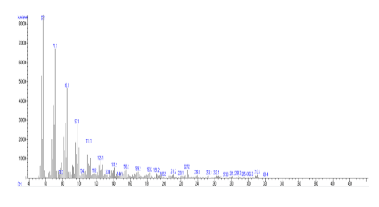 | Nonahexacontanoic acid | 32
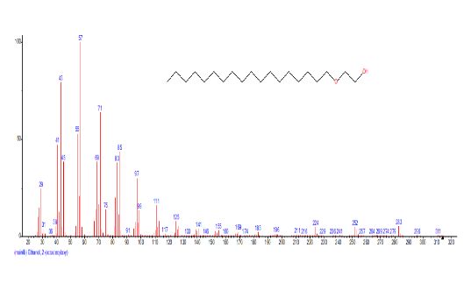 | 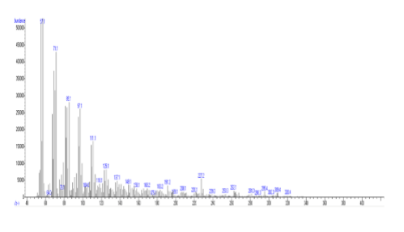 | Ethanol, 2-(octadecyloxy)  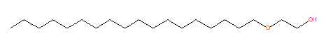 | 33
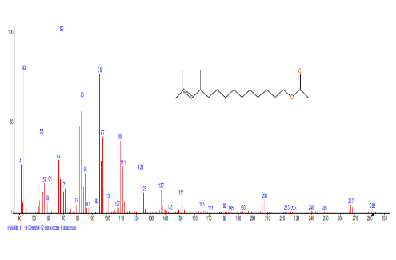 | 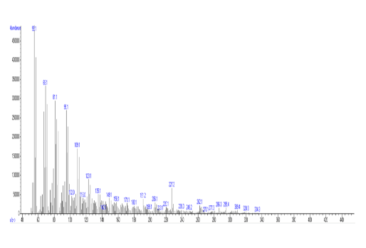 | 11,13-Dimethyl-12-tetradecen-1-ol acetate  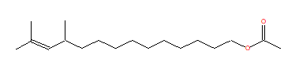 | 34
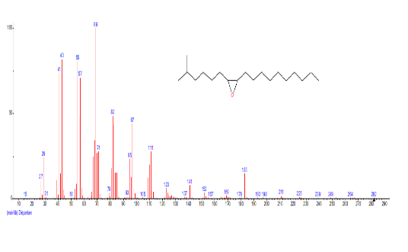 | 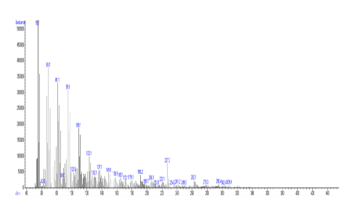 | Disparlure  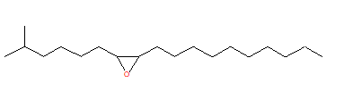 | 35
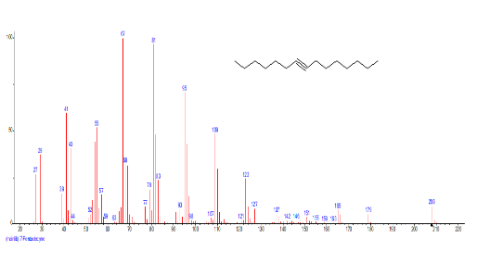  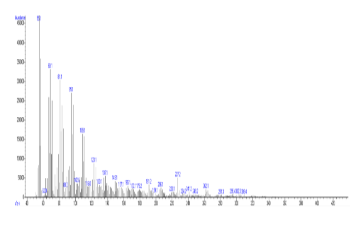 |  | 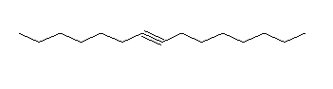  7-Pentadecyne | 36
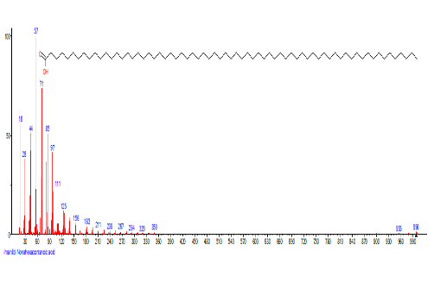 | 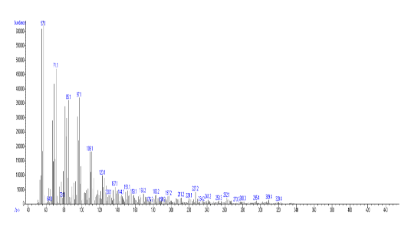 | Nonahexacontanoic acid | 37
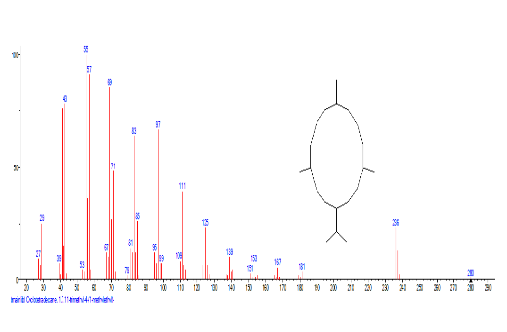 | 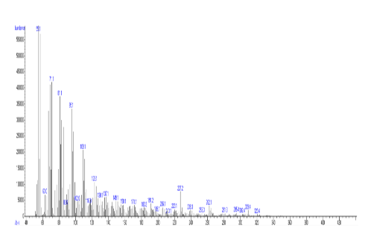 | Cyclotetradecane, 1,7,11-trimethyl-4-(1-methylethyl  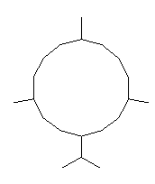 | 38
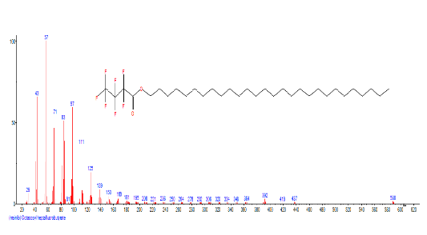 | 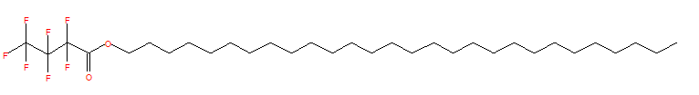  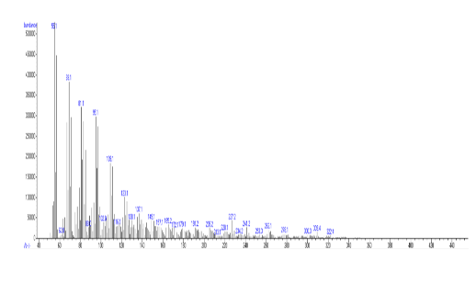 | Octacosyl heptafluorobutyrate | 39
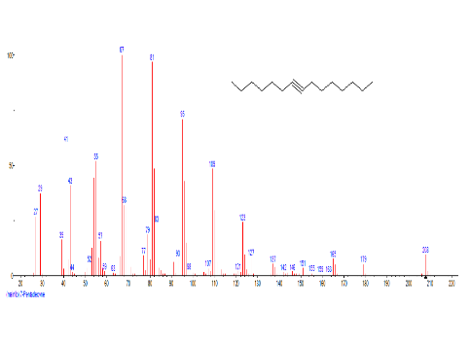 | 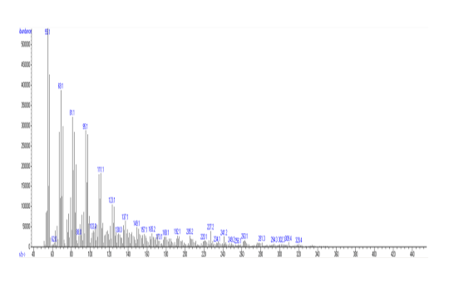 | 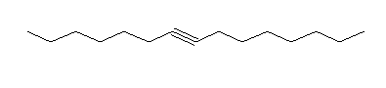  7-Pentadecyne | 40
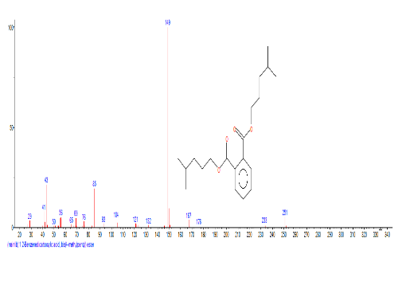 | 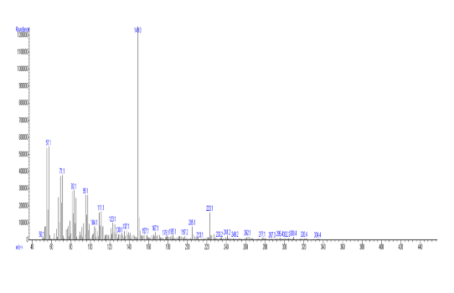 | 1,2-Benzenedicarboxylic acid, bis(4-methylpentyl) ester  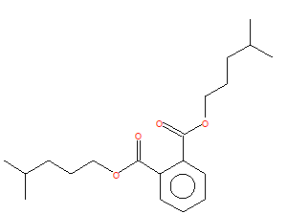 | 41
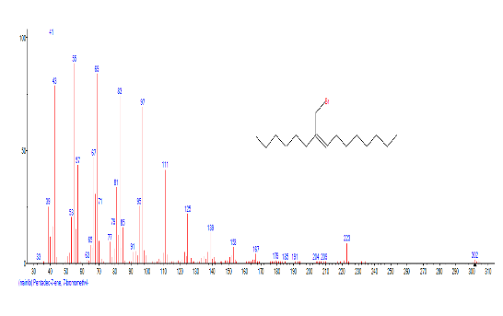 | 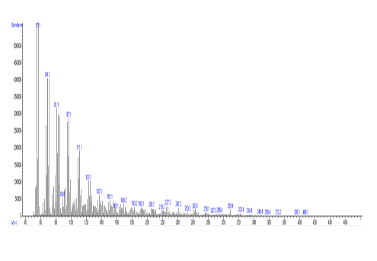 | 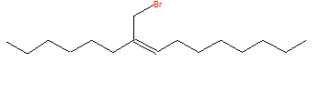  Pentadec-7-ene, 7-bromomethyl- | 42
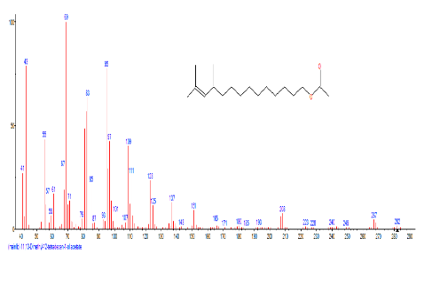 | 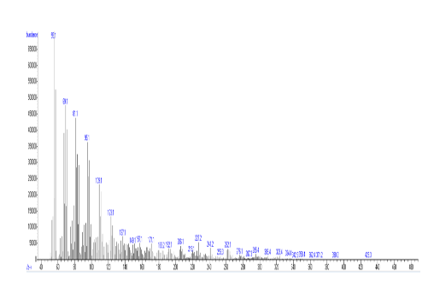 | 11,13-Dimethyl-12-tetradecen-1-ol acetate  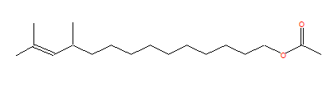 | 43
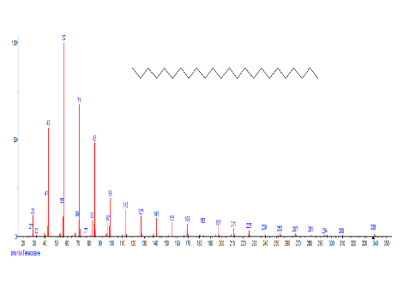 | 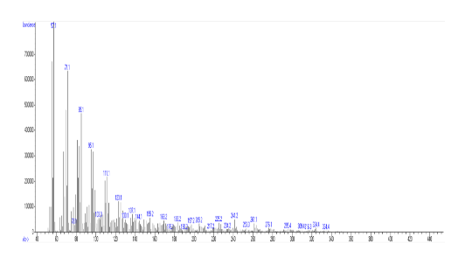 | Tetracosane | 44
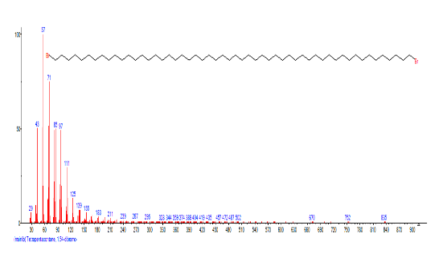 | 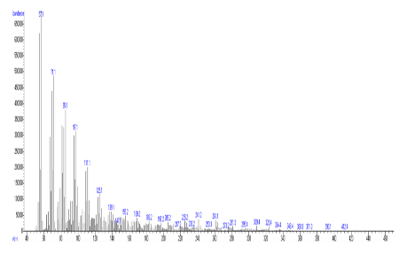 | Tetrapentacontane, 1,54-dibromo | 45
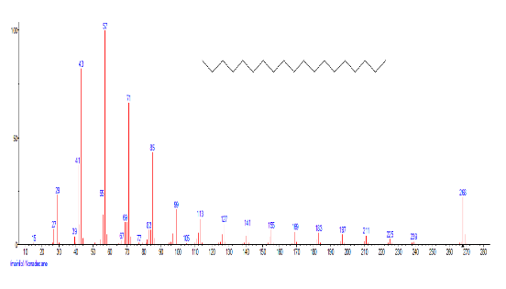 | 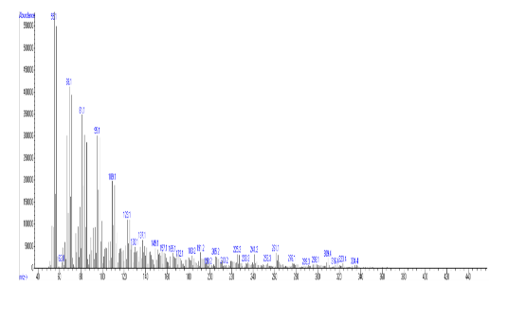 | Nonadecane  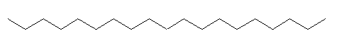 | 46
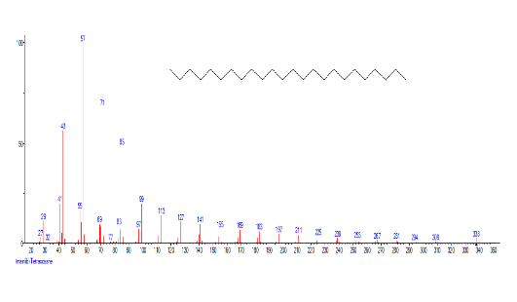 | 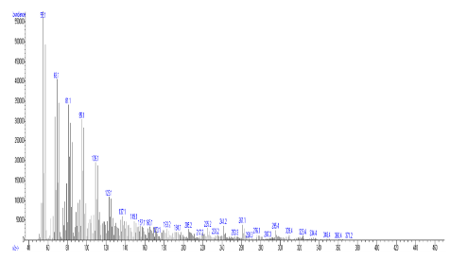  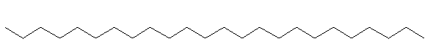 | Tetracosane | 47

