HeLa: Cervical Cancer
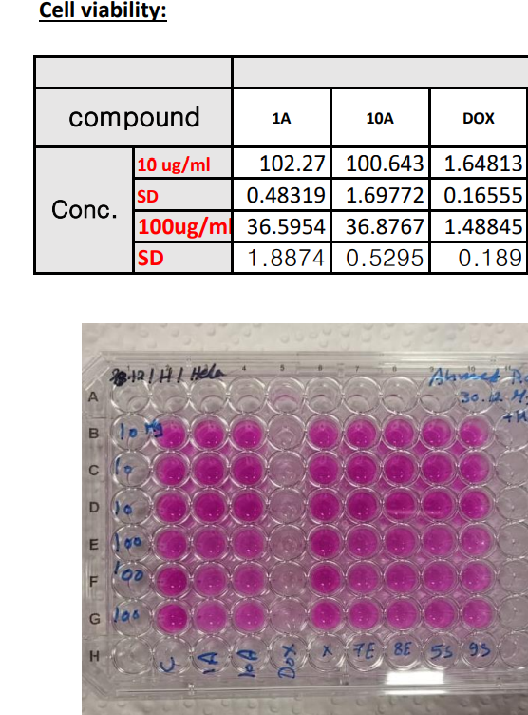

Colo-205 Colorectal cancer:
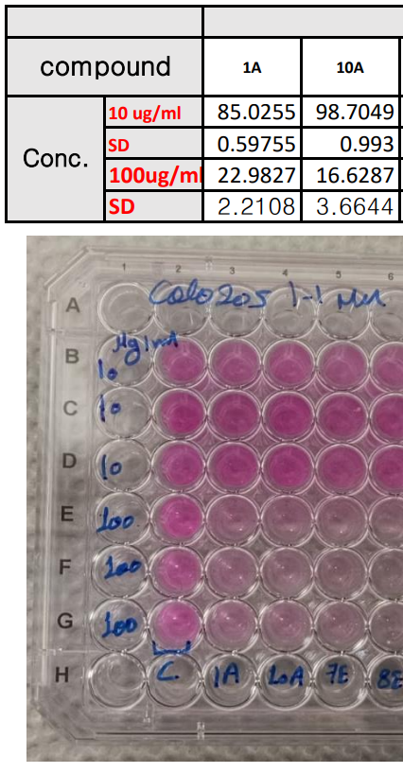

MCF-7: Breast Adenocarcinoma
