Sample ( 10A )
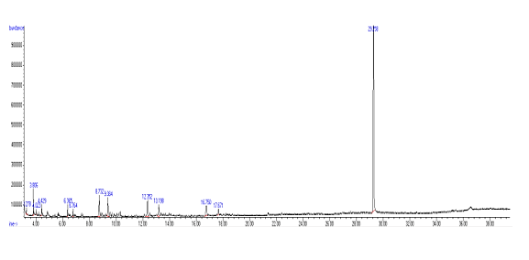
No | Chemical compound | MOLECULAR FORMULA | MOLECULAR WEIGHT | RT | AREA%
1 | (1R)-2,6,6-Trimethylbicyclo[3.1.1]hept-2-ene | C10H16 | 136 | 3.276 | 0.701%
2 | Heptane, 2,2,4,6,6-pentamethyl | C12H26 | 170 |  | 3.125%
3 | β-Ocimene | C10H16 | 136 | 4.025 | 0.751%
4 | Octane, 2-methyl- | C9H20 | 128 | 4.431 | 1.261%
5 | Tetracosane | C24H50 | 338 | 6.365 | 1.360 %
6 | Undecane, 3,4-dimethyl- | C13H28 | 184 | 6.766 | 1.212 %
7 | Octadecane, 1-iodo- | C18H37I | 380 | 8.734 | 4.531 %
8 | Methoxyacetic acid, 3-tetradecyl ester | C17H34O3 | 286 | 9.387 | 3.851%
9 | 2-Bromo dodecane | C12H25Br | 248 | 12.351 | 3.968 %
10 | Hentriacontane | C31H64 | 436 | 13.197 | 3.152 %
11 | Hentriacontane | C31H64 | 436 | 16.751 | 3.581 %
12 | Hexadecane, 2-methyl- | C17H36 | 240 | 17.672 | 1.921 %
13 | Bis(2-ethylhexyl) phthalate | C24H38O4 | 390 | 29.259 | 70.588 %

Compound Structure | Compound Spectrum
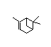  (1R)-2,6,6-Trimethylbicyclo [3.1.1] hept-2-ene | 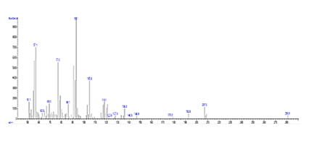  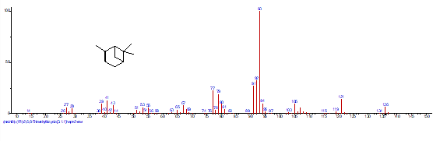  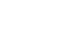
Heptane, 2,2,4,6,6-pentamethyl  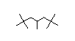 | 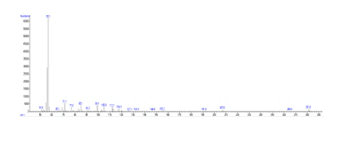  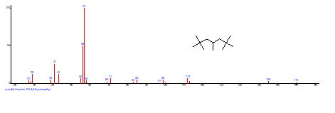
β-Ocimene  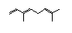 | 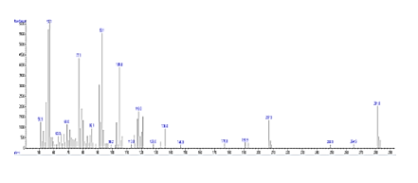  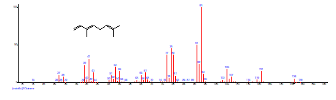
Octane, 2-methyl-  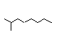 | 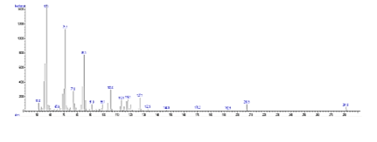  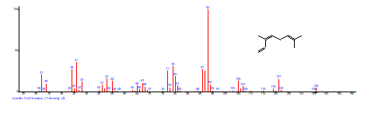
Tetracosane  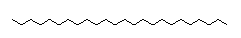 | 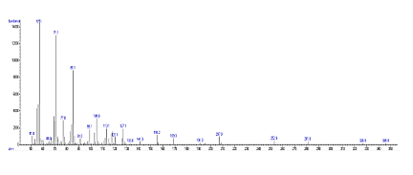  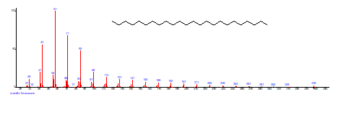
Undecane, 3,4-dimethyl-  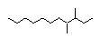 | 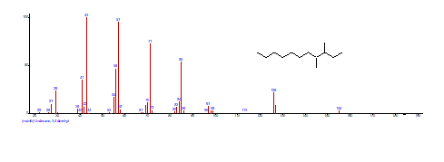  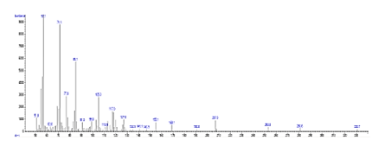  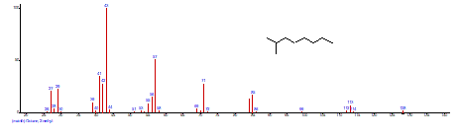
Octadecane, 1-iodo-  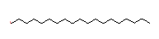 | 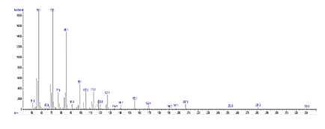  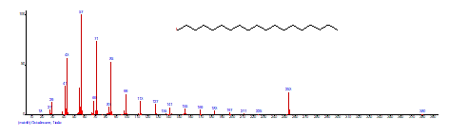
Methoxyacetic acid, 3-tetradecyl ester | 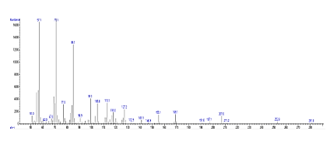  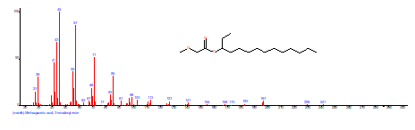
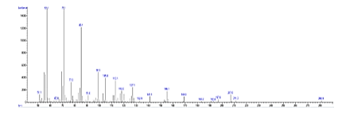  2-Bromo dodecane  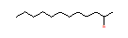 | 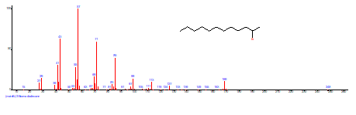
Hentriacontane  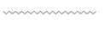 | 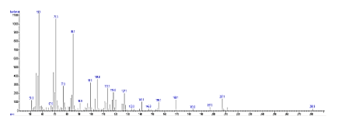  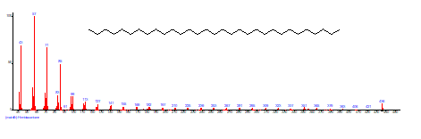
Hexadecane, 2-methyl-  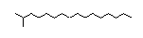 | 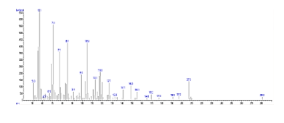  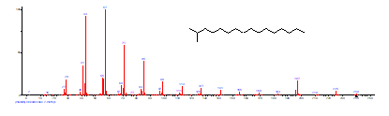
Bis(2-ethylhexyl) phthalate  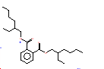 | 