Supplementary materials
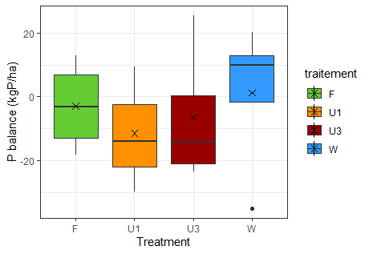
Figure 1S: P balance calculated with all pools except Pi HCl, so that the balance error can be interpreted as the variation of the Pi HCl pool over the time of the experiment.

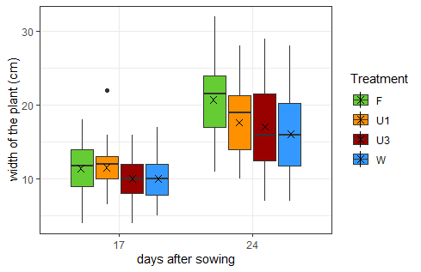
Figure 2S: Plant diameter measurements at 2 dates. Each boxplot represents the average width of the 16 plants per treatment

Table 1S: Visual Minteq outputs and calculations of the total ammonia volatilisation per treatment
U3
 | T0 | T1 | T2 | T3 | T4 | T5 | T6 | TF
pH | 8.7 | 8.7 | 8.7 | 8.6 | 8.5 | 8.5 | 8.4 | 8.4
N- NH₄⁺ (kgN/ha) | 0.0 | 81.5 | 204.3 | 263.1 | 289.1 | 364.7 | 442.2 | 0.9
Output % NH_{3(aq)} |  | 21.2 | 21.2 | 17.6 | 13.9 | 13.9 | 11.5 | 10.3
NH_{3(aq)} simulated (kg/ha) |  | 17.3 | 43.3 | 46.3 | 40.2 | 50.7 | 50.6 | 0.1
Ammonia volatilisation (kg/ha) |  |  |  |  |  |  |  | 248.5
U1
 | T0 | T1 | T2 | T3 | T4 | T5 | T6 | TF
pH | 8.7 | 8.7 | 8.7 | 8.6 | 8.6 | 8.5 | 8.5 | 8.5
N- NH₄⁺ (kgN/ha) | 0.0 | 31.3 | 92.6 | 121.7 | 107.7 | 72.0 | 72.9 | 0.5
Output % NH_{3(aq)} | 0.0 | 21.2 | 21.2 | 21.2 | 21.2 | 21.2 | 21.2 | 21.2
NH_{3(aq)} simulated (kg/ha) | 0.0 | 6.6 | 19.6 | 25.8 | 22.6 | 15.3 | 15.5 | 0.1
Ammonia volatilisation (kg/ha) |  |  |  |  |  |  |  | 105.5
F
 | T0 | T1 | T2 | T3 | T4 | T5 | T6 | TF
pH | 8.7 | 8.7 | 8.7 | 8.6 | 8.6 | 8.5 | 8.5 | 8.5
N- NH₄⁺ (kgN/ha) | 0.0 | 35.1 | 50.0 | 54.4 | 50.0 | 49.3 | 72.4 | 0.7
Output % NH_{3(aq)} | 0.0 | 21.2 | 21.2 | 21.2 | 21.2 | 21.2 | 21.2 | 21.2
NH_{3(aq)} simulated (kg/ha) | 0.0 | 7.4 | 10.6 | 11.5 | 10.6 | 10.5 | 15.3 | 0.15
Ammonia volatilisation (kg/ha) |  |  |  |  |  |  |  | 66.1

Table 2S: Soil concentrations in nutrients at the end of the experiment. Different letters (a,b,c) indicate significant differences between treatments
soil stock (0-10 cm) (kg/ha) | W | F | U1 | U3 | p-value
Ca²⁺ | 208 b | 195 b | 203 b | 314 a | <0,0001 ***
K⁺ | 21,8 a | 13,5 a | 12,4 a | 15,3 a | 0.17
Mg²⁺ | 19,1 b | 16,5 b | 15,7 b | 20,8 a | 0.06
Na⁺ | 75,4 bc | 58,4 c | 80,8 b | 113 a | 0.00001 ***
Cl⁻ | 90,1 b | 76,6 b | 96,9 b | 146 a | 0.0002 ***
SO4²⁻ | 60,4 b | 40,3 b | 57,6 ab | 76,7 a | 0.0041 **

Table 3S: Concentrations and plant uptake in macro and micronutrients in plant dry matter. Different letters (a,b,c) indicate significant differences between treatments
 | W | F | U1 | U3 | p-value
%K | 6,8 a | 6,4 a | 6,5 a | 6,9 a | 0,2
K uptake (kg.ha⁻¹) | 45,66 b | 78,65 a | 63,67 ab | 71,30 ab | 0,04 *
%Mg | 1,15 b | 1,53 a | 1,43 ab | 1,14 b | 0,01 *
Mg uptake (kg.ha⁻¹) | 7,1 b | 17,9 a | 12,7 ab | 11,6 b | 0,02 *
%Ca | 3,30 a | 3,42 a | 3,61 a | 3,35 a | 0,7
Ca uptake (kg.ha⁻¹) | 21,8 a | 40,1 a | 34,8 a | 32,2 a | 0,08
%Na | 0,54 b | 1,08 a | 0,91 a | 0,80 ab | 0,005
Na uptake (kg.ha⁻¹) | 3,9 b | 14,3 a | 8,6 ab | 10,1 ab | 0,001 *
Al (mg.kg⁻¹) | 867 a | 769 a | 1433 a | 1114 a | 0,5
Al uptake (kg.ha⁻¹) | 0,44 a | 0,77 a | 1,56 a | 0,94 a | 0,1
Bo (mg.kg⁻¹) | 37,1 a | 35 a | 36 a | 33,7 a | 0,3
Bo uptake (kg.ha⁻¹) | 0,02 b | 0,04 a | 0,03 ab | 0,03 ab | 0,03 *
Cu (mg.kg⁻¹) | 23,0 a | 20,5 a | 21,2 a | 19,9 a | 0,19
Cu uptake (kg.ha⁻¹) | 0,014a | 0,023 a | 0,021 a | 0,019 a | 0,08
Fe (mg.kg⁻¹) | 484 a | 441 a | 787 a | 620 a | 0,5
Fe uptake (kg.ha⁻¹) | 0,26 a | 0,45 a | 0,86 a | 0,54 a | 0,4
Mn (mg.kg⁻¹) | 113 a | 85 bc | 103 ab | 77 c | 0,001 **
Mn uptake (kg.ha⁻¹) | 0,73a | 0,9 a | 0,10 a | 0,72 a | 0,1
Zn (mg.kg⁻¹) | 122 a | 111 ab | 103 b | 121 a | 0,02 *
Zn uptake (kg.ha⁻¹) | 0,074 b | 0,128 a | 0,09 ab | 0,118 ab | 0,03 *

Table 4S: Nitrogen balance components on 10 cm measured or simulated by Hydrus. Ferti=Fertilisation, Nupt= Crop N Uptake, Den=Denitrification, Leach=Leaching of NO₃⁻ + NH₄⁺, Vol: volatilisation, ΔNmic: microbial N storage ΔNsoil=Change in soil N concentration, δ_{N}=balance error. All values in the table are means by treatment. The blue columns contain Hydrus simulated data while the white column contains measured observations.
 | Ferti | Nupt | Vol | ΔNmic | Min | ΔNsoil | δ_{N} (% of Ferti)
U1 | 156 | -18 | -90 | -10 | +10 | -19 | 29 (18%)
U3 | 469 | -22 | -260 | -35 | +10 | -209 | -47 (-10%)
F | 170 | -23 | -48 | -10 | +10 | -21 | 78 (45%)

Table 5S: Comparison of the parameters used in Hydrus 1D and Visual Minteq simulations
Visual Minteq | Hydrus 1D
NH₄⁺/NO₃⁻ soil concentrations  Fertilisation inputs  Major ions soil concentrations  Soil pH  Soil ionic strength  Soil temperature | NH₄⁺/NO₃⁻ soil concentrations  Fertilisation inputs  Soil texture  Soil moisture at T0 and irrigation  Soil temperature  Nitrogen processes rates (nitrification, denitrification, mineralisation)  Crop growth data

