Supplementary materials

Serine/threonine kinase of human Monkeypox virus: computational modeling and structural analysis

Jameel M. Abduljalil ª, Haitham A. Al-Madhagi ^{b}, Abdo A. Elfiky ^{c}*, and Maha M. AlKhazindar ^{d}

ª Department of Biological Sciences, Faculty of Applied Sciences, Thamar University, Dhamar, Yemen.
^{b} Biochemistry Technology program, Department of Chemistry, Faculty of Applied Sciences, Thamar University, Dhamar, Yemen.
^{c} Department of Biophysics, Faculty of Science, Cairo University, Giza, 12613, Egypt.
^{d} Department of Botany and Microbiology, Faculty of Science, Cairo University, Giza, 12613, Egypt.

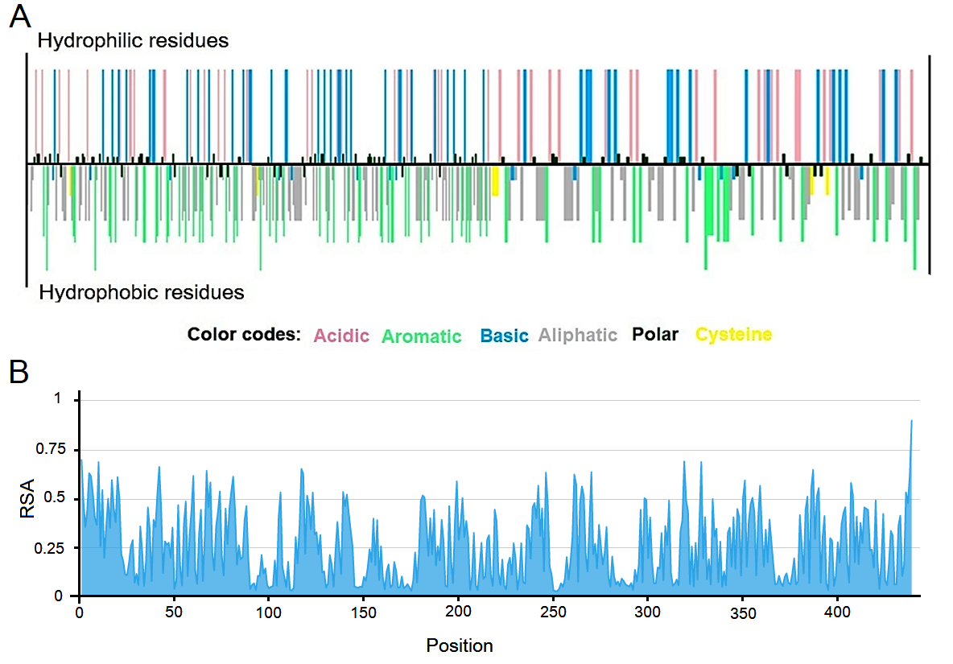
Figure S1. Predicted chemical properties of the STK. A), Hydropathy plot of the kinase B) Relative surface accessibility (RSA) of residues

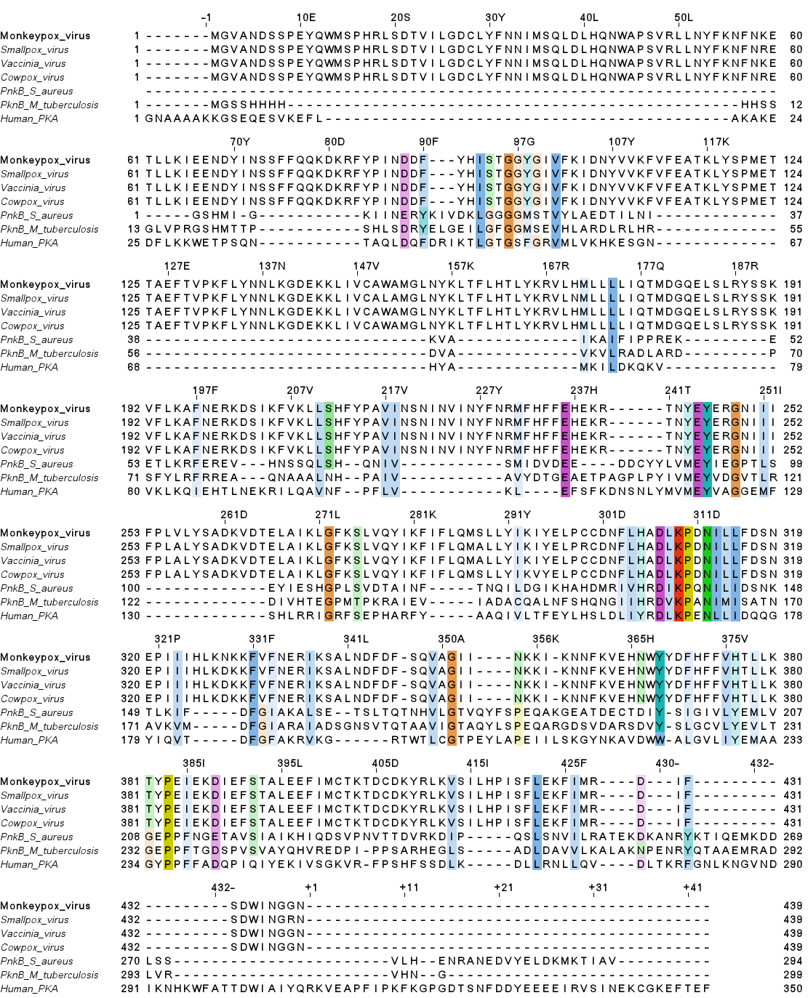Figure S2. Sequence alignments of STK from Orthopoxvirus, bacteria, and humans. The alignment was done by ClustalΩ ¹ and colored by conservation at the 50% threshold.

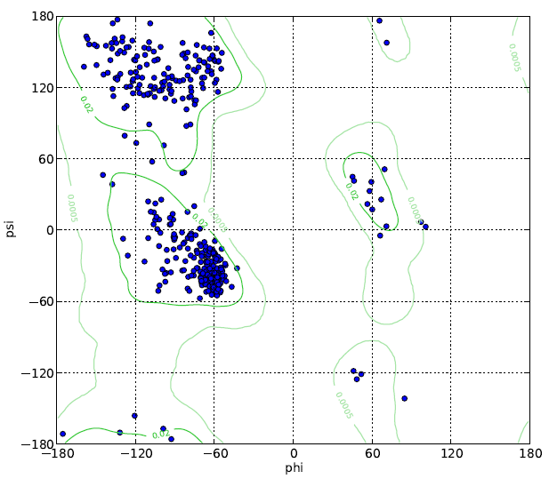
Figure S3. Ramachandran plot of AlphaFold model. The two residues outside the allowed contours are glycine. The plot was generated by UCSF Chimera 2.

Table S1. Validation criteria of the predicted models for the STK of hMPXV.
Feature | AlphaFold2 | RoseTTAfold | trRosetta
MolProbity score | 1.39 | 1.95 | 1.60
Total clashscore | 3.4 | 7.61 | 4.02
Poor rotamers | 0.0% | 0.24% | 0.24%
Favored rotamers | 99.5% | 99.3% | 98.06
Ramachandran outliers | 0.0% | 1.83% | 1.60%
Ramachandran favored | 96.17% | 90.62% | 93.82%
Bad bonds | 0.0% | 0.13% | 0.19%
Bad angles | 0.08% | 0.74% | 0.54%
Cɑ-BLAM outliersª | 1.0% | 9.4% | 3.4%
Cɑ Geometry outliers | 0.24% | 3.45% | 1.38%
a CɑBLAM: alpha carbon-Based Low-resolution Annotation Method

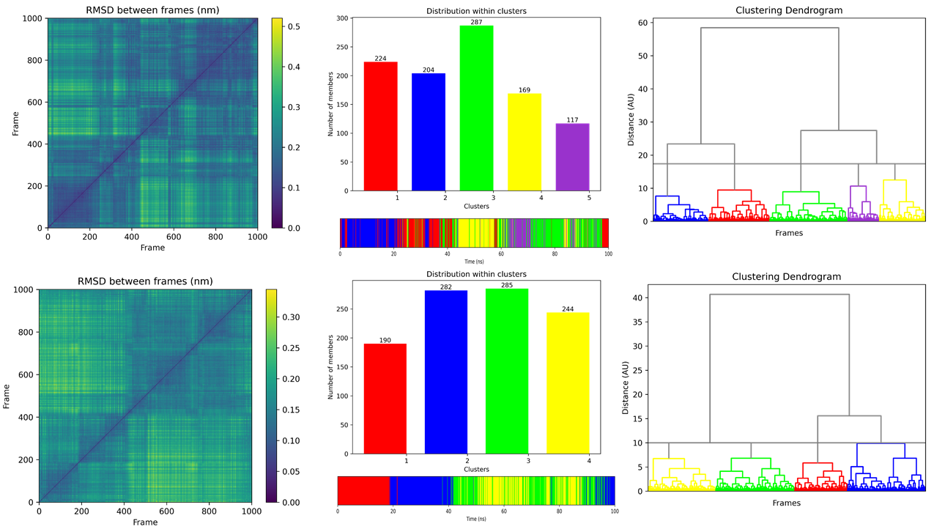
Figure S4. Clustering of MD simulation trajectories. A) The apo system and B) is the ATP-bound complex 3.

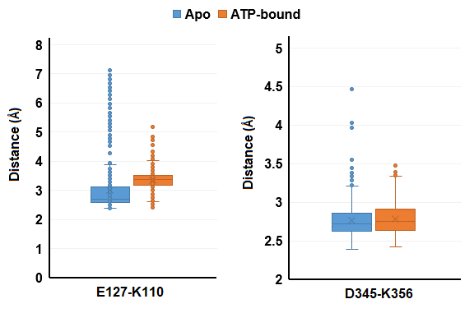
Figure S5. Salt-bridges length between selected residues over the simulation period.

References

1. Sievers, F. et al. Fast, scalable generation of high-quality protein multiple sequence alignments using Clustal Omega. Mol. Syst. Biol. 7, 539 (2011).
2. Pettersen, E. F. et al. UCSF Chimera—A visualization system for exploratory research and analysis. J. Comput. Chem. 25, 1605–1612 (2004).
3. Tubiana, T., Carvaillo, J.-C., Boulard, Y. & Bressanelli, S. TTClust: A Versatile Molecular Simulation Trajectory Clustering Program with Graphical Summaries. J. Chem. Inf. Model. 58, 2178–2182 (2018).

