SupplementaryFile

In Silico Profiling of Non-Synonymous SNPs of FTO Gene for Early Diagnosis of Non-Alcoholic Fatty Liver Disease
DaminiPatnaik¹, Atala Bihari Jena^{2*}
¹PostGraduateDepartmentofBiotechnology,UtkalUniversity,Bhubaneswar-751004,Odisha,India
²CentreofExcellenceinIntegratedOmicsandComputationalBiology,UtkalUniversity,Bhubaneswar-751004,Odisha,India
*Corresponding Author: Atala Bihari Jena (jena.atala@utkaluniversity.ac.in; Jena.atala@gmail.com)

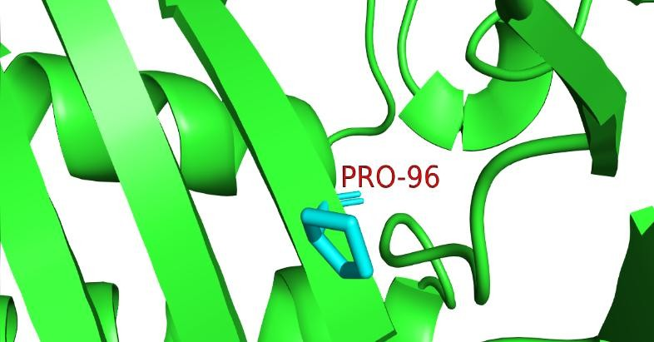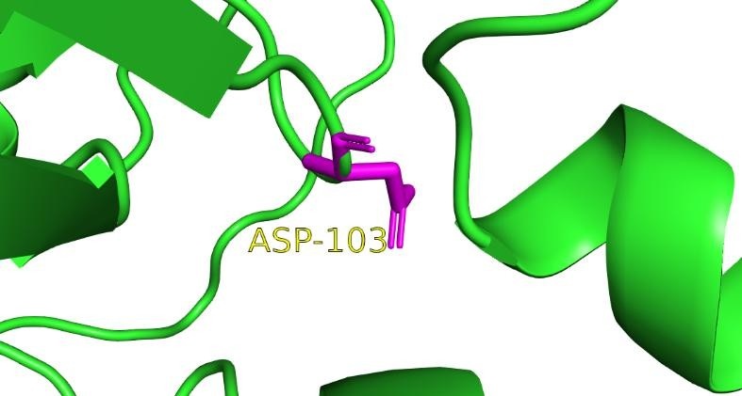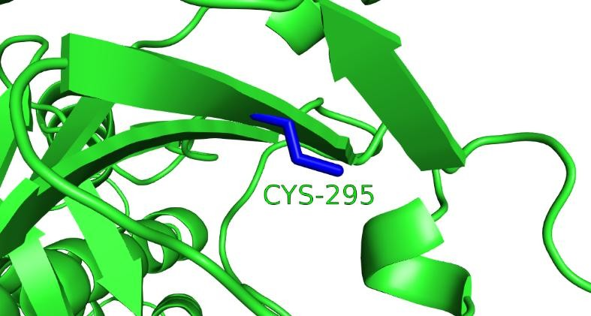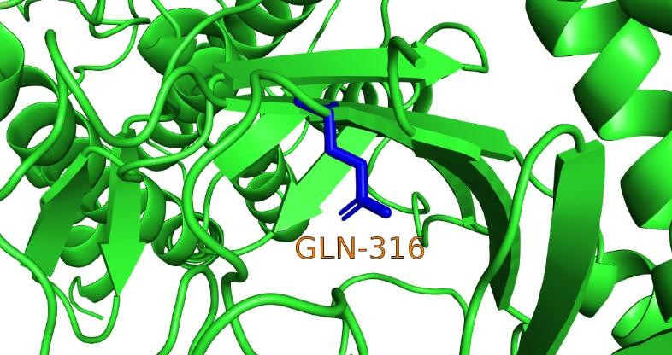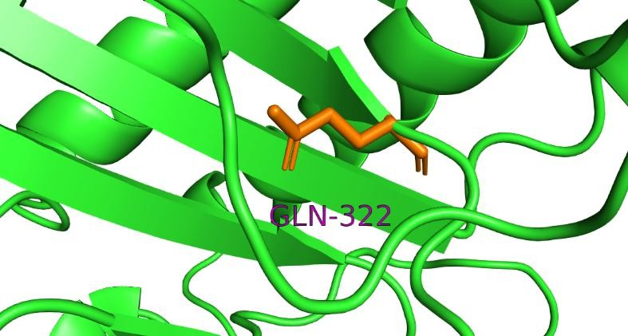
C
E
B
D
A

Figure S1: 3-Dimensional structure of deleterious ns-SNPs (A) R96P (B) G103D (C) Y295C (D) R322Q (E) R316Q.

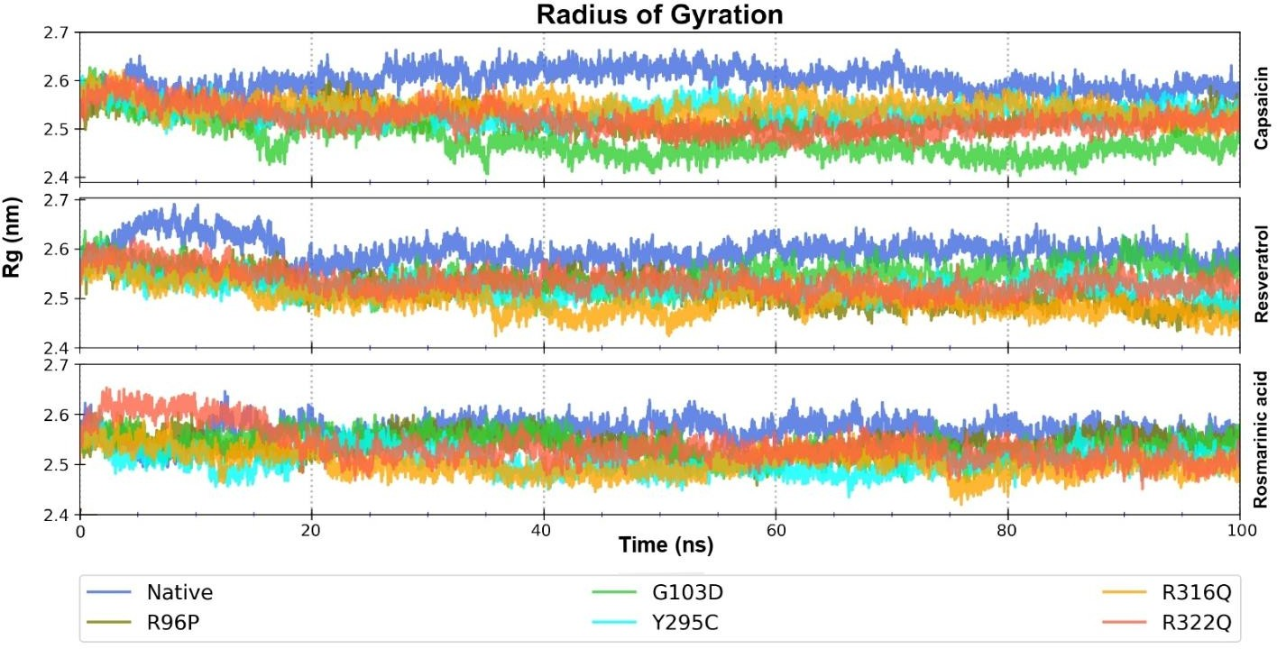

Figure S2: Radius of Gyration plots for mutant and native forms of FTO bound to the drug molecules.

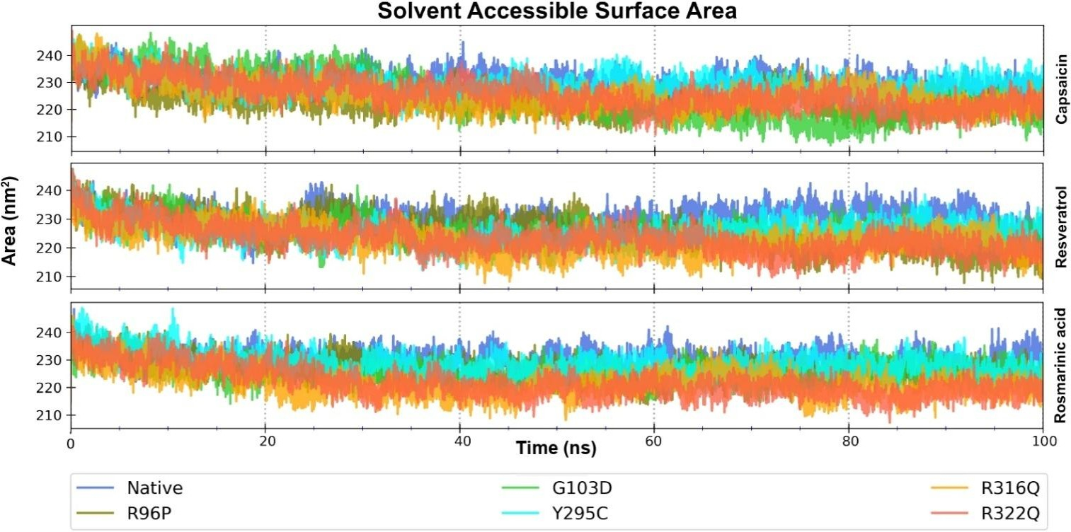

Figure S3: Solvent Accessible Surface Area of the protein-ligand complex throughout the simulation length.

Table S1: List of ‘‘possible deleterious ns-SNPs’’ by combined prediction. 12 ns-SNPs predicted to be deleterious are in bold.

S.No. | RsID | ALLELE | RESIDUAL  CHANGE | SIFT | PolyPhen-2 | PolyPhen-2 | I-Mutant30 | PANTHER | fathmm
 |  |  |  |  | HUMANDIV | HUMAN  VARIANCE
1 | rs121918214 | G/A | R316Q | 0 | 0.999 | 0.922 | -0.4 | 1628 | -2.02
2 | rs886052104 | C/T | T320I | 0 | 0.999 | 0.954 | -0.6 | 1628 | -1.82
3 | rs138348216 | A/G | M207V | 0 | 0.985 | 0.977 | -1.02 | 1628 | -1.59
4 | rs139577103 | G/C | R96P | 0 | 1 | 0.999 | -1.51 | 1628 | -2.06
5 | rs139577103 | G/A | R96H | 0 | 1 | 0.999 | -2.15 | 1628 | -2.05
6 | rs147561986 | A/G | N143S | 0 | 0.999 | 0.997 | -0.54 | 455 | -1.83
7 | rs200201735 | C/G | R322G | 0 | 0.996 | 0.945 | -2.42 | 1628 | -1.7
8 | rs370009039 | A/T | K216N | 0 | 1 | 0.998 | -0.38 | 1628 | -1.62
9 | rs373076420 | C/T | P288L | 0 | 1 | 0.999 | -0.32 | 1628 | -2.2
10 | rs550932456 | A/G | H62R | 0 | 1 | 0.998 | -0.32 | 1628 | -1.95
11 | rs745616565 | G/A | R322Q | 0 | 0.999 | 0.922 | -1.58 | 1628 | -2.02
12 | rs756850408 | A/G | N200D | 0 | 0.994 | 0.999 | -0.4 | 1628 | -1.82
13 | rs757311078 | C/T | R96C | 0 | 0.996 | 0.999 | -2.36 | 1628 | -2.07
14 | rs759168981 | C/T | P117S | 0 | 0.999 | 1 | -1.36 | 1628 | -2.39
15 | rs773635184 | G/T | V83F | 0 | 0.999 | 1 | -1.03 | 1628 | -1.54
16 | rs776743009 | G/T | G76V | 0 | 1 | 1 | -0.42 | 1628 | -1.54
17 | rs780803760 | C/G | F38L | 0 | 0.999 | 0.992 | -0.19 | 1628 | -1.31
18 | rs1028237381 | A/C | K216Q | 0 | 1 | 0.998 | -0.46 | 1628 | -1.59
19 | rs1160651565 | C/G | P117R | 0 | 1 | 1 | -0.63 | 1628 | -2.42
20 | rs1179039850 | G/T | V228L | 0 | 0.997 | 0.994 | -0.45 | 1628 | -1.79
21 | rs1203776934 | G/A | G103D | 0 | 1 | 1 | -2.28 | 1628 | -2.51
22 | rs1259762053 | A/G | Y295C | 0 | 1 | 0.999 | -0.22 | 1628 | -1.96
23 | rs1317685509 | T>A | S240T | 0 | 0.999 | 0.995 | 0.18 | 1628 | 1.84
24 | rs1322897154 | C>T | H307Y | 0 | 0.998 | 0.943 | 0.15 | 1628 | -1.96
25 | rs1392454854 | G>C | R112T | 0 | 1 | 0.998 | -0.61 | 1628 | -2.04
26 | rs1479729827 | T>C | Y106H | 0 | 1 | 0.999 | -0.7 | 1628 | -2.08

27 | rs1567384728 | G>A | G312S | 0 | 1 | 0.991 | -0.43 | 1628 | -2.49

Table S2: RMSD Values of Deleterious SNPs.

S.No. | RESIDUAL  CHANGE | RMSDGROMACS  VALUE | SCHRONDIGERRMSD  VALUE
1 | P288L | 0.383 | 19.801
2 | R322Q | 67.13 | 19.6809
3 | G103D | 0.714 | 20.0964
4 | Y295C | 0.377 | 5.0827
5 | H307Y | 0.305 | 19.8465
6 | G312S | 111.9 | 19.8515
7 | V83F | 0.269 | 0
8 | F38L | 0.251 | 19.4759
9 | V228L | 0.288 | 20.8018
10 | R316Q | 0.449 | 19.3233
11 | M207V | 0.255 | 19.3084
12 | R96P | 0.544 | 18.8998

