Supporting Information
Highly Viscoelastic, Stretchable, Conductive, and Self-Healing Strain Sensors based on Cellulose Nanofibers-Reinforced Polyacrylic Acid Hydrogel
Yue Jiao,^{a, b} Kaiyue Lu,ª Ya Lu,^{a, b} Yiying Yue,*^{d} Xinwu Xu,ª Huining Xiao,^{e} Jian Li,*^{c} Jingquan Han,*^{a, b}
a Material Science and Engineering College, Nanjing Forestry University, Nanjing 210037, China
b Co-Innovation Center of Efficient Processing and Utilization of Forest Resources, Nanjing Forestry University, Nanjing 210037, China
c Material Science and Engineering College, Northeast Forestry University, Harbin 150040, China
d Biology and Environment College, Nanjing Forestry University, Nanjing 210037, China
e Chemical Engineering Department, New Brunswick University, Fredericton, New Brunswick, E3B 5A3, Canada
*To whom correspondence should be addressed. Email: hjq@njfu.edu.cn

1. Rheological measurements
Rheological properties of hydrogels were measured using HAAKE RheoStress 600 rheometer (Thermo Fisher Science Inc., Waltham, USA) with a 25 mm parallel-plate geometry. A constant temperature of 25 ℃ was maintained during all the measurements. Silicone oil was coated on the surface of the hydrogel samples before the tests to prevent water evaporation. Before measurements were conducted, a dynamic strain sweep was performed first from 0.1 to 100% strain to determine the linear viscoelastic regime (LVR). A controlled strain (γ) of 1.0% was then chosen to ensure that the oscillatory deformation was within the LVR region in the rheological measurements. The rheological parameters (log mode) involving the storage modulus (G′) and loss modulus (G″) were measured as functions of angular frequency (ω) at ω = 0.01–100 rad s⁻¹ at room temperature. The complex modulus (G*) was calculated using the following formula:
$G^{*}=\sqrt{{G'}^{2}+{G''}^{2}}$ (1)

2. Self-healing efficiency testing
The self-healing efficiencies were evaluated by comparing the virgin and healed hydrogel samples. The healing of damaged as-prepared hydrogels (blade cut) was performed by placing the two freshly cut surfaces in contact (without adding any chemicals). After the allotted time, mechanical test of the healed hydrogels was performed at room temperature, and the mechanical self-healing efficiency f₁ was calculated from the equation (2). The electrical self-healing efficiency f₂ of hydrogel was calculated by formula (3).
$f_{1}=\frac{'}{}100\%$ (2)
$f_{2}=\frac{{}^{'}}{}×100\%$ (3)
Where ε and ε’ were the elongation at break of the original and self-healed hydrogels, and σ and σ’ corresponded to the conductivities of the original and self-healed hydrogels, respectively.

3. Strain-sensing tests
The strain sensing performance of the composite hydrogels was assessed with a homemade stretching device and an electrochemical workstation. The cylindrical samples (40 mm in length and 4 mm in diameter) were stretched up to 800% strain and the resistance values derived from the linear sweep voltammetry were continuously recorded. The sensitivity of a strain sensor is typically characterized via gauge factor (GF). The GF was calculated by the equation (GF = ΔR/εR₀), where R₀ is the unstrained resistance, ΔR is the resistance change under different strains, and ε is the applied strain. To monitor human motion, the assembled sensors were directly attached to human finger, fist, wrist, and face. The output I-t curves were recorded from cyclic movements under various amplitudes.

4. Composition of PAA, TOCNF/PAA and TOCNF-CNTs/PAA hydrogels
Table S1. Composition of PAA, TOCNF/PAA and TOCNF-CNTs/PAA Hydrogels
AA  (g) | H₂O  (g) | MBA  (g) | FeCl₃·6H₂O  (g) | CNTs  (wt%)^{I} | TOCNFs(wt%)^{I} | APS  (mg) | Samples
6 | 24 | 0.03 | 0.2 | 0 | 0 | 12 | PAA
6 | 24 | 0.03 | 0.2 | 0 | 2 | 12 | TOCNF/PAA
6 | 24 | 0.03 | 0.2 | 0.3 | 2 | 12 | TOCNF-CNTs/PAA -0.3
6 | 24 | 0.03 | 0.2 | 0.5 | 2 | 12 | TOCNF-CNTs/PAA -0.5
6 | 24 | 0.03 | 0.2 | 0.7 | 2 | 12 | TOCNF-CNTs/PAA -0.7
6 | 24 | 0.03 | 0.2 | 1.0 | 2 | 12 | TOCNF-CNTs/PAA -1.0
^{I} wt%：mass ratio of CNTs to AA

5. Mechanical performance parameters of hydrogels
Table S2. Physical-mechanical properties of various gels
Sample | Compression strength at 70% strain (MPa) | Tensile Strength  (kPa) | Elongation at Break (%) | Water Content  Wc (%) | Density ρ  (g cm⁻³)
PAA | 0.17±0.02 | 25.58±5.18 | 795±53 | 81.98±0.11 | 1.13±0.04
TOCNF/PAA | 0.52±0.05 | 35.78±3.43 | 1069±26 | 82.06±0.04 | 1.17±0.03
TOCNF-CNTs/PAA-0.3 | 1.02±0.13 | 37.90±9.54 | 967±25 | 82.52±0.14 | 1.24±0.12
TOCNF-CNTs/PAA -0.5 | 1.18±0.12 | 44.96±10.03 | 949±12 | 82.45±0.25 | 1.24±0.08
TOCNF-CNTs/PAA -0.7 | 1.80±0.23 | 59.16±6.53 | 850±54 | 82.01±0.28 | 1.26±0.05
TOCNF-CNTs/PAA -1.0 | 1.21±0.13 | 49.17±9.05 | 819±38 | 81.42±0.23 | 1.27±0.07
The pure PAA hydrogel exhibited an extremely low tensile strength (~25.58 kPa) and elongation at break (~795.3%). TOCNFs as a nanofillers could reinforce the tensile property and ductility of the PAA hydrogel, the tensile strength and elongation at break increased to ~35.78 kPa and ~1069.5%. Similar to the compressive strength and rheological viscoelasticity, with increasing the CNTs content from 0.3 to 0.7 wt%, the tensile strength of TOCNF-CNTs/PAA hydrogels increased from 37.9 kPa to 59.16 kPa. When the CNTs content further increased to 1.0 wt%, the tensile strength decreased to 49.17 kPa (still higher than that of PAA and TOCNF/PAA hydrogels). It can be seen from the Table S2 that the water content of hydrogels was above 80%, and the average water content was 82.07%. This was because the porous network structure of hydrogels could hold a large number of water molecules. The average density of hydrogels was 1.22 g cm⁻³, close to that of water. With the addition of TOCNFs and CNTs, TOCNF-CNTs were entangled with PAA chains, and the porous structure became compact and stable, resulting in an increase in density.
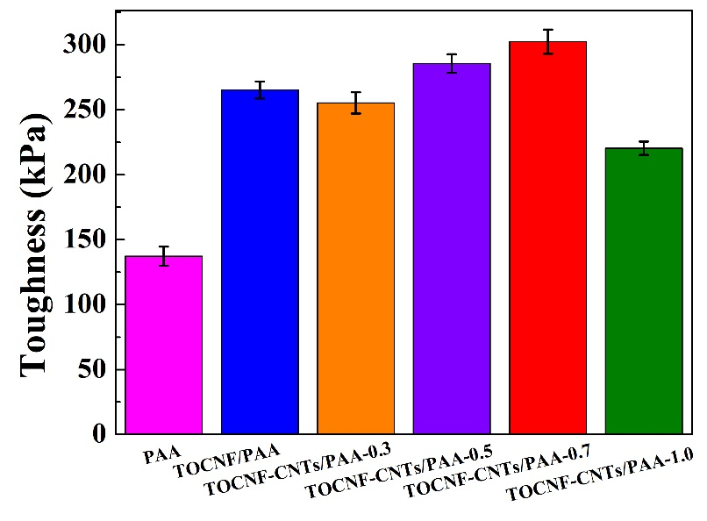
Figure S1. Toughness of hydrogels
The toughness of hydrogels is shown in Figure S1. It could be seen that the toughness values of TOCNF/PAA hydrogel (265.24 kPa) was greater than that of PAA hydrogel (137.27 kPa), indicating that TOCNF can enhance the toughness of hydrogel. After adding CNTs, the toughness value of TOCNF-CNTs/PAA-0.7 hydrogel reached the maximum of 302.44 kPa.

6. Self-healing characteristics of hydrogels
Table S3. Self-healing characteristics of various hydrogels
Sample | ε^{I}  (%) | ε'^{I}  (%) | ƒ₁^{III}  (%) | σ^{II}  (S m⁻¹) | σ' ^{II}  (S m⁻¹) | ƒ₂^{IV}  (%)
PAA | 795±53 | 749±21 | 94.23 | 2.32±0.04 | 2.31±0.03 | 99.56
TOCN/PAA | 1069±26 | 1008±18 | 94.36 | 2.33±0.03 | 2.32±0.06 | 99.57
TOCN-CNT/PAA-0.3 | 967±25 | 925±53 | 95.66 | 2.61±0.03 | 2.57±0.05 | 98.47
TOCN-CNT/PAA-0.5 | 949±12 | 896±45 | 94.42 | 2.81±0.02 | 2.79±0.03 | 99.29
TOCN-CNT/PAA-0.7 | 850±54 | 811±25 | 95.41 | 2.88±0.05 | 2.88±0.03 | 99.99
TOCN-CNT/PAA-1.0 | 819±38 | 764±32 | 93.28 | 2.94±0.08 | 2.92±0.04 | 99.32
^{I}: ε of the original and healed hydrogel with different components
^{II}: σ of the original and healed hydrogel with different components
^{III}: Mechanical self-healing efficiency of various hydrogels
^{IV}: Electrical self-healing efficiencies of different hydrogels
The electrical conductivities of hydrogels before and after self-healing were shown in the Table S3. The self-healing efficiencies of PAA, TOCNF/PAA and TOCNF-CNTs/PAA hydrogels were 99.56%, 99.57 and 99.99%, respectively, indicating that hydrogels could completely recover the electrical conductivities.

7. Sensing performance of strain sensors assembled from TOCNF-CNTs/PAA
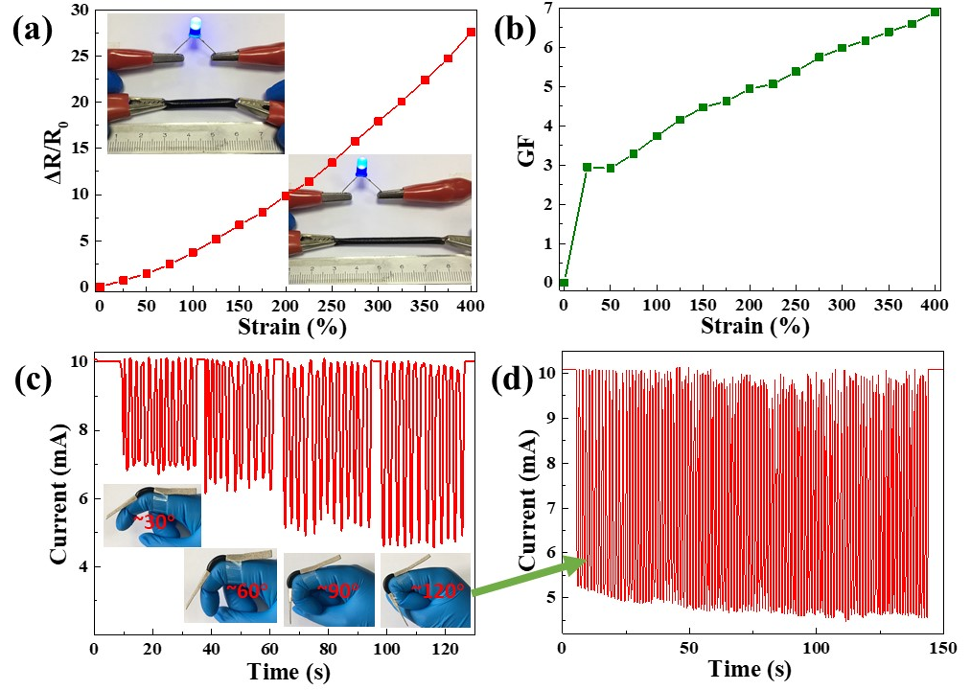
Figure S2. Plot of (a) ΔR/R₀ and (b) GF as a function of applied strain for TOCNF-CNTs/PAA-0.7 hydrogel. (c) Real-time I–t response of the sensor for monitoring finger bending motion with different bending degree (about 30°, 60°, 90° and 120°). (d) I–t curve of finger bending 120° after repetition for 200 times
Figure S2a shows a typical plot of relative resistance variation as a function of strains assembled from TOCNF-CNTs/PAA-0.7. The resistance change ratio could be defined as the ratio of the resistance change (ΔR = R − R₀) to the initial resistance R₀, described as ΔR/R₀. The obtained result displayed that the ΔR/R₀ value of the specimens monotonic increased with strain, where R₀ and ΔR represent the original resistance and the difference values being stretched, respectively. The darkening of the LED lighting system provided further confirmation of above conclusion (inset of Figure S1a). When the maximal strain increased up to 400%, the corresponding GF increased from 0 to 6.86 (Figure S2b). The strain sensor can be attached to a finger and monitor the finger joint motion (bending) with obvious current variations with applied strains. When the finger was progressive bended, the current decreased gradually in response to the movements of the finger via a step-by-step manner (Figure S2c). A further cyclic measurement was presented in Figure S2d. After repetition for about 200 times (about 120° bending angle), it still exhibited discernible strain sensitivity, implying the excellent repeatability of this strain sensor.

