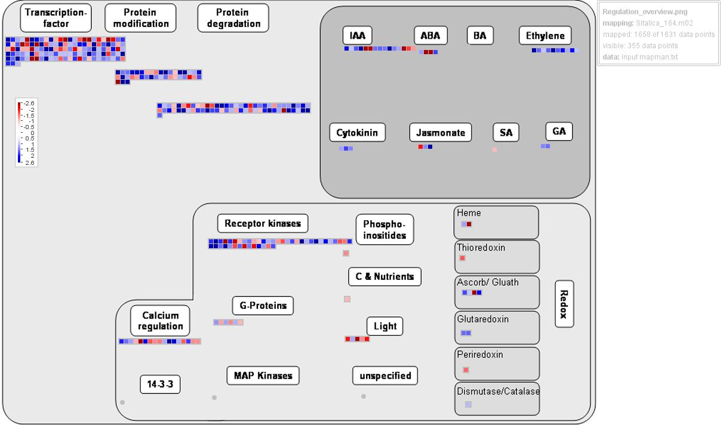
Fig. S5a. Schematic overview of gene regulation of differentially expressed genes in foxtail millet under drought response, as drawn by MapMan. Color coding; red: down-regulated genes and blue: up-regulated genes.

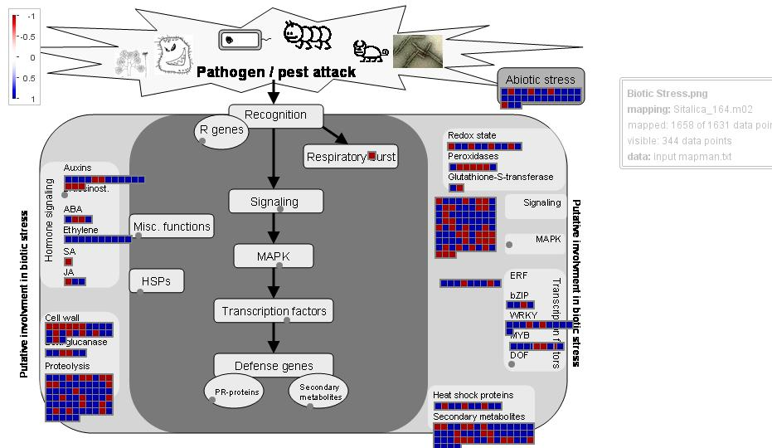
Fig. S5b. Schematic overview of biotic stress mapping of differentially expressed genes in foxtail millet under drought response, as drawn by MapMan. Color coding; red: down-regulated genes and blue: up-regulated genes.

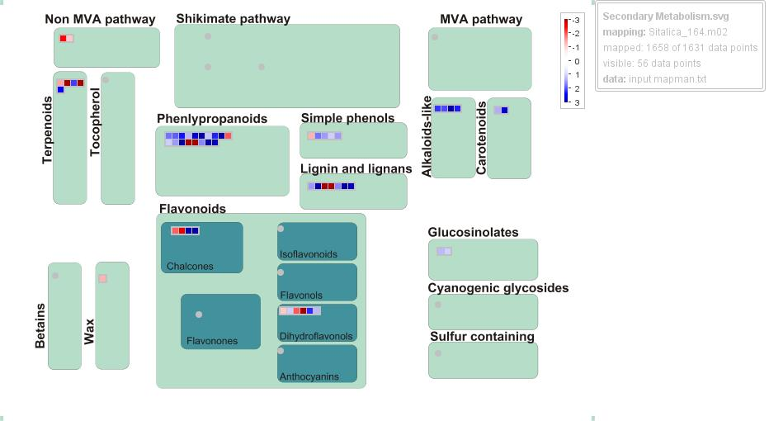
Fig. S5c. Schematic overview of secondary metabolism mapping of differentially expressed genes in foxtail millet under drought response, as drawn by MapMan. Color coding; red: down-regulated genes and blue: up-regulated genes.
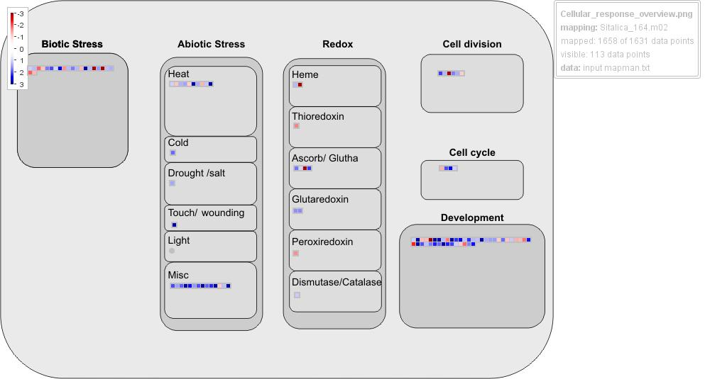
Fig. S5d. Schematic overview of cellular response overview mapping of differentially expressed genes in foxtail millet under drought response, as drawn by MapMan. Color coding; red: down-regulated genes and blue: up-regulated genes.

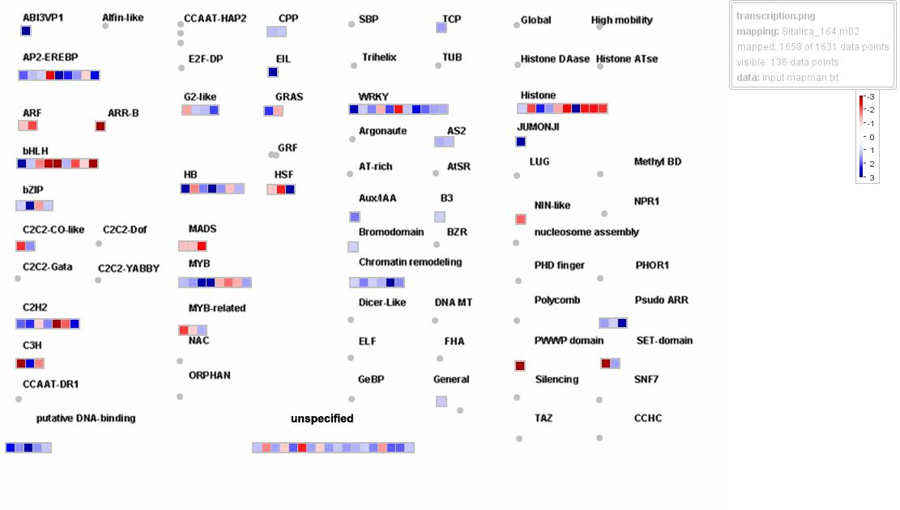
Fig. S5e. Schematic overview of transcription overview mapping of differentially expressed genes in foxtail millet under drought response, as drawn by MapMan. Color coding; red: down-regulated genes and blue: up-regulated genes.

