(a)

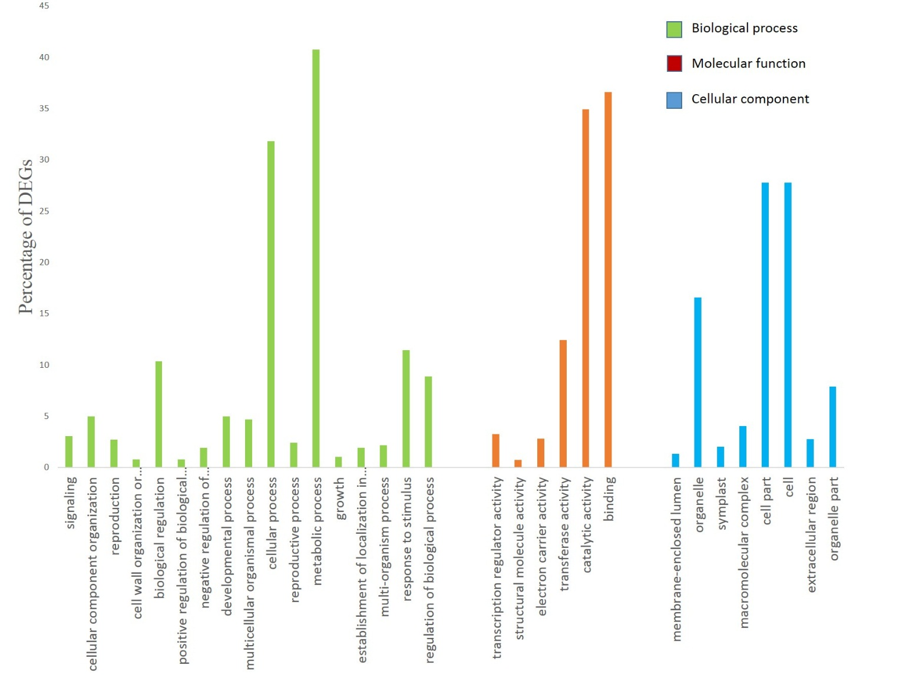

Fig. S4a. GO annotation clusters of novel differentially expressed genes between normal and drought stress

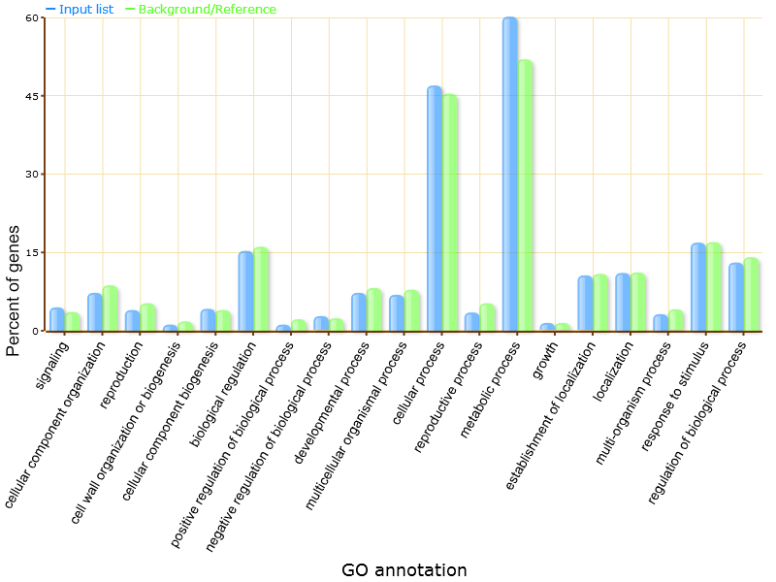
Fig. S4b. GO annotation clusters of 41_DEG_biological process

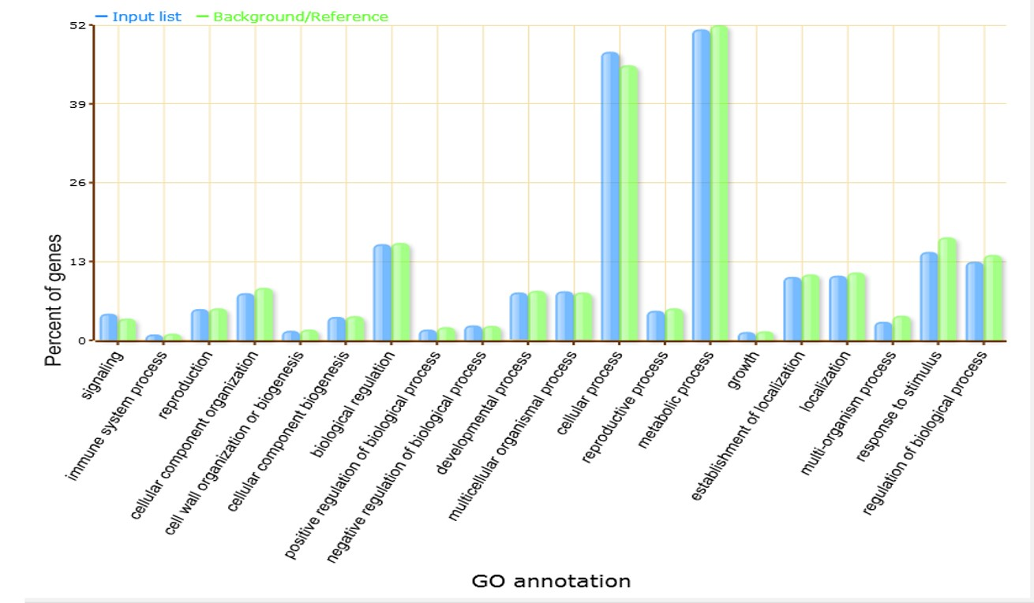
Fig. S4c. GO annotation clusters of 41_Non DEG _biological process

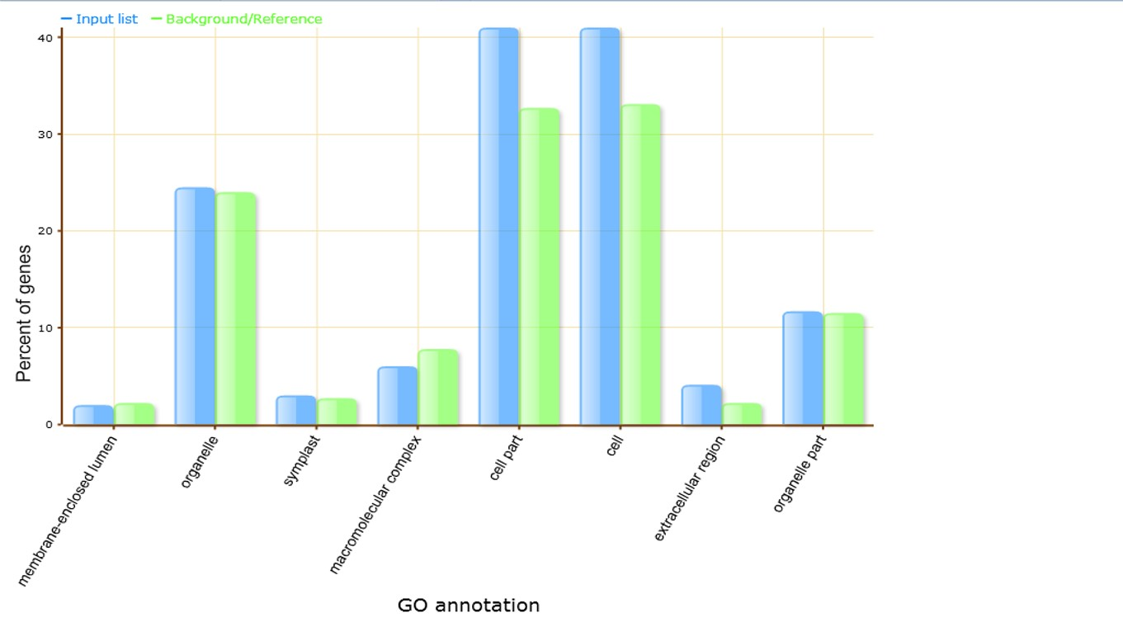

Fig. S4d. GO annotation clusters of 41_DEG_cellular component

(a)

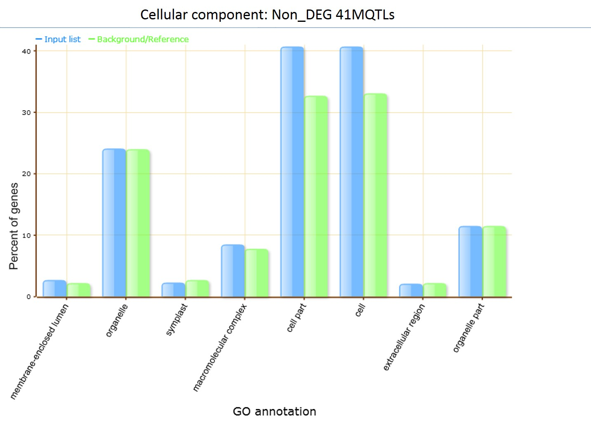

Fig. S4e. GO annotation clusters of 41_Non DEG_cellular component

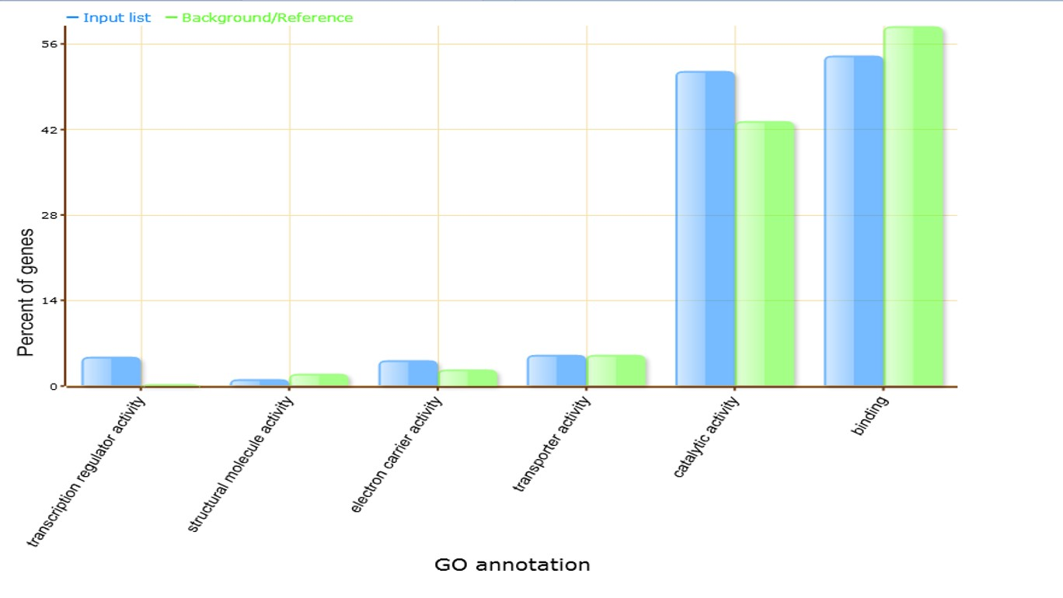

Fig. S4f. GO annotation clusters of 41_DEG_molecular function

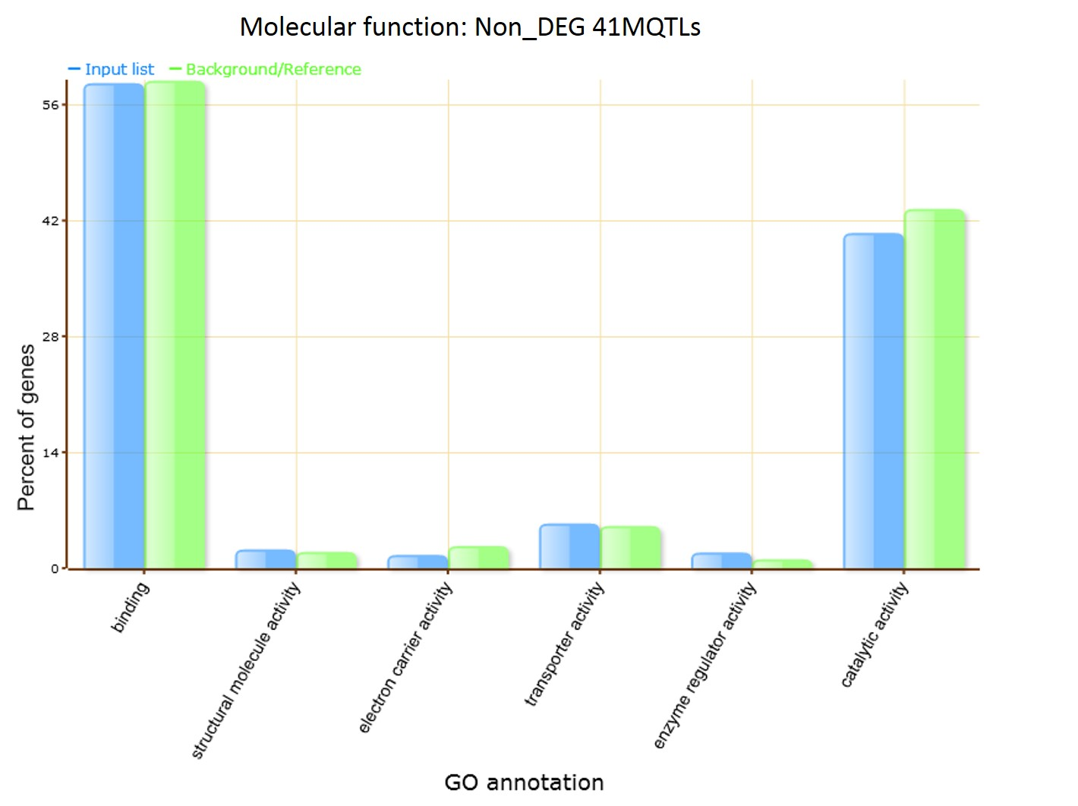
Fig. S4g. GO annotation clusters of 41_NonDEG_molecular function.

