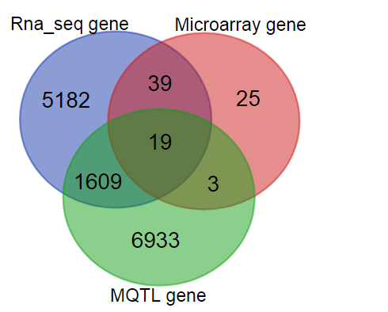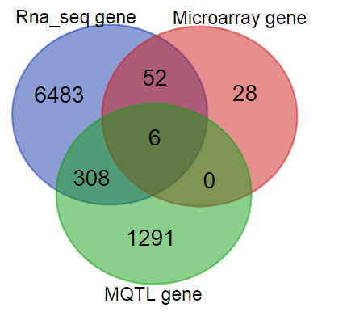
- (b)

Figure S3. Venn diagram of differential expressed genes (DEGs) derived from RNA-seq, microarray data compared with (a) 8 MQTLs regions with CI of less than 1Mb (b) all MQTLs regions (Venn diagram was drawn using a tool in this website: http://bioinformatics.psb.ugent.be/webtools/Venn/)

