Supporting Information

Confining donor conformation distributions for efficient thermally activated delayed fluorescence with fast spin-flipping

Weidong Qiu¹, Denghui Liu¹, Mengke Li¹*, Xinyi Cai¹, Zijian Chen¹, Yanmei He¹, Baoyan Liang², Zhenyang Qiao¹, Jiting Chen¹, Wei Li¹, Wentao Xie¹, Xiaomei Peng¹, Zhiheng Wang^{1,2}, Deli Li¹, Yiyang Gan¹, Yihang Jiao¹, Junrong Pu¹, Qing Gu¹ & Shi-Jian Su¹*

- State Key Laboratory of Luminescent Materials and Devices Institute of Polymer Optoelectronic Materials and Devices, South China University of Technology, Guangzhou 510640, P. R. China.
- Ji Hua Laboratory, Foshan 528200, P. R. China.
* Corresponding authors, email: limk@scut.edu.cn, mssjsu@scut.edu.cn.

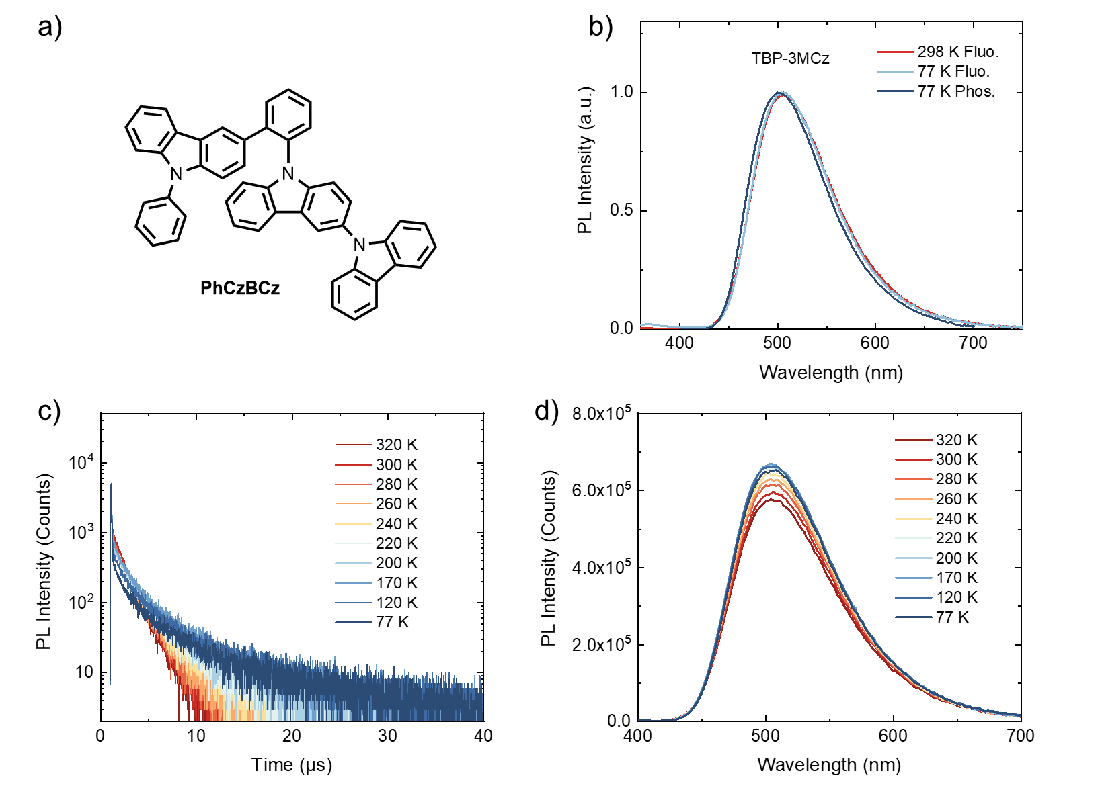
Supplementary Figure 1. Photo-physical properties of 15 wt% TBP-3MCz in PhCzBCz host. a) Molecular structure of the PhCzBCz host; b) Fluorescence spectra measured at 298 K and 77 K and phosphorescence spectrum measured at 77 K (delayed 5 ms); Temperature-dependent c) transient PL decay characters and d) PL spectra of the TBP-MCz doped film.

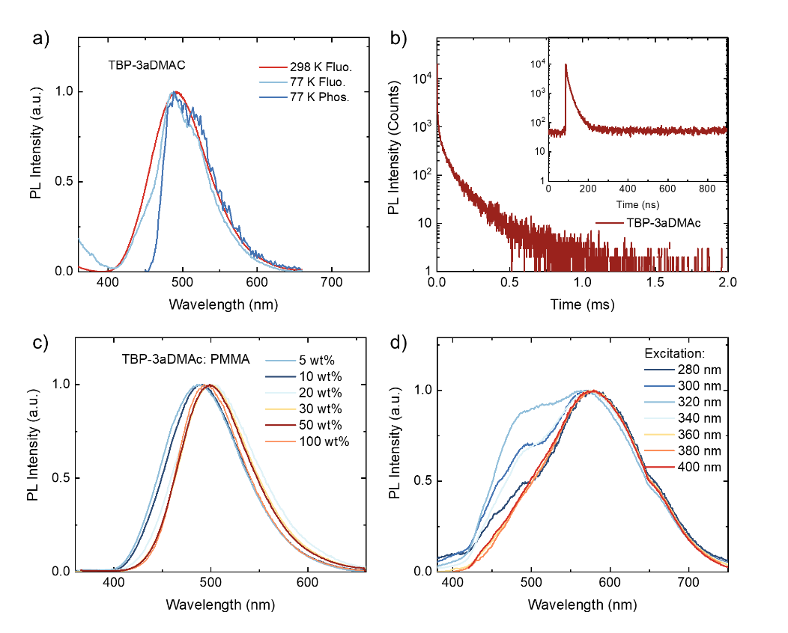
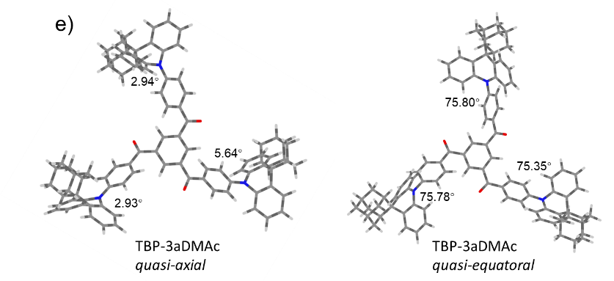
Supplementary Figure 2. Photo-physical properties of TBP-3aDMAc. a) Fluorescence spectra measured at 298 K and 77 K and phosphorescence spectrum measured at 77 K (delayed 5ms) of the TBP-3aDMAc doped film; b) Transient PL decay characters of 15 wt% TBP-3aDMAc doped PhCzBCz film measured at different timescales; c) concentration-dependent PL spectra of TBP-3aDMAc in PMMA host; d) PL spectra of the TBP-3aDMAc dichloromethane solution (10⁻⁵ M) with different excitation wavelengths; e) DFT optimized quasi-axial and quasi-equatorial geometries of TBP-3aDMAc.

Identification of the dual conformation characters of TBP-3aDMAc.
Dual conformation emission is an interesting phenomenon in organic luminescent materials and can be realized by using donors with large distortion such as phenothiazine.¹⁻⁴ In TBP-3aDMAc, the adamantane units with large steric hindrance can also twist the donor plane, which can stabilize the quasi-axial conformation to achieve dual conformation distribution. In Supplementary Figure 2e, two stable conformers can be found by DFT optimization, corresponding to quasi-axial (small dihedral angels) and quasi-equatorial conformer. Due to the twisted intramolecular CT character, the quasi-equatorial conformer has lower energy and smaller ΔE_{ST}, which can be revealed by TD-DFT calculation in Supplementary Table 1. In reality, there can be multiple conformations such as two quasi-equatorial and one quasi-axial conformers in single molecules, resulting in a broad conformation distribution. In this case, energy transfer from high energy quasi-axial to low energy quasi-equatorial form can happen. To experimentally identify the dual conformation character, we compared the PL spectra with different doping concentrations in PMMA film (Supplementary Figure 2c). At low concentration, intermolecular energy transfer can be suppressed, and the quasi-axial emission at blue region can be observed. When increasing the doping concentration, all energies can be transfer to the quasi-equatorial conformer, and only the long-wavelength emission from quasi-equatorial conformer remains. In addition, the different conformers have different transition dipole moment, and therefore, in high polarity solvent such as dichloromethane, the two-emission band can be separated, which can be more distinctive when changing the excitation wavelengths (Supplementary Figure 2d). Therefore, the TBP-3aDMAc is a new dual-emissive emitter from dual conformations.

Supplementary Table 1. TD-DFT calculation results of the investigated molecules.
 | D-A angels | Singlet |  |  | Triplet |  | SOCME
 | ° | eV |  | f | eV |  | cm⁻¹
TBP-3MCz | 77.42 | S₁ | 2.5531 | 0.0398 | T₁ | 2.5208 | S₁-T₁ | 0.07732
TBP-3MCz | 78.78 | S₂ | 2.5540 | 0.0393 | T₂ | 2.5211 | S₁-T₂ | 0.03804
TBP-3MCz | 77.47 | S₃ | 2.5580 | 0.0071 | T₃ | 2.5218 | S₁-T₃ | 0.01399
TBP-DMAc | 80.76 | S₁ | 2.4758 | 0.0002 | T₁ | 2.4699 | S₁-T₁ | 0.00686
TBP-DMAc | 84.26 | S₂ | 2.4761 | 0.0002 | T₂ | 2.4703 | S₁-T₂ | 0.00372
TBP-DMAc | 84.2 | S₃ | 2.4768 | 0.0002 | T₃ | 2.4710 | S₁-T₃ | 0.00220
TBP-3aDMAc  (QA/QE) | 2.93/75.78 | S₁ | 3.3591/2.6076 | 0.7308/0.0007 | T₁ | 2.7318/2.6005 | S₁-T₁ | 0.29806/0.01103
TBP-3aDMAc  (QA/QE) | 5.64/75.35 | S₂ | 3.3641/2.6079 | 0.7879/0.0006 | T₂ | 2.7492/2.6010 | S₁-T₂ | 0.48063/0.01346
TBP-3aDMAc  (QA/QE) | 2.94/75.80 | S₃ | 3.44232.6081 | 0.1294/0.0011 | T₃ | 2.7536/2.6013 | S₁-T₃ | 0.66278/0.00597
TRZ-3MCz | 83.55 | S₁ | 2.5802 | 0.0164 | T₁ | 2.5654 | S₁-T₁ | 0.05021
TRZ-3MCz | 85.03 | S₂ | 2.5821 | 0.0248 | T₂ | 2.5687 | S₁-T₂ | 0.03973
TRZ-3MCz | 84.09 | S₃ | 2.5868 | 0.0036 | T₃ | 2.5692 | S₁-T₃ | 0.02164
TB-3MCz | 83.99 | S₁ | 2.7656 | 0.0097 | T₁ | 2.7511 | S₁-T₁ | 0.05021
TB-3MCz | 84.1 | S₂ | 2.7661 | 0.0097 | T₂ | 2.7515 | S₁-T₂ | 0.03973
TB-3MCz | 84.01 | S₃ | 2.7709 | 0.0001 | T₃ | 2.7575 | S₁-T₃ | 0.02164

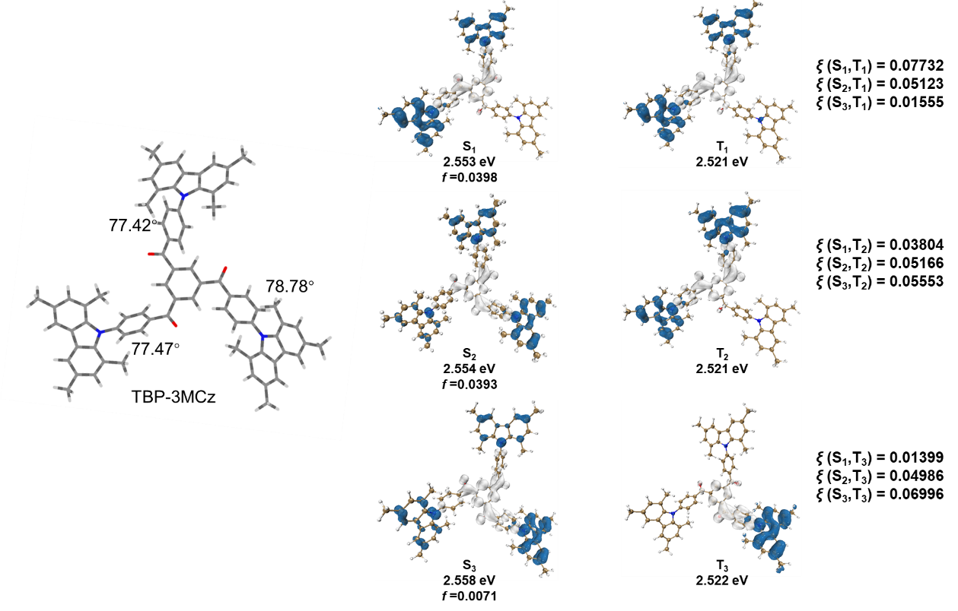
Supplementary Figure 3. Optimized ground state geometry, calculated hole-electron distributions, excited state energies, oscillator strengths (f), and spin-orbit coupling matrix elements (H_{SOC}, ξ) of TBP-3MCz.

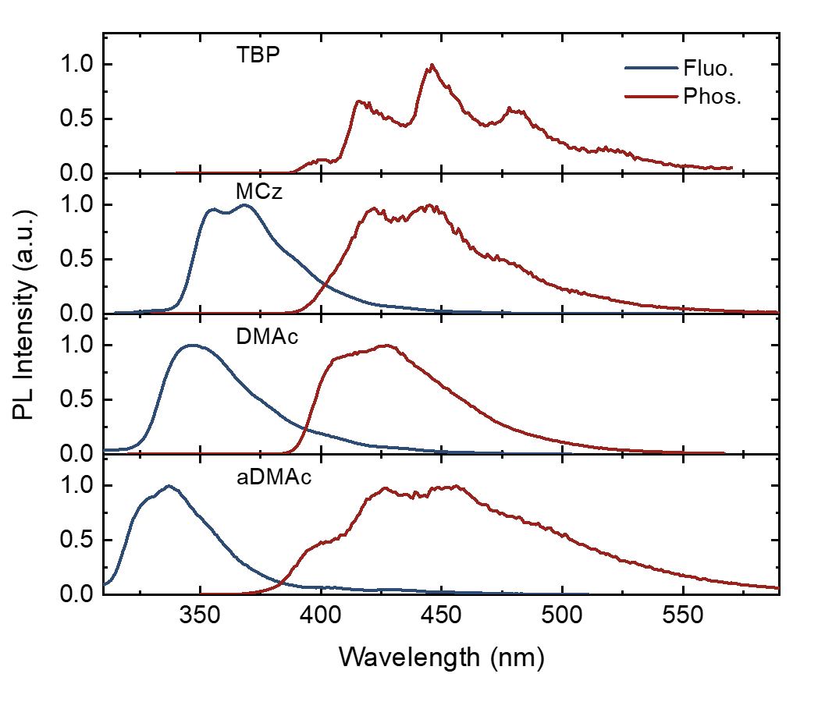
Supplementary Figure 4. Fluorescence and phosphorescence spectra of the donor and acceptor fragments of the investigated molecules in diluted toluene solution (10⁻⁴ M).

Supplementary Table 2. TD-DFT calculated ΔE_{ST} in the optimized ground state geometries and average ΔE_{ST} according to Boltzmann distribution on the scanned PES in Fig 2.
 | Vertical absorption  meV | S₁ averageª  meV | T₁ averageª  meV
TBP-MCz | 40.4 | 23.6 | 25.6
TBP-DMAc | 7.7 | 25.4 | 75.4
TBP-a-DMAc | 463.0 (QA)/8.5 (QE)^{b} | 28.7 | 153.8

- The conformer distributions were estimated by Boltzmann distribution: $\%Conormer i= \frac{exp⁡(-\frac{E_{i}}{k_{b}T})}{\sum_{j}{exp⁡(-\frac{E_{j}}{k_{b}T})}}$, where Ei is the conformational energy of conformer i calculated by TD-DFT, k_{b} is Boltzmann constant and T is the ambient temperature (298K); and the average energies were calculated by timing TD-DFT calculated ΔE_{ST} in each geometry with the %Conformer i of the corresponding scanned singlet or triplet PES.
- The ΔE_{ST} calculated in quasi-axial (QA) and quasi-equatorial (QE) conformation.

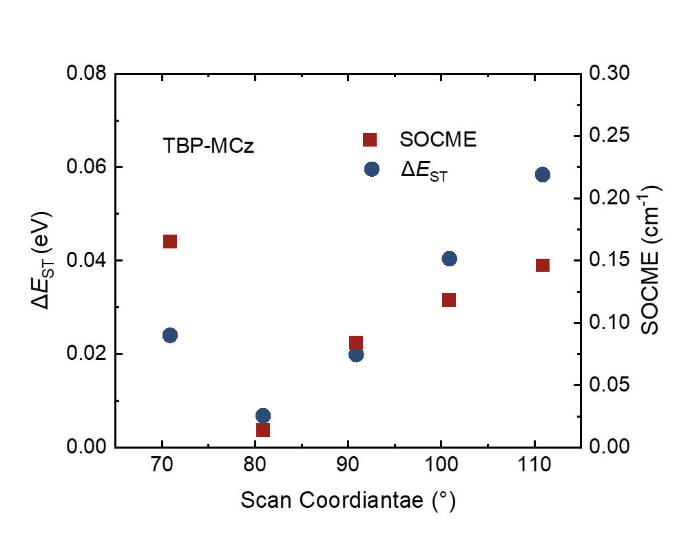
Supplementary Figure 5. Calculated ΔE_{ST} and spin-orbital coupling matrix element (SOCME) of TBP-MCz as a function of D-A dihedral angles.

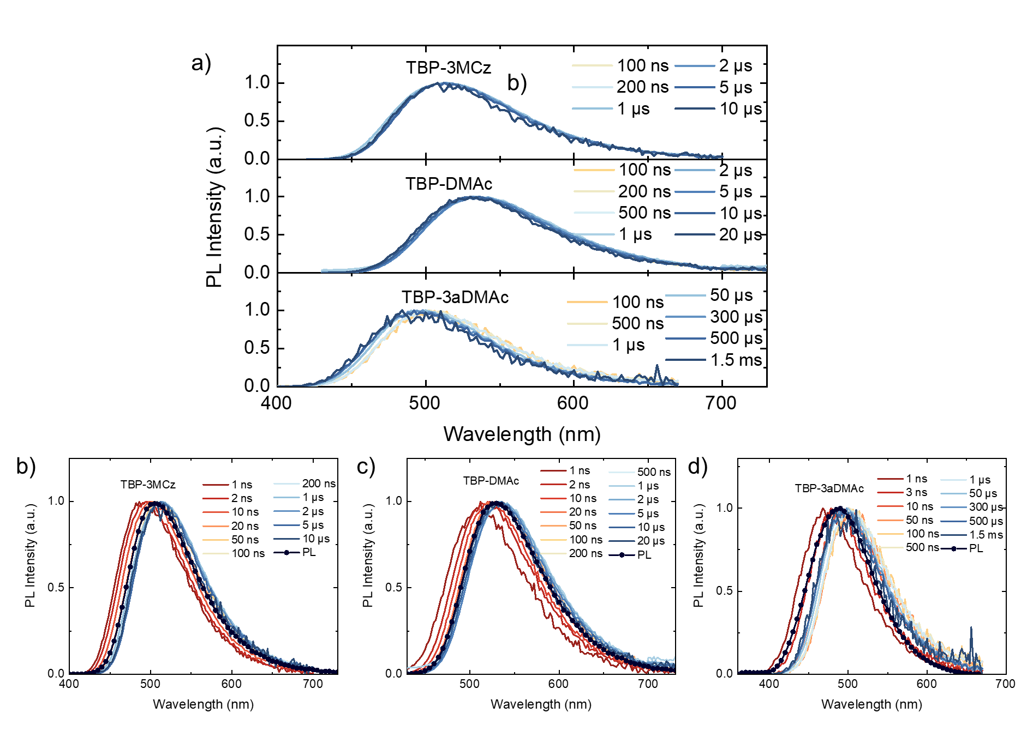
Supplementary Figure 6. Time-resolved emission spectra of the TBP-3MCz, TBP-DMAc and TBP-3aDMAc doped films, Figure S6a demonstrates the time-resolved PL spectra of the delayed components after solvent stabilization and fluorescence emission.

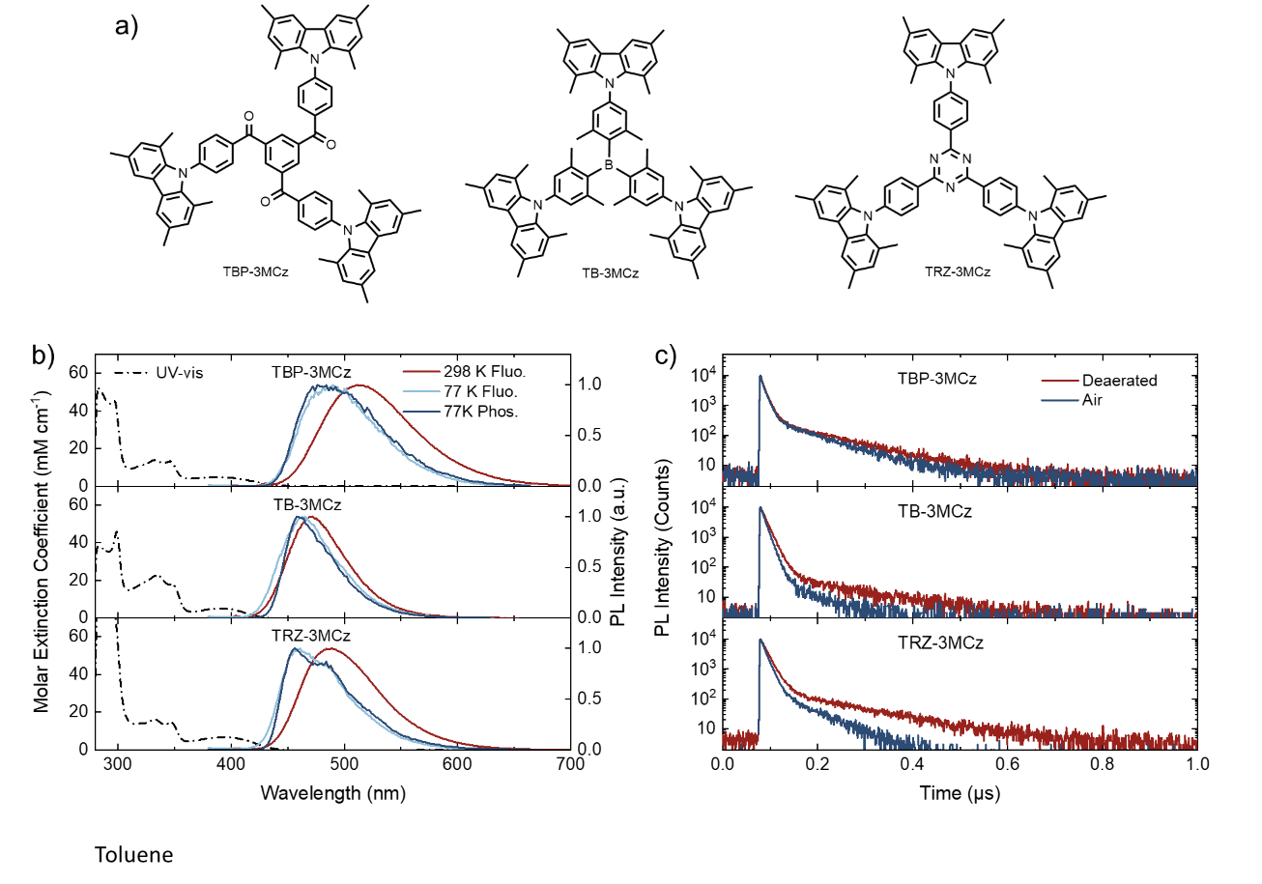
Supplementary Figure 7. Photo-physical properties of TBP-3MCz, TB-3MCz and TRZ-3MCz in dilute toluene solution (10⁻⁵ M). a) Chemical structures of the TADF emitters with MCz donor; b) UV-vis absorption, fluorescence spectra measured at 298 K and 77 K and phosphorescence spectra measured at 77 K (delayed 5 ms); b) Transient PL decay characters of the diluted toluene solutions before and after argon bubbling for 10 minutes.

Supplementary Figure Table 3. Photo-physical parameters of TBP TBP-3MCz, TB-3MCz and TRZ-3MCz in toluene.
 | λ_{em} | Φ_{PL}ª | Φ_{PF} | Φ_{DF} | τ_{PF} | τ_{DF} | k_{r}^{S} | k_{ISC} | k_{RISC} | k_{TADF}
 | nm | % | % | % | ns | μs | 10⁷ s⁻¹ | 10⁷ s⁻¹ | 10⁶ s⁻¹ | 10⁵ s⁻¹
TBP-3MCz | 514 | 51.90 | 34.59 | 17.31 | 10.08 | 0.11 | 3.43 | 3.31 | 13.25 | 2.25
TB-3MCz | 471 | 70.30 | 65.56 | 4.74 | 12.08 | 0.14 | 5.43 | 2.85 | 7.88 | 0.54
TRZ-3MCz | 487 | 85.85 | 69.61 | 16.24 | 13.62 | 0.14 | 5.11 | 2.23 | 8.89 | 1.33
- Measured PLQY after argon bubbling for 10 min.

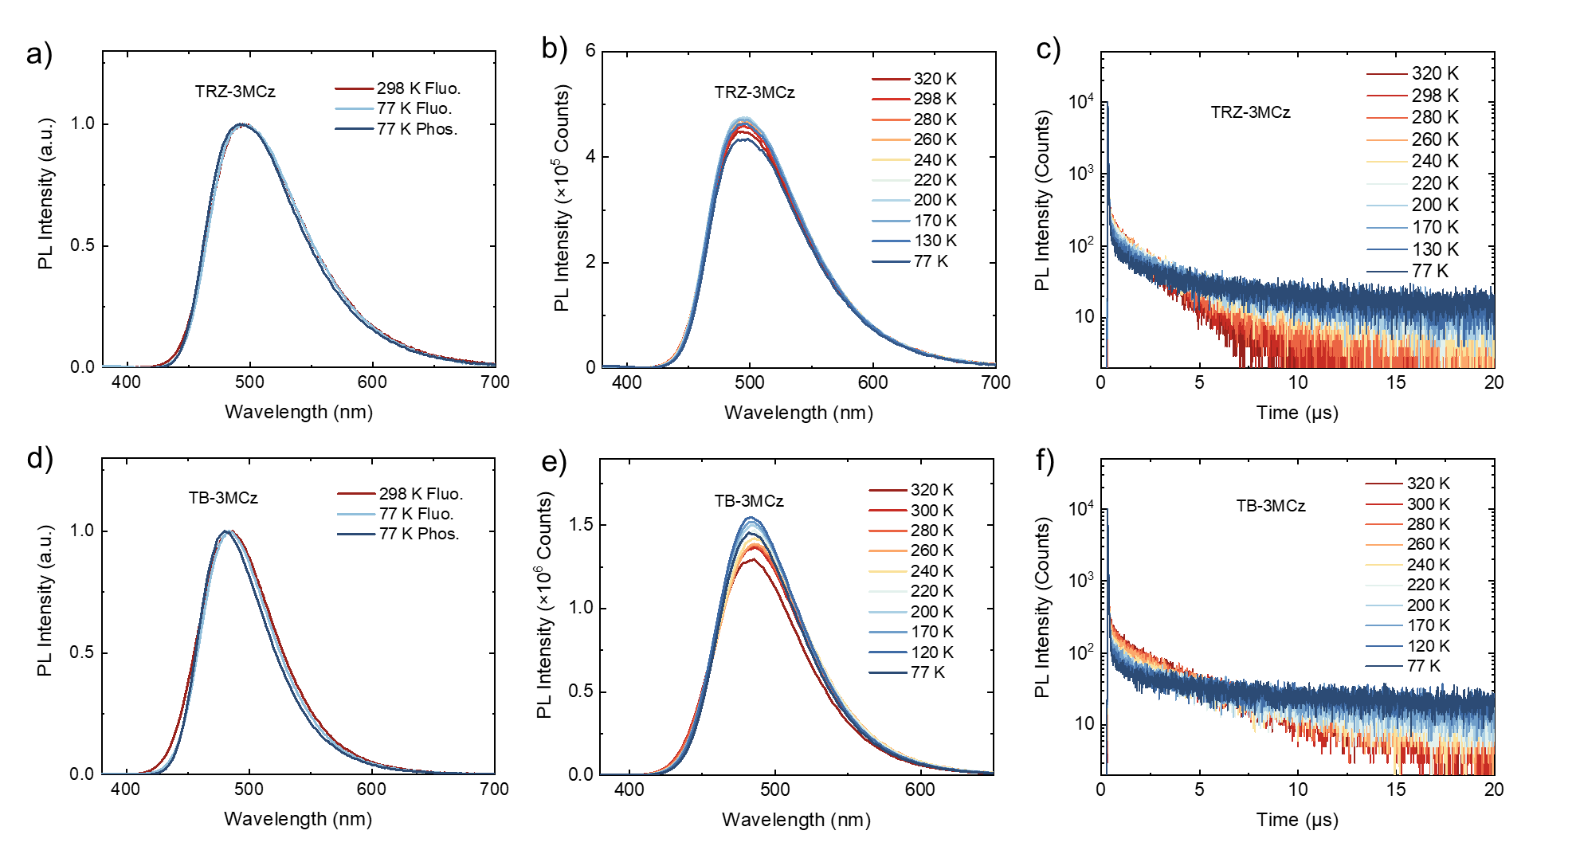
Supplementary Figure 8. Photo-physical properties of 15 wt% TRZ-3MCz and TB-3MCz doped in PhCzBCz host matrix. a), d) Fluorescence spectra measured at 298 K and 77 K and phosphorescence spectrum measured at 77 K (delayed 5ms); b), e) Temperature-dependent b) transient PL decay characters and c), f) PL spectra of the TRZ-3MCz and TB-3MCz doped films respectively.

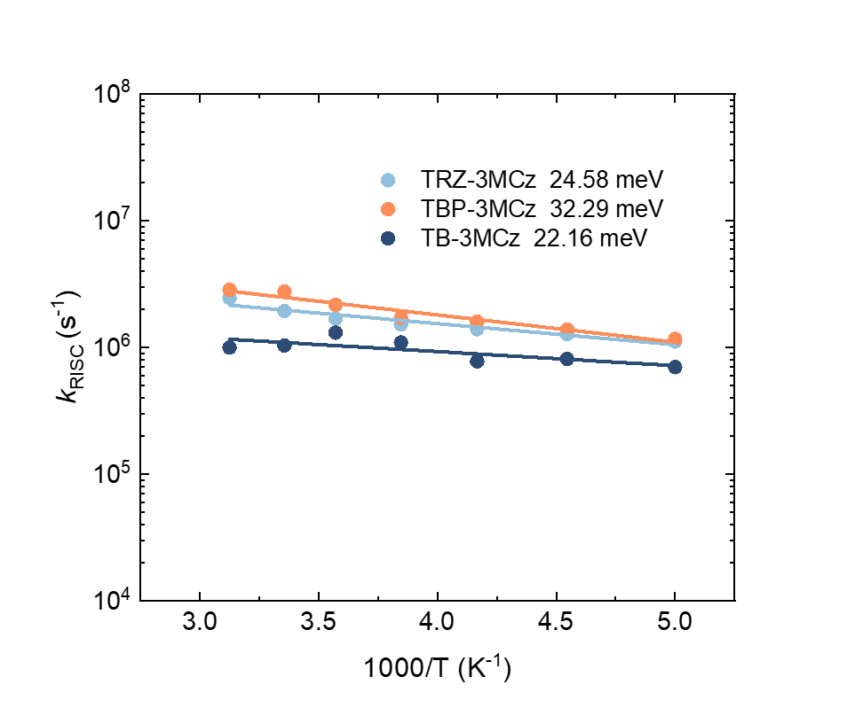
Supplementary Figure 9. Arrhenius plot of the k_{RISC} of 15 wt% TRZ-3MCz, TBP-3MCz and TB-3MCz doped PhCzBCz films as a function of temperature (1000/T).
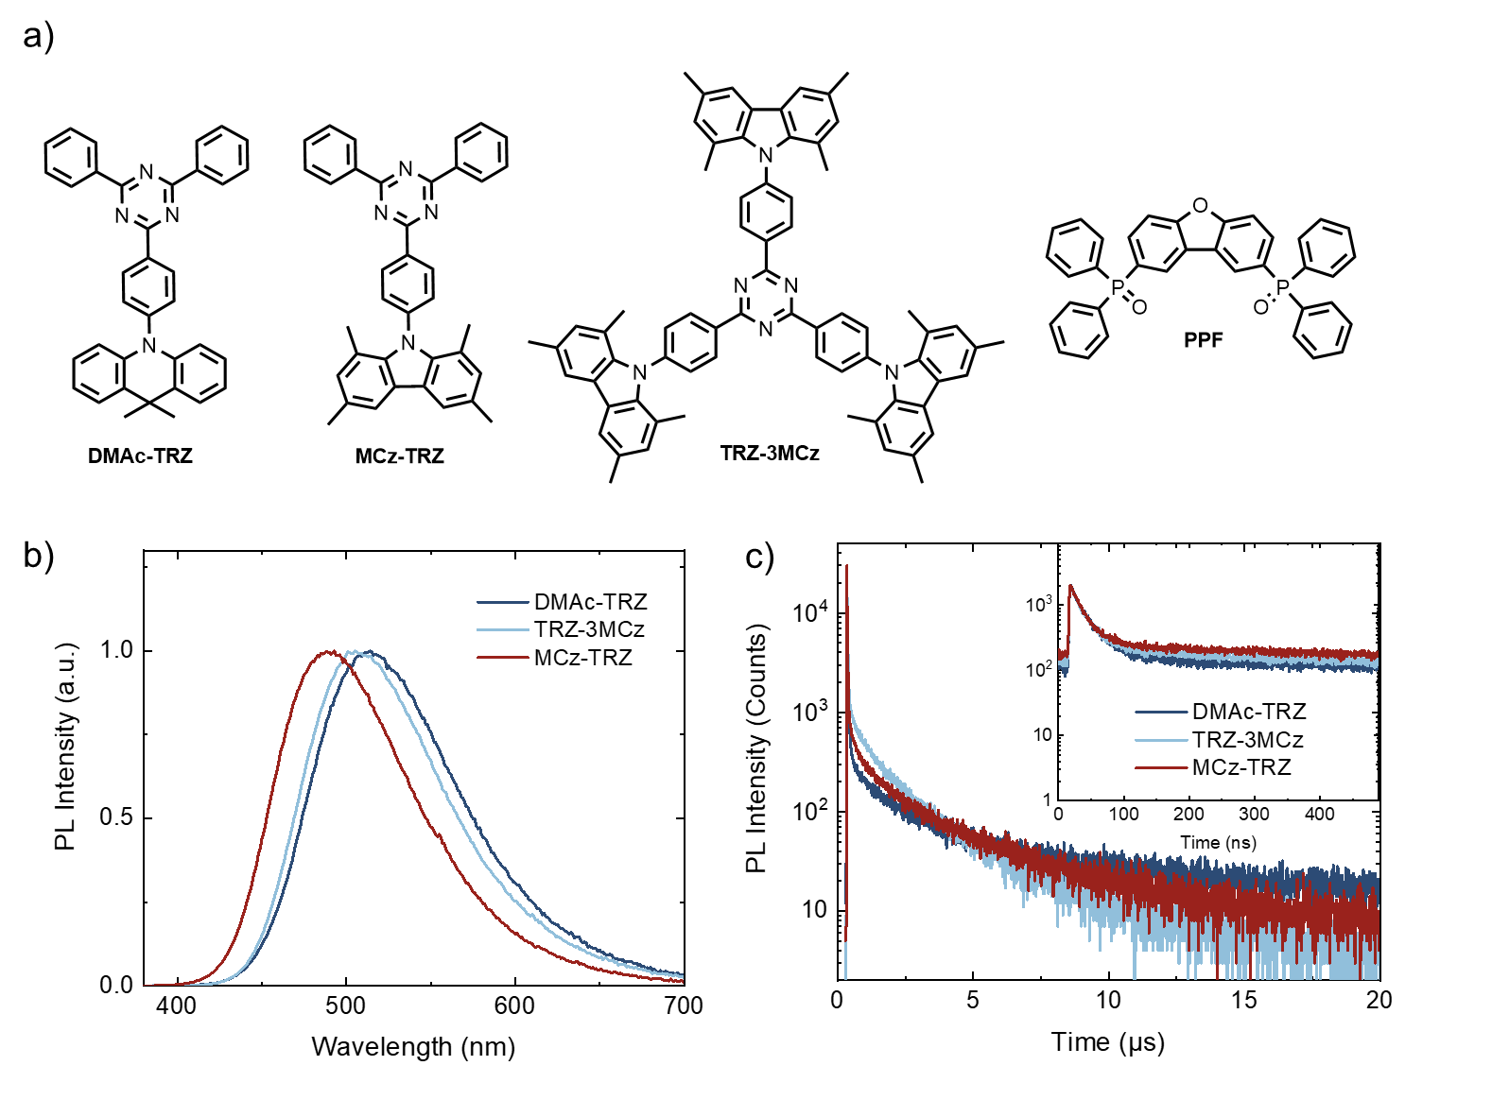
Supplementary Figure 10. a) Molecular structures, b) PL spectra and c) transient PL decay characters of the 10 wt% investigated TADF emitters with a triazine acceptor in PPF host.

Supplementary Table 4. Photo-physical parameters of 10 wt% DMAc-TRZ, MCz-TRZ and TRZ-3MCz in PPF host.
 | λ_{em} | Φ_{PL} | Φ_{PF} | Φ_{DF} | τ_{PF} | τ_{DF} | k_{r}^{S} | k_{ISC} | k_{RISC} | k_{TADF}
 | nm | % | % | % | ns | μs | 10⁷ s⁻¹ | 10⁷ s⁻¹ | 10⁶ s⁻¹ | 10⁵ s⁻¹
DMAc-TRZ | 515 | 83.0 | 42.24 | 40.76 | 23.64 | 2.81 | 1.79 | 2.08 | 0.70 | 2.95
TRZ-3MCz | 506 | 86.9 | 29.07 | 57.87 | 21.19 | 1.68 | 1.37 | 3.14 | 1.78 | 5.17
MCz-TRZ | 488 | 84.5 | 29.63 | 54.88 | 17.45 | 2.37 | 1.70 | 5.73 | 1.20 | 3.56

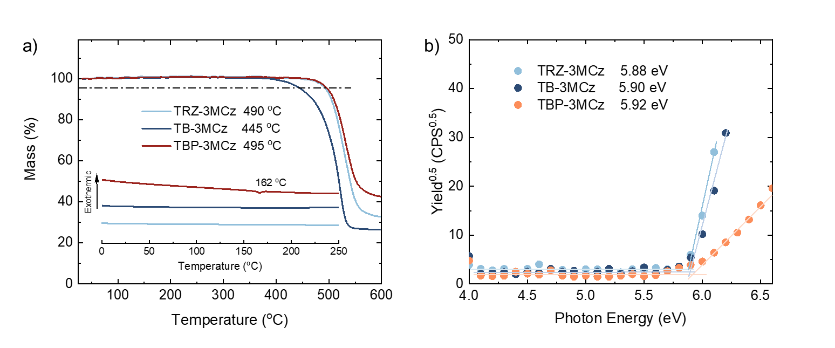
Supplementary Figure 11. a) Thermal properties of TRZ-3MCz, TB-3MCz and TBP-3MCz. b) Photoelectron yield spectra (AC-3) of TRZ-3MCz, TB-3MCz and TBP-3MCz neat films, where the corresponding ionization potential (IP) was defined by the intersection point of two fitting lines.

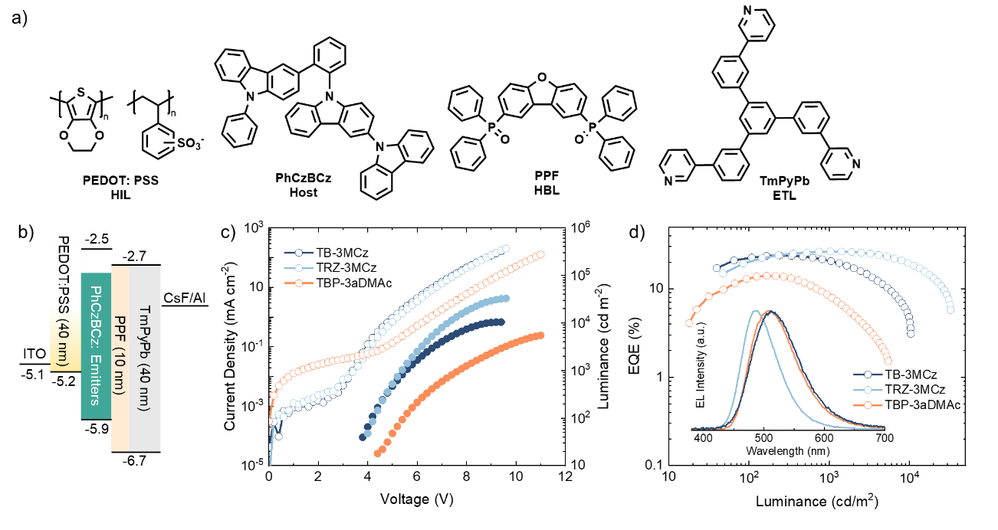

Supplementary Figure 12. OLED performance of the devices incorporating PPF as blocking layer. a) Chemical structures of the materials in OLED devices; b) Device architecture and energy levels of the materials; c) Current-density-voltage-luminance (J-V-L) and d) EQE-luminance curves (insert: EL spectra of the devices driven at the current density of 1 mA cm⁻²) of the TADF OLEDs

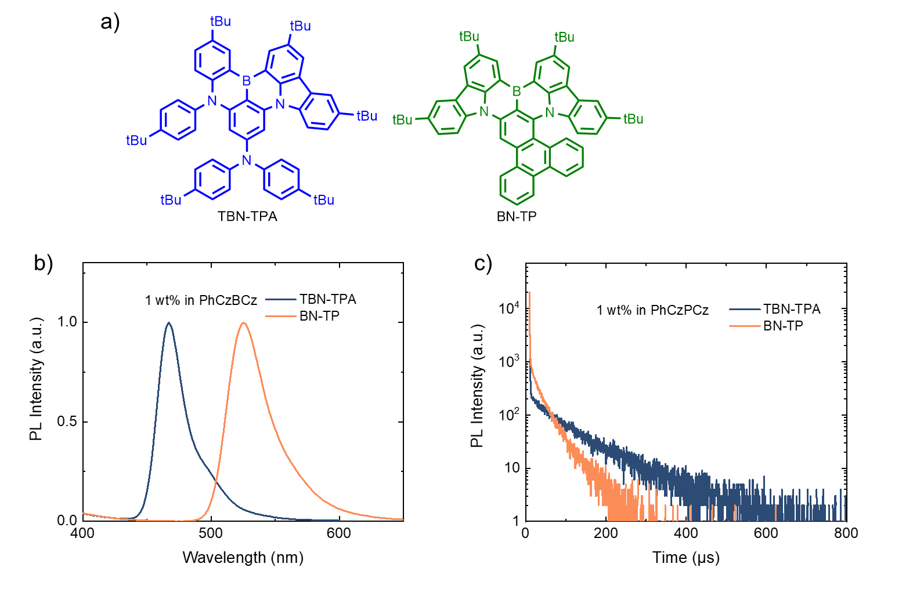
Supplementary Figure 13. Molecular structures, PL spectra and transient PL decay characters of the 1 wt% MR-TADF guest in PhCzBCz host.

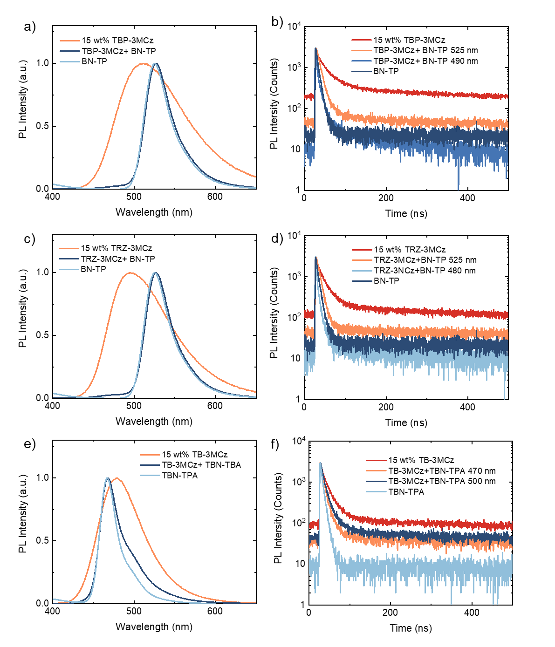
Supplementary Figure 14. Characterization of the energy transfer between TBP-3MCz, TRZ-3MCz and TB-3MCz TADF assistant host and MR-TADF guest, where the significantly shortened fluorescence decay of the TADF assistant host indicates efficient Förster resonance energy transfer from the TADF assistant host to MR-TADF emitter.

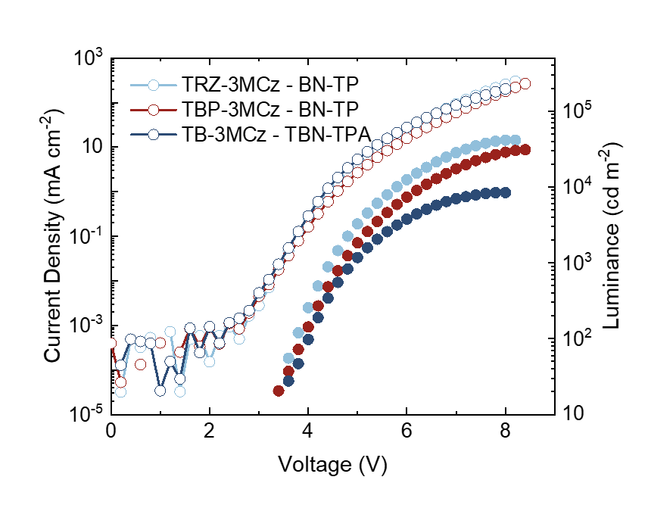
Supplementary Figure 15. J-V-L curves of the sensitized OLED devices.

Supplementary Table 5. Summary of the device performances of the solution-processed OLED devices.
Device | V_{on} | λ_{EL}^{a)} | L_{max} | CE_{max} | EQE (max/@ 1000 cd m⁻²/ @ 3000 cd m⁻²) |  |  | CIE ^{a)}
Device | V | nm | cd m⁻² | cd A⁻¹ | % |  |  | (x, y)
TRZ-3MCz | 3.2 | 505 | 30683 | 67.24 | 24.39 | 23.75 | 21.54 | (0.21, 0.47)
TRZ-3MCz/ PPF | 3.8 | 512 | 32750 | 77.07 | 26.51 | 26.51 | 25.64 | (0.22, 0.48)
TB-3MCz | 3.4 | 487 | 9286 | 48.11 | 19.22 | 14.92 | 11.22 | (0.14, 0.29)
TB-3MCz/ PPF | 3.6 | 486 | 10432 | 52.59 | 23.85 | 20.60 | 14.67 | (0.14, 0.31)
TBP-3MCz | 3.4 | 521 | 19823 | 59.27 | 19.01 | 17.03 | 14.40 | (0.27, 0.54)
TBP-3aDMAc | 4.2 | 507 | 5460 | 43.07 | 14.06 | 7.90 | 3.68 | (0.23, 0.49)
TRZ-3MCz - BN-TP | 3.4 | 525 | 41343 | 96.14 | 24.62 | 23.03 | 19.14 | (0.23, 0.69)
TB-3MCz - TBN-TPA | 3.4 | 468 | 8425 | 34.05 | 20.17 | 15.42 | 9.51 | (0.13, 0.19)
TBP -3MCz - BN-TP | 3.4 | 525 | 30904 | 89.77 | 21.98 | 19.46 | 16.60 | (0.24, 0.68)
- EL spectra at 1 mA cm⁻²

The efficiency roll-off of the sensitized MR-TADF OLED
It is interesting to find that, after the doping of MR-TADF, the efficiency roll-off increases slightly in the TRZ-3MCz-based OLED while that based on TBP-3MCz shows reduced efficiency roll-off compared with the OLED without MR-TADF doping. The former can be attributed to the trapping effect of the MR-TADF guest with shallow HOMO energy leve.⁵ The direct injection and accumulation of the triplet excitons in the BN-TP site with long lifetime would increase the exciton density and exciton quenching processes are more likely to happen. For the TBP-3MCz-based OLED, TBP-3MCz possesses a slow radiative transition rate (0.80×10⁷ s⁻¹) in compared with the ISC process, which can become the “bottleneck” for exciton utilization in OLED. Such a “trad-off” between radiative transition and RISC process makes realizing efficient TADF with ultra-short excited state lifetime challenging. The introduction of MR-TADF can lead to fast Förster energy transfer and radiative transition. And the fast Förster energy transfer process that competes with ISC can reduce the exciton circulation between singlet and triplet states (repeating ISC/RISC process). As a result, the overall excited state lifetime in OLED can be reduced, and both the efficiency and efficiency roll-off of the TBP-3MCz based sensitized device can be improved. Therefore, combining TADF with efficient RISC process and fluorescence guest with fast radiative transition and relieved charge trapping effect can be advantageous for highly efficient roll-off free OLED devices in the future.

Synthesis:
Additional characterization methods
¹H and ¹³C NMR spectra were recorded on a Bruker NMR spectrometer operating at 400 and 150 MHz, respectively. Thermogravimetric analyses (TGA) were performed on Netzsch TG 209 under nitrogen flow at a heating rate of 10 °C min⁻¹. The differential scanning calorimetry analysis was conducted using a NETZSCH (DSC-204) instrument with the rate of increasing temperature at 10 °C min⁻¹ under nitrogen flushing. The HOMO energy levels were obtained from photoelectron yield measurement (AC-3) of the neat films, and the LUMO energy level can be calculated by the on-set of the absorption spectra.

Supplementary Figure 16. Synthetic routes of the investigated compounds.

Synthesis of benzene-1,3,5-triyltris((4-(1,3,6,8-tetramethyl-9H-carbazol-9-yl)phenyl)methanone) (TBP-3MCz): 1,3,6,8-tetramethyl-9H-carbazole (1.41 g, 6.3 mmol) and TBP-Br (1.13 g, 1.5 mmol) were dissolved into 100 mL toluene in a 150 mL three-necked flask. The mixture was degassed for 15 minutes, then acetic acid palladium(II) (Pd(OAc)₂) (50 mg, 0.3 mmol), sodium tert-butoxide (tBuONa) (865 mg, 9 mmol) and tri(tert-butyl) phosphine (P(t-Bu)₃) (0.6 mL, 0.6 mmol) were added in the three-necked flask. And the mixture was degassed for 30 min. The mixture was heated to 110 ºC and continually stirred for 12 h. After removing the solvent in vacuum, the mixture was partitioned between DCM and water. The combined organic layers were washed with brine, dried over anhydrous Mg₂SO₄ and concentrated in vacuo. Column chromatography of the residue solid (eluent: DCM/PE=1/1) afforded 1.2 g yellow solids (Yield: 78%). ¹H NMR (500 MHz, Chloroform-d) δ 8.57 (s, 3H), 8.03 – 7.96 (m, 6H), 7.76 (d, J = 1.8 Hz, 6H), 7.68 – 7.62 (m, 6H), 6.88 (d, J = 1.7 Hz, 6H), 2.49 (s, 18H), 1.88 (s, 18H). ¹³C NMR (126 MHz, CDCl₃) δ 193.66, 147.63, 139.47, 138.20, 136.02, 134.16, 131.70, 130.43, 130.08, 130.01, 129.61, 124.58, 121.04, 121.00, 117.96, 77.27, 77.22, 77.02, 76.76, 21.09, 19.67, 19.63. MALDI-TOF MS: calcd. 1054.4, found 1054.6.

Synthesis of TBP-3aDMAc: Reaction of intermediate 10H-spiro[acridine-9,2'-adamantane] with TBP-Br following the same procedure for synthesis of TBP-3MCz generated the pure TBP-3aDMAc as a yellow power (Yield: 64%). ¹H NMR (500 MHz, Chloroform-d) δ 8.41 (s, 3H), 7.95 – 7.91 (m, 6H), 7.61 – 7.54 (m, 12H), 7.43 – 7.39 (m, 6H), 7.14 – 7.10 (m, 12H), 3.01 (d, J = 12.7 Hz, 6H), 2.93 (q, J = 2.8 Hz, 3H), 2.34 (q, J = 3.0 Hz, 3H), 1.99 – 1.93 (m, 6H), 1.85 (t, J = 3.4 Hz, 6H), 1.74 (d, J = 12.3 Hz, 3H), 1.63 – 1.53 (m, 6H), 1.49 – 1.38 (m, 13H). ¹³C NMR (126 MHz, CDCl₃) δ 193.58, 147.04, 141.79, 141.02, 138.90, 133.02, 132.78, 129.10, 127.15, 125.01, 123.90, 123.39, 116.42, 77.27, 77.22, 77.02, 76.76, 48.45, 37.95, 35.30, 33.94, 33.48, 30.84, 29.33, 27.60. MALDI-TOF MS: calcd. 1288.7, found 1288.6.

Synthesis of 2,4,6-tris(4-(1,3,6,8-tetramethyl-9H-carbazol-9-yl)phenyl)-1,3,5-triazine (TRZ-3MCz): Reaction of intermediate 1,3,6,8-tetramethyl-9H-carbazole with 2,4,6-tris(4-bromophenyl)-1,3,5-triazine following the same procedure for synthesis of TBP-3MCz generated the pure TRZ-3MCz as a yellow power (Yield: 82%). ¹H NMR (500 MHz, Chloroform-d) δ 9.02 – 8.92 (m, 6H), 7.79 (d, J = 1.8 Hz, 6H), 7.76 – 7.70 (m, 6H), 6.96 (d, J = 1.8 Hz, 6H), 2.51 (s, 18H), 1.97 (s, 18H). ¹³C NMR (126 MHz, CDCl₃) δ 171.26, 146.88, 139.27, 136.03, 131.76, 130.32, 129.23, 128.98, 124.32, 121.14, 117.89, 77.27, 77.22, 77.01, 76.76, 21.11, 19.61. MALDI-TOF MS: calcd. 973.3, found 973.7.

Synthesis of tris(2,6-dimethyl-4-(1,3,6,8-tetramethyl-9H-carbazol-9-yl)phenyl)borane (TB-3MCz): Reaction of intermediate 1,3,6,8-tetramethyl-9H-carbazole with tris(4-bromo-2,6-dimethylphenyl)borane following the same procedure for synthesis of TBP-3MCz generated the pure TB-3MCz as a pale yellow power (Yield: 71%). ¹H NMR (500 MHz, Chloroform-d) δ 7.75 (d, J = 1.7 Hz, 6H), 7.18 (s, 6H), 6.93 (d, J = 1.7 Hz, 6H), 2.49 (s, 18H), 2.21 (s, 18H), 2.02 (s, 18H). ¹³C NMR (126 MHz, CDCl₃) δ 146.36, 143.82, 140.81, 139.52, 130.97, 130.15, 128.99, 124.25, 121.27, 117.84, 29.74, 23.10, 21.16, 19.56. MALDI-TOF MS: calcd. 990.2, found 990.7.
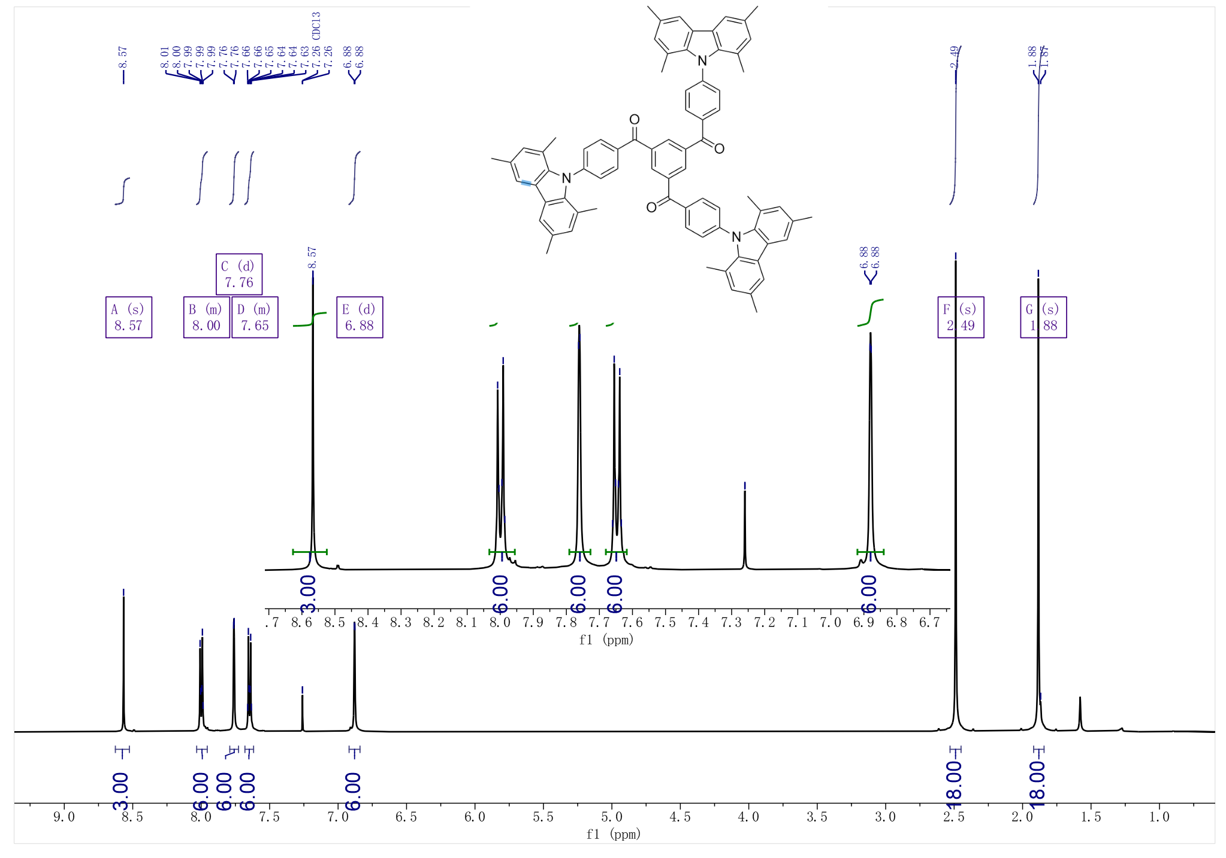
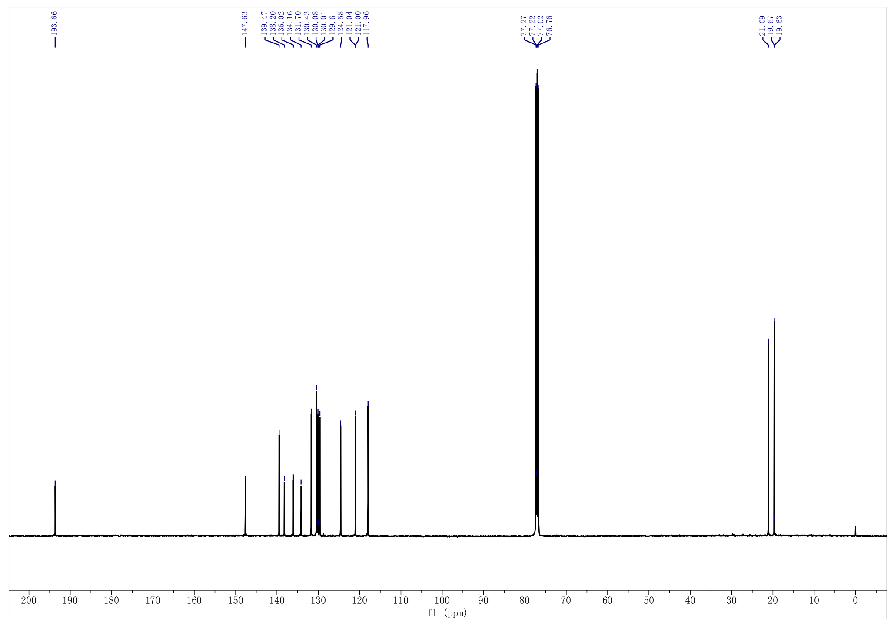
Supplementary Figure 17. ¹H and ¹³C NMR spectra of TBP-3MCz in d-CDCl₃.

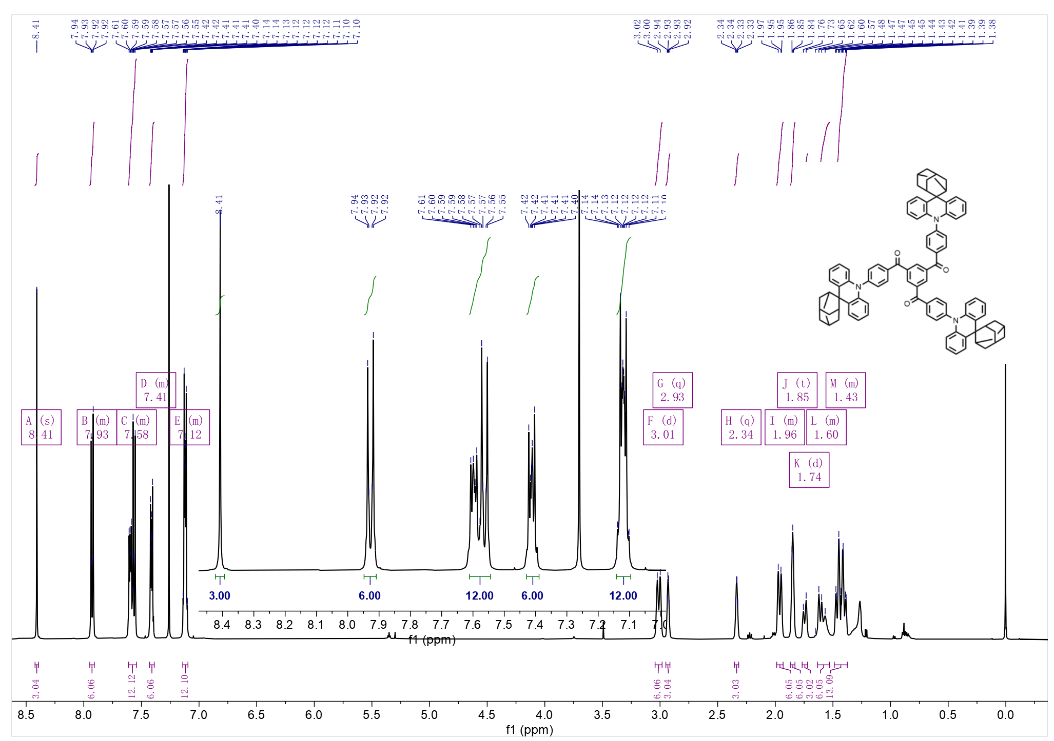
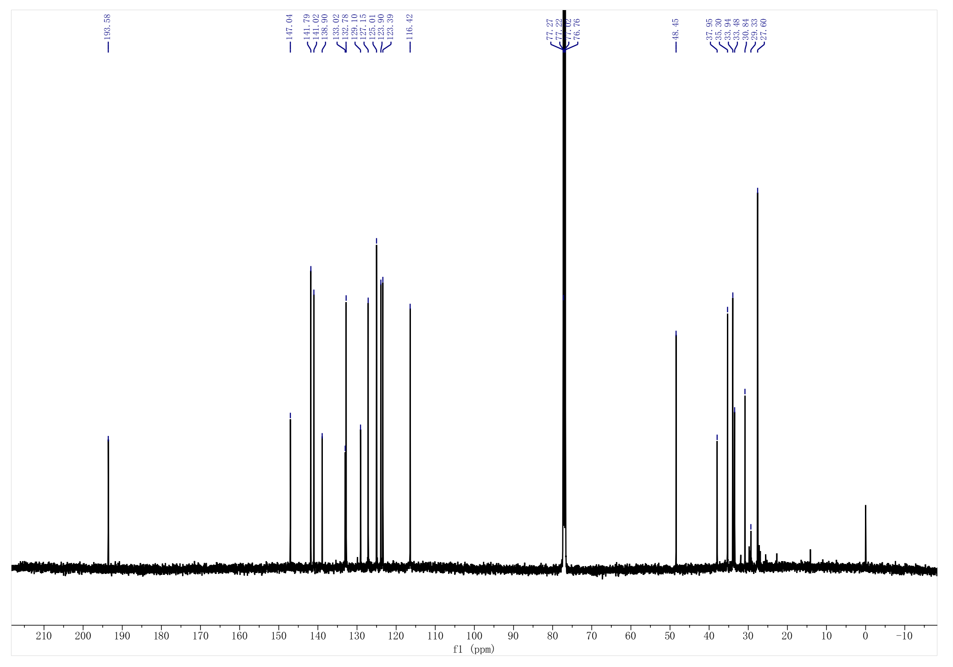
Supplementary Figure 18. ¹H and ¹³C NMR spectra of TBP-3aDMAc in d-CDCl₃.

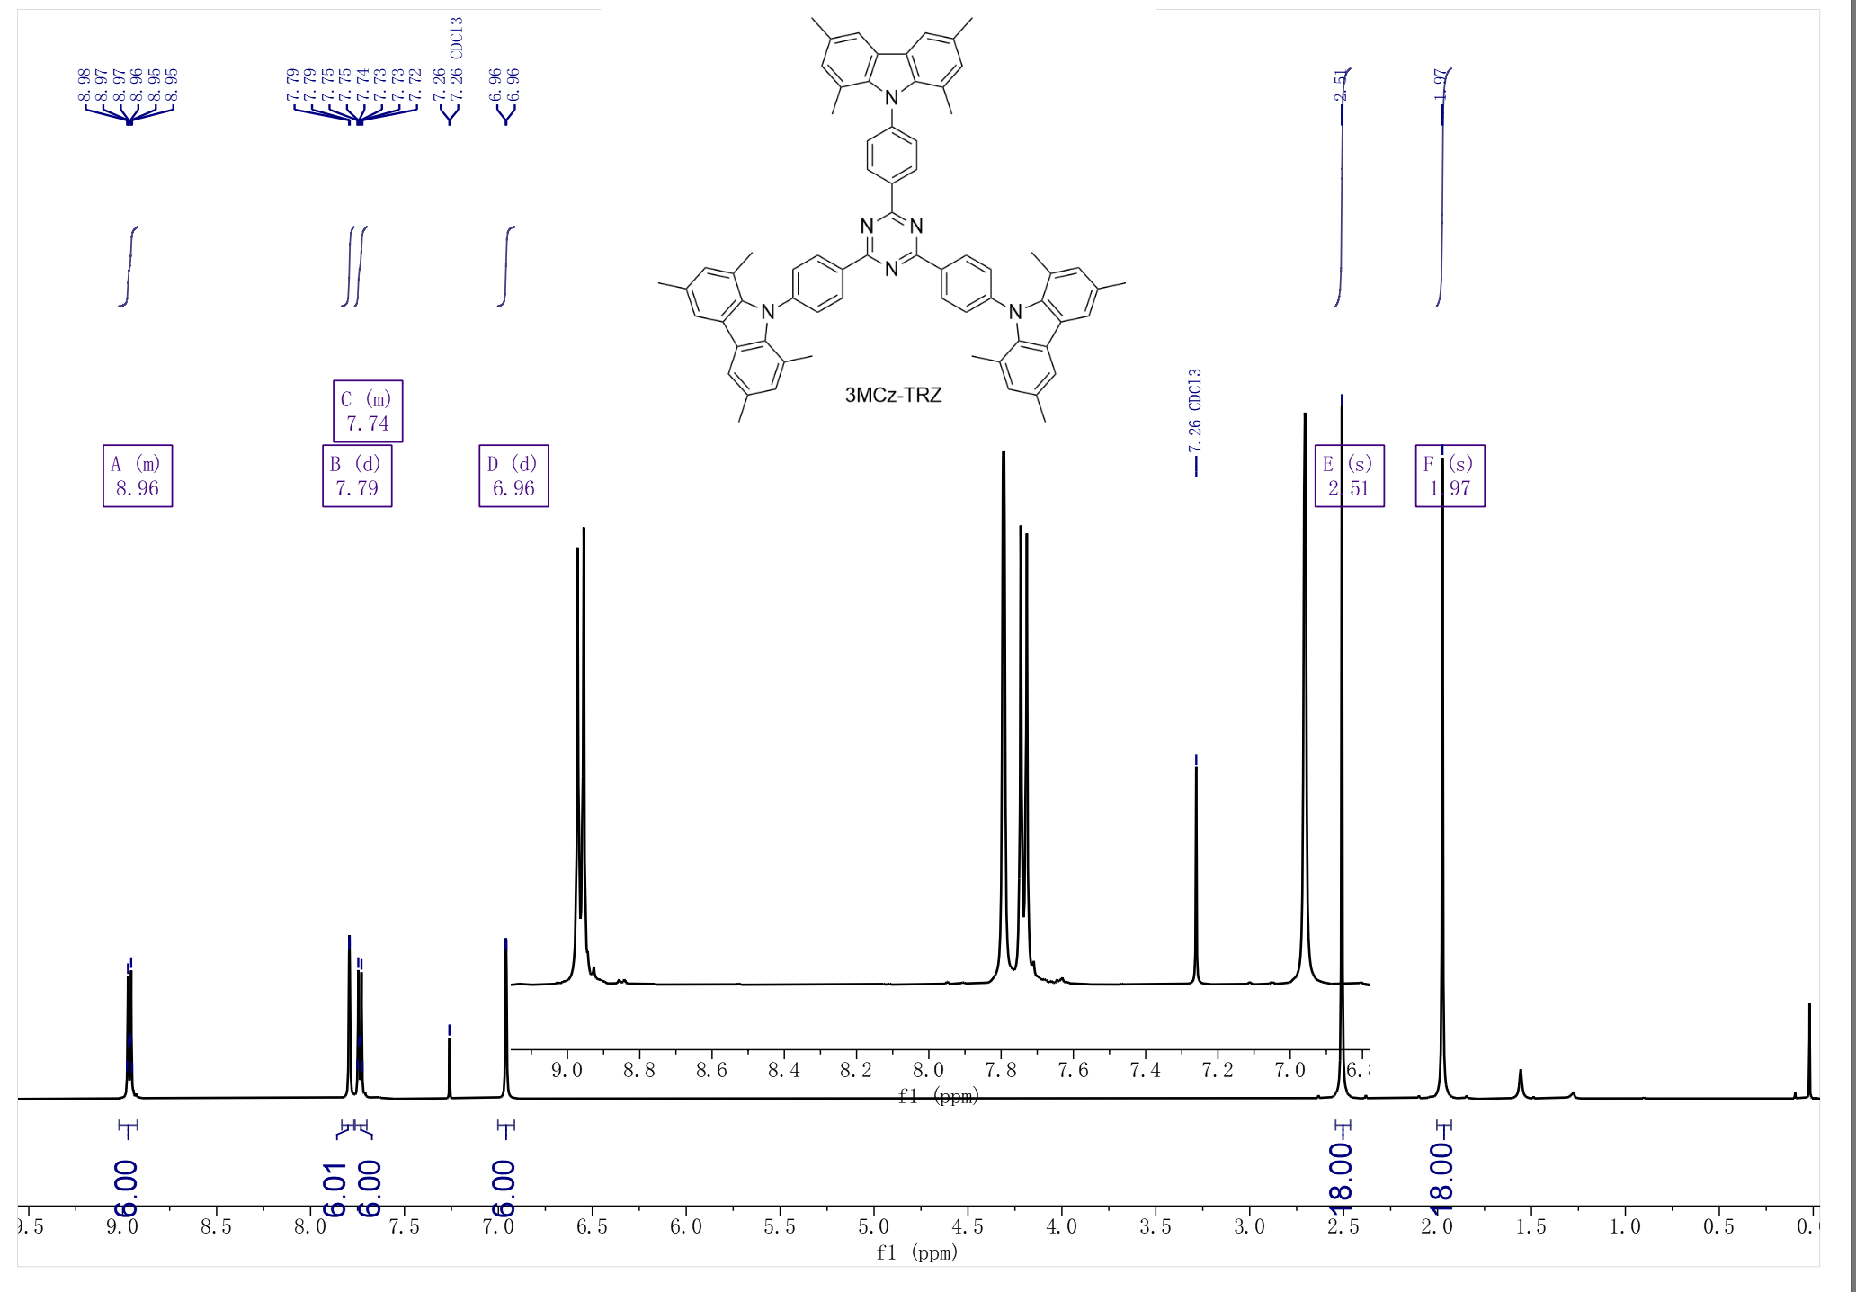
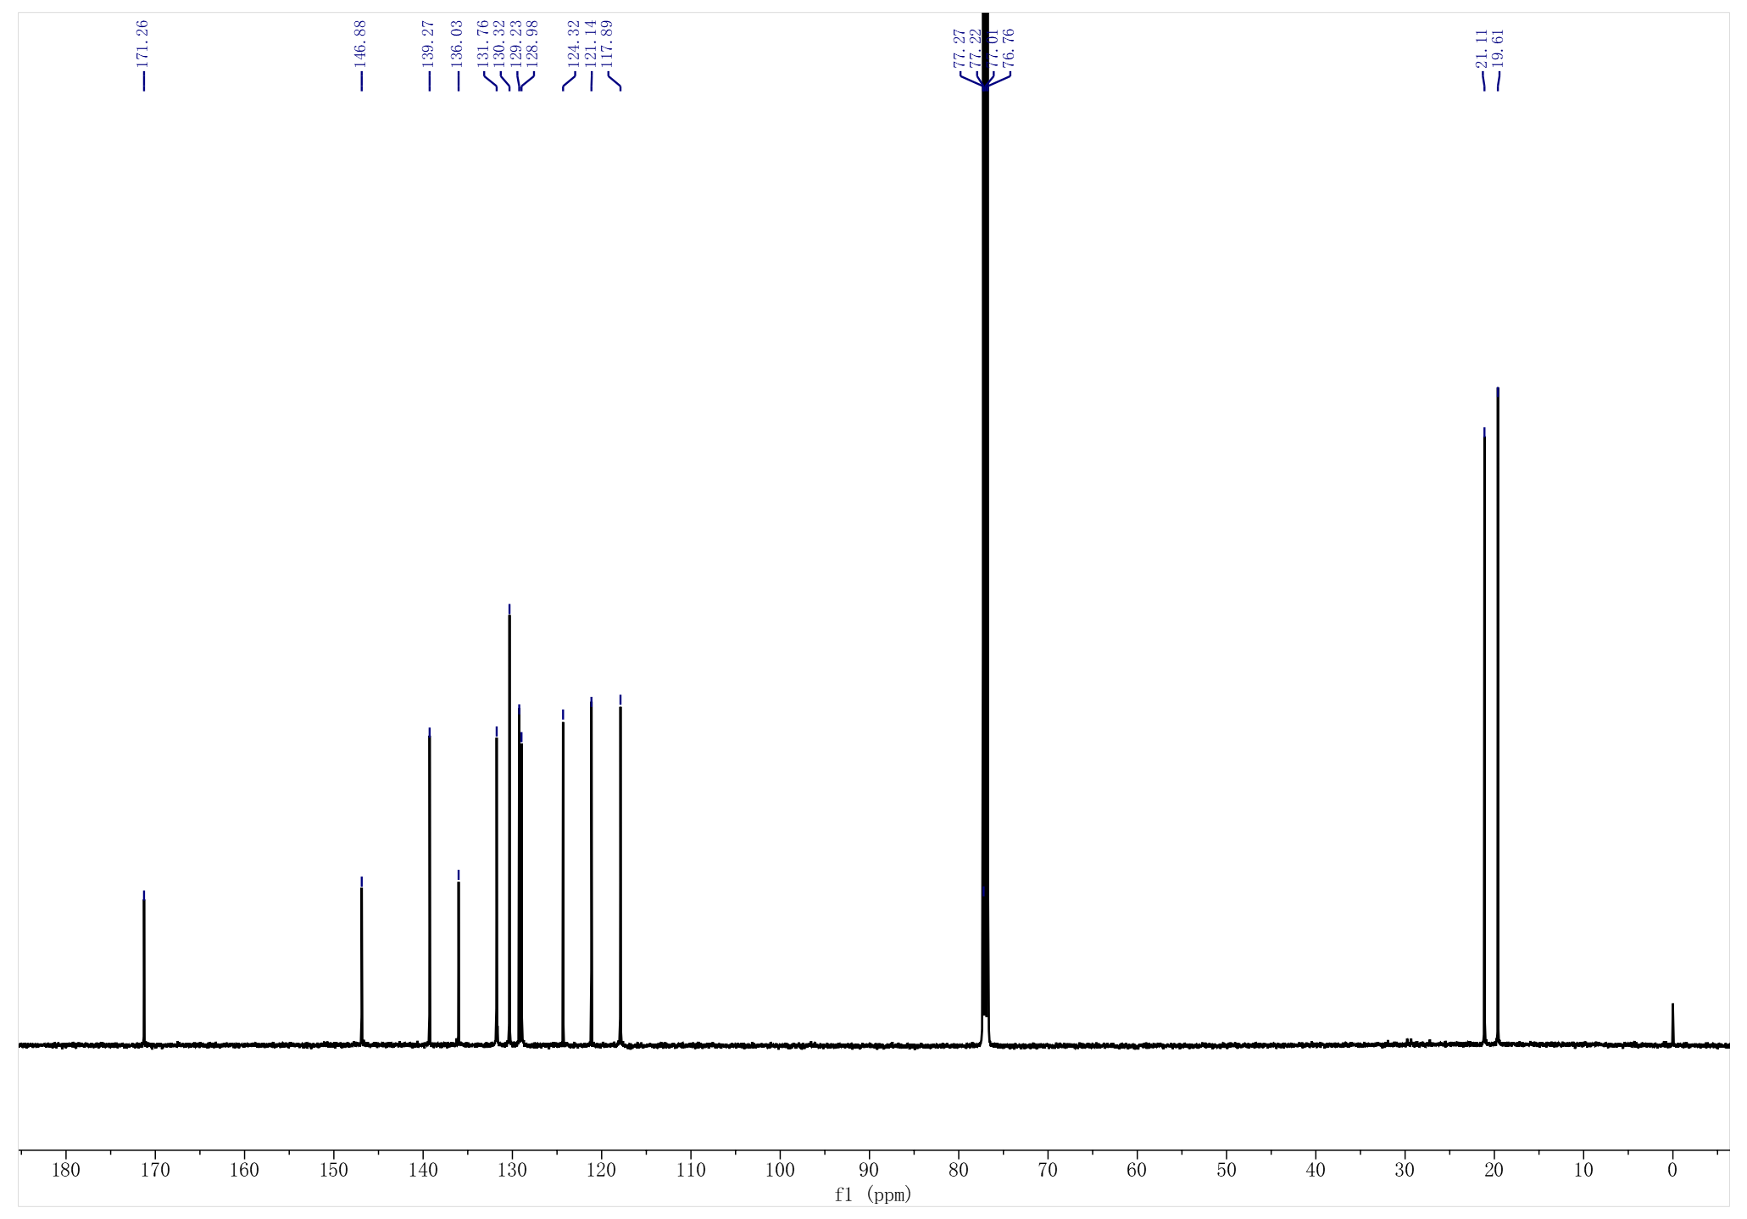
Supplementary Figure 19. ¹H and ¹³C NMR spectra of TRZ-3MCz in d-CDCl₃.

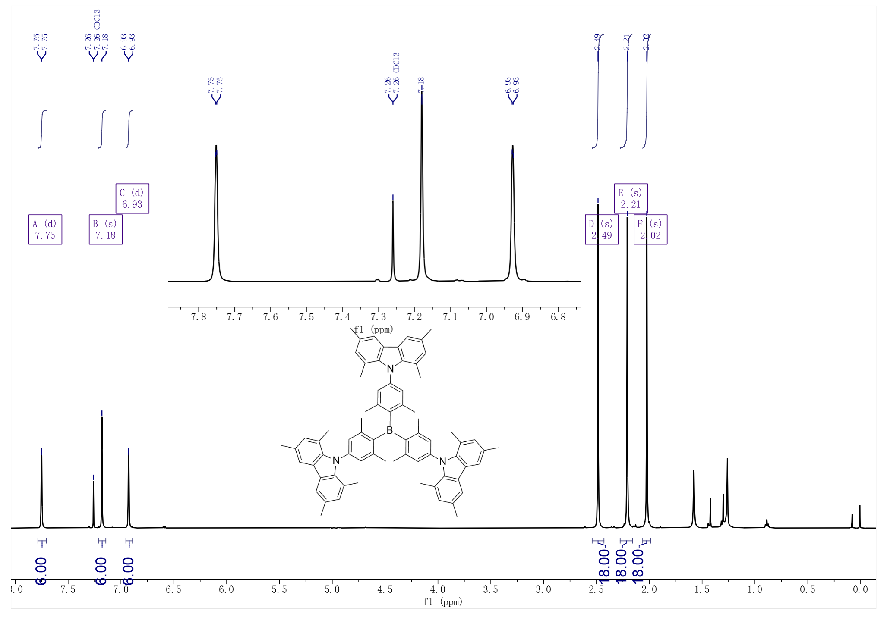
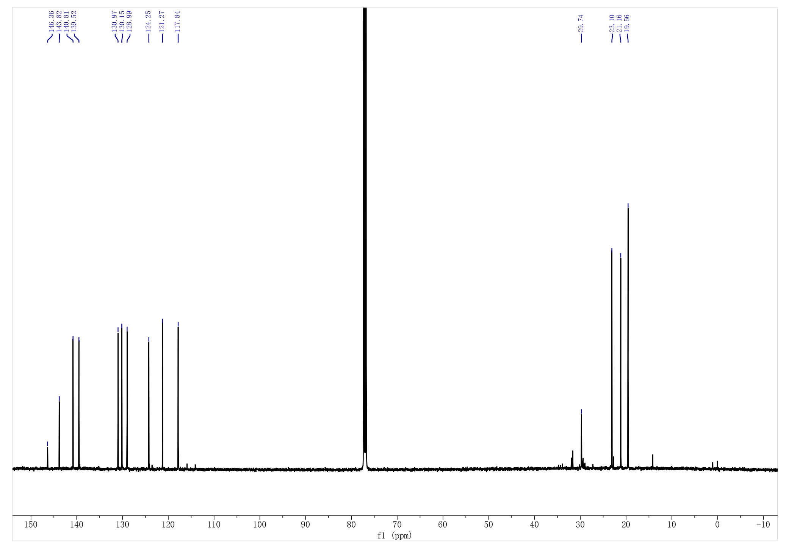
Supplementary Figure 20. ¹H and ¹³C NMR spectra of TB-3MCz in d-CDCl₃.

Reference
1 Okazaki, M. et al. Thermally activated delayed fluorescent phenothiazine-dibenzo[a,j]phenazine-phenothiazine triads exhibiting tricolor-changing mechanochromic luminescence. Chem. Sci. 8, 2677-2686, doi:10.1039/c6sc04863c (2017).
2 de Sa Pereira, D. et al. The effect of a heavy atom on the radiative pathways of an emitter with dual conformation, thermally-activated delayed fluorescence and room temperature phosphorescence. J. Mater. Chem. C 7, 10481-10490, doi:10.1039/C9TC02477H (2019).
3 Li, B. et al. Realizing Efficient Single Organic Molecular White Light-Emitting Diodes from Conformational Isomerization of Quinazoline-Based Emitters. ACS Appl. Mater. Interfaces 12, 14233-14243, doi:10.1021/acsami.9b20162 (2020).
4 He, Z. et al. Reversible switching between normal and thermally activated delayed fluorescence towards “smart” and single compound white-light luminescence via controllable conformational distribution. Sci. China Chem. 61, 677-686, doi:10.1007/s11426-017-9219-x (2018).
5 Kim, E. et al. Highly efficient and stable deep-blue organic light-emitting diode using phosphor-sensitized thermally activated delayed fluorescence. Sci Adv 8, eabq1641, doi:10.1126/sciadv.abq1641 (2022).

