PubMed: 193
(“Breast Neoplasm”[MH] OR “Breast Neoplasm”[TIAB] OR “Breast Tumors”[TIAB] OR “Breast Tumor”[TIAB] OR “Breast Cancer”[TIAB] OR “Mammary Cancer”[TIAB] OR “Mammary Cancers”[TIAB] OR “Malignant Neoplasm of Breast”[TIAB] OR “Breast Malignant Neoplasm”[TIAB] OR “Breast Malignant Neoplasms”[TIAB] OR “Malignant Tumor of Breast”[TIAB] OR “Breast Malignant Tumor”[TIAB] OR “Breast Malignant Tumors”[TIAB] OR “Cancer of Breast”[TIAB] OR “Cancer of the Breast”[TIAB])AND (“Genetic Testing”[MH] OR “Genetic Predictive Testing”[TIAB] OR “Predictive Genetic Testing”[TIAB] OR “Genetic Predisposition Testing”[TIAB] OR “Genetic Screening”[TIAB] OR “Genetic Screenings”[TIAB]) AND (“Patient Acceptance of Health care”[MH] OR “Patient Acceptance of Health care”[TIAB] OR “willingness to pay”[TIAB] OR “willingness-to-pay”[TIAB] OR “stated preference”[TIAB] OR preference*[TIAB] OR interest [TIAB] OR “Contingent valuation method”[TIAB] OR “discrete choice”[TIAB] OR “open ended question”[TIAB] OR “payment card”[TIAB])

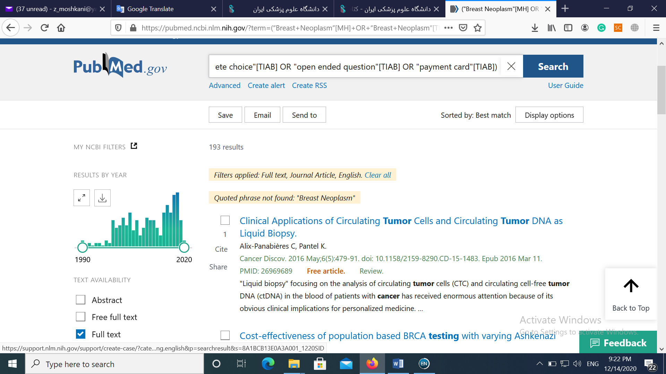

Scopus: 354

TITLE-ABS-KEY(“Breast Neoplasm” OR “Breast Tumors” OR “Breast Tumor” OR “Breast Cancer” OR “Mammary Cancer” OR “Mammary Cancers” OR “Malignant Neoplasm of Breast” OR “Breast Malignant Neoplasm” OR “Breast Malignant Neoplasms” OR “Malignant Tumor of Breast” OR “Breast Malignant Tumor” OR “Breast Malignant Tumors” OR “Cancer of Breast” OR “Cancer of the Breast”)AND TITLE-ABS-KEY(“Genetic Testing” OR “Genetic Predictive Testing” OR “Predictive Genetic Testing” OR “Genetic Predisposition Testing” OR “Genetic Screening” OR “Genetic Screenings”) AND TITLE-ABS-KEY(“Patient Acceptance of Health care” OR “willingness to pay” OR “stated preference” OR preference* OR interest OR “Contingent valuation method” OR “discrete choice” OR “open-ended question” OR “payment card”)

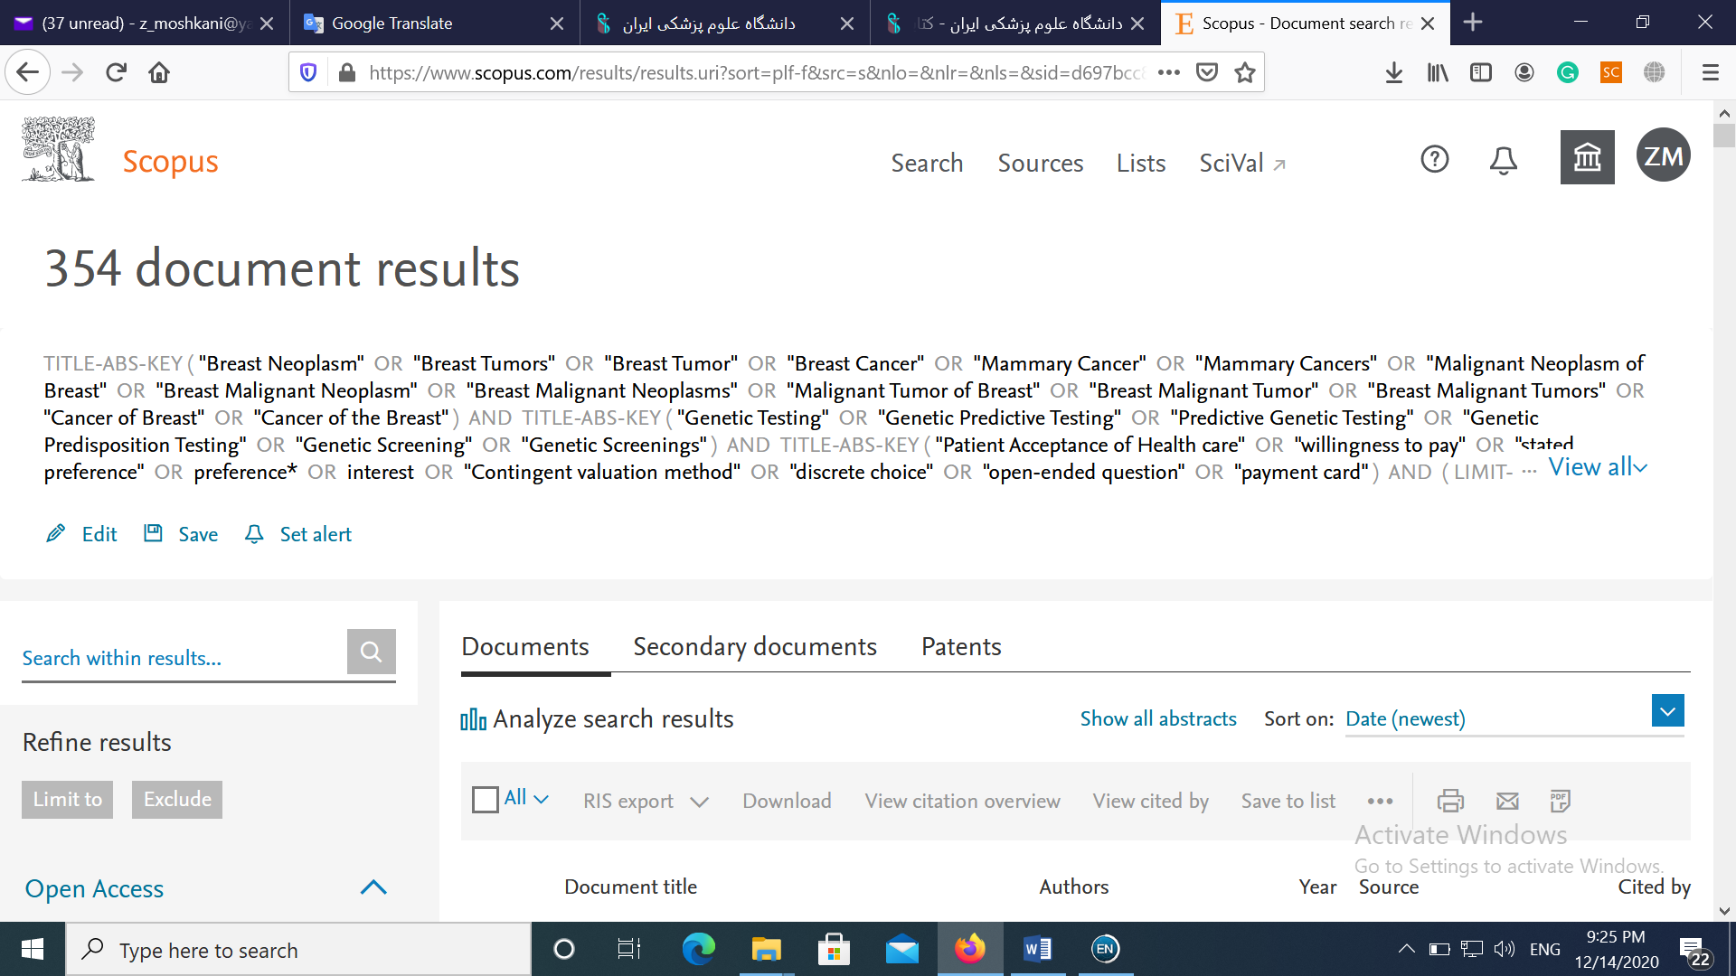

WOS: 214
(“Breast Neoplasm” OR “Breast Neoplasm” OR “Breast Tumors” OR “Breast Tumor” OR “Breast Cancer” OR “Mammary Cancer” OR “Mammary Cancers” OR “Malignant Neoplasm of Breast” OR “Breast Malignant Neoplasm” OR “Breast Malignant Neoplasms” OR “Malignant Tumor of Breast” OR “Breast Malignant Tumor” OR “Breast Malignant Tumors” OR “Cancer of Breast” OR “Cancer of the Breast”) AND (“Genetic Testing” OR “Genetic Predictive Testing” OR “Predictive Genetic Testing” OR “Genetic Predisposition Testing” OR “Genetic Screening” OR “Genetic Screenings”) AND (“Patient Acceptance of Health care” OR “willingness to pay” OR “stated preference” OR preference* OR interest OR “Contingent valuation method” OR “discrete choice” OR “open ended question” OR “payment card”)

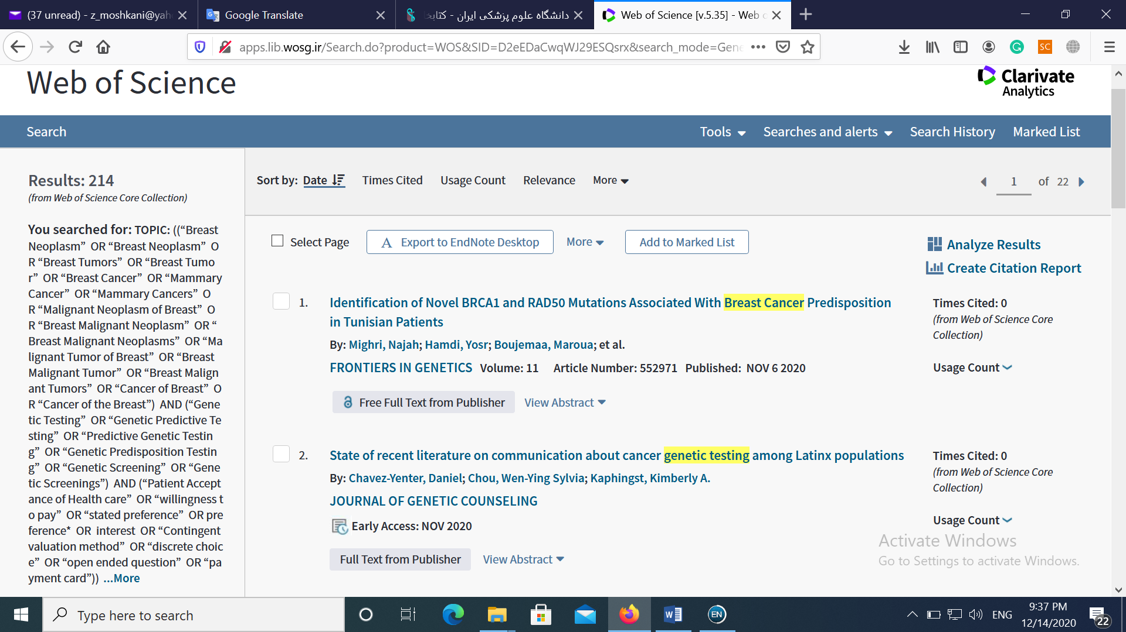

EMBASE:428
(‘Breast Cancer’ OR ‘Breast Cancer’ OR ‘Breast Neoplasm’ OR ‘Breast Neoplasm’ OR ‘Breast Tumors’ OR ‘Breast Tumor’ OR ‘Mammary Cancer’ OR ‘Mammary Cancers’ OR ‘Malignant Neoplasm of Breast’ OR ‘Breast Malignant Neoplasm’ OR ‘Breast Malignant Neoplasms’ OR ‘Malignant Tumor of Breast’ OR ‘Breast Malignant Tumor’ OR ‘Breast Malignant Tumors’ OR ‘Cancer of Breast’ OR ‘Cancer of the Breast’) AND (‘Genetic Testing’ OR ‘Genetic Predictive Testing’ OR ‘Predictive Genetic Testing’ OR ‘Genetic Predisposition Testing’ OR ‘Genetic Screening’ OR ‘Genetic Screenings’) AND (‘willingness to pay’ OR ‘Patient Acceptance of Health care’ OR ‘stated preference’ OR preference* OR interest OR ‘Contingent valuation method’ OR ‘discrete choice’ OR ‘open ended question’ OR ‘payment card’)

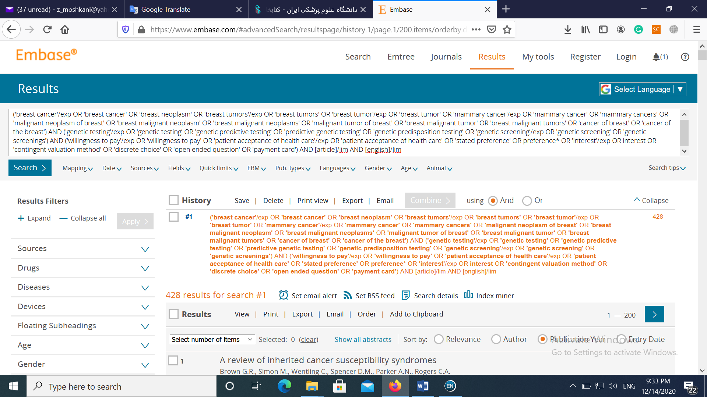
ProQuest: 68
AB, TI (“Breast Neoplasm” OR “Breast Neoplasm” OR “Breast Tumors” OR “Breast Tumor” OR “Breast Cancer” OR “Mammary Cancer” OR “Mammary Cancers” OR “Malignant Neoplasm of Breast” OR “Breast Malignant Neoplasm” OR “Breast Malignant Neoplasms” OR “Malignant Tumor of Breast” OR “Breast Malignant Tumor” OR “Breast Malignant Tumors” OR “Cancer of Breast” OR “Cancer of the Breast”) AND TI,AB (“Genetic Testing” OR “Genetic Predictive Testing” OR “Predictive Genetic Testing” OR “Genetic Predisposition Testing” OR “Genetic Screening” OR “Genetic Screenings”) AND TI,AB (“Patient Acceptance of Health care” OR “willingness to pay” OR “willingness-to-pay” OR “willing-to-pay” OR “stated preference” OR preference* OR interest OR “Contingent valuation method” OR “discrete choice” OR “open ended question” OR “payment card”)
