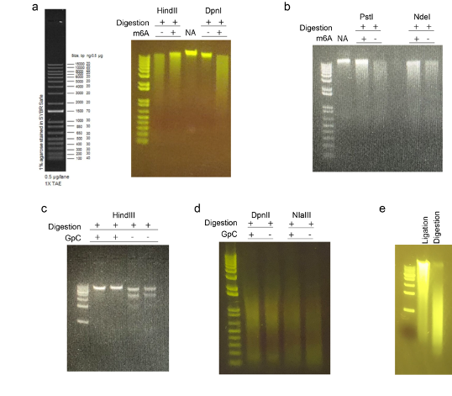
Sfig1. Selecting the compatible restriction enzymes. In the SCA-seq, we used methyltransferase (EcoGII or M.CviPI) to label the accessible chromatin. Then we used the restriction enzyme to digest the genome and prepare for the next step ligation. The EcoGII methyltransferase transferred the methyl group to the 6’ carbon in adenosine (m6A modification). Due to the high density of the adenosines in the genome (~25%), the abundant artificial m6A may impair the restriction enzymes. We used the EcoGII to treat the HEK293T genomic DNAs (m6A +), and leave the control (m6a -) untreated. We tested HindIII (a) PstI and NdeI (b) on the methylated and unmethylated genomic DNAs, and all these restriction enzymes were inhibited by the abundant m6A modifications. DpnI is the m6A-dependent restriction enzymes and only digested the genomic locus with m6A modification (a DpnI). NA was the genomic DNA control. By the similar process, we tested the HindIII (c for lambda DNA), DpnII, and NIaIII (d for HEK293T genomic DNAs) on the GpC methylated DNAs, which were treated by methyltransferase M.CviPI. DpnII and NIaIII were not significantly inhibited by GpC methylation. In the next step, we examined if the digested products could be ligated by T4 DNA ligase (e).

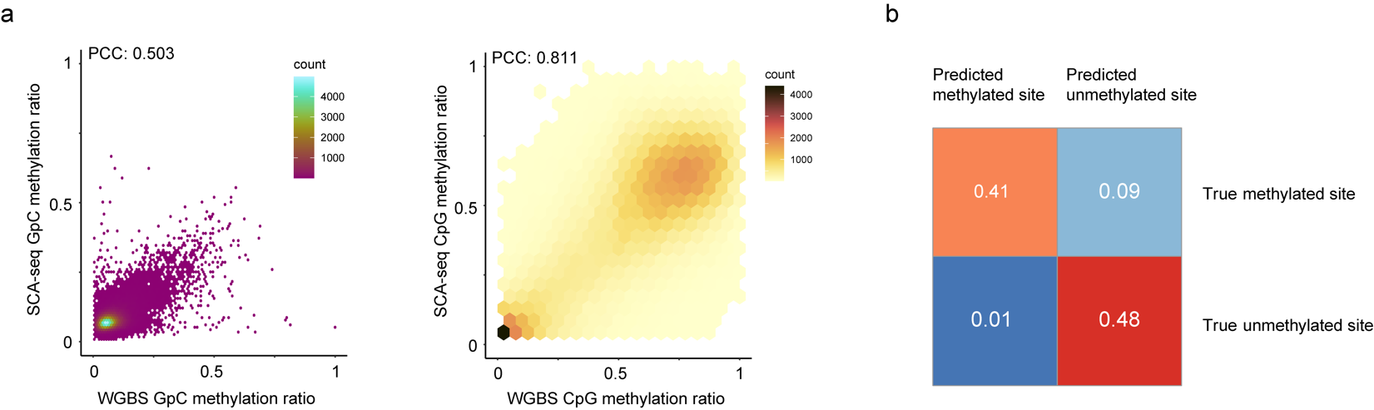
Sfig2. The feasibility of the methylation calling. (a) The similarity between the gold standard WGBS GpC methylation calls and SCA-seq GpC methylation calls. The methylation ratios in 200bp bins of SCA-seq were scatter plotted with WGBS methylation ratio (Pearson correlation, p<2.6*10⁻¹⁶). A similar plot of the CpG methylation ratio was on the side(Pearson correlation, p<2.6*10⁻¹⁶). (b) Confusion matrix of GpC methylation calling. Subsets of 100,000 sites in unmethylated pore-C hek293T samples and methylated lambda DNA samples were methylation called by default threshold of nanopolish cpggpc model. The results are classified into four categories; specifically, false positive and true negative from unmethylated pore-C run and true positive and false negative from GpC labeled lambda DNA sample.

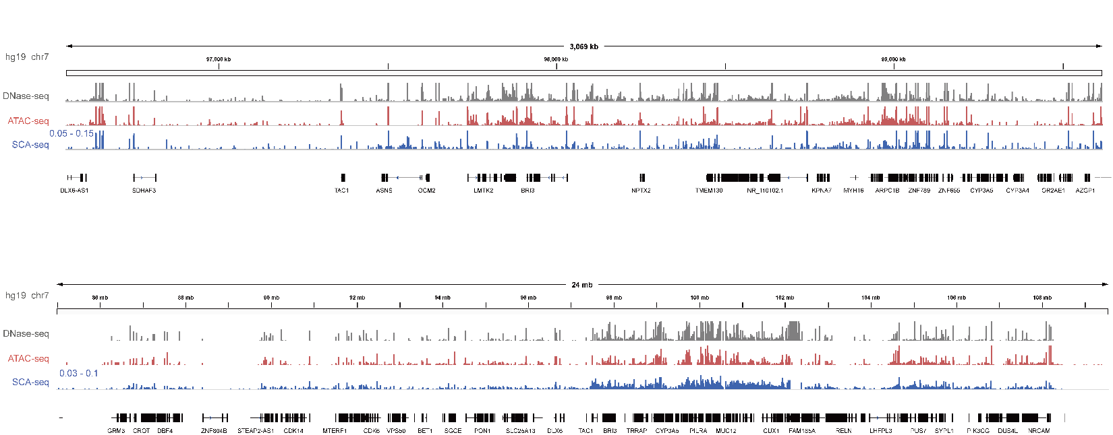
Sfig3. The chromatin accessibility in various resolutions. The panels showed the raw data of DNase-seq, ATAC-seq, and SCA-seq in the genome browser. DNase-seq and ATAC-seq showed the read counts in each genomic locus, and the SCA-seq showed the methylation site counts in each genomic locus.
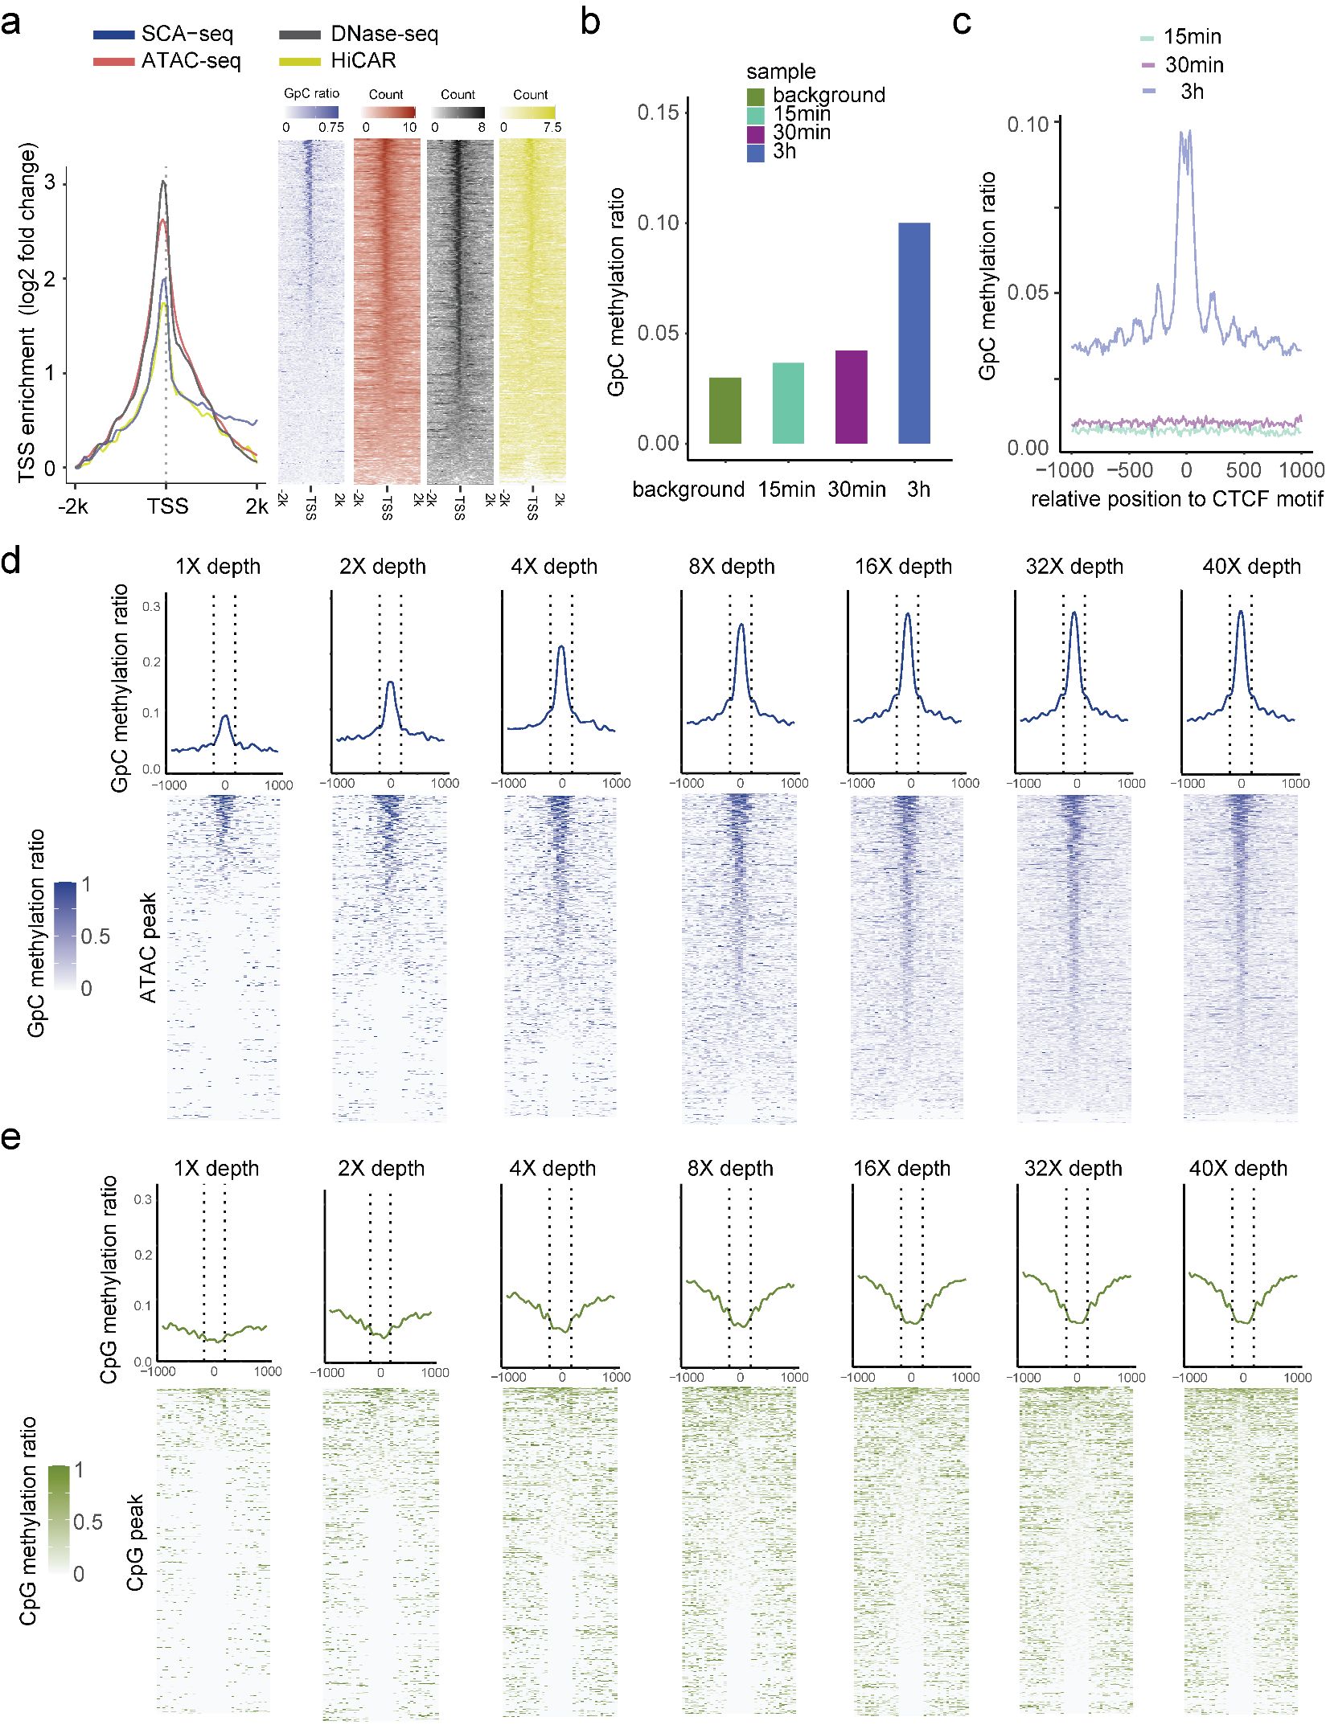
Sfig4. The labeling efficiency and signal strength in treatment dose and sequencing depth. (a) TSS-centered plot. We plotted the enrichment score (Y-axis) of different methods around TSSs (0 on the X-axis), which have a significant nucleosome depletion pattern. The enrichment score= log2(signal in each bin/lowest signal in scale). (b) We tested three different labeling times (15 min 2 times added enzyme, 30 min 2 times added enzyme, 3 hours 3 times added enzyme). As our observation, the 3h treatment showed the highest GpC labeling efficiency, and the labeled GpC signal accurately showed the CTCF motif nucleosome pattern (c). The 3 hours of treatments were also similar to the nanoNOME-seq tissue sample preparation ¹. (d-e) The ATAC-seq peaks were identified first, and the methylation ratios of SCA-seq were plotted around the identified peaks (center to 0) with different sequencing depths. The line panels showed a single molecular resolution.
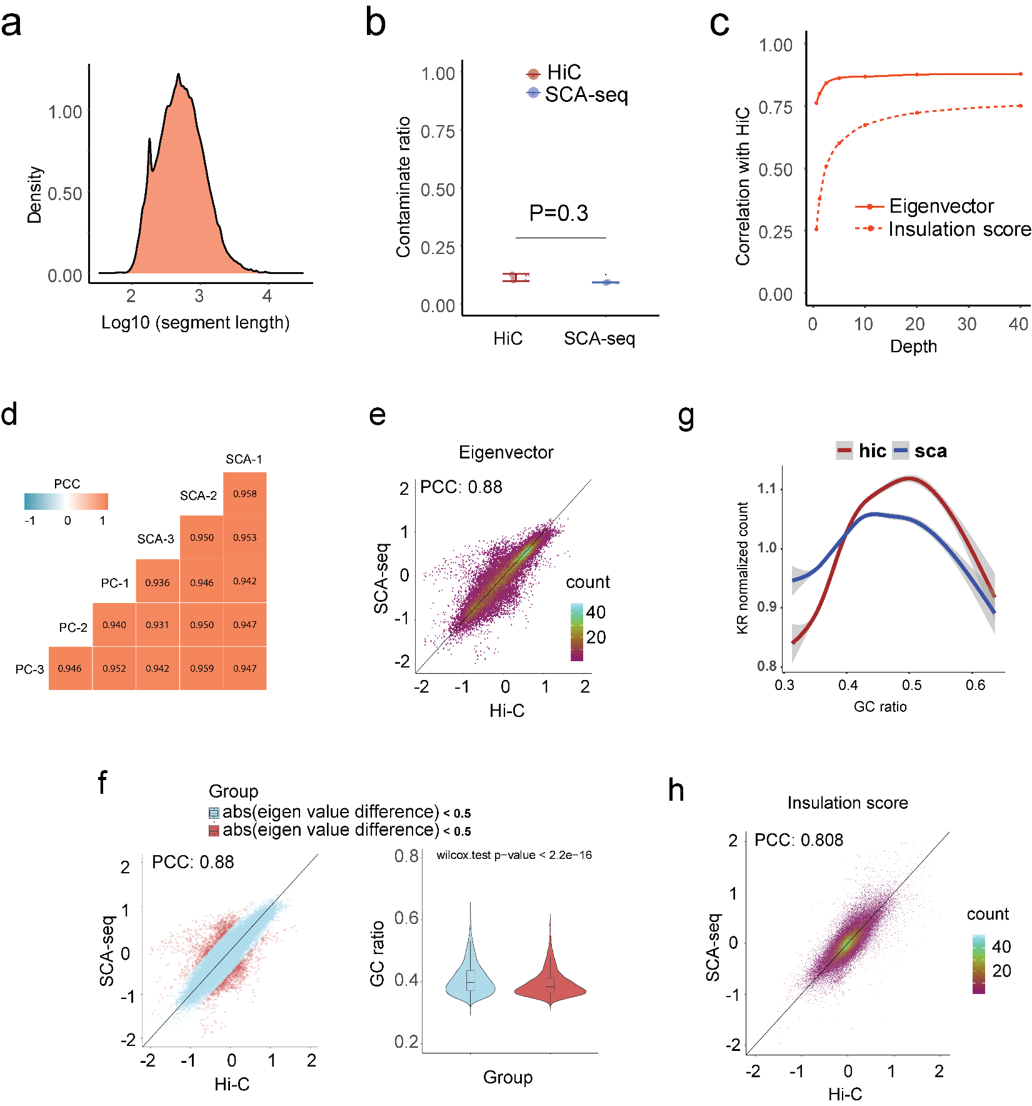
Sfig5. The quality statics of SCA-seq for resolving the genome structure. (a) The medium length of segments in concatemers was around 700bp. (b) We further calculated the false positive contacts caused by the ligations (contamination). We used the contacts between the mitochondrial genome and nucleic genome/total contacts to calculate the contaminations. There was 9% contamination in SCA-seq, compared with the Hi-C 12% contamination. (c) We then subsampled the reads to test the sequencing threshold to calculate the eigenvector (AB compartment) and insulation score (TAD). We need over 5 million and 30 million reads to accurately produce the Hi-C similar results in the AB compartment and TAD. (d) We then tested the correlation (0.93~0.94) between SCA-seq replicates, and pore-C replicates ². SCA-seq demonstrated good consistency between samples. (e) The global eigenvalue correlation (without quality control) between SCA-seq and Hi-C was 0.88. (f) The compartment correlations with bias were far from the diagonal line and colored red. The bias regions showed a significantly lower GC ratio than the unbiased region in the violin plot. (g) The GC ratio distribution in SCA-seq and Hi-C. (h) The global insulation score (without quality control) correlation between SCA-seq and Hi-C was 0.808.
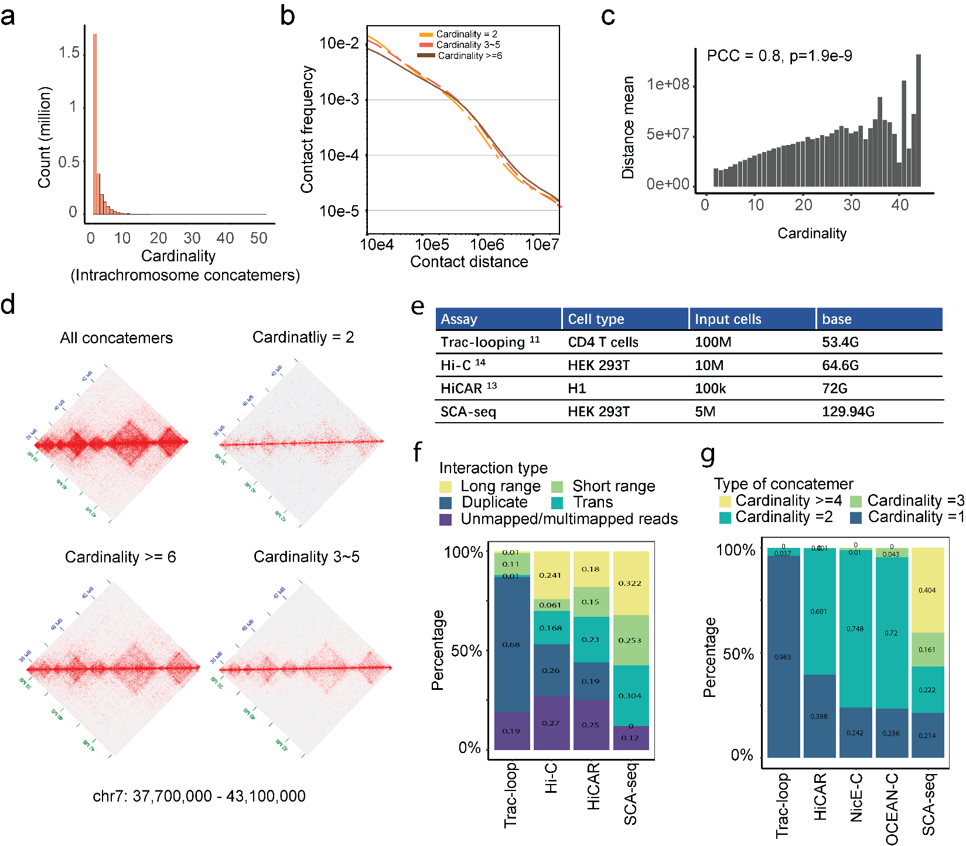
Sfig6. The high-order contacts resolved the long-distance genome interaction. (a) Intra-chromosome contacts on chr7. 65% of concatemers contain one segment without any genome contacts. 14.7% of concatemers contain two segments, and 14.5% contain 3-5 segments. 5.4% of concatemers have >= six segments. (b) We plotted the contact frequency with the contact distance in different concatemer cardinality. The high-cardinality concatemers have more distant contacts than the low-cardinality concatemers. (c) The maximum contact distance in each concatemer also positively correlated with the concatemer cardinality. (d) We converted the concatemers with different cardinality to pair-wise contact maps. The high-cardinality concatemers tend to maintain the TAD structures and indicate long-distance interaction. (e) The data, cell type, and cell number of each method. (f) The interaction distance >= 20kb was classified as long-range interaction. The interaction distance <20kb was classified as short-range interaction. The duplicates were the duplicated reads. Trans indicated the interaction across chromosomes. (g) The cardinality represented the segment number in one read, suggesting the higher-cardinality interaction. (h) The reads with 2 promoter/enhancers and >2 promoter/enhancers were transformed to the pair-wise interaction in chr7:25800000~26400000. The resolution of each bin is 25kb. The average accessible chromatin ratio (accessible/inaccessible segments in concatemers), GpC ratio, and CpG ratio were plotted to a 2D interaction map. (i) We plotted the contact frequency with the contact distance in different promoter/enhancer cardinality. The high-cardinality promoter/enhancers have more distant contacts than the low-cardinality concatemers.

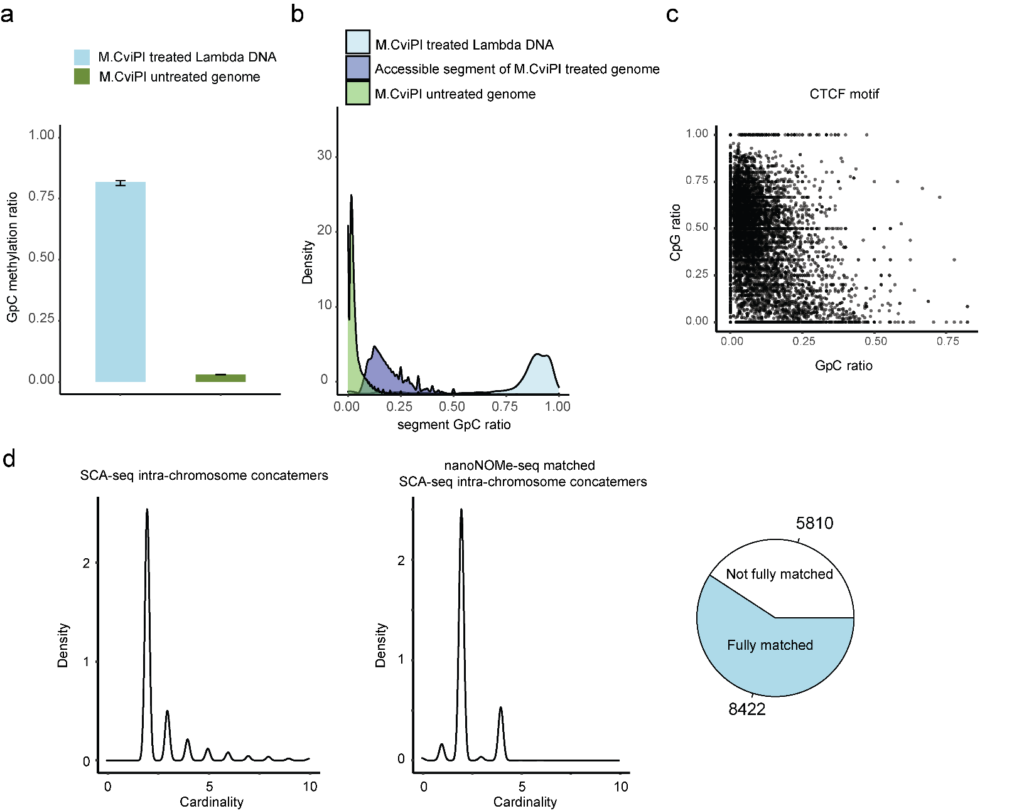
Sfig7. The GpC labeling efficiency in vitro and in vivo. We used the lambda DNA as the spike-in DNA control to monitor the M.CviPI efficiency. The genomic DNAs without labeling were used as the background control to calculate the background level of GpC. The labeled genomic DNAs were processed as SCA-seq. We plotted the density plot of GpC ratios in each segment (methylated GpC/total GpC in each segment) for background genomic DNA, treated genomic DNA, and spike-in control. The background level of the GpC ratio in each segment was around 0.018 (a,b). The spike-in lambda DNA showed that the M.CviPI labeling efficiency is around 0.88 in vitro (a,b). We then selected the CTCF motifs as the in vivo control to calculate the in vivo labeling efficiency(c). We plotted the CpG methylation ratio (methylated CpG/total CpG) with the GpC methylation ratio in CTCF motifs. Previous publications showed the pre-existing methylation can antagonize CTCF binding in CTCF motifs ³⁻⁵. Therefore, we could assume that the CTCF motifs with low methylation (CpG methylation<0.25) maintained as the accessible chromatins with the CTCF binding. Then the CTCF motif labeling efficiency was calculated as NCpGmethylation<0.25&GpCmethylation>0.07/N_{GpCmethylation<0.25}=0.79. However, the highly methylated CTCF motifs might also bind the CTCF to maintain the accessible chromatin. Therefore, the in vivo labeling efficiency only could be roughly estimated. We then used the nanoNOME-seq to cross validate the labeling efficiency of SCA-seq (d). Both nanoNOME-seq and SCA-seq were single molecular assays. nanoNOME-seq could observe the chromatin accessibility in 2~20kb single DNA molecule. Literately, the accessibility of concatemers in SCA-seq could find the dedicated DNAs in nanoNOME-seq with the same accessibility on corresponding genome loci. The left panel (d) showed the number of segments in the SCA-seq concatemers. 68% of labeled concatemers could find the dedicated DNAs in nanoNOME-seq (d right panel). The most matched concatemers contained only two segments, representing the short distance interaction. The concatemers with multiple segments, representing the long-distance interaction, may be out of the detection range with nanoNOME-seq.

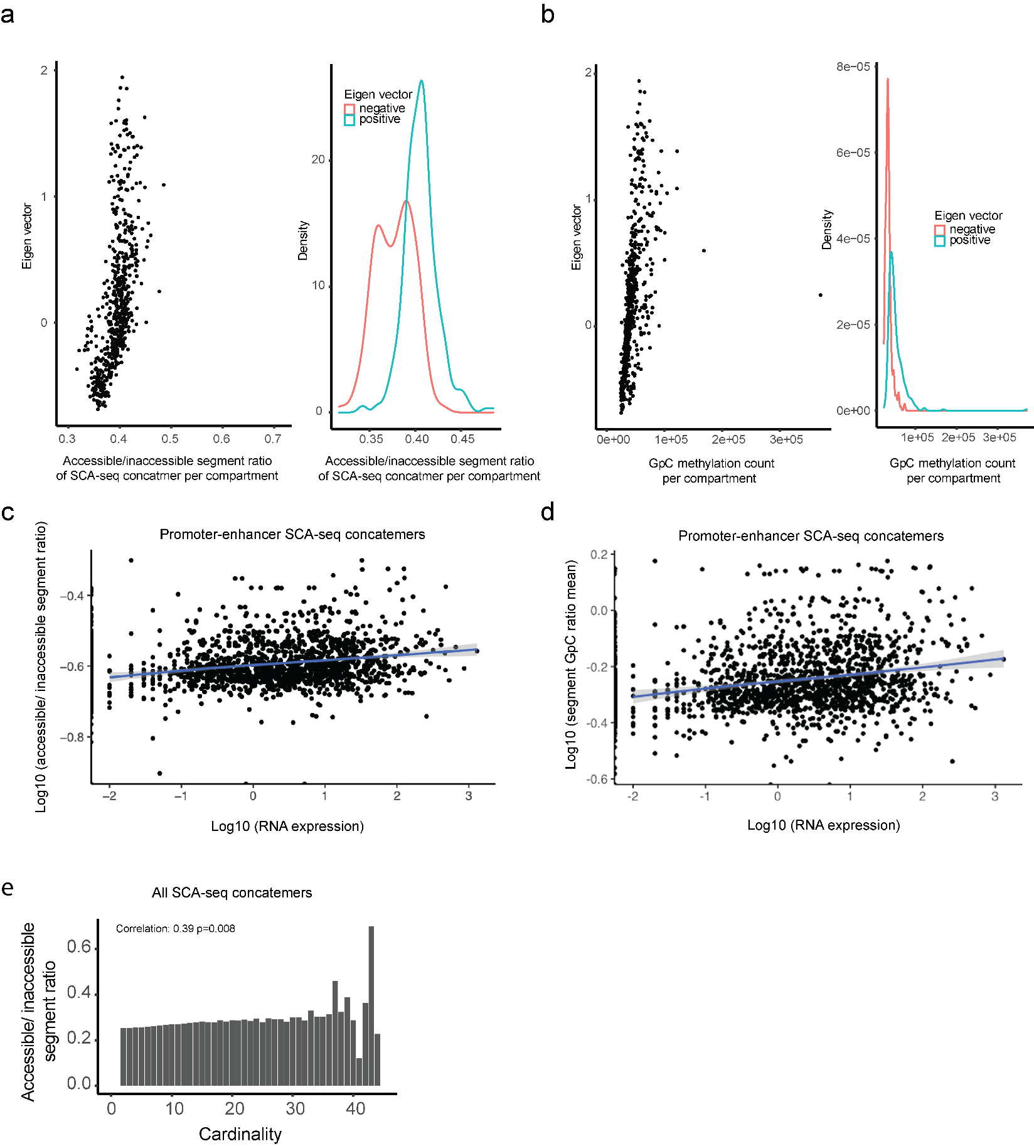

Sfig8. The correlation between compartmental eigenvalue, RNA expression, and spatial accessibility. (a)We plotted the compartmental eigenvalues with the average concatemer accessible/inaccessible ratio in the compartments. The average concatemer accessible/inaccessible ratio is higher correlated with the compartmental eigenvalue (Pearson correlation p<2.6e-16). The average concatemer accessible/inaccessible ratio was significantly higher in the A compartments (positive eigenvalue) than in the B compartments (negative eigenvalue) (p<2.6e-16, student t-test). (b)In a similar way, we plotted the compartmental eigenvalues with the labeled GpC methylations. The labeled GpC methylations were highly correlated with the compartmental eigenvalue (Pearson correlation p<2.6e-16). The labeled GpC methylations were significantly more abundant in the A compartments (positive eigenvalue) than in the B compartments (negative eigenvalue) ( p<2.6e-16, student t-test). (c) For enhancer/promoter accessibility contacts in Fig4d, we summarized the mean contactable accessibility on the promoters/enhancers (inaccessible/inaccessible 0, inaccessible/accessible 1, accessible/accessible 2). The mean contactable accessibilities on promoters were highly correlated with their gene expression (Pearson correlation p<2.6e-16). (d)Similarly, we summarized the mean GpC methylation ratio on the concatemers with the promoters/enhancer’s regions. Then average concatemer GpC methylation ratios on promoters/enhancers were significantly correlated with gene expression (Pearson correlation p<2.6e-16). (e) The accessible/inaccessible ratios of concatemers were positively correlated with the cardinality (Pearson correlation p=0.0008). In the Sfig6bc, we found the high order concatemers indicated the long-distance interactions.

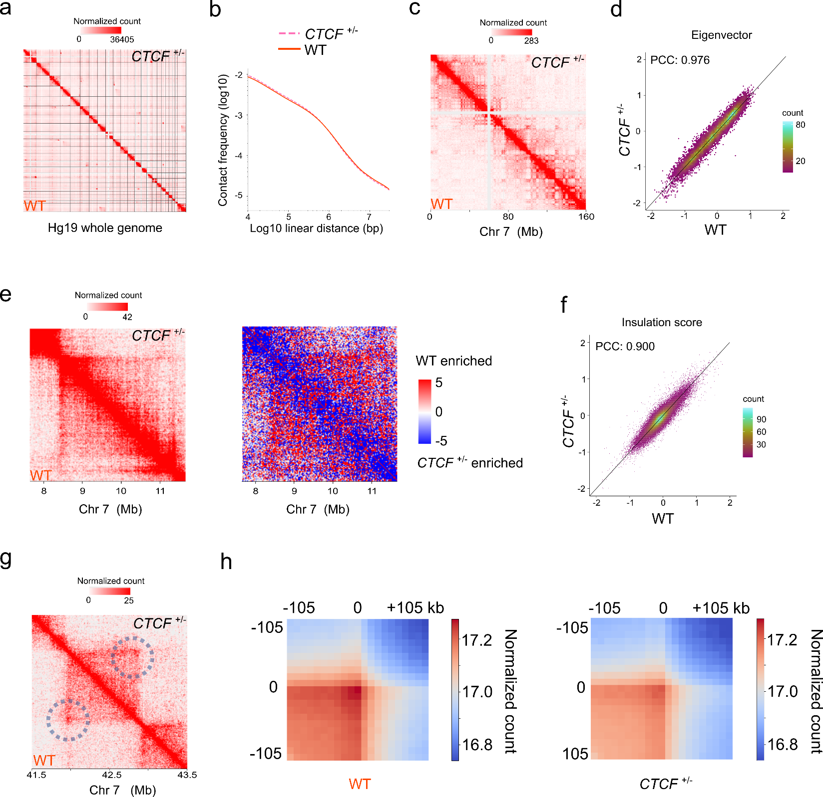
Sfig9. Compare the genome architecture between WT and CTCF^{+/-}. (a)Comparison of 1.11 M virtual pairwise contacts (lower triangle) of SCA-seq hek293T wild type (WT) and 1.16 M virtual pairwise contacts (upper triangle) of SCA-seq hek293T CTCF allele specific knockout (CTCF^{+/-}) for chromosome 1-22 and X (hg19). (b) Contact frequency (y-axis) as a function of linear genomic distance (x-axis) was plotted across all hg19 chromosomes for WT (solid line) and CTCF^{+/-} (dashed line). (c) and (e) Comparison of WT and CTCF^{+/-} (c) 250 kb and (e) 25 kb contact maps for chromosome 7. Color key: log normalized read counts. (d) and (f) Scatterplots comparing (d) eigenvector and (f) insulation score between WT and CTCF^{+/-}. PCC: Pearson correlation coefficient. (g) Contact map showing an example of CTCF peaks at 10kb resolution with loop anchor signal indicated in the black circle. Color key: log normalized read counts. (h) Aggregate peak analysis (APA) showing the visual correspondence of enrichment pattern between Hi-C and SCA within 100kb of loop anchors at 10kb resolution. Color key: sum of contacts detected across the entire loop sets at CTCF ChIP-seq peaks in a coordinate system centered around each loop anchor.
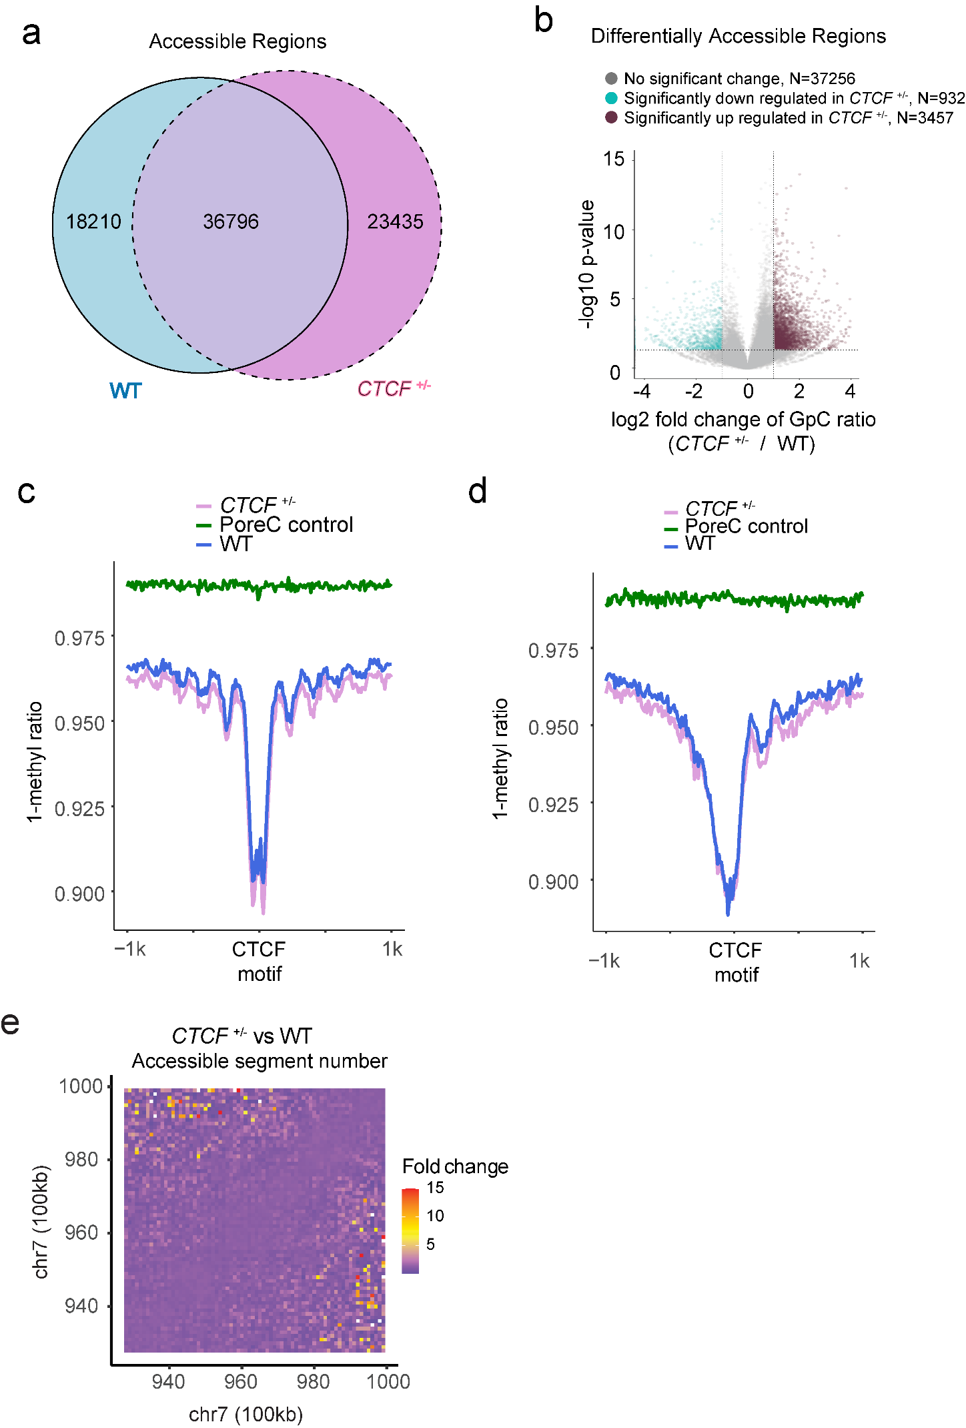
Sfig10. Compare the chromatin accessibility between WT and CTCF^{+/-}. (a) The peak calling algorithm was based binomial test (p=background GpC methylation ratio) from the previous publication nanoNOME¹. There are 23435 and 18210 peaks unique in each sample. (b) For each peak, we performed the differential accessibility analysis with Fisher’s exact test on raw counts of methylated GpCs and unmethylated GpCs. There are 3457 significantly upregulated regions. The P values were corrected using Benjamini-Hochberg correction. (c-d) The CTCF^{+/-} showed higher chromatin accessibility around the CTCF (c) motif and TSS(d). (e) We compared the accessibility (GpC methylation ratios of contacts in each region) in each region of the pair-wise contact map. The fold change was equal to the CTCF ^{+/-} accessibility/WT accessibility.

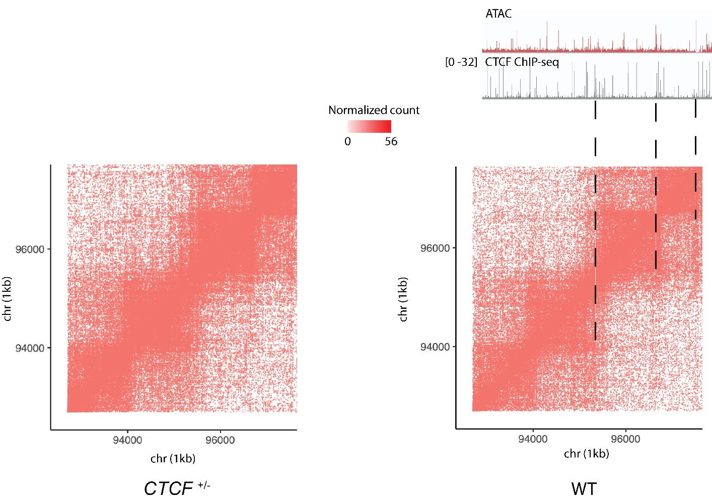
Sfig11. The distribution of the accessible/half-accessible pairwise contacts. The SCA-seq data were converted to the 2-way contacts. The inaccessible-inaccessible chromatin contacts were defined as 0; the inaccessible-accessible chromatin contacts were defined as 1; the accessible-accessible chromatin contacts were defined as 2. We filtered contacts with accessibility >0. In WT, the accessible contacts were distributed as lines, which overlapped with the CTCF ChIP signal and ATAC peaks. In CTCF^{+/-}, the accessible contact lines were blurred and most accessible contacts were distributed in the cores.

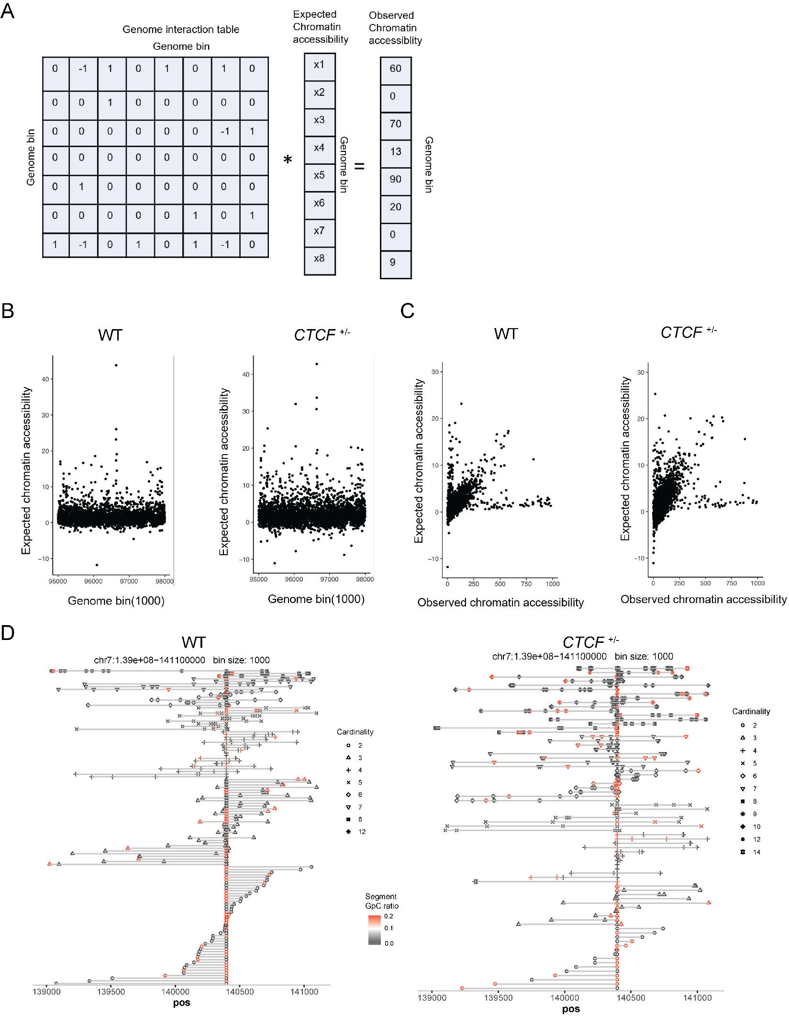
Sfig12. The expected chromatin accessibility. The chromatin accessibility could be activated by the contacts with spatially inaccessible genome locus. We designed the equation to eliminate the effects of the genome interaction. (a) We used the SCA-seq to establish the genome interaction table between genome bins. In the genome interaction table, the accessible-accessible contacts were defined as 2, which means the contacts could initiate the activation. The inaccessible-inaccessible contacts were defined as -2, and the accessible-inaccessible contacts were defined as 0. Then these values were summarized in the genome interaction table as means. The 3D genome interaction matrix times the expected accessibility was equal to the observed chromatin accessibility. Then we resolved the matrix equation. The expected chromatin accessibility represented the original chromatin accessibility without the genome interaction effects. The high signal in expected chromatin accessibility also indicated that this site could potentially activate the contacted sites, which we recognized as the “power center.” We plotted the expected chromatin accessibility from WT and CTCF ^{+/-}. The expected chromatin accessibilities were significantly higher in CTCF ^{+/-} than in WT (t.test p<2.6e-16), implying that CTCF ^{+/-} has more power centers to affect the contacting sites. We then plotted expected chromatin accessibility with the observed chromatin accessibility. The differences between the expected chromatin accessibilities and the observed chromatin accessibilities (slope) were larger in CTCF ^{+/-} than in WT. This result suggested that chromatin accessibilities in CTCF ^{+/-} are more susceptible to genome interaction. We selected a representative CTCF motif with high expected signals. Each line represented the segments in the concatemers. In CTCF ^{+/-}, the CTCF motif activated 50% contacting sites.
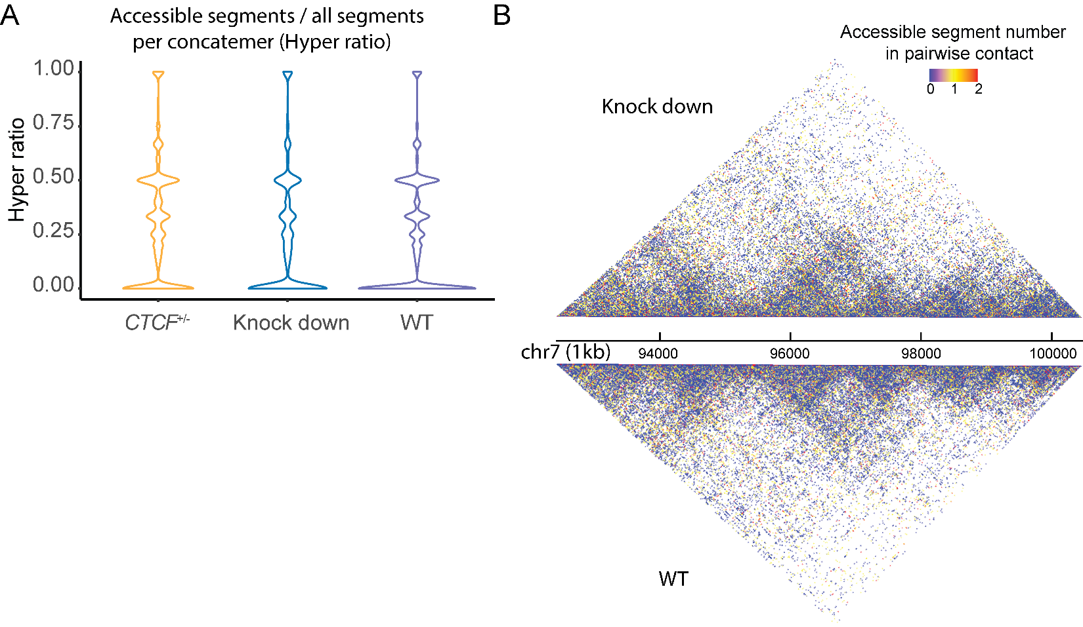
Sfig13. The spatial chromatin accessibility in HEK293T with CTCF knockdown. (a) Hyper ratio= the number of accessible segments in one concatemer/the total number of segments in one concatemer (Refer to Fig4b). (b) We further converted the contact maps to accessibility contact maps (The inaccessible chromatin contacts (inaccessible-inaccessible~0 blue; the inaccessible-accessible contacts were 1 yellow; the accessible-accessible contacts were 2 red; refer to Fig5b). The CTCF knockdown cells significantly enhanced the overall proximal accessibility in the contact maps (Wilcoxon rank test, p<2.6e-16)
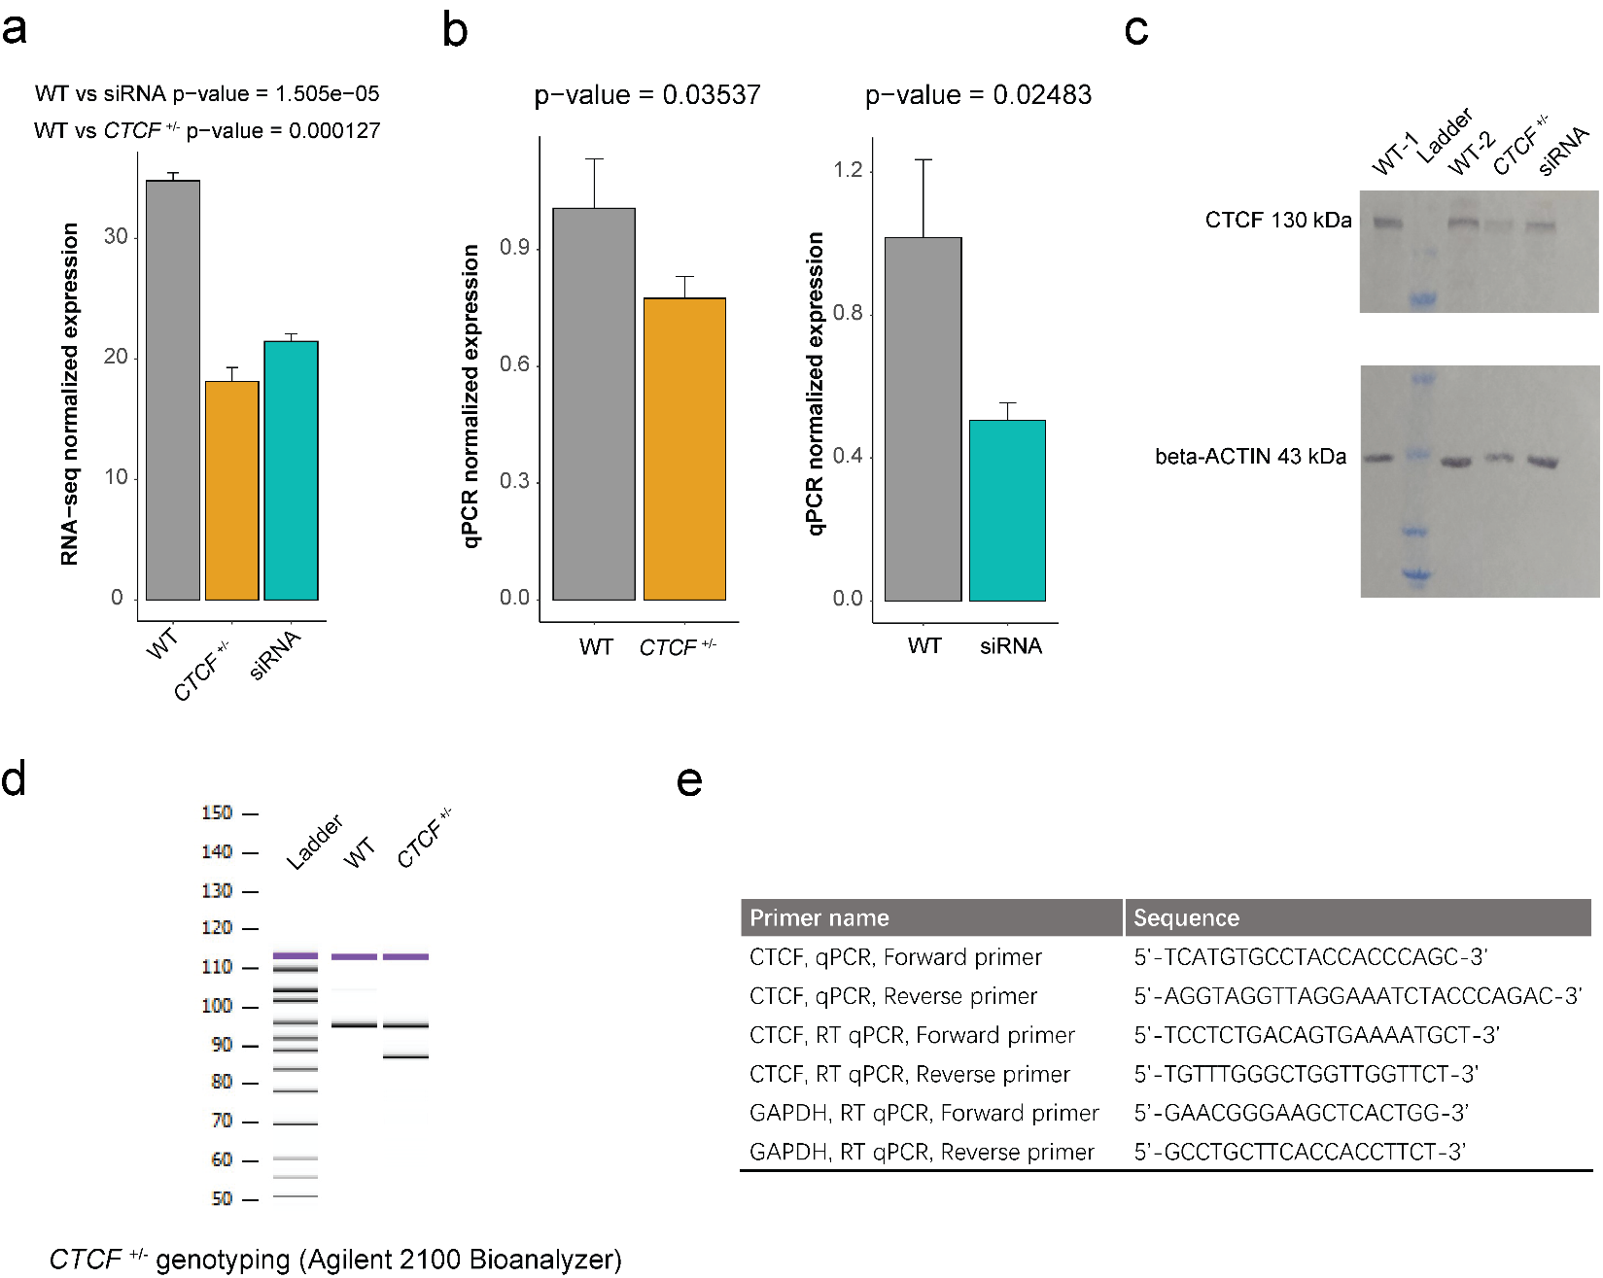
Sfig14. Cell phenotype characterization. (a) The counts of CTCF gene in RNA-seq. (b) The qPCR normalized by beta-ACTIN. (c) The western plot of CTCF normalized by beta-ACTIN. (d) The genotyping of the cell lines. (e) The primers of genotyping.

1. Lee, I. et al. Simultaneous profiling of chromatin accessibility and methylation on human cell lines with nanopore sequencing. Nature Methods 17, 1191-1199 (2020).
2. Ulahannan, N. et al. Nanopore sequencing of DNA concatemers reveals higher-order features of chromatin structure. bioRxiv, 833590 (2019).
3. Bell, A.C. & Felsenfeld, G. Methylation of a CTCF-dependent boundary controls imprinted expression of the Igf2 gene. Nature 405, 482-5 (2000).
4. Hark, A.T. et al. CTCF mediates methylation-sensitive enhancer-blocking activity at the H19/Igf2 locus. Nature 405, 486-9 (2000).
5. Kanduri, C. et al. Functional association of CTCF with the insulator upstream of the H19 gene is parent of origin-specific and methylation-sensitive. Curr Biol 10, 853-6 (2000).

