Supplemental material 1 Western blot against GDF15 in muscle samples

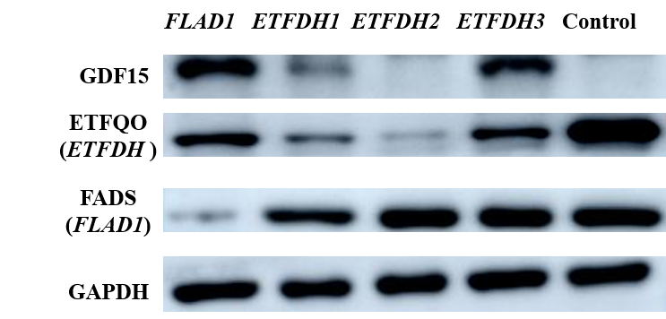

The protein expression of GDF15 was significantly increased in one FLAD1-MADD patients and two ETFDH-MADD patients. The protein expression of ETF:QO was reduced in three ETFDH-MADD patients and the protein expression of FADS was significantly reduced in one ETFDH-MADD patient.

Methods
Western blot analysis of protein extracted from muscle homogenate was performed in one FLAD1-MADD patients and three ETFDH-MADD patients with antibodies raised towards GDF15 (Abcam, ab106006), ETF:QO (ETFDH gene, Protein Tech Group, 11109-1-AP), FADS (FLAD1 gene, Santa Cruz, sc-376819) and a monoclonal antibody raised towards GAPDH (Invitrogen, AM4300). The control was normal muscle biopsies of patients who, after all tests was performed, were considered free of muscle diseases.

