Optimization of tyrosine kinase inhibitor-loaded gold nanoparticles for stimuli-triggered antileukemic drug release
Andra-Sorina Tatar^{1,2}, Timea Nagy-Simon¹, Adrian Bogdan Tigu³, Ciprian Tomuleasa^{3,4}, Sanda Boca^{1,2} *
¹Interdisciplinary Research Institute in Bio-Nano-Sciences, Babes-Bolyai University, 400271 Cluj-Napoca, Romania
²National Institute for Research and Development of Isotopic and Molecular Technologies, 400293 Cluj-Napoca, Romania
³Research Center for Advanced Medicine - MEDFUTURE, Department of Translational
Medicine, “Iuliu Hatieganu” University of Medicine and Pharmacy Cluj-Napoca, 400347 Cluj-Napoca, Romania
⁴Department of Hematology, Oncologic Institute Prof. Dr. Ion Chiricuta, 400015 Cluj-Napoca, Romania

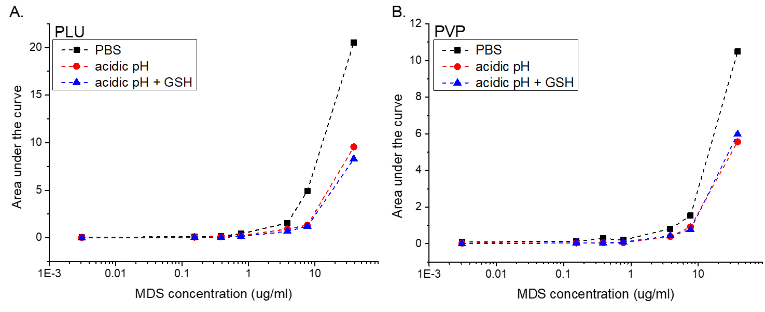
SI Figure 1. Calibration curves for MDS quantification, obtained for each of the polymers (A: Pluronic B: PVP) and in all three release media solutions (black: PBS; red: acidic pH; blue: GSH presence in acidic pH).

For each type of polymer, and each of the buffer solution, we constructed a separate calibration curve, to account more closely and correctly for the optical effects of the presence of the excess polymer molecules with the released MDS, and their behavior in each release media. For each of the calibration curves, we used “simulated supernatants” obtained from identical particle functionalizations (GNPs + polymers), in the absence of MDS, and thus the solutions contain similar amounts of traces of washed off polymer. Particularly, we constructed 6 calibration curves based on area under the curve measurements (from the four peaks in the 300-380 nm region) as a function of MDS concentration; we fitted them and obtained 6 trendline equations, and used the data to extrapolate MDS concentration in the samples, both for the calculation of Loading Efficiency (%) and for tracking the MDS controlled release.

SI Figure 2. TEM micrograph of the GNPs. Scale is 200 nm

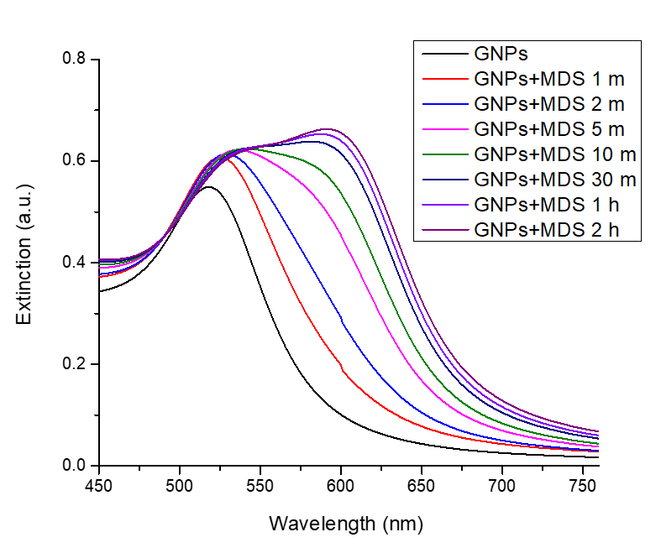
SI Figure 3. Extinction spectra of GNPs incubated with MDS solely. Time-lapse showing aggregation-inducing effect of MDS up to 2 hours.

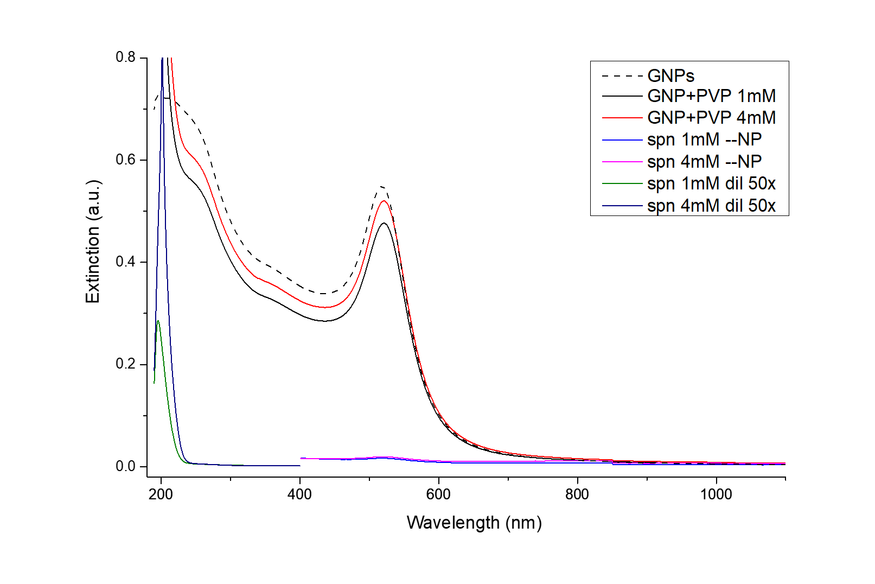
SI Figure 4. Extinction spectra of GNPs incubated with different PVP concentrations: 1 mM vs 4 mM.

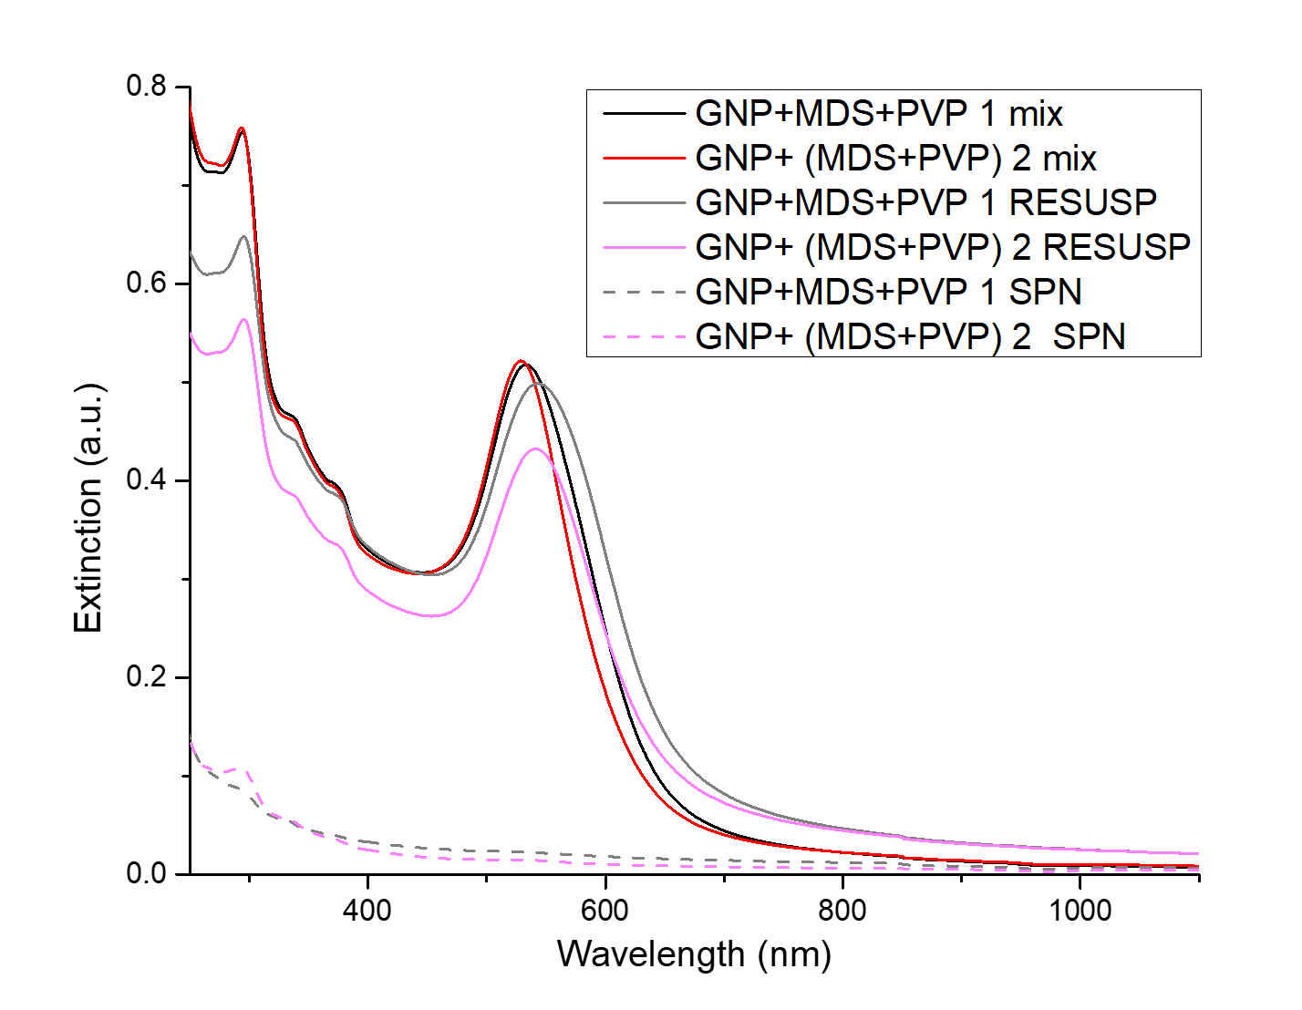
SI Figure 5. Extinction spectra of GNPs functionalised with MDS and PVP in different protocol configurations: ((GNP + MDS) + PVP): addition of MDS before polymer introduction; (GNP + (MDS+PVP)): pre-incubation of the MDS with the PVP before addition to the GNPs.

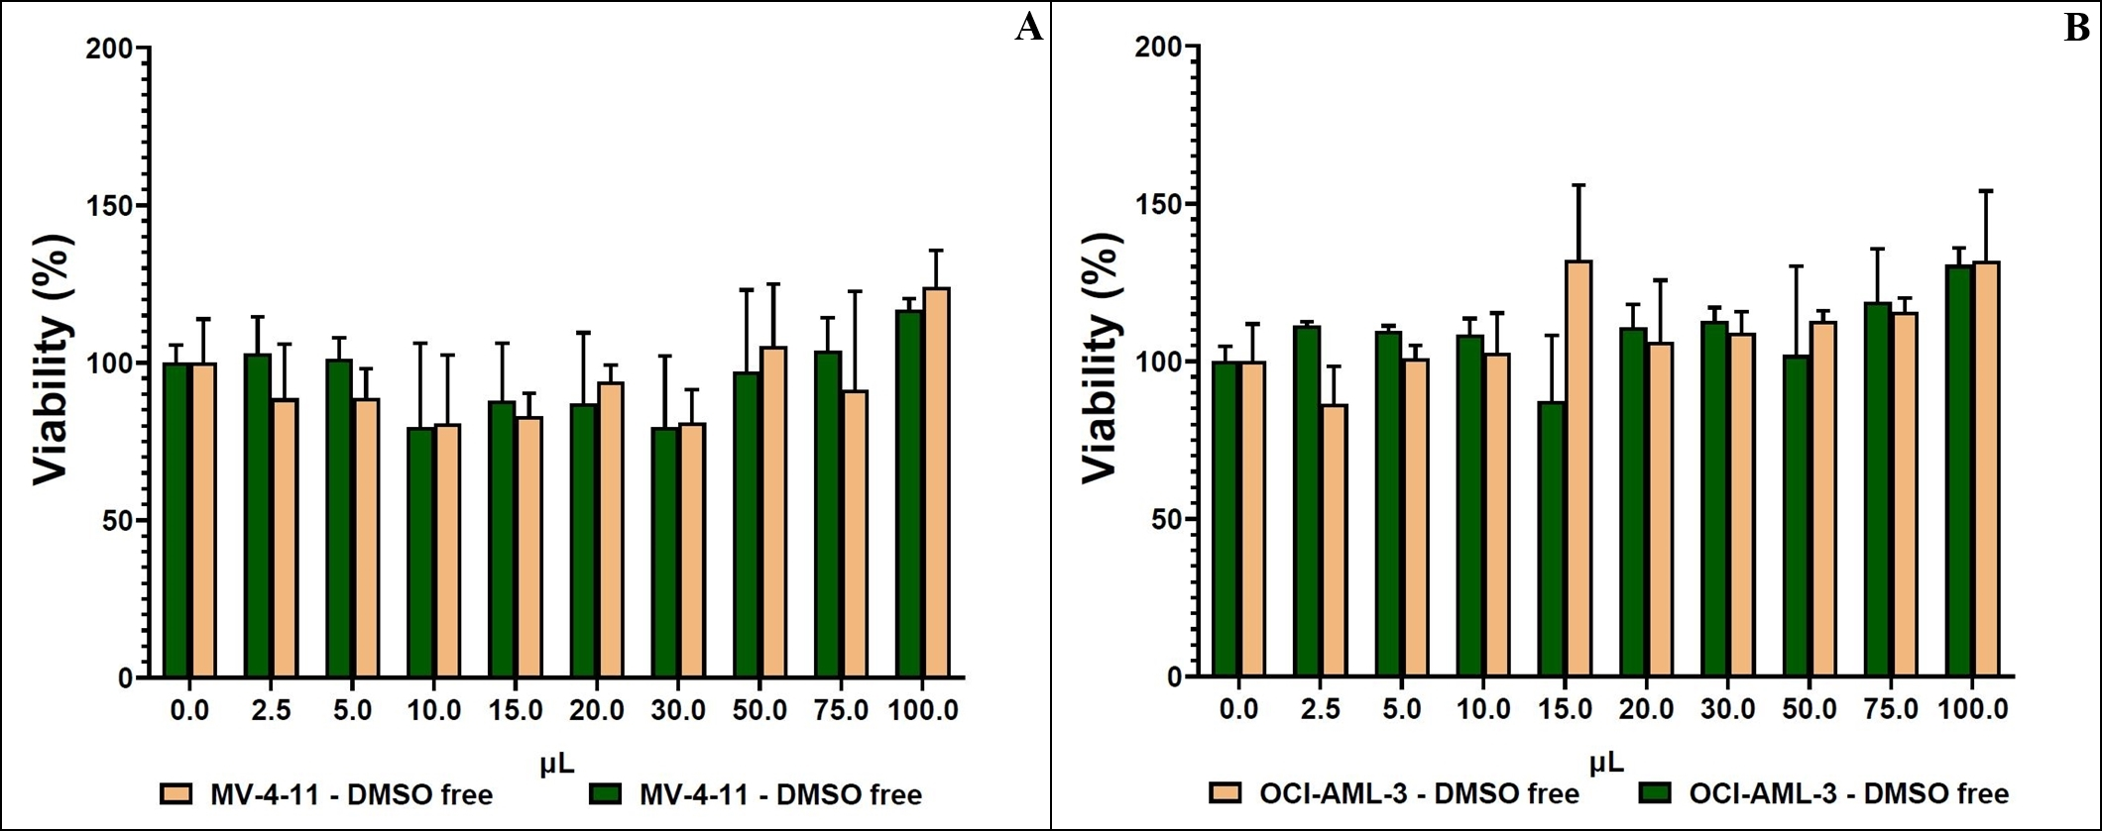
SI Figure 6. Histograms showing XTT assessment of cell viability of MV4-11 cells (left) and OCI-AML3 cells (right) incubated with DMSO, as control.

