Supplementary Information
Galvanic displacement of Co with Rh boosts hydrogen and oxygen evolution reactions in alkaline media
Bojana Nedić Vasiljević^{1†}, Aleksandar Z. Jovanović^{1†}, Natalia V. Skorodumova², Igor A. Pašti¹*
¹University of Belgrade – Faculty of Physical Chemistry, Studentskitrg 12-16, 11000 Belgrade, Serbia
²Department of Materials Science and Engineering, School of Industrial Engineering and Management, KTH – Royal Institute of Technology, Brinellvägen 23, 100 44 Stockholm, Sweden
† equal contribution
*Corresponding author: Prof. Dr. Igor Pašti, e-mail: igor@ffh.bg.ac.rs, ORCiD: 0000-0002-1000-9784

Supplementary Figures
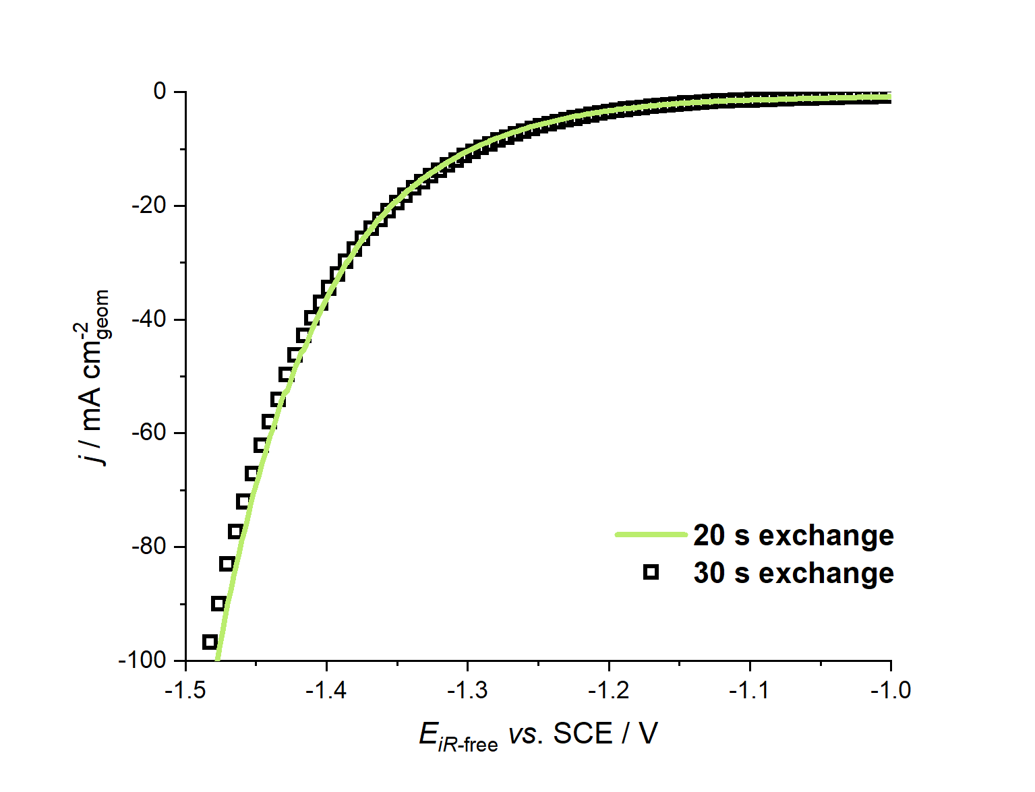
Fig. S1 The comparison of the HER polarization curves for Rh(20)@Co and Rh(30)@Co electrodes
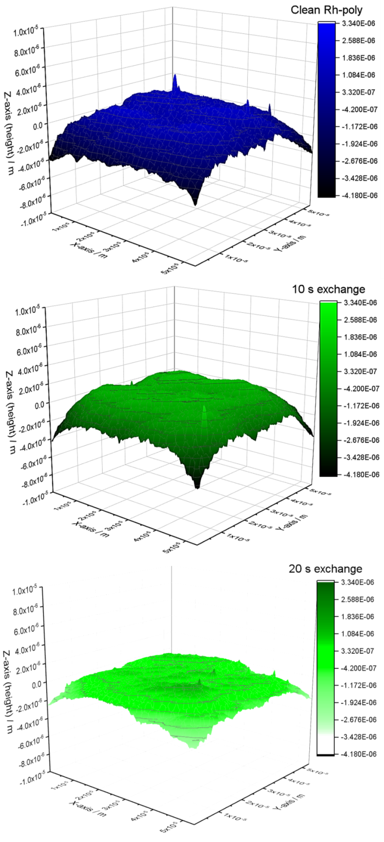
Fig. S2 SEM 3D reconstructed surface profile for Co-poly (top), Rh(10)@Co (middle) and Rh(20)@Co (bottom) electrode
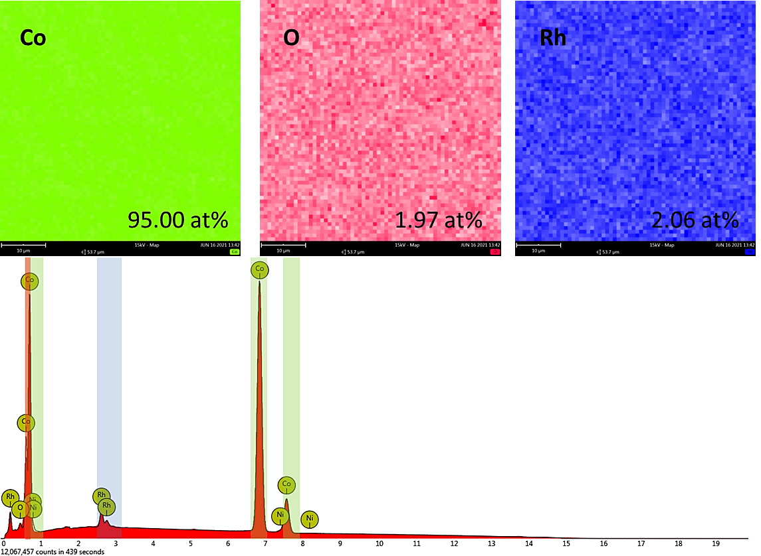

Fig. S3 EDX mapping and EDX spectra of the Rh(30)@Co electrode. Chemical composition (in at.%) is corresponding elemental maps. Field of view 53.9μm

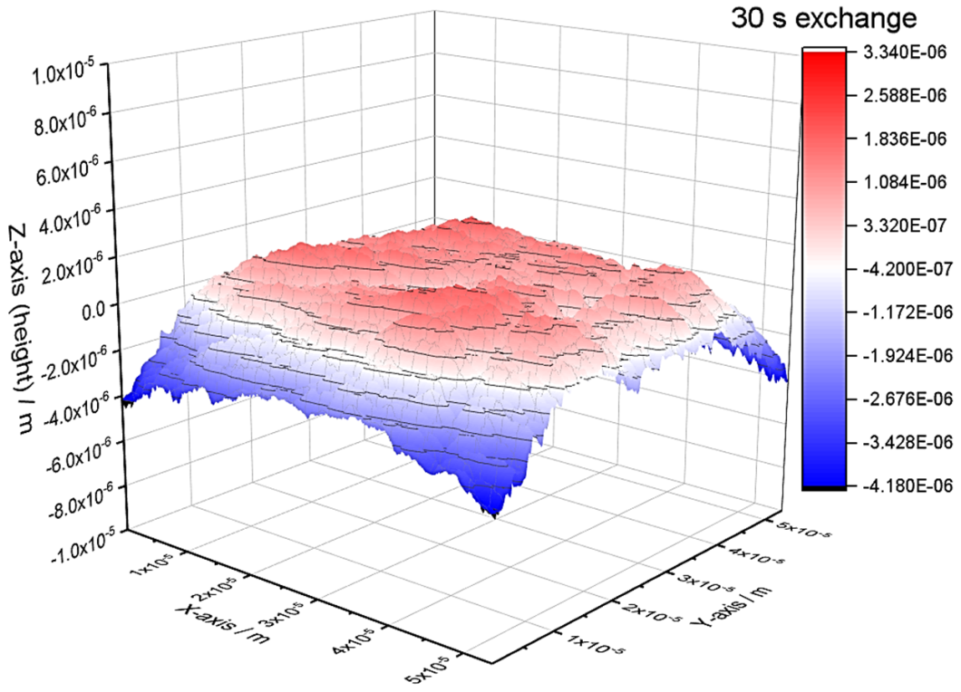
Fig. S4 SEM 3D reconstructed surface profile of Rh(30)@Co electrode

