Supporting Information
Direct OC-CHO coupling towards highly C₂₊ products selective electroreduction over stable Cu⁰/Cu²⁺ interface
Xin Yu Zhang,^{1†} Zhen Xin Lou,^{1†} Jiacheng Chen,² Yuanwei Liu,¹ Xuefeng Wu,¹ Jia Yue Zhao,¹ Hai Yang Yuan,^{1*} Minghui Zhu,² Sheng Dai,³ Hai Feng Wang,⁴ Chenghua Sun,⁵ Peng Fei Liu^{1*} & Hua Gui Yang^{1*}
¹ Key Laboratory for Ultrafine Materials of Ministry of Education, Shanghai Engineering Research Center of Hierarchical Nanomaterials, School of Materials Science and Engineering, East China University of Science and Technology, 130 Meilong Road, Shanghai, 200237 (China)
² State Key Laboratory of Chemical Engineering, School of Chemical Engineering, East China University of Science and Technology, 130 Meilong Road, Shanghai, 200237 (China)
³ Key Laboratory for Advanced Materials and Feringa Nobel Prize Scientist Joint Research Center, Institute of Fine Chemicals, School of Chemistry and Molecular Engineering, East China University of Science and Technology, 130 Meilong Road, Shanghai, 200237 (China)
⁴ Key Laboratory for Advanced Materials, Centre for Computational Chemistry and Research Institute of Industrial Catalysis, School of Chemistry and Molecular Engineering, East China University of Science and Technology, 130 Meilong Road, Shanghai, 200237 (China)
⁵ Department of Chemistry and Biotechnology, and Center for Translational Atomaterials, Swinburne University of Technology, Hawthorn, VIC, 3122 (Australia)
† These authors contributed equally to this work.
* Emails: hgyang@ecust.edu.cn; pfliu@ecust.edu.cn; hyyuan@ecust.edu.cn
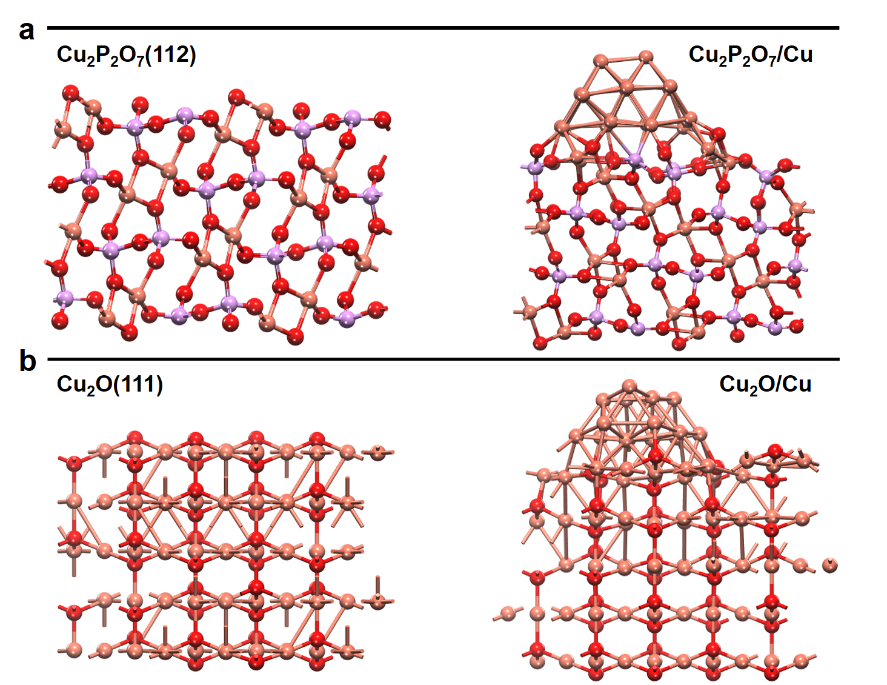
Supplementary Fig. 1 a Cu⁰/Cu²⁺ structure constructed by Cu loaded on Cu₂P₂O₇; b Cu⁰/Cu¹⁺ structure constructed by Cu loaded on Cu₂O.

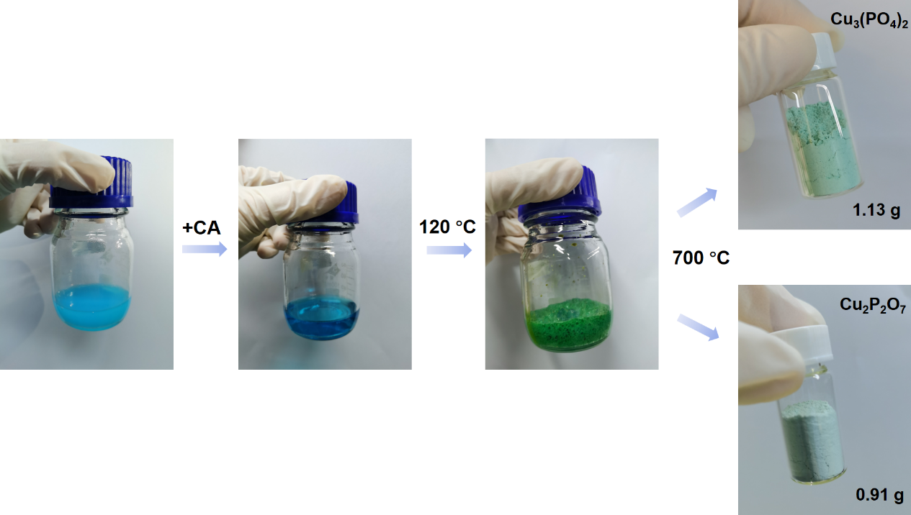 Supplementary Fig. 2 Schematic illustration of the sol-gel preparation process, showing that the final Cu₃(PO₄)₂ (~1.13 g) and Cu₂P₂O₇ (~0.91 g) products were obtained.
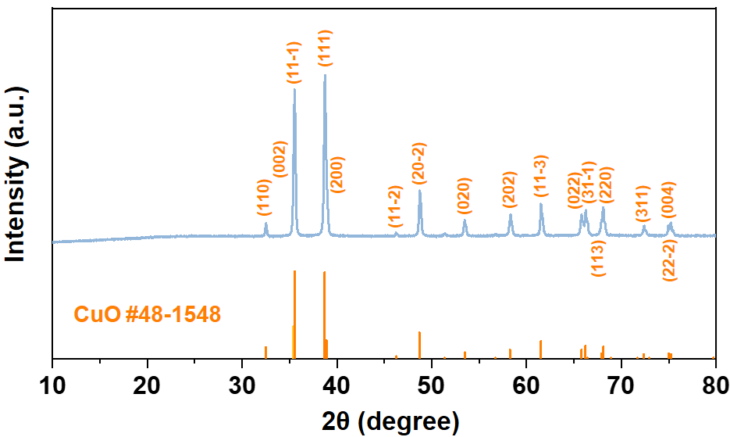
Supplementary Fig. 3 XRD pattern of CuO control sample, which indicates the crystalline phase of CuO.

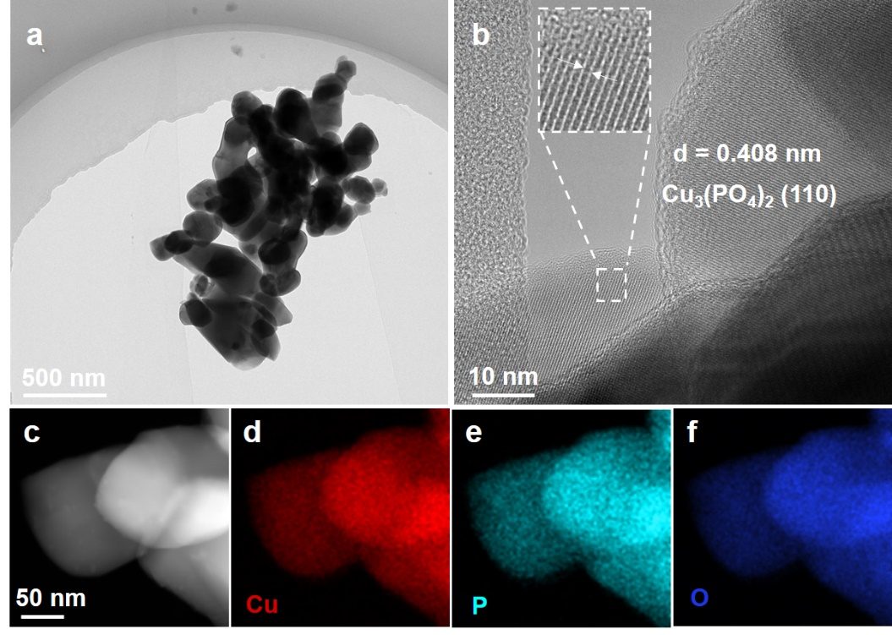
Supplementary Fig. 4 a TEM image and b HRTEM image of the Cu₃(PO₄)₂ sample. c HAADF-STEM image of Cu₃(PO₄)₂ and d-f cooresponding elemental maps of d Cu, e P, and f O elements, respectively.

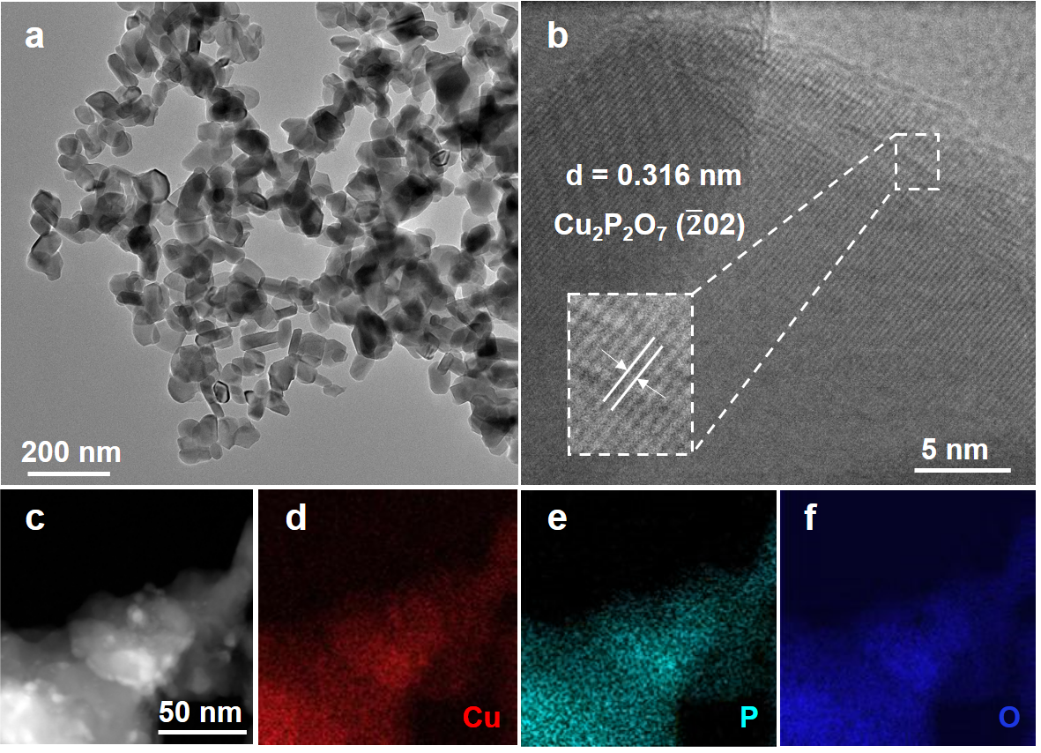
Supplementary Fig. 5 a Low-magnificaiton TEM image and b HRTEM image of the Cu₂P₂O₇ sample. c HAADF-STEM image of Cu₂P₂O₇ and d-f cooresponding elemental maps of d Cu, e P, and f O elements, respectively.

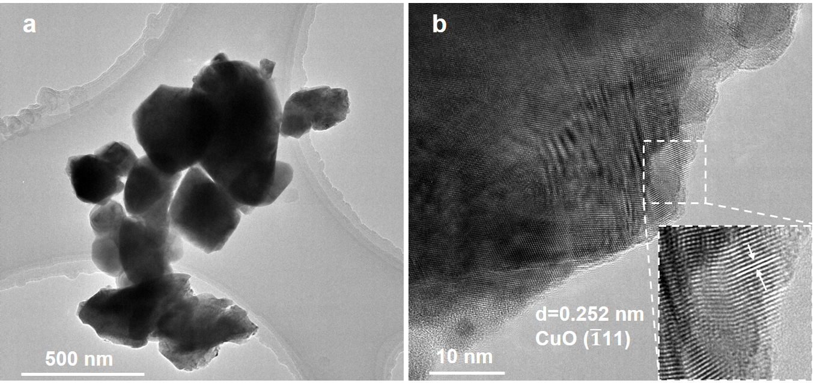
Supplementary Fig. 6 a TEM image and b HRTEM image of the CuO sample.

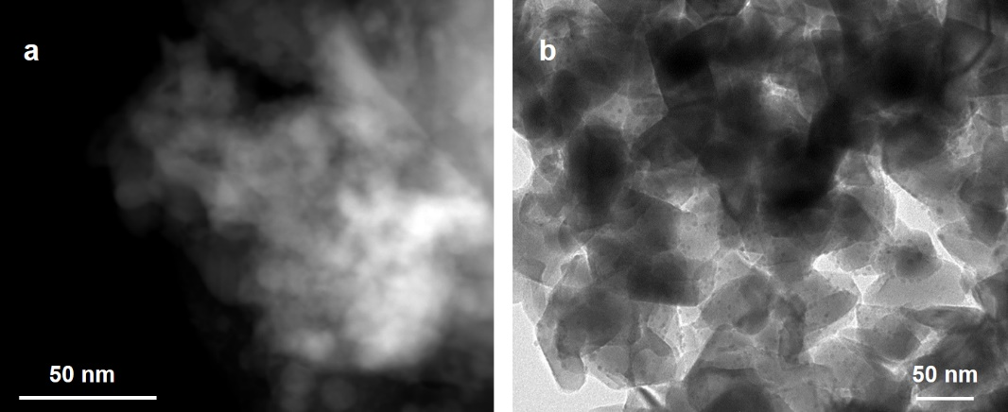
Supplementary Fig. 7 a HAADF-STEM image of the Cu₃(PO₄)₂ sample and b TEM image of the Cu₂P₂O₇ sample after 0.5 hour’s CO₂RR at the applied potential of -1.40 V vs. RHE.

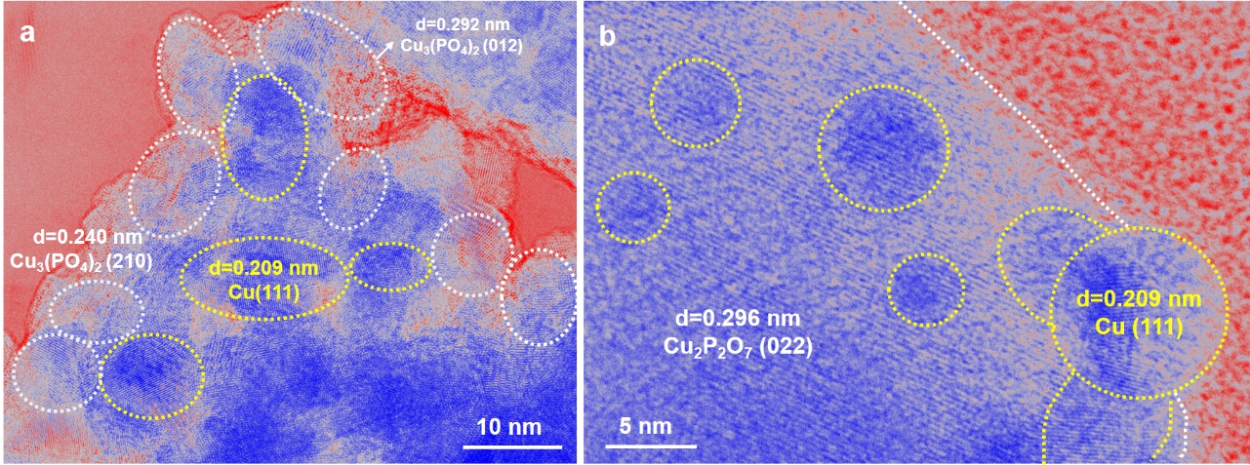
Supplementary Fig. 8 False-color HRTEM images of the a Cu₃(PO₄)₂ and b Cu₂P₂O₇ sample after CO₂RR at the potential of -1.40 V vs. RHE.

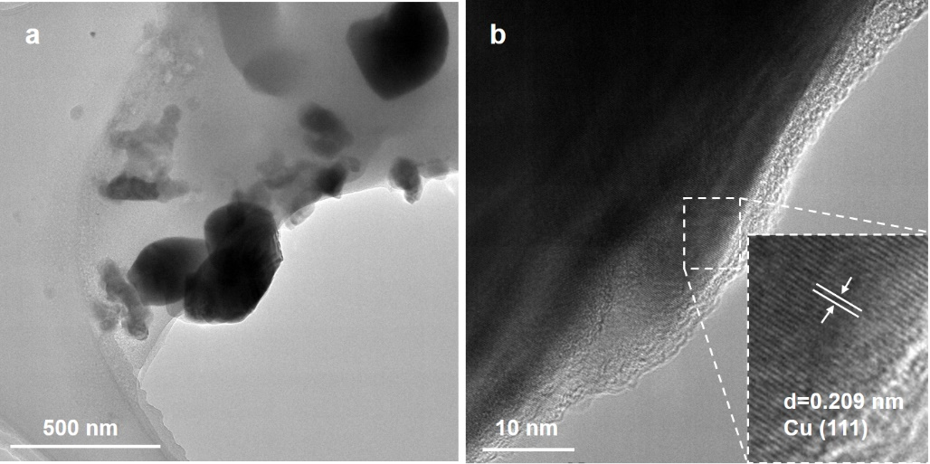
Supplementary Fig. 9 a TEM image and b HR-TEM image of the CuO control sample after 0.5 hour’s CO₂RR at the applied potential of -1.40 V vs. RHE, showing that the pristine CuO phase has been reduced to metallic Cu during the test.

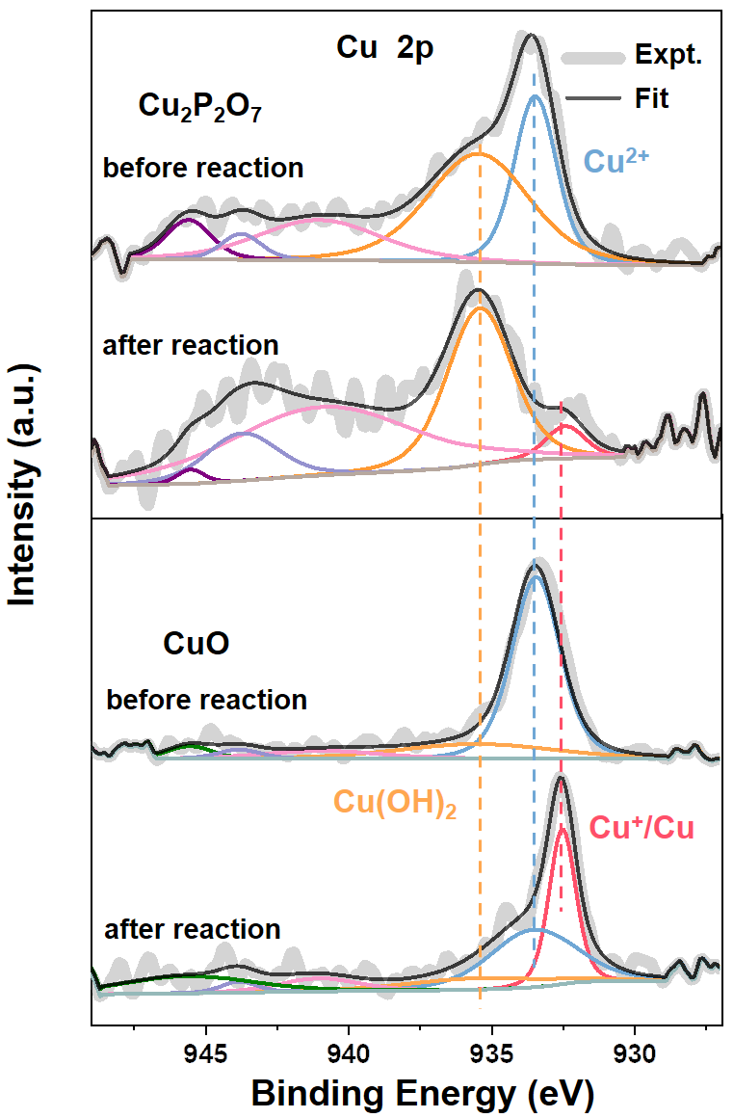
Supplementary Fig. 10 XPS spectra of Cu 2p region of Cu₂P₂O₇ and CuO control sample collected before and after CO₂RR at -1.40 V vs. RHE for 1 h, showing that the Cu species of Cu₂P₂O₇ exhibited the main component of Cu²⁺, while Cu species of CuO were largely reduced to metallic Cu⁰ states after CO₂RR.

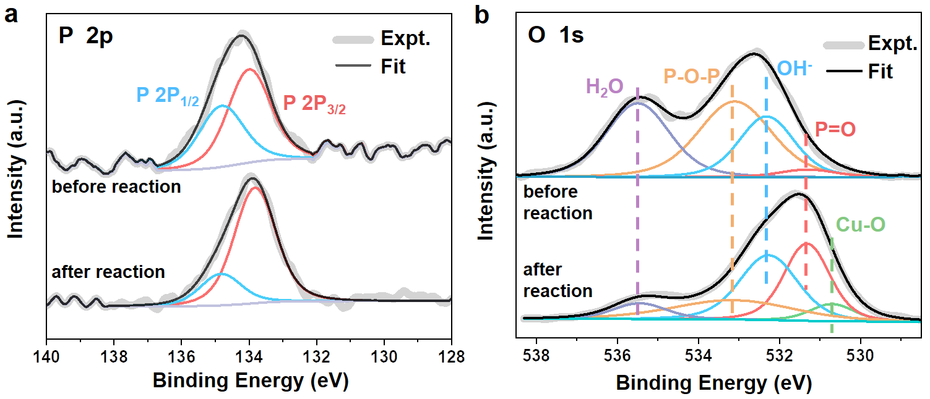
Supplementary Fig. 11 a, b XPS spectra of Cu₂P₂O₇ before and after 1 hour’s CO₂RR at the applied potential of -1.40 V vs. RHE in a P 2p and b O 1s regions, indicating the phosphate group persisted during the test. Notes: Cu-O might result from the slight oxidation in the air.

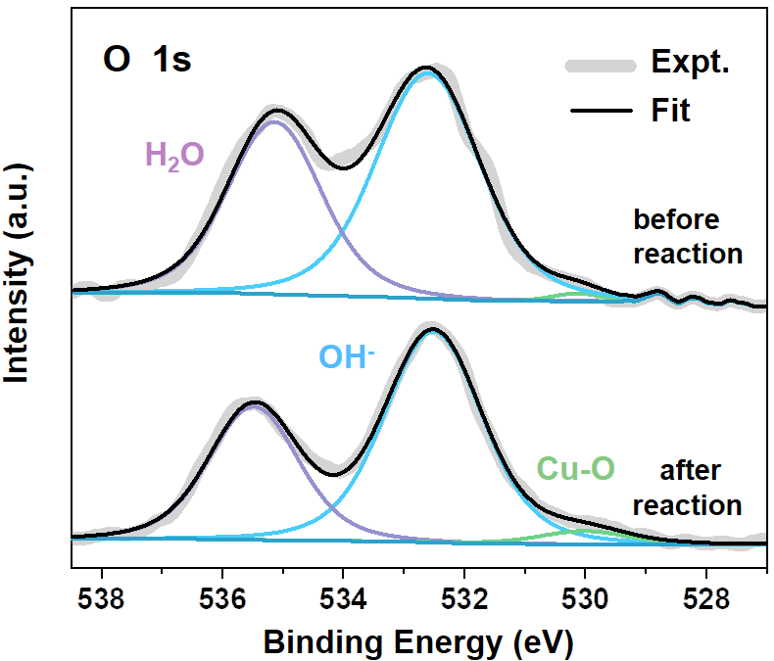
Supplementary Fig. 12 XPS spectra of CuO control sample before and after 1 hour’s CO₂RR at the applied potential of -1.40 V vs. RHE in O 1s region.

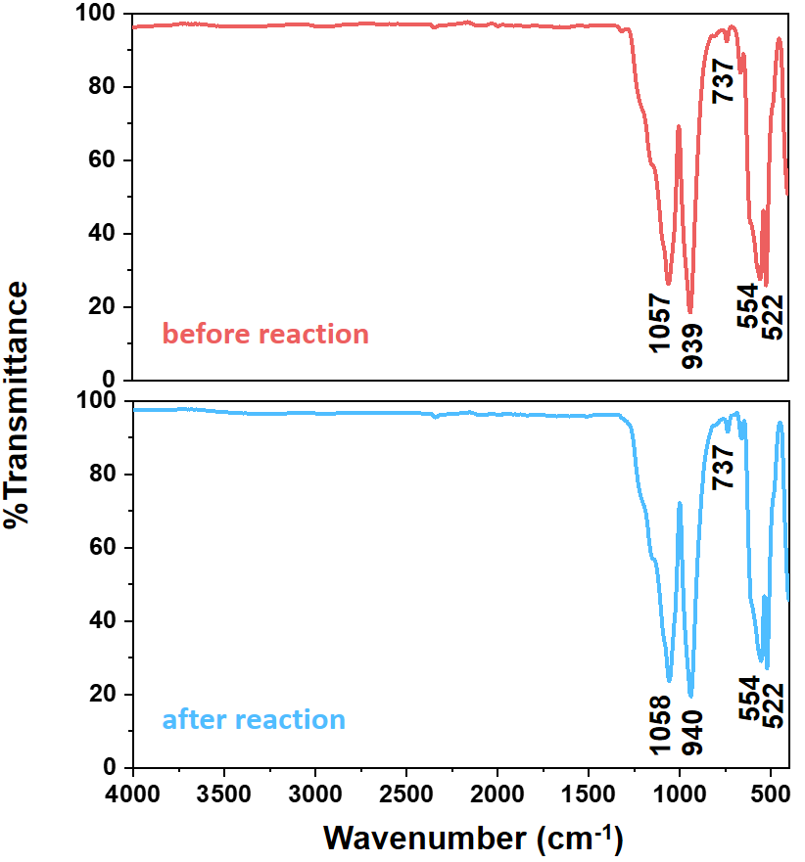
Supplementary Fig. 13 FT-IR spectra of Cu₂P₂O₇ before and after 1 hour’s CO₂RR at the applied potential of -1.40 V vs. RHE.

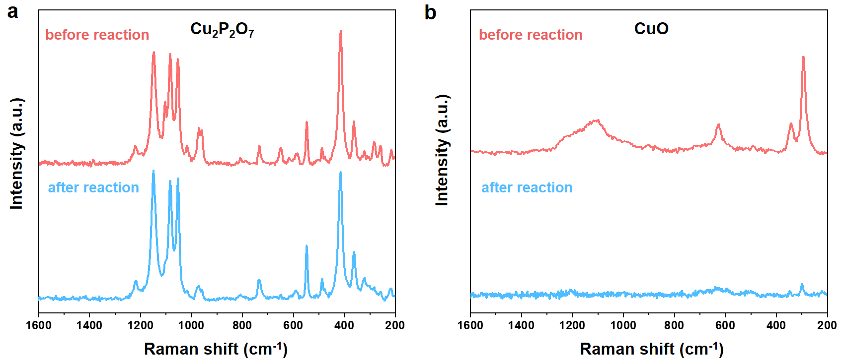
Supplementary Fig. 14 a, b Raman spectra of a Cu₂P₂O₇ and b CuO control sample before and after 1 hour’s CO₂RR at the applied potential of -1.40 V vs. RHE.

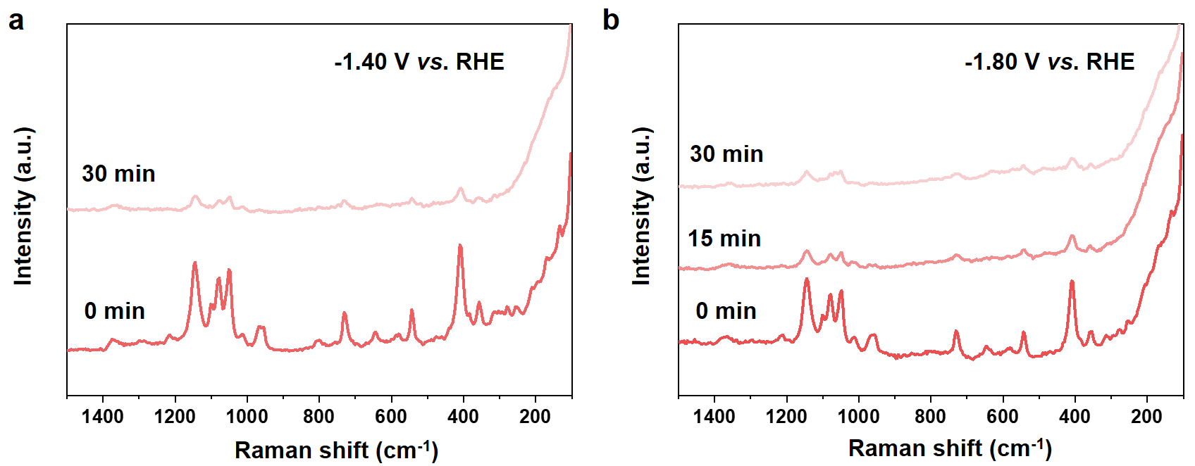
Supplementary Fig. 15 a, b Operando Raman spectra of Cu₂P₂O₇ during CO₂RR at a -1.40 V vs. RHE and b -1.80 V vs. RHE in CO₂-saturated 0.1 M KHCO₃.

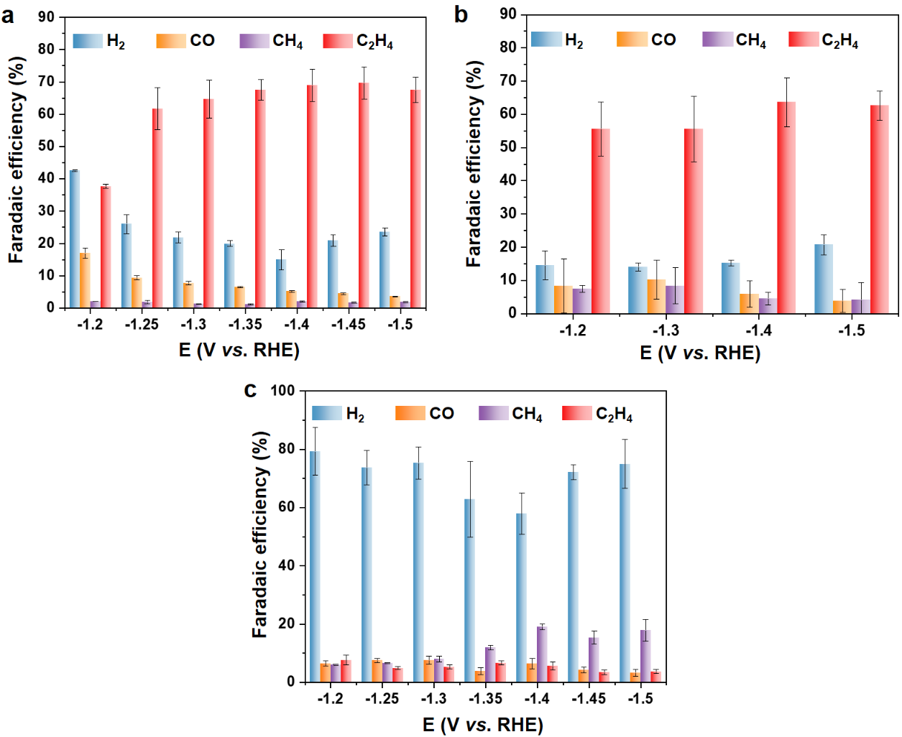
Supplementary Fig. 16 Faradaic efficiencies of gas products of a Cu₃(PO₄)₂/GC, b Cu₂P₂O₇/GC and c CuO/GC at different applied potentials in CO₂-saturated 0.1 M KHCO₃, suggesting the superior C₂H₄ selectivity for CuPO.

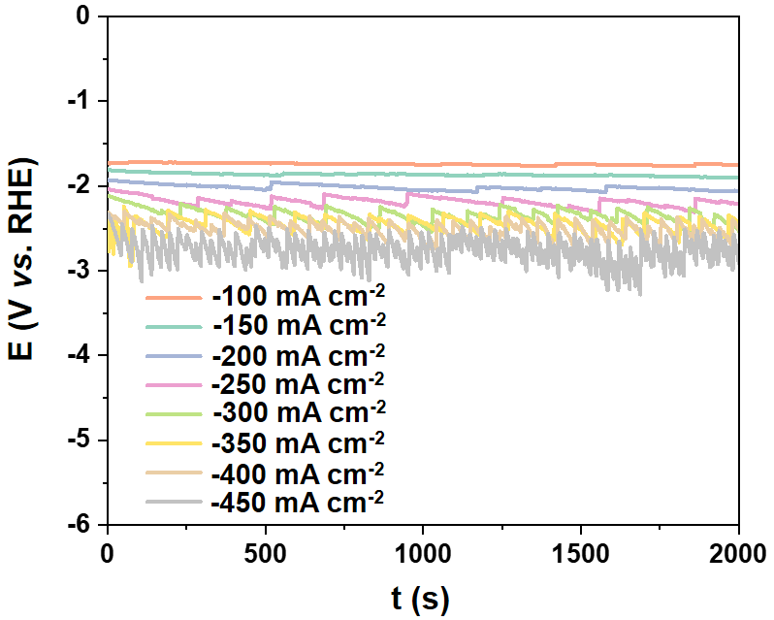
Supplementary Fig. 17 Potential dependence on time during CO₂RR at -100~-450 mA cm⁻² in 2.0 M KOH aqueous electrolyte on the Cu₃(PO₄)₂/Cu/PTFE.

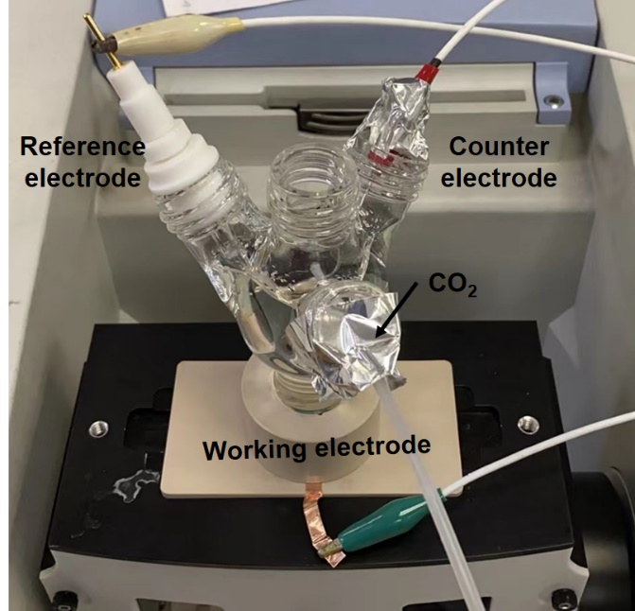
Supplementary Fig. 18 Digital photograph of the homemade cell attached to the PerkinElmer spectrum 100 spectrometer for in situ SEIRAS measurement. The CO₂ gas flow rate through the gas chamber was controlled as 10 sccm by a gas flow controller.

Supplementary Table 1 Cu⁰, Cu¹⁺, and Cu²⁺ ratios and for the fitting of the linear combination of XANES spectra.
Cu₃(PO₄)₂  Cu oxidation state | Time (-1.45 V vs. RHE)
Cu₃(PO₄)₂  Cu oxidation state | 6 min | 12 min | 18 min | 24 min | 30 min | post
Cu⁰ | 0.04 | 0.06 | 0.16 | 0.23 | 0.28 | 0.08
Cu¹⁺ | 0.01 | 0.06 | 0.12 | 0.14 | 0.24 | 0.41
Cu²⁺ | 0.95 | 0.88 | 0.72 | 0.63 | 0.49 | 0.51
CuO  Cu oxidation state | Time (-1.45 V vs. RHE)
CuO  Cu oxidation state | 6 min | 12 min | 18 min | 24 min | 30 min | post
Cu⁰ | 0.04 | 0.18 | 0.62 | 0.68 | 0.73 | 0.69
Cu¹⁺ | 0.00 | 0.20 | 0.13 | 0.13 | 0.13 | 0.17
Cu²⁺ | 0.96 | 0.63 | 0.25 | 0.19 | 0.13 | 0.13

Supplementary Table 2 Faradaic efficiencies of gas products for CuPO/GC in 0.1 M KHCO₃.
Cu₃(PO₄)₂/GC Faradaic efficiencies (%)
Potential  (V vs. RHE) | Current density  (mA cm²) | H₂ | CO | CH₄ | C₂H₄ | Total all
-1.20 | -18.1 | 42.9 | 18.7 | 2.0 | 37.9 | 101.6
-1.20 | -18.6 | 42.4 | 16.9 | 2.0 | 37.0 | 98.2
-1.20 | -18.6 | 42.4 | 15.4 | 2.1 | 38.2 | 98.2
-1.25 | -19.1 | 29.3 | 8.7 | 2.4 | 54.2 | 95.1
-1.25 | -19.3 | 24.7 | 9.5 | 1.6 | 65.4 | 101.2
-1.25 | -19.6 | 24.0 | 10.0 | 1.5 | 65.6 | 101.1
-1.30 | -23.7 | 22.9 | 8.1 | 1.2 | 58.0 | 90.1
-1.30 | -23.2 | 22.8 | 8.0 | 1.3 | 67.3 | 99.4
-1.30 | -23.5 | 20.0 | 7.1 | 1.3 | 68.4 | 96.7
-1.35 | -27.3 | 20.9 | 6.7 | 1.3 | 63.8 | 92.7
-1.35 | -27.1 | 19.1 | 6.5 | 1.1 | 68.9 | 95.6
-1.35 | -27.1 | 19.8 | 6.4 | 1.1 | 69.7 | 97.0
-1.40 | -29.7 | 18.6 | 5.4 | 2.2 | 63.2 | 89.5
-1.40 | -29.6 | 13.3 | 5.3 | 2.0 | 72.4 | 92.7
-1.40 | -29.7 | 13.0 | 4.9 | 2.0 | 71.3 | 91.5
-1.45 | -33.0 | 20.1 | 4.6 | 1.8 | 63.9 | 90.4
-1.45 | -33.0 | 19.8 | 4.6 | 1.8 | 71.7 | 97.9
-1.45 | -33.1 | 23.0 | 4.2 | 1.4 | 73.4 | 102.0
-1.50 | -36.7 | 24.4 | 3.7 | 1.9 | 63.0 | 93.1
-1.50 | -36.6 | 22.1 | 3.6 | 2.1 | 69.6 | 97.3
-1.50 | -36.7 | 24.0 | 3.4 | 1.6 | 70.0 | 99.0
Cu₂P₂O₇/GC Faradaic efficiencies (%)
Potential  (V vs. RHE) | Current density  (mA cm²) | H₂ | CO | CH₄ | C₂H₄ | Total all
-1.20 | -14.7 | 19.5 | 17.8 | 6.3 | 46.8 | 90.4
-1.20 | -15.1 | 12.4 | 3.7 | 8.2 | 57.0 | 81.7
-1.20 | -15.4 | 11.6 | 3.7 | 8.0 | 62.9 | 86.8
-1.30 | -20.1 | 14.5 | 13.1 | 5.7 | 48.8 | 82.6
-1.30 | -20.3 | 15.0 | 14.0 | 14.6 | 51.0 | 94.7
-1.30 | -20.7 | 12.7 | 3.4 | 4.7 | 66.8 | 87.6
-1.40 | -26.3 | 15.8 | 10.4 | 6.7 | 55.3 | 88.4
-1.40 | -27.9 | 14.2 | 3.1 | 3.3 | 66.9 | 87.5
-1.40 | -28.0 | 15.7 | 4.0 | 3.6 | 69.7 | 92.9
-1.50 | -33.0 | 17.4 | 7.6 | 10.1 | 57.9 | 92.9
-1.50 | -33.9 | 21.5 | 2.9 | 1.2 | 63.4 | 89.0
-1.50 | -34.3 | 23.3 | 1.0 | 1.2 | 66.5 | 92.1
Supplementary Table 3 Faradaic efficiencies of gas products for CuO/GC in 0.1 M KHCO₃.
Potential  (V vs. RHE) | Current density  (mA cm²) | H₂ | CO | CH₄ | C₂H₄ | Total all
-1.20 | -5.0 | 75.1 | 5.4 | 6.2 | 9.3 | 92.5
-1.20 | -5.1 | 74.0 | 6.8 | 6.0 | 7.7 | 94.6
-1.20 | -5.4 | 88.7 | 7.2 | 5.7 | 6.0 | 107.6
-1.25 | -6.9 | 78.8 | 6.7 | 6.7 | 5.3 | 97.5
-1.25 | -6.9 | 67.2 | 7.8 | 6.7 | 4.3 | 85.9
-1.25 | -7.2 | 75.2 | 8.0 | 6.4 | 5.1 | 94.7
-1.30 | -8.6 | 74.8 | 6.3 | 9.1 | 6.0 | 96.2
-1.30 | -8.4 | 70.1 | 7.4 | 7.4 | 5.0 | 89.8
-1.30 | -8.3 | 81.1 | 8.9 | 7.5 | 4.8 | 102.3
-1.35 | -10.0 | 50.1 | 2.7 | 12.4 | 7.5 | 72.7
-1.35 | -10.1 | 62.4 | 3.8 | 12.3 | 6.4 | 85.0
-1.35 | -10.0 | 76.2 | 5.1 | 10.9 | 6.1 | 98.1
-1.40 | -10.1 | 65.9 | 4.6 | 19.9 | 7.1 | 97.5
-1.40 | -9.7 | 55.2 | 6.4 | 19.2 | 5.3 | 86.1
-1.40 | -9.6 | 52.4 | 8.1 | 17.9 | 4.4 | 82.7
-1.45 | -14.0 | 69.9 | 3.1 | 17.8 | 4.0 | 94.7
-1.45 | -13.9 | 74.9 | 4.5 | 13.5 | 3.7 | 96.5
-1.45 | -13.7 | 71.7 | 5.1 | 14.7 | 2.5 | 94.1
-1.50 | -17.6 | 71.4 | 2.2 | 22.1 | 4.5 | 100.3
-1.50 | -17.0 | 69.0 | 3.0 | 16.5 | 3.3 | 91.7
-1.50 | -16.7 | 84.6 | 4.4 | 14.9 | 3.2 | 107.1

Supplementary Table 4 Maximum FE_{C2+}, j_{C2+} and the corresponding potential of CuPO, and some recently reported outstanding CO₂-to-C₂₊ electrocatalysts.
Catalyst | Electrolyte | FE_{C2+}  (%) | j_{C2+}  (mA cm²) | Reference
CuPO/Cu/PTFE | 2.0 M KOH | 90.9 | -318.2 | This work
Cu-Pd¹ | 0.5 M K₂SO₄ (pH=2) | 89 | -445 | Nat. Catal. 5, 564−570 (2022)
Cu(OH)₂/Cu foil² | 1 M KOH | 87 | -217 | Angew. Chem. Int. Ed. 60, 4879−4885 (2021)
F-Cu³ | 0.75 M KOH | 85.8 | -1372.8 | Nat. Catal. 3, 478−487 (2020)
reconstructed Cu⁴ | 3 M KOH | ~84 | -336 | Adv. Mater. 30, 1804867 (2018)
Cu/GDL⁵ | 3 M KCl | 82.7 | -97.3 | J. Am. Chem. Soc. 143, 3245−3255 (2021)
Cu/GDL⁵ | 2 M KCl | 80.4 | -120.6 | J. Am. Chem. Soc. 143, 3245−3255 (2021)
dCu₂O/Ag_{2.3%}⁶ | 1 M KOH | 82.1 | -656.8 | Nat. Commun. 13, 3754 (2022)
CuPb-0.7/C⁷ | 1 M KOH | 81.6 | -326.4 | ACS Nano 15, 1039–1047 (2021)
Cu_I⁸ | 0.1 M KHCO₃ | ~80 | ~-31.2 | Angew. Chem. Int. Ed. 58, 17047−17053 (2019)
B-Cu-Zn⁹ | 1 M KOH | 79 | -158 | Angew. Chem. Int. Ed. 60, 9135−9141 (2021)
Cu(B)-2¹⁰ | 0.1 M KHCO₃ | 79 | -55 | Nat. Chem. 10, 974−980 (2018)
Cu-FEP¹¹ | 1 M KOH | ~77 | ~-600 | Adv. Energy Mater. 12, 2103663 (2022)
monodispersed  Cu₂O NPs¹² | 1 M KHCO₃ | 75.5 | -226.5 | Joule 4, 1−17 (2020)
monodispersed  Cu₂O NPs¹² | 1 M KHCO₃ | 68.4 | -342 | Joule 4, 1−17 (2020)
multi-hollow Cu₂O¹³ | 2 M KOH | 75.2 | -267 | J. Am. Chem. Soc. 142, 6400–6408 (2020)
OD-Cu¹⁴ | 1 M KHCO₃ | 74.9 | -224.7 | J. Am. Chem. Soc. 144, 259−269 (2022)
N-Cu¹⁵ | 1M KOH | 73.7 | -810.7 | J. Am. Chem. Soc. 144, 14936–14944 (2022)
Cu-CuI¹⁶ | 1 M KOH | 71 | -591 | Angew. Chem. Int. Ed. 60, 14329−14333 (2021)
Cu-D¹⁷ | 1 M KOH | 64 | -255 | J. Am. Chem. Soc. 143, 8011−8021 (2021)

Supplementary Note 1. Data extraction.
In the preparation phase of extracting materials from the Materials Project (MP) database, we obtained all materials containing Cu²⁺ used the pymatgen package with Python code.¹⁸ Here, in the potential candidates, one metal element Cu and the non-metal elements (B, C, N, O, F, Si, P, S, Cl, Br, I, Se) are considered. A total of 83 candidates were obtained for the further high-throughput screening.

Supplementary Note 2. Materials.
Copper nitrate trihydrate (Cu(NO₃)₂·3H₂O) was purchased from Aladdin, and Ammonium dihydrogen phosphate (NH₄H₂PO₄) was obtained from Sinopharm Chemical Reagent Co., Ltd. Citric acid monohydrate (C₆H₁₀O₈) was purchased from Shanghai Lingfeng Chemical Reagent Co., Ltd. Ammonium fluoride (NH₄F), carbon paper (TGP-H-060) and Nafion 117 proton exchange membrane were bought from Alfa Aesar. Potassium hydroxide (KOH), Potassium bicarbonate (KHCO₃) and iso-propyl alcohol (AR, ≥99.0%) were obtained from Shanghai Chemical Reagent Co., Ltd. Deuterium oxide (D₂O) was bought from J&K Scientific Ltd. Dimethyl sulfoxide (DMSO, C₂H₆OS), Nafion (5 wt% in a mixture of lower aliphatic alcohols and water) was obtained from Sigma-Aldrich. Carbon dioxide (CO₂, 99.9999%) was bought from Shanghai Jiajie Special Gas Co., Ltd. All reagents were commercially available as analytical grade. All water used was purified with a Millipore system (typically 18.2 MΩ cm resistivity).

References
- Xie, Y. et al. High carbon utilization in CO₂ reduction to multi-carbon products in acidic media. Nat. Catal. 5, 564−570 (2022).
- Zhong, D. et al. Coupling of Cu(100) and (110) facets promotes carbon dioxide conversion to hydrocarbons and alcohols. Angew. Chem. Int. Ed. 60, 4879−4885 (2021).
- Ma, W. et al. Electrocatalytic reduction of CO₂ to ethylene and ethanol through hydrogen-assisted C–C coupling over fluorine-modified copper. Nat. Catal. 3, 478−487 (2020).
- Kibria, M. G. et al. A surface reconstruction route to high productivity and selectivity in CO₂ electroreduction toward C₂₊ hydrocarbons. Adv. Mater. 30, 1804867 (2018).
- Zhang, X. et al. Selective and high current CO₂ electro-reduction to multicarbon products in near-neutral KCl electrolytes. J. Am. Chem. Soc. 143, 3245−3255 (2018).
- Wang, P. et al. Boosting electrocatalytic CO₂–to–ethanol production via asymmetric C–C coupling. Nat. Commun. 13, 3754 (2022).
- Wang, P. et al. Synergized Cu/Pb core/shell electrocatalyst for high-efficiency CO₂ reduction to C₂₊ liquids. ACS Nano 15, 1039−1047 (2020).
- Gao, D. et al. Selective CO₂ electroreduction to ethylene and multicarbon alcohols via electrolyte-driven nanostructuring. Angew. Chem. Int. Ed. 58, 17047−17053 (2019).
- Song, Y. et al. B-Cu-Zn Gas Diffusion Electrodes for CO₂ Electroreduction to C₂₊ products at high current densities. Angew. Chem. Int. Ed. 60, 9135−9141 (2021).
- Zhou, Y. et al. Dopant-induced electron localization drives CO₂ reduction to C₂ hydrocarbons. Nat. Chem. 10, 974−980 (2018).
- Pham, T. H. M. et al. Enhanced electrocatalytic CO₂ reduction to C₂₊ products by adjusting the local reaction environment with polymer binders. Adv. Energy Mater. 12, 2103663 (2022).
- Miao, R. K. et al. Electroosmotic flow steers neutral products and enables concentrated ethanol electroproduction from CO₂. Joule 5, 2742−2753 (2021).
- Wu, Z.-Z. et al. Identification of Cu(100)/Cu(111) interfaces as superior active sites for CO dimerization during CO₂ electroreduction. J. Am. Chem. Soc. 144, 259−269 (2022).
- Chen, Z. et al. Grain-boundary-rich copper for efficient solar-driven electrochemical CO₂ reduction to ethylene and ethanol. J. Am. Chem. Soc. 142, 6878−6883 (2020).
- Zheng, M. et al. Electrocatalytic CO₂-to-C₂₊ with ampere-level current on heteroatom-engineered copper via tuning *CO intermediate coverage. J. Am. Chem. Soc. 144, 14936−14944 (2022).
- Li, H. et al. High-rate CO₂ electroreduction to C₂₊ products over a copper-copper iodide catalyst. Angew. Chem. Int. Ed. 60, 14329−14333 (2021).
- Niu, Z.-Z. et al. Hierarchical copper with inherent hydrophobicity mitigates electrode flooding for high-rate CO₂ electroreduction to multicarbon products. J. Am. Chem. Soc. 143, 8011−8021 (2021).
- Jain, A. et al. Commentary: the materials project: a materials genome approach to accelerating materials innovation. APL Mater. 1, 011002 (2013).

