Figure S2
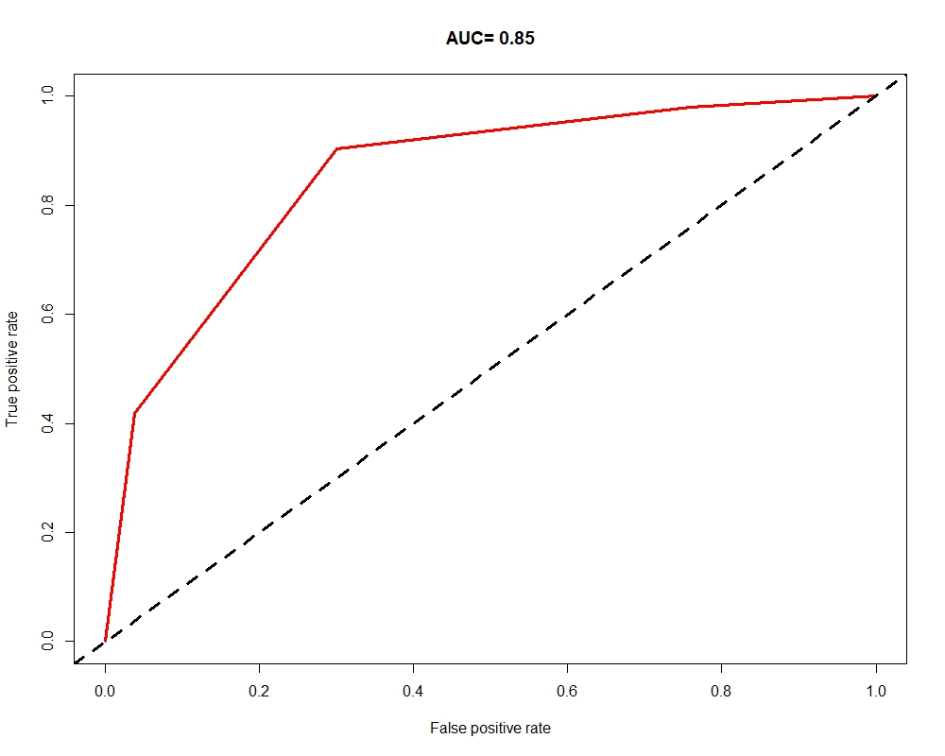
Figure S2 ROC curve reflecting the predictive accuracy of 8th TNM staging criteria in the final endpoint.

