Supplementary Material

Gut Microbiome Dynamics Associated with Rifamycin Therapy for Latent Tuberculosis Infection: findings from a prospective cohort study
Marie Nancy Séraphin^{1,2*}, Julia Bellot^{1,2}, Emily Klann^{,2,3}, Maria Ukhanova^{2,3}, Florence G. Saulsberry⁴, Charles A. Peloquin^{2,5}, and Volker Mai^{2,3}
¹Department of Medicine, Division of Infectious Diseases and Global Medicine, College of Medicine, University of Florida, Gainesville, Florida, United States
²Emerging Pathogens Institute, University of Florida, Gainesville, Florida, United States
³Department of Epidemiology, College of Public Health and Health Professions and College of Medicine, University of Florida, Gainesville, Florida, United States
⁴Florida Department of Health in Alachua County, Disease Control Unit, Alachua County Health Department, Gainesville, Florida, United States
⁵Infectious Disease Pharmacokinetics Laboratory, College of Pharmacy, University of Florida, Gainesville, Florida, United States
* Correspondence:
Marie Nancy Séraphin
nseraphin@ufl.edu

Keywords: latent tuberculosis infection, 3HP, 4R, rifamycins, gut microbiome, dysbiosis

Supplementary Figures and Tables

Supplementary Figures

Supplementary Figure 1. Relative abundance of gut bacterial taxa as a proportion of the total number of ASVs per sample after resampling 33,582 sequence reads to correct for uneven sampling efforts) grouped by sampling interval (Pre-RX: pretreatment; First: after 30 days of RIF/RPT exposure; Second: after 60 days of RIF/RPT exposure; Third: after 90/180 days of RPT/RIF exposure; Post-RX: 60 posttreatment completion) in LTBI patient (AL002 – MD001; Treatment) and healthy volunteer samples (HC001 – HC006; Control). Healthy volunteers were unexposed to rifamycins but were sampled at similar intervals as the LTBI patients receiving 4R. All participants had not used antibiotics at least one month prior to study enrollment. AL005, AL012, and HC004 reported the use of antibiotics during follow-up (second and posttreatment intervals, respectively, while AL007 introduced daily probiotic during treatment (First and Second sampling intervals).

Supplementary Figure 2 Principal coordinates analysis (PCoA) plot on the weighted UniFrac distance matrix generated from ASVs randomly resampled to 33,582 sequence reads and depicting patterns of beta diversity for gut microbial communities of healthy volunteers. Points represent the beta diversity at a sampling interval for each of the six participants. Each healthy volunteer provided three stool samples during treatment (First, Second, Third) collected at 30, 60, and 180 days from baseline. Points that are closer together on the ordination have more similar bacterial communities. Permutational multivariate analysis of variance analysis indicates that differences between microbial communities across sampling intervals are not significantly different (R² = 0.019; P = 1).

Supplementary Figure 3 Boxplots of the relative abundance of bacterial taxa aggregated at the phylum level in LTBI patients (Treatment) and healthy volunteers (Control). Each dot represents one of five samples collected from each participant. Dot color indicates the sampling timepoint for each sample. Significant differences in relative abundance of Candidatus_Saccharibacteria, Elusimicrovia, Lentisphaerae, Proteobacteria, Synergistetes, and Tenericutes were observed between LTBI patients and controls.

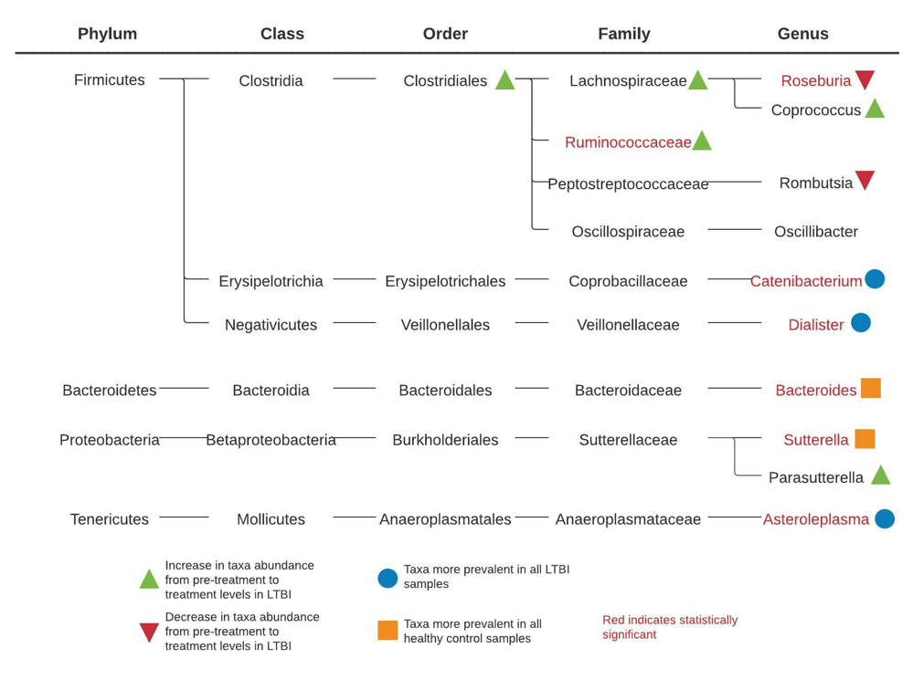
Supplementary Figure 4 Summary of the direction of change in relative abundance of bacterial taxa in LTBI and healthy controls. Green triangles indicate increases in taxa abundance, and red triangles indicate a decrease in taxa abundance from pretreatment to treatment in LTBI patients. Blue circles indicate bacterial taxa more prevalent in all LTBI fecal samples, while orange squares identify those more prevalent in healthy volunteers. Taxa highlighted in red indicate instances where a statistically significant difference (P < 0.05) in taxa abundance was observed.

Supplementary Figure 5. Shannon diversity index of LTBI (Treatment) and control participants pretreatment, during, and two months posttreatment completion after removing observations from participants (AL012, AL005, and HC004) who reported using antibiotics during Treatment (AL005-2) and posttreatment (AL012-4, HC004-4) intervals. Observations from AL007 who reported probiotic use at months one (AL007-1) and two (AL007-2) of their 4R regimen were also excluded. Controls were not exposed to rifamycins but collected stool samples at similar intervals as LTBI patients receiving 4R. In contrast to the statistics presented in Supplementary Table 2 below, dropping these observations resulted in a lower mean Shannon index during treatment (Shannon index: 4.413 vs. 4.429) but higher Shannon index posttreatment (4.605 vs. 4.449). In the Controls, Shannon index changed from 4.462 to 4.513 in the posttreatment interval after dropping the sample from HC004.

Supplementary Figure 6. Principal coordinates analysis (PCoA) plot on the weighted UniFrac distance matrix after removing observations from participants who reported using antibiotics during treatment (AL005 – Second sampling interval) and posttreatment (AL012, HC004 – Post-RX). Observations from AL007 who reported probiotic use at months one (First) and two (Second) of their 4R regimen were also excluded. Points closer to the ordination have more similar bacterial communities. Left panel depicts patterns of beta diversity for bacterial communities sampled from LTBI patients only. Permutational multivariate analysis of variance analysis indicates that differences between communities mapped according to individual patients (colors) and sampling interval (shapes) are non-significant (R² = 0.067; P = .379). Right panel depicting the patterns of beta diversity for bacterial communities sampled from LTBI and controls shows a significant PERMANOVA for the differences between communities mapped according to treatment [(3HP, 4R, or control) (R² = 0.152; P = .001)]

Supplementary Figure 7. Principal coordinates analysis (PCoA) plot on the weighted UniFrac distance matrix generated from ASVs randomly resampled to 33,582 sequence reads and depicting patterns of beta diversity for gut microbial communities of healthy volunteers. Points represent the beta diversity at a sampling interval for each of the six participants. The posttreatment sample collected from HC004 was dropped from these analyses, as the participant reported taking antibiotics. Points that are closer together on the ordination have more similar bacterial communities. Permutational multivariate analysis of variance analysis indicates that differences between microbial communities across sampling intervals are not significantly different (R² = 0.021; P = 1).

Supplementary Figure 8. Alpha diversity of the gut microbial community of LTBI patients (Treatment) and healthy volunteers (control) across the time course. Healthy volunteers did not receive rifamycin therapy but provided stool samples at concurrent intervals as the LTBI patients receiving 4R.

Supplementary Tables
Supplementary Table 1. Timing in days of all sample collection for each study participant
Participant | Enrollment to baseline | Pre-RX sample | First Sample | Second Sample | Third Sample | Post-RX sample
AL002 (3HP) | 6 | 8 | 36 | 82 | 100 | 156
AL003 (4R) | 1 | 0 | 30 | 61 | 122 | 179
AL005 (4R) | 0 | 0 | 31 | 60 | 122 | 178
AL007 (4R) | 1 | 0 | 28 | 67 | 99 | 182
AL012 (3HP) | 0 | 0 | 31 | 64 | 78 | 150
MD001 (4R) | 0 | 0 | 21 | 51 | 110 | 170
HC001 | 0 | 0 | 30 | 63 | 119 | 179
HC002 | 5 | 0 | 31 | 56 | 123 | 182
HC003 | 1 | 0 | 35 | 60 | 122 | 180
HC004 | 29 | 0 | 33 | 62 | 120 | 180
HC005 | 2 | 0 | 28 | 66 | 122 | 180
HC006 | 1 | 0 | 32 | 58 | 120 | 180
Notes: Stool samples during treatment follow-up were collected at 30-day interval ±7 days, estimated based on the date the LTBI participants ingested their first dose of the rifamycin treatment. We fixed the “treatment start date” for healthy volunteers using the date the baseline sample was collected. LTBI patients received 3HP by direct observation at the TB clinic or via video. Patients received 4R by self-administration but had to return to the clinic monthly for prescription refill.

Group | Shannon diversity |  |  | P-value** (paired; cases and controls compared within groups)
 | Pre-RX | Treatment*** | Post-RX | Pre-RX vs. treatment | Treatment vs. post-RX | Pre-RX vs. post-RX
Cases | 4.625 | 4.429 | 4.449 | 0.063 | 0.563 | 0.688
Controls* | 4.559 | 4.410 | 4.462 | 0.589 | 0.937 | 0.563
Difference in Shannon diversity |  |  |  | P-value** (unpaired; cases and controls compared between groups)
 | Pre-RX | Treatment*** | Post-RX | Pre-RX | Treatment | Post-RX
Cases vs. controls | 0.066 | 0.019 | 0.013 | 0.937 | 0.937 | 1
Supplementary Table 2. Shannon diversity within and between groups (cases and controls) over time

Notes: *Though controls did not undergo treatment, samples were collected at the same intervals as they were for cases. Therefore, the pre-RX, treatment, and post-RX time points merely indicate the same collection time as cases and not actual receival of treatment. Alpha diversity for each timepoint is shown in Figure 1. **P-values were calculated using both paired and unpaired non-parametric Wilcoxon tests, respectively. ***Three samples were collected from each participant during the treatment interval. In order to compare this interval to the pre-RX and post-RX intervals with only one sample each, the Shannon diversity index values for the three samples were averaged by each participant.

Supplementary Table 3a. Differentially abundant taxa in cases pre-treatment versus treatment
 | Abundance count
Bacterial taxa (ASV) | Pre-treatment | Treatment | P-value*
Clostridiales | 0 | 34 | 0.074
Clostridium_XIVa | 201 | 62 | 0.002
Coprococcus | 0 | 6 | 0.074
Lachnospiraceae** | 43 | 118 | 0.087
Parasutterella | 0 | 31 | 0.074
Romboutsia | 18 | 0 | 0.074
Roseburia** | 75 | 0 | 0.028
Ruminococcaceae | 0 | 29 | 0.015
Notes: *P-values were calculated using the non-parametric paired Wilcoxon test and were corrected using the Benjamini-Hochberg method. Some p-values are similar as the wilcox.test function in R returns normal approximated p-values for less than 50 observations with ties. Only ASVs associated with a p-value < 0.1 are included in this table. **Multiple ASVs classified as Lachnospiraceae (N=2) and Roseburia (N=2) were identified as differentially abundant. Only the ASVs with the largest differential abundance are shown here. At the exception of Parasutterella, all bacterial taxa shown group under the phylum Firmicutes. The data were rarefied to diminish differences due to sequence depth prior to conducting these analyses. Three samples were collected from each participant during the treatment interval. In order to compare this interval to the pre-treatment interval with only one sample, we pooled the three samples from each participant.

Supplementary Table 3b. Differentially abundant taxa in cases pre-treatment versus post-treatment
 | Abundance count
Bacterial taxa (ASV) | Pre-treatment | Post-treatment | P-value*
Clostridium XIVa | 201 | 104 | 0.065
Lachnospiraceae** | 153 | 0 | 0.074
Oscillibacter | 43 | 0 | 0.074
Romboutsia | 18 | 0 | 0.074
Notes: *P-values were calculated using the non-parametric paired Wilcoxon test and were corrected using the Benjamini-Hochberg method. Some p-values are similar as the wilcox.test function in R returns normal approximated p-values for less than 50 observations with ties. Only ASVs associated with a p-value < 0.1 are included in this table. **Four ASVs classified at the family level as Lachnospiraceae (N=4) were identified as differentially abundant. Only the ASV with the largest differential abundance is shown here. The data were rarefied to diminish differences due to sequence depth prior to conducting these analyses. All bacterial taxa shown group under the phylum Firmicutes.

Supplementary Table 4a. Percent change from before and during treatment interval (pre-RX and RX) in TB patients and controls
 | LTBI |  |  |  |  |  | Controls*
 | AL002 | AL003 | AL005 | AL007 | AL012 | MD01 | HC001 | HC002 | HC003 | HC004 | HC005 | HC006
Phylum
Actinobacteria | -58.22% | 237.31% | 140.86% | 99.86% | 344.07% | 153.29% | -9.08% | 44.99% | 73.13% | -50.44% | -19.98% | -7.33%
Bacteroidetes | -2.35% | 9.88% | -3.16% | 6.95% | -15.49% | 109.77% | -9.03% | 4.53% | -11.94% | 31.41% | 0.04% | 16.75%
Candidatus Saccharibacteria | 0.00% | 0.00% | 0.00% | 0.00% | 0.00% | 0.00% | -10.64% | 0.00% | 0.00% | 0.00% | -66.67% | 0.00%
Cyanobacteria/Chloroplast | 0.00% | 0.00% | 0.00% | 0.00% | 0.00% | 0.00% | 0.00% | 0.00% | 0.00% | 0.00% | 0.00% | 0.00%
Elusimicrobia | 0.00% | 0.00% | 0.00% | 0.00% | 0.00% | 0.00% | 191.40% | 0.00% | 0.00% | 0.00% | 0.00% | 0.00%
Firmicutes | 4.53% | -9.32% | -7.34% | 6.70% | 0.68% | -8.51% | 9.10% | -5.97% | 6.26% | -25.08% | 19.38% | -17.17%
Fusobacteria | 0.00% | 0.00% | 0.00% | 0.00% | 0.00% | -100.00% | 0.00% | 0.00% | 0.00% | 0.00% | -88.00% | 0.00%
Lentisphaerae | 0.00% | -16.67% | -6.06% | 0.00% | -13.58% | -82.93% | 45.24% | 0.00% | 0.00% | 0.00% | 0.00% | 0.00%
Proteobacteria | 388.25% | 3.43% | -0.81% | -51.68% | -78.72% | -57.93% | -45.71% | 36.73% | -5.32% | 73.89% | -19.36% | 31.51%
Synergistetes | 0.00% | 0.00% | 0.00% | 0.00% | 0.00% | 0.00% | -16.67% | 0.00% | 0.00% | 0.00% | 0.00% | 0.00%
Tenericutes | -100.00% | -0.24% | -100.00% | -100.00% | 148.73% | -37.35% | 13.89% | 0.00% | 0.00% | -92.31% | 0.00% | 0.00%
Verrucomicrobia | 0.00% | -100.00% | 89.58% | 0.00% | -50.72% | -50.00% | 400.00% | 173.81% | -83.33% | 0.00% | -100.00% | 0.00%
Notes: The treatment (RX) interval contains three different time points with samples for each time point. The relative abundance is averaged for these three time points to create one treatment interval to compare to the single sample collected pre-treatment. Negative percentages (red) indicate a higher relative abundance at the pre-RX interval compared to the post-RX interval. Values highlighted in green indicates an increase in relative abundance at the post-RX interval, compared to pre-RX. Zero percentage change values highlighted in red indicate that the relative abundance of a phylum increase during treatment compared to pre-treatment, although the percentage change is zero. *Controls did not undergo treatment. However, samples were obtained at the same intervals as with patients on a 4R treatment regimen.

Supplementary Table 4b. Percent change from before and after treatment interval (pre-RX and post-RX) in TB patients and controls
 | LTBI |  |  |  |  |  | Controls*
 | AL002 | AL003 | AL005 | AL007 | AL012 | MD01 | HC001 | HC002 | HC003 | HC004 | HC005 | HC006
Phylum
Actinobacteria | -91.667% | 124.280% | 44.453% | -36.441% | 468.889% | 156.920% | 10.448% | -46.305% | -19.977% | -49.530% | -5.223% | 28.605%
Bacteroidetes | -5.187% | -20.326% | 18.721% | 33.874% | 46.973% | 135.276% | -26.115% | 22.248% | -14.019% | 13.636% | 6.169% | -0.719%
Candidatus Saccharibacteria | 0.000% | 0.000% | 0.000% | 0.000% | 0.000% | 0.000% | 18.067% | 100.000% | 0.000% | 0.000% | 100.000% | 0.000%
Cyanobacteria/Chloroplast | 0.000% | 0.000% | 0.000% | 0.000% | 0.000% | 0.000% | 0.000% | 0.000% | 0.000% | 0.000% | 0.000% | 0.000%
Elusimicrobia | 0.000% | 0.000% | 0.000% | 0.000% | 0.000% | 0.000% | 25.806% | 0.000% | 0.000% | 0.000% | 0.000% | 0.000%
Firmicutes | 19.102% | 9.251% | -13.904% | -15.788% | -49.269% | -6.269% | 18.166% | -14.316% | 10.845% | -15.076% | 37.990% | -5.606%
Fusobacteria | 0.000% | 0.000% | 0.000% | 0.000% | 0.000% | -100.000% | 0.000% | 0.000% | 0.000% | 0.000% | -76.000% | 0.000%
Lentisphaerae | 0.000% | -25.000% | -86.364% | 0.000% | -100.000% | -82.927% | 95.238% | 0.000% | 0.000% | 0.000% | 0.000% | 0.000%
Proteobacteria | -71.223% | 15.662% | 1.610% | -47.424% | -39.889% | -73.852% | -78.816% | 67.622% | 39.239% | 103.619% | -60.030% | 52.875%
Synergistetes | 0.000% | 0.000% | 0.000% | 0.000% | 0.000% | 0.000% | 28.571% | 0.000% | 0.000% | 0.000% | 0.000% | 0.000%
Tenericutes | 600.000% | -15.431% | -100.000% | -100.000% | 219.859% | -11.607% | 58.333% | 0.000% | 0.000% | -100.000% | 0.000% | 0.000%
Verrucomicrobia | 0.000% | -100.000% | -71.875% | 0.000% | -100.000% | -100.000% | 471.429% | 7.143% | -25.000% | 0.000% | -100.000% | 0.000%
Notes: Negative percentages (blue) indicate a higher relative abundance at the pre-RX interval compared to the post-RX interval. Values highlighted in green indicates a higher relative abundance post-treatment compared to pre-treatment. *Controls did not undergo treatment. However, samples were obtained at the same intervals as with patients on a 4R treatment regimen.

Supplemental Table 5. Parent and metabolite rifamycin concentrations and their ratios (Cm/Cp) recovered in stool samples collected during treatment and two months after treatment completion.
 | First Treatment Interval |  |  | Second Treatment Interval |  |  | Third Treatment Interval |  |  | Post Treatment Interval
Subject ID | Parent Rifamycin | Metabolite | Cm/Cp* | Parent Rifamycin | Metabolite | Cm/Cp* | Parent Rifamycin | Metabolite | Cm/Cp* | Parent Rifamycin | Metabolite | Cm/Cp*
AL002 | 0.422 | 0.093 | 0.220 | 0.011 | 0.010 | 0.895 | 0.011 | 0.012 | 1.031 | 0.008 | 0.002 | 0.218
AL003 | 9.593 | 13.024 | 1.358 | 4.404 | 3.354 | 0.762 | 0.233 | 0.292 | 1.255 | 0.001 | 0.000 | 0.162
AL005 | 9.720 | 37.401 | 3.848 | 1.954 | 14.062 | 7.195 | 4.850 | 19.470 | 4.014 | 0.001 | 0.015 | 10.488
AL007 | 5.874 | 7.249 | 1.234 | 0.000 | 0.002 | 13.454 | 0.001 | 0.001 | 0.735 | 0.001 | 0.002 | 1.270
AL012 | 0.087 | 0.001 | 0.009 | 2.614 | 0.094 | 0.036 | 0.765 | 0.012 | 0.016 | 0.010 | 0.001 | 0.061
MD001 | 8.268 | 28.834 | 3.487 | 14.287 | 68.097 | 4.766 | 1.394 | 4.014 | 2.88 | 0.001 | 0.001 | 2.811
Notes: *Cm: rifamycin metabolite concentration; Cp: parent rifamycin metabolite concentration. Cm/Cp measures the ratio of parent drug to metabolite that was recovered in stool. To avoid dividing by zero some noise was added to the data using the base::jitter function in R. Drug concentration was measured at UF - Infectious Disease Pharmacokinetics Laboratory (IDPL), using an assay modified to measure the rifamycins parent and metabolite concentrations in a phosphate buffer wash of the stool samples collected during treatment and two months after treatment completion in the LTBI group.

