Flowering is the critical growth stage for adverse effects of salinity on the grain yield of sunflower
Plant and Soil
Afrin Jahan Mila*†, Richard W. Bell, Edward G. Barrett-Lennard, Enamul Kabir and Bernard Dell
*Centre for Sustainable Farming Systems, Future Food Institute, Murdoch University, Perth, WA-6150, Australia, and
†Irrigation and Water Management Division, Bangladesh Agricultural Research Institute, Gazipur, 1701, Bangladesh; E-mail: afrinbau@gmail.com

SUPPLEMENTARY INFORMATION
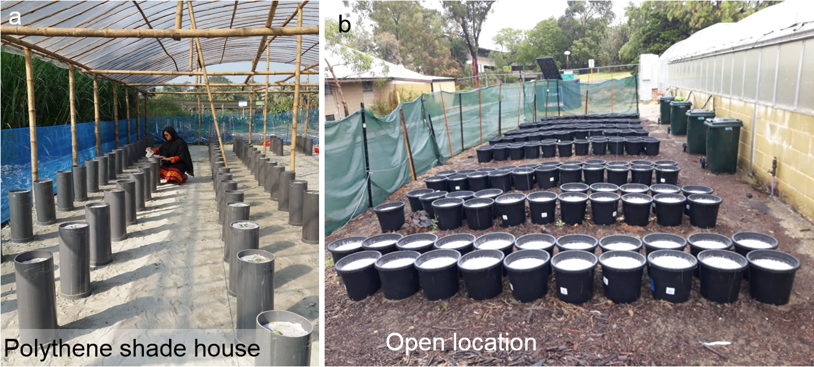

Fig. S1 Location of pot experiments. a polythene shade house in Khulna University; b open location at Murdoch University
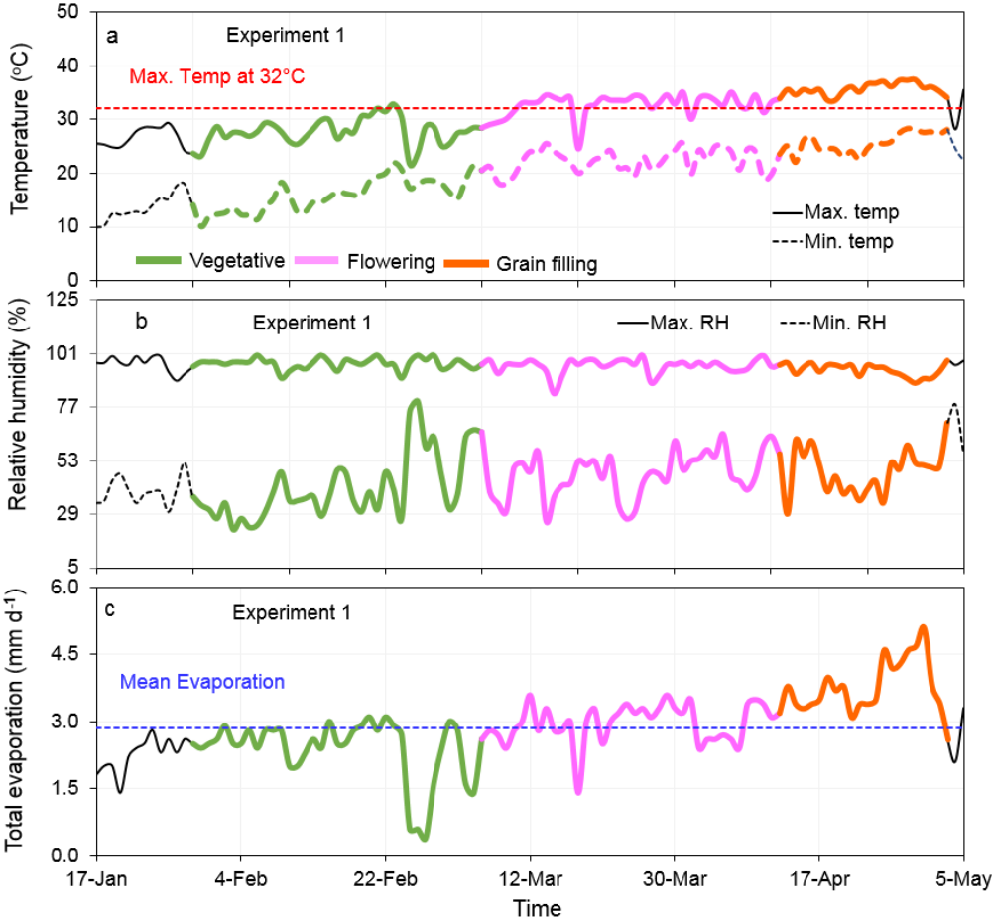

Fig. S2 Weather variables as a function of time during the study period in 2019 (a–c, Experiment 1 in Khulna). a maximum and minimum temperature; b maximum and minimum relative humidity; c daily total evaporation. Values are from the Khulna meteorological stations next to the experimental location. The heavy lines of green, purple and orange colour (a–c) represent the timing of the vegetative, flowering and grain filling stage for Experiment 1
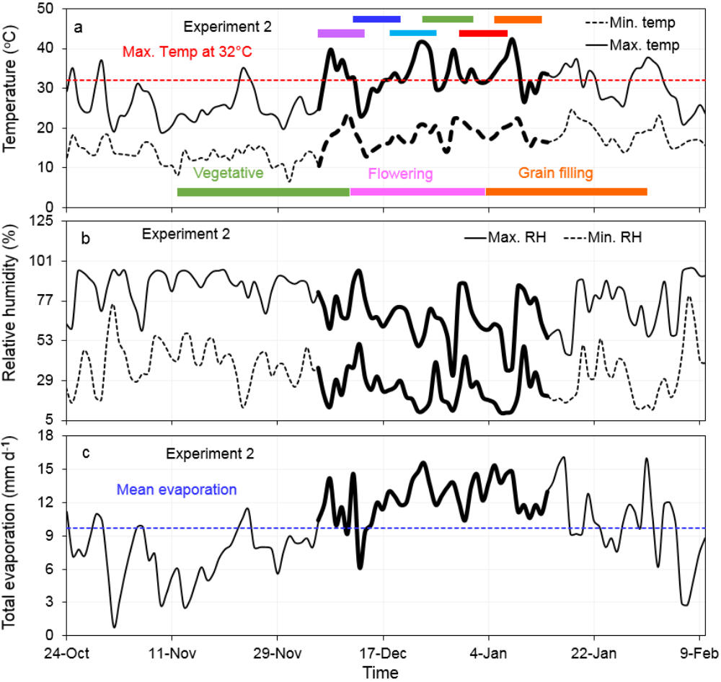

Fig. S3 Weather variables as a function of time during the study period in 2020–21 (a–c, Experiment 2 in Murdoch). a maximum and minimum temperature; b maximum and minimum relative humidity; c daily total evaporation. Values are from the Murdoch meteorological stations next to the experimental location. a Six horizontal bars of violate, blue, indigo, green, red and orange colour above the heavy lines indicate the timing of saline irrigation (Timing 1_6–15 Dec, Timing 2_12–21 Dec, Timing 3_18–27 Dec, Timing 4_24 Dec–2 Jan, Timing 5_30 Dec–8 Jan, and Timing 6_5–14 Jan, respectively) for Experiment 2. a Bars of green, purple and orange colour represents the timing of the vegetative, flowering and grain filling stage for Experiment 2

Table S1 Weather parameters during vegetative, flowering and grain filling stages of growth in 2019 and 2021 for Experiment 1 (Khulna) (Part a) and Experiment 2 (Murdoch) (Part b). Values are from the Khulna and Murdoch meteorological stations, close to each experimental area
a. Experiment 1 (Khulna) in 2019
Weather parameters | Vegetative | Flowering | Grain filling
Range of hours of sunshine | 0.4–9.9 | 3.5–10.3 | 2.2–10.8
Mean hours of sunshine | 7.2 | 8.1 | 8.8
Range of vapour pressure deficit (kPa) | 0.3–1.4 | 0.5–1.4 | 0.4–1.2
Mean vapour pressure deficit (kPa) | 0.9 | 0.8 | 0.8
Range of solar radiation (W m⁻²) | 92.6–239.5 | 166.6–281.2 | 151.6–302.0
Mean solar radiation (W m⁻²) | 193.7 | 238.4 | 264.2
Range of day length (hr) | 11:03–11:44 | 11:45–12:33 | 12:34–12:59
Mean day length (hr) | 11:22 | 12:08 | 12:46

- Experiment 2 (Murdoch) in 2021
Weather parameters | Timing 1 | Timing 2 | Timing 3 | Timing 4 | Timing 5 | Timing 6
Range of vapour pressure deficit (kPa) | 0.84–2.29 | 0.86–1.67 | 1.43–4.15 | 1.28–3.49 | 1.28–3.64 | 1.15–3.64
Mean vapour pressure deficit (kPa) | 1.44 | 1.36 | 2.01 | 1.92 | 2.09 | 1.95
Range of solar radiation (W m⁻²) | 1.8–1631.8 | 2.0–1631.8 | 1.8–1515.4 | 1.8–1515.4 | 1.8–1442.7 | 1.8–1649.0
Mean solar radiation (W m⁻²) | 383.7 | 401.8 | 418.3 | 404.9 | 404.7 | 399.1
Range of day length (hr) | 14.08–14.14 | 14.12–14.15 | 14.14–14.15 | 14.11–14.15 | 14.07–14.13 | 14.02–14.09
Mean day length (hr) | 14.12 | 14.14 | 14.15 | 14.13 | 14.10 | 14.06

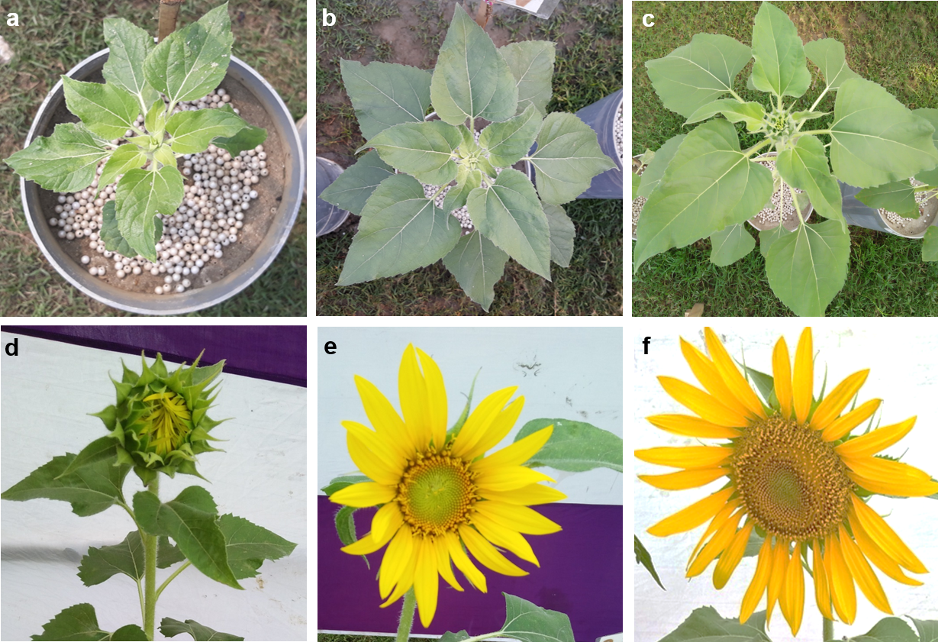

Fig. S4 Flowering stages of sunflower according to Schneiter and Miller (1981). a Pre-formation of star-like shape at around day 49; b Formation of star-like shape at around day 59 (R1); c Pre-formation of a disk at around day 67 (R3); d Pre-formation of flower (R4); e Opening of flower (R5.1); f Formation of 80% disk flower at around day 85 (R5.8)
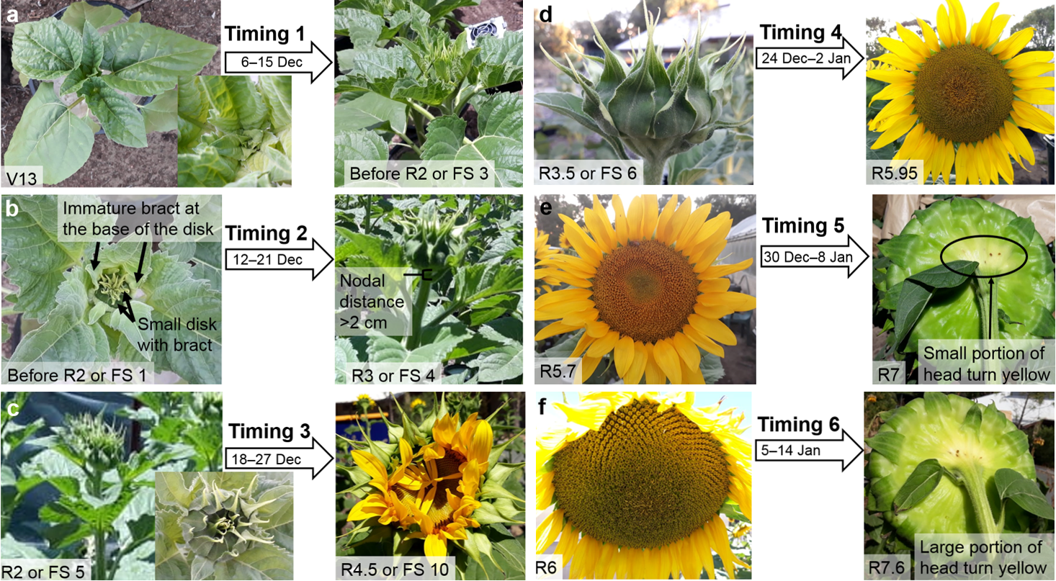

Fig. S5 Images of timing treatments showing crop phenology at the initiation and termination of salinity according to Schneiter and Miller (1981). a Timing 1: 13-leaf (V13) to small disk (before R2); b Timing 2: before R2 to > 2 cm nodal distance (R3); c Timing 3: 0.5–2.0 cm nodal distance (R2) to 50% disk opening (R4.5); d Timing 4: before opening of disk flower (R3.5) to 95% anthesis (R5.95); e Timing 5: R5.7 to small yellow colour at the back of the disk (R7); f Timing 6: wilting of ray flowers (R6) to large yellow colour at the back of the disk (R7.6). For a better understanding of the biology of stages from timing 1–4, we used Mark and Palmer (1981) terminology of classification of inflorescence development of FS 1–10
Table S2 Definition of sunflower crop growth stages based on Schneiter and Miller (1981)
Crop growth stage | Definition of crop growth stage (Schneiter and Miller 1981)
V13 | 13 true leaves of at least 4 cm in length.
R1 | The appearance of immature bracts on the apex of the vegetative shoot, which looks like a star.
R2 | Nodal distance between the bottom of the inflorescence (disk) and the nearest leaf remain 0.5–2.0 cm in length.
R3 | Nodal distance increase by more than 2 cm in length.
R4 | Opening of the disk with the appearance of ray flowers when viewed from the top.
R5 | The disks are completely open with the appearance of developed ray flowers. This stage is divided into sub-stages based on the per cent disk area covered by anthesis. For example, if 70% of head cover anthesis then the stage will be R5.7 and similar for 95% head area cover will be R5.95.
R6 | Development of flower is completed and the ray flowers are wilted by losing their firmness. However, the wilting of ray flowers may or may not exist but the evidence of the falling down of ray flower are noticed.
R7 | The light yellow colour at the back of the disk is present.

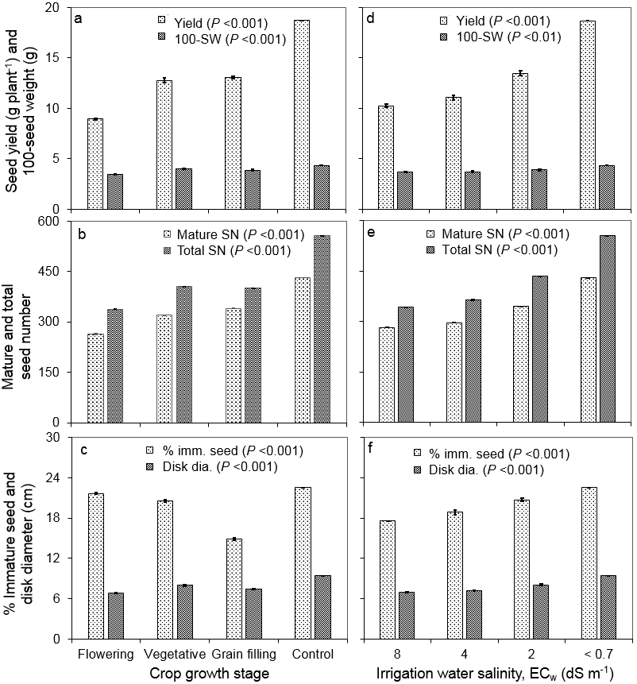

Fig. S6 Yield and yield attributes due to main effect of crop growth stage (a–c) and saline irrigation (d–f) for Experiment 1 in 2019. a & d seed yield and 100-seed weight; b & e mature and total seed number; c & f % immature seed and disk diameter. Values plotted are mean ± SE with P-values indicated. Experiment 1

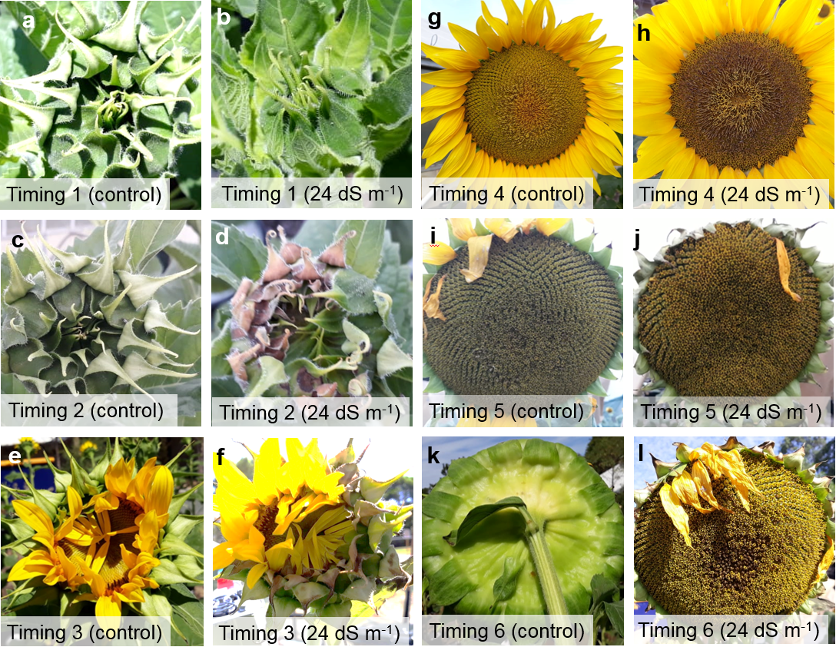

Fig. S7 Images of sunflower head showing the changes of crop phenology after 24 dS m⁻¹ of saline irrigation with control. Parts a, c and e at the first column and Parts g, i and k at the third column represent the control-treated plant during timing 1 to timing 6. Parts b, d and f at the second column and Parts h, j and l at the fourth column represent the 24 dS m⁻¹ treated plants for timing 1 to timing 6 (Experiment 2)
In addition, Fig. S7 shows the images of sunflower head for control (<0.7 dS m⁻¹) and high saline (24 dS m⁻¹) irrigated treatments after the termination of salinity. Changes in the head were observed after high saline irrigation over control for all treatments. Among them, stunted dish growth was common. In particular, the bract of the disk for timing 2 showed the appearance of 40–50% of brown colour, while timing 3 showed brown colour at the tip of the disk bract compared to control (Fig. S7c–S7f). Timing 4 and timing 5 showed the brown colour of almost 80% and 60% of the disk towards the centre (Fig. S7g–S7j).
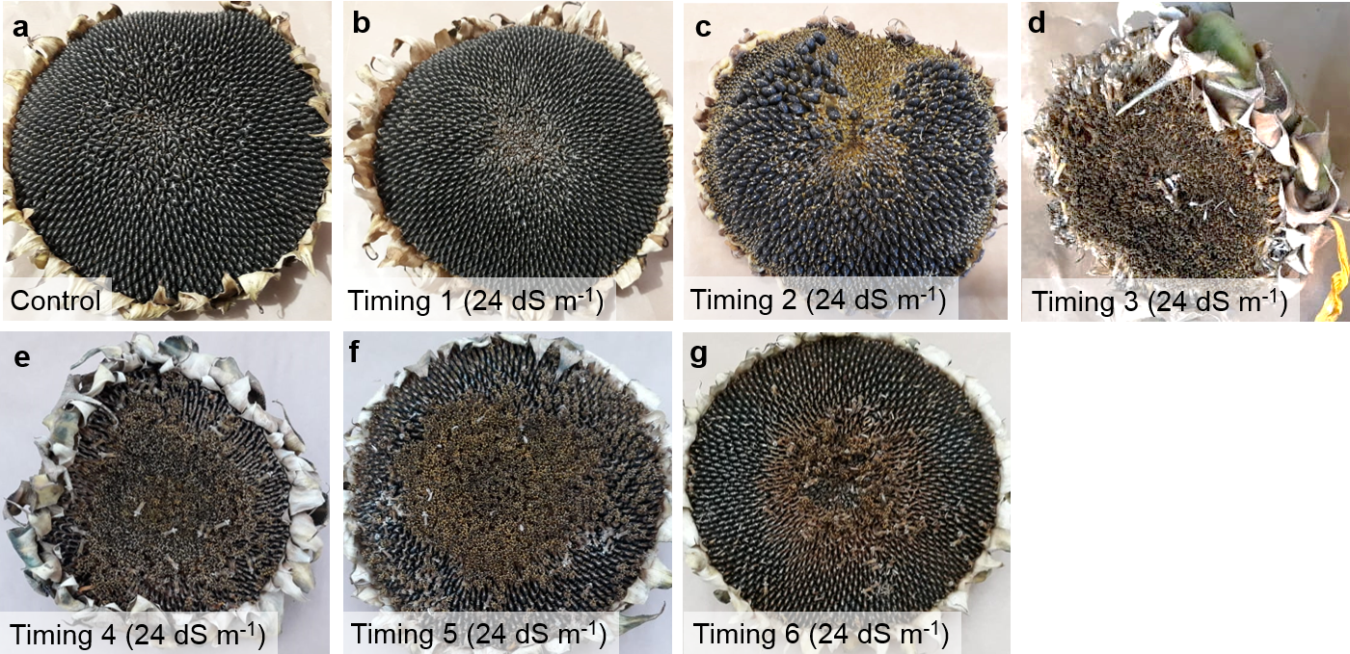

Fig. S8 Images of sunflower head showing the changes in seed set after 24 dS m⁻¹ of saline irrigation and control. a control; b to g timing 1 to timing 6 for 24 dS m⁻¹ (Experiment 2)

Table S3 Correlation matrix of seed yield and yield attributes showing P-values and Pearson's r-values (in parenthesis). a Experiment 1 (Khulna); b Experiment 2 (Murdoch)
- Experiment 1
 | Seed yield | Mature seed number | 100-seed weight | % immature seed | Disk diameter | Total seed number | Curl seed number
Seed yield | -
Mature seed number | *** (0.90) | -
100-seed weight | *** (0.69) | ** (0.32) | -
% immature seed | ns | ns | ns | -
Disk diameter | *** (0.75) | *** (0.72) | *** (0.44) | * (0.25) | -
Total seed number | *** (0.90) | *** (0.97) | ** (0.35) | ** (0.32) | *** (0.74) | -
Curl seed number | *** (0.72) | *** (0.71) | ** (0.35) | ***(0.77) | *** (0.65) | *** (0.85) | -
- Experiment 2
 | Seed yield | Mature seed number | 100-seed weight | % immature seed | Disk diameter | Total seed number | Curl seed number | Weight of harvest head
Seed yield | -
Mature seed number | ***(0.93) | -
100-seed weight | ***(0.85) | ***(0.67) | -
% immature seed | ***(-0.86) | ***(-0.94) | ***(-0.61) | -
Disk diameter | ***(0.82) | ***(0.83) | ***(0.63) | ***(-0.71) | -
Total seed number | ***(0.71) | ***(0.81) | ***(0.48) | ***(-0.63) | ***(0.84) | -
Curl seed number | ***(-0.73) | ***(-0.72) | ***(-0.55) | ***(0.84) | **(-0.40) | ns | -
Weight of harvest head | ***(0.52) | ***(0.53) | **(0.35) | ***(-0.42) | ***(0.74) | *** (0.61) | ns | -
*** P < 0.001; ** P < 0.01, * P < 0.05; ns not significant
Supplementary Information, Table S4 shows the correlation matrix of seed yield and crop stress parameters. Na⁺/K⁺ was strongly correlated (r = 0.99 or r² = 0.99) with Na⁺.

Table S4 Correlation matrix of seed yield, leaf Na⁺/K⁺, leaf Na⁺, leaf K⁺, photosynthesis (A), stomatal conductance (gs), and transpiration (E) showing P-values and Pearson's r-values (in parenthesis) for Experiment 2
 | Seed yield | Sodium/  Potassium (Na⁺/K⁺) | Sodium (Na⁺) | Potassium (K⁺) | Photosynthesis (A) | Stomatal conductance (gs) | Transpiration (E)
Seed yield | -
Na⁺/K⁺ | ***(-0.82) | -
Na⁺ | ***(-0.80) | ***(0.99) | -
K⁺ | ns | ns | *(0.26) | -
A | ***(0.83) | ***(-0.77) | ***(-0.76) | *(-0.26) | -
gs | ***(0.76) | ***(-0.66) | ***(-0.65) | **(-0.36) | ***(0.91) | -
E | ***(0.76) | ***(-0.66) | ***(-0.66) | *(-0.28) | ***(0.83) | ***(0.87) | -
*** P < 0.001; ** P < 0.01, * P < 0.05; ns not significant
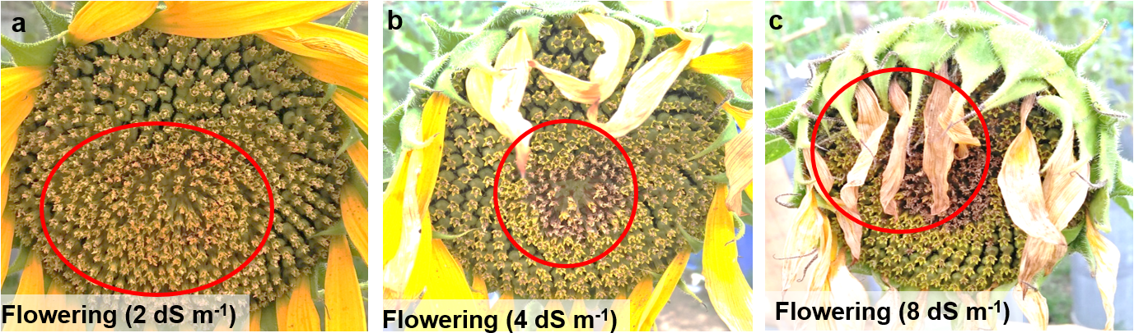

Fig. S9 Abnormal seed formation due to continuous use of saline irrigation (EC) at the flowering stage. a EC of 2 dS m⁻¹ produced ~40–50% curl or immature seed at the centre. b EC of 4 dS m⁻¹ created a gap at the centre surrounded by brown coloured seed and immature seed that accounted for ~30–40% of total disk area. c EC of 8 dS m⁻¹ produced brown dead spikelets at the centre of the disk

